**Apache支持cgi**

1、打开Apache配置文件httpd.conf，搜索“cgi”，找到下面的一段，去掉“addhandler”前面的“#“，这样就开启了Apache的cgi功能

|  |
| --- |
| # AddHandler allows you to map certain file extensions to "handlers":  # actions unrelated to filetype. These can be either built into the server  # or added with the Action directive (see below)  #  # To use CGI scripts outside of ScriptAliased directories:  # (You will also need to add "ExecCGI" to the "Options" directive.)  #  AddHandler cgi-script .cgi |

2、cgi的目录在“/var/www/cgi-bin/”，在这里创建一个测试文件“test.cgi”输入内容如下

|  |
| --- |
| #!/usr/bin/perl  print "Content-type: text/html\n\n";  print "hello cgi"; |

3、将“cgi-bin”的权利改为777

|  |
| --- |
| # Timeout: The number of seconds before receives and sends time out.  #  Timeout 60 |

4、在浏览器输入“127.0.0.1/cgi-bin/test.cgi”可以看到下面的结果

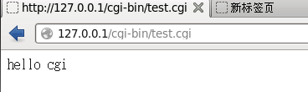

Copyright@david zhytwj2018@163.com