**Apache支持ssl**

1、检测是否安装ssl模块，如果没有就安装

|  |
| --- |
| [root@localhost cgi-bin]# rpm -qa | grep mod_ssl //查看是否安装ssl模块  [root@localhost cgi-bin]# yum install -y mod_ssl //安装ssl  Loaded plugins: fastestmirror, refresh-packagekit, security  Loading mirror speeds from cached hostfile  Complete!  [root@localhost cgi-bin]# |

2、修改ssl的配置文件“/etc/httpd/conf.d/ssl.conf”如下，开启ssl，设置监听端口

|  |
| --- |
| # Do NOT simply read the instructions in here without understanding  # what they do. They're here only as hints or reminders. If you are unsure  # consult the online docs. You have been warned.  #  LoadModule ssl_module modules/mod_ssl.so //开启ssl功能  #  # When we also provide SSL we have to listen to the  # the HTTPS port in addition.  #  Listen 443 //监听的端口 |

3、修改防火墙配置，开启对上面端口443的支持

1)在终端输入命令“setup”，在弹出的框中选择“防火墙”，接着选择“定制”

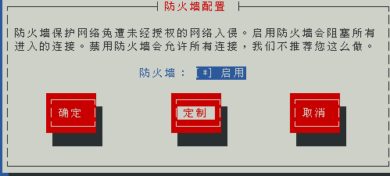

2)使用空格键选中”https“，接着选择“转发”

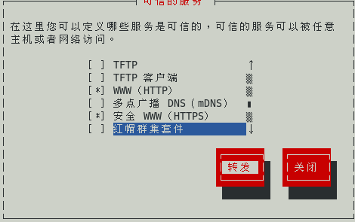

3)选择“添加“

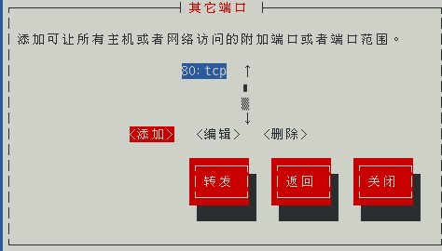

4)添加端口443，协议tcp，然后确定

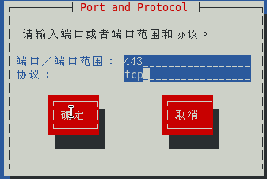

5)回到最初的界面，“确定”

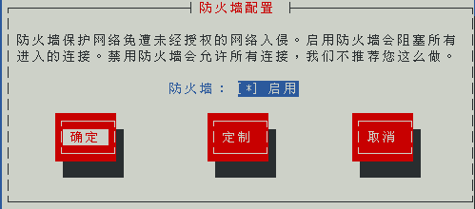

6)重启防火墙

|  |
| --- |
| [root@localhost ~]# service iptables restart  iptables：将链设置为政策 ACCEPT：filter nat [确定]  iptables：清除防火墙规则： [确定]  iptables：正在卸载模块： [确定]  iptables：应用防火墙规则： [确定]  [root@localhost ~]# |

7)重启apache

|  |
| --- |
| [root@localhost ~]# service httpd restart  停止 httpd： [确定]  正在启动 httpd：httpd: Could not reliably determine the server's fully qualified domain name, using localhost.localdomain for ServerName  [确定]  [root@localhost ~]# |

4、测试

1）在浏览器输入<https://127.0.0.1>，注意必须是“https“ ，看到如下结果

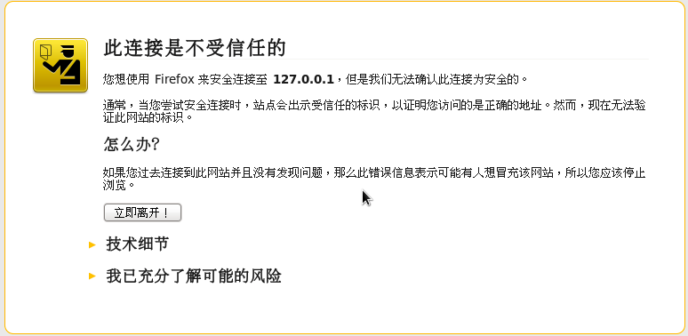

2)选择“我已充分了解”，弹出如下对话框，选择“确认安全例外”就可以正常访问

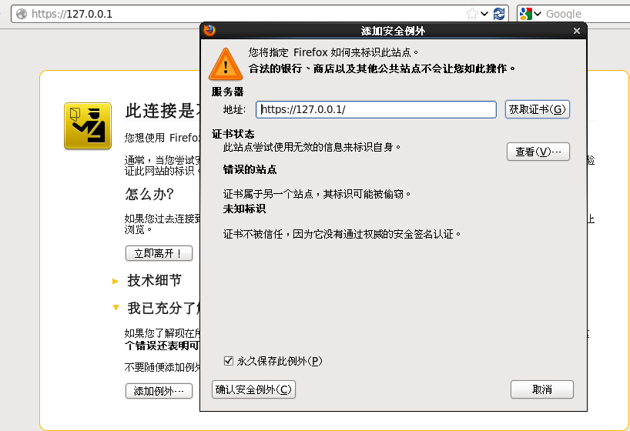

Copyright@david zhytwj2018@163.com