**安装samba**

1、检测samba是否安装，如果没有，那么可以使用yum来安装。至少需要安装3个软件：samba， samba-client、samba-common

|  |
| --- |
| [root@localhost pub]# **rpm -qa | grep samba**  samba-winbind-clients-3.6.9-164.el6.i686  samba-client-3.6.9-164.el6.i686  samba-common-3.6.9-164.el6.i686  samba4-libs-4.0.0-58.el6.rc4.i686  samba-winbind-3.6.9-164.el6.i686  [root@localhost pub]# **yum install –y samba samba-client samba-common //如果没有，那么可以用此命令安装** |

2、创建共享目录

|  |
| --- |
| [root@localhost /]# **mkdir /wj //创建目录**  [root@localhost /]# **chmod 777 /wj //设置权限** |

3、修改配置文件“/etc/samba/smb.cnf”

|  |
| --- |
| [root@localhost /]# **gedit /etc/samba/smb.conf**  # ----------------------- Standalone Server Options ------------------------  # Scurity can be set to user, share(deprecated) or server(deprecated)  # Backend to store user information in. New installations should  # use either tdbsam or ldapsam. smbpasswd is available for backwards  # compatibility. tdbsam requires no further configuration  **security = share //这里默认是user，改为share，这样不用输入密码就可访问**  passdb backend = tdbsam  **[wj] //创建共享目录配置**  **comment=wj //名字**  **path=/wj //路径**  **read only=no //是否只读，这里为no，这样用户就可以创建文件夹**  **guest ok=yes //是否允许guest用户登录**  **browseable=yes //是否可以浏览目录** |

4、修改防火墙，打开tcp的端口137、138、139、445

|  |
| --- |
| [root@localhost wj]# **gedit /etc/sysconfig/iptables**  **-A INPUT -m state --state NEW -m tcp -p tcp --dport 137 -j ACCEPT**  **-A INPUT -m state --state NEW -m tcp -p tcp --dport 138 -j ACCEPT**  **-A INPUT -m state --state NEW -m tcp -p tcp --dport 139 -j ACCEPT**  **-A INPUT -m state --state NEW -m tcp -p tcp --dport 445 -j ACCEPT**  [root@localhost wj]# **service iptables restart**  iptables：将链设置为政策 ACCEPT：filter nat [确定]  iptables：清除防火墙规则： [确定]  iptables：正在卸载模块： [确定]  iptables：应用防火墙规则： [确定]  iptables：载入额外模块：nf_conntrack_ftp [确定] |

5、启动smb服务

|  |
| --- |
| [root@localhost wj]# **service smb start**  启动 SMB 服务： [确定] |

6、测试，在终端输入命令“testparm”，可以看到共享目录的信息

|  |
| --- |
| [root@localhost wj]# **testparm**  Load smb config files from /etc/samba/smb.conf  rlimit_max: increasing rlimit_max (1024) to minimum Windows limit (16384)  Processing section "[homes]"  Processing section "[printers]"  Processing section "[wj]"  WARNING: The security=share option is deprecated  Loaded services file OK.  Server role: ROLE_STANDALONE  Press enter to see a dump of your service definitions  [global]  workgroup = MYGROUP  server string = Samba Server Version %v  security = SHARE  log file = /var/log/samba/log.%m  max log size = 50  idmap config * : backend = tdb  cups options = raw  [homes]  comment = Home Directories  read only = No  browseable = No  [printers]  comment = All Printers  path = /var/spool/samba  printable = Yes  print ok = Yes  browseable = No  [wj]  comment = wj  path = /wj  read only = No  guest ok = Yes |

7、从windows测试，按下快捷键“window+r”，在弹出的窗口输入命令“smb:\\192.168.0.113”，可以看到本机的共享目录

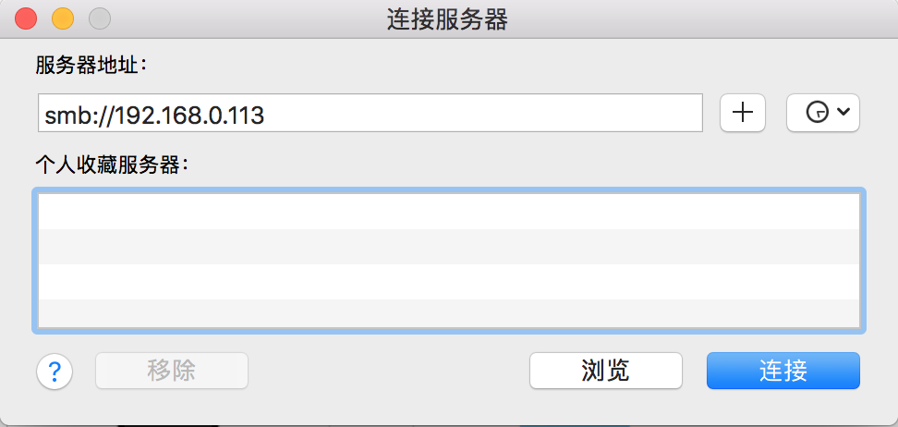

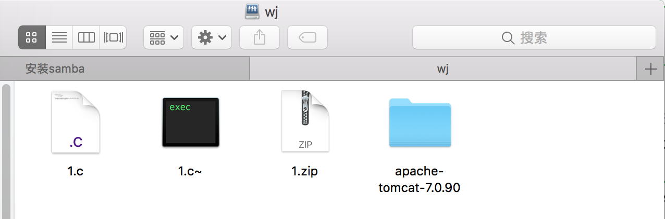

Copyright@david zhytwj2018@163.com