

Installation Guide

Apache Roller Weblogger
Version 5.2
July 2017

Table of Contents
1 Overview 3
1.1 Copyright and trademark information 3
1.2 Feedback 3
1.3 Acknowledgments 3
2 Securing Roller 4
3 Ready to roll? 5
4 Download and un-package Roller 6
4.1 Installation directory layout 6
5 Prepare your database for Roller 7
5.1 Create a database for Roller 7
5.2 MySQL and Oracle considerations 7
6 Deploy Roller to Tomcat 9
6.1 Tomcat: Create Roller Configuration File 9
6.2 Using Server-provided database & mail resources (optional) 10
6.3 Tomcat: Add JDBC Driver and JavaMail API Files 12
6.4 Tomcat: Set URI Encoding 12
6.5 Tomcat: Deploy Roller 13
7 Deploying Roller to Glassfish 14
7.1 Glassfish: Add Roller Configuration 14
7.2 Glassfish: Add JDBC Driver File(s) 14
7.3 Glassfish: Create Datasource 14
7.4 Glassfish: Create Mail Connection 17
7.5 Glassfish: Deploy Roller 18
8 Deploying Roller to JBoss 20
8.1 JBoss: Create Roller configuration 20
8.2 JBoss: Create Datasource 21
8.3 JBoss: Create Mail Server connection 25
8.4 JBoss: Deploy Roller 28
9 Getting started with Roller 29
9.1 Navigate to Roller and finish the install 29
9.2 Register a user and create a weblog 30
10 Configuration tips and tricks 32
10.1 Setting up Roller's Planet feed aggregator 32
10.2 Manual table creation and upgrade 33
11 Upgrading Roller 34
11.1 Backup your old Roller 34
11.2 Install and startup the new Roller 35

Overview
This document describes how to install the Apache Roller Weblogger software. It explains what you need to install first, how to download Roller, how to configure Roller and how to install it to your existing Java application server and relational database.

Copyright and trademark information
The contents of this document are subject to the terms of the Apache Software License.
All trademarks within this document belong to legitimate owners.

Feedback
Please direct any comments or suggestions about this document to the Roller User Mailing list. For more information on the Roller mailing lists please refer to the following page:

Roller Mailing Lists - https://cwiki.apache.org/confluence/x/ZYk

Acknowledgments
The original version of this document was written by Dave Johnson. The document is currently written and updated by the Apache Roller project of the Apache Software Foundation.

The general format of this document was based on the documentation template used by the OpenDS project which in turn was based on the templates used by the OpenOffice.org project.

Securing Roller
Security should be top-of-mind when setting up any web site, even one that is on a private network and internal to your organization. Here are some recommendations for keeping your Roller installation secure:
- Perform Roller installation on a secure network. When you are installing Roller it is possible for other users to interfere with your installation. If other users have access to the server, one of them could create the admin account before you do. So, when you install Roller, do so on a server that cannot be accessed by others.
- Do not allow open registration of new users. Roller can offer a registration link so that new users can register themselves, but this feature is turned off because it is not safe to allow just anybody to register for an account on your blog server. If you want to turn it on, login as an administrative user, go to Roller's Server Administration page and enable the Allow New Users option.
- Enable HTML Sanitization. If you cannot trust the webloggers who will use your Roller site to author HTML, then you should configure Roller to sanitize all HTML published by the system. Do this by setting the weblogAdminsUntrusted=true property in your roller-custom.properties file.
- Do not allow HTML in comments. Roller can allow users to write comments in a safe-subset of HTML, but HTML use in comments is not allowed at all because of security concerns with even a so called safe-subset of HTML. If you want to turn it on, login as an administrative user, go to Roller's Server Administration page, enable the Allow html in comments option and make sure the HTML Subset Restriction box is checked.
- Run Roller over SSL connection. If you run Roller over a plain old HTTP connection, it is possible for others to snoop your password when you login, for example over an open WIFI network. To configure Roller to work over SSL (i.e., using https:// URLs), first modify the web.xml located in the Roller WAR (WEB-INF folder), uncommenting the <security-constraint/> element and following the instructions given in that file above that element. Next, follow your servlet container's documentation for setting up SSL (http://tomcat.apache.org/tomcat-7.0-doc/ssl-howto.html for Tomcat, for example.) Then redeploy Roller and confirm that pages containing secure data such as the login page and new user registration page are available only via https:// URLs.

Ready to roll?
First, let's make sure you have everything you need to install and run Roller.
Roller is a database-driven Java web application. To run it you need Java, a Java Servlet container such as Tomcat, a connection to a database such as MySQL and optionally a connect to a mail server. More specifically, here's what you need to install and run Roller:
- Java Development Kit, specifically the Java 2 SE 1.6 JDK or more recent. The computer on which you install Roller should already have the JDK installed and configured.
- Java EE 6 Application Server, or more specifically a Servlet container that supports at least the Servlet 2.4 API. Hereinafter, we'll just call this your server. Roller has traditionally worked best on Tomcat and Tomcat only, but Roller is known to run on:
  - Tomcat 6 and 7
  - Glassfish 3
  - JBoss AS 6
  - WebSphere 8 (beta)
- Relational database such as MySQL or Apache Derby. Roller stores blog entries, comments, bookmarks and almost all other data in a relational database accessed via the Java Persistence API 2.0. MySQL and Derby are best supported but Roller also includes database creation scripts for DB2, HSQL-DB, Microsoft SQL Server, Oracle and PostgreSQL.
- (Optional) An SMTP mail server. Roller can send email notifications for comments and other events via the JavaMail and Activation APIs.
- Roller installation file. The Roller installation file contains the Roller WAR file, ready to reploy to your server, plus Roller license files, README and documentation. Unpack using either file based on a compression method your operating system supports:
- roller-5.2.0.zip
- roller-5.2.0.tar.gz
This step can also be done after deployment and determination that you would like themes other than the defaults available available, just modify the WAR and redeploy on your servlet container.
- (Optional) Additional blog themes. Roller comes pre-packaged with several blog themes (templates) for you to choose and optionally customize for each blog you create. You may wish to add additional themes to the Roller WAR file so they will be available to choose from when you deploy the application. To do this, just open the Roller WAR and add the theme to the “themes” folder located at the top level of the WAR. Google <<Apache Roller Themes>> and/or check the non-Apache resources section of the Roller wiki page (https://cwiki.apache.org/confluence/display/ROLLER/Roller+Wiki) for any externally available themes—external themes are not supported by the Roller team, however.

Download and un-package Roller
Download the Apache Roller release file from http://roller.apache.org. If you're a Windows user download the .zip file and use your favorite ZIP program to unzip the release into a directory on your computer's disk. Unix users can download the .tar.gz file and use GNU tar to un-package.

Installation directory layout
Once you've unpackaged the files you'll find a directory structure like this:

README.txt
LICENSE.txt
NOTICE.txt
docs/
roller-install-guide.odt
roller-user-guide.odt
roller-template-guide.odt
webapp/
roller.war

The LICENCE.txt and NOTICE.txt files contain the Apache Software License and other legal notices related to the release. The README.txt file just points to the documentation in the docs directory.

https://cwiki.apache.org/confluence/display/ROLLER/Roller+Wiki

Prepare your database for Roller
Before you can install Roller you'll probably need to some work to prepare your database. You'll need to create a place to put the Roller tables; some call this a table-space and we refer to it as a database in this installation guide. You'll need to create a database for Roller, or get your database administrator to do it for you. You also need to have a JDBC driver for your database of choice, but we'll cover that later.

Create a database for Roller
If you're luck enough to have your own database administrator, ask them to setup a database for Roller. When they are done, ask them to provide you with this information, you'll need it later:
- Username and password for connecting to database
- JDBC connection URL for database
- JDBC driver class name
If you don't have a database administrator then you'll have to refer to the documentation for your database and do it yourself. You need to create a database for Roller, protected by username and password. For example, if you're using MySQL you might do something like this (be sure to use a different username and password from the scott/tiger below):
% sudo service mysql start
% mysql -u root -p
password: *****
mysql> create database rollerdb DEFAULT CHARACTER SET utf8 DEFAULT COLLATE utf8_general_ci;
mysql> grant all on rollerdb.* to scott@'%' identified by 'tiger';
mysql> grant all on rollerdb.* to scott@localhost identified by 'tiger';
mysql> exit;

If you're using Derby:
% ij
ij> connect 'jdbc:derby:/path/to/new/MYROLLERDB;create=true';
ij> quit;

For PostgreSQL:

%sudo -u postgres psql postgres
postgres=# create user scott createdb;
postgres=# \du (see list of users and roles)
postgres=# \password scott
Enter new password: ?????
postgres-# \q
%createdb -h localhost -U scott -W pgsqlroller -E UTF8

MySQL and Oracle considerations
Based on our experience supporting MySQL, we have the following recommendations:
- For MySQL, make sure that TCP/IP networking is enabled.
- For MySQL, UTF-8 must be enabled for your database, as done in the “create database rollerdb” command above or server-wide (http://dev.mysql.com/doc/refman/5.6/en/charset-applications.html).
If a non-UTF8 database has already been created you can switch the database to UTF-8 as follows providing the tables have not already been created:
ALTER DATABASE roller DEFAULT CHARACTER SET utf8 COLLATE utf8_general_ci;
- For Oracle users, use the 10g (10.1.0.2 higher) drivers which should be packaged as ojdbc14.jar, even if operating on Oracle 9 server.
- See the server specific sections to information on where to place the JDBC driver jars.

Deploy Roller to Tomcat
Deploying Roller to the Tomcat servlet container involves creating a Roller configuration file, adding some jars to Tomcat and then deploying the Roller WAR file.
You are expected to install and configure Apache Tomcat before you attempt to install Roller, and be aware of how to deploy a WAR archive on Tomcat. Refer to the Tomcat documentation linked from this page for more information: http://tomcat.apache.org

Tomcat: Create Roller Configuration File
There are a variety of ways to configure Roller and Tomcat and here we'll explain the easiest route: providing database and mail connection information directly to Roller via the Roller configuration file.
Create the Configuration File
For most settings, Roller can be configured from its own web console. But for some startup-properties and advanced configuration options you must set properties in an override file called:
roller-custom.properties
That is a simple Java properties file, a text file that overrides settings defined in Roller's internal roller.properties file. To configure Roller you look at Roller's internal properties file, decide which properties you need to override and then set those in your roller-custom.properties file.

The precise roller.properties file your distribution is using is located in /WEB-INF/classes/ org/apache/roller/ weblogger/config/ within the roller.war file. It is also viewable online at http://svn.apache.org/viewvc/roller/trunk/app/src/main/resources/org/apache/roller/weblogger/config/roller.properties, click the “(view)” button at a revision just prior to the Roller release you're using. We encourage you to look through this file to determine other properties you may wish to override, but we'll get you started right here and now with a simple example that shows you the minimum startup, database, and mail configuration settings that you need to run Roller. You’ll need to alter this information using settings appropriate for your filesystem, database, and mail server. (Also note the database and mail configuration shown below will be done differently if you’re using JNDI, which will be discussed in the next section. JNDI, in particular, is presently required if your mail SMTP server requires authentication.)

Example: roller-custom.properties file
installation.type=auto
mediafiles.storage.dir=/usr/local/rollerdata/mediafiles
search.index.dir=/usr/local/rollerdata/searchindex
log4j.appender.roller.File=/usr/local/rollerdata/roller.log
database.configurationType=jdbc
database.jdbc.driverClass=com.mysql.jdbc.Driver
database.jdbc.connectionURL=jdbc:mysql://localhost:3306/rollerdb?autoReconnect=true&useUnicode=true&characterEncoding=utf-8&mysqlEncoding=utf8
database.jdbc.username=scott
database.jdbc.password=tiger
mail.configurationType=properties
mail.hostname=smtp-server.example.com
mail.username=scott
mail.password=tiger

The installation.type=auto property tells Roller to operate in automatic installation mode. In this mode Roller will provide very detailed error output to help you debug database connection problems. If Roller finds that the database exists but its tables are not, it will offer to run the database creation scripts. If find finds that the tables are there, but they are not up-to-date Roller will offer to upgrade them for you. Once your Roller installation is complete and you are ready to go “live” then you should set installation.type=manual.
The above sample roller-custom.properties uses a MySQL connection. It shows the MySQL JDBC driver class name, an example MySQL connection URL and username/password settings for the mail connection:
If you’re using Derby, database configuration properties similar to the following will be more appropriate. Note authentication is not used by default with Derby (any username and password provided below will be accepted), see http://db.apache.org/derby/docs/10.2/tuning/rtunproper27467.html on how to require authentication with Derby. The username configured below will be the table owner used when the Roller installation process later creates the database tables.
database.configurationType=jdbc
database.jdbc.driverClass=org.apache.derby.jdbc.EmbeddedDriver
database.jdbc.connectionURL=jdbc:derby:/path/to/new/MYROLLERDB
database.jdbc.username=app
database.jdbc.password=app

For PostgreSQL:
database.configurationType=jdbc
database.jdbc.driverClass=org.postgresql.Driver
database.jdbc.connectionURL=jdbc:postgresql://localhost:5432/pgsqlroller
database.jdbc.username=scott
database.jdbc.password=tiger

Alternative Authentication Options
The above instructions rely on Roller's default user authentication mechanism, i.e., using a Roller-provided database table (roller_user) to store usernames and encrypted passwords. Roller provides other authentication options defined under the “authentication.method” setting in the roller.properties file: OpenID, OpenID/DB combination, and LDAP (https://cwiki.apache.org/confluence/display/ROLLER/Roller+5.1+with+LDAP). These authentication methods are used less frequently so should be tested more thoroughly with your particular setup if you wish to use them. Check the roller.properties file included in your WAR for available options and configuration information, and consult the Roller User's Mailing List should you need assistance.

Add Configuration file to Tomcat
Place the configuration file into the Tomcat lib directory so that it is on the Tomcat classpath and therefore available to Roller.

Using Server-provided database & mail resources (optional)
It's easiest to setup your Roller for Tomcat database connection using the 'jdbc' approach and the mail connection using 'properties' but in some cases you might want to use the datasource and/or mail session resources provided by your application server instead. For authentication-requiring mail connections like Google’s Gmail service, JNDI is presently required. For databases, you might use JNDI to take advantage of the database connection pool management that is built into your server. Or, your boss might want everything to be managed via your server's Admin Console. No matter the reason, it's easy to do in Roller.
Here, you omit the roller-custom.properties database and mail configuration given in the previous section and replace it with just:

installation.type=auto
mediafiles.storage.dir=/usr/local/rollerdata/mediafiles
search.index.dir=/usr/local/rollerdata/searchindex
log4j.appender.roller.File=/usr/local/rollerdata/roller.log

database.configurationType=jndi
database.jndi.name=jdbc/rollerdb
mail.configurationType=jndi
mail.jndi.name=mail/Session

The database.configurationType=jndi setting tells Roller to look up its datasource via Java Naming and Directory Interface (JNDI). Roller will look for a datasource with the JNDI name jdbc/rollerdb. You must set that datasource up in your server.
The mail.configurationType=jndi setting tells Roller to look up it's mail sessions via JNDI. Roller will look for a mail session provider with the JNDI name mail/Session. You must set that provider up in your server. Let's discuss how to do that on Tomcat.

Setting up database and mail resources on Tomcat
There are a couple of different ways to setup database and mail resources on Tomcat. One way is to provide a Context Configuration file. Here's how to do this on Tomcat.
Before you deploy Roller to Tomcat, create a new Context Configuration file in the installation directory webapp/roller/META-INF. You'll find an example configuration file there, shown below. Rename it from context.xml-example to context.xml and substitute the correct values for your system where you see the bold text.
<Context path="/roller" debug="0">

<Resource name="jdbc/rollerdb" auth="Container" type="javax.sql.DataSource"
driverClassName="com.mysql.jdbc.Driver"
url="jdbc:mysql://localhost:3306/rollerdb?autoReconnect=true&amp;useUnicode=true&amp;characterEncoding=utf-8&amp;mysqlEncoding=utf8"
username="scott"
password="tiger"
maxActive="20" maxIdle="3" removeAbandoned="true" maxWait="3000" />

<Resource name="mail/Session" auth="Container" type="javax.mail.Session"
mail.transport.protocol="smtp"
mail.smtp.host="smtp.gmail.com"
mail.smtp.port="465"
mail.smtp.auth="true"
mail.smtp.user="blah.blah@gmail.com"
password="yourgmailpassword"
mail.smtp.starttls.enable="true"
mail.smtp.socketFactory.class="javax.net.ssl.SSLSocketFactory"
mail.smtp.socketFactory.port="465"
mail.smtp.socketFactory.fallback="false"
mail.debug="false"
/>
</Context>

The Java mail properties listed above are defined here: https://javamail.java.net/nonav/docs/api/com/sun/mail/smtp/package-summary.html. Note the email account defined above will appear in the “From:” line of notification email messages sent to blog owners (and, if they select “Notify me of further comments”, blog commenters) so take care not to use a email account you wish to keep private.
Another method is to the add the configuration to the Tomcat server.xml file under the correct host value already present in the file. (The Tomcat project advises against this method as it requires restarting the server whenever changes are made to this file, see http://tomcat.apache.org/tomcat-7.0-doc/config/context.html#Defining_a_context.) For example, with the same mail connection as above:
<Host name="localhost" appBase="webapps"
unpackWARs="true" autoDeploy="true">

<Context
path="/roller"
docBase="roller"
antiResourceLocking="false">
<Resource name="mail/Session"
auth="Container"
type="javax.mail.Session"

mail.transport.protocol="smtp"
mail.smtp.host="smtp.gmail.com"
...rest of properties same as above...
/>
</Context>
</Host>

Tomcat: Add JDBC Driver and JavaMail API Files
You will also need to place some additional jars in the Tomcat lib directory:
- JDBC Driver Jars. Add the appropriate JDBC driver jars to the Tomcat classpath. Once they are in your classpath, Roller's database subsystem will be able to find and use them. Download them from your database vendor/provider and place them in Tomcat's lib directory.
- Java Mail and Activation. Tomcat does not include the Java Mail and Activation jars. Even if you do not plan to use email features, you must download those jars and place them in Tomcat's classpath. Download them from Oracle (https://java.net/projects/javamail/pages/Home) and place them in Tomcat's lib directory.

Tomcat: Set URI Encoding
Roller supports internationalization (I18N), but on Tomcat some additional configuration is necessary. You must ensure that Tomcat's URI encoding is set to UTF-8. You can do this by editing the Tomcat configuration file conf/server.xml and adding URIEncoding=”UTF-8” to each connector element, as shown below:
<Connector port="8080" maxThreads="150" minSpareThreads="25" maxSpareThreads="75"
enableLookups="false" redirectPort="8443" debug="0" acceptCount="100"
connectionTimeout="20000" disableUploadTimeout="true" URIEncoding="UTF-8" />

And make sure you do this for every connector through which you use Roller. For example, if you use the AJP connector or HTTPS connector you need to add the URIEncoding="UTF-8" attribute to those connectors as well.

Tomcat: Deploy Roller
Refer to the Tomcat documentation for information on the various ways to deploy a WAR. By renaming the Roller WAR to roller.war and placing it in the webapps directory of a running Tomcat instance, you should be able to access Roller at http://localhost:8080/roller (the /roller portion comes from the name of the WAR.) Another way to do this is to use the Tomcat Manager application, which you can reach at the following URL http://localhost:8080/manager. Once you are there, you'll see something like this:
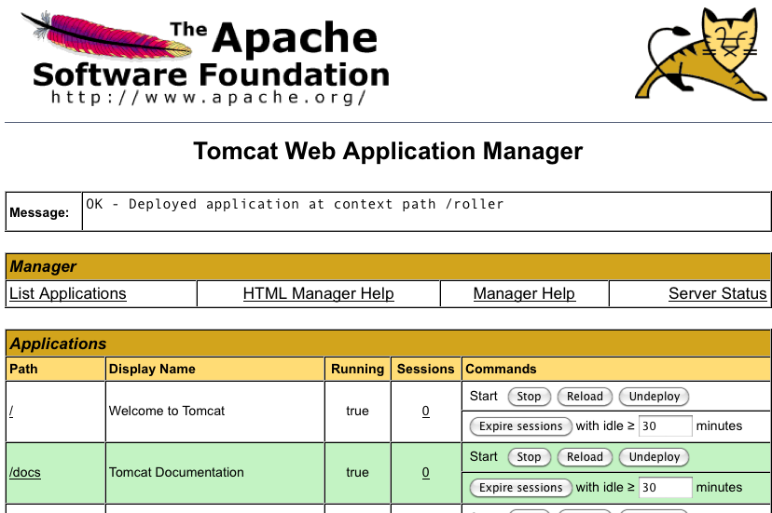
On the manager screen above, scroll down until you see the Deploy section, see below:
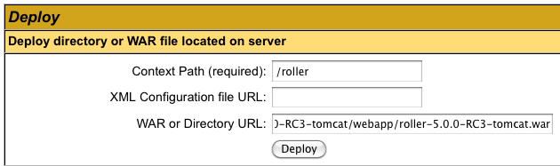
Enter the context path at which you would like to see Roller, above we use /roller. Enter the full path to the Roller WAR file, in the webapps directory of the Roller installation and click Deploy to deploy Roller.
Finally, navigate to http://localhost:8080/roller to complete the installation.

Deploying Roller to Glassfish
Deploying Roller to Glassfish involves creating a Roller configuration file, adding some jars to Glassfish and then deploying the Roller WAR file. The following instructions have been tested on GlassFish 3.1.2.2. You are expected to install and configure Glassfish before you attempt to install Roller. Refer to the Glassfish documentation linked from this page for more information: http://www.oracle.com/technetwork/middleware/glassfish/documentation/index.html

Glassfish: Add Roller Configuration
When running on GlassFish, Roller expects both the database and mail configuration to be configured using JNDI, so the minimal roller-custom.properties file described in Section 6.2, Using Server-provided database & mail resources (optional) is what should be used. Place your configuration file into the lib directory of your Glassfish Domain directory, e.g. in domains/domain1/lib/classes. Also due to the sun-web.xml in the Roller WAR’s WEB-INF folder, the JNDI resource name is expected to be jdbc/rollerdb, as listed in Section 6.2.

Glassfish: Add JDBC Driver File(s)
Add the appropriate JDBC driver jars to your Glassfish domain's classpath (domains/domain1/lib/ext). Once they are in your classpath, Roller's database subsystem will be able to find and use them.

Glassfish: Create Datasource
Database connectivity with GlassFish is a two-step process. First, we must configure the JDBC Connection Pool with the necessary connectivity information and test that its “Ping” button succeeds. Once ping works, then we need to configure a JDBC Resource using that Connection Pool we created (or reused).
First, start or restart Glassfish then use the Glassfish console at http://localhost:4848/
Next, use the tree on the left to navigate to the JDBC Connection Pools page.
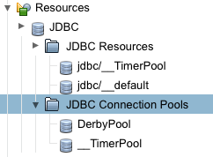
You can use the Derby Pool, if you want to use Glassfish's built-in Derby database. Or you can click the New button to create a new database connection pool if you’re using another database such as MySQL or an external Derby database.
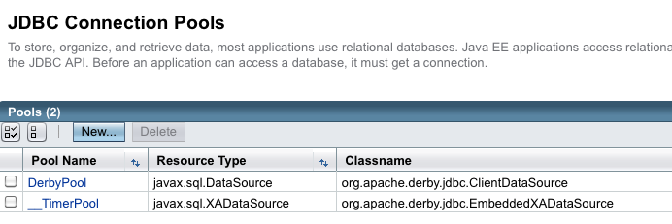
If you create a new Connection Pool, choose the database and on the next screen you’ll see a Datasource classname filled in for you.

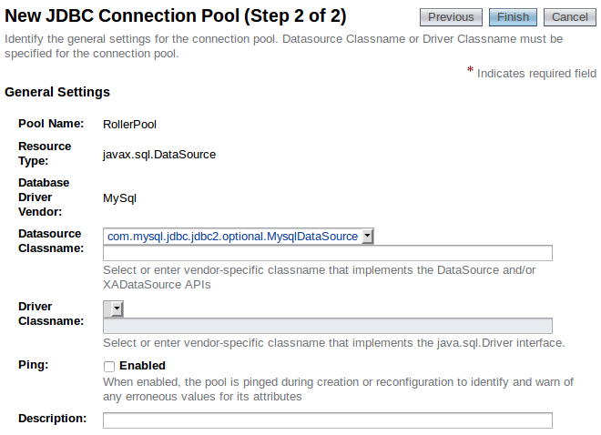

From this screen, slide down to the Additional Properties section to add necessary database connectivity information (if you’re reusing the Derby Pool, select Edit and go to the Additional Properties tab). Whether you’re creating a new Connection Pool or re-using the DerbyPool, you’ll need to configure connectivity information – Refer to the Glassfish documentation (http://docs.oracle.com/cd/E26576_01/doc.312/e24928/jdbc.htm#ggnfv, http://docs.oracle.com/cd/E26576_01/doc.312/e24928/jdbc.htm#beamw) for database-specific connectivity requirements. Make sure the Ping button works, indicating successful connectivity, prior to configuring the JDBC resource in the next section.
For the Derby Pool, the standard connectivity options listed should be sufficient for a new Roller database, although you’ll probably want to change the DatabaseName field to a Roller-specific DatabaseName so you’re not reusing a database (if so, make sure the pool is not being used by other applications):

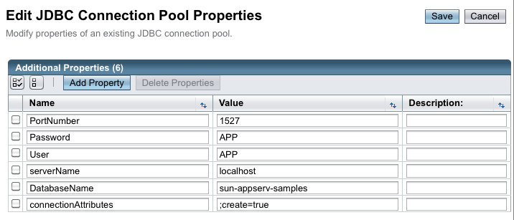
For MySQL, in the Additional Properties section, check for the presence of the URL and/or Url fields and delete them if they’re there, as they may conflict with the following four new properties below you’ll need to add (assuming the sample connection URL for MySQL provided in the Section 5.1 Create a database for Roller is being used, change the values as appropriate for your database):
user: scott
password: tiger
serverName: localhost
databaseName: rollerdb
Also, check the PortNumber (which should already be present) is set to the value of 3306.
Once you have configured your Datasource, click the Save button to complete the configuration. Testing the “Ping” button should work for you now. If the Ping test works, then you are ready to create a JNDI Resource to make the database connection pool available to Roller. Click on the JDBC Resources item (under Resources | JDBC) in the left-side tree view and select the “New” button on the JDBC Resources page:

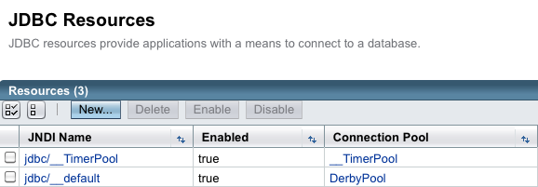

Name your new resource jdbc/rollerdb and select the database pool name that you configured earlier.

Once that's done, it's time to configure mail.

Glassfish: Create Mail Connection
Via the Glassfish Console, use the tree menu to navigate to the JavaMail Sessions page.
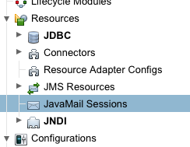
On the JavaMail Sessions page, shown below, use the New... button to create a new JavaMail session.
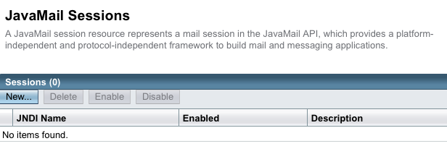
On the JavaMail Sessions page, click the New button to be taken to the New JavaMail Session page. Name your new session resource mail/Session (or as you configured in the roller-custom.properties file). Refer to the Glassfish documentation for information on how to set the remaining properties. For Google Mail, you’d have the following fields (fields that are unimportant for Roller or those for which the defaults are acceptable are not listed below):
Mail Host: smtp.gmail.com
Default User: your.email.address@gmail.com
Default Sender Address: your.email.address@gmail.com
At the bottom of this page, under Additional Properties, you will need to create the following properties and their values to complete configuration, these form largely a subset of the mail.smtp.properties and their values listed in Section 6.2, Using Server-provided database & mail resources (optional). Note instead of the password field required by Tomcat use the mail.smtp.password required by GlassFish:
mail.smtp.port="465"
mail.smtp.auth="true"
mail.smtp.password="yourgmailpassword"
mail.smtp.starttls.enable="true"
mail.smtp.socketFactory.class="javax.net.ssl.SSLSocketFactory"
mail.smtp.socketFactory.port="465"
mail.smtp.socketFactory.fallback="false"
mail.debug="false"

Click OK to save and finally, we are ready to deploy.

Glassfish: Deploy Roller
To deploy Roller, use the Glassfish console and navigate to the Applications page.
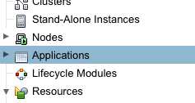
On the Applications page, shown below, click the Deploy... button.
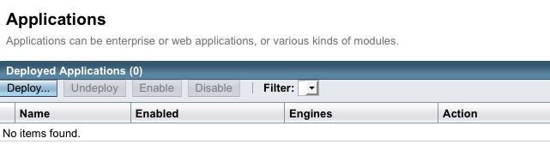
On the Deploy Applications or Modules page, use the Choose File button to browse for and select the Roller for Java EE WAR file, which is in the webapps directory of the Roller installation.
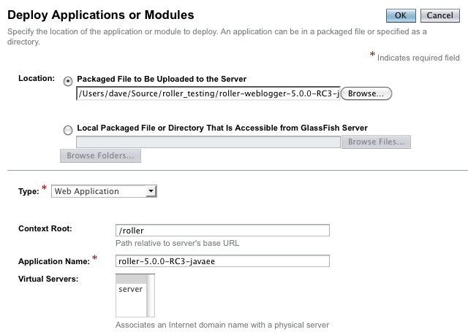

Set the context root to /roller or whatever you prefer and click OK to save and deploy Roller.
Finally, navigate to http://localhost:8080/roller to complete the installation.
Note: 23 July 2013: Due to a bug in the EclipseLink 2.5.0 JPA framework used by Roller (https://bugs.eclipse.org/bugs/show_bug.cgi?id=408015), fixed in the upcoming 2.5.1, disabling and then re-enabling the Roller application (after the initial install) may return a “java.lang.ClassCastException: org.apache.roller.weblogger.pojos.RuntimeConfigProperty cannot be cast to org.apache.roller.weblogger.pojos.RuntimeConfigProperty” error. Stopping and re-starting the Glassfish server should fix this problem.

Deploying Roller to JBoss
Deploying Roller to JBoss is done be creating some configuration files, making them available to JBoss and then using the JBoss console create the necessary resources and deploy the Roller WAR. Before you start make sure you have gotten JBoss configured properly by following the documentation here:
https://access.redhat.com/site/documentation/JBoss_Enterprise_Application_Platform
The below instructions have been tested on JBoss Enterprise Application Platform 6.1.0.GA and 7.1.1 (but screenshots reflect JBoss 6.1.1).

JBoss: Create Roller configuration
The first step is to create Roller's configuration files so that it will know know to find its database and mail server connections. We will need a Roller configuration file, a Hibernate configuration file and a JBoss module configuration file to ensure that JBoss can find those configuration files for Roller.

Create Roller configuration File
For JBoss you can use a minimal roller-custom.properties file, as described in Section 6.2, Using Server-provided database & mail resources (optional). On JBoss we will use JNDI to look-up things and you must set the database.jndi.name property to java:/RollerDS and the mail.jndi.name property to java:/RollerMail, as shown below.
Example roller-custom.properties file:
installation.type=auto
mediafiles.storage.dir=/usr/local/rollerdata/mediafiles
search.index.dir=/usr/local/rollerdata/searchindex
log4j.appender.roller.File=/usr/local/rollerdata/roller.log

installation.type=auto
database.configurationType=jndi
database.jndi.name=java:/RollerDS
mail.configurationType=jndi
mail.jndi.name=java:/RollerMail

Create Hibernate Configuration File
On JBoss, Roller uses the Hibernate library to access its database and we need to tell Hibernate what type of database is involved. You may have to check the JBoss and Hibernate documentation for the right “dialect” to be used. The example below shows the correct Hibernate configuration file for MySQL.
Example hibernate.cfg.xml file:
<hibernate-configuration>
<session-factory>
<property name="hibernate.dialect">org.hibernate.dialect.MySQLDialect</property>
</session-factory>
</hibernate-configuration>

JBoss Module Configuration
Next you need to make the above configuration files available to JBoss and Roller by creating a JBoss Module. To do this we create a directory under the JBoss directory, like so:
mkdir -p $JBOSS_HOME/modules/org/apache/roller/configuration/main
And within that directory, place the above two configuration files roller-custom.properties and hibernate-cfg.xml plus the new JBoss Module configuration file below.
Example module.xml file:
<?xml version="1.0" encoding="UTF-8"?>
<module xmlns="urn:jboss:module:1.1" name="org.apache.roller.configuration">
<resources>
<resource-root path="."/>
</resources>
</module>

You can read more the module technique we are using here:
https://community.jboss.org/wiki/HowToPutAnExternalFileInTheClasspath
Now that we've got the Roller configuration files we can go to the JBoss console and finish up the deployment.

JBoss: Create Datasource
Next we need to add a JBoss Datasource so that Roller can connect to its database. There are three steps to this: deploying your JDBC Driver JAR, setting up a Datasource and setting the Default JPA Datasource. Before you start, you should already have your database setup and if you don't, please return to Section 5.1, Create a database for Roller and do so now.
Startup JBoss and do the the web administration console to get started:
http://localhost:9990/console/App.html

Deploy your JDBC Driver JAR
In this step you deploy a JDBC Driver JAR to JBoss so that Roller can connect to your database. You will need to obtain this JAR from your database vendor. In the examples below, we use the MySQL JDBC Driver JAR.
First, go to the Runtime Console via the link in the upper-right corner of the console. Then go to the Manage Deployments page via the menu on the left and Click the Add button the add a new Deployment”
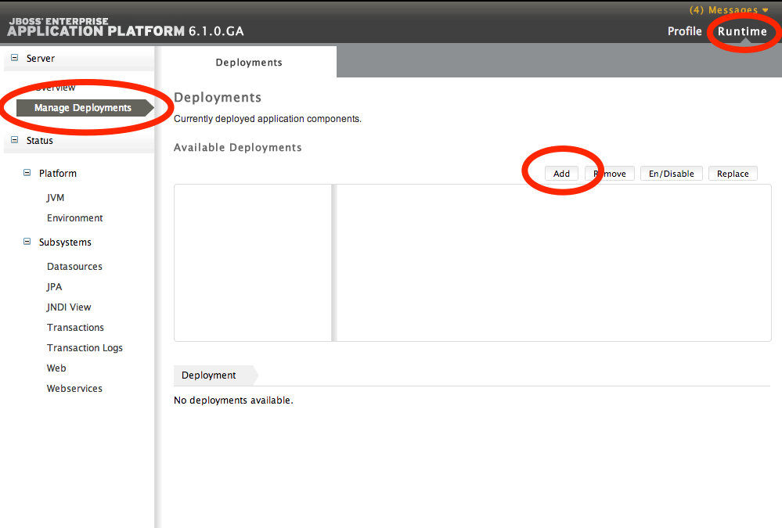
The Add button will lauch a popup window which will allow you to select the file that contains your JDBC driver JAR. Click the Next button and then click the Save button to accept the default values.
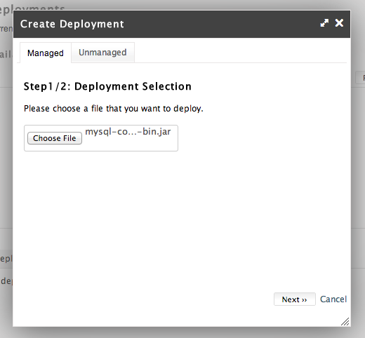
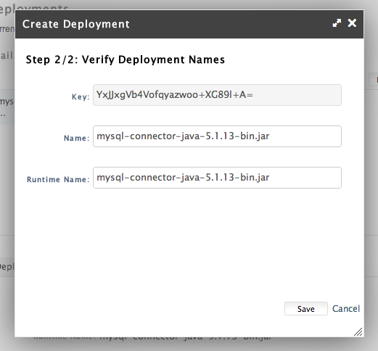

Once you've saved your new JDBC Driver JAR deployment, you must enable it via the En/Disable button on the Runtime / Manage Deplyments page, shown below.
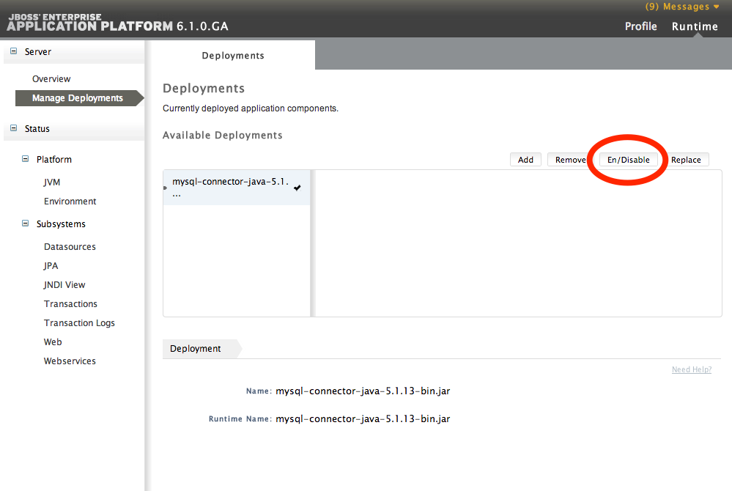
Set up a Datasource
Next, you need to setup a Datasource to allow Roller to connect to a specific “table space” within your database. Go to the Profile part of the console via the link in the upper-right and then the Datasources page via the menu on the left.
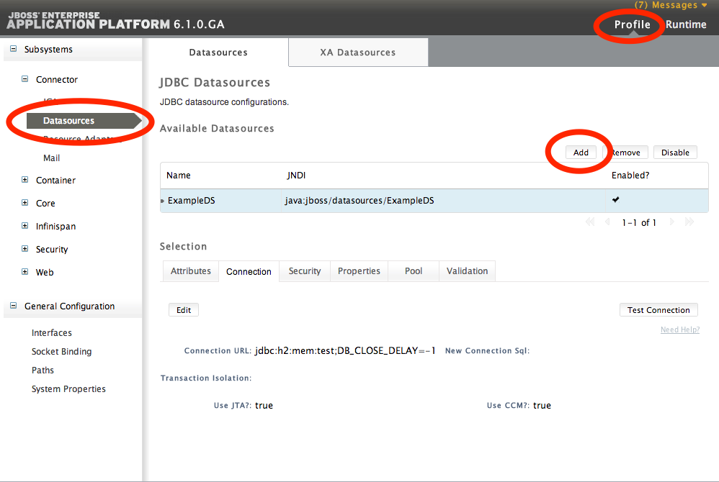

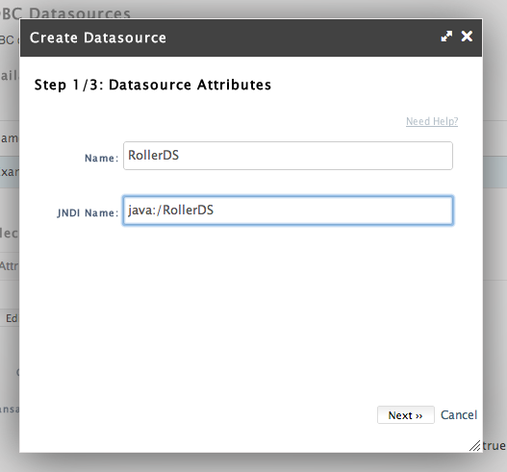
When you click the Add button, specify the name RollerDS and the JNDI Name java:/RollerDS, as shown below. Next, you have to choose which JDBC Driver JAR to use for the Datasource. Choose the one that you deployed before.
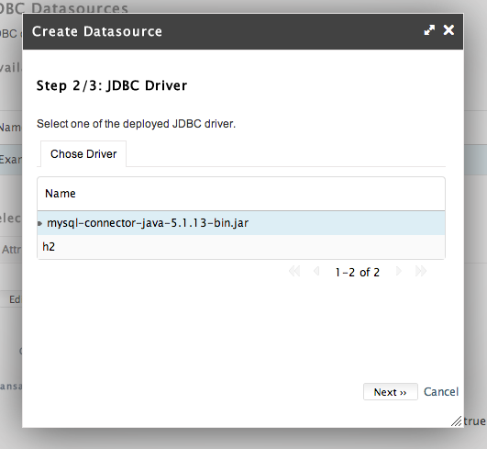

On the third step, specify the JDBC Connection URL, we use jdbc:mysql://localhost:3306/rollerdb in this document, the username and the password of your database user account.
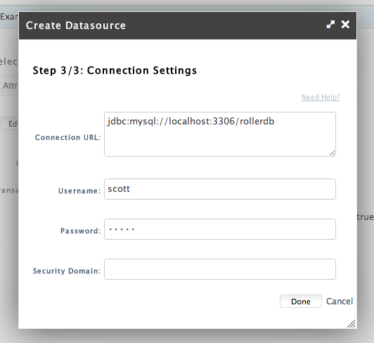

Once you save your new Datasource you should use the Enable button to enable it. Then go to the Connection tab and use the Test Connection button to ensure that your Database connection will work. If the test fails, look at the JBoss log for clues to help you determine what went wrong.

Set the Default JPA Datasource
Next, you must let JBoss know which is the default JPA Datasource. You can do this via the Profile portion of the console and the Container / JPA page. Enter java:/RollerDS as the Default Datasource.
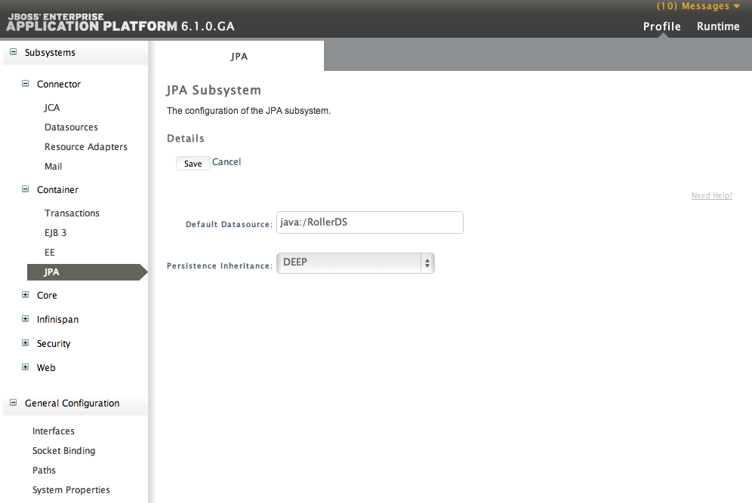

JBoss: Create Mail Server connection
The last step before we deploy Roller is to setup a Mail Server connection so that Roller can send email notifications. Do this via the Profile portion of the console and the Connector / Mail page. Click the Add button to add a new Mail Connector.
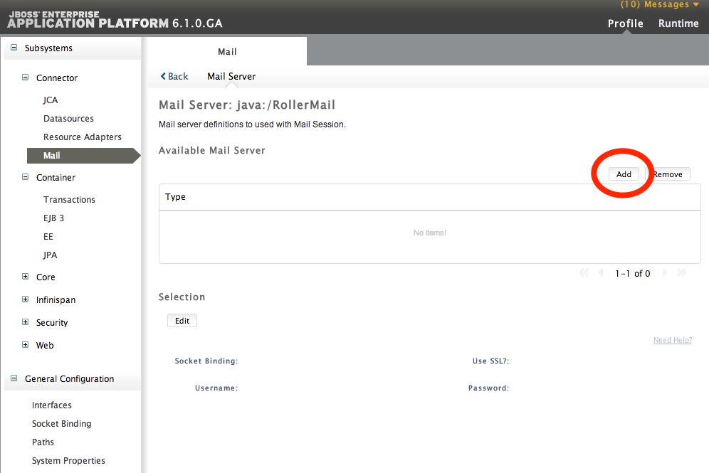

In the Create Mail Session window that appears, set java:/RollerDS as the JNDI name.
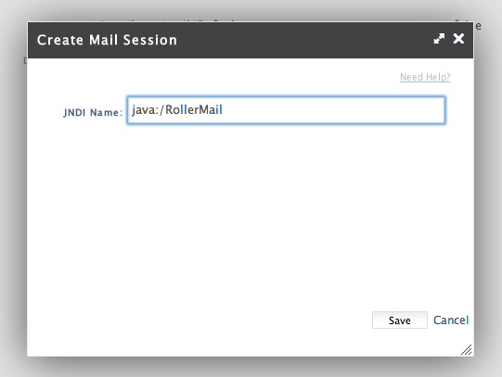
After you save the new connection, use the View link to view it.
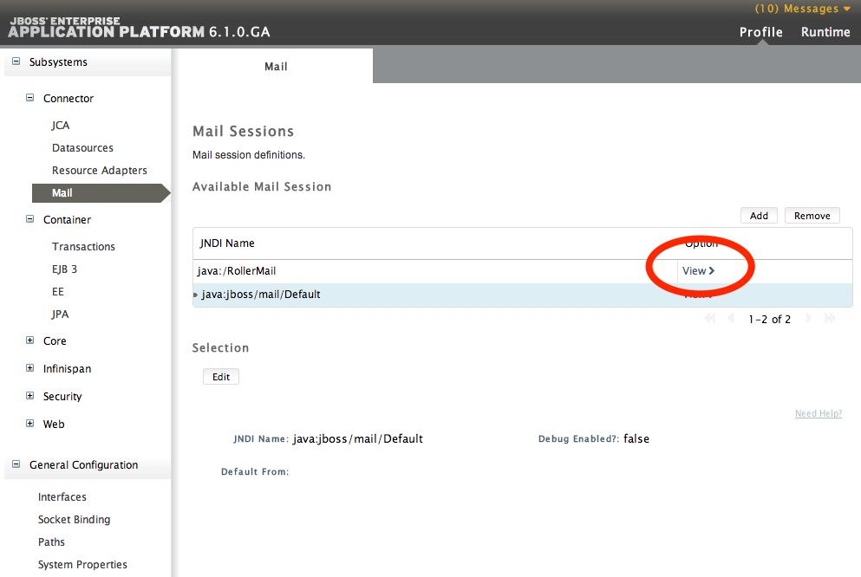

Next, use the Create Mail Server window to set your Mail Server's domain name, protocol and your user account. The example below shows what you would set if you want to use Gmail as your server.

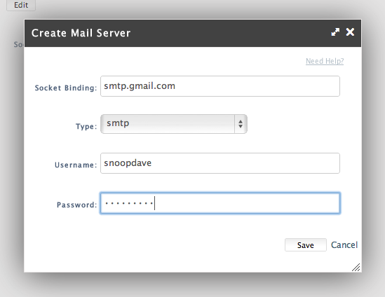
If you are using Gmail, then after you save you will want to edit your Mail Server configuration and tell it to use SSL as shown below.

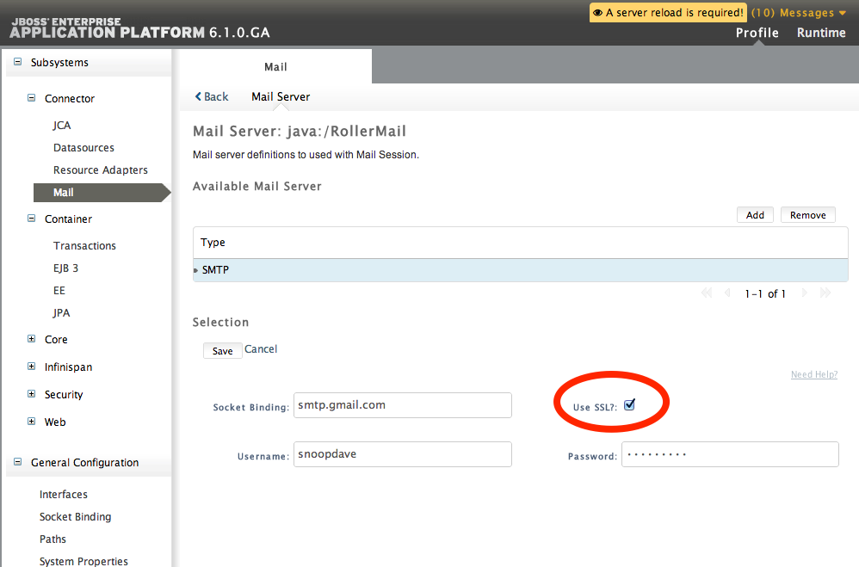

Now, finally we’re ready to deploy the JBoss Roller WAR.

JBoss: Deploy Roller
To deploy Roller, go to to the Runtime part of the console and use the Manage Deployments page. Click the Add button to add a new deployment.
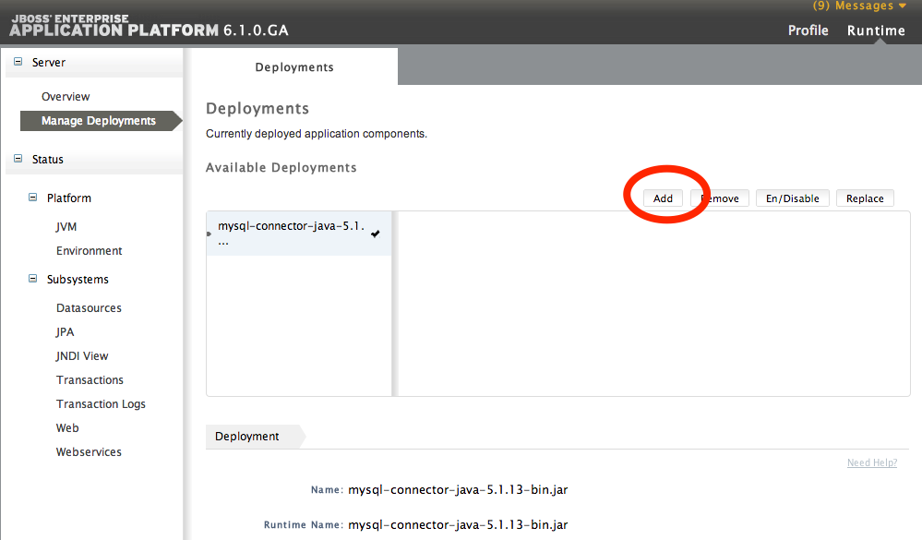

Choose the roller.war file that came with your Roller download and then use the En/Disable button to enable and thus start Roller.
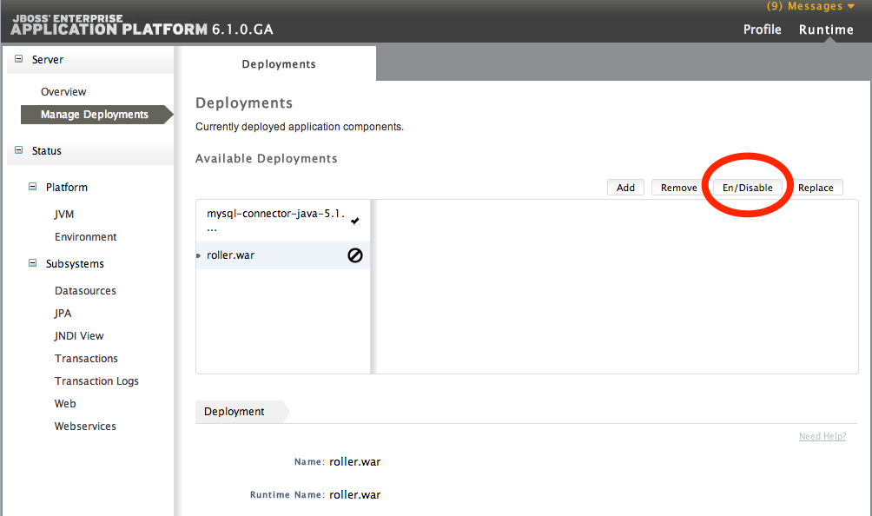
You should now be able to navigate to http://localhost:8080/roller to complete the installation. If you can’t see Roller at that site, check both the console screen where you started JBoss for error messages as well as the standalone/log/server.log file for troubleshooting.

Getting started with Roller
You're not quite done with the installation process, but now you're ready to start using Roller, so we'll walk you through getting started, registering a user and setting up a blog. We'll also discuss briefly what happens when there is an error.

Navigate to Roller and finish the install
Navigate to Roller, if you are using a default Tomcat or Glassfish installation then then URL of Roller is probably http://localhost:8080/roller. You will see either a web page of error messages, a web page offering to create database tables for you or web page asking you to complete the installation by registering an admin user and creating a front-page blog. First, let's talk about what happens when things go wrong.
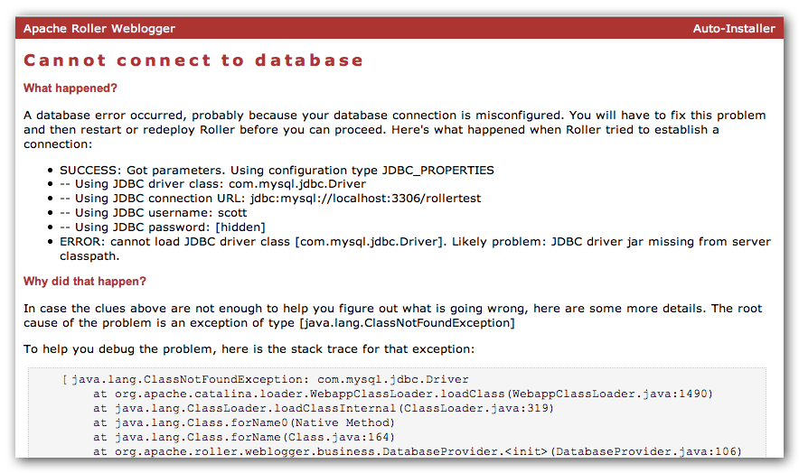
If there's a problem with your database configuration, Roller will display a page or error messages to help you diagnose the problem. It's possible that you entered the wrong JDBC driver class name, connection URL, username or password. Or perhaps your database is not running. Use the information provided to determine what is wrong, fix it and then redeploy Roller.

Automatic tables creation
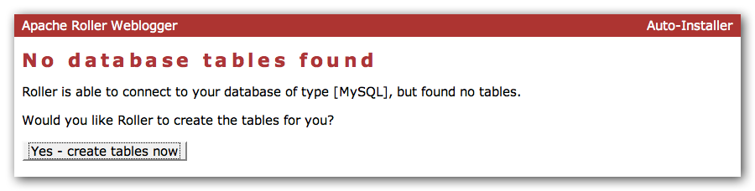
If your database configuration is good but Roller cannot find its database tables, then Roller will offer to create those pages automatically for you. If you give the go-ahead, Roller will run the appropriate database creation script for your database and then show you the results. You can then proceed to the next step to setup your first user account and weblog.

Register a user and create a weblog
If Roller starts up fine but doesn't find a front-page weblog then it will display the Completing Your Installation below that explains how to register your first user, create your first weblog and setup your site's front page.
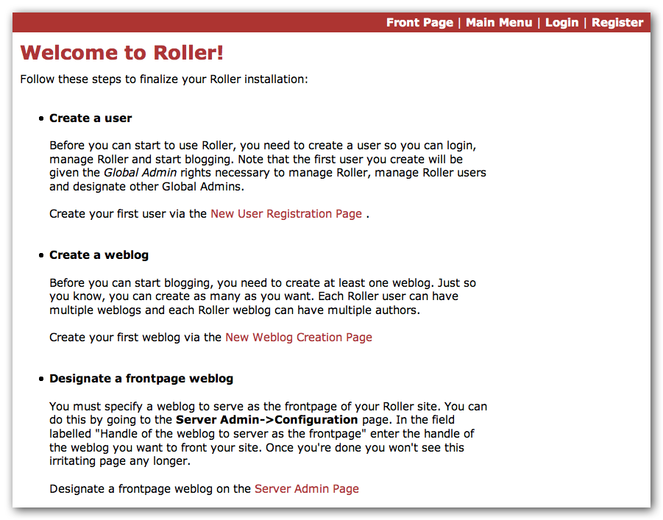
You have to decide what you want as the front-page of your Roller site. If you are using Roller to run your personal weblog, then you probably want your weblog to be the front-page of the site. In this case, create a weblog for yourself, don't choose the front-page theme but do set your weblog as the front-page weblog for the site.
If you are using Roller to run a community of multiple weblogs, then you'll probably want to display an aggregated front-page combining all weblogs on the site. In that case, create a weblog to serve as the front-page, set it as the front-page weblog and make sure you set the “aggregated front-page” setting on the Server Admin page.

Don't forget: Reset the installation.type flag
Now that you're done with the installation you should turn off Roller's auto-installation system. Edit your roller-custom.properties file and set installation.type=manual. Then restart your server or Roller so that it accepts the new setting.

What's next?
Once you've gotten Roller up and running refer to the Roller User Guide for more information on running your Roller system and your weblog. For information on customizing your weblog, refer to the Roller Template Guide. If you can't find what you want in the documentation then subscribe to the Roller user mailing list and ask your questions there:
https://cwiki.apache.org/confluence/display/ROLLER/Roller+Mailing+Lists

Configuration tips and tricks
This section covers some tips and tricks that can help you get the most out of Roller. It covers Roller's Planet feed aggregator and how to setup Roller to use server-provided resources.

Setting up Roller's Planet feed aggregator
Roller includes a RSS/Atom feed aggregator that makes it possible to run a site like https://blogs.oracle.com/ which provides weblogs for thousands of writers and an aggregated front-page that displays the most recent posts form those plus dozens of Sun bloggers from other sites such as blogger.com, typepad.com and other services. Here's what you need to do.

STEP 1: Create a Planet cache directory
Roller Planet needs a cache directory in which to store the feeds it fetches. By default, Roller Planet will put it's cache in your home directory under roller_data/planetcache. If you want to place the cache somewhere else, you must override the planet.aggregator.cache.dir property in your roller-custom.properties file. For example:
cache.dir=c:\\roller_data\planetcache

Whether you override that property or not, you must create the cache directory. Planet will not work unless the cache directory exists and is writable by Roller.

STEP 2: Enable Planet via Roller custom properties
Enable Planet by adding the following to your roller-custom.properties file:
planet.aggregator.enabled=true

# Tasks which are enabled. Only tasks listed here will be run.
tasks.enabled=ScheduledEntriesTask,ResetHitCountsTask,\
PingQueueTask,RefreshRollerPlanetTask,SyncWebsitesTask

# Set of page models specifically for site-wide rendering
rendering.siteModels=\
org.apache.roller.weblogger.ui.rendering.model.SiteModel,\
org.apache.roller.weblogger.ui.rendering.model.PlanetModel

Those property settings enable Planet and enable the Planet tasks, both the RefreshRollerPlanetTask, which runs every hour and fetches all RSS/Atom feed subsciptions, and the SyncWebsitesTask, which runs every midnight and ensures that each weblog in the Roller system is represented by a subscription in the Planet aggregator. To enable usage of the PlanetModel in the front-page weblog, we also override the rendering.siteModels property.

STEP 3: Configure Planet via Planet custom properties
Create a new file called planet-custom.properties and place it in the same directory as your existing roller-custom.properties file. In this configuration file, add a property called cache.dir that points to the directory that you'd like Planet to use for caching it's RSS and Atom newsfeeds. The default setting is:
cache.dir=${user.home}/roller_data/planetcache
Once you've made those property settings restart Roller and proceed to the next step.

STEP 4: Display your Planet aggregations
You can use Roller's UI to add external RSS/Atom feeds to the Planet setup. To display these feeds you'll need to do a little template customization. The easier way to get started is to Roller's existing Front-Page theme. Here's how.
Create a weblog to server as the front-page of your Roller site. Start with the Front-Page theme and customize it. Edit the weblog template and look for the part that mentions PLANET-entries. Comment-out the SITE-WIDE part and un-comment the PLANET-entries part. The double hash “##” marks indicate a commented-out line. The code should look like this:
## 1) SITE-WIDE entries (the default)
##set($pager = $site.getWeblogEntriesPager($since, $maxResults))

## 2) PLANET-entries
#set($pager = $planet.getAggregationPager($since, $maxResults))

With that in place, your front-page will be display your Planet entries. You can find your Planet feeds at the following URLs:
- Main Planet feed
http://localhost:8080/roller/planetrss
- Per group feed
http://localhost:8080/roller/planetrss?group=<group-name>

Manual table creation and upgrade
If you would rather create your database tables yourself instead of letting Roller do it automatically, you can. Instead of enabling automatic installation you should disable it by putting this in your roller-custom.properties file:
installation.type=manual

Now you've got to run the database creation script. You can find the database creation scripts in the webapp/roller/WEB-INF/classes/dbscripts directory. You'll find a createdb.sql script for each of the databases we hope to support.
If you are upgrading Roller, you'll have to run the migration scripts instead of createdb.sql. You'll find those under the dbscripts directory too. However, the migration script should probably be run statement-by-statement checking the database responses as you go along, or alternatively by first removing any delete index or delete foreign key statement that you know doesn't exist in your database. Certain databases like MySQL throw errors when one attempts to delete objects such as foreign keys or indexes that don't already exist, a specific error type which the automated installation process is coded to ignore.

Upgrading Roller
This section describes how to upgrade an existing Roller installation to the latest release of Roller by shutting down, backing up and then following the installation instructions with a couple of key exceptions. But first, there is some required reading for those upgrading from ancient versions of Roller.

Backup your old Roller
Before you get started with your upgrade, shutdown your existing Roller install and make a backup of your Roller data.
Backup your database to somewhere safe on your system or to a remote file-system. Here are a couple of examples: of how to do that on various databases:
- On MySQL you create a dump file
mysqldump -u scott -p rollerdb > /somewhere/safe/roller.dmp
- With PostgreSQL you can do the same thing
pg_dump -h 127.0.0.1 -W -U scott rollerdb > /somewhere/safe/roller.db
And backup any other data. Make a copy of your Roller data directory, i.e. the one with your Roller resources and search-index files. If you added or modified any files within your old Roller web application directory, then you'll want to backup that whole directory.

Migrating your old file uploads to the new Media Blogging system
If upgrading from Roller 4.0 to 5.1 (5.0 already has this configuration done), when you first start Roller 5.1 it will migrate your old file uploads to the new Media Blogging system. If this is to work properly you MUST ensure that the three properties below are set correctly before you start Roller 5.0/5.1 for the first time.

# The directory in which Roller 5.x will upload files
mediafiles.storage.dir=${user.home}/roller_data/mediafiles

# The directory in which Roller 4.0 uploaded files
uploads.dir=${user.home}/roller_data/uploads

# Set to true to enable migration
uploads.migrate.auto=true

The mediafiles.storage.dir property should be set to the location where you would like to store uploaded files. The uploads.dir property should be set to the location where you stored uploaded files in Roller 4.0.

Install and startup the new Roller
Follow the normal installation instructions for the new version of Roller, but...
- When creating your roller-custom.properties, copy of your old one. Carefully review each property and compare it to the property settings in the Roller property file described in Section 6.1.
- Don't create a new database for Roller. Instead point Roller to your existing Roller database. This is completely safe because you created a backup of your database, right?
When you deploy and startup, Roller will detect that your database needs to be upgraded and it will offer to run each of the migrations scripts necessary to upgrade you from your old version to the new version of Roller.
NOTE: You can run the database scripts manually too, see Section 10.2.
NOTE: On Tomcat, before startup you should delete the contents of the Tomcat work directory (located under the webapps folder.)

