Module 4.2 – MySQL Install
Walter Jacobo | CSD310 Database Development and Use | November 11, 2026

1. Initial MySQL Connection
I installed MySQL Community Server 8.0.46 on Windows and connected using the MySQL 8.0 Command Line Client. The connection information and mysql> prompt are shown below.
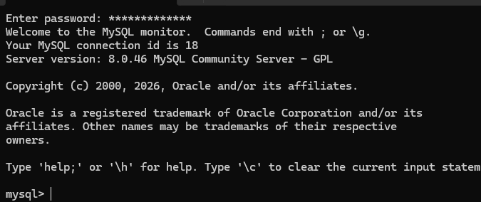

2. Create and Verify the Movies Database
I created a database named movies and ran SHOW DATABASES to confirm it appeared in the list.
CREATE DATABASE movies;
SHOW DATABASES;
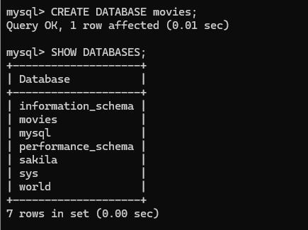

3. MySQL Functions and Aliases
I tested three MySQL functions using SELECT statements. Each query uses AS to give the result column a descriptive heading.

Function 1: UPPER()
UPPER() converts letters in text to uppercase. It could be used to display movie titles in a consistent format, even if the original text contains lowercase letters.
SELECT UPPER('movies database') AS Uppercase_Text;
Alias: Uppercase_Text Result: MOVIES DATABASE
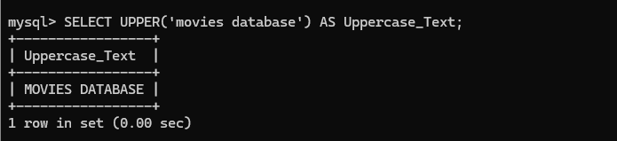

Function 2: LENGTH()
LENGTH() returns the number of bytes in a text string. It can be useful when checking how much space a text value uses. For ordinary English letters and spaces, the byte count matches the character count.
SELECT LENGTH('movies database') AS Text_Length;
Alias: Text_Length Result: 15
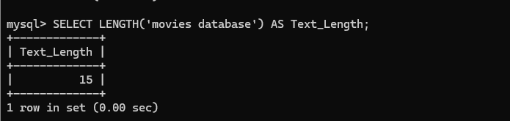

MySQL Functions and Aliases (continued)

Function 3: ROUND()
ROUND() rounds a number to a specified number of decimal places. For example, it can be used when displaying calculated prices, averages, or other numeric results that do not need extra decimal places.
SELECT ROUND(125.678, 2) AS Rounded_Value;
Alias: Rounded_Value Result: 125.68


