Module 4.3 – Movies!
Walter Jacobo
CSD310 – Database Development and Use
November 11, 2026
Assignment 4.3 – Movies ERD

Entity Relationship Diagram
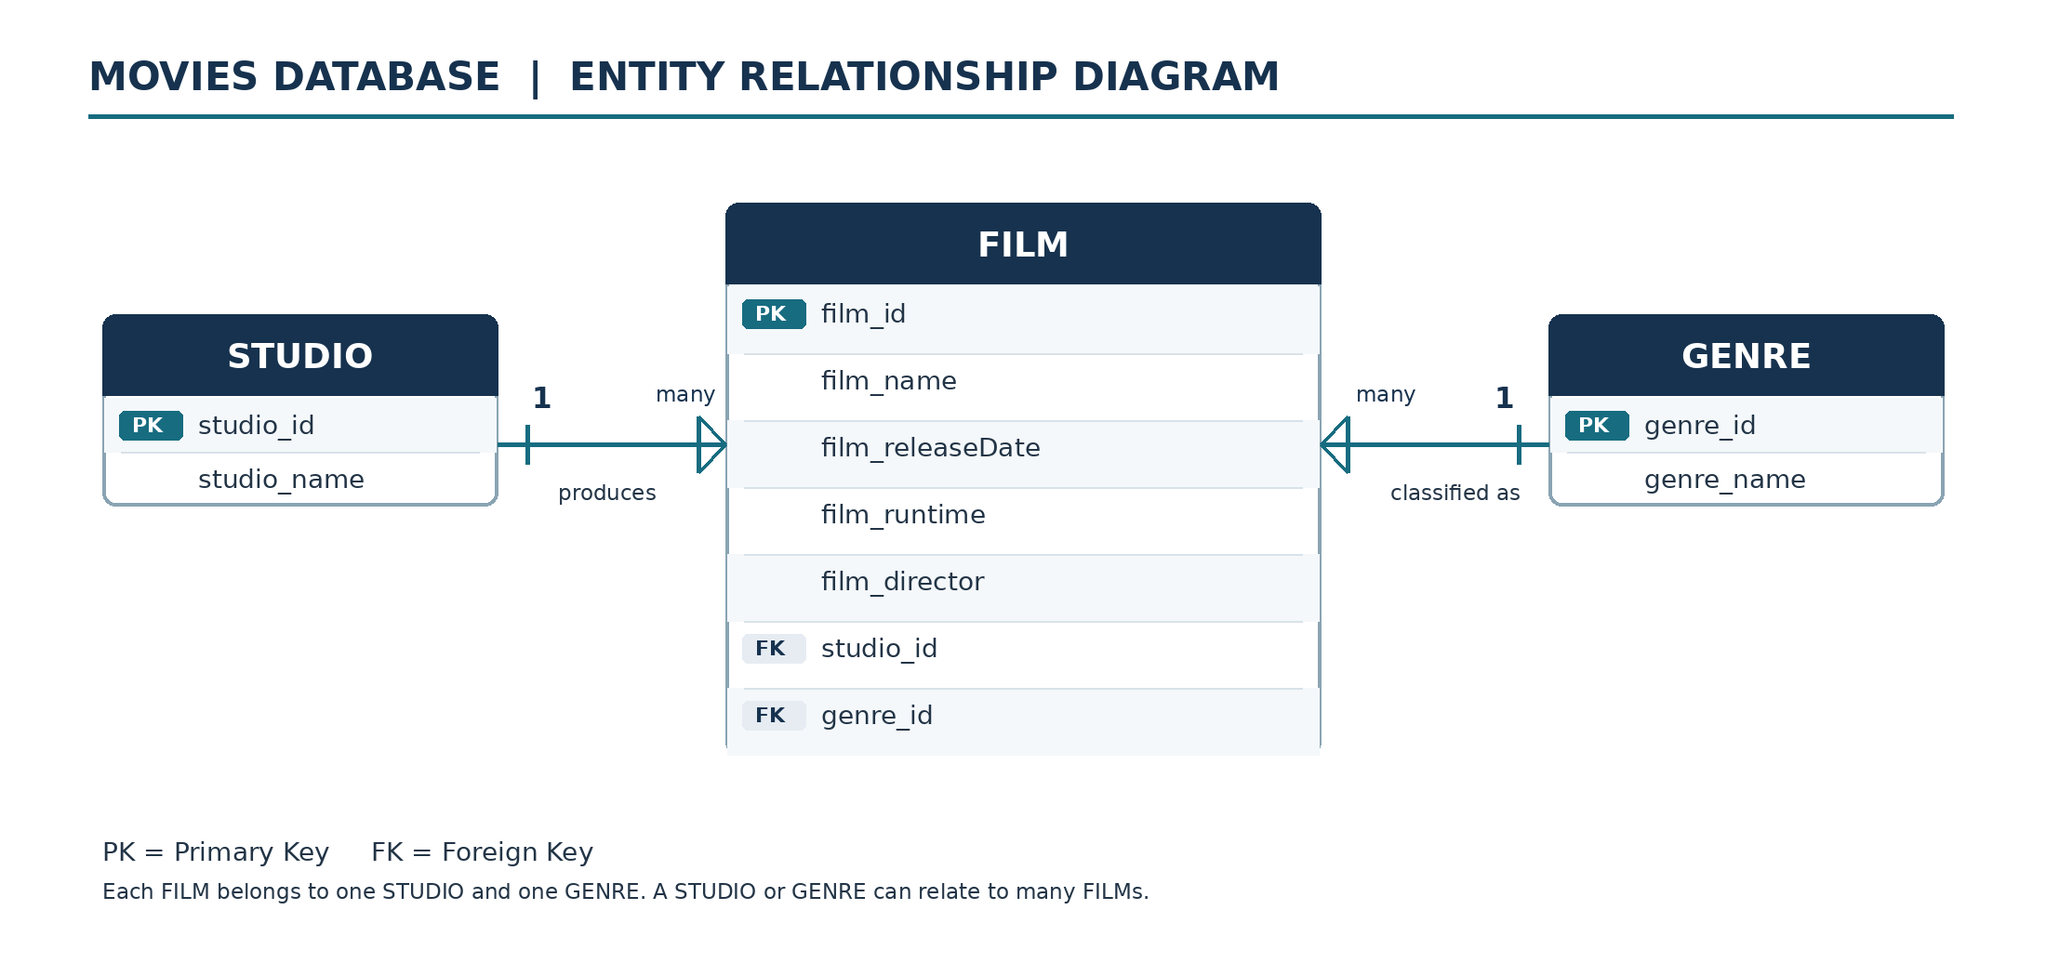
The FILM table contains foreign keys studio_id and genre_id, linking each film to its studio and genre. Both relationships are one-to-many from STUDIO or GENRE to FILM.

