Module 5.2 Assignment – Movies: Setup
Walter Jacobo | CSD310 Database Development and Use | November 11, 2026
Assignment 5.2 – MySQL table setup and Python connection

1. Run the database initialization script
I selected the movies database and ran the instructor-provided db_init_2022.sql script in MySQL Command Line Client. I updated its authentication setting to caching_sha2_password for my MySQL 8.0 installation. The script created the tables and inserted the sample records.
Commands used:
USE movies;
source C:/Users/bigwa/csd/csd-310/module-5/db_init_2022.sql
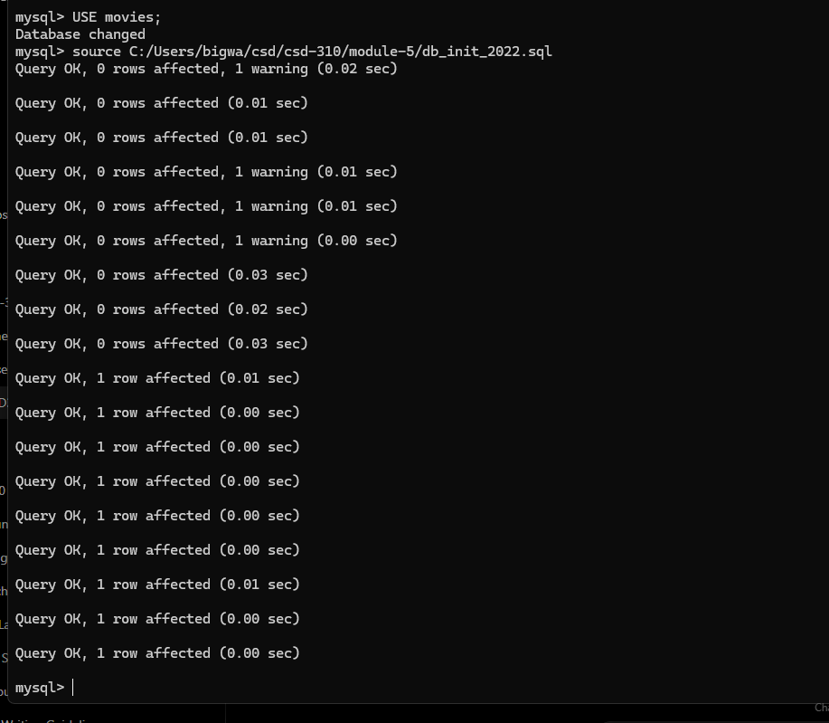
Figure 1. MySQL Command Line Client showing successful execution of the initialization script.

2. Verify the movies tables
After running the SQL script, I entered SHOW TABLES; to confirm that the database contained the three required tables: film, genre, and studio.
SQL command: SHOW TABLES;
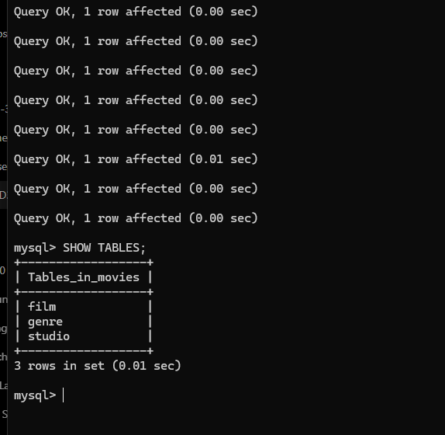
Figure 2. The movies database lists film, genre, and studio.

3. Python and MySQL connection
I installed mysql-connector-python and python-dotenv, stored the local connection settings in a .env file, and ran mysql_test.py. The program connected as movies_user to the movies database on localhost. The .env file must be excluded from GitHub.

Python connection test result
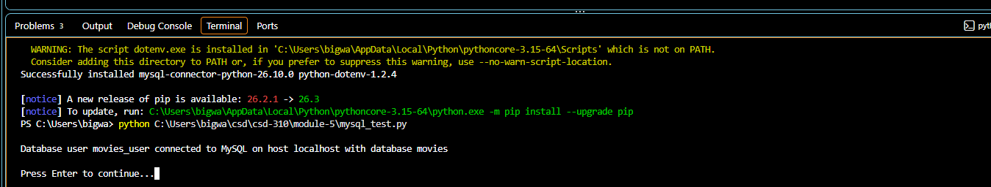
Figure 3. The Python program confirms a successful connection to the movies database.

GitHub repository
https://github.com/wjacobo/csd-310
Module 5 folder: https://github.com/wjacobo/csd-310/tree/main/module-5

