Walter Jacobo
CSD310 – Database Development and Use
Module 2.3 – Data Models

Relational Database Model (ERD)
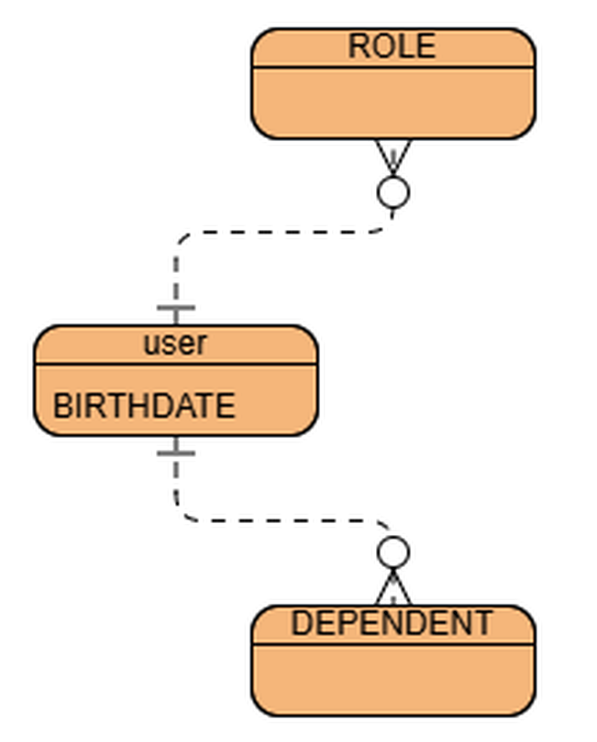
ERD created in Visual Paradigm. A USER has many ROLES, one BIRTHDATE, and can have many DEPENDENTS.

NoSQL Document Model
A USER document stores one birthdate and arrays for multiple roles and dependents.
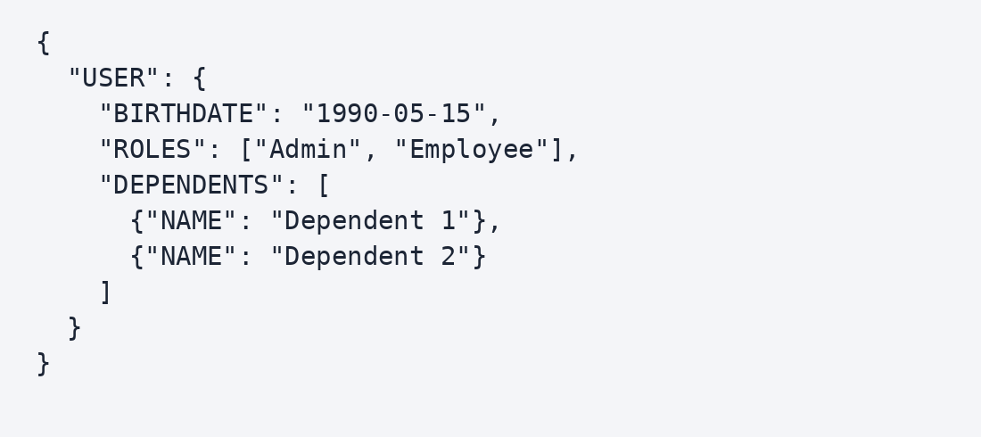
The date and dependent names shown are sample values.

