Walter Jacobo
CSD325 Advanced Python | Module 3.2: Brownfield + Flowchart
Flowchart 1: Game Setup and Player Inputs
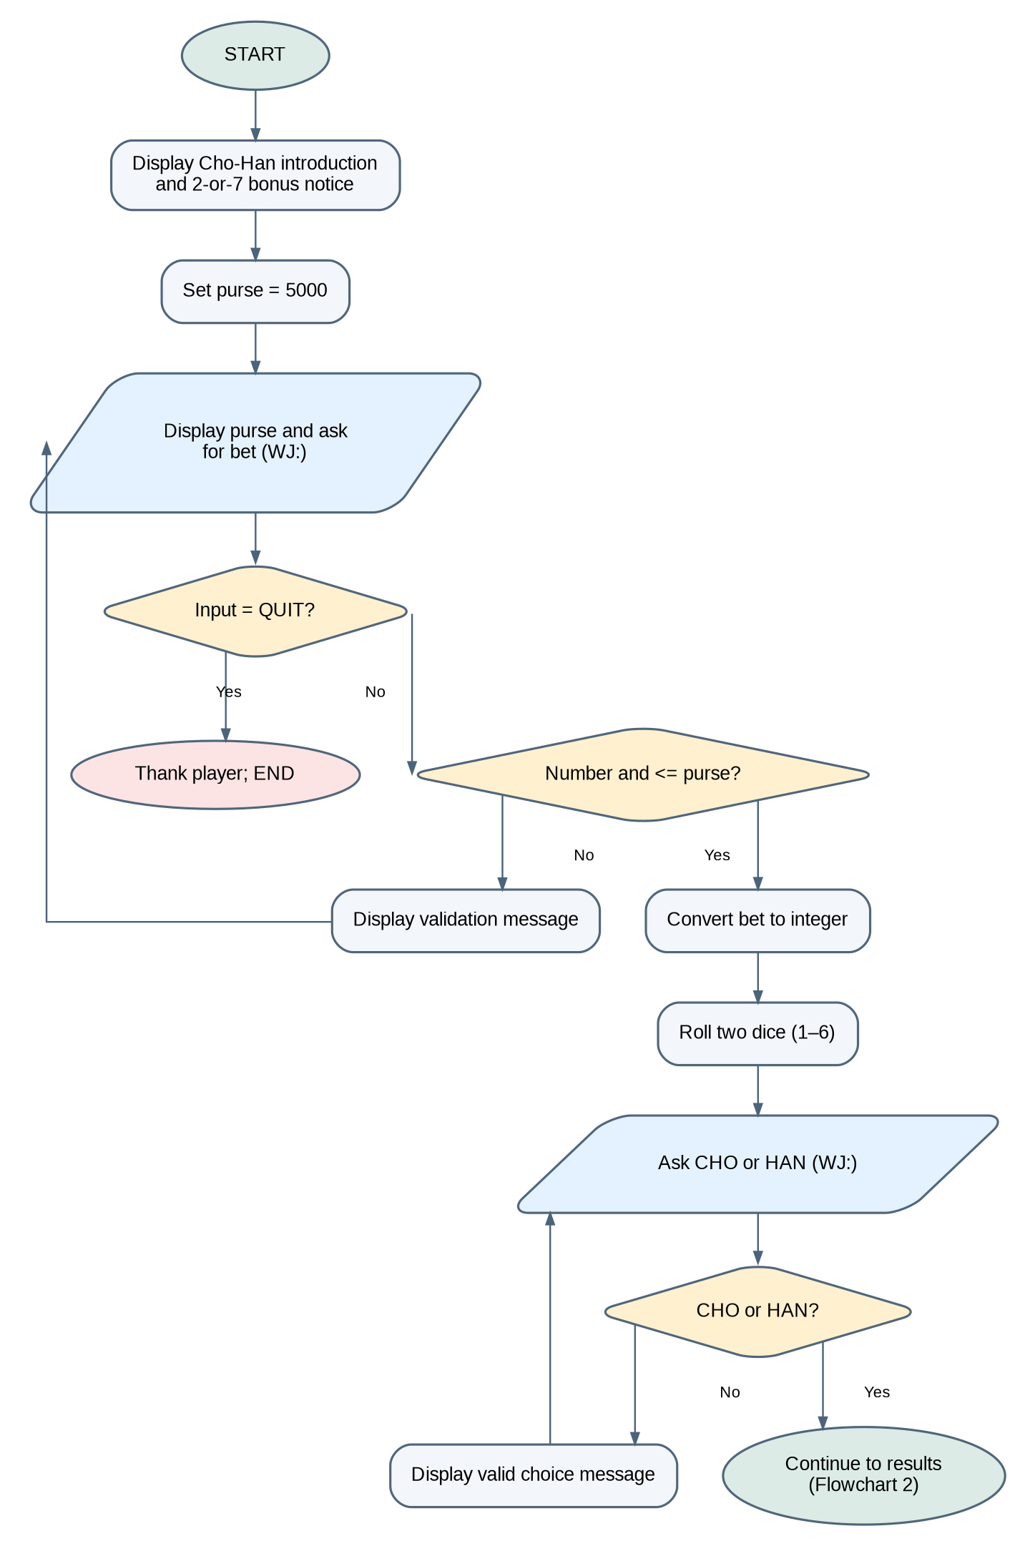
The game displays the balance, validates the wager, rolls the dice, and validates the CHO/HAN guess.

Walter Jacobo
CSD325 Advanced Python | Module 3.2: Brownfield + Flowchart
Flowchart 2: Results, House Fee, and Bonus
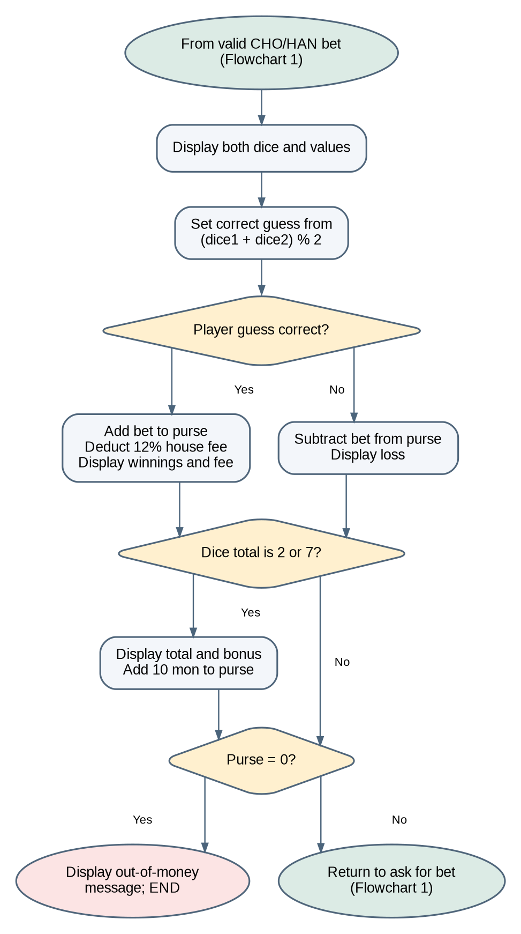
The program calculates the winning guess, settles the bet, applies the 12% fee on wins, awards a 10-mon bonus for a total of 2 or 7, and checks the remaining balance.

