Walter Jacobo
CSD325 Advanced Python | Assignment 4.2

Original Program Flowchart
sitka_highs.py | Provided program
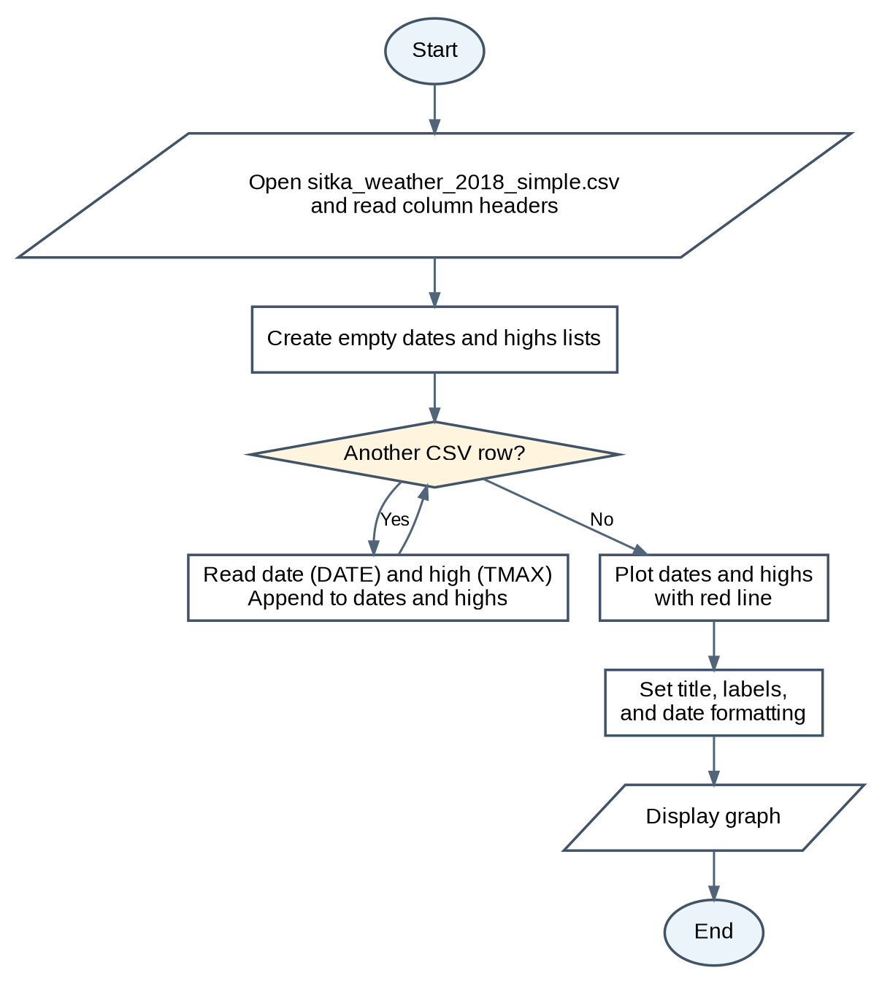
Original behavior: read the CSV data once and display a graph of 2018 high temperatures in red.

Walter Jacobo
CSD325 Advanced Python | Assignment 4.2

Revised Program Flowchart
sitka_high_low_wj.py | Modified program
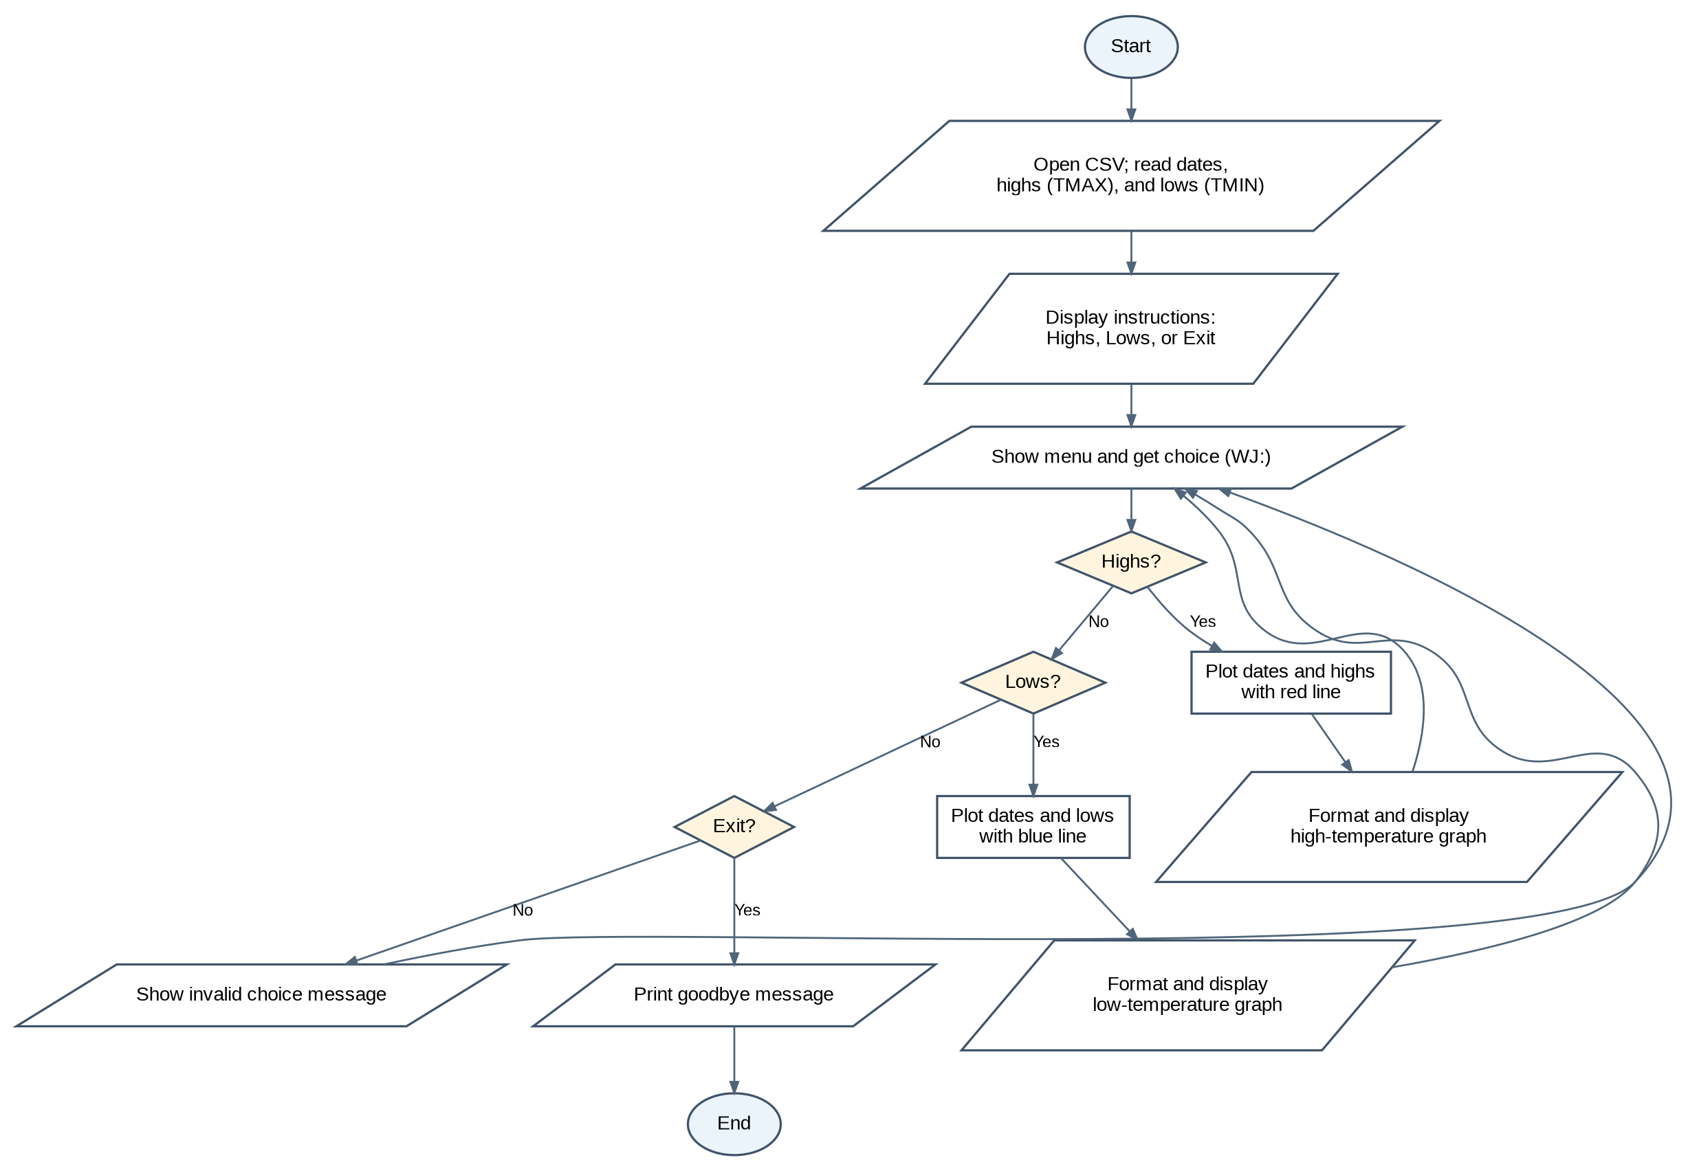
Updated behavior: display a menu, graph highs in red or lows in blue, and repeat until Exit is selected.

