Module 2.2: Documented Debugging
Walter Jacobo | CSD-325 Advanced Python | Assignment 2.2
Program: Jacobo-Assignment2_2.py (Bottle Countdown)
Debugging tool: Visual Studio Code Python Debugger. Test input: 5 bottles.

Screenshot 1: Breakpoint
The debugger paused on line 38, just before calling count_bottles(bottles). The Locals panel shows the starting value of bottles = 5.
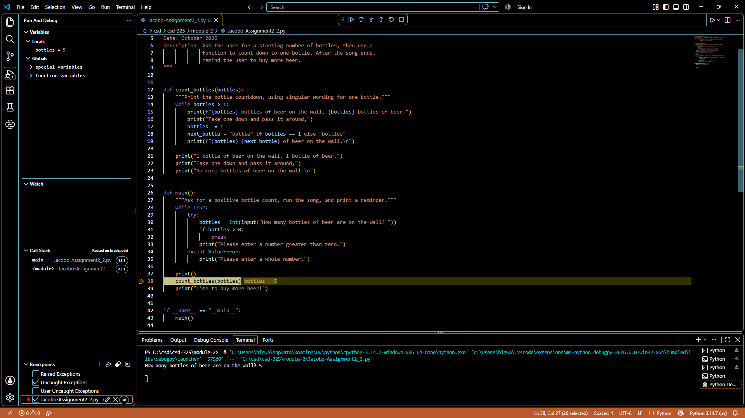
Evidence: screenshot captured during the actual debugging session.

Screenshot 2: Step Into
Using Step Into, I entered the count_bottles() function. Execution paused on line 14 at the while condition, with bottles still equal to 5.
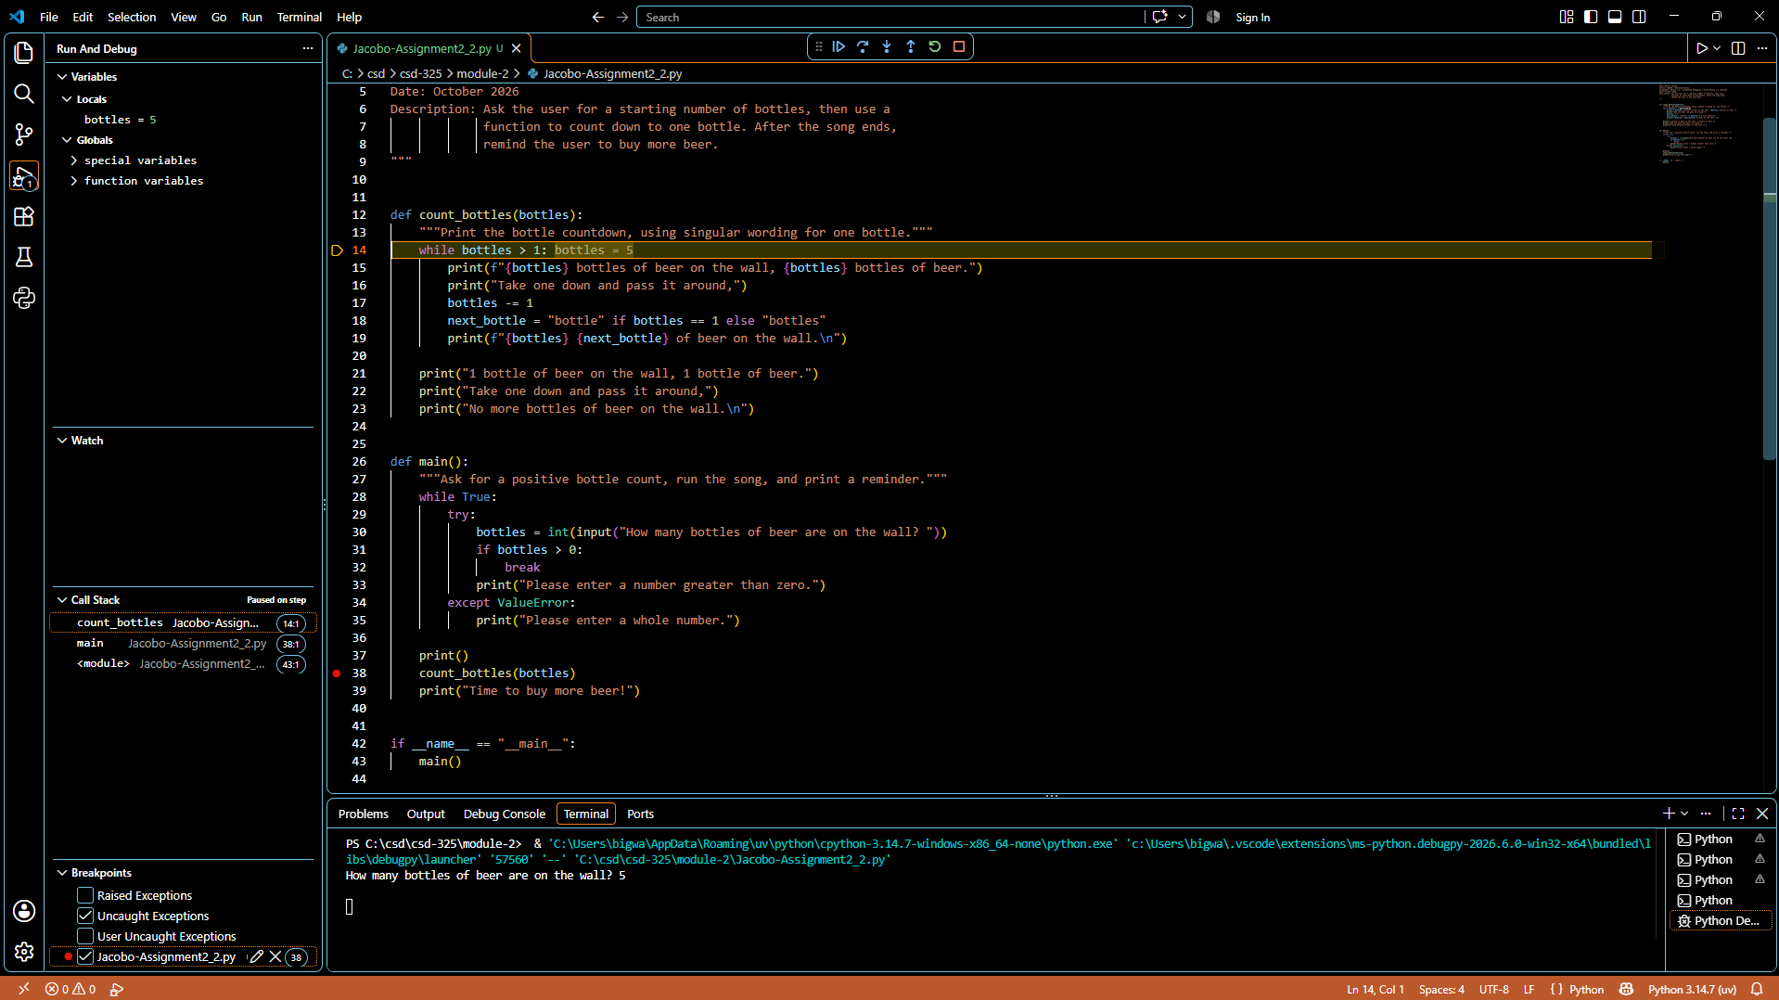
Evidence: screenshot captured during the actual debugging session.

Screenshot 3: Step Over and Variable Change
After stepping over the subtraction on line 17, the Locals panel shows bottles = 4. The debugger is now paused on line 18.
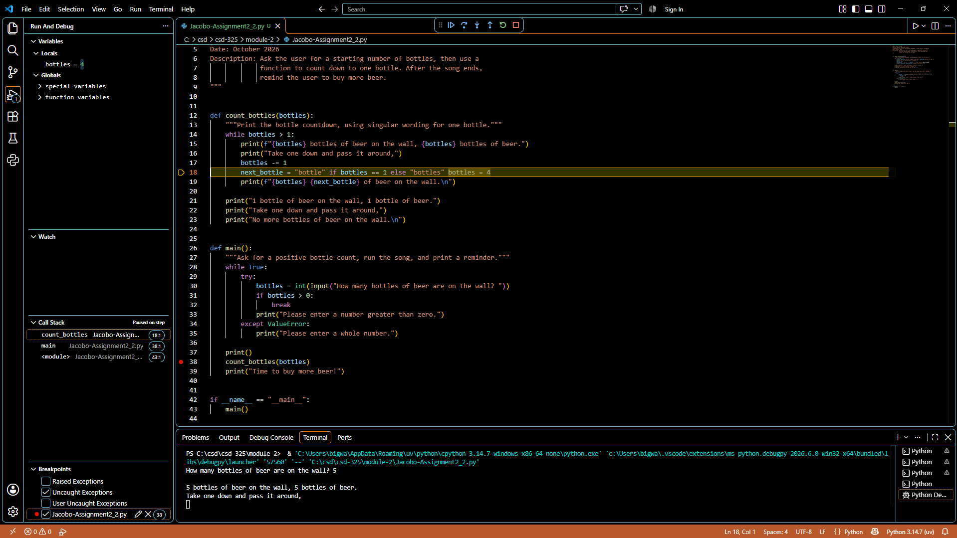
Evidence: screenshot captured during the actual debugging session.

Debugging Summary
I set a breakpoint immediately before the function call and started the Python debugger with an input of 5. Next, I stepped into the countdown function and checked the local value. Finally, I stepped over the subtraction statement and confirmed that the bottle count changed from 5 to 4. This showed that the countdown updated the variable as intended.

