Walter Jacobo
CSD325-309A Advanced Python | Module 2.2
Program Flowchart
Program: Jacobo-Assignment2_2.py (adapted from Module 1.3)
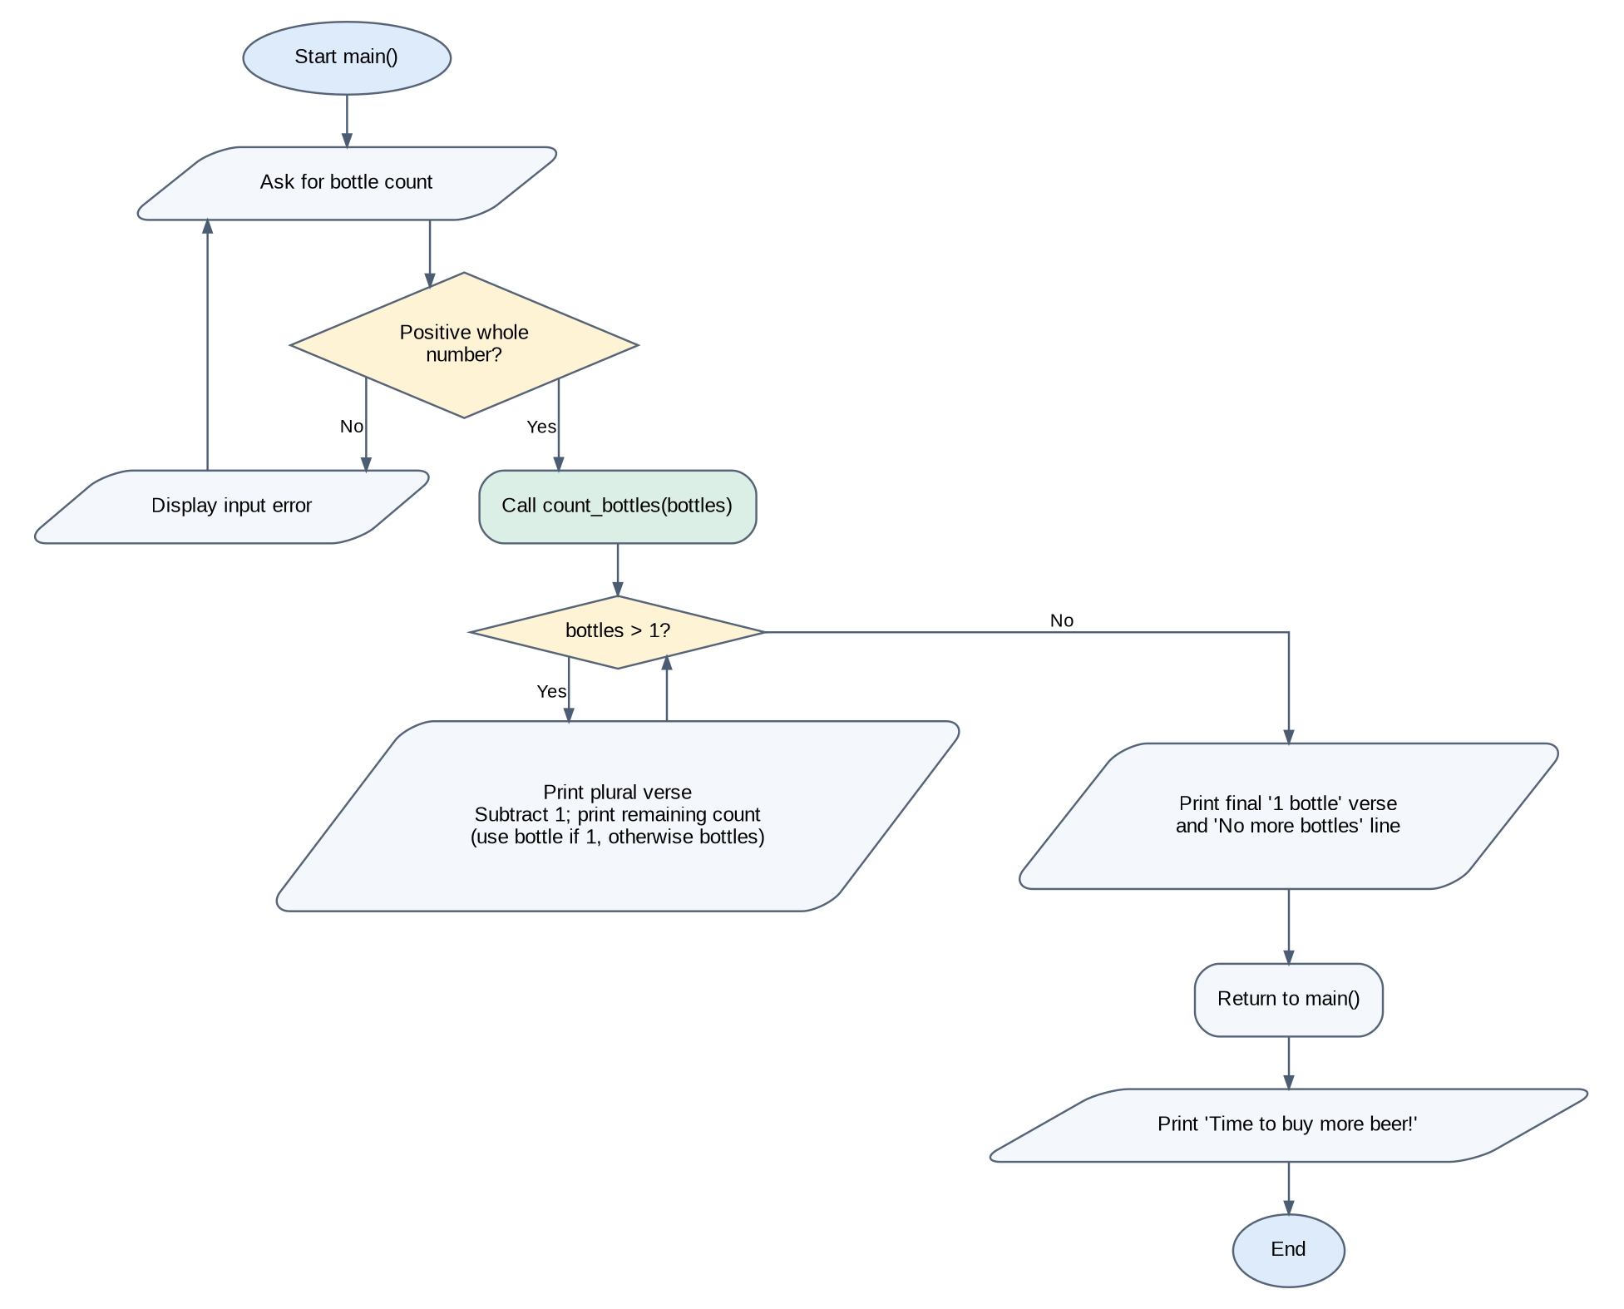
Flowchart follows the input validation in main(), the count_bottles() function, the plural-to-singular change at one bottle, and the final reminder after the function returns.

