Module 1.2: GitHub Repository Setup
Walter Jacobo
CSD325-309A Advanced Python
GitHub Repository: https://github.com/wjacobo/csd-325

GitHub repository screenshot
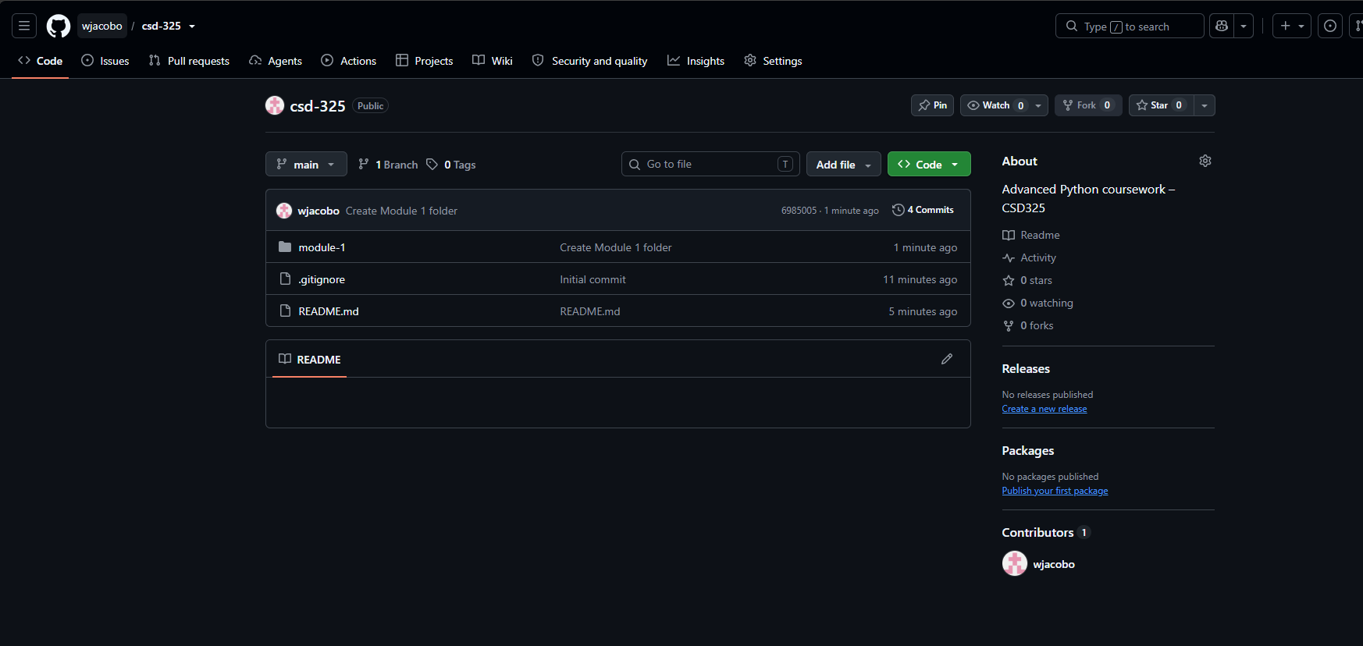

Local directory screenshot
Local repository path: C:\csd\csd-325
