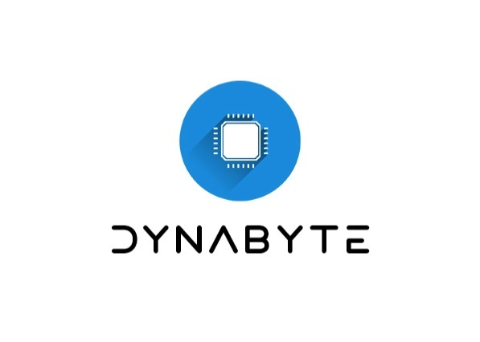



Instituto de engenharia do porto

licenciatura em Engenharia informática

User Manual

Done By:  
1150920 – Vasco sodré  
1200630 – Wilson júnior  
1201401 – josé cruz  
1201405 – ricardo faria  
1201406 – Rodrigo oliveira  
1201500 – gonçalo pereira

# **Glossary**

🡪ADM – Administrator

🡪REP – Receptionist

🡪CLT – Client

🡪MLT – Medical Lab Technician

🡪CCT – Clinical Chemistry Technologist

🡪SPD – Specialist Doctor

🡪LBC – Laboratory Coordinator

🡪Dev Team – Development Team

🡪TIN – Tax Identification Number

🡪SOC – Standard Occupational Classification

🡪NHS – National Healthcare Service

# **Table of Contents**

**1.** **Glossary** 1

**2.** **Table of Contents** 2

**3.** **Table of Images** 4

**4.** **Introduction** 5

**5.** **Roles** 6

**a.** **Administrator (ADM)** 6

**b.** **Receptionist (REP)** 6

**c.** **Client (CLT)** 6

**d.** **Medical Lab Technician (MLT)** 6

**e.** **Clinical Chemistry Technologist (CCT)** 6

**f.** **Specialist Doctor (SPD)** 6

**g.** **Laboratory Coordinator (LBC)** 6

**6.** **Opening the App** 8

**a.** **Login** 8

**b.** **Development Team** 9

**7.** **Necessary Registrations** 10

**a.** **How to register an employee (ADM)** 10

**b.** **How to register a new clinical (ADM)** 11

**c.** **How to register a new client (REP)** 12

**8.** **Test Components** 14

**a.** **How to create a new parameter category (ADM)** 14

**b.** **How to create a new parameter (ADM)** 15

**c.** **How to create a new test type (ADM)** 15

**d.** **How to register a test of a client (REP)** 16

**e.** **How to identify the test samples in the system (MLT)** 17

**f.** **How to insert the results of a test in the system (CCT)** 19

**g.** **How to create the diagnosis and report of a test (SPD)** 21

**9.** **Client Information:** 22

**a.** **How to update the client’s data (CLT)** 22

**b.** **How can the client see their tests’ information (CLT)** 23

**10.** **Data Analysis and Report:** 24

**a.** **How to validate the test’s information and notify the client (LBC)** 25

**b.** **How to see all the clients’ information of the tests (CCT)** 26

**c.** **How to read files with information of tests (LBC)** 27

**d.** **How to overview all the tests and analyse the company’s performance (LBC)** 28

**e.** **How to do the Covid report and send it to the NHS (ADM/Automatically)** 29

**11.** **Troubleshooting** 30

**12.** **FAQ’s** 30

**13.** **Conclusion** 30

**14.** **References** 31

**15.** **Annex A._MATCP** 32

**a.** **Simple Linear Regression** 32

**i.** **Overview** 32

**ii.** **Simple Linear Regression Model** 32

**b.** **Multiple Linear Regression** 32

**i.** **Overview** 32

**ii.** **Multiple Linear Regression Model** 32

**16.** **Annex A._MDISC** 32

**a.** **Sorting tests results by client name or TIN** 32

**i.** **Introduction** 32

**ii.** **Runtime tests for inputs of varying sizes** 33

**iii.** **Worst-case time complexity analysis** 34

**b.** **Evaluation of the effectiveness of the company’s response** 35

**i.** **Introduction** 35

**ii.** **Runtime tests for inputs of varying sizes** 35

**iii.** **Worst-case time complexity analysis** 35

# **Table of Images**

Figure 1 - Dependencies diagram 6

Figure 2 - Main Menu 9

Figure 3 - Login Menu 9

Figure 4 - Development Team 10

Figure 5 - Administrator Menu 11

Figure 6 - Employee Creation Menu 11

Figure 7 - Register new Clinical Menu 12

Figure 8 - Receptionist Menu 13

Figure 9 - Register new Client Menu 13

Figure 10 - Parameter Category Menu 15

Figure 11 - Parameter Menu 15

Figure 12 - Test type Menu 16

Figure 13 - Test Creation Menu 17

Figure 14 - Test Creation: parameter choice 18

Figure 15 - Medical Tech Menu 18

Figure 16 - Record a Sample Menu 19

Figure 17 - Barcode example 19

Figure 18 - Chemistry Technologist Menu 20

Figure 19 - Record Results Menu 20

Figure 20 - Record Results Menu: parameters results 21

Figure 21 - Specialist Doctor Menu 21

Figure 22 - Diagnosis Menu 22

Figure 23 - Client Menu 23

Figure 24 - Update your data Menu 23

Figure 25 - Your Tests: test chosen 24

Figure 26 - Laboratory Coordinator Menu 25

Figure 27 - Validate Diagnosis Menu 25

Figure 28 - Validate Diagnosis: test chosen 26

Figure 29 - Consult Tests Menu 26

Figure 30 - Consult Tests: test info 27

Figure 31 - Import FIle 27

Figure 32 - Import File: file chosen 28

Figure 33 - Performance Report Menu 29

Figure 34 - Performance Report Menu complete 29

Figure 35 - Configuration file 30

Figure 36 - Simple Linear Regression Report 31

Figure 37 - Multi Linear Regression Report 31

Figure 38 - NHS Report 32

Figure 39 - Simple Linear Regression 32

Figure 40 - Multi Linear Regression 33

Figure 41 - Mathematic Model 40

Figure 42 - Sum of squares 40

Figure 43 - Simple Anova Table 41

Figure 44 - Anova Table: first simple 41

Figure 45 - Anova Table: second simple 41

Figure 46 - Correlation Coefficient 41

Figure 47 - Sum of squares and crossed sum 42

Figure 48 - Correlation coefficients for the models 42

Figure 49 - Hypothesis tests expressions 42

Figure 50 - Hypothesis tests: first model 43

Figure 51 - Hypothesis tests: second model 43

Figure 52 - Confidence interval expression 44

Figure 53 - Variation expression 44

Figure 54 - Confidence intervals: first model 44

Figure 55 - Confidence intervals: second model 44

Figure 56 - Mathematic model 45

Figure 57 - Matrix model 45

Figure 58 - Important matrices 45

Figure 59 - Multiple Anova Table 46

Figure 60 - Sum of Squares 46

Figure 61 - Anova Table for the regression model 46

Figure 62 - Determinant coefficient expression 47

Figure 63 - Determinant coefficient value 47

Figure 64 - Hypothesis tests form and expression 47

Figure 65 - Hypothesis tests for beta 0 47

Figure 66 - Hypothesis tests for beta 1 and 2 48

Figure 67 - Confidence interval expression 48

Figure 68 - Confidence interval: multiple model 48

Figure 69 - graph 2 50

Figure 70 - graph 1 50

Figure 71 - x^3 graph 52

Figure 72 - Brute-Force and Benchmark algorithms graphs 52

# **Introduction**

This user manual is to help the employees and clients that need to use the application. It has all kinds of topics and steps to help understand how each feature in the app works and what kinds of errors can appear through its usage.

The application consists in a test analysis management app, to be used on all kinds of clinicals of the Many Labs company, making easier the work of any employee and the access of any client. To understand better how the app works, it is presented below a diagram with the dependencies between the features and which are the most important. It’ll start from left to right, left being the one feature with no dependencies, and right the ones that give no dependency. The ones marked with a blue “I” are the core modules, which means, without these, the application is useless.

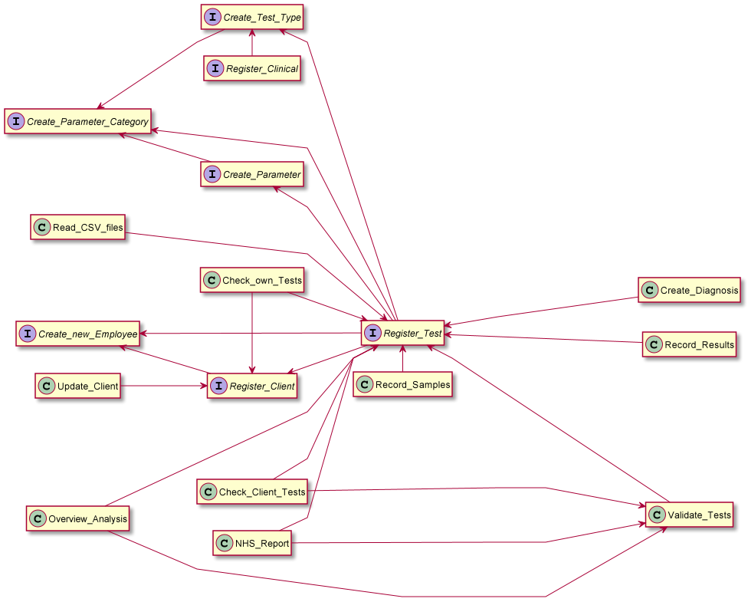

Figure 1 - Dependencies diagram

To use the app, it is possible to have any OS as long it has Java 8. It is advised that the computer has 6 GB of RAM or more.

The only way to obtain the app, as it isn’t published anywhere for installation, is the development team to give it directly. To get to the executable, open the project folder and open the file WHERE_IS_THE_EXECUTABLE.txt, that’ll show the path where the executable is stored.

# **Roles**

The users will be divided in various roles in the system to identify better what can each role do. To be able to find better what each role does specifically, on each title there is initials corresponding to each one of them. The roles are the following:

## **Administrator (ADM)**

Responsible for the most of the creating and register of the system. Reporting the Covid cases is also a responsibility of this role.

## **Receptionist (REP)**

Responsible for the direct communication with the client.

## **Client (CLT)**

Responsible for taking care of their own information.

## **Medical Lab Technician (MLT)**

Responsible for the identification of the samples

## **Clinical Chemistry Technologist (CCT)**

Responsible for the register and manipulation of the results of each test

## **Specialist Doctor (SPD)**

Responsible for translating the medical language of the results into generic language for the client.

## **Laboratory Coordinator (LBC)**

Responsible for validating all the test components and check if they’re all done correctly and notify the client when the tests are ready.

In the following table, it is possible to see the specific features each role can do to help find whatever feature is needed.

|  |  |  |  |  |  |  |  |
| --- | --- | --- | --- | --- | --- | --- | --- |
| Features/Roles | ADM | REP | CLT | MLT | CCT | SPD | LBC |
| Register an employee | X |  |  |  |  |  |  |
| Register a clinical | X |  |  |  |  |  |  |
| Register a Client |  | X |  |  |  |  |  |
| Create a category | X |  |  |  |  |  |  |
| Create a parameter | X |  |  |  |  |  |  |
| Create a test type | X |  |  |  |  |  |  |
| Register a test |  | X |  |  |  |  |  |
| Identify the tests’ samples |  |  |  | X |  |  |  |
| Record the test results |  |  |  |  | X |  |  |
| Create a diagnosis and a report |  |  |  |  |  | X |  |
| Update client data |  |  | X |  |  |  |  |
| Check client’s validated test |  |  | X |  |  |  |  |
| Validate test’s components |  |  |  |  |  |  | X |
| See all the clients’ tests |  |  |  |  | X |  |  |
| Read files with test information |  |  |  |  |  |  | X |
| Analyse the company’s performance |  |  |  |  |  |  | X |
| Send the covid report to the NHS | X |  |  |  |  |  |  |

**NOTES:**

**🡪**The crosses mean that the corresponding role is responsible for that specific feature.

**🡪**All the roles’ initials meanings are in the Glossary and after each role in the table of contents and titles.

🡪The “Send the covid report to the NHS” feature can be done automatically without any login from any role.

# **Opening the App**

To be able to use the application correctly, it is needed, firstly, to open it and then be able to login.

Once the app is opened, it is possible to see a main menu with the designation of the company in the centre of the window and two buttons: Login and Dev Team (as it is possible to see in the following image).

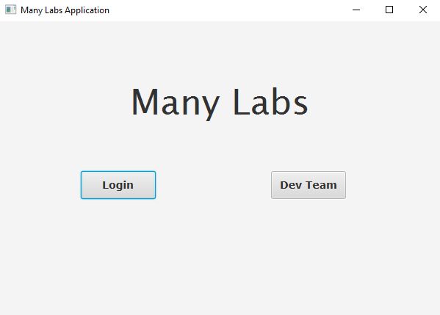

Figure 2 - Main Menu

## **Login**

To login, the first action that is required, after opening the app and seeing the main menu, is to click in the visible Login button. After that, it’ll appear on the screen a new window with the title “Authentication Menu”, below two text boxes with labels next to them saying, respectively, “Enter Email” and “Enter Password” and, finally, two buttons, one saying “Return” and the other saying “Confirm”. The next image shows the window described previously.

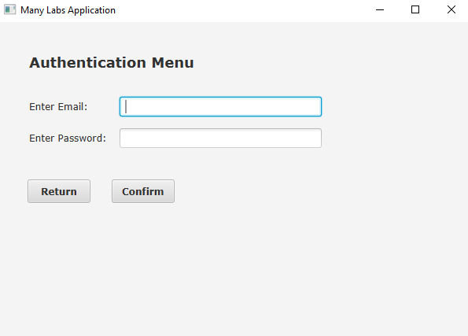

Figure 3 - Login Menu

After seeing that window, to finally login, it is required to be registered in the system (registrations are made by the Administrator, if it is an employee’s account, or the Receptionist, if it is a client’s one). Now, the asked email, is the registration email, inserted in the first text box, and the respective password, inserted in the second one. Then, to enter, click the “Confirm” button. In case of wanting or having the need to go back to the main menu, click the “Return” button (Note: the “Return” button is on almost all the available windows and it works in the same way in all of them).

## **Development Team**

To see the development team that created the application, it is needed to see the main menu window on the screen. Then, click on the “Dev Team” button and it’ll appear a new window with the title “Development Team”, with the names of the members and next to each member, the respective email, as it is shown in the image below.

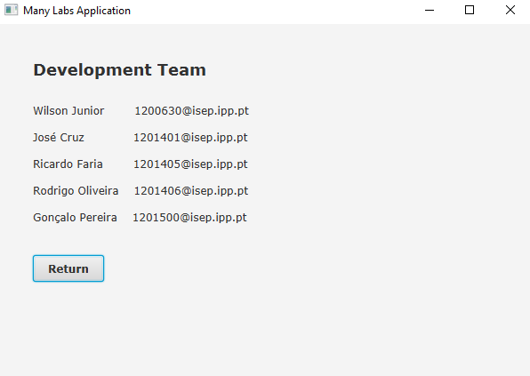

Figure 4 - Development Team

# **Necessary Registrations**

To do any of these features, it is required that the user is logged in with their account, following the steps of the Login topic (page 6).

## **How to register an employee (ADM)**

The first step to do is logging in the system with an administrator account. After doing that, it’ll appear a new window with the title “Administrator Menu”, six possible options of the application’s features and a “Return” button, as it is shown in the next picture.

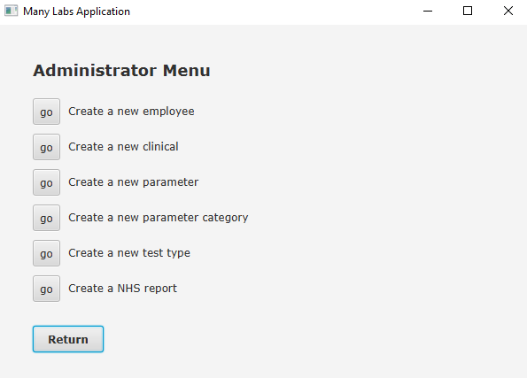

Figure 5 - Administrator Menu

Then, once this window appears in the screen, click in the “go” button next to the “Create a new employee” option (Note: the “go” buttons, when clicked, show a new window depending on the option chosen. To choose a certain option, it is required to click in the “go” button next to that option. This works for all the Role Menus). After clicking on it, the window that will show is the one showing in the following image:

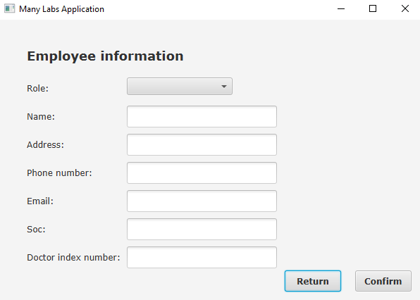

Figure 6 - Employee Creation Menu

As it is possible to see, this window contains all the information related to the employees. A combo box for the role, when clicking on it, it’ll show the list of possible roles to choose, and it is just needed to click on the desired role. The next step is filling all the text boxes. There’s six of them in total, and each has a label next to it regarding which data to input. The first is the name, no more than 35 chars; then it’s the address, no more than 30 chars; next is the phone number, that needs to have 11 digits; after there’s the email, with the mandatory format [employee@email.extension](mailto:employee@email.extension) (Note: employee can be the name of the employee, email the type of email used and the extensions are, for example, .pt or .com, etc.); finally, the soc (Standard Occupation Classification) with only 4 digits. The Doctor Index Number is only required when the intention is to register a Specialist Doctor employee, even though the field will always appear, it won’t change anything in the registrations of the other roles. To finally register the employee, after having all the data filled correctly, click on the “Confirm” button and a pop-up message will show to inform the saving was successful, if not, an error pop-up message will be shown instead.

## **How to register a new clinical (ADM)**

In this feature is also needed to be logged in with an administrator account and after that step the Administrator Menu window will appear (Figure 4, page 7). Then, as the user wants to register a new clinical, it is required to click the “go” button next to the “Create a new clinical” option and a window with the title “Register new Clinical” with all the information related to the clinical, like in the picture.

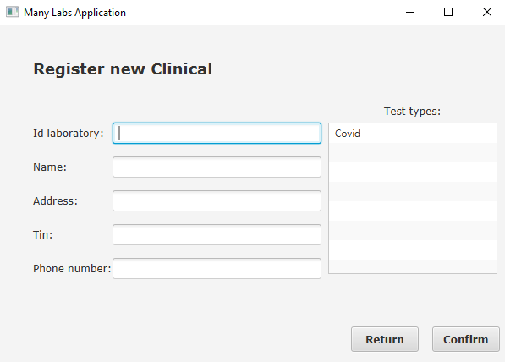

Figure 7 - Register new Clinical Menu

To create the clinical, it is needed to indicate which test types it can perform, and, for that, there is a list view with all the test types available. To choose the wanted test types, click on them, and, once that’s done, the chosen test types will disappear from the list, to avoid the possibility of the user to choose the same test type more than once. There’re also five text boxes which need the following data, respectively, from top to bottom: Id Laboratory, with 5 digits; name, with a max of 30 chars; address, with also 30 chars, max; TIN (Tax Identification Number), with 10 digits; Phone Number, with 11 digits. Finally, when everything is correctly filled, click on the “Confirm” button and the clinical will be registered. and a pop-up message will show to inform the saving was successful, if not, an error pop-up message will be shown instead.

## **How to register a new client (REP)**

In this case, the account needed is a receptionist one. After logging in successfully, following the right steps, the next window, with the title “Receptionist Menu” and two possible options and the “Return” button, as usual, is what’s going to show on the screen.

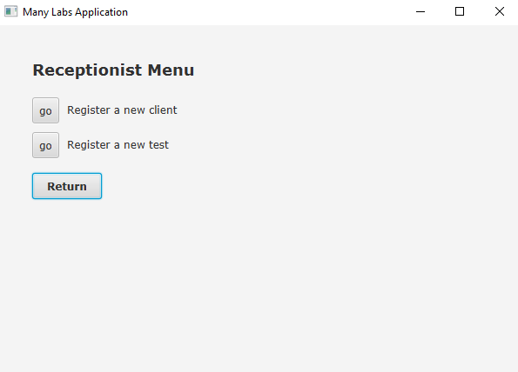

Figure 8 - Receptionist Menu

Now, to register the client, click on the “go” button next to the “Register a new client” option. Then the following window will appear:

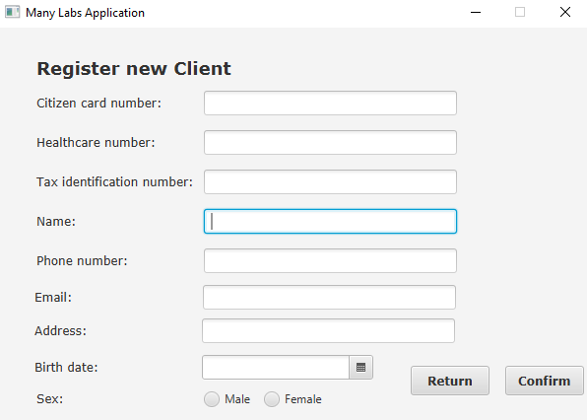

Figure 9 - Register new Client Menu

It’s possible to see a total six text boxes. The TIN and address data are treated the same way as the clinical one (page 8) and the name, phone number and email data are treated the same way as the employee ones (page 7 and 8). The other data is treated this way: the citizen card number, with 16 digits; the healthcare number, with 10 digits; the birthdate, it can be written directly with the dd-mm-yyyy format or chosen through the date picker on the right of the text box; the sex, with two radio buttons, being able to pick only one. After everything is completely and correctly filled, click the “Confirm” button to save the created client and a pop-up message will show to inform the saving was successful, if not, an error pop-up message will be shown instead.

# **Test Components**

Once again, to be able to do any of these features, it is needed to login with the correct account, depending on which one will be chosen to do. To know the type of accounts needed, next to each title there’s initials that indicate what is the role that is able to do the specific feature (the meaning of the initials are on the Glossary, page 1).

## **How to create a new parameter category (ADM)**

After logging in with an administrator account successfully, the “Administrator Menu” will appear (Figure 4, page 7). With that menu on the screen, it is, now, necessary to click the “go” button next to the “Create a new parameter category” option to start the desired operation.

As a result of the previous step, a new window will appear in the screen, with the title “Parameter category info”, the needed information to create the parameter category and the usual “Return” and “Confirm” buttons.

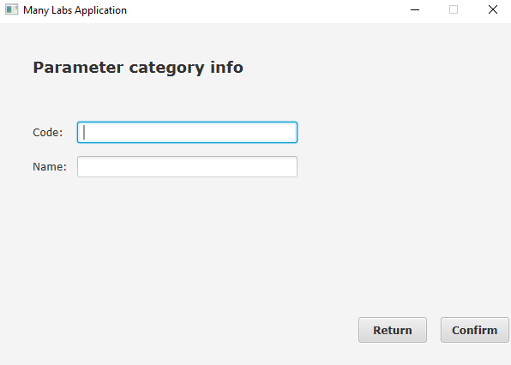

Figure 10 - Parameter Category Menu

Looking at the Figure 9, it is noticeable the two text boxes for data. The first one is for the code of the parameter category, which is unique and can only have 5 digits. The second one is its name, and it cannot have more than 10 chars. When all the data is completed correctly, click on the “Confirm” button to save it and a pop-up message will appear and inform if the saving was or not successful, if not, an error pop-up message will appear instead.

## **How to create a new parameter (ADM)**

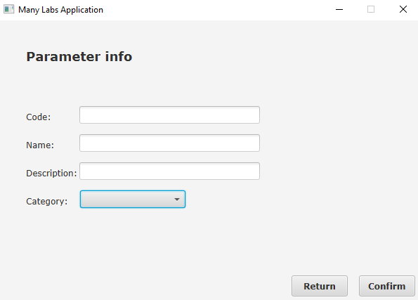With the login step done, using the correct account, the “Administrator Menu” is, once again, going to pop up on the screen (Figure 4, page 7). Now, to continue, click on the “go” button next to the “Create a new parameter” option, and then, a new window will be shown on the screen with the title “Parameter info” containing all the fields necessary to create a parameter.

Figure 11 - Parameter Menu

In this case, the menu has three text boxes. The code is treated the same way as the parameter category one (page 10). The name and description can have any char but cannot have more than 8 and 20, respectively. To choose the category, it’ll be used a choice box, which, when it is clicked, it shows the list of categories available to pick, and once that’s done, the name of that category will appear in the choice box. Once everything is completed correctly, clicking on the “Confirm” button will save and a pop-up message will show on the screen saying the saving process was successful, if not, a different pop-up message will appear with the error occurred.

## **How to create a new test type (ADM)**

As usual, the login is the first step, and with that done, the “Administrator Menu” will show up again (Figure 4, page 7). As the goal of this feature is to create a new test type, it is required to click on the “go” button next to the “Create a new test type” with all the info to create a test type.

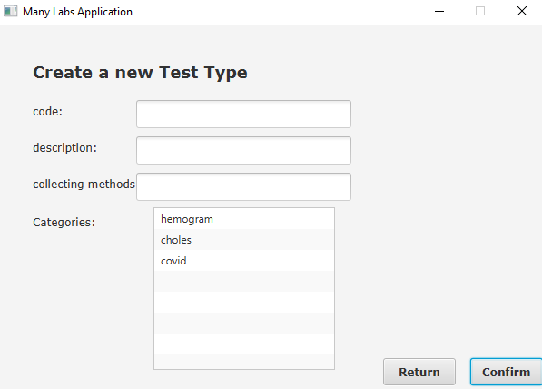

Figure 12 - Test type Menu

There’re four different data to input: the code, can only have 5 digits and needs to be unique; the description, can’t have more than 15 chars; the collecting method, can’t have more than 20 chars; and the categories, with all the categories available being shown on a list view and once one is clicked on, it’ll disappear from the list so the user can’t choose the same one more than once. After having all the data well completed, click on the “Confirm” button to save and a pop-up message will show to inform the saving was successful, if not, an error pop-up message will be shown instead.

## **How to register a test of a client (REP)**

Here, the account to be logged in, must be a receptionist one. With that done, the “Receptionist Menu” will be shown on the screen (Figure 7, page 9) and, to register a test, it is necessary to click on the “go” button next to the “Register a new test” option. Then, a new menu, with the title “Test Creation and all the information needed to create a test, will appear.

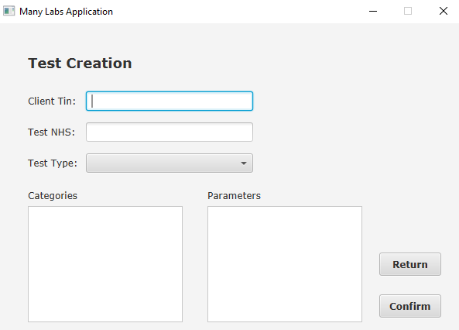

Figure 13 - Test Creation Menu

With the new menu on the screen, it shows five different types of data. The two first are text boxes with the following data, respectively, from top to bottom: the client TIN, that needs to be 10 digits and to be the TIN of a registered client; the test NHS (National Healthcare Service) code, which needs 12 digits and must be unique. Secondly, the test type is chosen through a choice box, and, when it is clicked, the available list of test types will appear and, once one of them is chosen, it’ll appear on the choice box. Finally, after the test type is picked, the categories and the parameters will appear, and their treatment is similar. On the category list view (left one, below the “Categories” label), the available list will be shown (categories only part of that test type) and once one of the categories is chosen, that one will be taken out of the list view and the parameters corresponding will appear on the parameter list view (right one, below the “Parameters” label), and the their choice is done the same way as the categories, the only difference is, when the parameters are chosen, a new list view will appear with the selected ones.

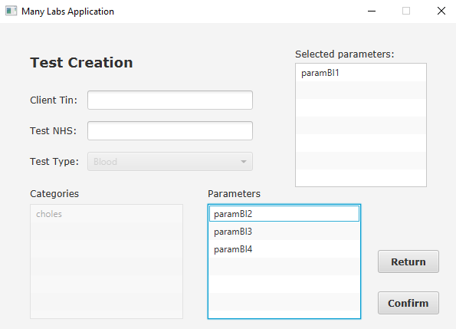

Figure 14 - Test Creation: parameter choice

With everything correctly done, click on the “Confirm” button to save and a pop-up message will show to inform the saving was successful, if not, an error pop-up message will be shown instead.

## **How to identify the test samples in the system (MLT)**

The only role that can do this feature is the Medical Lab Technician. Therefore, the account the logged in, needs to be from this type of employee. With the login done successfully, it’ll be shown the “Medical Technician Menu” with one feature as an option and the usual “Return” button. The next image shows the described menu.

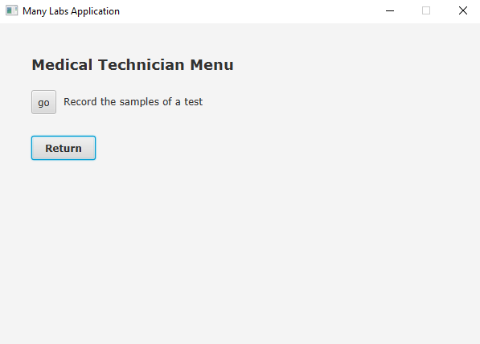

Figure 15 - Medical Tech Menu

After, to start the features operation, it’s required to click the “go” button next to the “Record the samples of a test” option, and, when that’s done, a new menu with the title “Record a Sample” and the two data needed to record the samples.

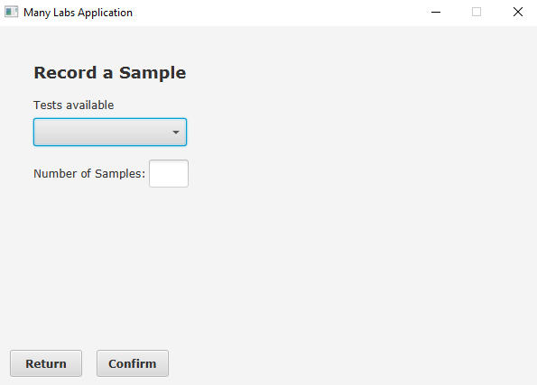

Figure 16 - Record a Sample Menu

The first one is a choice box that shows the tests available once it’s clicked on, and when one of the tests is chosen, its id will be presented in the choice box. After doing that, it is required to fill the text box next to the “Number of Samples” label with the number of samples desired to be recorded. Finally, when all of the previous steps are done, click on the “Confirm” button to save the samples and a pop-up message will show to inform the saving was successful, if not, an error pop-up message will be shown instead. If the save is successful, the barcode will be created in a .jpg extension and look like the next image.



Figure 17 - Barcode example

## **How to insert the results of a test in the system (CCT)**

As, to access this feature, the only role possible is the Clinical Chemistry Technologist, that’s the type of account it’s going to be needed. After the login, the “Chemistry Technologist Menu” will appear with two features available and the usual “Return” button.

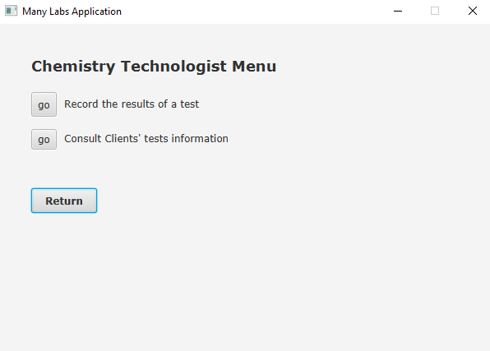

Figure 18 - Chemistry Technologist Menu

As the wanted feature is to Record test results, then clicking on the “go” button next to the “Record the results of a test” option will bring a new menu with the title “Record Results” and a choice box, which is for choosing the barcode.

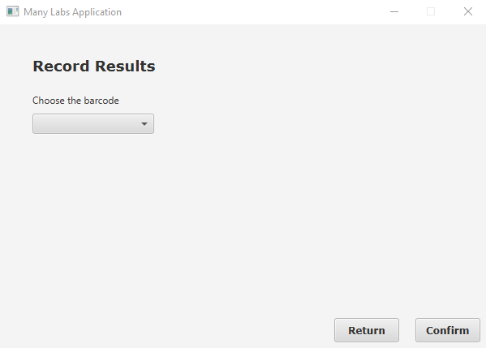

Figure 19 - Record Results Menu

After choosing the desired barcode, the choice box will be disabled, and a new text box will appear below a label with the test parameters. When the text box is filled, by clicking the visible “Next” button, under the text box, the results will be saved temporarily, and it’ll appear another parameter on the label. This will keep going until there’s no more parameters to record results for, and so, the parameter label will say “No more parameters”.

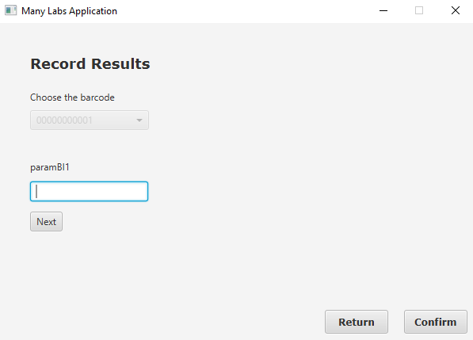

Figure 20 - Record Results Menu: parameters results

Once the “No more parameters” appears, click on the “Confirm” button to save completely the recorded results and a pop-up message will show to inform the saving was successful, if not, an error pop-up message will be shown instead.

## **How to create the diagnosis and report of a test (SPD)**

This feature will only be available if the system is logged in with a Specialist Doctor account, so it is crucial to be logged in with that type of account for this to work. If the login was successful, then, it should appear a new menu called “Specialist Doctor Menu” with one possible option and the usual “Return” button.

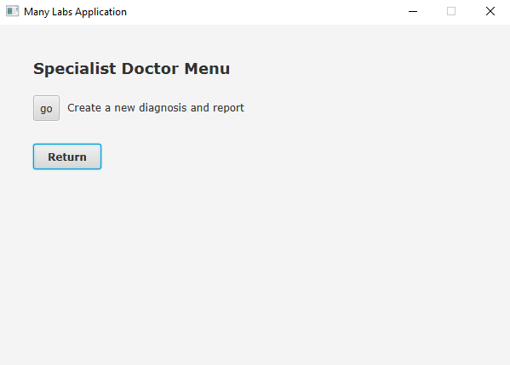

Figure 21 - Specialist Doctor Menu

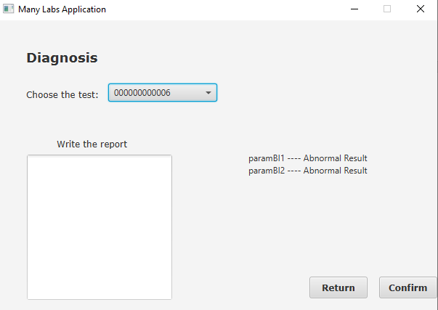 Now, to go to the feature, click on the “go” button and a menu with the title “Diagnosis” and with all the information required to create the diagnosis and report of a test, starting with the choice box that shows the tests available (the tests with results already recorded).

Figure 22 - Diagnosis Menu

When one of tests available is chosen, it’ll appear in the choice box its id and the diagnosis will be presented on the right side, next to the text box. After that, it’s necessary that the report is written, and for that it is used the text box below the “Write the report” label. The report cannot have more than 400 chars. Once everything is filled correctly, click on the “Confirm” button to save the data and a pop-up message will show to inform the saving was successful, if not, an error pop-up message will be shown instead.

# **Client Information:**

As in every feature, it is needed to be logged in to be able to use these features. In this case, the type of the account is the same, a Client account. Once the login is done with the account type said before, the “Client Menu” should appear with two available features and the usual “Return” button.

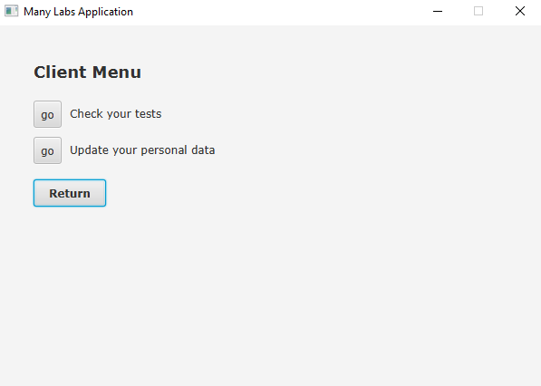

Figure 23 - Client Menu

## **How to update the client’s data (CLT)**

After the login, to do this feature, click on the “go” button next to the “Update your personal data” option and it’ll bring a new window with the title “Update your data” and all the logged in client’s data to be able to change any data needed.

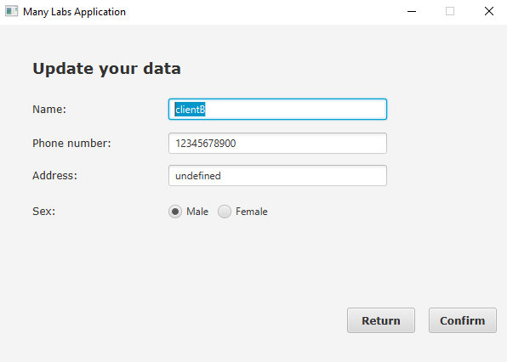

Figure 24 - Update your data Menu

Now, it is possible to change the shown data freely, but the rules for the data filling are the same as in the registration of the client (page 9 and 10), meaning that, if any of these rules are broken, once the “Confirm” button is clicked on, an error pop-up message will appear specifying which data was filled wrongly. If none of those appear, then it’ll show a pop-up message saying the saving of the new data was done correctly.

## **How can the client see their tests’ information (CLT)**

For this feature, click on the “go” button next to the “Check your tests” option to appear a new menu with the title “Your Tests” and with the list of tests belonging to that client.

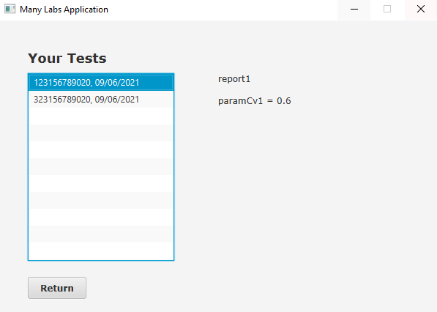

Figure 25 - Your Tests: test chosen

After one of the tests of the list is clicked, next to the list, it will appear the corresponding report, commenting on the results of the test, and the parameters results.

# **Data Analysis and Report:**

These features are the same way as the others, in terms of having to logged in to access them. In this case there’s three possible roles: Clinical Chemistry Technologist (Figure 17, page 17); Administrator (Figure 4, page 8); and the Laboratory Coordinator (will be shown next).

As the Laboratory Coordinator, is the only role whose menu hasn’t been shown yet, and so, it’ll be done now. Off course, for that to happen, it is needed to be logged in into an account that belongs to this role (follow the Login steps, page 6). After making sure that was done correctly, the “Laboratory Coordinator Menu” is going to show up with three possible choices of features and the usual “Return” button.

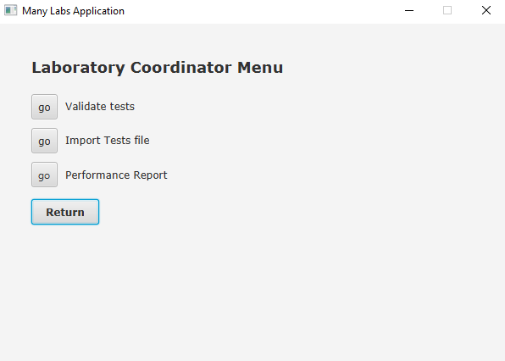

Figure 26 - Laboratory Coordinator Menu

And now, it is possible to choose any of the features shown.

## **How to validate the test’s information and notify the client (LBC)**

For this one, it is needed the Laboratory Coordinator menu (Figure 25, page 22). Click on the “go” button next to the “Validate tests” option to start the operation and a new window will appear with the title “Validate Diagnosis” having a choice box to choose the test pretended to be validated.

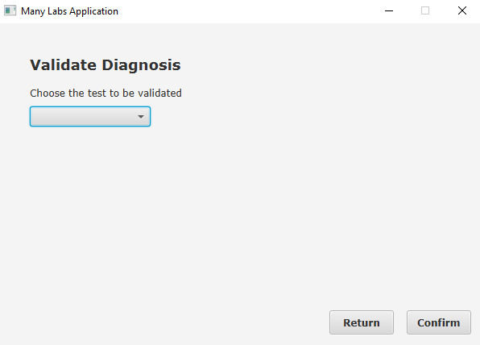

Figure 27 - Validate Diagnosis Menu

When a test is then chosen, its report and diagnosis will be shown below the choice box so that the user can read them and validate them.

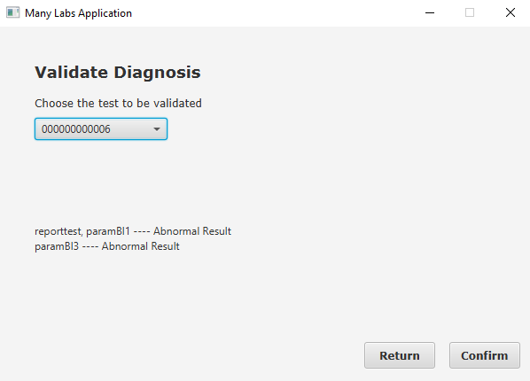

Figure 28 - Validate Diagnosis: test chosen

To finally validate it, click on the “Confirm” button and a pop-up message will show to inform the saving was successful, if not, an error pop-up message will be shown instead.

## **How to see all the clients’ information of the tests (CCT)**

Here, the role needed to do this feature is the Clinical Chemistry Technologist. After doing the login and seeing the corresponding menu (Figure 17, page 17), click on the “go” button “Consult Clients’ tests information” option and a menu with the title “Consult Tests”, a choice box, a client list and a test list.

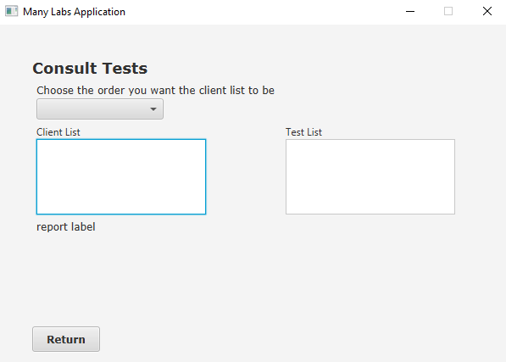

Figure 29 - Consult Tests Menu

The choice box is for the user to choose which order they want the client list to be shown, by TIN or by name. Once one of them is chosen, the client list will appear in the desired order. Then, when clicking one of the clients, the test list corresponding will appear on the right list view. To see the information of one test, it is needed to click on one of them. If another test or another client is clicked, the system will work the same way and correctly.

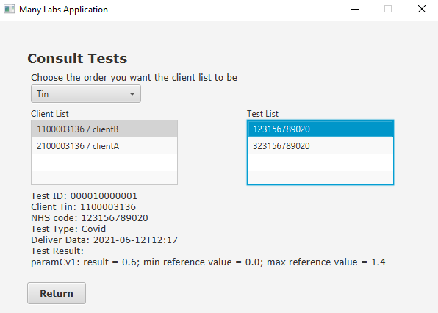

Figure 30 - Consult Tests: test info

## **How to read files with information of tests (LBC)**

Here it is needed the Laboratory Coordinator menu again (Figure 25, page 22). With that done, click the “go” button next to the “Import Tests files” option. It’ll appear, then, a new window with the title “Import File” and with a button saying, “Choose one file”.

Figure 31 - Import FIle

After clicking on the “Choose one file” button, a window to choose a CSV file. Once that’s done, the path of the chosen file will appear next to the button, and, when the “Confirm” button is clicked. The lines will appear in the list view on the right if they’ve been read correctly, if not, the lines where an error occurred, and the corresponding errors will appear in the list on the left.

Figure 32 - Import File: file chosen

## **How to overview all the tests and analyse the company’s performance (LBC)**

In this feature, the Laboratory Coordinator will be able to study the company’s performance in an interval of days. For that it is needed to see, firstly, the “Laboratory Coordinator Menu” (Figure 26, page 24). To start this feature, click on the “go” button next to the “Performance Report” option and that’ll make the screen show a new window with the title “Performance Report” and all the necessary items to be able to do the overview of the company’s performance in that certain interval.

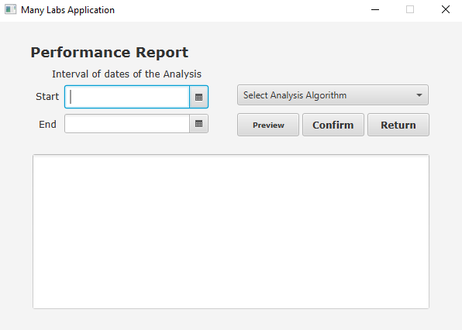

Figure 33 - Performance Report Menu

The interval of dates is chosen through those date pickers. The one next to the “Start” label is the beginning date and the one next to the “End” label is the finishing date. After those are picked, there is the algorithm desired to be performed. These algorithms analyse the diagnosed and registered tests and through the date, they analyse if the company was or not efficient, pointing out the best and worst day. The difference between the Bruce-Force Algorithm and the Benchmark ISEP Algorithm is that the second has a better performance, since it takes less time to do its function, but both do the exact same. After having all the previous step done, click the “Preview” button and the performance report will appear on the text box below.

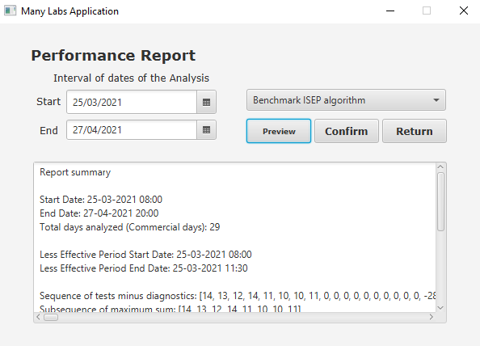

Figure 34 - Performance Report Menu complete

By clicking the “Confirm” button, it will save the report.

## **How to do the Covid report and send it to the NHS (ADM/Automatically)**

In this feature, there’s no need to have any menu in the screen, because the NHS report is done automatically at 6 am of everyday. To do the report, it is used two models of Linear Regression, one Simple and one Multiple. With that said, there’s some data that is needed to be defined through a configuration file:

* The regression model to be used.
* The significance level of the intervals and the hypothesis tests of the coefficients (significanceLevel.COEFFICIENT).
* The significance level for the anova table.
* The historical days.
* The start and end of the regression model.

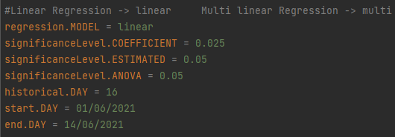

Figure 35 - Configuration file

After having these well-defined, once it is 6 am, the following reports might be sent depending on what regression model was defined.

For the Simple Linear Regression, it can have two different models, with different independent variables: the number of Covid tests or the mean age of positive cases. The chosen one will be the most efficient. Once that’s done the following report is done.

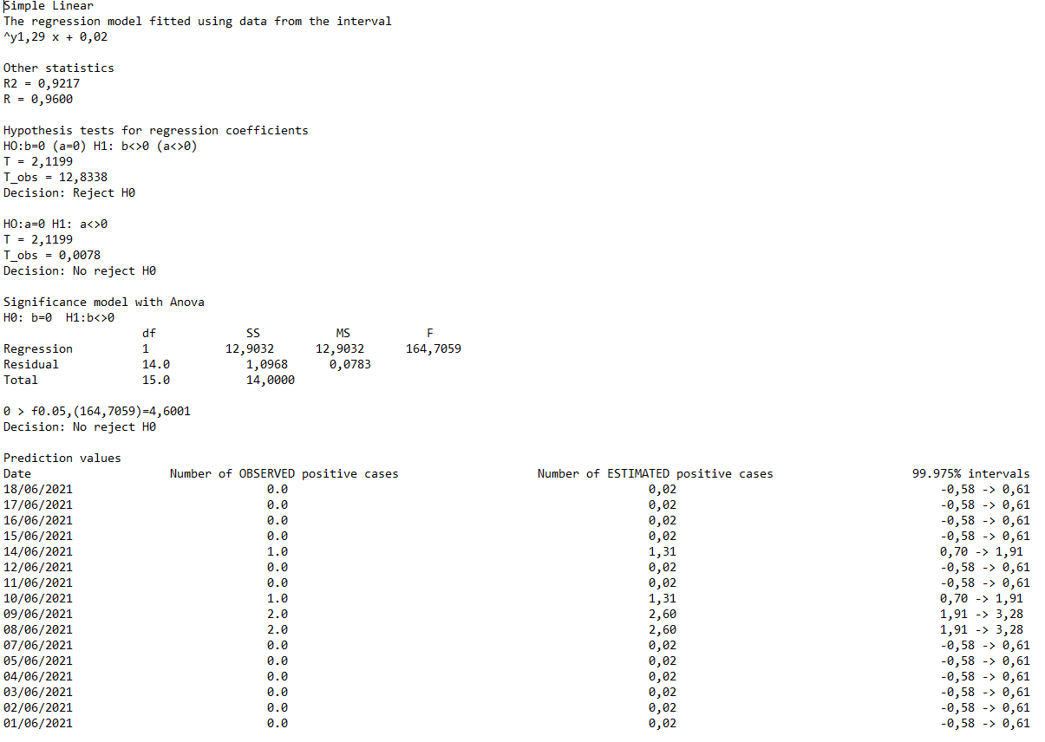

Figure 36 - Simple Linear Regression Report

For the Multiple one, the variables are always the same which means the report has always the same structure, just different values.

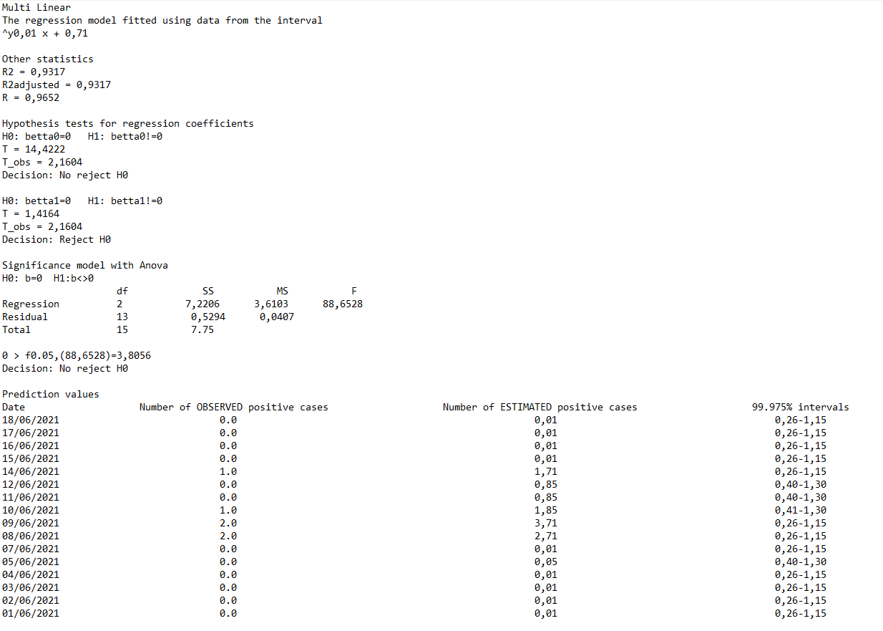

Figure 37 - Multi Linear Regression Report

Now, the administrator is also able to do this feature. They will be able to send the NHS report at any time. For that it is needed to see, firstly, the “Admin Menu” (Figure 5, page 10). To start this feature, click on the “go” button next to the “Create a NHS report” option and that’ll make the screen show a new window with the title “NHS” and all the necessary items to be able to do send the NHS report with all necessary requirements.

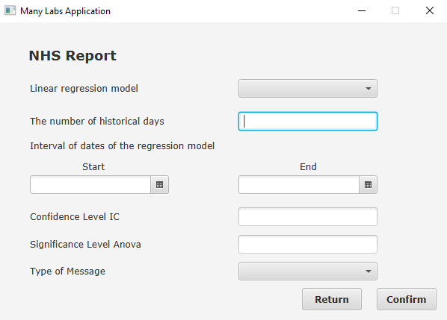

Figure 38 - NHS Report

With everything correctly done, click on the “Confirm” to see the information requested.

After clicking on the confirm button is going to appear a different screen depending on what was chosen, Simple Linear Regression or Multi Linear Regression.

If chosen Simple Linear Regression the following screen will appear:

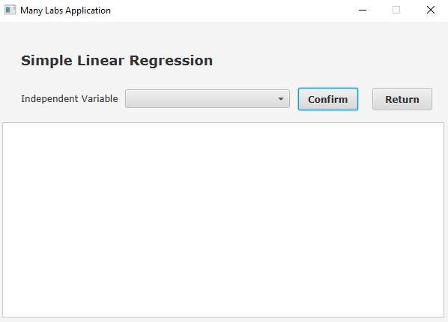

Figure 39 - Simple Linear Regression

It is possible to choose between two different independent variable, Covid-19 tests or mean age.

After choosing the independent variable and clicking confirm the data will be shown in the text area below.

If chosen Multi Linear Regression the following screen will appear:

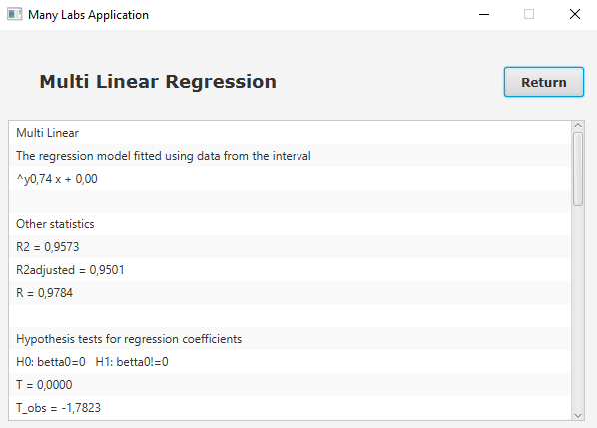

Figure 40 - Multi Linear Regression

The data will be showed immediately as there is no other required information.

# **Troubleshooting**

**Problem**: test creation error.

**Cause**: error with the test introduced or selected data.

**Solution**: check that you have introduced all test data correctly, the test code must be five characters long and can only have numbers, the nhs code must be twelve characters long and must be alphanumeric. Also make sure you have selected at least one test type, a category and a parameter.

------------------------------------------------------------------------------------------------------------------------------

**Problem**: Test Creation Menu – Client not valid

**Cause**: picking a client that doesn’t exist

**Solution**: Check in the system if that client exists. Talk with a Receptionist to see if any client with the introduced data was in the clinical.

------------------------------------------------------------------------------------------------------------------------------

**Problem**: clinical creation error.

**Cause**: error with the clinical introduced or selected data.

**Solution**: check that you have introduced all clinical data correctly, remember that the laboratory id must be 5 characters long and must be alphanumeric, the name and the address must be thirty characters and must be alphanumeric, the Tin must be ten characters long and must have only numbers, the phone number must be eleven characters long and must have only numbers. Also make sure you have selected at least one test type from the list.

------------------------------------------------------------------------------------------------------------------------------

**Problem**: file not found

**Cause**: the file path is wrong

**Solution**: check if the file exists, if it does then check if you introduced the file path correctly

------------------------------------------------------------------------------------------------------------------------------

**Problem**: error in all lines of the file

**Cause**: the file was already introduced

**Solution**: check the tests list and verify if the tests from the file are already there, if they are then you already introduced that file. If they aren’t then check if the file information is correct.

------------------------------------------------------------------------------------------------------------------------------

**Problem**: Test list empty

**Cause**: there are no tests registered for that client or the tests are not validated

**Solution**: if there are no tests on the test list first check if the receptionist as already created a test for that client, if there are tests created for that client then they haven’t been validated so they are not introduced in the list.

------------------------------------------------------------------------------------------------------------------------------

**Problem**: Error with updated client data

**Cause**: error with the introduced client data

**Solution**: check if the introduced data is correct. Remember that the citizen card number must be sixteen characters long and must only have numbers, the healthcare number and the Tin must be ten characters long and must only have numbers, the name must be thirty characters long and can only have letters, the phone number must be eleven characters long and must only have numbers, don’t forget to choose the birth date and the sex.

------------------------------------------------------------------------------------------------------------------------------

**Problem**: Error with client creation

**Cause**: error with the introduced client data

**Solution**: check if the introduced data is correct. Remember that the citizen card number must be sixteen characters long and must only have numbers, the healthcare number and the Tin must be ten characters long and must only have numbers, the name must be thirty characters long and can only have letters, the phone number must be eleven characters long and must only have numbers, don’t forget to choose the birth date and the sex.

------------------------------------------------------------------------------------------------------------------------------

**Problem**: Test list empty

**Cause**: there are still no tests that have been seen by a medical tech

**Solution**: you should wait for the medical tech to collect the sample for the tests and then you will receive it in that list so that you can analyze it.

------------------------------------------------------------------------------------------------------------------------------

**Problem**: Performance Report Menu – Index 0 out of bounds for length 0

**Cause**: No data on the picked date interval

**Solution**: Check if you insert the correct interval. If you did, then check if you inserted in the system data related to that interval of dates and check if the data is all inputted correctly.

------------------------------------------------------------------------------------------------------------------------------

**Problem**: Record Results Menu – Parameter without results

**Cause**: No test picked

**Solution**: Check if you picked a test correctly. If there’s no test to pick, it probably means that the test doesn’t have its samples properly identified in the system.

**Problem**: Error with Diagnosis Creation!

**Cause**: null diagnosis and/or report

**Solution**: You need to make sure that a test was picked for the system to do the diagnosis, and, after that, you need to do the report. Is there’s no test to be picked, it means that the Clinical Chemistry Technologist didn’t record any results.

------------------------------------------------------------------------------------------------------------------------------

**Problem**: Error with category data

**Cause**: Code or name data input wrong

**Solution**: Check if the inputs fulfil all the rules.

------------------------------------------------------------------------------------------------------------------------------

**Problem**: Error with category data

**Cause**: Code, name, description and/or category data input wrong

**Solution**: Check if the inputs fulfil all the rules

# **FAQ’s**

**Question**: I cannot log in to the program, what should I do?

**Answer**: Make sure you are registered in our system, for that you must have spoken to a receptionist to proceed with the registration.

------------------------------------------------------------------------------------------------------------------------------

**Question**: When trying to update my personal data, the program would not let me change some of it, what might have happened?

**Answer**: You must make sure that when entering the new data, they continue to meet the requirements, you can check the page 22 of the program manual to get some help with this topic

------------------------------------------------------------------------------------------------------------------------------

**Question**: When I try to consult my tests, the test list is empty, why does this happen?

**Answer**: Only tests that have already been validated will appear in the list.

------------------------------------------------------------------------------------------------------------------------------

**Question**: When trying to register a new client, I forgot to choose the gender and clicked “confirm”, what can I do to fix this?

**Answer**: You should tell the client to log in to the app and go to the “update data” window and update their gender there.

------------------------------------------------------------------------------------------------------------------------------

**Question**: When trying to view my tests, I noticed that some of them say “undefined” instead of showing the diagnosis. Why is this happening?

**Answer**: When tests are entered into the system automatically by a file instead of being entered manually, what will happen is that the diagnostic is “undefined” by default. If you want to know the diagnosis of these tests, you should go to the clinic.

------------------------------------------------------------------------------------------------------------------------------

**Question**: How can I contact the team?

**Answer**: In the development team topic, in the page 9 of the application manual, explains how to see the team that worked on this project and their respective emails, which are the ones you can use to contact.

# **Conclusion**

To summarize everything the best way possible, this User Manual explains the structure of the application and who can do what. With that said, it is desired that this app facilitates the lives of everyone involved with the Many Labs Company, employees and clients.

Going through this document, it was also provided everything needed to learn how to use the app properly step by step, with the most possible question the user might have with their respective answer to guarantee the best experience possible.

# **References**

Stephan. (2017). PixaBay. 28/02. <https://pixabay.com/pt/vectors/cpu-processador-computador-2103856/>

Mans Greback. (n.d.). daFont. Retrieved June 17, 2021, from <https://www.dafont.com/pt/>

# **Annex A._MATCP**

## **Simple Linear Regression**

### **Overview**

Simple Linear Regression consists in relating two variables (one independent, and the other one dependent), which their behaviour is known, to help in any process of decision making.

This Regression type can be defined but the following mathematic model.

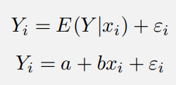

Figure 41 - Mathematic Model

However, we only used directly the one expression below. The is called the deterministic component, the is the y-intercept and the b is the slope. Both these parameters need to be calculated. The parameter is the observation value of the independent variable and the is the dependent variable.

### **Simple Linear Regression Model**

For this study, we’ve done two models with 20 historical days, starting in the day 28/05/2021 and ending in the 19/06/2021. The first model uses the number of covid tests performed in a day as the independent variable and the second one uses the mean age of the clients that performed covid tests in a day. The dependent variable is, for both, the number of positive cases.

* Model significance:

Here it’ll be used the Anova table that consists in the analysis method of the quality of the regression model based on the division of the total variation of the dependent variable, Y. For that it’ll be calculated the total variation (the sum of squares of the totals deviations), the explained variation (sum of squares of the deviations explained by the regression) and the non-explained variation (sum of squares of residues).

Figure 42 - Sum of squares

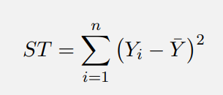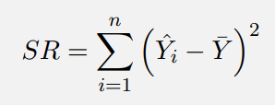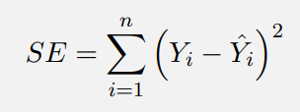

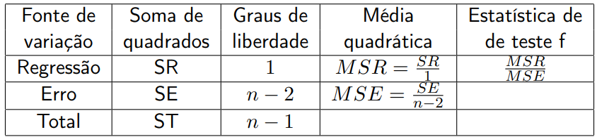 The Anova table is the following:

Figure 43 - Simple Anova Table

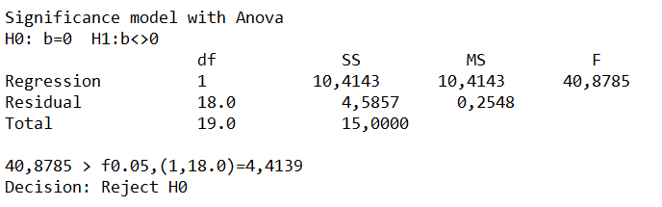In our study the Anova table of the number of tests performed is:

Figure 44 - Anova Table: first simple

Here, in the first one, it is possible to see that, after calculating the F0, the null hypothesis was rejected, which means this regression model is linear.

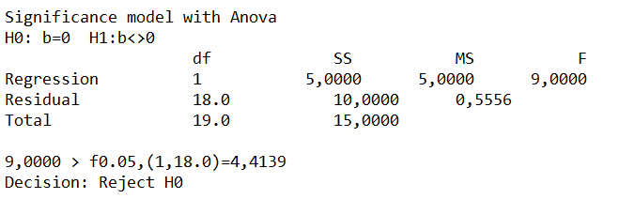The Anova table of the mean age is:

Figure 45 - Anova Table: second simple

As in the previous one, by rejecting the null hypothesis, it is possible to prove that the regression model is linear.

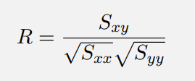Now to know even better, if the model is or not significant, it is used the correlation coefficient with the following expression to calculate:

Figure 46 - Correlation Coefficient

This coefficient dictates the sine of the slope and the closer it is to -1 or 1, the more significant the model is. To calculate the , and it was used the following expressions:



Figure 47 - Sum of squares and crossed sum

The n is the number of observations and the and are the mean of the observable values of the independent and dependent variables, respectively.

The correlation coefficient for each model is:

Figure 48 - Correlation coefficients for the models



Analysing both results, it is able to conclude that the regression model, that has the number of tests performed as the independent variable, is the most significant one, since it is closer to 1 than the other result.

* Hypothesis tests for model coefficients:

These are statistic tests about the parameters and the explaining capability of the model. There’re two different tests to be done: for the parameters and . These are the expressions to use with the hypothesis made:

Figure 49 - Hypothesis tests expressions

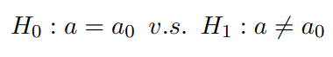

The calculations done before can be called (observation T) and need to be compared to the , that is obtained through the table of the t-student distribution. If the is bigger, then we reject the hypothesis 0.

For the first regression model, the tests are the following:

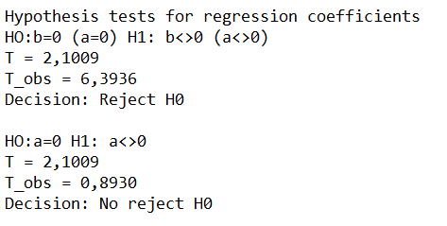

Figure 50 - Hypothesis tests: first model

The first one rejecting the H0, means that the test is conclusive, meaning that in a 5% significance level, there’s static evidence enough to say that the slope is different than 0. However, the second test didn’t reject the H0, meaning that there’s no evidence, in a 5% significance level, that the y-interception is different than 0.

Now, the tests of the second regression model:

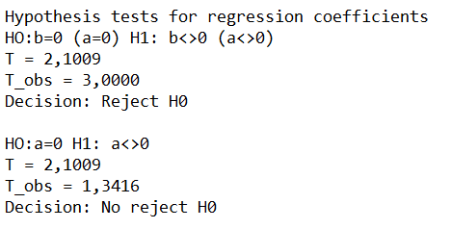

Figure 51 - Hypothesis tests: second model

As the first one rejecting the H0, it is possible to say that the test is conclusive, meaning that in a 5% significance level, there’s static evidence enough to say that the slope is different than 0. However, the second test didn’t reject the H0, so, there’s not enough evidence, in a 5% significance level, that the y-interception is different than 0.

* Confidence intervals for prediction values:

The confidence intervals are a range of values, calculated through a percentage level of confidence, having an upper limit and a lower limit.

The expression used to calculate the confidence intervals was the following:

Figure 52 - Confidence interval expression

The is the value of the independent variable for which the confidence interval will be calculated and the is the correspondent value of the dependent variable. The s is the pattern deviant that can be calculated through:

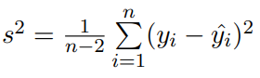

Figure 53 - Variation expression

For the regression models, it was used a 95% confidence level. The intervals are going to be shown in the next two images. They are the numbers in the right column.

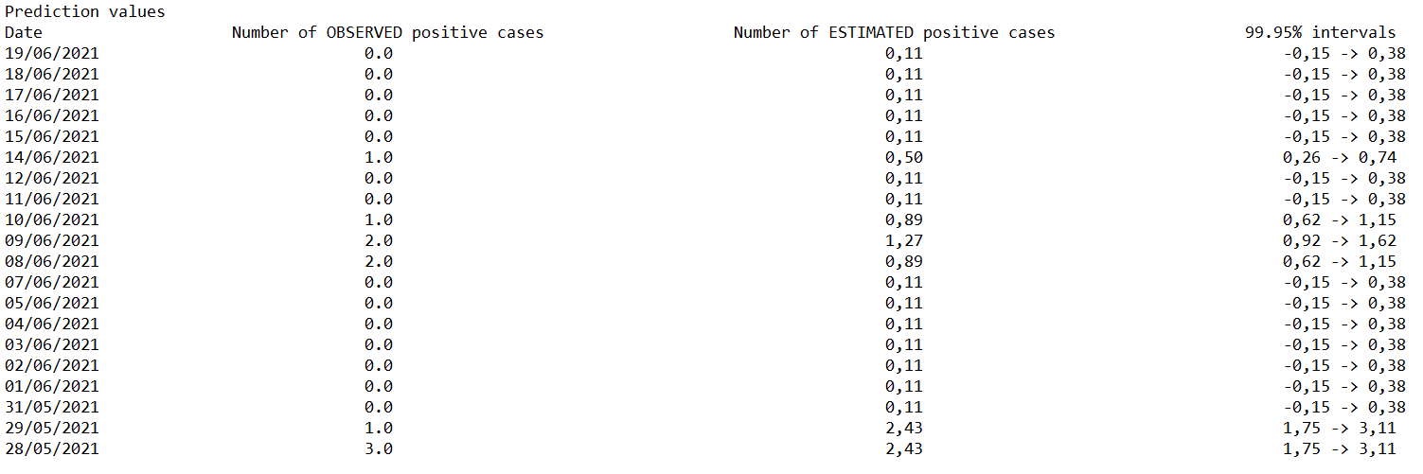

Figure 54 - Confidence intervals: first model

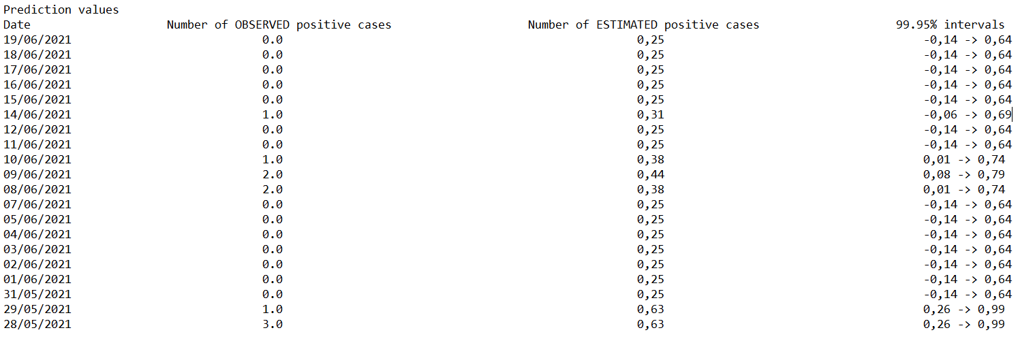

Figure 55 - Confidence intervals: second model

## **Multiple Linear Regression**

### **Overview**

Sometimes, while doing a regression analysis, it is possible to find more than one independent variable. There’s one dependent variable related to *k* independent variables.

This is the mathematic model:



Figure 56 - Mathematic model

The X’s are the independent variables and the Y is the dependent variable. The ’s are the regression coefficients.

This regression type also has a matrix form:

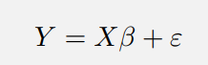

Figure 57 - Matrix model

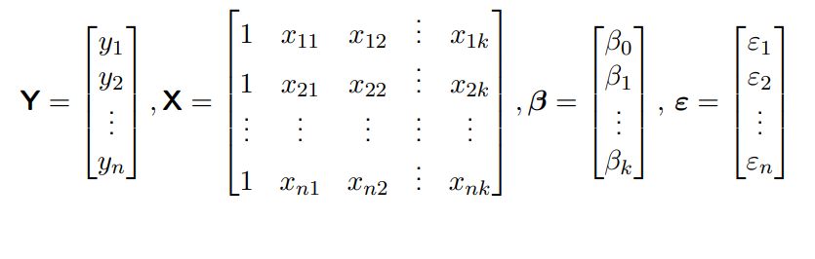Having the all the matrices presented in the following:

Figure 58 - Important matrices

The n is the number of observations, and the k is the number of the independent variables.

### **Multiple Linear Regression Model**

This one is done with the exact same historical days and date interval as the simple ones. The independent variables are the number of covid tests performed and the mean age. The dependent one is the number of positive cases.

* Model significance:

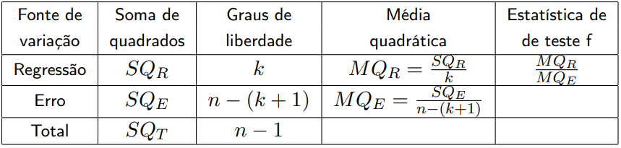The Anova table is used to evaluate the model significance. The table is the following:

Figure 59 - Multiple Anova Table

The SQT measures the total variation of the observations about the mean; The SQR measures the explained dependent variable variation of the model; The SQE measures the non-explained variation of the model. These are calculated the following way:

Figure 60 - Sum of Squares



The Anova table for this model is:

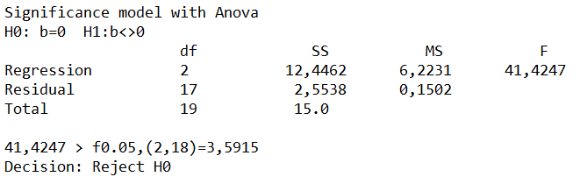

Figure 61 - Anova Table for the regression model

As the H0 was rejected, it proves that there’s at least one independent variable that contributes significatively to explain the variation of the dependent variable, Y. Which means that the regression model is significant.

To be sure of its significance, it’ll be calculated the determinant coefficient. The closer to 1 the more significant the regression model is. The way to calculate it is the following:



Figure 62 - Determinant coefficient expression

The determinant coefficient for the model is:



Figure 63 - Determinant coefficient value

With the coefficient being close to 1, means that the regression model is significant.

* Hypothesis tests for the model coefficients

These tests are done the same way for every coefficient and for that, the proceeding is the following:

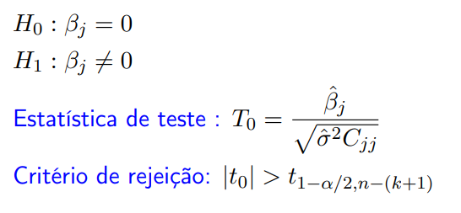

Figure 64 - Hypothesis tests form and expression

It is needed to do the hypothesis and then calculate the test statistic through the expression. Once that’s done, the result, , was compared to and that concept is obtained through the F-Snedcor distribution, using its table. If the is bigger the hypothesis 0 is rejected.

It was done three tests, one for each regression coefficient. Since there’s two independent variables, there is three coefficients. The tests are the following:

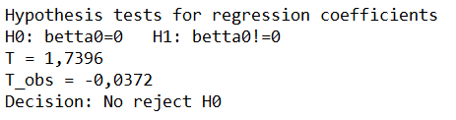

Figure 65 - Hypothesis tests for beta 0

As the H0 was not rejected, the regressor x0 can be “eliminated” because it has no explanative power.

Figure 66 - Hypothesis tests for beta 1 and 2

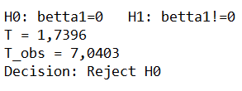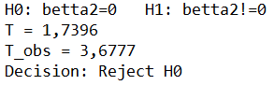

Here, the H0 is rejected, meaning that the regressors x1 and x2 have explanative power.

* Confidence intervals for prediction values

The confidence intervals are calculated through the following:

Figure 67 - Confidence interval expression

Explaining the parameters:

* + – is the X matrix transposed time the coefficient matrix.
  + – value possible to get through the t-student distribution table.
  + – is the variance.
  + – X matrix transposed.
  + – gotten through the multiplication of the X matrix and its transposed one.
  + – the X matrix given.

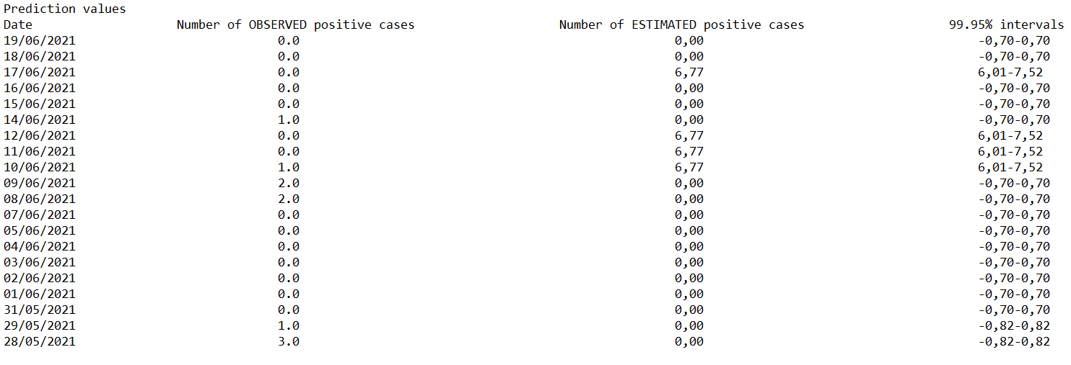The intervals calculated are presented in the next table in the right column:

Figure 68 - Confidence interval: multiple model

# **Annex A._MDISC**

## **Sorting tests results by client name or TIN**

### **Introduction**

In this topic, it’ll be studied the complexity of the ordering algorithms of the client test for the US13: “As a clinical chemistry technologist, I intend to consult the historical tests performed by a particular client and to be able to check tests details/results.” And their asymptotic behaviour.

Order by TIN algorithm:

procedure getClientOrderTin(tinList[1], tinList[2],…, tinList[n]:String)

for (i:=1 to n)

for (j:=i+1 to n)

if tinList[j] < tinList[i] then swap tinList[i] and tinList[j]

return tinList

Order by name algorithm:

procedure getClientOrderName(nameList[1], nameList[2],… nameList[n]:String)

for (i:=1 to n)

for (j:=i+1 to n)

if nameList[j] < nameList[i] then swap nameList[i] and nameList[j]

return nameList

NOTE: As both algorithms are the same, the only differences between them is the name of the method and the name of the variable, so, the way the method works and the lines that matter are the same, and, due to that, it’ll be done one study being considered for both for the Worst-case time complexity analysis part.

### **Runtime tests for inputs of varying sizes**

Here, it’ll be shown the study of the asymptotic behaviour of the algorithms. For that, it’ll be used a various number of different inputs and the calculation of the execution time of each method to analyse. Even though the algorithms are basically the same, it was still made two graphs to study the desired topic.

With that said, the x-axis corresponds to the number of inputs done and the y-axis is the execution time for each input. The graphs were done with the following number of inputs, respectively: . Using the values, the co-domains gotten were the following:

* for the graph 1 -
* for the graph 2 -

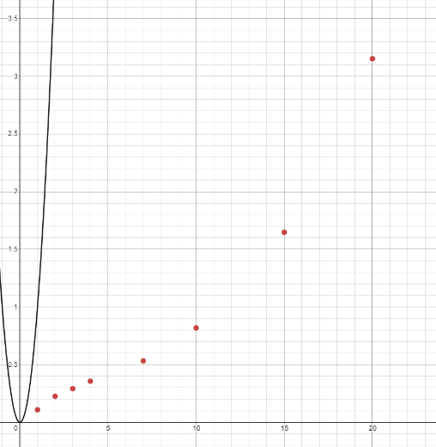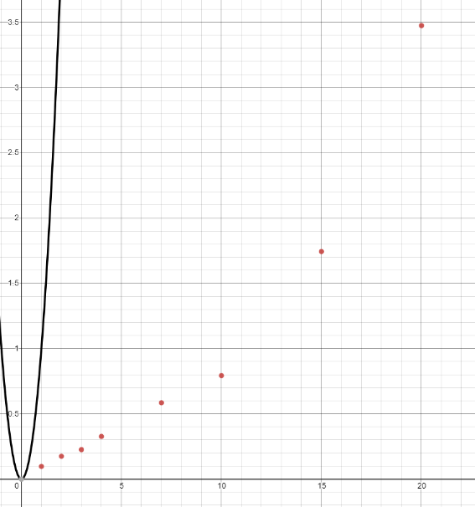

Figure 69 - graph 2

Figure 70 - graph 1

By analysing the graphs, it’s possible to conclude that, if those loose points are connected, they will form a kind of parabola, which means that the function is a type. Comparing the graphs of the execution times with the function, proves that the asymptotic behaviour, with the big O notation, is O(), because there’s at least one value, c, when multiplied to the function, all its co-domain values will be bigger than the execution time values, in this case the c value is 1.

### **Worst-case time complexity analysis**

To study the worst-case time complexity, it’ll be used a table with each line for the algorithm’s lines and, next to each, it’ll be the number of times that line could occur at max.

It will also have the kind of actions that was done in that specific line, and, to help understand that, it’ll be used the following letters with these meanings:

* A – Attribution
* C – Comparison
* Op – Arithmetic Operation
* L – Reading
* R - Return

|  |  |
| --- | --- |
| Line 1 |  |
| Line 2 |  |
| Line 3 |  |
| Line 4 |  |
| TOTAL |  |
| Big O |  |

Through the table, it is possible to say that the worst-case time scenario is:

## **Evaluation of the effectiveness of the company’s response**

### **Introduction**

In this topic, it’ll be studied the complexity of the algorithms used in the creation of the performance report for the US16: “As a laboratory coordinator, I want to have an overview of all the tests performed by Many Labs and analyse the overall performance of the company (for instance, check the sub intervals in which there were more samples waiting for the result). To facilitate overall analysis, the application should also display statistics and graphs..” And their asymptotic behaviour.

Basically, its a cycle of n iterations within another cycle of n iterations in the inside another cycle of n iterations. ⇒ O(n3), cubic algorithm. Estimated value by excess, as some cycles have less than n iterations.

public static int[] bruteForceAlgorithm(int[] seq)

for (i:=1 to n)

for (j:=1 to n)

for (k:=j+1 to n)

sum += seq[k];

if (seq[k] != 0) tempEnd = k + 1

if (sum >= max) max = sum / startId = m - i - 1 / endId = tempEnd;

sum = 0

return Arrays.copyOfRange(seq, startId, endId);

### **Runtime tests for inputs of varying sizes**

Here, the second study of asymptotic behaviour of the algorithms. In this case the algorithms have very different behaviours, the Brute-force algorithm and the Benchmark ISEP algorithm. It was still made two graphs to study the desired topic.

Here, as in the first analysis, the x-axis corresponds to the number of inputs done and the y-axis is the execution time for each input. The graphs were done with the following number of inputs, respectively: . Using the values, the co-domains gotten were the following:

* graph of Brute-force algorithm-
* graph of Benchmark ISEP algorithm-

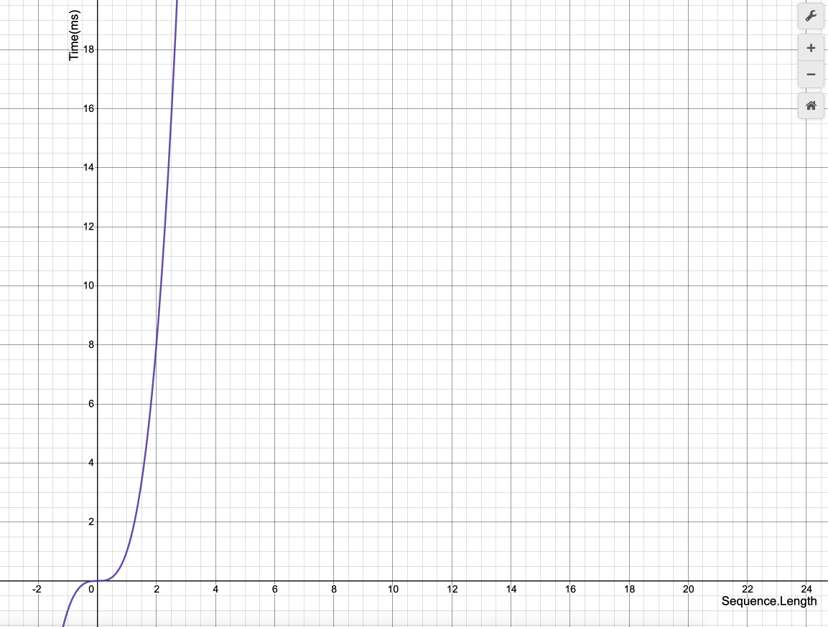

Figure 71 - x^3 graph

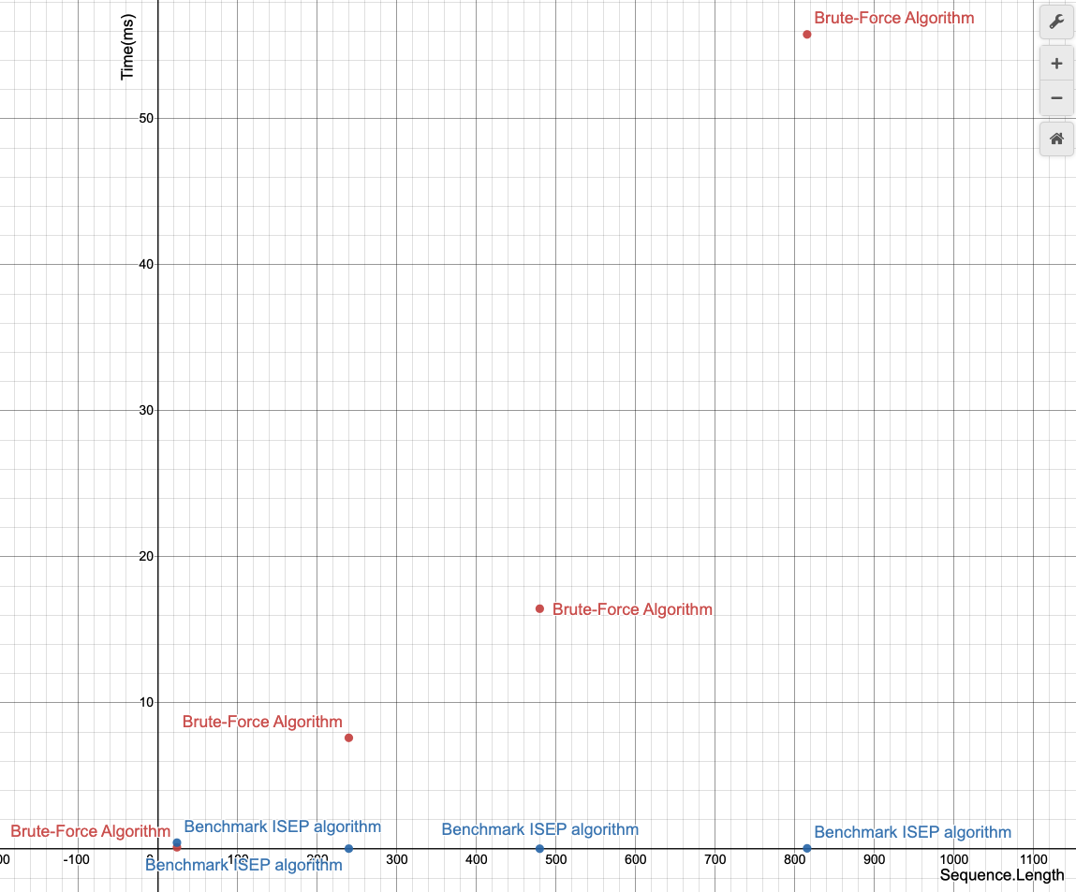

Figure 72 - Brute-Force and Benchmark algorithms graphs

### **Worst-case time complexity analysis**

* A – Attribution
* C – Comparison
* Op – Arithmetic Operation
* L – Reading
* R - Return

|  |  |
| --- | --- |
| Line 1 |  |
| Line 2 |  |
| Line 3 |  |
| Line 4 |  |
| Line 5 |  |
| Line 6 | + |
| TOTAL |  |
| Big O |  |

Through the table, it is possible to say that the worst-case time scenario is: