# An Evaluation of Methods for Assessing Model Fit for Diagnostic Classification Models

W. Jake Thompson

Accessible Teaching, Learning, and Assessment Systems (ATLAS), University of Kansas

# Author Note

W. Jake Thompson https://orcid.org/0000-0001-7339-0300

The author has no conflict of interest to declare. This study was supported by Grant R305D210045 from the Institute for Education Sciences.

Correspondence concerning this article should be addressed to W. Jake Thompson, Accessible Teaching, Learning, and Assessment Systems (ATLAS), University of Kansas, 1122 West Campus Road, Lawrence, KS 66045-3101, Email: jakethompson@ku.edu

# Abstract

This document is a template demonstrating the apaquarto format.

*Keywords*: keyword1, keyword2, keyword3

# An Evaluation of Methods for Assessing Model Fit for Diagnostic Classification Models

here() starts at /Users/jakethompson/Documents/GIT/projects/measr-reports/measr-simulation

This is my introductory paragraph. The title will be placed above it automatically. *Do not start with an introductory heading* (e.g., “Introduction”). The title acts as your Level 1 heading for the introduction.

Readers are better able to follow your ideas if you differentiate sections in your introduction with headings. Mostly stick to level 2 headers. Sometimes level 3 headings are needed, though. Be sparing to the point of stinginess with levels 4 and 5.

# Method

To evaluate the performance of absolute and relative fit indices for DCMs, we conducted a simulation study. In this study, we manipulated the number of assessed attributes (2 or 3), the minimum number of items measuring each attribute (5 or 7), the sample size (500 or 1,000). Additionally, we also manipulated the data generating model (LCDM or DINA) in order to evaluate the performance of model fit metrics when the estimated model should and should not fit the data. We used a full factorial design, resulting in 16 total conditions, with 50 replications per condition.

The simulation and subsequent analyses were conducted in R version 4.3.1 (R Core Team, 2023). All DCMs were estimated using the measr package (Thompson, 2023a, 2023b).

# Results

## Descriptive Statistics

Here we describe the basic characteristics of our primary variables.

Let’s make a figure. A reference label for a figure in APA format must have the prefix apafg-. This is different from the usual Quarto prefix fig-.

Figure 1

This is the figure caption.

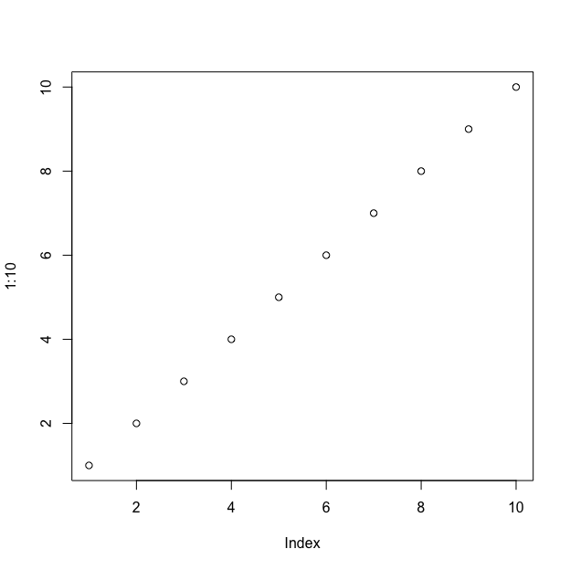

*Note*. This is a note below the figure.

We can make a table the same way as a figure except that the label prefix is apatb-. Again, this is different from the usual quarto prefix tbl-, which will put the table table caption in the wrong place and with non-APA formatting. Generating a table that conforms to APA format in all document formats can be tricky. Feel free to experiment with different methods, but I have found that David Gohel’s [flextable](https://davidgohel.github.io/flextable/) to be the best option.

Table 1

Here is the table caption.

| Numbers | Letters |
| --- | --- |
| 1 | A |
| 2 | B |
| 3 | C |
| 4 | D |

*Note*. Here is the note below the table.

To refer to this table in text, put the table’s reference label in curly braces like so: As seen in Table 1, there is not much information.

Table 2 is an example of a table without a note beneath.

Table 2

This is a table without a note.

| Numbers | Letters |
| --- | --- |
| 1 | A |
| 2 | B |
| 3 | C |
| 4 | D |

In Table 3, there is an example of using a plain markdown table via the asis engine.

Table 3

Table caption of a markdown table

| Default | Left | Right | Center |
| --- | --- | --- | --- |
| 12 | 12 | 12 | 12 |
| 123 | 123 | 123 | 123 |
| 1 | 1 | 1 | 1 |

*Note*. This is a note below the markdown table.

What if you want the tables and figures to be at the end of the document? In the .pdf format, you can set the floatsintext option to false. For .html and .docx documents, there is not yet an automatic way to put tables and figures at the end. You can, of course, just put them all at the end, in order. The reference labels will work no matter where they are in the text.

# Discussion

Describe results in non-statistical terms.

## Limitations and Future Directions

Every study has limitations. Based on this study, some additional steps might include…

## Conclusion

Let’s sum this up.

# References

R Core Team. (2023). *R: A language and environment for statistical computing*. R Foundation for Statistical Computing. <https://www.R-project.org/>

Thompson, W. J. (2023a). measr: Bayesian psychometric measurement using Stan. *Journal of Open Source Software*, *8*(91), 5742. <https://doi.org/10.21105/joss.05742>

Thompson, W. J. (2023b). *measr: Bayesian psychometric measurement using Stan*. <https://measr.info>