HafTrust

Verifier Registration Web Application

Content Page

List of Requirements 3

Use Case Model 4

Use Case Specifications 5

Entity Relationship Diagram 11

Conceptual Class Diagram 12

Analysis Model 13

Design Model 14

List of Requirements

Functional Requirements

FR1 The Verifier Candidate shall be able to pre-register by inputting preregistration details into the system.

FR2 The Verifier Candidate shall be able to register by inputting registration details into the system.

FR3 The Verifier Candidate shall be able to save registration details.

FR4 The Verifier Candidate shall be able to Login into the system.

FR5 The Verifier Candidate shall be able to Logout of the system.

FR6 The Back Office Admin shall be able to verify registration details of the Verifier Candidate.

FR7 The Back Office Admin shall be able to delete registration details of the Verifier Candidate from the system.

FR8 The Operative Manager shall be able to arrange an interview with the Verifier Candidate using the system.

FR9 The Operative Manager shall be able to rearrange the interview with the Verifier Candidate using the system.

FR10 The Operative Manager shall be able to cancel the interview with the Verifier Candidate using the system.

FR11 The Operative Manager shall be able to employ the Verifier Candidate using the system.

FR12 The Back Office Admin shall be able to allocate a mobile phone to the Verifier.

Non-Functional Requirements

NFR1 The system shall be in operation 24/7.

NFR2 The system shall be secure.

NFR3 The system shall validate all the data.

NFR4 All the data used by the system shall be persistent.

NFR6 The system shall respond to a request in 3 seconds.

Use Case Model

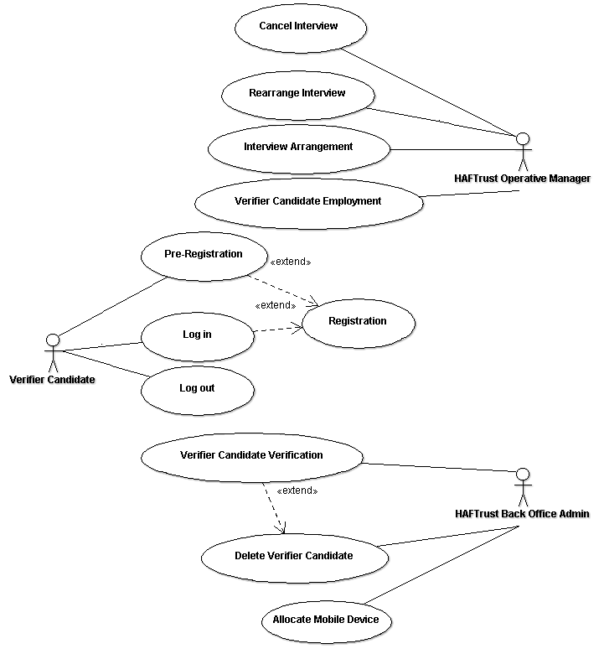

Use Case Specifications

Use Case Name: | Pre-Registration
Description: | The Verifier Candidate user accesses the system and requests to pre-register. The Verifier Candidate user enters the necessary details and a pre-registration is done by the system.
Actor: | Verifier Candidate
Pre-Conditions: | 1. The system is operational.
Flow of Events
Basic Flow: | - The Verifier Candidate user requests to pre-register.  - The system prompts for pre-registration details (email and password).  - The Verifier Candidate user enters pre-registration details and chooses to proceed.  - The system validates pre-registration details and confirms the pre-registration.
Alternate Flow:
Exceptions: | E1. In Steps 4, if any of the pre-registration details are missing or incorrect details are entered, the system prompts for the valid details and informs the Verifier Candidate user what needs to be corrected. Use case continues.
Post-Conditions: | The system stores all the pre-registration details provided.

Use Case Name: | Log in
Description: | The Verifier Candidate user accesses the system and requests to log in. The Verifier Candidate user inputs the necessary details and logs in into the system.
Actor: | Verifier Candidate
Pre-Conditions: | 1. The system is operational.  2. The Verifier Candidate user is logged out of the system (UseCase: Log out).  3. The Verifier Candidate has been pre-registered (UseCase: Pre-Registration).
Flow of Events
Basic Flow: | - The Verifier Candidate user requests to log in into the system.  - The system prompts for log in details (email and password).  - The Verifier Candidate user enters the log in details and chooses to proceed.  - The system retrieves the Verifier Candidate’s details and confirms the log in.
Alternate Flow:
Exceptions: | E1. In Steps 4, if any of the log in details are missing or incorrect details are entered, the system prompts for the valid details and informs the Verifier Candidate user what needs to be corrected. Use case continues.
Post-Conditions:

Use Case Name: | Registration
Description: | The Verifier Candidate user accesses the system and requests to register. The Verifier Candidate user inputs the necessary details and registers into the system.
Actor: | Verifier Candidate
Pre-Conditions: | 1. The system is operational.  2. The Verifier Candidate user is pre-registered into the system (UseCase: Pre-Registration) or the Verifier Candidate user is logged in into the system (UseCase: Log in).
Flow of Events
Basic Flow: | 1. The Verifier Candidate user requests to register.  2. The system prompts for the registration details.  3. The Verifier Candidate inputs the registration details (personal, bank, references, address, photo and identity document details) and chooses to proceed.  4. The system validates the registration details and confirms the registration.
Alternate Flow: | AF4.1. The Verifier Candidate chooses to save uncompleted registration details.  AF4.2. The system validates uncompleted registration details and saves them.
Exceptions: | E1. In Steps 4, if any of the registration details are missing or incorrect details are entered, the system prompts for the valid details and informs the Verifier Candidate user what needs to be corrected. Use case continues.
Post-Conditions: | The system stores all the Verifier Candidate’s registration details provided.

Use Case Name: | Log out
Description: | The Verifier Candidate user requests to log out. The system logs out the Verifier Candidate user.
Actor: | Verifier Candidate
Pre-Conditions: | 1. The system is operational.  2. The Verifier Candidate user is logged into the system (UseCase: Log in).
Flow of Events
Basic Flow: | 1. The Verifier Candidate user requests to log out of the system.  2. The system logs out the Verifier Candidate and confirms.
Exceptions:
Post-Conditions:

Use Case Name: | Verifier Candidate Verification
Description: | The Back Office Admin user accesses the system and requests to verify the Verifier Candidate. The Back Office Admin user inputs the necessary details and verifies the Verifier Candidate into the system.
Actor: | Back Office Admin
Pre-Conditions: | 1. The system is operational.  2. The Back Office Admin user is logged-in into the system.  3. The Verifier Candidate is registered into the system (UseCase: Registration).
Flow of Events
Basic Flow: | 1. The Back Office Admin user requests to verify a Verifier Candidate.  2. They system prompts for the Verifier Candidate search criteria.  3. The Back Office Admin user inputs the search criteria.  4. The system retrieves the Verifier Candidate’s registration details (personal, address, identity document, bank and photo details).  5. The system prompts for verification details.  6. The Back Office Admin user inputs the verification details, allocates the Operative Manager and chooses to proceed.  7. The system validates verification details and confirms the verification.
Alternate Flow:
Exceptions: | E1. In Steps 7, if any of the verification details are missing or incorrect details are entered, the system prompts for the valid details and informs the Back Office Admin user what needs to be corrected. Use case continues.
Post-Conditions: | The system stores all the verification details provided.

Use Case Name: | Delete Verifier Candidate
Description: | The Back Office Admin user accesses the system and requests to delete the Verifier Candidate. The Back Office Admin user inputs the necessary details and the system deletes the Verifier Candidate details.
Actor: | Back Office Admin
Pre-Conditions: | 1. The system is operational.  2. The Back Office Admin user is logged-in into the system.  3. The Verifier Candidate is registered into the system (UseCase: Registration).
Flow of Events
Basic Flow: | 1. The Back Office Admin user requests to delete a Verifier Candidate.  2. They system prompts for the Verifier Candidate search criteria.  3. The Back Office Admin user inputs the search criteria.  4. The system retrieves the Verifier Candidate’s registration details.  5. The system prompts for delete confirmation.  6. The Back Office Admin chooses to delete the Verifier Candidate’s details and chooses to proceed.  7. The system deletes the Verifier Candidate’s details and confirms.
Alternate Flow:
Exceptions: | E1. In Steps 4, if system doesn’t retrieves the Verifier Candidate’s details based on the search criteria inputted, the system notifies the Back Office Admin that no details were found. Use case terminates.  E2. In Steps 6, if the Back Office Admin user chooses to cancel the deletion of the Verifier Candidate’s details, the system confirms that the Verifier Candidate’s details have not been deleted.
Post-Conditions: | The system stores all the changes.

Use Case Name: | Interview Arrangement
Description: | The Operative Manager user accesses the system and requests to arrange an interview with the Verifier Candidate. The Operative Manager user inputs the necessary details and saves interview details into the system.
Actor: | Operative Manager
Pre-Conditions: | 1. The system is operational.  2. The Operative Manager user is logged-in into the system.  3. The Verifier Candidate is verified into the system (UseCase: Verifier Candidate Verification).
Flow of Events
Basic Flow: | 1. The Operative Manager user requests to arrange an interview.  2. They system retrieves the details of the interviews that need to be arranged by the Operative Manager.  3. The Operative Manager user chooses the interview to arrange and chooses to proceed.  4. The system prompts for interview details.  6. The Operative Manager user inputs the interview details and chooses to proceed.  7. The system validates interview details and confirms the interview arrangement.
Alternate Flow:
Exceptions: | E1. In Steps 2, if system doesn’t retrieve any interviews that need arrangements, the system notifies the Operative Manager user that no interviews were found. Use case terminates.  E2. In Steps 7, if any of the interview details are missing or incorrect details are entered, the system prompts for the valid details and informs the Operative Manager user what needs to be corrected. Use case continues.
Post-Conditions: | The system stores all the interview details provided.

Use Case Name: | Rearrange Interview
Description: | The Operative Manager user accesses the system and requests to rearrange an interview with the Verifier Candidate. The Operative Manager user inputs the necessary details and saves new interview details into the system.
Actor: | Operative Manager
Pre-Conditions: | 1. The system is operational.  2. The Operative Manager user is logged-in into the system.  3. The Interview is arranged (UseCase: Interview Arrangement).
Flow of Events
Basic Flow: | 1. The Operative Manager user requests to rearrange an interview.  2. They system retrieves the details of the arranged interviews by the Operative Manager.  3. The Operative Manager user chooses the interview to rearrange and chooses to proceed.  4. The system prompts for new interview details.  6. The Operative Manager user inputs the new interview details and chooses to proceed.  7. The system validates interview details and confirms the interview rearrangement.
Alternate Flow:
Exceptions: | E1. In Steps 2, if system doesn’t retrieve any interviews, the system notifies the Operative Manager user that no interviews were found. Use case terminates.  E2. In Steps 7, if any of the interview details are missing or incorrect details are entered, the system prompts for the valid details and informs the Operative Manager user what needs to be corrected. Use case continues.
Post-Conditions: | The system stores all the interview details provided.

Use Case Name: | Cancel Interview
Description: | The Operative Manager user accesses the system and requests to cancel an interview with the Verifier Candidate. The Operative Manager user inputs the necessary details and cancels the interview.
Actor: | Operative Manager
Pre-Conditions: | 1. The system is operational.  2. The Operative Manager user is logged-in into the system.  3. The Interview is arranged (UseCase: Interview Arrangement).
Flow of Events
Basic Flow: | 1. The Operative Manager user requests to cancel an interview.  2. They system retrieves the details of the arranged interviews by the Operative Manager and prompts for an interview that needs cancelation.  3. The Operative Manager user chooses the interview to cancel and chooses to proceed.  4. The system cancels the interview and confirms that the interview has been canceled.
Alternate Flow:
Exceptions: | E1. In Steps 2, if system doesn’t retrieve any arranged interviews, the system notifies the Operative Manager user that no interviews were found. Use case terminates.
Post-Conditions: | The system updates the interview status.

Use Case Name: | Verifier Candidate Employment
Description: | The Operative Manager user accesses the system and requests to employ a Verifier Candidate. The Operative Manager user inputs the necessary details into the system and employs the Verifier Candidate.
Actor: | Operative Manager
Pre-Conditions: | 1. The system is operational.  2. The Operative Manager user is logged-in into the system.  3. The Interview is arranged (UseCase: Interview Arrangement).  4. The Verifier Candidate is registered into the system (UseCase: Registration).
Flow of Events
Basic Flow: | 1. The Operative Manager user requests to employ the Verifier Candidate.  2. They system retrieves the details of the arranged interviews by the Operative Manager.  3. The Operative Manager user chooses the interview and chooses to proceed.  4. The system prompts for interview results.  6. The Operative Manager user inputs the interview results and chooses to proceed.  7. The system validates and saves interview results and prompts for employing the Verifier Candidate.  8. The Operative Manager chooses to employ the Verifier Candidate and chooses to proceed.  9. The system updates the Verifier Candidate details and confirms that the Verifier Candidate has been employed.
Alternate Flow: | AF8.1. The Operative Manager chooses not to employ the Verifier Candidate and chooses to proceed.  AF9.1. The system updates the Verifier Candidate details and confirms that the Verifier Candidate has not been employed.
Exceptions: | E1. In Steps 2, if system doesn’t retrieve any interviews, the system notifies the Operative Manager user that no interviews were found. Use case terminates.  E2. In Steps 7, if any of the interview details are missing or incorrect details are entered, the system prompts for the valid details and informs the Operative Manager user what needs to be corrected. Use case continues.
Post-Conditions: | The system stores all the details provided.

Use Case Name: | Allocate Mobile Device
Description: | The Back Office Admin user accesses the system and requests to allocate a mobile device to the. The Back Office Admin user inputs the necessary details and allocates the mobile phone.
Actor: | Back Office Admin
Pre-Conditions: | 1. The system is operational.  2. The Back Office Admin user is logged-in into the system.  3. The Verifier Candidate is employed (UseCase: Verifier Candidate Employment).
Flow of Events
Basic Flow: | 1. The Back Office Admin user requests to allocate a mobile phone to a Verifier.  2. They system prompts for the Verifier search criteria.  3. The Back Office Admin user inputs the search criteria.  4. The system retrieves the Verifier’s details.  5. The system prompts for mobile phone details.  6. The Back Office Admin user inputs the mobile phone details, allocates it and chooses to proceed.  7. The system validates details and confirms the mobile phone allocation.
Alternate Flow:
Exceptions: | E1. In Steps 5, if any of the mobile phone details are missing or incorrect details are entered, the system prompts for the valid details and informs the Back Office Admin user what needs to be corrected. Use case continues.  E2. In Steps 7, if there are no mobile phones to allocate, the system informs The Back Office Admin user that there are no mobile phones available to allocate. Use case terminates.
Post-Conditions: | The system stores all the verification details provided.

Entity Relationship Diagram

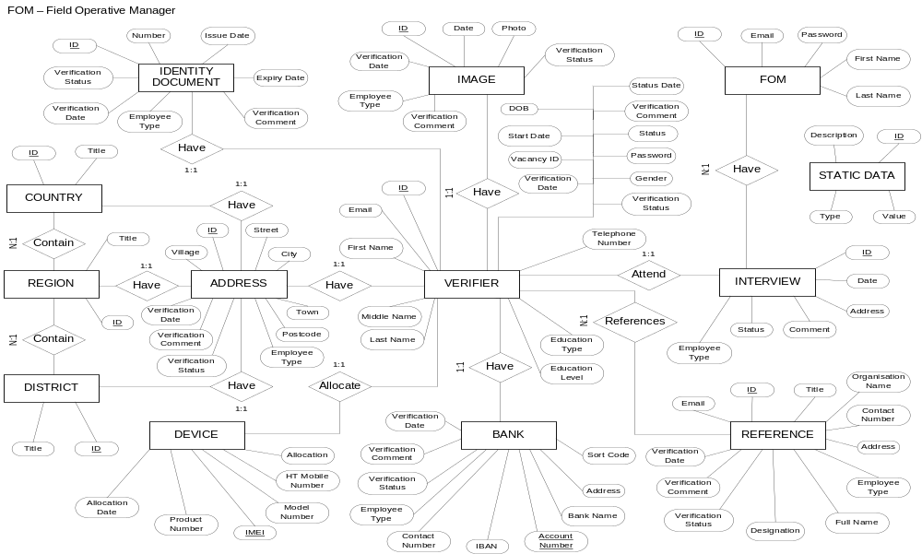

Conceptual Class Diagram

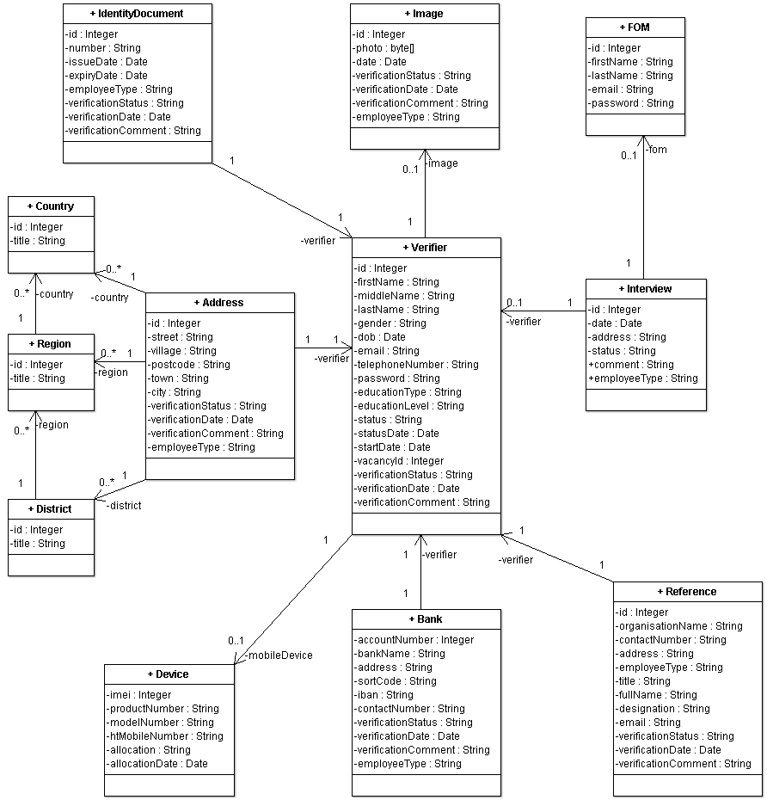

Analysis Model

Analysis Model Sequence Diagram for Use case: Pre-Registration
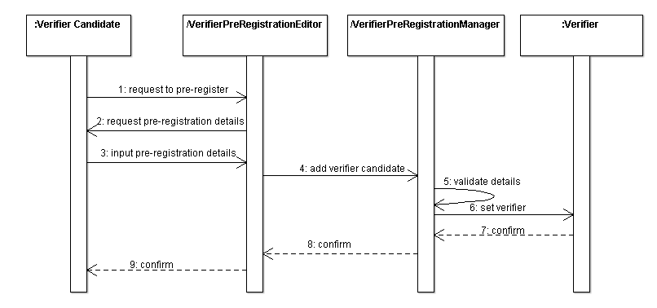 Analysis Model Class Diagram for Use case: VPA Pre-Registration

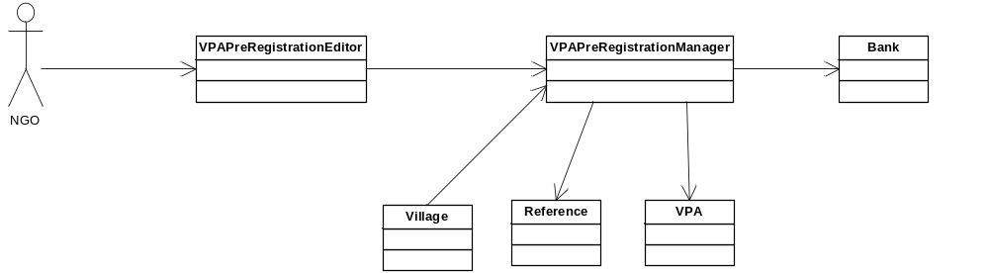

Design Model

Database Design Model: EER Diagram
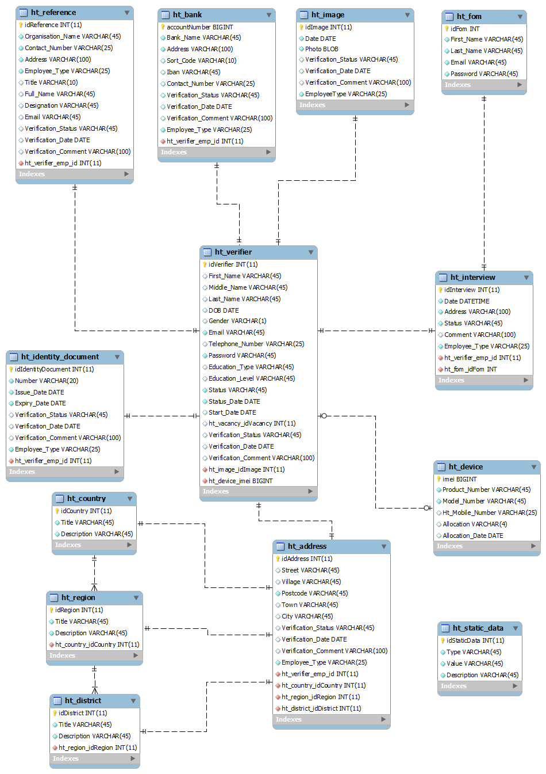
User Interface Design and Flow Model: Pre-Register VPA

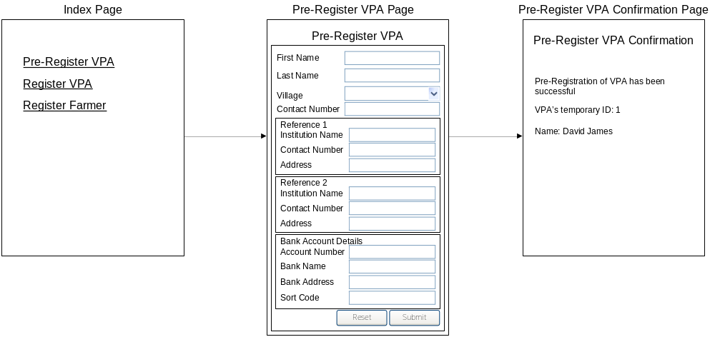
User Interface Design and Flow Model: Register VPA
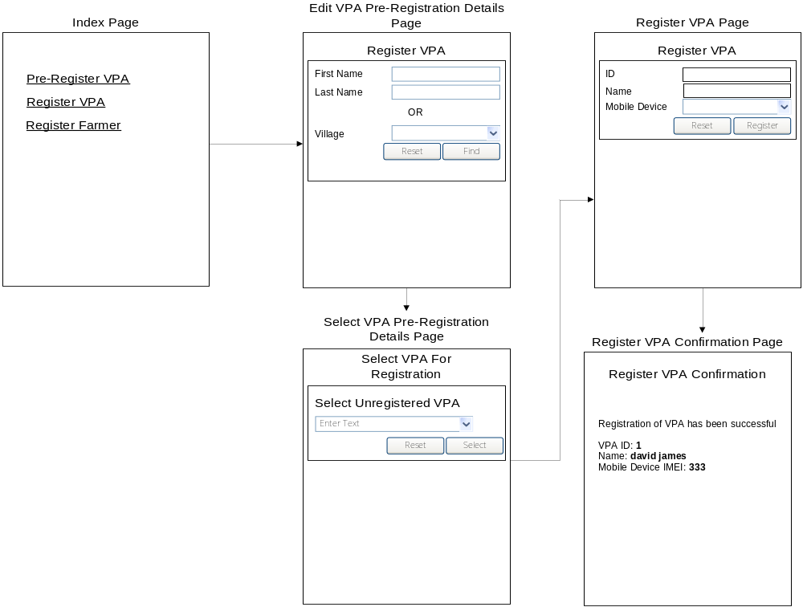
User Interface Design and Flow Model: Register Farmer

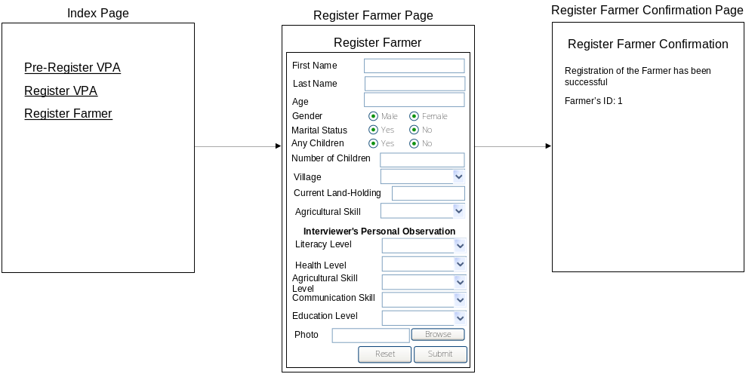

Design Model Sequence Diagram for Use case: Register

