Client Satisfaction Report (Percents)

May 2019

# Experience Attribute 1: Makes a Positive Contribution

## Data Summary - All Surveys

## PosContrib  
## Surveyed 1-Always 2-Mostly 3-Sometimes 4-Rarely 5-Never  
## 01-F18 24 13 0 0 0  
## 02-W19 26 7 2 0 0  
## 03-S19 35 17 3 1 1

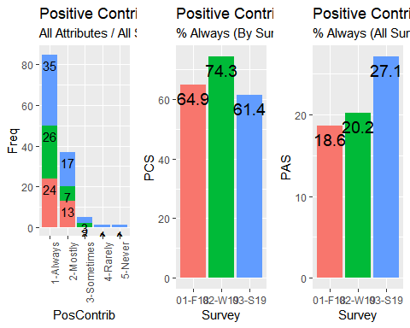

## Improvement for 'Always' over period: 31.43 %

# Experience Attribute 2: Provides a Timely Response

## Data Summary - All Surveys

## TimelyResp  
## Surveyed 1-Always 2-Mostly 3-Sometimes 5-Never NR  
## 01-F18 20 15 2 0 0  
## 02-W19 22 12 1 0 0  
## 03-S19 32 18 5 1 1

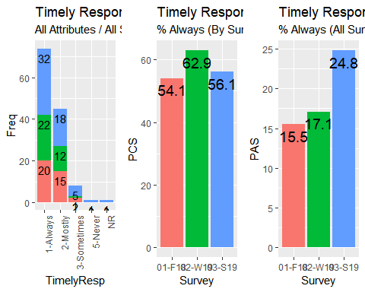

## Improvement for 'Always' over period: 37.5 %

## Experience Attribute 3: Accountability

## Data Summary - All Surveys

## Accountability  
## Surveyed 1-Always 2-Mostly 3-Sometimes 4-Rarely NR  
## 01-F18 27 10 0 0 0  
## 02-W19 28 5 1 0 1  
## 03-S19 40 13 2 1 1

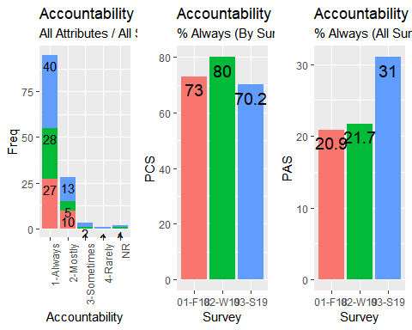

## Improvement for 'Always' over period: 32.5 %

## Experience Attribute 4: Knowledgeable

## Data Summary - All Surveys

## Knowledgeable  
## Surveyed 1-Always 2-Mostly 3-Sometimes 4-Rarely NR  
## 01-F18 22 12 3 0 0  
## 02-W19 21 13 1 0 0  
## 03-S19 36 14 5 1 1

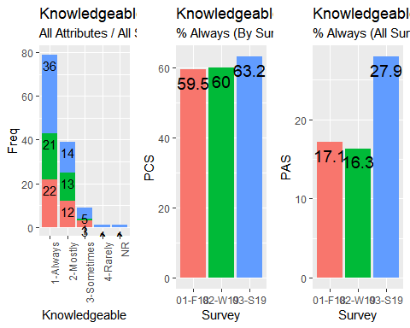

## Improvement for 'Always' over period: 38.89 %

## Experience Attributes Summary

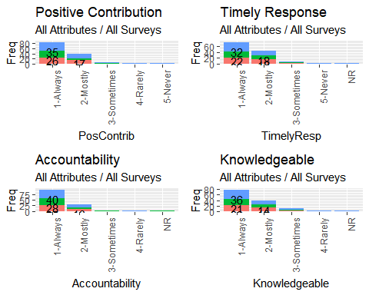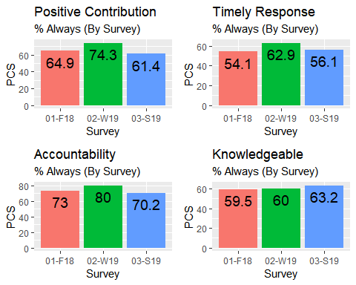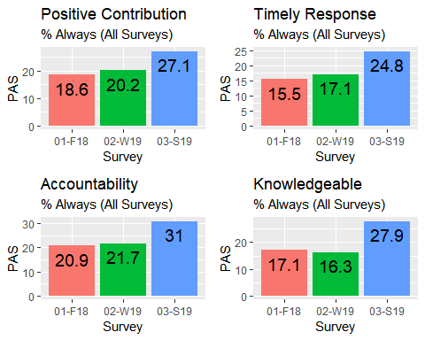

## Summary of Percent Improvement Over All Surveys

## Positive Contribution improvement to date: 31.43 %

## Timely Response improvement to date: 37.5 %

## Accountable improvement to date: 32.5 %

## Knowledgeable improvement to date: 38.89 %

## Group Performance: Account Managers

## Group Performance: B&MPS

## Group Performance: Business Applications

## Group Performance: Event Services

## Group Performance: Project Support

## Group Performance: Service Desk

## Group Performance: Studio Services

## Group Performance: Vendor Management

## Group Performance Summary

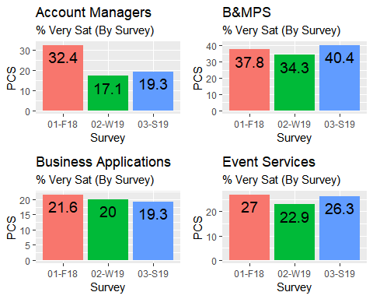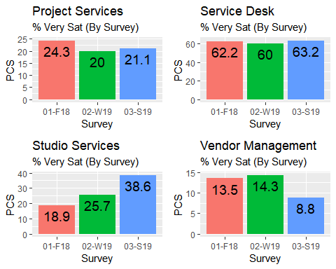

## Account Managers improvement to date: -9.09 %

## BMPS improvement to date: 39.13 %

## Business Applications improvement to date: 27.27 %

## Event Services improvement to date: 33.33 %

## Project Support improvement to date: 25 %

## Service Desk improvement to date: 36.11 %

## Studio Services improvement to date: 68.18 %

## Vendor Management improvement to date: 0 %