Client Satisfaction Report

Fall 2018 / Winter 2019 / Spring 2019

May 2019

## Experience Attribute: Positive Contribution

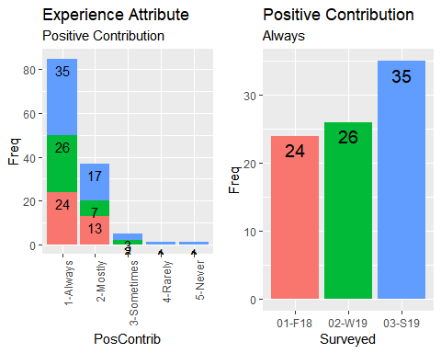

## Improvement for 'Always' over period: 31.43 %

## Experience Attribute: Timely Response

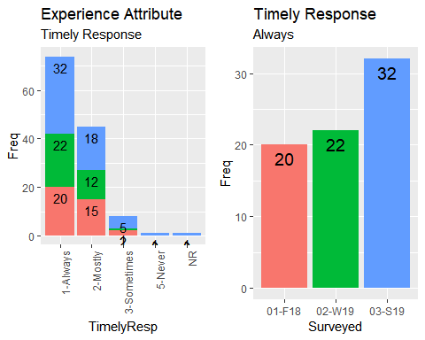

## Improvement for 'Always' over period: 37.5 %

## Experience Attribute: Accountability

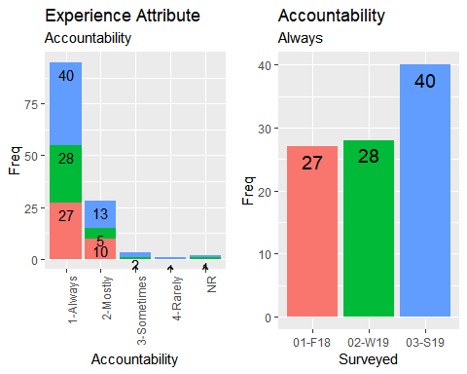

## Improvement for 'Always' over period: 32.5 %

## Experience Attribute: Knowledgeable

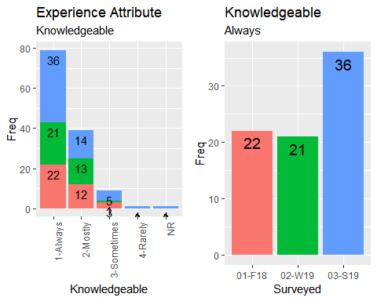

## Improvement for 'Always' over period: 38.89 %

## Experience Attributes Summary

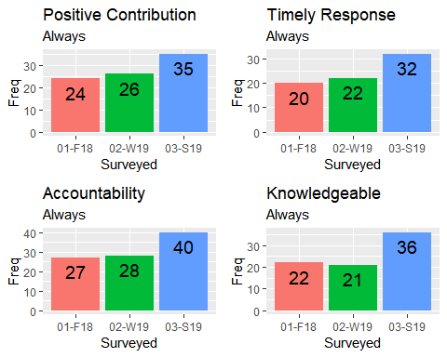

## Positive Contribution improvement to date: 31.43 %

## Timely Response improvement to date: 37.5 %

## Accountable improvement to date: 32.5 %

## Knowledgeable improvement to date: 38.89 %

## Group Performance: Account Managers

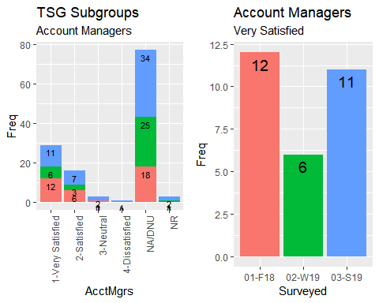

## Improvement for 'Very Satisfied' over period: -9.09 %

## Group Performance: B&MPS

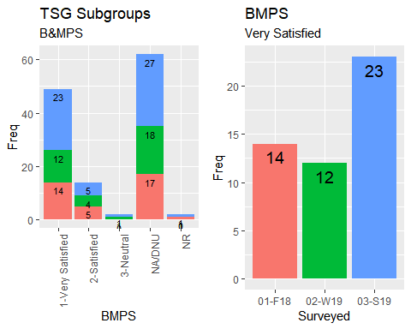

## Improvement for 'Very Satisfied' over period: 39.13 %

## Group Performance: Business Applications

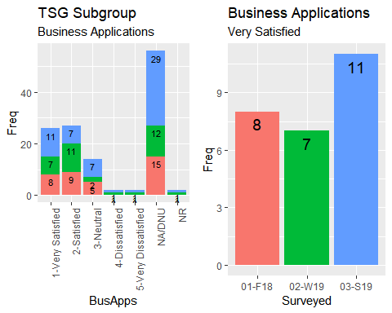

## Improvement for 'Very Satisfied' over period: 27.27 %

## Group Performance: Event Services

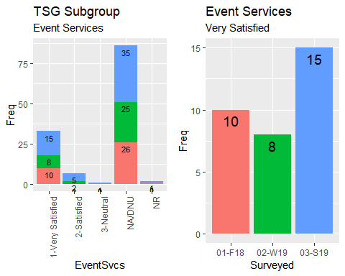

## Improvement for 'Very Satisfied' over period: 33.33 %

## Group Performance: Project Support

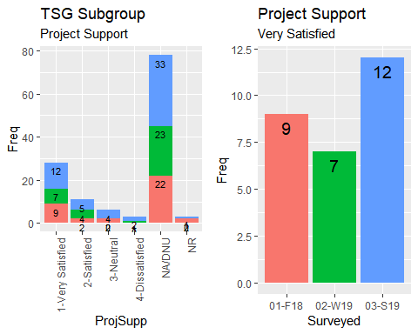

## Improvement for 'Very Satisfied' over period: 25 %

## Group Performance: Service Desk

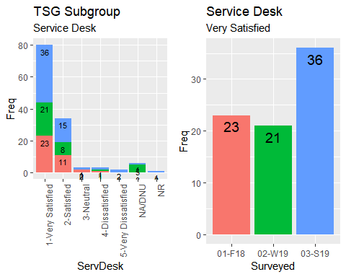

## Improvement for 'Very Satisfied' over period: 36.11 %

## Group Performance: Studio Services

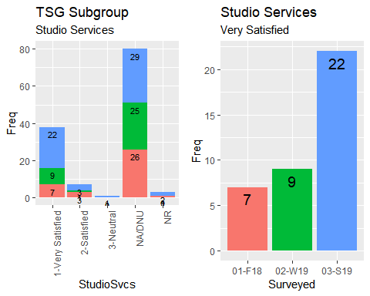

## Improvement for 'Very Satisfied' over period: 68.18 %

## Group Performance: Vendor Management

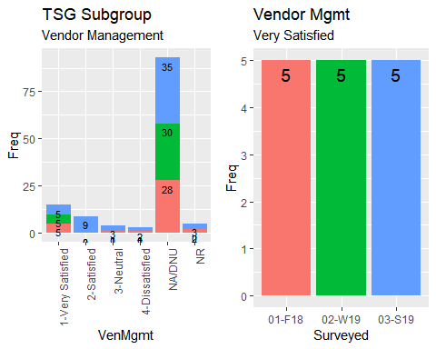

## Improvement for 'Very Satisfied' over period: 0 %

## Group Performance Summary

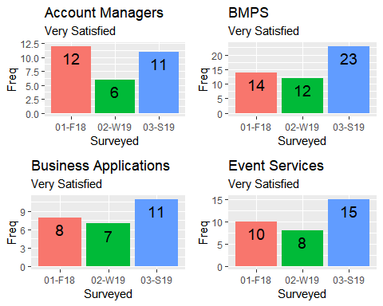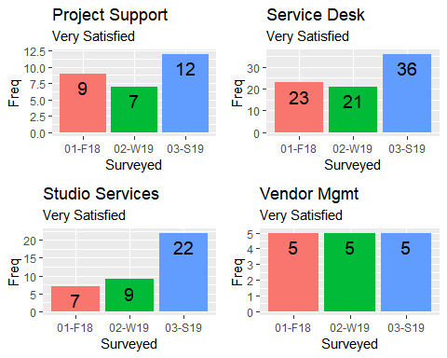

## Account Managers improvement to date: -9.09 %

## BMPS improvement to date: 39.13 %

## Business Applications improvement to date: 27.27 %

## Event Services improvement to date: 33.33 %

## Project Support improvement to date: 25 %

## Service Desk improvement to date: 36.11 %

## Studio Services improvement to date: 68.18 %

## Vendor Management improvement to date: 0 %