Client Satisfaction Report

Fall 2018 / Winter 2019 / Spring 2019

May 2019

## Experience Attribute: Positive Contribution

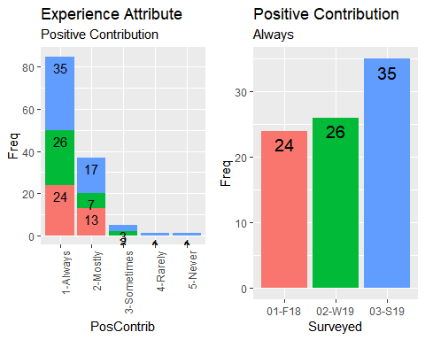

## Improvement for 'Always' over period: 31.43 %

## Experience Attribute: Timely Response

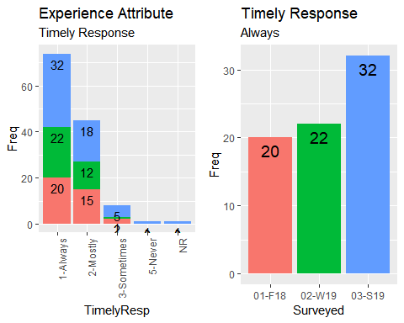

## Improvement for 'Always' over period: 37.5 %

## Experience Attribute: Accountability

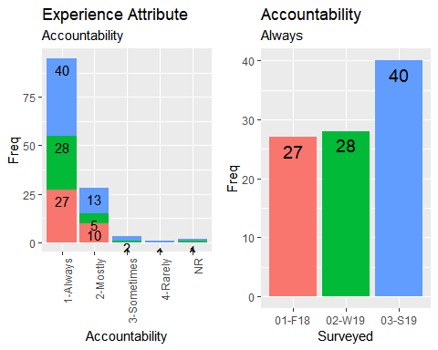

## Improvement for 'Always' over period: 32.5 %

## Experience Attribute: Knowledgeable

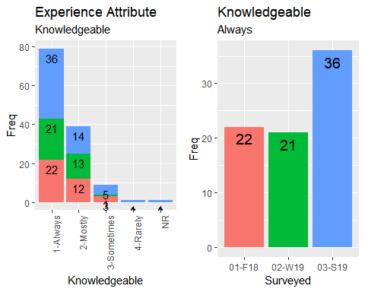

## Improvement for 'Always' over period: 38.89 %

## Group Performance: Account Managers

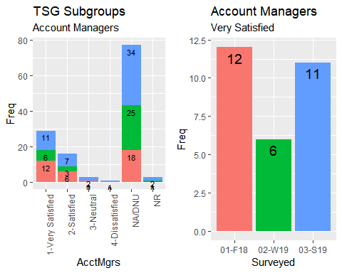

## Group Performance: B&MPS

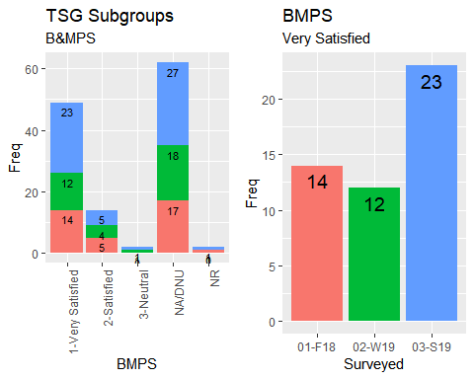

## Group Performance: Business Applications

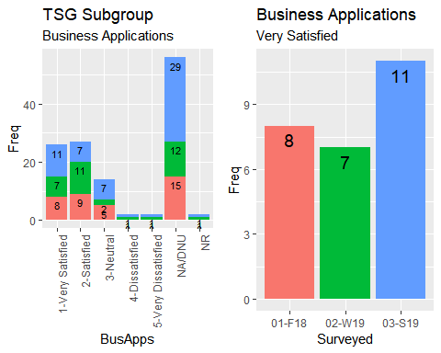

## Group Performance: Event Services

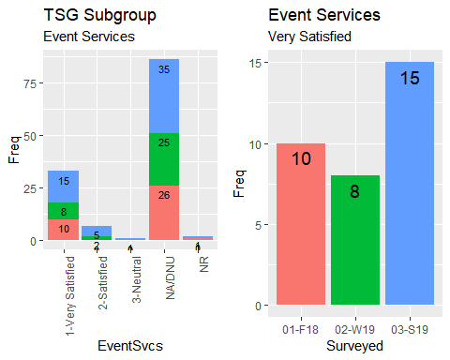

## Group Performance: Project Support

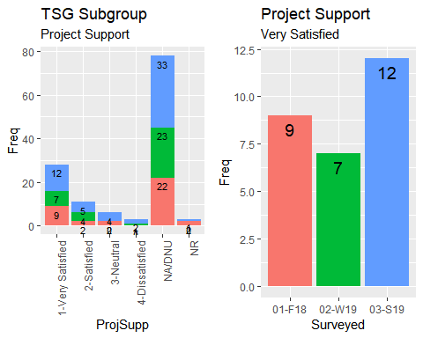

## Group Performance: Service Desk

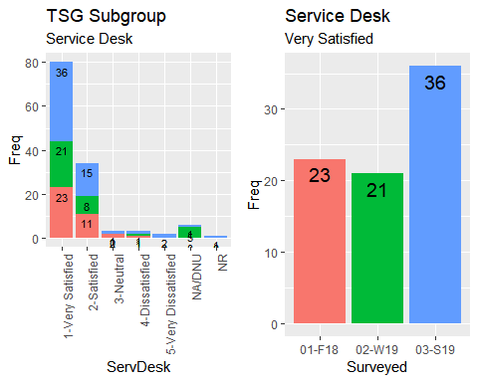

## Group Performance: Studio Services

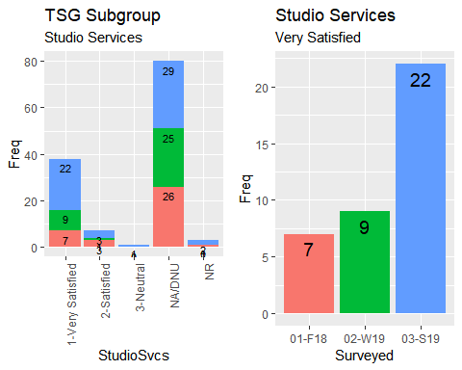

## Group Performance: Vendor Management

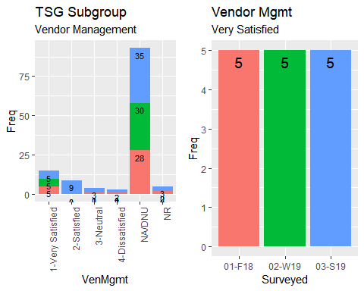

## Trends Summary

