LIA – SDG Workshop Questions

1. What major and/or minor degree are you pursuing for your undergraduate and/or graduate studies?

Bachelor degree of Engineering, maybe. I am consider about Mechanical Engineering, Materials Engineering, and Industrial Engineering. I believe industry was, is and will always be an essential part in the world, and engineering will also be a good choice.

2) Ideally, what type of work and/or service would you like to do after your formal education?

Manufacture, Management. To be honest, I am not sure. I think I will further explore it in the university by having some co-op or part time jobs. But ideally, I think I will not only sit in the office, but also work in the factory and corporate with different people with different jobs.

3) Which one of the 17 SDG goals would you like to incorporate into your studies and/or work over the next 12 years until 2030?

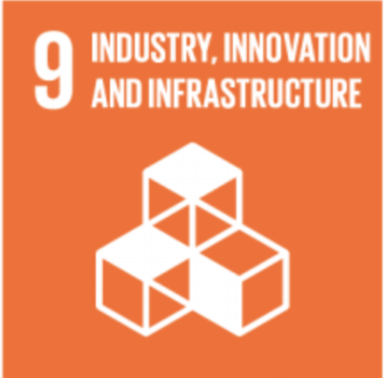

I think that Goal 9 industry, innovation and infrastructure is easily to be incorporated into engineering. As an engineer, I need to improve the work efficiency and consider about so many different aspects such as environmental issue (Goal12). There are lots of things I need to learn in the future.

4) Which one of the 221 SDG goals would you like to incorporate into your studies and/or work over the next 12 years until 2030?

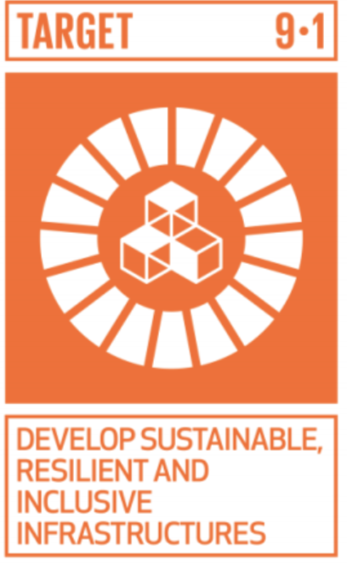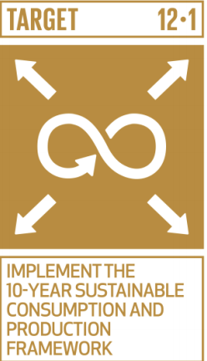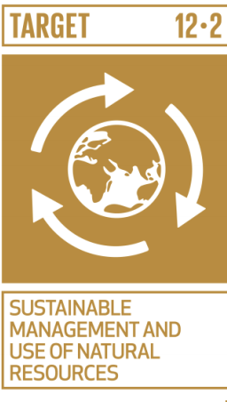

I think I will hold this “develop sustainable resilient and inclusive infrastructure” and “operating-friendly” as a principle and apply this in my future work. This idea can guide me to work better for people and environment.

5) How have you practically integrated any of your learnings from the Human Innovation Workshop? In the past, present or future?

Past:



Motivated by Target4 and since I am also a student, I hope I can do something on the education for the next generation. I am not sure how to combine my future job with this part, but I think I will use my spare time to help.

My friends and I are building a blog to share our learning experience about English, Physics, and Chemistry online. I think I am approaching to the Target 4.

Future:

I think I will approach the Target 9 with 12 when studying in the university. Apply this ideas in my belief, and then I will succeed. If I could apply any one of these ideas, my life will be meaningful as a human.