Calibrating the PCI-DAS1001/1002
Rev. 3
08/27/98
jps

1.0 Introduction

The PCI-DAS1001/1002 provides self-calibration of the analog source and measure systems thereby eliminating the need for external equipment and user adjustments. All adjustments
are made via 8-bit calibration DACs or 7-bit digital potentiometers referenced to an on-board factory calibrated standard. Calibration factors are stored on the serial nvRAM starting at location 80h. Please see the "AMCC S5933 PCI Controller Data Book, 1997" section 9.5.2 for more details regarding nvRAM access.

A variety of methods are used to calibrate the different elements on the board. The analog front-end has several knobs to turn. Offset calibration is performed in the instrumentation amplifier gain stage. Front-end gain adjustment is performed via a variable attenuator/gain stage.

The analog output circuits are calibrated for both gain and offset. Offset adjustments for
the analog output are made in the output buffer section. The tuning range of this adjustment
allows for max DAC and output buffer offsets. Gain calibration of the analog outputs are
performed via DAC reference adjustments.

Figure 1 below is a block diagram of the analog front-end calibration system:

Figure 1

The calibration scheme for the Analog Out section is shown in Figure 2 below. This circuit is duplicated for both DAC0 and DAC1

Figure 2

2.0 Programming

There are two different calibration mechanisms on the PCI-DAS1001/1002 that have unique
programming requirements. These chips are the AD7376 7-bit digital potentiometer and the
DAC8800 Octal Trim DAC. All calibration features are programmed via the write-only 16-bit register at BADR1 + 6. The bit map for the cal register is shown in Figure 3 below:

D15 | D14 | D13 | D12 | D11 | D10 | D09 | D08 | D07 | D06 | D05 | D04 | D03 | D02 | D01 | D00
SDI | CALEN | CSRC2 | CSRC1 | CSRC0 | N/A | SEL7376 | SEL8800 | N/A | N/A | N/A | N/A | N/A | N/A | N/A | N/A

Figure 3 - BADR1 + 6 Bit Map

Table 1 provides a summary of the programmable cal devices and their functions.
Please note that the addresses shown for the serial devices refer to the internal DAC addresses within each device. All programming of the serial devices is performed via multiple writes to the SDI bit in BADR1 + 6 as described in the next section.

Device | Address | Prog method | Calibrates... | Nominal Value
AD7376 | 0 | Serial | ADC Gain | 40h
DAC8800 | 0 | Serial | DAC0 Fine Gain | 80h
" | 1 | " | DAC0 Coarse Gain | "
" | 2 | " | DAC0 Offset | "
" | 3 | " | DAC1 Offset | "
" | 4 | " | DAC1 Fine Gain | "
" | 5 | " | DAC1 Coarse Gain | "
" | 6 | " | ADC Coarse Offset | "
" | 7 | " | ADC FineOffset | "

Table 1 - Calibration DAC summary
2.1 Programming AD7376

The AD7376 is a 7-bit device with a three-wire serial interface: chip select, clock and data.
Since the calibration process is done infrequently and in general at start-up, programming speed
is not of great importance. As a result, the serial programming of the 7376 is done one bit at a time with each bit taking up one write cycle to the PCI-DAS1001/1002 (8 PCI clocks) plus some
timing overhead on the order of 200nS. Therefore, a 7-bit write including chip select and
address overhead is on the order of 6uS.

The bits of interest for the 7376 in BADR1 + 6 are SEL7376 (D9) and SDI (D15). It is
important SEL8800 be cleared when programming the 7376. The programming sequence is shown below in Table 2. Note that *** = selected cal source via CSRC[2:0] bits (see Table 3) and that D14 CALEN switches the different cal sources into the analog front end and must be set during calibration. Note that Tables 2,4 &5 use a 16-bit binary word format with the right-most bit being D0, the LSB.

Write BADR1 + 6 with ... | Comments
01***010XXXXXXXX | SEL7376 high, selects device
01***010XXXXXXXX if ADR = 0  11***010XXXXXXXX if ADR = 1 | One bit written via SDI. All writes must keep SEL7376 high.
01***010XXXXXXXX if D[n] = 0  11***010XXXXXXXX if D[n] = 1 | Repeat this for 6 remaining bits of data written via SDI.
01***000XXXXXXXX | SEL7376 low, deselects device, output update

Table 2 - 7376 Programming Sequence
Table 3a summarizes the calibration reference options for the PCI-DAS1001.

CSRC2 | CSRC1 | CSRC0 | Source
0 | 0 | 0 | AGND
0 | 0 | 1 | 7.0V Ref
0 | 1 | 0 | Not Used
0 | 1 | 1 | 88.6mV Ref
1 | 0 | 0 | 0.875V Ref
1 | 0 | 1 | 8.67 mV Ref
1 | 1 | 0 | DAC0
1 | 1 | 1 | DAC1

Table 3a - PCI-DAS1001 Calibration Source Select

Table 3b summarizes the calibration reference options for the PCI-DAS1002.

CSRC2 | CSRC1 | CSRC0 | Source
0 | 0 | 0 | AGND
0 | 0 | 1 | 7.0V Ref
0 | 1 | 0 | 3.5V Ref
0 | 1 | 1 | 1.75V Ref
1 | 0 | 0 | 0.875V Ref
1 | 0 | 1 | 8.67 mV Ref
1 | 1 | 0 | DAC0
1 | 1 | 1 | DAC1

Table 3b - PCI-DAS1002 Calibration Source Select

2.2 Programming the DAC8800

The DAC8800 octal Trim DAC uses a similar but not identical three-write interface like
that of the 7376. The primary difference is that the SEL8800 bit is not actually a chip select
but rather a data strobe which latches the last 11 bits written to the DAC8800 (3 bits ADR,
8 bits DATA). Therefore, SEL8800 will not be toggled until after the address and data have been written. Table 4 describes the programming sequence:

Write BADR1 + 6 with ... | Comments
01***000XXXXXXXX if ADR = 0  11***000XXXXXXXX if ADR = 1 | One bit of address written via SDI. All writes  must keep SEL8800 low. Repeat this for remaining 2 bits of address.
01***000XXXXXXXX if D[n] = 0  11***000XXXXXXXX if D[n] = 1 | Repeat this for 8 bits of data written via SDI.
01***001XXXXXXXX | SEL8800 to set load clock
01***000XXXXXXXX | SEL8800 to reset load clock and update output

Table 4 - Programming the DAC8800

2.4 nvRAM Organization

The AMCC S5933 PCI controller requires the use of an external 24C02 serial nvRAM. All memory locations are not used which allows the PCI-DAS1001/1002 calibrations to make use of this unused memory space. This space begins at offset 80h.

There are two types of data ultimately stored in the nvRAM. The first are the values of the
four calibration standards unique to each board which are measured at the factory. Secondly,
there are a number of calibration DAC values which must be determined and then stored in
nvRAM. These values will be loaded during the first run-time after power-up. Factory
calibration reference values will be stored in nvRAM using standard floating-point representation as shown in Figure 4 below:

23-bit Mantissa
MSB LSB
Exponent | Sign
Byte 3 Byte 2 (incl. sign) Byte 1 Byte 0

Figure 4 - Floating-Point Data Format

Calibration coefficients written to the nvRAM will all have a standard byte format

Table 6 below summarizes the nvRAM organization.

Address | PCI-DAS1001 Value | PCI-DAS1002 Value
80 | 7.0V Ref mantissa byte 0 | 7.0V Ref mantissa byte 0
81 | 7.0V Ref mantissa byte 1 | 7.0V Ref mantissa byte 1
82 | 7.0V Ref mantissa byte 2 | 7.0V Ref mantissa byte 2
83 | 7.0V Ref exponent byte | 7.0V Ref exponent byte
84 | Not Used | 3.5V Ref mantissa byte 0
85 | Not Used | 3.5V Ref mantissa byte 1
86 | Not Used | 3.5V Ref mantissa byte 2
87 | Not Used | 3.5V Ref exponent byte
88 | 88.6mV Ref mantissa byte 0 | 1.75V Ref mantissa byte 0
89 | 88.6mV Ref mantissa byte 1 | 1.75V Ref mantissa byte 1
8A | 88.6mV Ref mantissa byte 2 | 1.75V Ref mantissa byte 2
8B | 88.6mV Ref exponent byte | 1.75V Ref exponent byte
8C | 0.875V Ref mantissa byte 0 | 0.875V Ref mantissa byte 0
8D | 0.875V Ref mantissa byte 1 | 0.875V Ref mantissa byte 1
8E | 0.875V Ref mantissa byte 2 | 0.875V Ref mantissa byte 2
8F | 0.875V Ref exponent byte | 0.875V Ref exponent byte
90 | 8.67mV Ref mantissa byte 0 | 8.67mV Ref mantissa byte 0
91 | 8.67mV Ref mantissa byte 1 | 8.67mV Ref mantissa byte 1
92 | 8.67mV Ref mantissa byte 2 | 8.67mV Ref mantissa byte 2
93 | 8.67mV Ref exponent byte | 8.67mV Ref exponent byte
94-BB | reserved | reserved
BC | BIP10V ADC Coarse offset | BIP10V ADC Coarse offset
BD | BIP10V ADC Fine offset | BIP10V ADC Fine offset
BE | BIP10V gain | BIP10V gain
BF | BIP1V ADC Coarse offset | BIP5V ADC Coarse offset
C0 | BIP1V ADC Fine offset | BIP5V ADC Fine offset
C1 | BIP1V gain | BIP5V gain
C2 | BIPPT1V ADC Coarse offset | BIP2.5V ADC Coarse offset
C3 | BIPPT1V ADC Fine offset | BIP2.5V ADC Fine offset
C4 | BIPPT1V gain | BIP2.5V gain
C5 | BIPPT01V ADC Coarse offset | BIP1.25V ADC Coarse offset
C6 | BIPPT01V ADC Fine offset | BIP1.25V ADC Fine offset
C7 | BIPPT01V gain | BIP1.25V gain
C8 | UNI10V ADC Coarse offset | UNI10V ADC Coarse offset
C9 | UNI10V ADC Fine offset | UNI10V ADC Fine offset
CA | UNI10V gain | UNI10V gain
CB | UNI1V ADC Coarse offset | UNI5V ADC Coarse offset
CC | UNI1V ADC Fine offset | UNI5V ADC Fine offset
CD | UNI1V gain | UNI5V gain
CE | UNIPT1V ADC Coarse offset | UNI2.5V ADC Coarse offset
CF | UNIPT1V ADC Fine offset | UNI2.5V ADC Fine offset

Address | PCI-DAS1001 Value | PCI-DAS1002 Value
D0 | UNIPT1V gain | UNI2.5V gain
D1 | UNIPT01V ADC Coarse offset | UNI1.25V ADC Coarse offset
D2 | UNIPT01V ADC Fine offset | UNI1.25V ADC Fine offset
D3 | UNIPT01V gain | UNI1.25V gain
D4-DB | reserved | reserved
DC | DAC0 BIP5V coarse gain | DAC0 BIP5V coarse gain
DD | DAC0 BIP5V offset | DAC0 BIP5V offset
DE | DAC0 BIP5V fine gain | DAC0 BIP5V fine gain
DF | reserved | reserved
E0 | DAC0 BIP10V coarse gain | DAC0 BIP10V coarse gain
E1 | DAC0 BIP10V offset | DAC0 BIP10V offset
E2 | DAC0 BIP10V fine gain | DAC0 BIP10V fine gain
E3 | reserved | reserved
E4 | DAC0 UNI5V coarse gain | DAC0 UNI5V coarse gain
E5 | DAC0 UNI5V offset | DAC0 UNI5V offset
E6 | DAC0 UNI5V fine gain | DAC0 UNI5V fine gain
E7 | reserved | reserved
E8 | DAC0 UNI10V coarse gain | DAC0 UNI10V coarse gain
E9 | DAC0 UNI10V offset | DAC0 UNI10V offset
EA | DAC0 UNI10V fine gain | DAC0 UNI10V fine gain
EB | reserved | reserved
EC | DAC1 BIP5V coarse gain | DAC1 BIP5V coarse gain
ED | DAC1 BIP5V offset | DAC1 BIP5V offset
EE | DAC1 BIP5V fine gain | DAC1 BIP5V fine gain
EF | reserved | reserved
F0 | DAC1 BIP10V coarse gain | DAC1 BIP10V coarse gain
F1 | DAC1 BIP10V offset | DAC1 BIP10V offset
F2 | DAC1 BIP10V fine gain | DAC1 BIP10V fine gain
F3 | reserved | reserved
F4 | DAC1 UNI5V coarse gain | DAC1 UNI5V coarse gain
F5 | DAC1 UNI5V offset | DAC1 UNI5V offset
F6 | DAC1 UNI5V fine gain | DAC1 UNI5V fine gain
F7 | reserved | reserved
F8 | DAC1 UNI10V coarse gain | DAC1 UNI10V coarse gain
F9 | DAC1 UNI10V offset | DAC1 UNI10V offset
FA | DAC1 UNI10V fine gain | DAC1 UNI10V fine gain
FB | reserved | reserved
0FC-7FF | Unused | Unused

Table 6 (cont.) - nvRAM Organization
3.0 Calibration

Calibration is a combination of factory and field-based measurements. For analog front-end
calibrations there are multiple sources depending upon the range and type of cal. Offset is calibrated for each Bipolar range with AGND as the cal source; a millivolt reference is used to calibrate offset for each Unipolar range.

The primary calibration is the ADC in Bipolar mode. This calibration is used as the starting point for the ADC Unipolar mode and DAC0/1 tweaks. All cal sources are switched in via CH0HI.

3.1 Calibration Types

3.1.1 Analog Input Calibrations

Table 7a below summarizes the PCI-DAS1001 Analog Input Offset calibrations to be performed.

Calibration | Range | Cal Source | # ADC Codes per cal DAC range | Nominal Sensitivity  (uV/cal DAC LSB) | ADC LSB to sensitivity ratio
ADC coarse offset | BIP10V | AGND | 96 | 1,820 | 2.7:1
ADC fine offset | BIP10V | AGND | 11 | 203 | 24:1
ADC coarse offset | BIP1V | AGND | 96 | 182 | 2.7:1
ADC fine offset | BIP1V | AGND | 11 | 20.3 | 24:1
ADC coarse offset | BIPPT1V | AGND | 96 | 18.2 | 2.7:1
ADC fine offset | BIPPT1V | AGND | 11 | 2 | 24:1
ADC coarse offset | BIPPT01V | AGND | 96 | 1.8 | 2.7:1
ADC fine offset | BIPPT01V | AGND | 11 | 0.2 | 24:1
ADC coarse offset | UNI10V | 8.67mV | 96 | 1,820 | 1.3:1
ADC fine offset | UNI10V | 8.67mV | 11 | 203 | 12:1
ADC coarse offset | UNI1V | 8.67mV | 96 | 182 | 1.3:1
ADC fine offset | UNI1V | 8.67mV | 11 | 20.3 | 12:1
ADC coarse offset | UNIPT1V | AGND | 96 | 18.2 | 1.3:1
ADC fine offset | UNIPT1V | AGND | 11 | 2 | 12:1
ADC coarse offset | UNIPT01V | AGND | 96 | 1.8 | 1.3:1
ADC fine offset | UNIPT01V | AGND | 11 | 0.2 | 12:1

Table 7a - PCI-DAS1001 Front End Offset Calibrations

Table 7b below summarizes the PCI-DAS1002 Analog Input Offset calibrations to be performed.

Calibration | Range | Cal Source | # ADC Codes per cal DAC range | Nominal Sensitivity  (uV/cal DAC LSB) | ADC LSB to sensitivity ratio
ADC coarse offset | BIP10V | AGND | 96 | 1,820 | 2.7:1
ADC fine offset | BIP10V | AGND | 11 | 203 | 24:1
ADC coarse offset | BIP5V | AGND | 96 | 910 | 2.7:1
ADC fine offset | BIP5V | AGND | 11 | 102 | 24:1
ADC coarse offset | BIP2.5V | AGND | 96 | 455 | 2.7:1
ADC fine offset | BIP2.5V | AGND | 11 | 51 | 24:1
ADC coarse offset | BIP1.25V | AGND | 96 | 228 | 2.7:1
ADC fine offset | BIP1.25V | AGND | 11 | 25 | 24:1
ADC coarse offset | UNI10V | 8.67mV | 96 | 1,820 | 1.3:1
ADC fine offset | UNI10V | 8.67mV | 11 | 203 | 12:1
ADC coarse offset | UNI5V | 8.67mV | 96 | 910 | 1.3:1
ADC fine offset | UNI5V | 8.67mV | 11 | 102 | 12:1
ADC coarse offset | UNI2.5V | 8.67mV | 96 | 455 | 1.3:1
ADC fine offset | UNI2.5V | 8.67mV | 11 | 51 | 12:1
ADC coarse offset | UNI1.25V | 8.67mV | 96 | 228 | 1.3:1
ADC fine offset | UNI1.25V | 8.67mV | 11 | 25 | 12:1

Table 7b - PCI-DAS1002 Front End Offset Calibrations

Sixteen nvRAM bytes are required to store the front-end offset information.
Tables 8a and 8b below outline the different Front-End Gain calibrations. Each of the 4 possible reference voltages are measured at the factory after time/temp soak using an NBS-traceable measurement system. Four bytes of nvRAM will be used to store each calibration factor. This will use a total of 16 nvRAM locations. Eight nvRAM bytes are required to store the front-end gain information.

Calibration | Range | High Cal Source | Low Cal  Source | Nominal input @ ADC | #ADC Codes per  cal DAC Range | Avg Gain Adjust Range | Avg Gain  Sensitivity  per CAL code
ADC Gain | BIP10V | 7.0V | AGND | 7.0V | 22 | 1.3% | 0.011%
" " | BIP1V | 0.875V | AGND | 8.8V | 22 | 1.3% | 0.011%
" " | BIPPT1V | 88.6mV | AGND | 8.9V | 22 | 1.3% | 0.011%
" " | BIPPT01V | 8.67mV | AGND | 8.7V | 22 | 1.3% | 0.011%
" " | UNI10V | 7.0V | 8.67mV | 4.0V | 11 | 1.3% | 0.011%
" " | UNI1V | 0.875V | 8.67mV | 7.5V | 11 | 1.3% | 0.011%
" " | UNIPT1V | 88.6mV | 8.67mV | 7.7V | 11 | 1.3% | 0.011%
" " | UNIPT01V | 8.67mV | AGND | 7.3V | 11 | 1.3% | 0.011%

Table 8a - PCI-DAS1001 Front-end Gain Calibrations

Calibration | Range | High Cal Source | Low Cal  Source | Nominal input @ ADC | #ADC Codes per  cal DAC Range | Avg Gain Adjust Range | Avg Gain  Sensitivity  per CAL code
ADC Gain | BIP10V | 7.0V | AGND | 7.0V | 22 | 1.3% | 0.011%
" " | BIP5V | 3.5V | AGND | 7.0V | 22 | 1.3% | 0.011%
" " | BIP2.5V | 1.75V | AGND | 7.0V | 22 | 1.3% | 0.011%
" " | BIP1.25V | 0.875V | AGND | 7.0V | 22 | 1.3% | 0.011%
" " | UNI10V | 7.0V | 8.67mV | 4.0V | 11 | 1.3% | 0.011%
" " | UNI5V | 3.5V | 8.67mV | 4.0V | 11 | 1.3% | 0.011%
" " | UNI2.5V | 1.75V | 8.67mV | 4.0V | 11 | 1.3% | 0.011%
" " | UNI1.25V | 0.875V | 8.67mV | 4.0V | 11 | 1.3% | 0.011%

Table 8b - PCI-DAS1002 Front-end Gain Calibrations

The transfer function for the ADC gain calibration is non-linear. As shown in Figure 4a below, the gain goes as 1/X displaying a higher sensitivity at the lower Cal DAC codes and lower sensitivity at higher Cal DAC codes. The total gain adjust range is approximately +0.4%, -0.7%. The required span is ±0.4%. The dashed line in Figure 4a represents a linearized version of the transfer function.

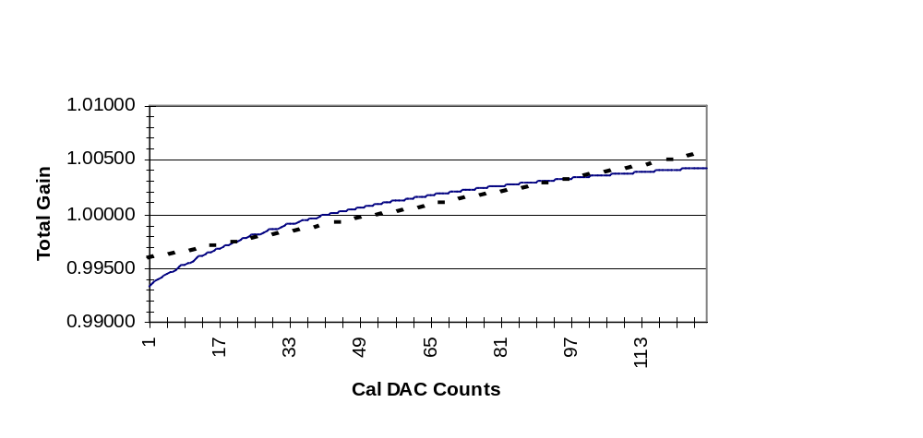

Figure 4a - Front-end Gain Cal Transfer Function

Figure 4b below shows the varying gain sensitivity with cal DAC code. The portion of the curve below the dashed line represents the part of the curve where there the ratio of Cal DAC codes
to ADC output codes is at least 2:1. The area between the solid and dashed lines represents a ratio of at least 1:1.

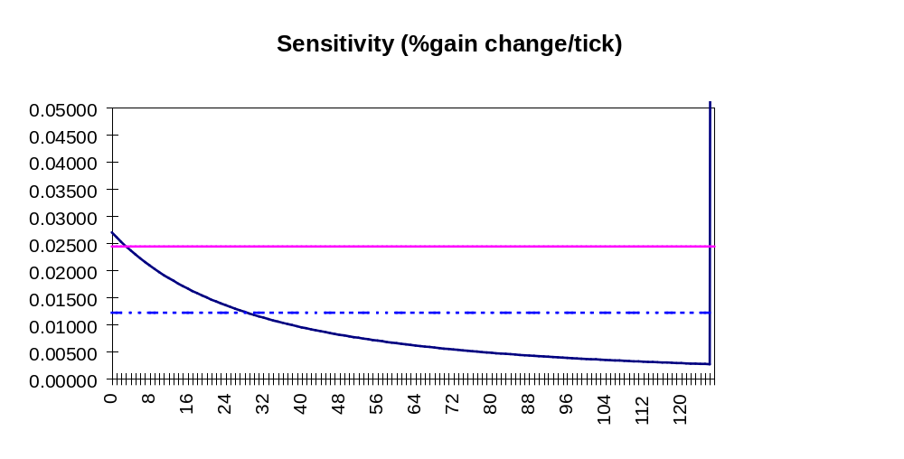

Figure 4b - Front-End Gain Cal Sensitivity

3.1.2 Analog Output Calibrations

Table 9 describes the analog output offset calibrations. As mentioned earlier, the combined offset of the DAC(s) and the output buffer are trimmed in the output buffer circuit. Note that
there are no references associated with the DAC calibration - a fully calibrated ADC set to
the respective DAC range is used as the measurement system.

Calibration | Range | DAC span per Offset Cal DAC Range | Cal DAC Sensitivity (uV/Cal Code) | Ratio of Cal DAC LSB to DACn LSB
AOUT Offset | BIP5V | 102mV | 398 | 6:1
" " | BIP10V | 204mV | 796 | 6:1
" " | UNI5V | 102mV | 398 | 3:1
" " | UNI5V | 204mV | 796 | 3:1

Table 9 - Analog Out Offset calibrations

Eight nvRAM bytes are required to store the analog out offset information, four each
for DAC0 and DAC1.

Table 10 describes the calibrations required for the analog output gain adjustments. All gain
adjustments are make via modification of the DACn reference voltage.

DAC  Range | DAC span per  Coarse Gain Cal DAC Range | Coarse Cal  Sensitivity  (mV/Cal DAC LSB) | CoarseRatio | Coarse  Cal  Range | DAC span per Fine Gain Cal DAC Range | Fine Cal  Sensitivity  (uV/Cal DAC LSB) | Fine Ratio | Coarse Cal Range
BIP5V | 375mV | 1.46 | 1.67:1 | ±0.1.875% | 42mV | 64 | 15:1 | ±0.2%
BIP10V | 750mV | 2.93 | 1.67:1 | ±0.1.875% | 84mV | 128 | 15:1 | ±0.2%
UNI5V | 375mV | 1.46 | 0.84:1 | ±3.75% | 42mV | 64 | 7.5:1 | ±0.4%
UNI10V | 750mV | 2.93 | 0.84:1 | ±3.75% | 84mV | 128 | 7.5:1 | ±0.4%

Table 10- Analog Out Gain calibrations

Sixteen nvRAM bytes are required to store the analog out gain information, eight each
for DAC0 and DAC1.
3.2 Calibration Algorithms

3 .2.1 Bipolar Mode ADC Calibration

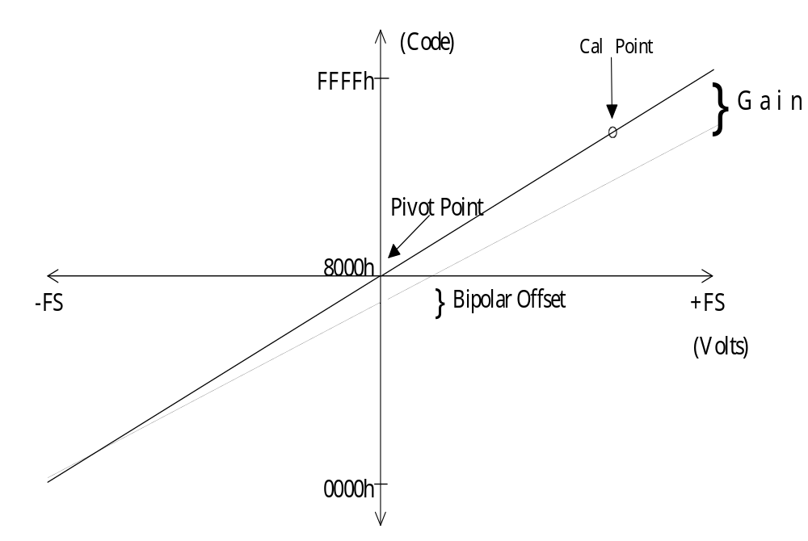

Figure 5 - Bipolar Transfer Function

Figure 5 above shows an ideal and a non-ideal ADC transfer function for the Bipolar
ranges. The gain adjust circuits correct for the gain error shown in the first quadrant while
the ADC offset adjust circuit compensates for the offset shown at 0V. The 7800 ADC has a pivot point at 0 which implies that the transfer curve rotates about this point during gain adjust and moves in the ±X direction at this point during offset adjust.

Procedure:

Note: All ADC codes are determined via the average of 50 ADC conversions.

1. Set ADC offset and ADC gain settings to their nominal values. (i.e AD7376, DAC8800 ADR 6, DAC8800 ADR 7).
2. Select AGND as input via CSRC[2:0] and adjust coarse Bipolar offset to obtain an ADC output code of 2048±1.0 using DAC8800 ADR 6.
3. Adjust fine Bipolar offset via DAC8800 ADR 7 to obtain an output code of 2048±0.25. If this converges, offset calibration is complete.
4. Select high cal source via CSRC[2:0] and determine resultant ADC code.
5. Select the low cal source (AGND) and determine resultant ADC code.
6. Calculate the slope of the line described by these points:

Slope = [Code_{HIGH} - Code_{LOW}] / [Gain*V_{HIGH}]

where V_{HIGH,} is the precise factory-measured reference value in nvRAM..

7. Compare to the target slope of 204.8 ± 0.04. If measured slope is less than
the target slope then gain is too low. Increase gain by writing a smaller
value to the AD7376 . If measured slope is greater than the target value
the gain is too high. Decrease the gain by writing a larger value into
AD7376.
8. Iterate steps 4-7 until the target slope is met. Gain is now set.
9. Re-check Bipolar offset with AGND as input. Expect 2048±0.5
10. If not within ±.5LSB then zero Bipolar offset with DAC8800 ADR 7 and repeat steps 4-7.
11. Iterate on steps 4-10 until cal converges. If cal does not converge after 3 attempts
then fail.

3.2.2 Unipolar Mode ADC Calibration

Figure 6 - Unipolar Transfer Function

Calibration of the Unipolar mode transfer function as shown above in Figure 6 is somewhat different from that of Bipolar mode. For a given range, Unipolar calibrations will use the respective Bipolar calibration data as a starting point. The gain and range of the ADC itself is fixed at Bipolar 10V. All ranges and modes are realized through manipulation of the Analog Front End gains and offsets; the signals are conditioned in such a way that the ADC is always
presented with a full scale range of ±10V. For this reason, the 0V offset point that the user
sees is presented to the ADC as -10V. An 8.67mV reference will be used to calibrate the Unipolar offset. This provides a non-zero ADC code about which a normal noise distribution may be calculated.

Each range will use two points as a cal source. As described earlier, Unipolar mode requires an additional gain factor of 2 and a -10V offset. The equation for the actual voltage presented to the ADC for a given cal source is as follows:

V_{ADC} = (Cal source * Gain * 2) - 10.0V

Table 10a below describes the PCI-DAS1001 upper and lower cal points and their corresponding voltage values:

Range | High Cal Source | Nom. V@  ADC | Low Cal Source
0-10V | 7.0V | +4.0V | 8.67mV
0-1V | 0.875V | +7.5V | 8.67mV
0-0.1V | 88.6mV | +7.7V | AGND
0-0.01V | 8.6mV | +7.3V | AGND

Table 10a

Table 10b below describes PCI-DAS1002 upper and lower cal points and their corresponding voltage values:

Range | High Cal Source | Nom. V@  ADC | Low Cal Source
0-10V | 7.0V | +4.0V | 8.67mV
0-5V | 3.5V | +4.0V | 8.67mV
0-2.5V | 1.75V | +4.0V | 8.67mV
0-1.25V | 0.875V | +4.0V | 8.67mV

Table 10b

Procedure:

1. Set ADC gain setting to the nominal calibration value for the corresponding Bipolar range. Set Coarse offset via DAC8800 ADR 6 to 00h. This will ensure a non-clipped reading for the low cal source. Set fine offset via DAC8800 ADR 7 to 80h.
2. Select high cal source via CSRC[2:0] and determine resultant ADC code.
3. Select the low cal source and determine resultant ADC code.
4. Calculate the slope of the line described by these points:

Slope = [Code_{HIGH} - Code_{LOW}] / [2*Gain*(V_{HIGH}-V_{LOW})]

where V_{HIGH} is the high cal source and V_{LOW} is the low cal source.

5. Compare to the target slope of 204.8 ± 0.04. If measured slope is less than
the target slope then gain is too low. Increase gain by writing a smaller
value to the AD7376. If measured slope is greater than the target value
then the gain is too high. Decrease the gain by writing a larger value to the
AD7376.
6. Iterate steps 4-5 until the target slope is met. Gain is now set.

Note: For the PCI-DAS1002, steps 7-9 pertain to the offset calibration on all ranges. For the PCI-DAS1001, steps 7-9 pertain only to offset calibration of the UNI10V, UNI1V and UNIPT1V ranges. See steps 10-x for UNI0PT1V range.

7. Select Low Cal Source as the cal source and adjust coarse offset via DAC8800 ADR 6 until the average ADC code falls in the range of Target Code ± 0.5.
Target code is calculated as follows:

Target = [V_{LOW} *2*Gain]/[20/(2^12)]

8. Adjust fine offset via DAC8800 ADR 7 until the average ADC code falls into the
range of Target Code ± 0.1. Offset calibration is complete.

9. Re-check gain slope. If gain is outside of 204.8 ± 0.05 limit then repeat gain and
offset calibration. If the Gain/Offset adjust (steps 2-9) does not converge after three tries then fail calibration
The following steps apply only to PCI-DAS1001 UNI0PT1V range.

10. Set the coarse offset DAC8800 ADR 6 to 00h. This will create an artificial offset of approximately 110 counts at the ADC input.

11. Select AGND as the Low Cal Source and make 1000 measurements with the ADC. Determine the main bin in the population. This is the bin with the highest number of samples. Calculate a weighted average using the following method:

- Add up the number of samples that fall into bins that correspond to ADC codes less than the main bin.
- Add this number to the number of samples in the main bin. These samples will be weighted by the code that corresponds to the main bin.
- Using the total population calculate the weighted average.

Example:

1000 pts gatherd. All data falls within 12 bins:

Freq | 2 | 0 | 54 | 66 | 142 | 400 | 155 | 72 | 43 | 38 | 18 | 10
Code | 105 | 106 | 107 | 108 | 109 | 110 | 111 | 112 | 113 | 114 | 115 | 116

Main bin = 110 (400 samples)

Number of samples below the Main bin = 2 + 0 + 54 + 66 + 142 = 264

Add these samples to the number of Main bin samples and weight all of these samples by the code which corresponds to the Main bin. Calculate the average of all points:

{[(264 + 400) *110] + [155*111] + [72*112] + [43*113] + [38*114] + [18*115] + [10*116]}/1000 = 110.73

12. Subtract the value of the Main bin from the calculated average ( ie; 110-110.73)
This is the target average offset value.

13. Select AGND as the cal source and adjust coarse offset via DAC8800 ADR 6 until the average ADC code falls in the range of Target Code ± 0.5.
14. Adjust fine offset via DAC8800 ADR 7 until the average ADC code falls into the
range of Target Code ± 0.1. Offset calibration is complete.

15. Re-check gain slope. If gain is outside of 204.8 ± 0.05 limit then repeat gain and
offset calibration. If the Gain/Offset adjust does not converge after three tries then fail calibration

3.2.3 DACn Calibration

The DAC calibrations are straightforward. The analog outputs may be directed to the
calibrated ADC front end via the CSRC[2:0] bits thereby allowing easy adjustment of the
DAC gain and offset errors. The procedures for calibrating both Bipolar and Unipolar DAC modes are nearly identical. In the following method, the addresses of Cal DACs related to DAC1 adjustments will follow the Address for DAC0 in parentheses; i.e. ADR1(5).

As mentioned earlier, all gain adjustments of the analog out circuits are made via adjustment
of the DAC reference voltage. All offset adjustments are made by modifying the output buffer
offset voltage. Cal points of 1/8 FS and 7/8 FS are used to accommodate the dynamic range of
the ADC.

All DAC offset mode/range calibrations should be made with the ADC front end in the
corresponding offset mode/range configuration. In other words, calibrate the DAC BIP10V
gain and offset using the ADC in BIP10V mode etc.

3.2.3.1 DACn Bipolar Mode Calibration

The Bipolar calibrations first adjust the span of the DAC (gain) followed by
offset. The 1/8 FS and 7/8 FS cal points correspond to codes 2000h and E000h,
respectively.

Procedure:

1. Set calibrated ADC front-end to appropriate offset mode/gain range.
2. Select DACn as ADC input source using the CSRC[2:0] bits.
3. Set DACn to same offset mode/gain range.

Coarse Gain -
4. Set DAC8800 ADR 0,1,2 (4,5,3) trimmers to 80h.
5. Set DACn code = 200h and measure V_{LOW} w/ADC
6. Set DACn code = E00h and measure V_{HIGH} w/ADC.
7. Calculate slope:

Slope = 3072/ (Code_{HIGH}-Code_{LOW})]

8. Compare this result to the target slope of 1±(20/2¹²)
9. If result is low, decrease the DAC8800 ADR 1 (5) coarse gain adjust code. If result is too high, increase the code.
10. Iterate on Steps 5-9 until target slope has been met. Coarse adjustment will
be sufficient. Gain is set.

Fine Gain -
11. Set DACn code = 200h and measure V_{LOW} w/ ADC.
12. Set DACn code = E00h and measure V_{HIGH} w/ADC.
13. Calculate slope:

Slope = 3072/ (Code_{HIGH}-Code_{LOW})]

14. Compare this result to the target slope of 1±(2/2¹²)
15. If result is low, decrease the DAC8800 ADR 0 (4) fine gain adjust code. If result is too high, increase the code.
16. Iterate on Steps 11-15 until target slope has been met. Final gain is set.

Offset -
17. Set ADC to BIP1P25V Range
18. Set DACn code to 800h (Bipolar Zero)
19. Adjust DAC8800 ADR 2 (3) offset trimmer until ADC reports 2048± 0.5 Coarse offset is now set.

3.2.3.2 DACn Unipolar Mode Calibration

Like Bipolar Mode, the Unipolar calibrations first adjust the span of the DAC (gain) followed by offset. The 1/8 FS and 7/8 FS cal points correspond to codes 200h and
E00h, respectively.

Procedure:

1. Set calibrated ADC front-end to appropriate offset mode/gain range.
2. Select DACn as ADC input source using the CSRC[2:0] bits.
3. Set DACn to same offset mode/gain range.

Coarse Gain -

4. Set DAC8800 ADR 0,1,2(4,5,3) trimmers to 80h.
5. Set DACn code = 200h and measure V_{LOW} w/ ADC.
6. Set DACn code = E00h and measure V_{HIGH} w/ADC.
7. Calculate slope:

Slope = 3072/ (Code_{HIGH}-Code_{LOW})

8. Compare this result to the target slope of 1±(10/2¹²)
9. If result is low, decrease the DAC8800 ADR 1 (5) coarse gain adjust code. If result is too high, increase the code.
10. Iterate on Steps 5-9 until target slope has been met. Coarse gain is set.

.
Fine Gain -

11. Set DACn code = 200h and measure VLOW w/ ADC.
12. Set DACn code = E00h and measure VHIGH w/ADC.
13. Calculate slope:

Slope = 3072/ (Code_{HIGH}-Code_{LOW})

14. Compare this result to the target slope of 1±(5/2¹⁶)
15. If result is low, decrease the DAC8800 ADR 0 (4) fine gain adjust code. If result is too high, increase the code.
16. Iterate on Steps 11-15 until target slope has been met. Final gain is set.

Offset -
17. Set ADC to BIP1P25V range (Use sub-ranging about 0V)
18. Set DACn code to 000h (Zero)
19. Adjust DAC8800 ADR 2 (3) offset trimmer until ADC reports 2048± 0.5
Offset is now set

