Week 8 Betting Card
Week 8 · Saturday October 24, 2026
Nine positions for Saturday: five spreads and four player props. The slate is 40 rated Saturday games with a posted spread and total, and every pick below is drawn from that pool.
No totals this week. Week 7's five went 0-5, and the three Overs missed by 19, 25 and 20.5 points in games where both selection measures agreed. Agreement between two measures that share the same blind spot is not independent confirmation, and until that is tested properly across every game rather than the five that were bet, the category sits out.
Spreads are selected on two measures built for every game: the model number, which is the SP+ differential plus home field, and the points check, which uses nothing but each team's own 2026 scoring and home field and shares no input with SP+. Each is taken relative to where the whole slate sits. A game qualifies only when both land on the same side, and candidates are ranked by the weaker of the two, so nothing reaches this card on one strong reading alone. Seventeen of the 40 games had the two agreeing this week.
Every figure in this card is checked against the source data before it is written. Team grades, five-factor ranks and per-game scoring come from the 2026 PFF team grades and the season-to-date CFBData ranks; each player's role, share and production come from the 2026 PFF season files. Per-game scoring uses each team's own game count, which is six, seven or eight this week. Where a rank ends in .5 the teams are tied and it is written as “tied Nth”. All nine kickoffs are verified Saturday in Eastern time, and every venue has been checked against the National Weather Service forecast at kickoff.
Season to date: 38-46-3 and two voids, down 13.29 units across 89 picks. Spreads 11-18-1 (-8.80u), totals 12-15-2 (-4.50u), props 15-13 and two voids (+0.01u). Week 7 finished 6-9 at -3.90 units: spreads 3-2, props 3-2, totals 0-5.

Spreads
Five spreads where the two measures agree on a side. Across the 40 rated Saturday games the model sits within a quarter-point of the market on average, the flattest reading of the season, so the raw and adjusted numbers are effectively the same this week.
The edges are smaller than they have been. Ranked by the weaker of the two measures, the strongest agreement on the board is 4.9 points against 9.4 last week, and the fifth pick here sits at 2.9. That is reported rather than dressed up: these are the five largest agreements available on a slate that offered few.
The standing exclusion still applies: do not lay a price into a team whose record against the spread is running ahead of its rating. Nothing triggered it. Three of the five take points; the two that lay them are laying into teams 3-4 and 2-4 against the number.
Ratings and the Five Factors come from the 2026 workbook: SP+, TAN, implied team totals and the season-to-date CFBData ranks, out of 138 teams. Player lines are 2026 PFF season to date. Records, ATS and over/under records are TeamRankings, 2026 to date. The PFF team grade file covers six games for 57 teams, seven for 78 and eight for 3. Futures prices are the week 8 pull except win totals, which are week 7.

Virginia Tech Hokies @ Clemson Tigers

Virginia Tech +2.5
Book line | Clemson -2.5
Model number | Virginia Tech -2.4
Gap | 4.9 pts, 4.9 net
Points check | Virginia Tech by 5.1, which is 7.6 past the market
SP+ (2026) | Virginia Tech +8.9 (41st) vs Clemson +4.0 (tied 56th), home edge +2.5
Virginia Tech 2026 | 5-2, 4-3 ATS, 37.1 points a game and 21.1 allowed
Clemson offense | 22.3 points a game, 126th in Success Rate, 124th in Finishing Drives
Virginia Tech run defense | 91.8, 12th in the country

Book has Clemson laying 2.5 at home. The rating has Virginia Tech winning by 2.4 and the points check, built only from each team's own 2026 scoring and home field, has them by 5.1. Both land on the visitor, and ranked by the weaker of the two readings this is the first spread on the board.
The scoring is the plainest part of it. Virginia Tech are 5-2 and put up 37.1 points a game while allowing 21.1; Clemson are 4-2 and score 22.3 while allowing 21.5. Virginia Tech are also the better side against the number at 4-3, where Clemson are 2-4.
Clemson's offence is the reason the market's number looks generous. It ranks 126th in Success Rate and 124th in Finishing Drives on a 63.9 grade, 120th in the country, which means it neither stays on schedule nor converts the possessions it does assemble. Virginia Tech's run defence grades 91.8, 12th nationally, and Clemson's 50.3 tackling grade ranks 128th, so the Hokies should be able to play the game on their terms at both ends.
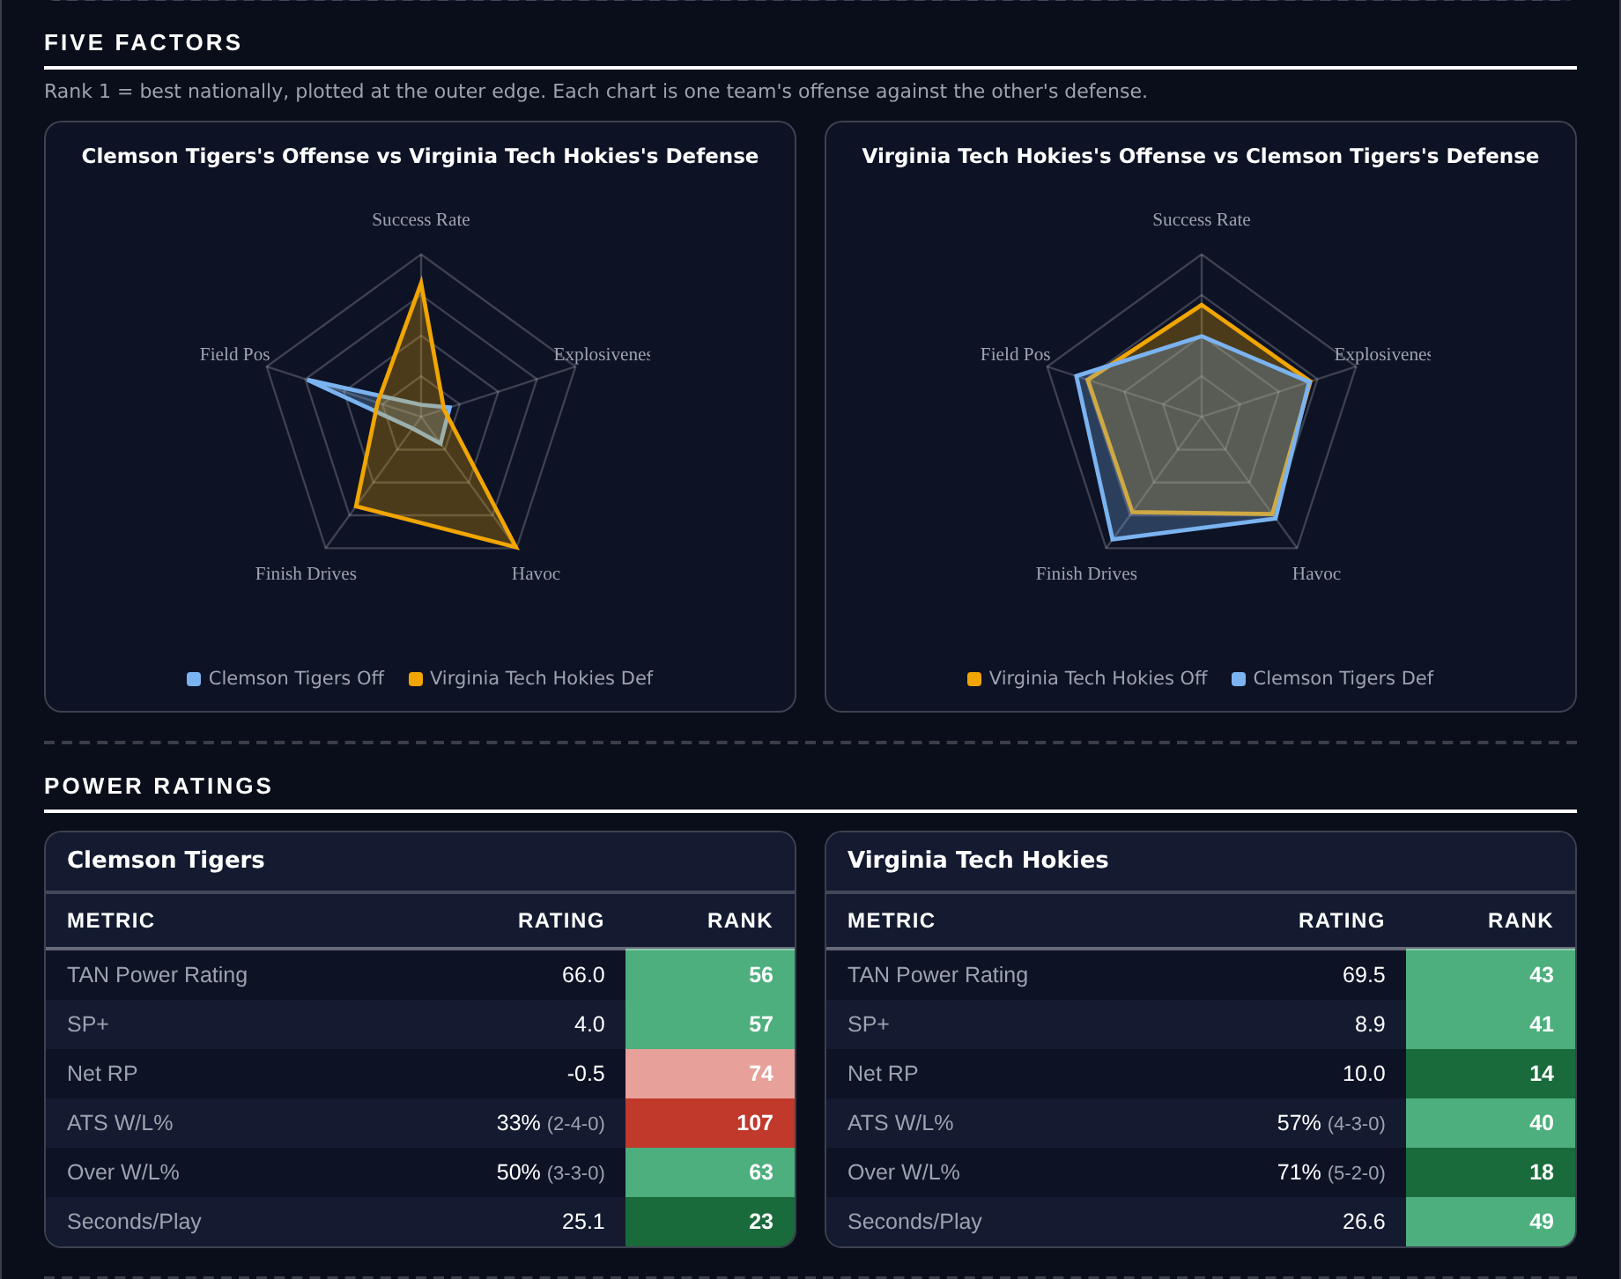
Five Factors and power ratings, captured from the CFB Betting Hub.
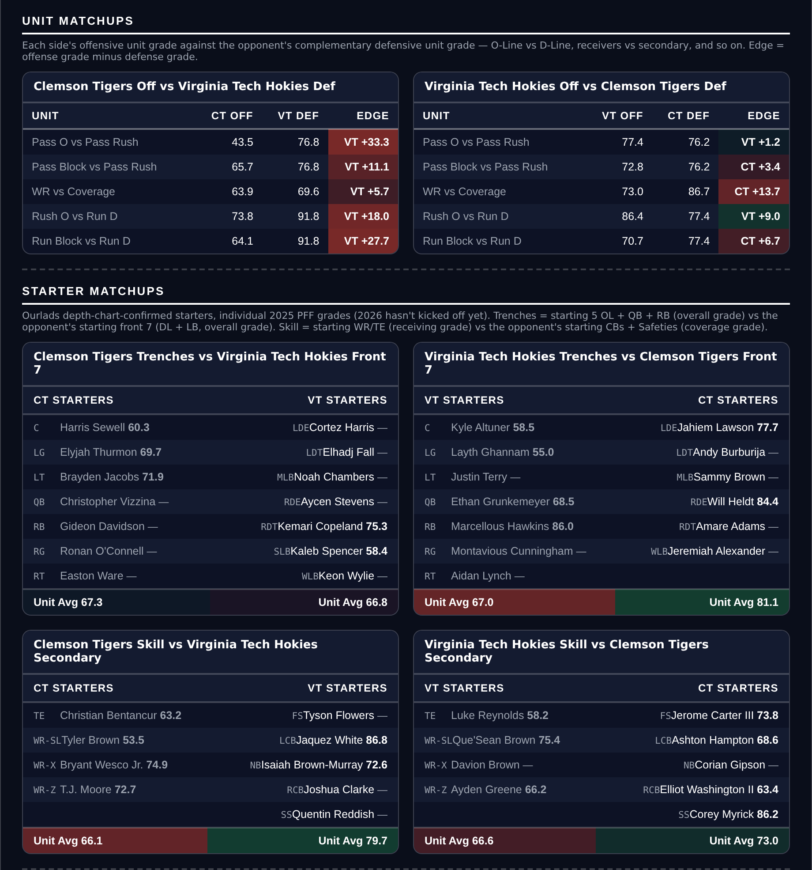
Unit matchups: each offensive unit grade against the opposing defensive unit. Edge = offense minus defense.

Bowling Green Falcons @ Buffalo Bulls

Buffalo -3.0
Book line | Buffalo -3.0
Model number | Buffalo -8.4
Gap | 5.4 pts, 5.4 net
Points check | Buffalo by 6.5, which is 3.5 past the market
SP+ (2026) | Buffalo -12.2 (118th) vs Bowling Green -17.9 (130th), home edge +2.7
Buffalo 2026 | 4-3, 21.4 points a game and 25.6 allowed
Buffalo defense | 42nd overall, 87.5 run defense (31st), 81.2 pass rush (20th)
Bowling Green offense | 18.0 points a game, 116th in Success Rate, 133rd in Explosiveness

Book has Buffalo -3.0. The rating has it at 8.4 and the points check at 6.5, both comfortably past the number and on the same side. This is a small game between two sides outside the top hundred, and the gap between them is wider than three points.
Buffalo have become the more functional team. They are 4-3 having started 1-3, their defence grades 86.8 and ranks 42nd with an 87.5 run-defence mark that ranks 31st and an 81.2 pass rush that ranks 20th, and they hold opponents to 25.6 after allowing far more early. Their 80.0 tackling grade ranks 19th.
Bowling Green score 18.0 points a game on an offence that ranks 116th in Success Rate, 133rd in Explosiveness and 131st in Finishing Drives, and their defence ranks 128th in Success Rate on a 63.0 run-defence grade that is 133rd. They also play at 31.3 seconds a snap, 133rd in the country, which is a slow team that is not scoring and is now on the road.
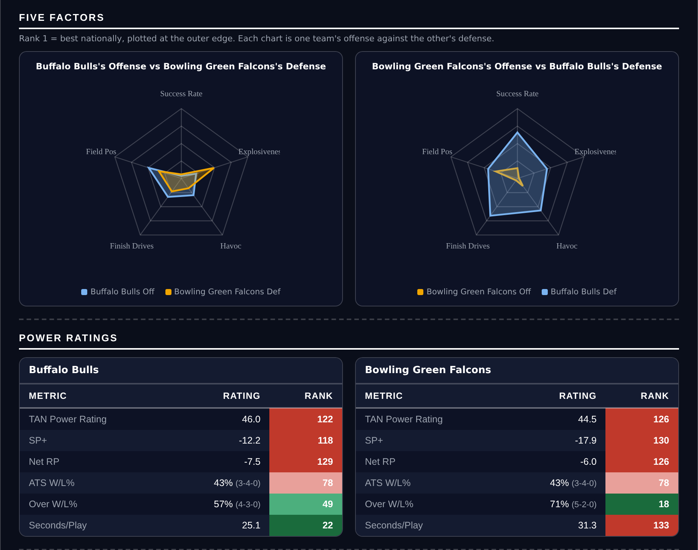
Five Factors and power ratings, captured from the CFB Betting Hub.
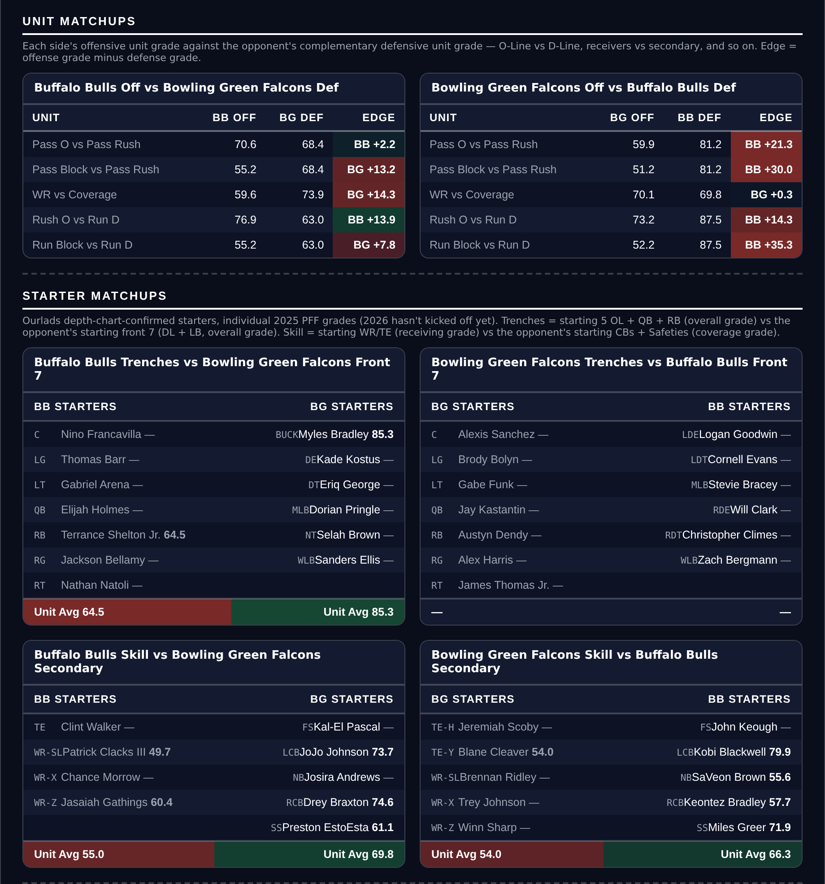
Unit matchups: each offensive unit grade against the opposing defensive unit. Edge = offense minus defense.

Oklahoma Sooners @ Mississippi State Bulldogs

Mississippi State +3.0
Book line | Mississippi State +3.0
Model number | 0.0, a pick'em
Gap | 3.0 pts, 3.0 net
Points check | Oklahoma by 2.9, which is 0.1 inside the market
SP+ (2026) | Oklahoma +9.8 (34th) vs Mississippi State +7.3 (48th), home edge +2.5
Mississippi State 2026 | 4-2, 4-2 ATS (23rd), 32.5 points a game
Oklahoma offense | 21.3 points a game, 119th in Success Rate, 134th in Explosiveness
Mississippi State tempo | 23.8 seconds a snap, 7th in the country

SP+ separates these two by 2.5 and home field is worth 2.5, which makes this a pick'em on the rating. The market asks Mississippi State to take three, and the points check has the game inside the number at Oklahoma by 2.9. Both measures say the Bulldogs are getting a free half-point or better at home.
Mississippi State are 4-2 and 4-2 against the spread, 23rd in the country, and they score 32.5 points a game against Oklahoma's 21.3. They play at 23.8 seconds a snap, 7th nationally, which adds possessions in a game the market expects to stay close.
Oklahoma's offence is the weak half of this matchup. It ranks 119th in Success Rate, 134th in Explosiveness and 115th in Finishing Drives on a 62.1 grade that is 127th in the country, and it ranks 114th in offensive Field Position. Their defence is genuinely good, 5th in Success Rate, but a team that cannot score 25 is a difficult team to lay three points with on the road.
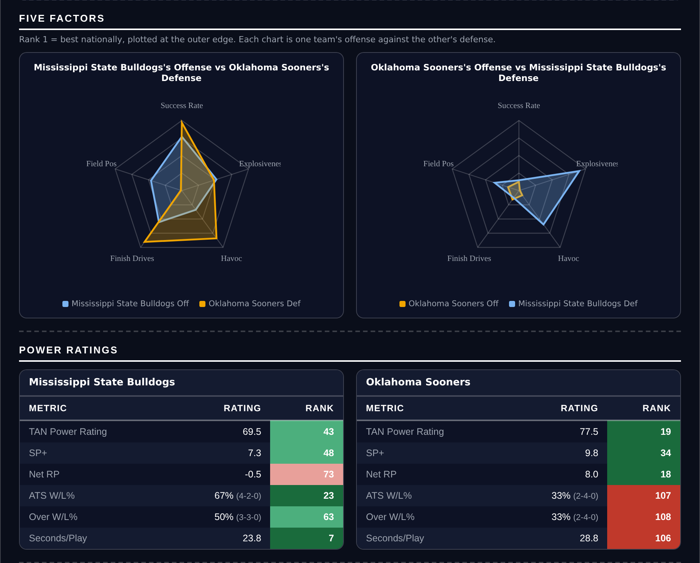
Five Factors and power ratings, captured from the CFB Betting Hub.
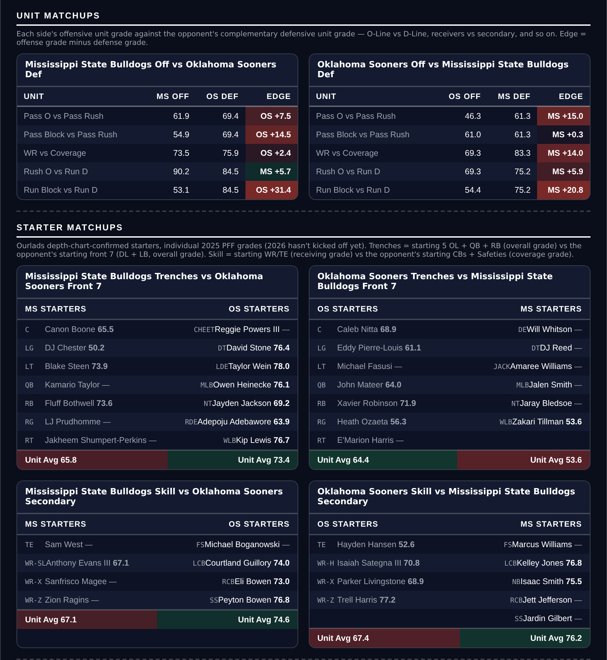
Unit matchups: each offensive unit grade against the opposing defensive unit. Edge = offense minus defense.

Tennessee Volunteers @ South Carolina Gamecocks

Tennessee +2.5
Book line | South Carolina -2.5
Model number | Tennessee -4.7
Gap | 7.2 pts, 7.2 net
Points check | Tennessee by 0.5, which is 3.0 past the market
SP+ (2026) | Tennessee +17.5 (13th) vs South Carolina +10.0 (32nd), home edge +2.8
Tennessee 2026 | 6-1, 33.4 points a game and 14.7 allowed
Tennessee defense | 21st in Success Rate, 6th in Explosiveness allowed, 84.6 pass rush (7th)
South Carolina defense | 123rd in Finishing Drives, 58.8 tackling (109th)

SP+ rates Tennessee 7.5 points clear of South Carolina and the market still asks the Volunteers to take points on the road. Home field accounts for 2.8 of that, leaving the rating at Tennessee by 4.7 and the points check at Tennessee by 0.5. Both want the visitor.
Tennessee are 6-1 and the defence is the reason. It ranks 21st in Success Rate, 6th in Explosiveness allowed, 7th in Finishing Drives and 3rd in Havoc, grades 90.5 overall with an 89.7 coverage mark that ranks 21st, and its 84.6 pass-rush grade ranks 7th in the country. They allow 14.7 points a game.
South Carolina score 37.7 a game, so this is not a case of a bad offence, but the defensive half of their sheet is where the game turns. They rank 123rd in Finishing Drives and tied 103rd in Havoc, their tackling grade of 58.8 ranks 109th and their coverage grade of 70.5 ranks 98th. Against a Tennessee team allowing 14.7, the Gamecocks need the shootout their own defence is least equipped to survive.
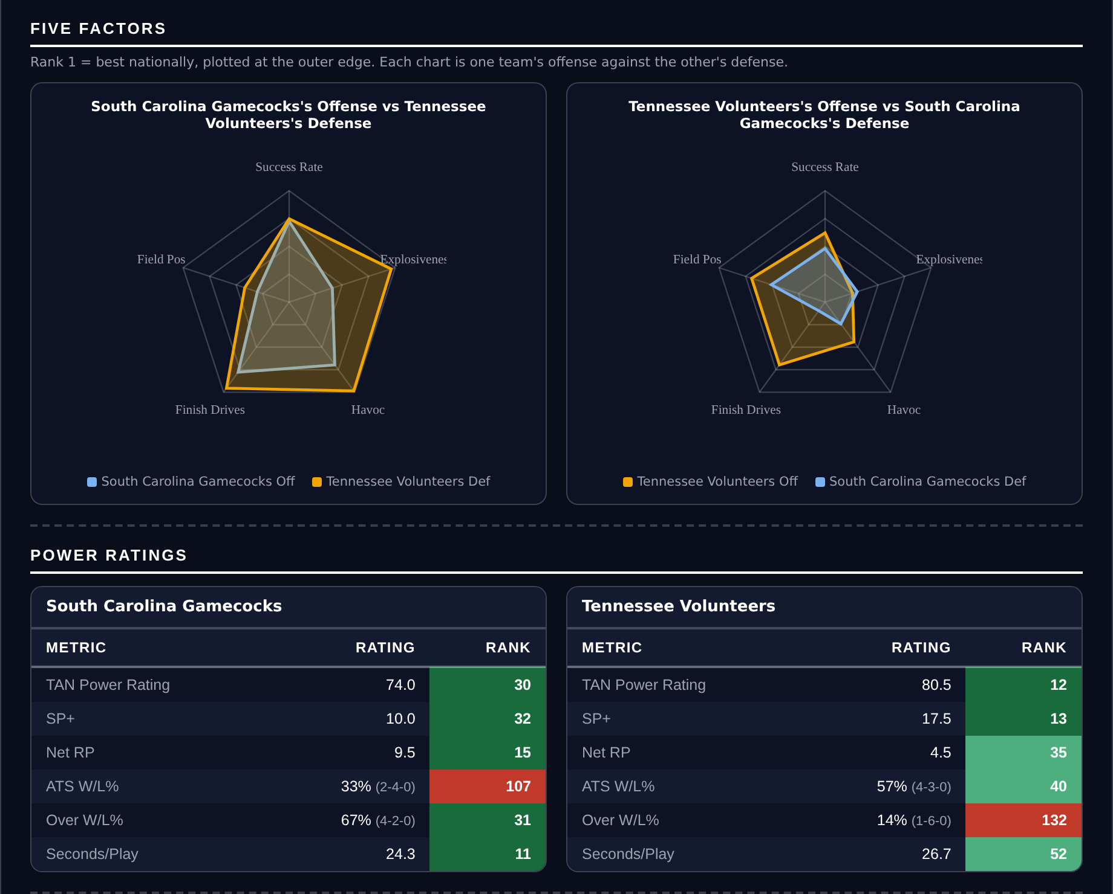
Five Factors and power ratings, captured from the CFB Betting Hub.
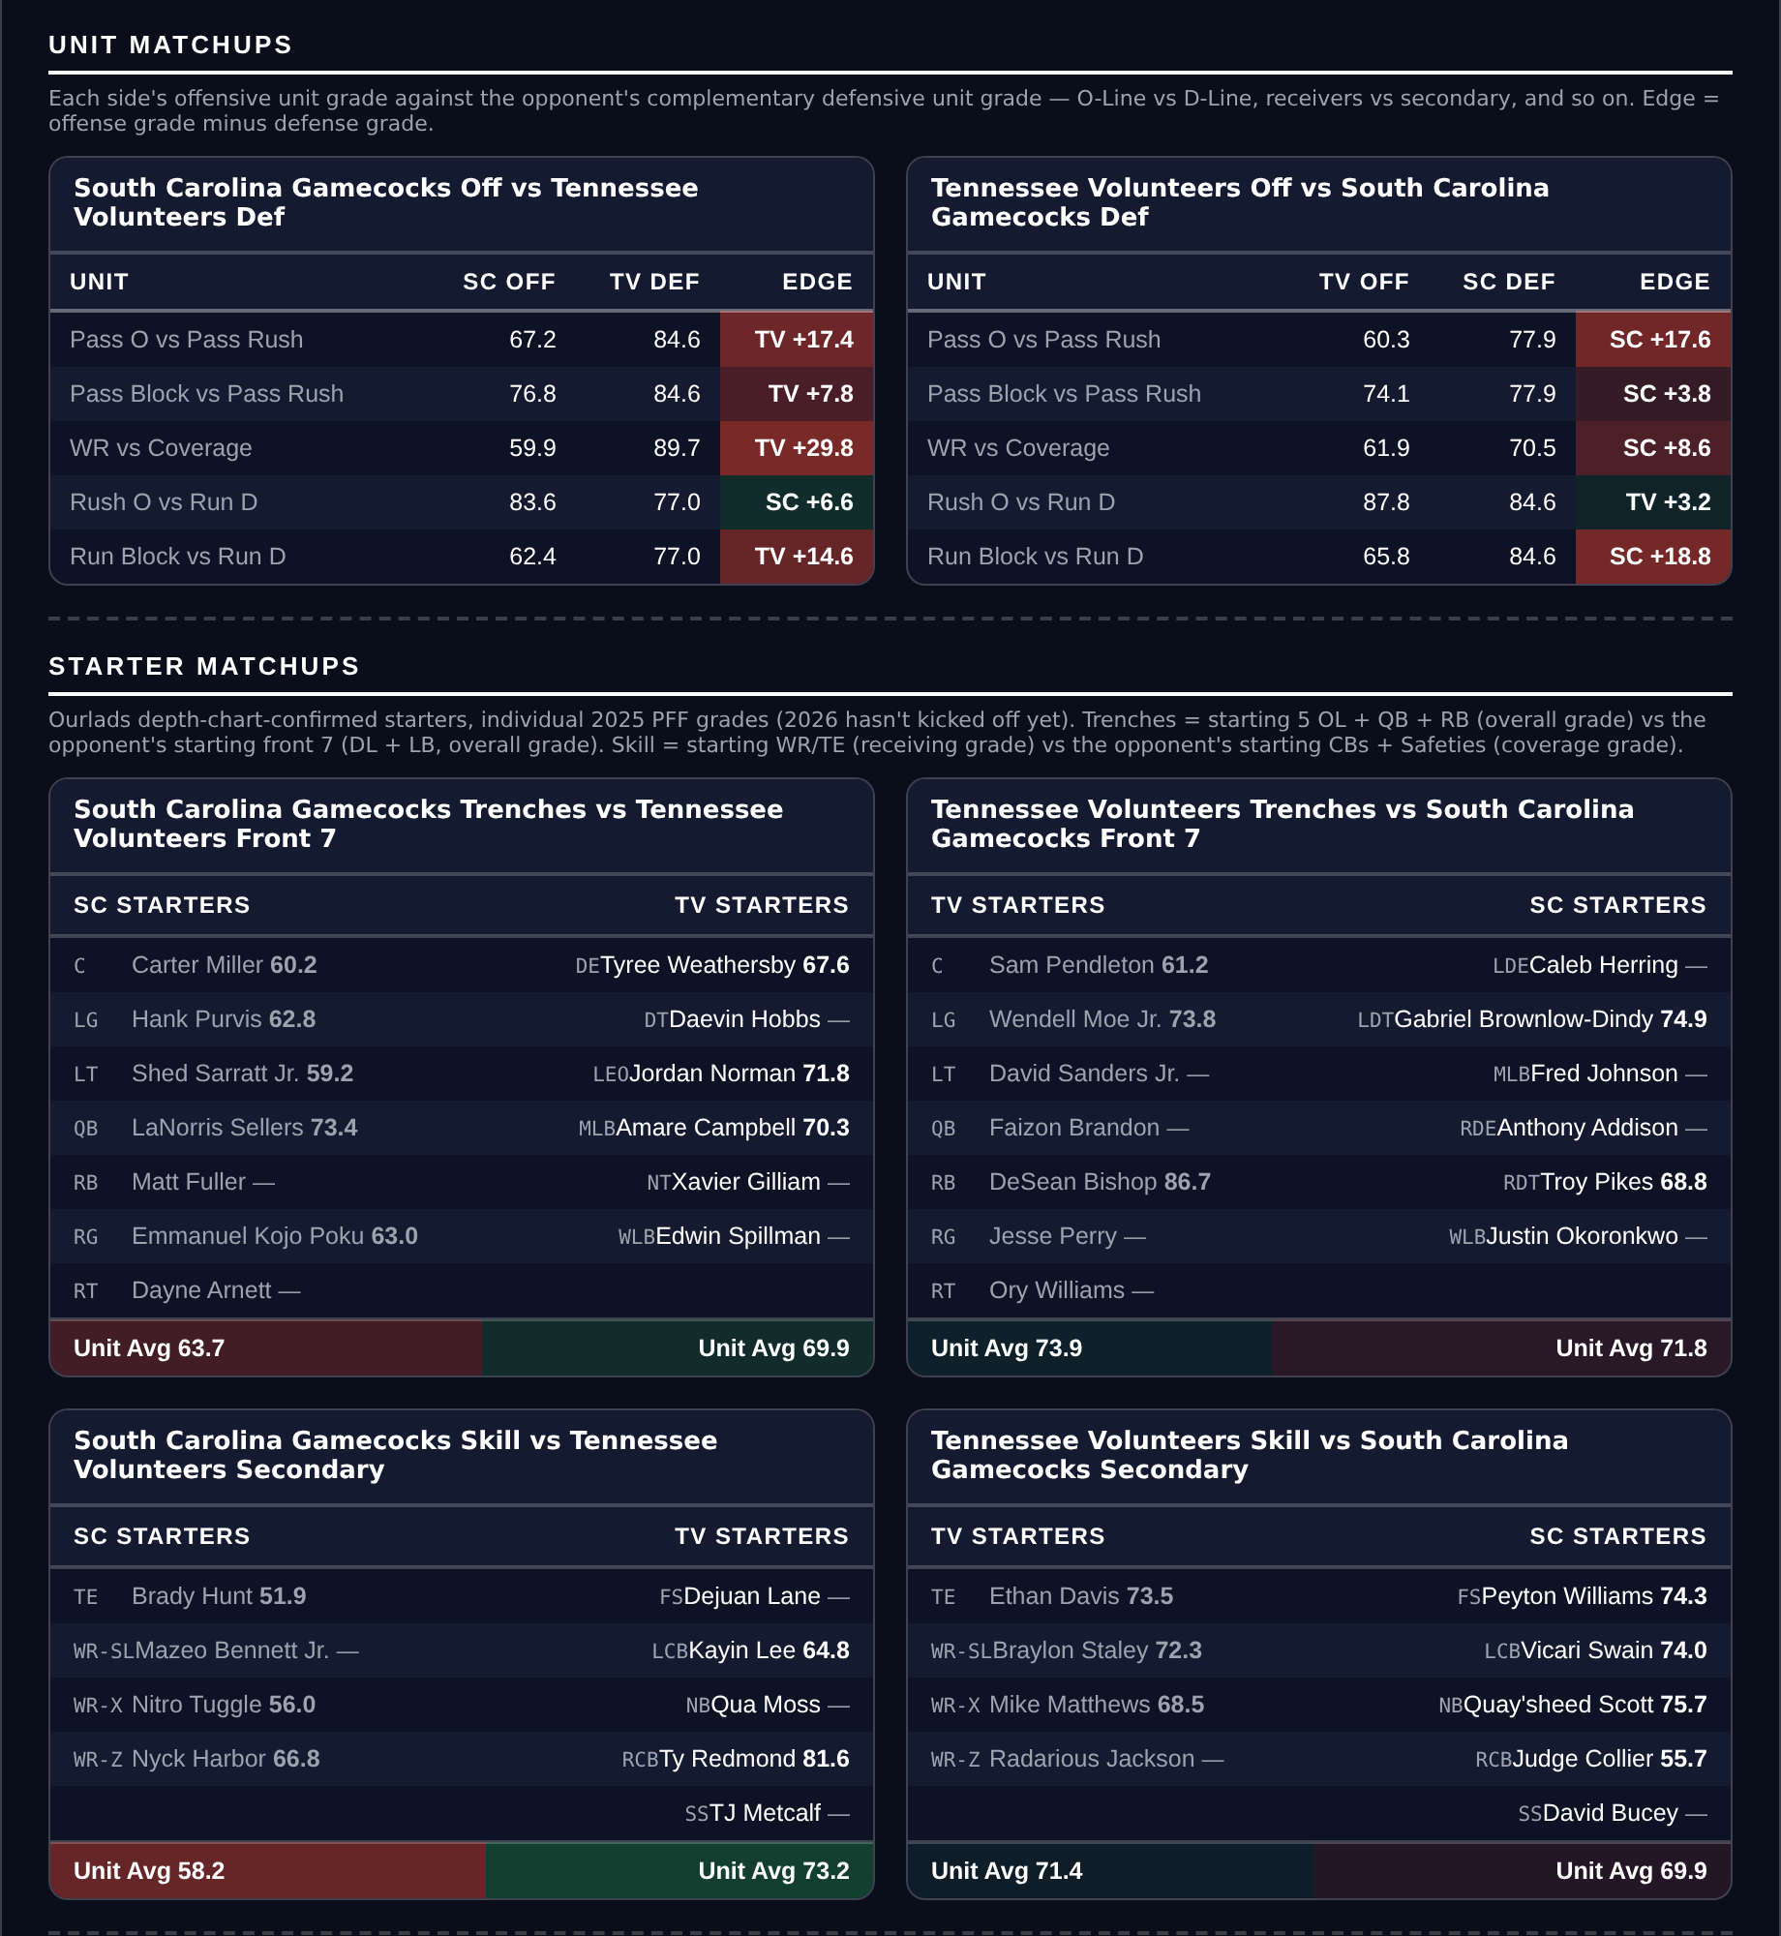
Unit matchups: each offensive unit grade against the opposing defensive unit. Edge = offense minus defense.

Western Michigan Broncos @ Toledo Rockets

Toledo -3.0
Book line | Toledo -3.0
Model number | Toledo -5.9
Gap | 2.9 pts, 2.9 net
Points check | Toledo by 4.9, which is 1.9 past the market
SP+ (2026) | Toledo +1.8 (65th) vs Western Michigan -1.5 (82nd), home edge +2.6
Toledo 2026 | 5-2, 36.3 points a game and 23.6 allowed
Toledo offense | 83.1 offensive grade (17th), 14th in Explosiveness
Western Michigan offense | 25.0 points a game, 123rd in Explosiveness

Book has Toledo -3.0. The rating has it at 5.9 and the points check at 4.9, so both sit on the same side of a field goal without either shouting. This is the narrowest of the five and it is ranked last here for that reason.
Toledo are 5-2 and score 36.3 points a game, more than eleven clear of Western Michigan's 25.0, on an offence that grades 83.1 and ranks 17th in the country and 14th in Explosiveness. They are also 5-2 to the Over, 18th, in a game posted at 47.5.
Western Michigan's defence is excellent and the card is not pretending otherwise: 4th overall by grade, 1st in pass rush, 1st in tackling. The problem is the other half. Their offence scores 25.0 on a 70.8 grade, ranks 123rd in Explosiveness, and their special teams grade 60.3, which is 126th. A team that cannot generate explosive plays and gives up field position has to win on defence alone, on the road, against the better offence.
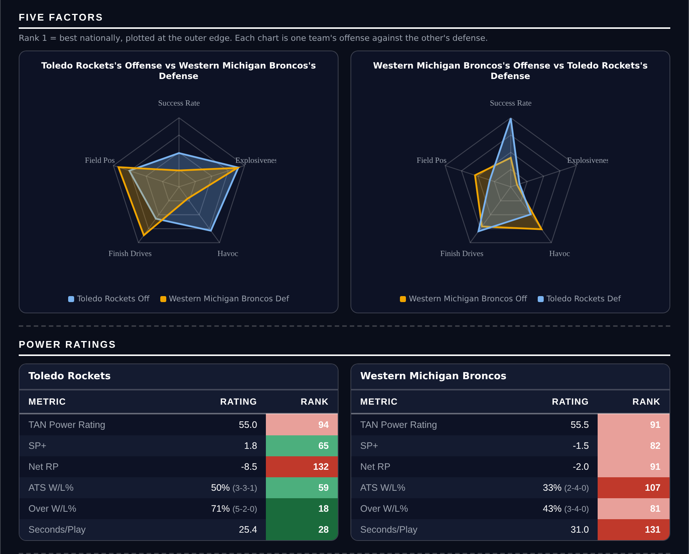
Five Factors and power ratings, captured from the CFB Betting Hub.
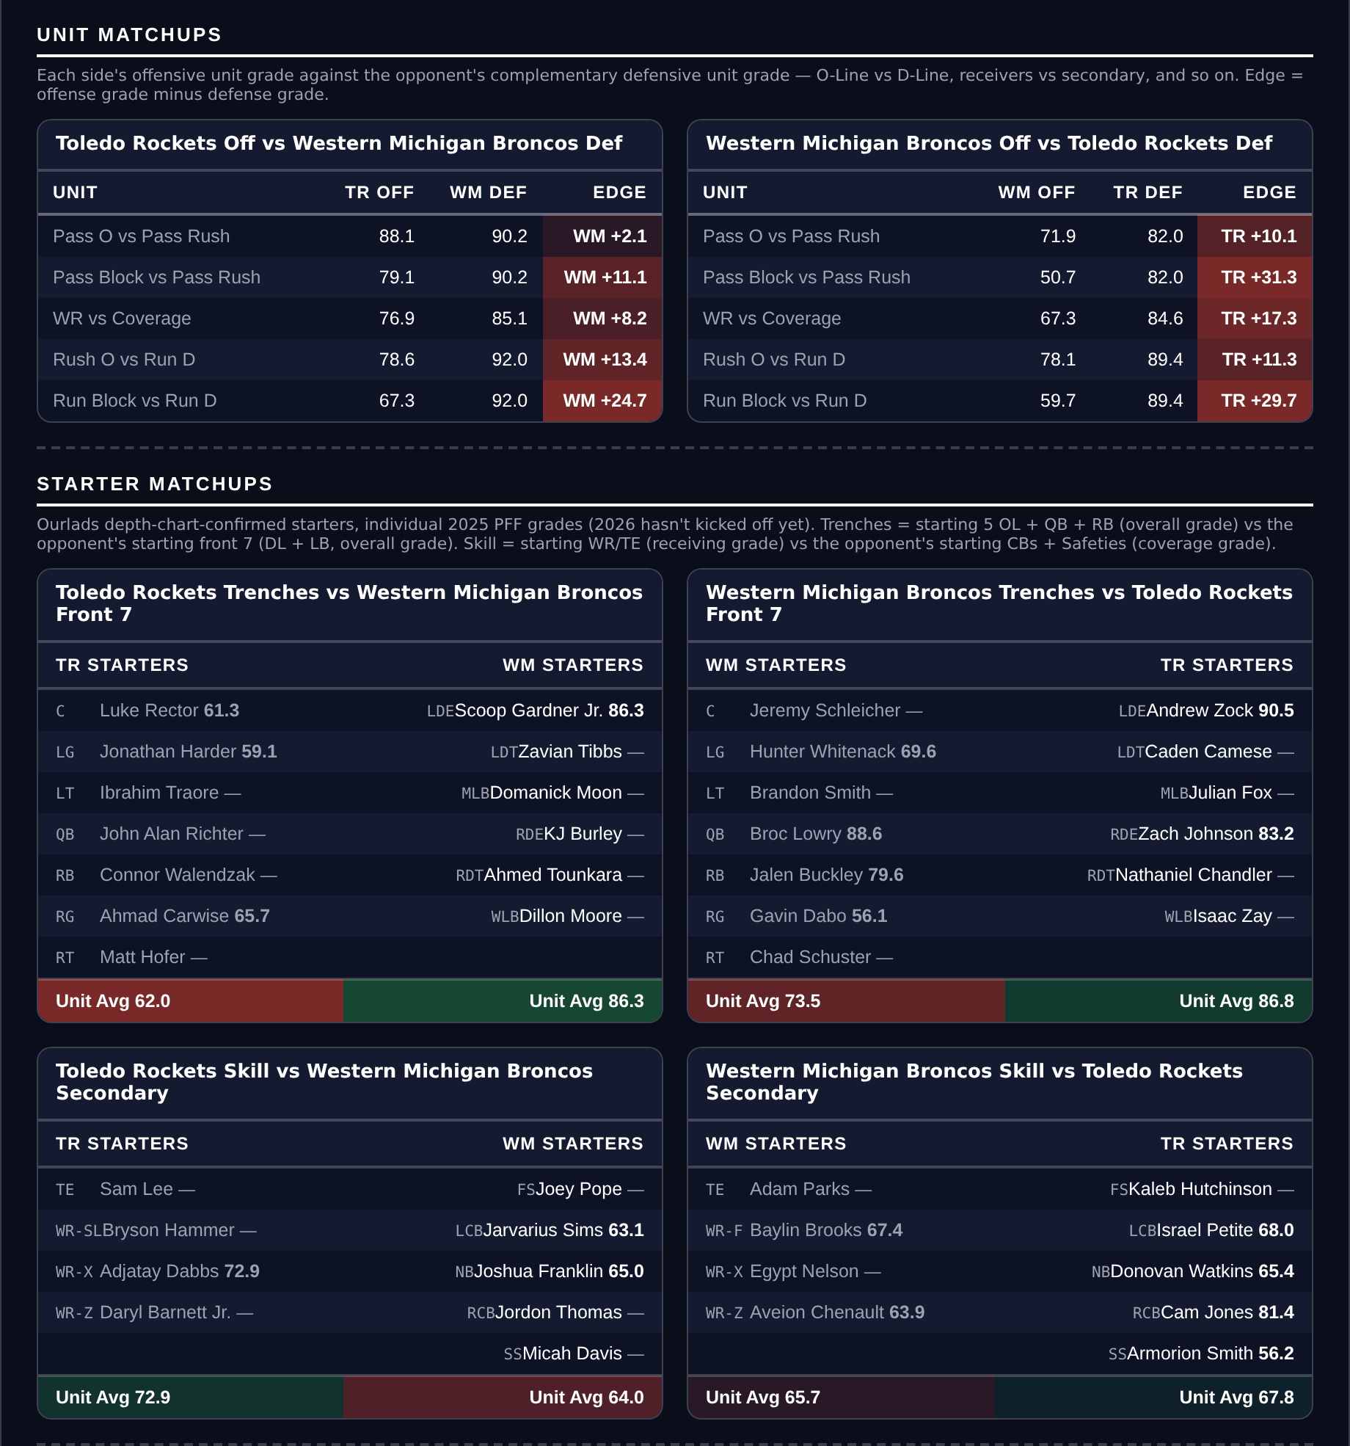
Unit matchups: each offensive unit grade against the opposing defensive unit. Edge = offense minus defense.

Player Props
Four props rather than five, and the reason is worth stating. 293 priced rows went through the eight screens — a model edge of at least 20 percent; the player’s own 2026 production agreeing with the side by at least 20 percent; a real role, 20+ targets for receivers and 12+ carries a game for backs; 4+ targets a game for any receiving Over; no opponent or pace multiplier outside 0.6 to 1.6; a spread under 28 points with a rated opponent; at least two books posting the number; and the player’s own game count level with his team’s — and seven survived.
Those seven were then checked against this morning’s depth charts, and three of them are not listed as starters: a tight end listed fourth at his position despite leading the board in targets, a back listed second behind the teammate who was named as his committee risk two weeks ago, and a slot receiver listed second. All three came off. The screens read production, which looks backwards; the depth chart reads role, which looks forwards, and on this slate they disagreed about nearly half the board.
The four below clear both. Each is stated first against the player’s own per-game rate, before the model is consulted.
Quarterback rushing props remain excluded. Sacks count against rushing yards in official college statistics and not in PFF, so the model projects a stat the market is not pricing.
Ratings and the Five Factors come from the 2026 workbook: SP+, TAN, implied team totals and the season-to-date CFBData ranks, out of 138 teams. Player lines are 2026 PFF season to date. Records, ATS and over/under records are TeamRankings, 2026 to date. The PFF team grade file covers six games for 57 teams, seven for 78 and eight for 3. Futures prices are the week 8 pull except win totals, which are week 7.

LSU Tigers @ Auburn Tigers

Eugene Wilson III Over 26.5 receiving yards
Book line | Over 26.5 receiving yards
Model projection | 40.3 yards
2026 production | 247 yards in 7 games, 35.3 a game
Role | 34 targets, 4.9 a game, 23 receptions over 204 routes
Profile | 8.4 average depth of target, 1.21 yards per route run, 58.0 route grade, long of 53
LSU offense | 6th in Success Rate, 40.4 points a game
Auburn coverage | 60.2 coverage grade, 120th in the country
Game total | 51.5, LSU -7.0

Wilson averages 35.3 receiving yards a game across seven and the line is 26.5. The margin is nearly nine yards on his own rate, and the projection lands at 40.3 after the opponent and pace adjustments.
He is a volume receiver rather than an efficient one, and the write-up should say so plainly: 34 targets and 23 receptions over 204 routes, 4.9 targets a game, 1.21 yards per route run and a 58.0 route grade at an 8.4-yard average depth of target. What makes the number reachable is the 68 percent catch rate and a long of 53 that shows the ceiling when the coverage breaks.
The matchup is the strongest part of it. LSU's offence ranks 6th in the country in Success Rate and scores 40.4 points a game, and Auburn's coverage grade of 60.2 ranks 120th on a defence that grades 73.1, 108th. LSU are laying seven in a game posted at 51.5, which is the script where the passing game stays live into the second half.

Texas A&M Aggies @ Alabama Crimson Tide

Rico Scott Under 55.5 receiving yards
Book line | Under 55.5 receiving yards
Model projection | 32.7 yards
2026 production | 278 yards in 7 games, 39.7 a game
Role | 36 targets, 5.1 a game, 22 receptions over 220 routes
Profile | 13.6 average depth of target, 1.26 yards per route run, 58.8 route grade
Season long | 32 yards, so the line needs at least two catches
Texas A&M defense | 31st in Success Rate, 20th in Finishing Drives
Game total | 50.5, Alabama -13.5

The line is 55.5 and Scott has averaged 39.7 receiving yards a game across seven. The market is asking him to beat his own season rate by sixteen yards, and the projection has him at 32.7.
The efficiency is why the number is hard for him. Twenty-two receptions on 36 targets over 220 routes is 1.26 yards per route run on a 58.8 route grade, and at a 13.6-yard average depth of target that is a receiver being thrown at downfield without converting. His longest catch of the season is 32 yards, so 55.5 cannot arrive on one play — it needs at least two, and his per-game rate says he rarely gets there with four.
The script points the same way. Alabama are laying 13.5 at home in a game posted at 50.5, which is the shape where a favourite leads comfortably and the passing volume comes down in the fourth quarter. Texas A&M's defence ranks 31st in Success Rate and 20th in Finishing Drives, so the Aggies are not the sort of opponent that forces Alabama to keep throwing.

Colorado Buffaloes @ Oklahoma State Cowboys

Caleb Hawkins Over 23.5 receiving yards
Book line | Over 23.5 receiving yards
Model projection | 35.3 yards
2026 production | 200 receiving yards in 6 games, 33.3 a game
Role | 25 targets, 4.2 a game, 20 receptions over 127 routes
Profile | 1.1 average depth of target, 1.57 yards per route run, 78.7 route grade, long of 66
Also the lead back | 592 rushing yards on 123 carries, 20.5 a game
Colorado defense | 135th in defensive Field Position, 2-4 and 19.5 points a game
Game total | 56.0, Oklahoma State -13.5

Hawkins averages 33.3 receiving yards a game and the line is 23.5. Ten yards of margin on his own rate, and the projection puts him at 35.3.
He is the complete back rather than a receiving specialist, which is what makes the receiving line reachable: 592 rushing yards on 123 carries alongside 25 targets and 20 receptions over 127 routes, 4.2 targets a game, at a 1.1-yard average depth of target. That is checkdown work with an 80 percent catch rate, a 78.7 route grade and 1.57 yards per route run, and his long of 66 shows what happens when one of them breaks.
The setting helps. The game is posted at 56.0, the highest total of the nine games on this card, with Oklahoma State laying 13.5 against a Colorado side that is 2-4, scores 19.5, and ranks 135th in defensive Field Position. Oklahoma State score 37.2 a game on an offence that ranks 11th in Success Rate, so the possessions and the short fields are both there.

Baylor Bears @ Kansas Jayhawks

Dawson Pendergrass Over 34.5 rushing yards
Book line | Over 34.5 rushing yards
Model projection | 48.9 yards
2026 production | 327 yards in 6 games, 54.5 a game
Role | 90 carries, 15.0 a game, 3.6 yards an attempt
Profile | 10.1 percent breakaway rate, 242 yards after contact, 14 avoided tackles, 77.7 run grade, long of 17
What the line asks | 2.3 yards a carry on his usual volume
Kansas defense | 125th in defensive Field Position, 24.0 points allowed a game
Game total | 53.5, Baylor -1.0

Pendergrass averages 54.5 rushing yards a game across six and the line is 34.5. Twenty yards of margin on his own rate, and the projection lands at 48.9.
This is a volume position and the profile says so: 90 carries at 3.6 yards an attempt with a 10.1 percent breakaway rate and a long of 17 for the season. He does not break games open. What he does is carry it 15 times a game with 242 yards after contact and 14 avoided tackles on a 77.7 run grade, and 34.5 yards on that volume asks for 2.3 a carry — below what he has averaged in every game this season.
Kansas give up the field position that keeps a running back busy, ranking 125th in defensive Field Position while allowing 24.0 points a game, and the game is posted at 53.5 with Baylor laying a point. Baylor play at 22.2 seconds a snap, 2nd in the country, which turns a close game into more possessions and more carries.

