Spreads to Target
Week 4 · September 25-27, 2026
Every figure here is checked against the underlying data: 39 PFF grade claims and 65 Five Factors rank claims were verified against team_pff_grades_2026.csv and the built board before this was written, and each player's role, carry or target share and 2026 production against the PFF season file.
Season to date: 13-16-1, down 4.85 units across 30 picks. Spreads 3-7 (-4.70u), totals 5-4-1 (+0.60u), props 5-5 (-0.75u).
Five spreads where the book and the 2026 power ratings disagree most. The model number is SP+ differential plus home field edge; the gap is the distance between it and the market.
Two changes to how these were picked. First, the slate has a level: across the 49 rated games the model sits 1.57 points more toward the home favorite than the book does, so each gap is quoted both raw and after that level is removed. Second, the pattern in the losses is now explicit. Seven of the ten spread picks so far have lost, and four of those seven were the same shape: laying a price against a team whose ATS record was running ahead of its rating. Georgia State beat that fade twice and Middle Tennessee once. Jacksonville State -7.0 was the largest de-meaned gap on this board and is not here, because it is a fade of a 3-0 ATS Middle Tennessee. Northern Illinois +10.5 is not here for the same reason.
Unlike the totals, line size and team quality filter nothing here: the correlation between average team rank and the size of the de-meaned gap is +0.15.
Ratings and the Five Factors come from the 2026 workbook (SP+, TAN, team totals, and the CFBData26 season-to-date ranks, out of 138 teams). Player lines are 2026 PFF season to date. Records, ATS and over/under are TeamRankings, 2026 to date, refreshed this week for all three pages. The PFF team grade file is two graded games deep while the records are three or four, so points for and against are labelled as two-game figures wherever they appear.

Troy +3.0
Troy Trojans @ Utah State Aggies
Book line | Utah State -3.0
Model number | Troy -7.7
Gap | 10.7 pts, 9.1 after the slate's own level
SP+ (2026) | Troy +1.0 (67th) vs Utah State -9.3 (106th)
Home edge | +2.6
2026 records | Troy 2-1 (+3.3 MOV), Utah State 0-3 (-15.7 MOV)
Utah State offense | 131st Success Rate, 136th Finishing Drives

Book has Utah State -3.0 at home. The 2026 rating puts Troy ahead by 7.7: Troy +1.0 (67th) against Utah State -9.3 (106th), home edge +2.6. A 10.7-point gap, and 9.1 of it survives once the slate's own level is removed, which is the largest on the board.
Utah State is 0-3 and has been outscored by 15.7 a game. The offense is the reason: 131st in Success Rate, 136th in Finishing Drives, and a 37.4 passing grade against a 55.1 offense grade, with 31 points scored across two graded games. Neither their record nor their scoring argues with the rating, which is what separates this from the week 3 fades that lost.
Troy is 2-1 with a +3.3 margin and an 80.6 passing grade, 76.7 running. Their offense ranks 10th in Explosiveness; it ranks 122nd in Success Rate, so the scoring arrives in chunks rather than drives. Against a defense ranked tied 77th in Success Rate that is the workable half of the profile.
The counterweight is Utah State's run defense, 88.9 rdef on an 81.2 tackling grade, the one unit on their roster grading above average. Troy's 53.2 run block grade is the matchup that could hold this to a field goal game. Taking the points rather than the side is the reason the number is +3.0 and not -3.0.
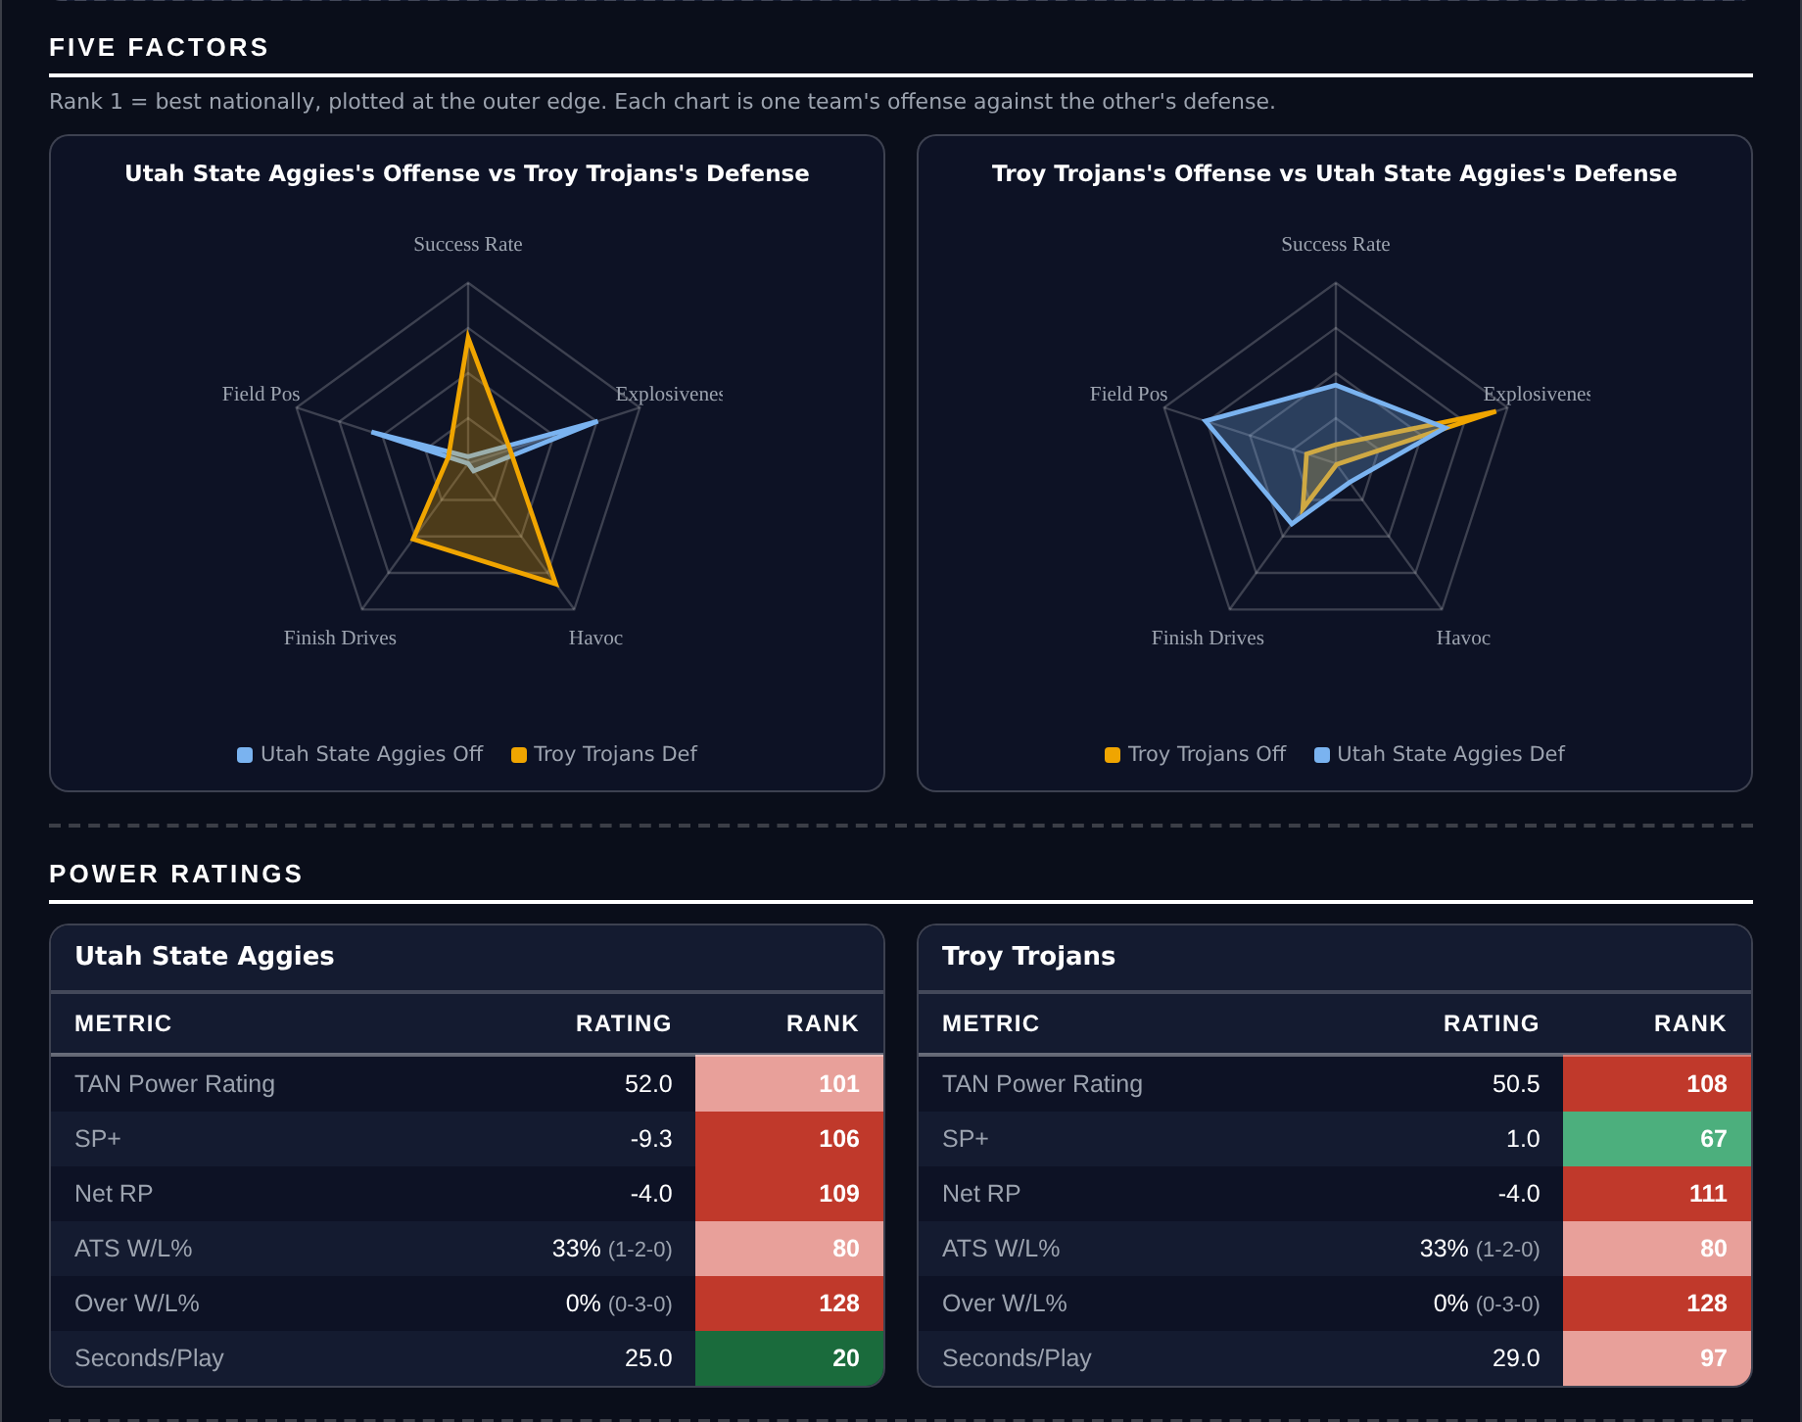
Five Factors and power ratings, captured from the CFB Betting Hub.
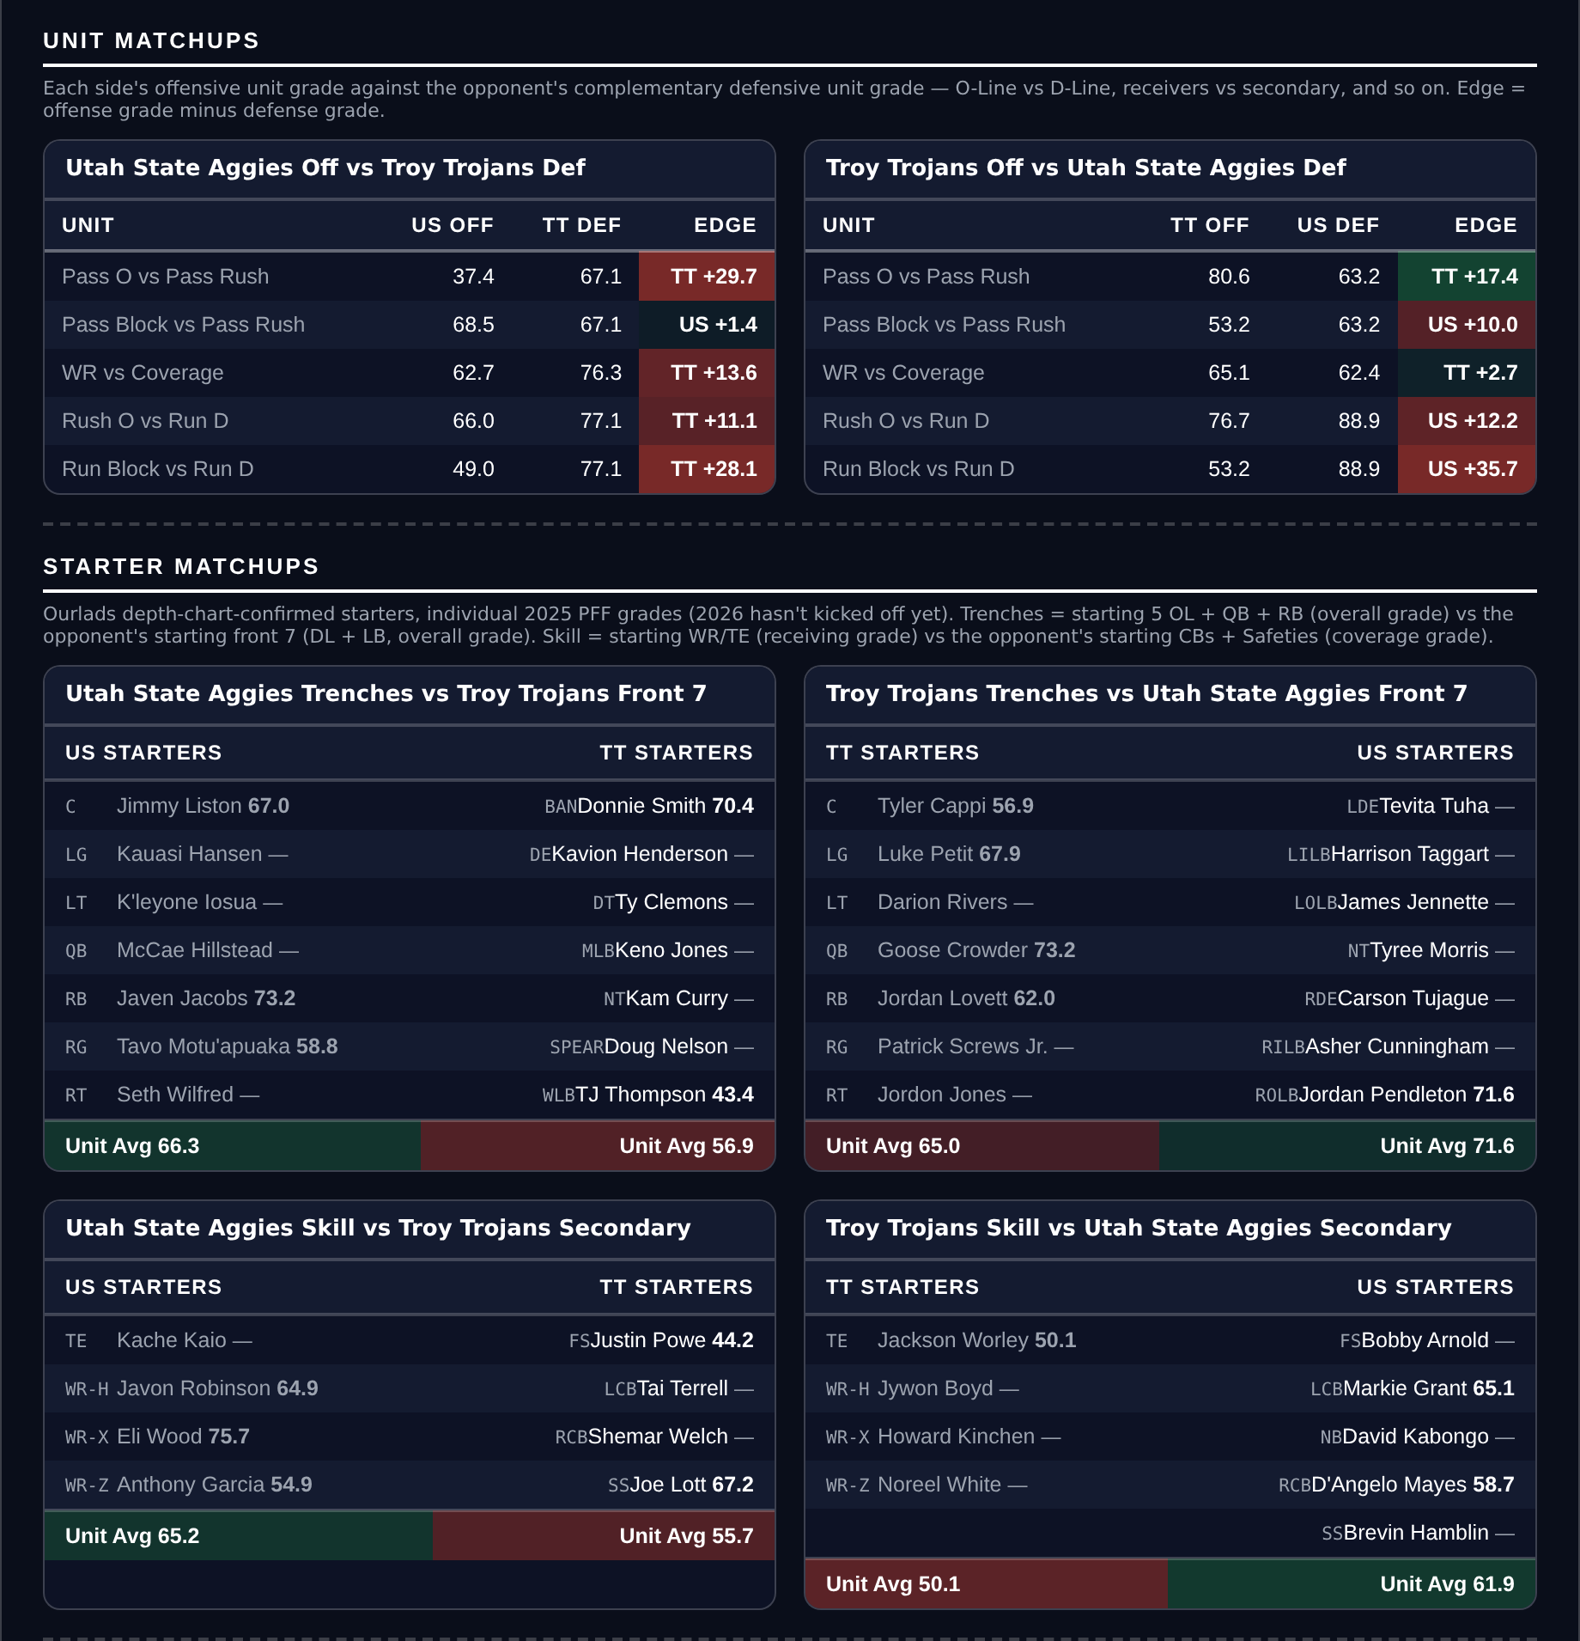
Unit matchups: each offensive unit grade against the opposing defensive unit. Edge = offense minus defense.

Penn State -10.0
Wisconsin Badgers @ Penn State Nittany Lions
Book line | Penn State -10.0
Model number | Penn State -17.2
Gap | 7.2 pts, 8.8 after the slate's own level
SP+ (2026) | Penn State +19.1 (12th) vs Wisconsin +5.1 (56th)
Penn State 2026 | 3-0, +35.0 MOV, 72 points for and 9 against
Penn State defense | 8th Success Rate, 2nd Field Position, 91.1 coverage
Wisconsin pass protection | 53.2 pass block grade

Book has Penn State -10.0. The 2026 rating puts it at -17.2: Penn State +19.1 (12th) against Wisconsin +5.1 (56th), home edge +3.2. A 7.2-point gap, 8.8 once the slate's Over-and-favorite tilt is taken out.
Penn State has allowed 9 points in two graded games. The defense ranks 8th in Success Rate, 11th in Explosiveness allowed and 2nd in Field Position, on a 91.1 coverage grade and an 85.1 defensive grade. The offense is not a passenger either: 91.1 passing, 83.4 offense, 82.3 receiving, and 72 points scored.
Wisconsin is 2-1 with a +14.3 margin and a 5th-ranked Net Rating, so this is not a bad team. The specific problem is the line of scrimmage: a 53.2 pass block grade against a 57.1 passing grade, and an offense that ranks tied 118th in Finishing Drives. Penn State's pass rush grades only 62.4, their weakest defensive number, which is the one lever Wisconsin has.
This is a lay on the better-rated team at home rather than a fade of a good record. Three of the seven spread losses so far were the other shape: laying a weak rating against a team whose ATS record was running ahead of it. Penn State is 2-1 ATS and covering by 5.8 a game; Wisconsin is 1-2 and minus 0.7.
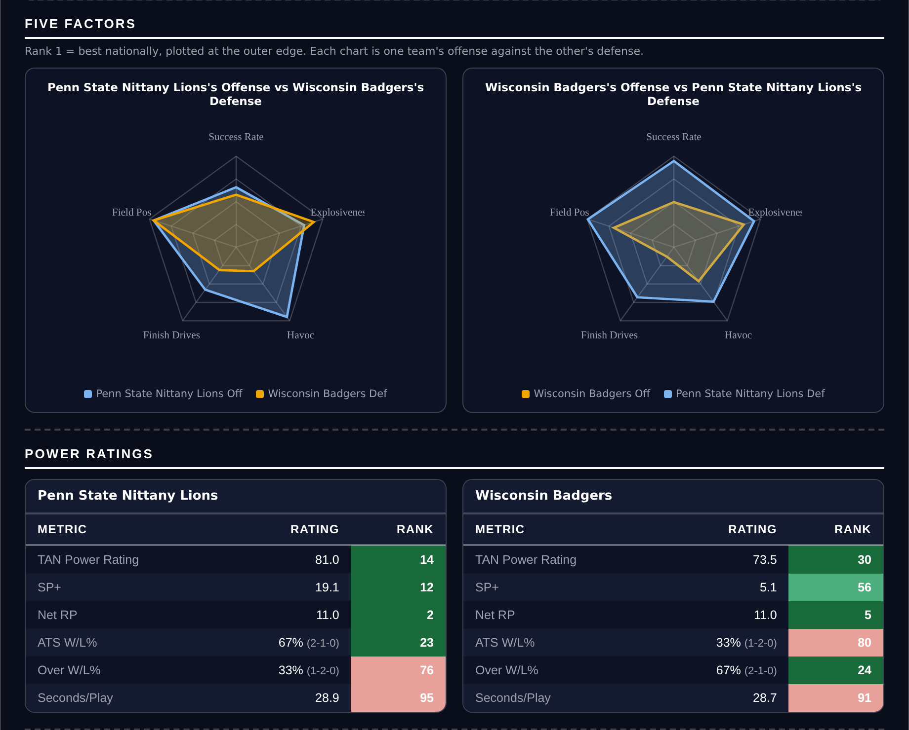
Five Factors and power ratings, captured from the CFB Betting Hub.
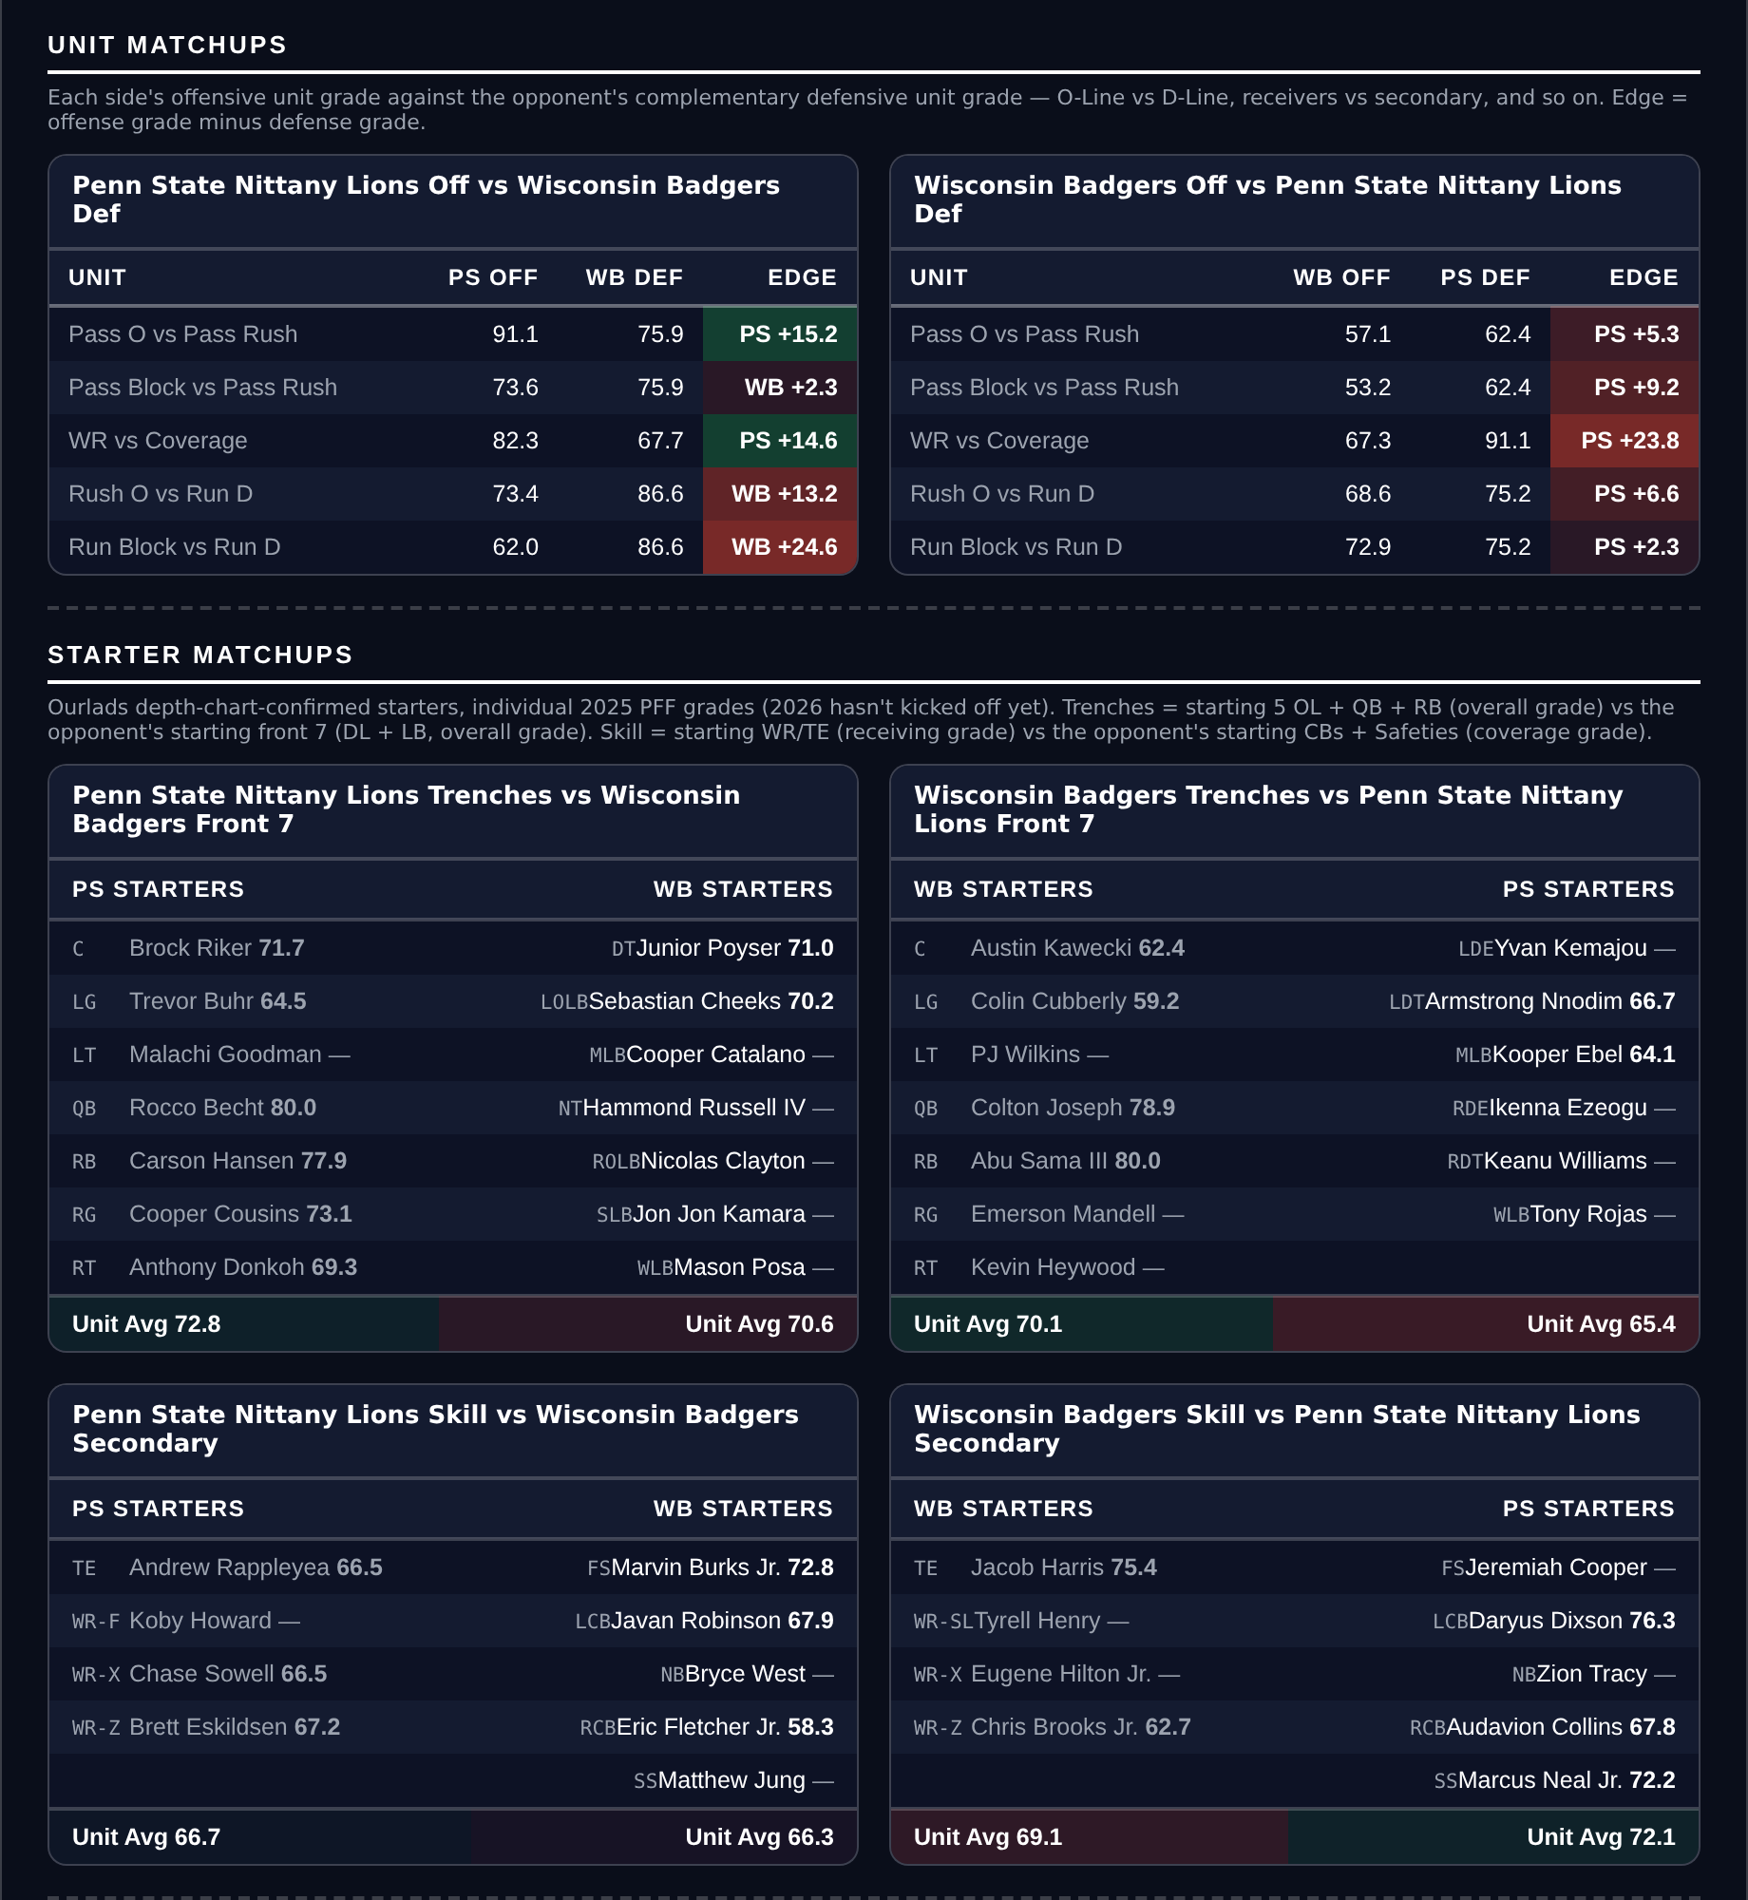
Unit matchups: each offensive unit grade against the opposing defensive unit. Edge = offense minus defense.

Georgia Tech +3.5
Georgia Tech Yellow Jackets @ Stanford Cardinal
Book line | Stanford -3.5
Model number | Georgia Tech -10.2
Gap | 6.7 pts, 5.1 after the slate's own level
SP+ (2026) | Georgia Tech +4.4 (60th) vs Stanford -7.4 (100th)
Home edge | +1.6
2026 margins | Georgia Tech +3.7, Stanford -19.0
Stanford defense | 121st Success Rate, 137th Finishing Drives, 128th Havoc

Book has Stanford -3.5 at home. The 2026 rating has Georgia Tech by 10.2: Georgia Tech +4.4 (60th) against Stanford -7.4 (100th), home edge only +1.6. A 6.7-point gap.
Both teams are 1-2, and the margins are not close. Georgia Tech is plus 3.7 a game, Stanford minus 19.0, with 43 points scored and 72 allowed across two graded games. Stanford's defense ranks 121st in Success Rate, 137th in Finishing Drives and 128th in Havoc; the offense ranks 116th, 121st and 135th in Success Rate, Finishing Drives and Field Position.
Georgia Tech's own profile is uneven. The passing grade is 69.3 and the run grade 76.7, but both lines grade badly: 42.4 pass block and 44.5 run block. Against a defense generating almost no havoc that is less costly than it would be anywhere else.
The caution is the ATS record: Georgia Tech is 0-3 and covering by minus 7.2 a game, so the market has been right about them three times. QB Alberto Mendoza transferred in from Indiana, which is why the hub carried him on Indiana's number until this week's team-resolution fix.
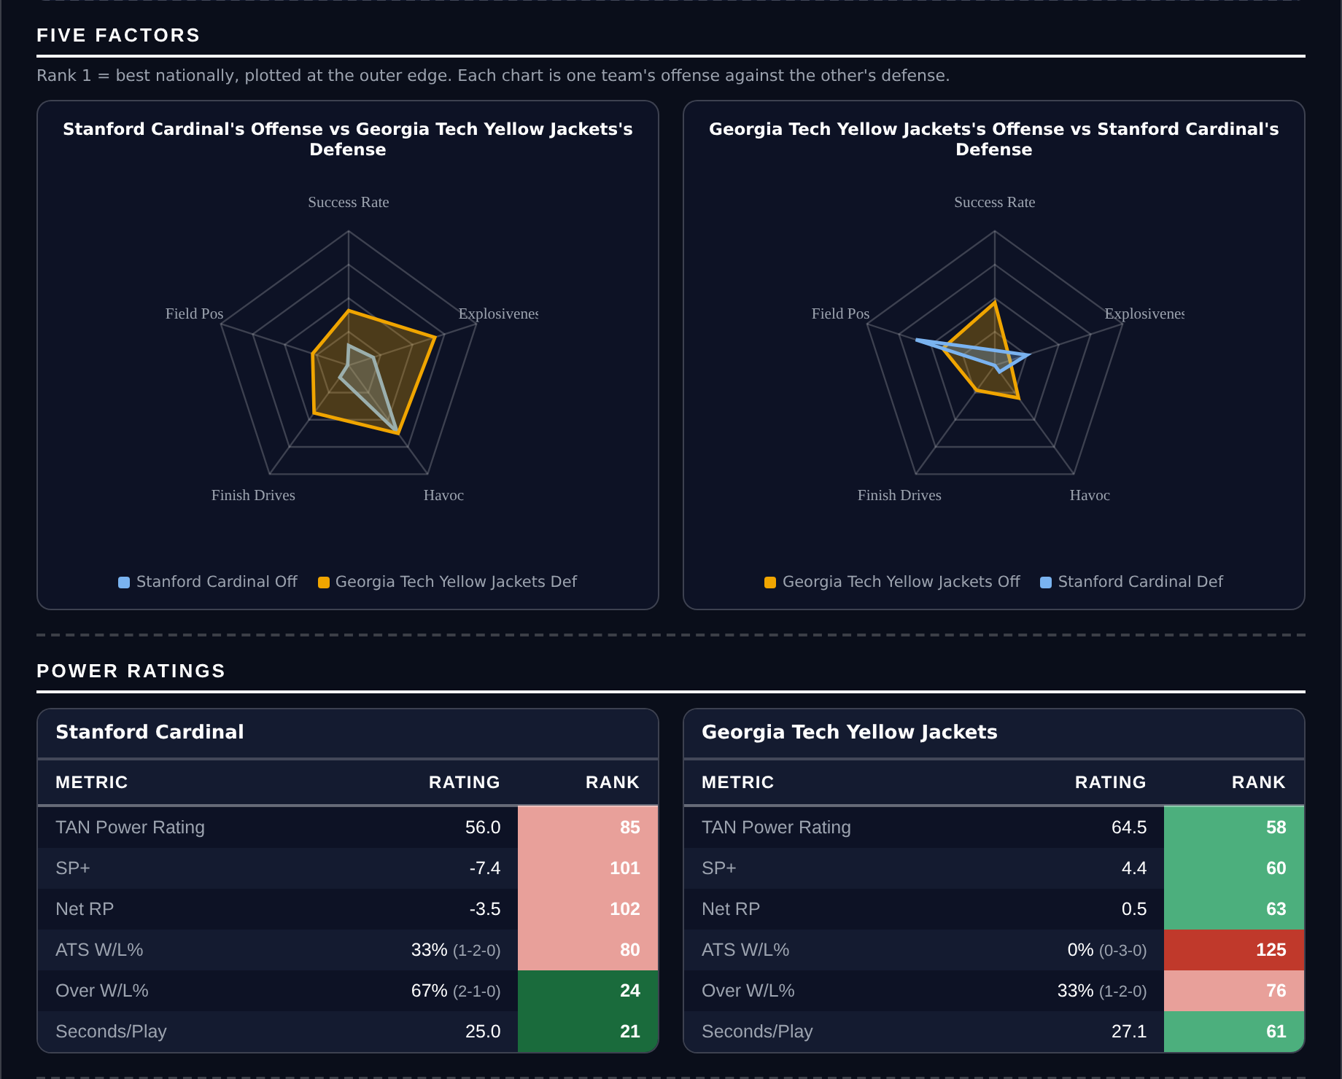
Five Factors and power ratings, captured from the CFB Betting Hub.
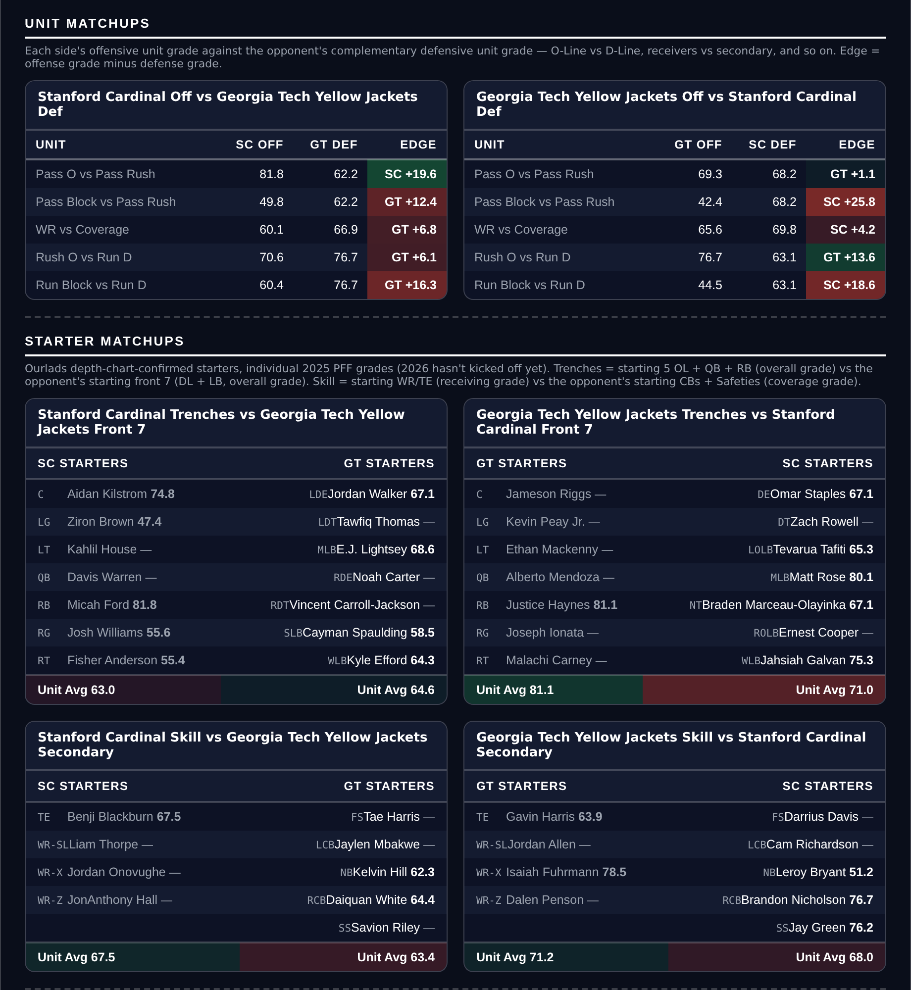
Unit matchups: each offensive unit grade against the opposing defensive unit. Edge = offense minus defense.

Iowa +5.5
Iowa Hawkeyes @ Michigan Wolverines
Book line | Michigan -5.5
Model number | Michigan -0.3
Gap | 5.2 pts, 3.6 after the slate's own level
SP+ (2026) | Iowa +17.3 (18th) vs Michigan +15.1 (21st)
Home edge | +2.5
2026 margins | Iowa +32.7, Michigan +14.3, both 3-0 and 2-1 ATS
Iowa defense | 1st Success Rate, tied 5th Field Position, 13 points allowed

Book has Michigan -5.5. SP+ has these two 2.2 points apart in Iowa's favor, so the model number after home field is Michigan -0.3. A 5.2-point gap on a game the ratings call close to even.
Iowa's defense ranks 1st nationally in Success Rate, 12th in Explosiveness allowed and tied 5th in Field Position, on a 91.6 run defense grade and a 90.3 defensive grade. They have allowed 13 points in two graded games and are winning by 32.7. Michigan is also 3-0 but by 14.3, with 30 points scored across the same two games.
Michigan's offense is the side of this the model is pricing: 85th in Success Rate, 78th in Explosiveness, 113th in Field Position, on a 45.0 passing grade. Their own defense is real, 20th in Success Rate and 9th in Finishing Drives on an 85.1 pass rush grade, which is the argument for a low number rather than for laying points.
The hub flags the other side of this itself. The 2026-forward continuity metric favors Michigan by a distance, rank 37 against Iowa's 104, so the market may be pricing roster change that a season-long rating cannot see yet. Both teams are 2-1 ATS.
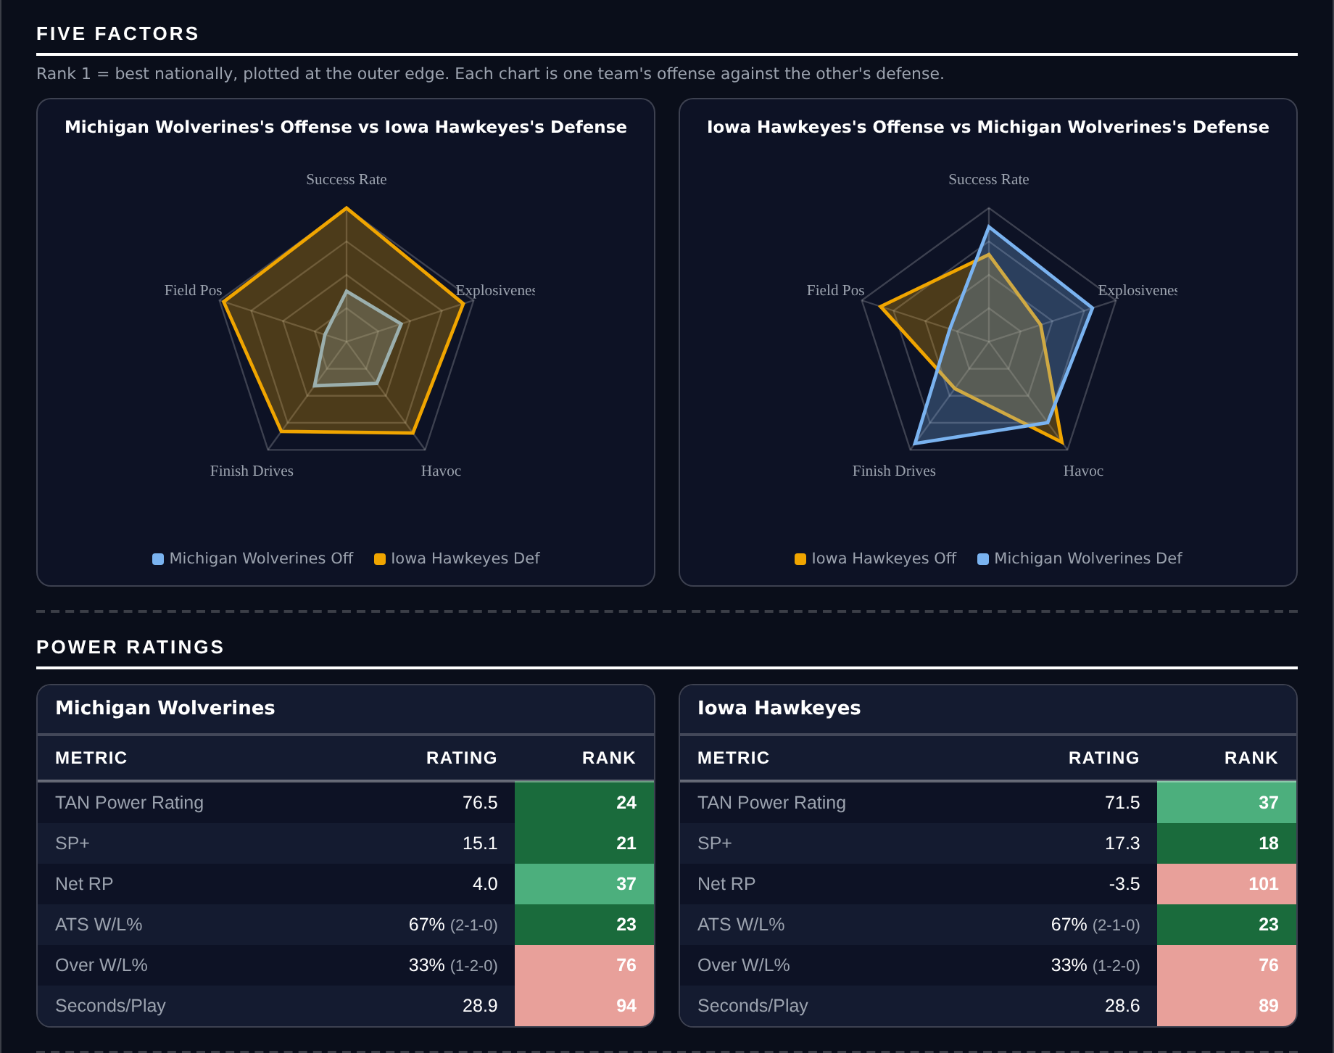
Five Factors and power ratings, captured from the CFB Betting Hub.
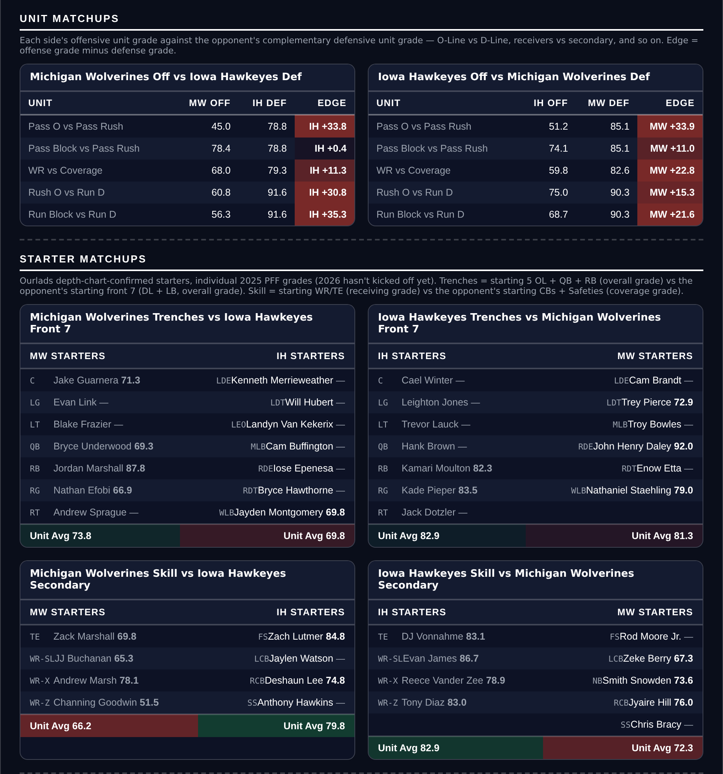
Unit matchups: each offensive unit grade against the opposing defensive unit. Edge = offense minus defense.

Nebraska -5.5
Nebraska Cornhuskers @ Michigan State Spartans
Book line | Nebraska -5.5
Model number | Nebraska -10.3
Gap | 4.8 pts, 3.2 after the slate's own level
SP+ (2026) | Nebraska +14.5 (23rd) vs Michigan State +2.3 (65th)
Home edge | +1.9, one of the slate's smallest
Nebraska 2026 | 3-0, +34.7 MOV, 105 points in two graded games
Nebraska offense | 5th Explosiveness, 6th Finishing Drives, 90.7 run grade

Book has Nebraska -5.5 on the road. The 2026 rating puts it at -10.3: a 12.2-point SP+ gap against a home edge of only +1.9. A 4.8-point disagreement.
Nebraska is 3-0 by 34.7 a game with 105 points scored across two graded games. The offense ranks 5th in Explosiveness, 6th in Finishing Drives and 21st in Success Rate, on an 86.7 offense grade, 90.7 running and 85.9 passing. Their Net Rating is 4th nationally.
Michigan State is 2-1 by 7.0 and has the record to defend, 2-0-1 ATS and covering by 7.3 a game. The rating disagrees with the schedule that produced it: the defense ranks 90th in Success Rate and the offense 77th, 108th and 99th in Success Rate, Explosiveness and Finishing Drives despite an 87.1 passing grade.
Laying a road number against a team that has not lost ATS is the shape that has cost this card before. The distinction here is the size of the rating gap and the size of the home edge; at 1.9 points, Michigan State's venue is worth less than almost any other on the slate.
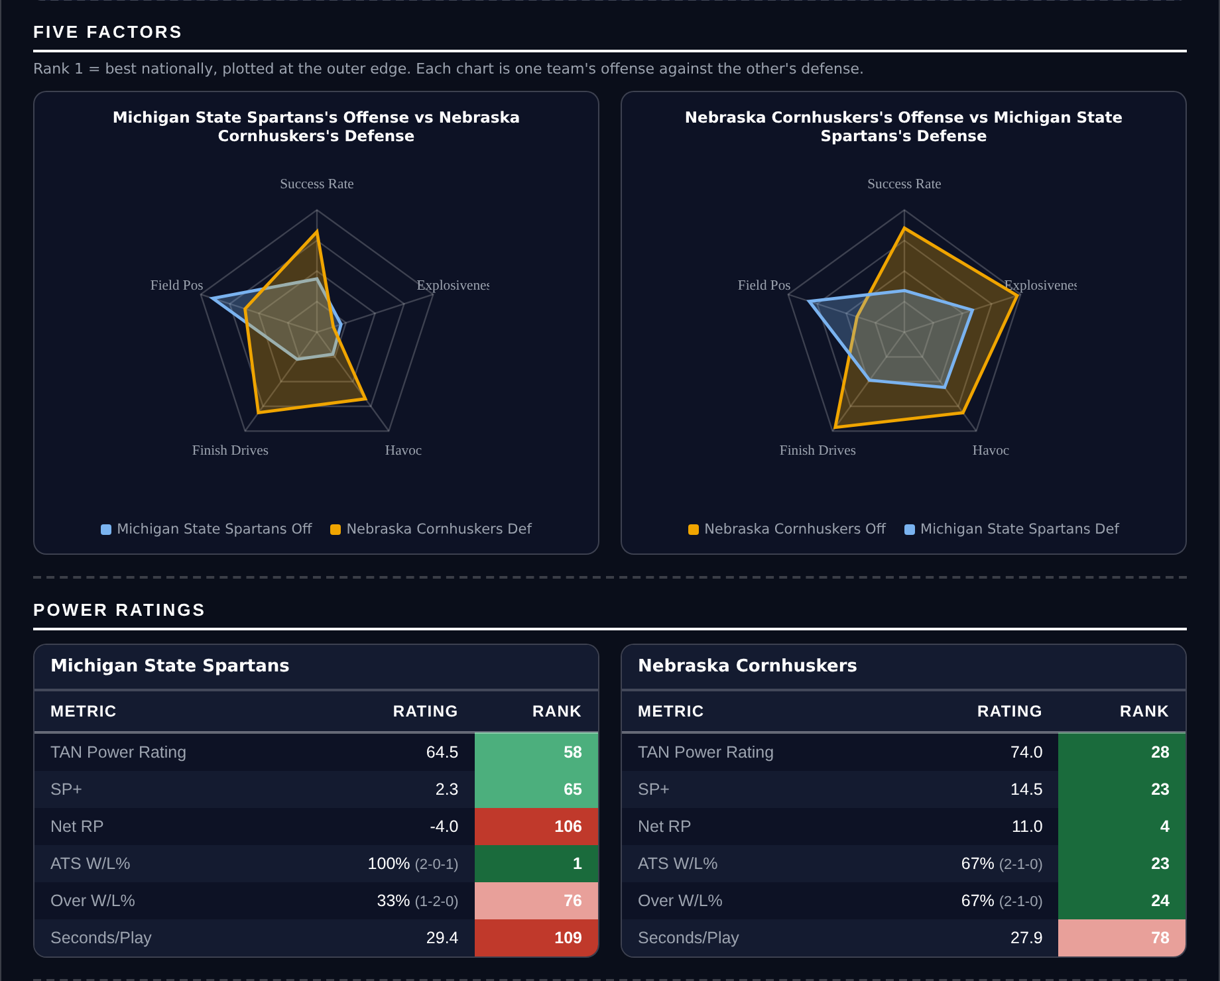
Five Factors and power ratings, captured from the CFB Betting Hub.
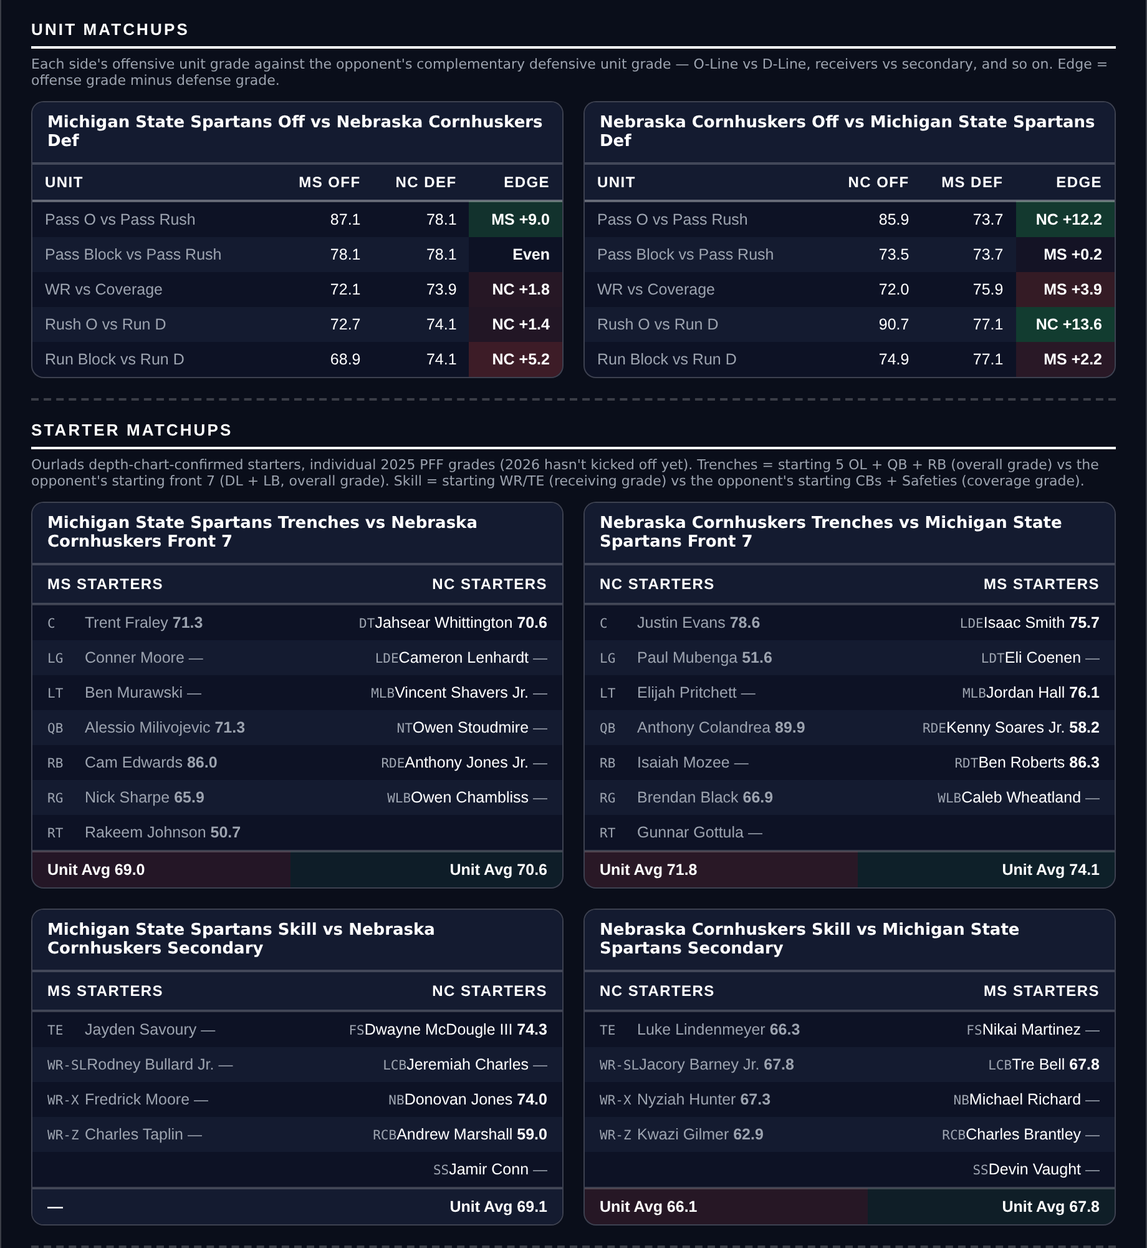
Unit matchups: each offensive unit grade against the opposing defensive unit. Edge = offense minus defense.

