Totals to Target
Week 4 · September 25-27, 2026
Every figure here is checked against the underlying data: 39 PFF grade claims and 65 Five Factors rank claims were verified against team_pff_grades_2026.csv and the built board before this was written, and each player's role, carry or target share and 2026 production against the PFF season file.
Season to date: 13-16-1, down 4.85 units across 30 picks. Spreads 3-7 (-4.70u), totals 5-4-1 (+0.60u), props 5-5 (-0.75u).
These five are not the five largest gaps on the board, and the reason is a bias worth stating plainly.
The predicted total is the sum of two team-total ratings. Those ratings are each team’s own scoring, regressed toward the slate mean by games played, but they are not adjusted for the opponent. The market is. On this slate the consequence is measurable: the correlation between a game’s average defensive Success Rate rank and the size of the model’s Over lean is -0.73. The model leans Over by 4.1 points in games with two top-45 defenses and Under by 3.1 in games with two bottom-45 defenses. That is not fifteen edges, it is one missing adjustment showing up fifteen times, and it is the same error that produced Over 45.5 in New Mexico at Oklahoma last week against a 6th-ranked defense, a game that landed on 20.
The tilt is also growing as offensive rates accumulate on unadjusted team totals: the same correlation was -0.13 in week 2 and -0.46 in week 3. Each pick below is therefore quoted as a residual, the part of the model’s disagreement with the book that the defensive tilt does not explain. Iowa at Michigan is the largest raw gap on the board at 15.4 points and does not appear here; the residual is still the highest at +7.3, but both defenses rank inside the top 20 and Michigan has scored 30 points in two graded games, which is the profile the correction exists to catch rather than to rescue.
Honest caveat on the method: residualising is diagnosed from the slate structure, where -0.73 across 49 games is not noise. It is not yet validated against results. Applied to the ten graded totals it moves the correlation with the closing margin from +0.17 to +0.21 and leaves direction at 5 of 10, which at that sample size says nothing either way.
Ratings and the Five Factors come from the 2026 workbook (SP+, TAN, team totals, and the CFBData26 season-to-date ranks, out of 138 teams). Player lines are 2026 PFF season to date. Records, ATS and over/under are TeamRankings, 2026 to date, refreshed this week for all three pages. The PFF team grade file is two graded games deep while the records are three or four, so points for and against are labelled as two-game figures wherever they appear.

Under 56.5
Houston Cougars @ Georgia Southern Eagles
Book total | 56.5
Model number | 56.8
Residual | -6.0 pts to the Under once the defensive tilt is removed
Game spread | Houston -17.5
Georgia Southern defense | 10th Success Rate, tied 7th Havoc
Georgia Southern offense | 111th Success Rate, 116th Explosiveness, 44.9 passing grade
Georgia Southern totals | 1-2 to the Over, games landing 13.2 under

Book has 56.5. The team-total sum says 56.8, so raw the model has no opinion. The reason this is a play is what that flat number means in context: across the 49 rated games on this slate the model leans Over by 2.7 on average, and it leans hardest exactly where the defenses are best. For two defenses of this quality the fit expects a 6-point Over lean, and the model is not giving one.
Georgia Southern's defense ranks 10th in Success Rate and tied 7th in Havoc, and their games have landed 13.2 points under the posted total. The offense is the other half: 111th in Success Rate, 116th in Explosiveness, tied 118th in Finishing Drives, 129th in Field Position, on a 44.9 passing grade. They have scored 38 points in two graded games.
Houston is the better team by a distance, 2-1 with a +27.3 margin and 110 points scored, and their own games are 3-0 to the Over. The shape of their offense is what matters for a total: 4th in Success Rate but 107th in Explosiveness. That is a unit that moves the chains and burns clock, not one that scores in two plays.
A 17.5-point spread also caps the second half. The favorite that is grinding by construction has less reason to keep throwing, and the underdog that cannot generate explosive plays has no fast way back.
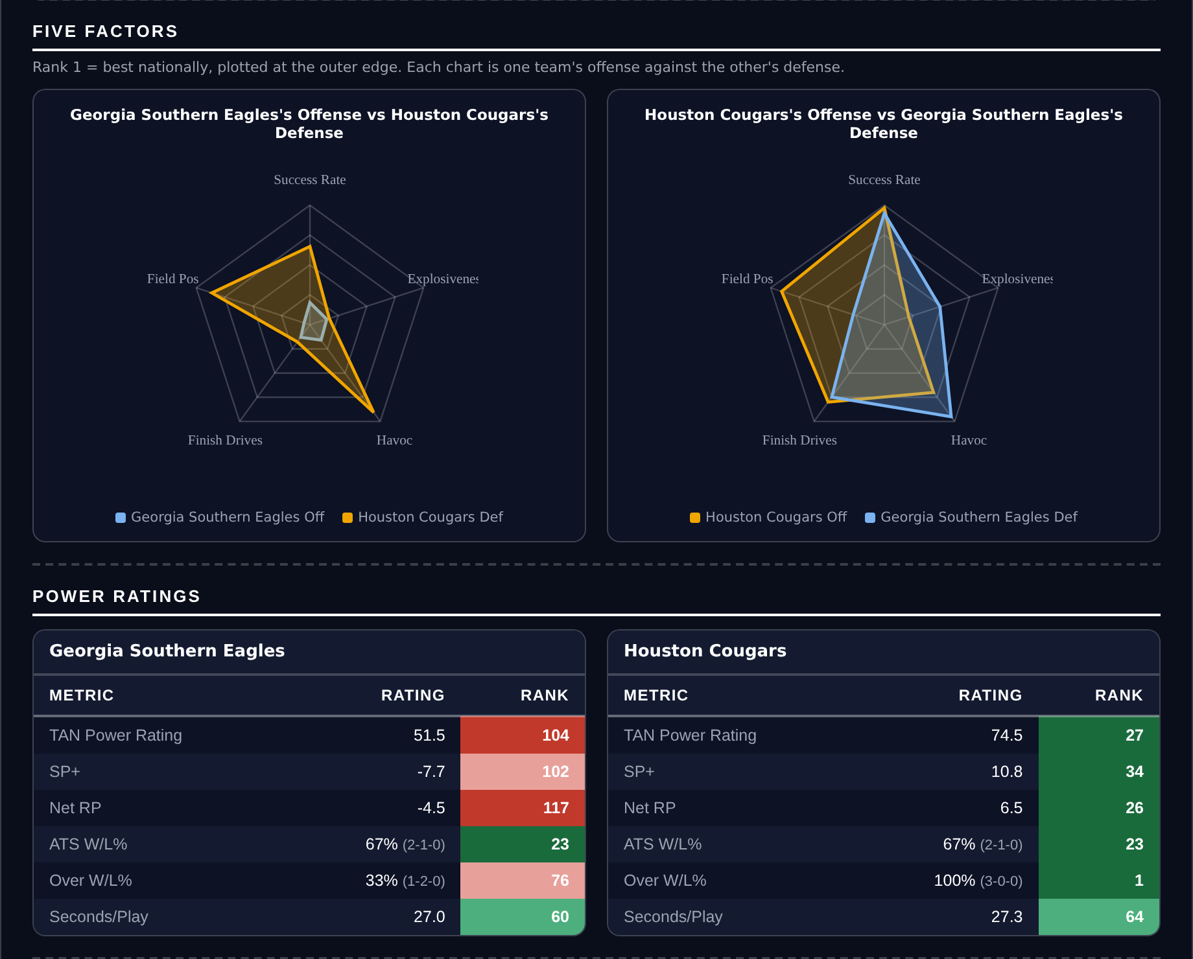
Five Factors and power ratings, captured from the CFB Betting Hub.
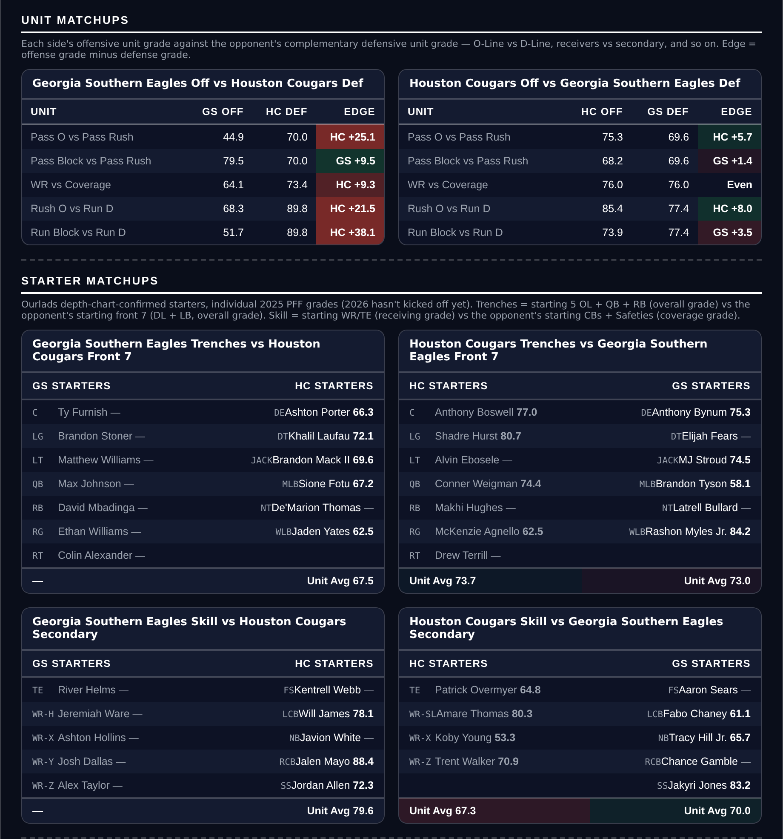
Unit matchups: each offensive unit grade against the opposing defensive unit. Edge = offense minus defense.

Over 43.5
Hawai'i Rainbow Warriors @ Wyoming Cowboys
Book total | 43.5
Model number | 48.8
Residual | +7.1 pts to the Over once the defensive tilt is removed
Hawai'i games | 62 points for, 77 against in two graded games
Wyoming defense | 117th Success Rate, 126th Havoc
Tempo | Hawai'i 26th at 25.1 seconds a snap, Wyoming 105th
Both defenses | Hawai'i 105th Success Rate, Wyoming 117th

Book has 43.5, the model 48.8. That 5.3 is a bigger number than it looks: with two defenses this bad the slate fit expects the model to lean Under by about 1.8, and it is leaning Over instead. The residual is +7.1, the largest Over on the board.
Hawai'i's two graded games have produced 62 points for and 77 against, 69.5 a game combined. They snap it every 25.1 seconds, 26th nationally, against a Wyoming offense that plays 105th. The tempo mismatch is worth possessions in a game priced at 43.5.
Wyoming's defense ranks 117th in Success Rate and 126th in Havoc, with a 58.9 coverage grade. Hawai'i's ranks 105th in Success Rate on a 53.5 tackling grade and a 57.9 run defense grade. Neither side has a unit that stops a drive on merit.
The argument against is Wyoming's offense: 91st in Success Rate, 130th in Explosiveness, 129th in Finishing Drives, and 34 points across two graded games. If this lands under it will be because Wyoming contributes 13 and the game never gets going, which is exactly what their 0-3 ATS record and minus 16.8 cover margin describe.
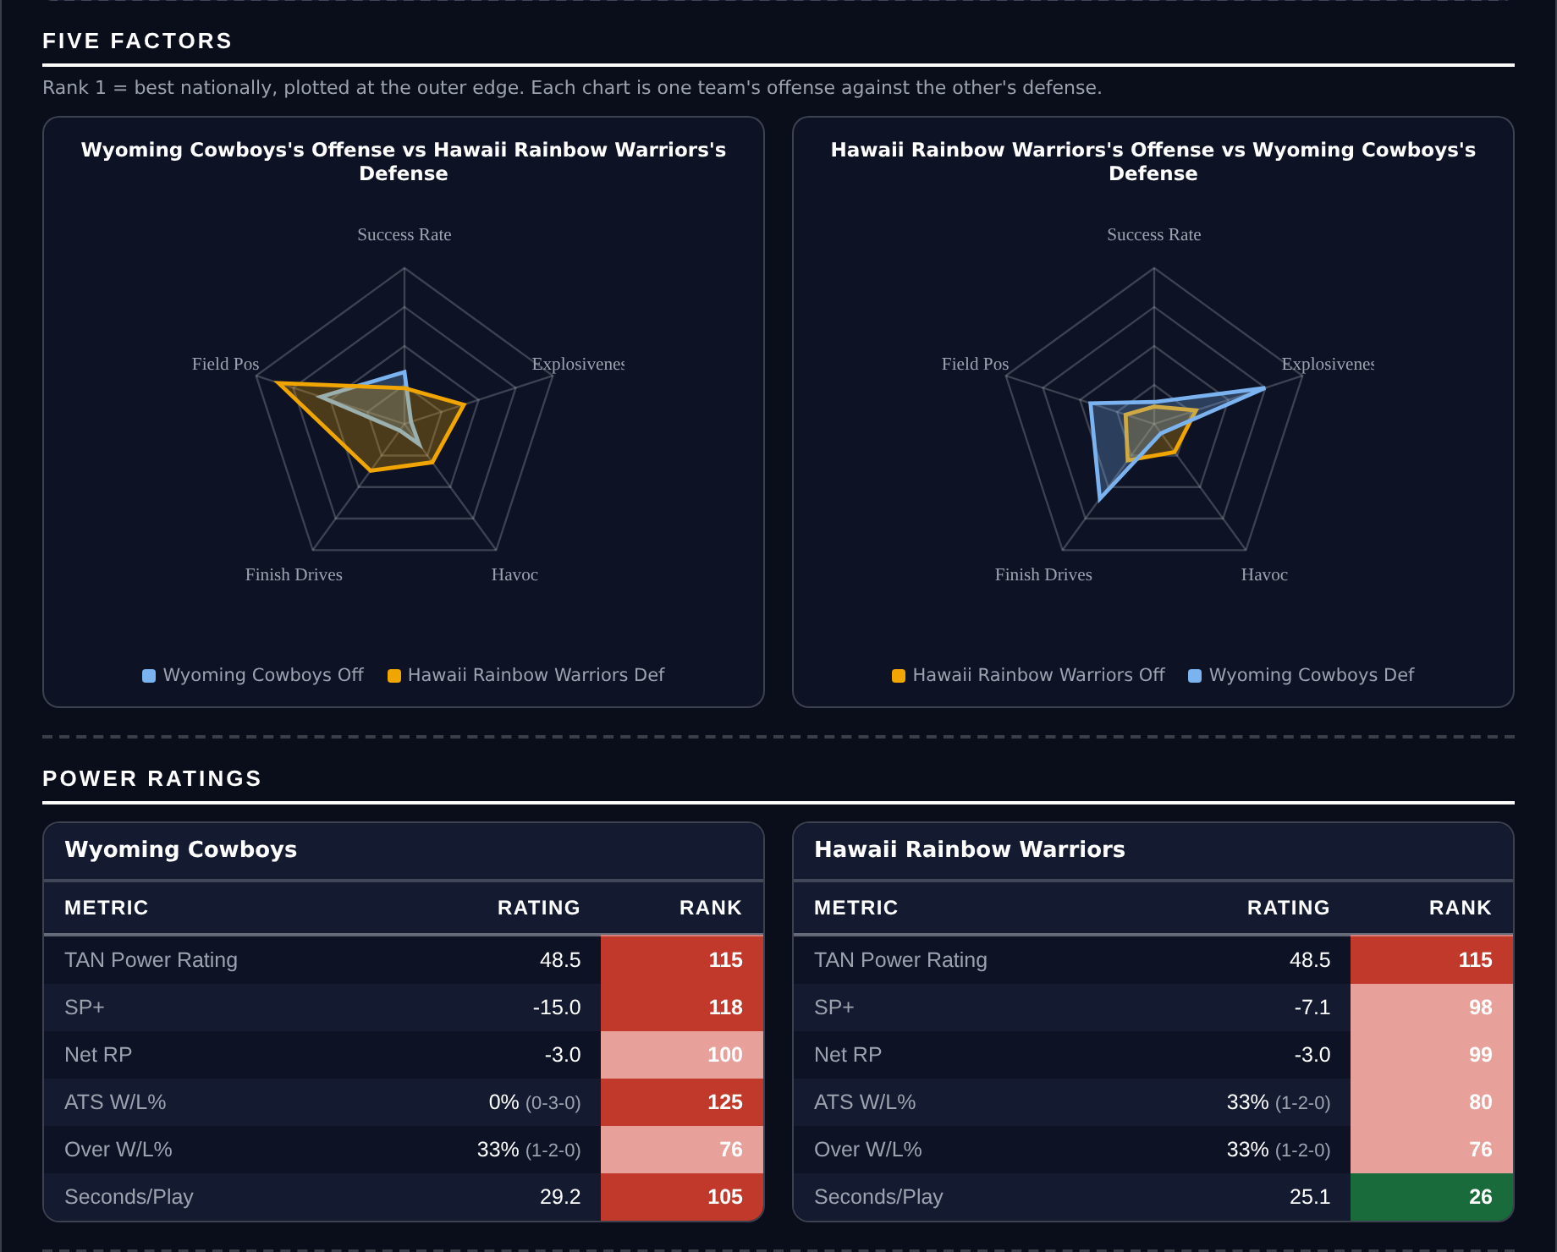
Five Factors and power ratings, captured from the CFB Betting Hub.
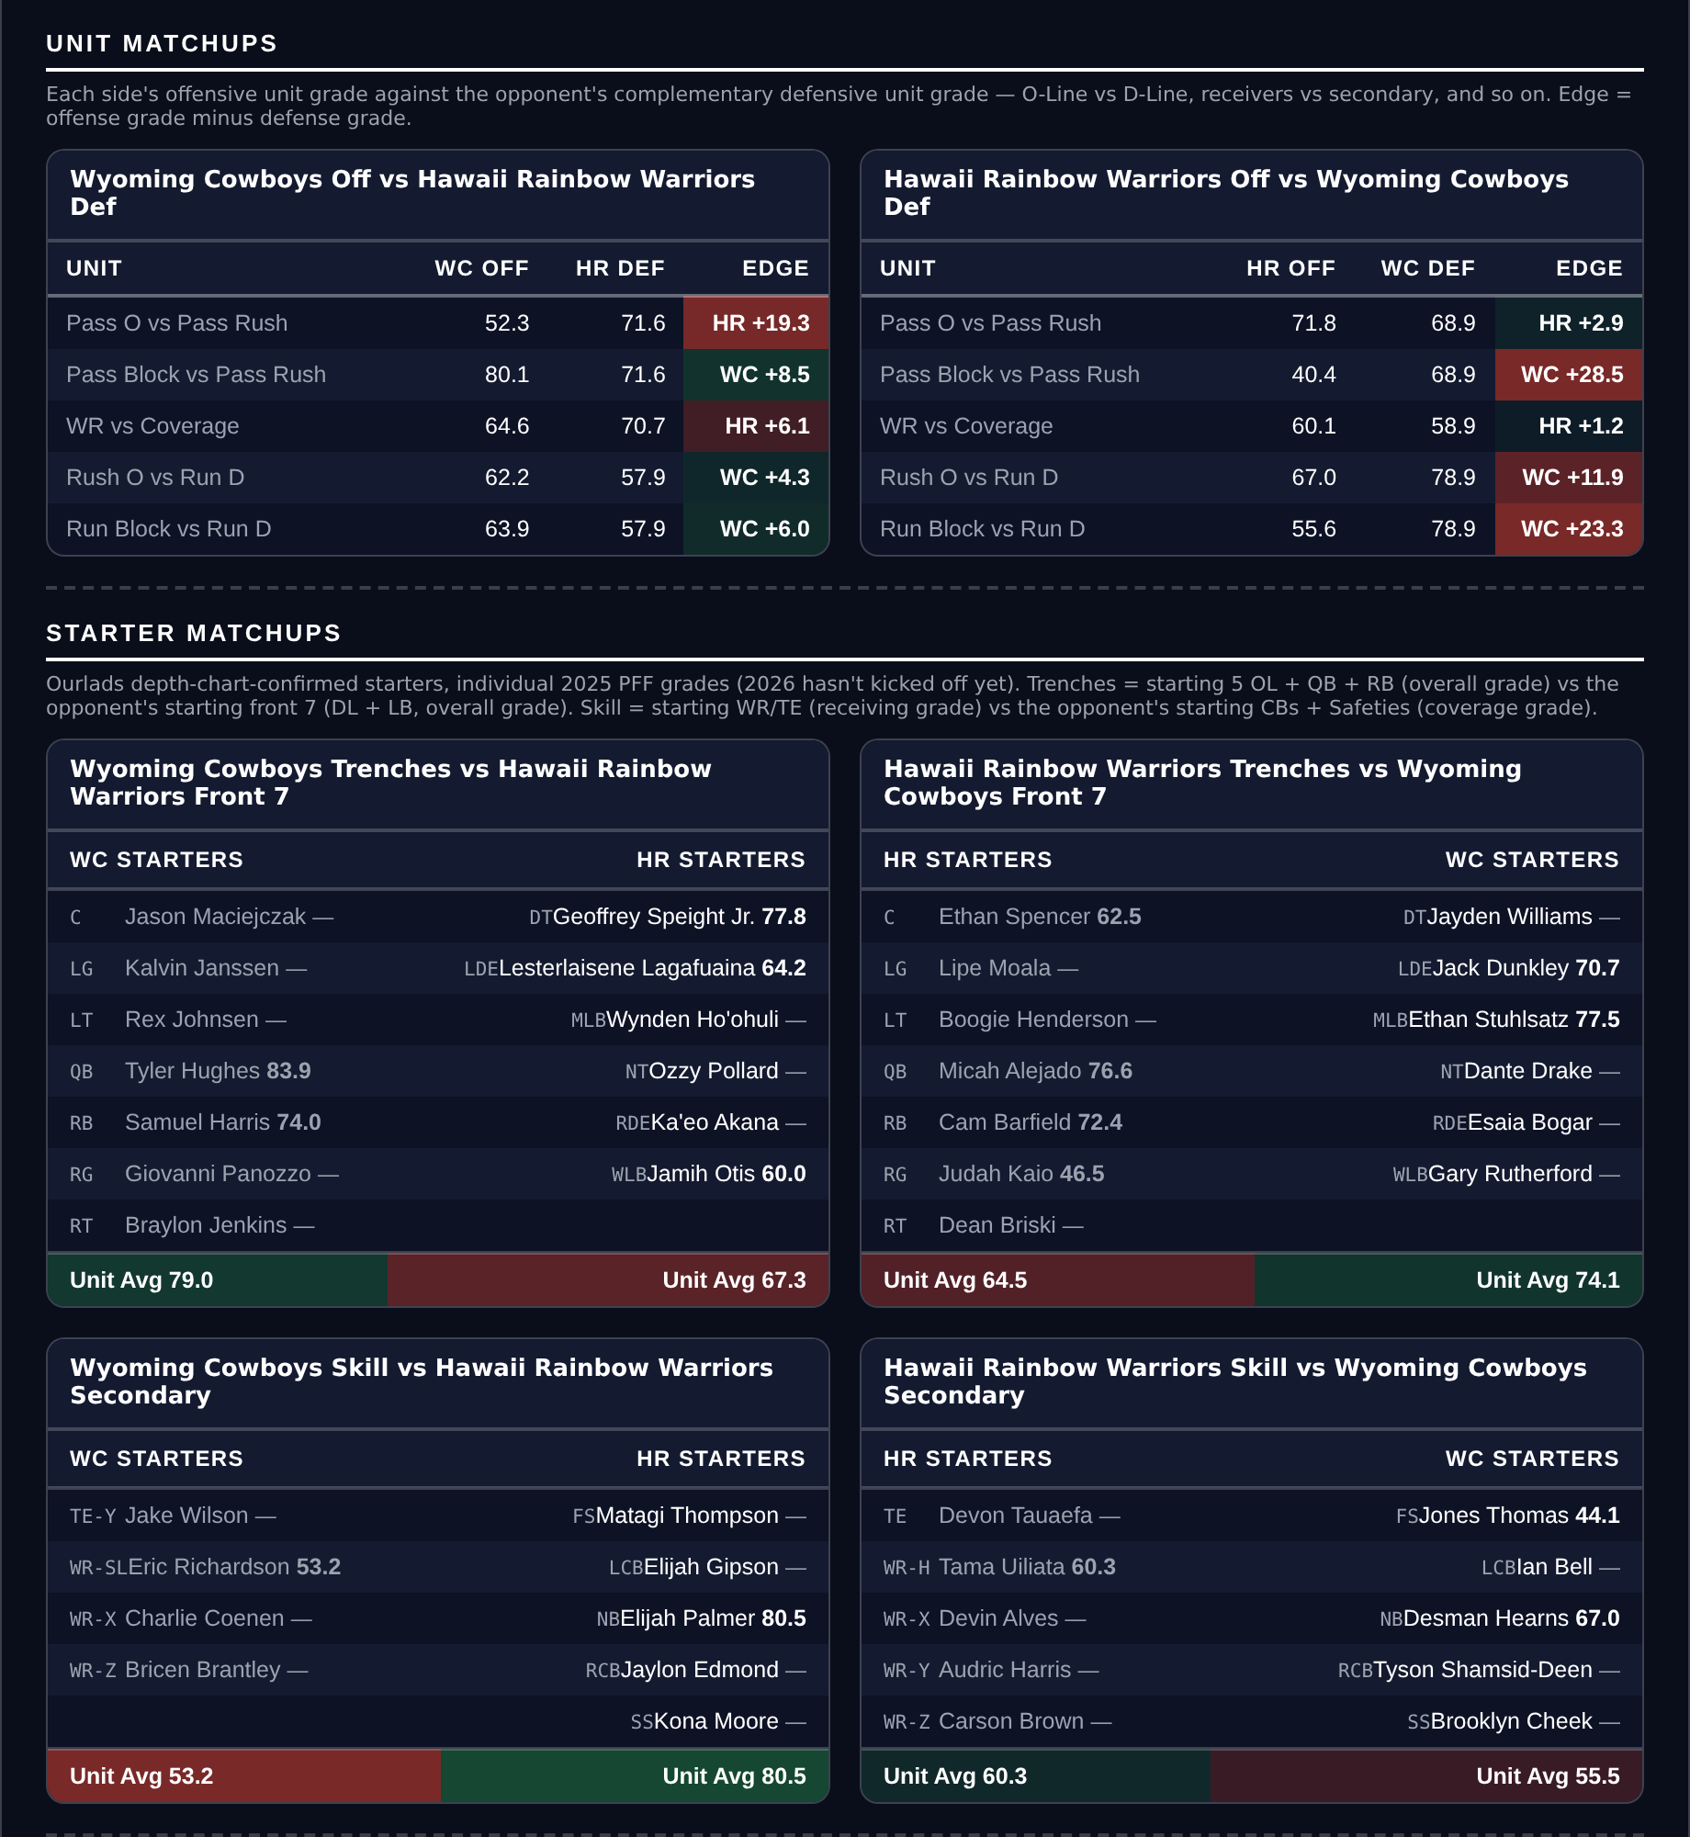
Unit matchups: each offensive unit grade against the opposing defensive unit. Edge = offense minus defense.

Under 56.5
Northern Illinois Huskies @ Georgia State Panthers
Book total | 56.5
Model number | 51.3
Residual | -5.7 pts to the Under
Game spread | Georgia State -10.5
Northern Illinois offense | 128th Success Rate, 137th Finishing Drives
Northern Illinois 2026 | 0-3, 24 points scored in two graded games
Georgia State | 2-1, 3-0 ATS, 90 points in two graded games

Book has 56.5, the model 51.3. Georgia State can get most of the way there on their own, so this is a bet about whether Northern Illinois contributes anything.
Northern Illinois is 0-3 and has been outscored by 23.0 a game. The offense ranks 128th in Success Rate, 137th in Finishing Drives and 115th in Explosiveness, on a 51.9 offense grade and a 45.5 run block grade, with 24 points scored across two graded games. That is 12 a game against a Georgia State defense allowing 13.5.
Georgia State is the live half. They are 2-1, 3-0 ATS covering by 15.2 a game, with 90 points in two graded games and a 90.5 passing grade behind an 81.1 pass block grade. Their offense ranks 35th in Success Rate.
The exposure is Georgia State's finishing: their defense ranks 121st in Finishing Drives, so opponents who reach the red zone convert. Northern Illinois getting there is the whole question, and 137th in Finishing Drives is the answer the season has given so far. This is also the third straight week the board has pointed at a Georgia State game; the previous two were spreads fading them, and both lost.
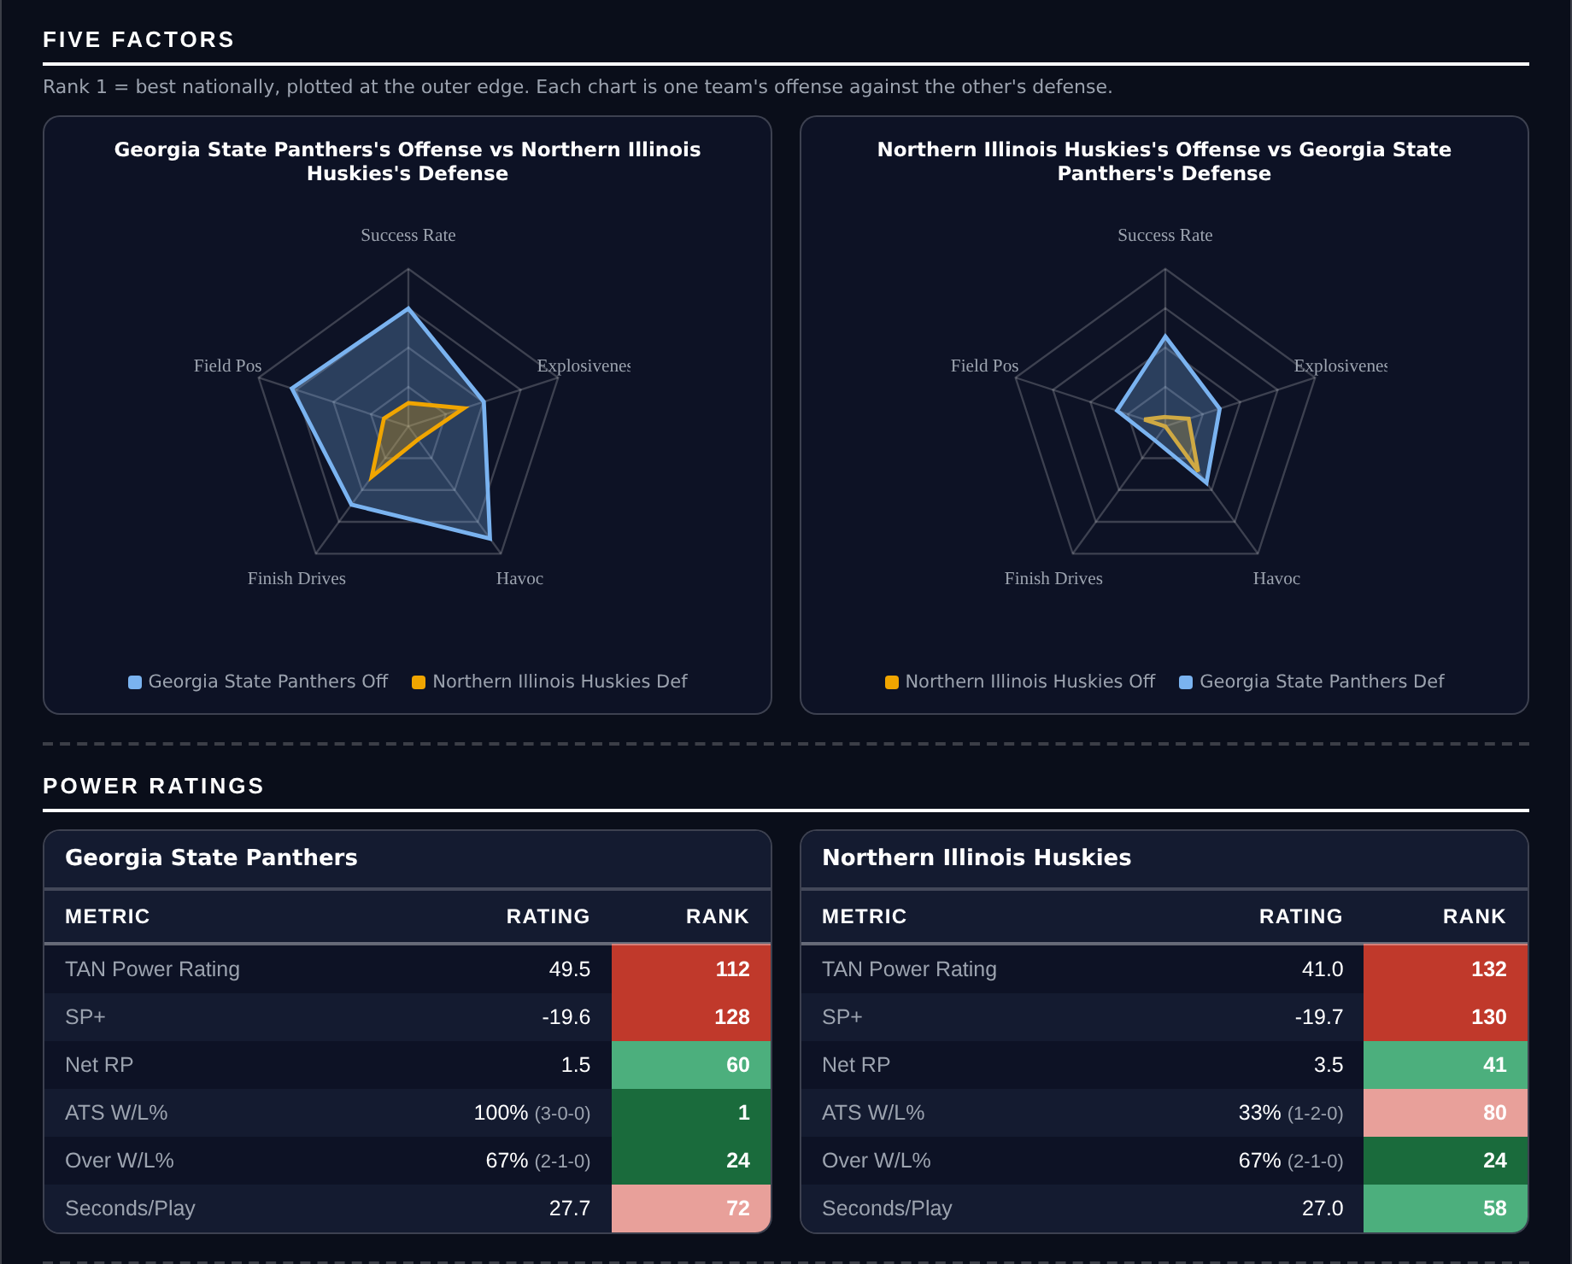
Five Factors and power ratings, captured from the CFB Betting Hub.
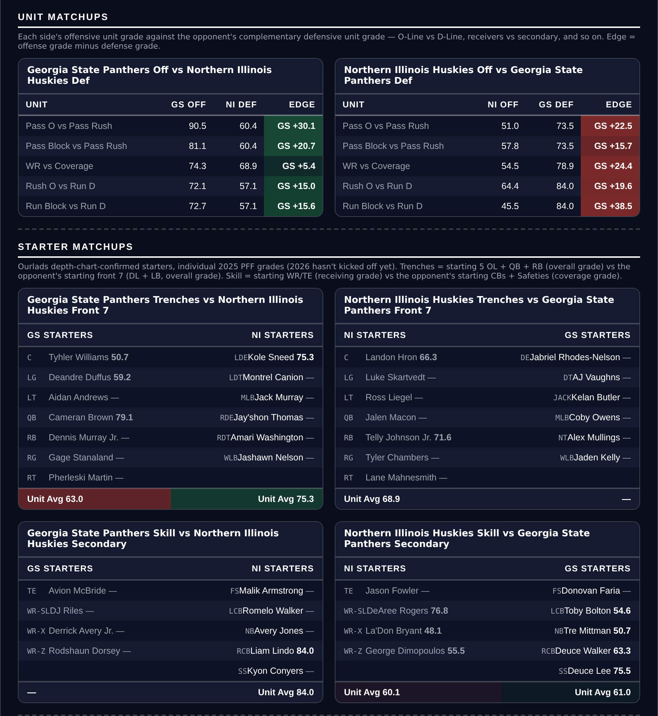
Unit matchups: each offensive unit grade against the opposing defensive unit. Edge = offense minus defense.

Under 58.5
Missouri Tigers @ Mississippi State Bulldogs
Book total | 58.5
Model number | 59.9
Residual | -5.1 pts to the Under
Records | both 3-0; Missouri +22.3 MOV, Mississippi State +27.0
Points allowed | Missouri 17.5 a game, Mississippi State 13.0
Missouri defense | 16th Success Rate, 5th Havoc
Mississippi State tempo | 10th fastest at 24.3 seconds a snap

Book has 58.5, the model 59.9, so raw this is a 1.4-point Over lean. With two defenses of this quality the slate fit expects the model to be 6.5 points over the book, which leaves a 5.1-point residual to the Under.
The scoring records are the Over case and they are built on schedule. Both teams are 3-0, Missouri by 22.3 a game and Mississippi State by 27.0, with 92 and 100 points in two graded games. What they have allowed is the more useful number: 17.5 and 13.0 a game.
Missouri's defense ranks 16th in Success Rate and 5th in Havoc with an 80.2 pass rush grade. Mississippi State's ranks 37th in Success Rate on an 87.2 run defense grade and an 82.3 coverage grade. A 58.5 total asks each of these offenses for 29 against the best defense either has seen.
Mississippi State's tempo is the reason this is the least comfortable of the five: 24.3 seconds a snap, 10th nationally, and their games have gone 11.2 points over the posted total. Missouri's own weak spot is Explosiveness allowed, 134th, so one long play changes the arithmetic here faster than in the other four.
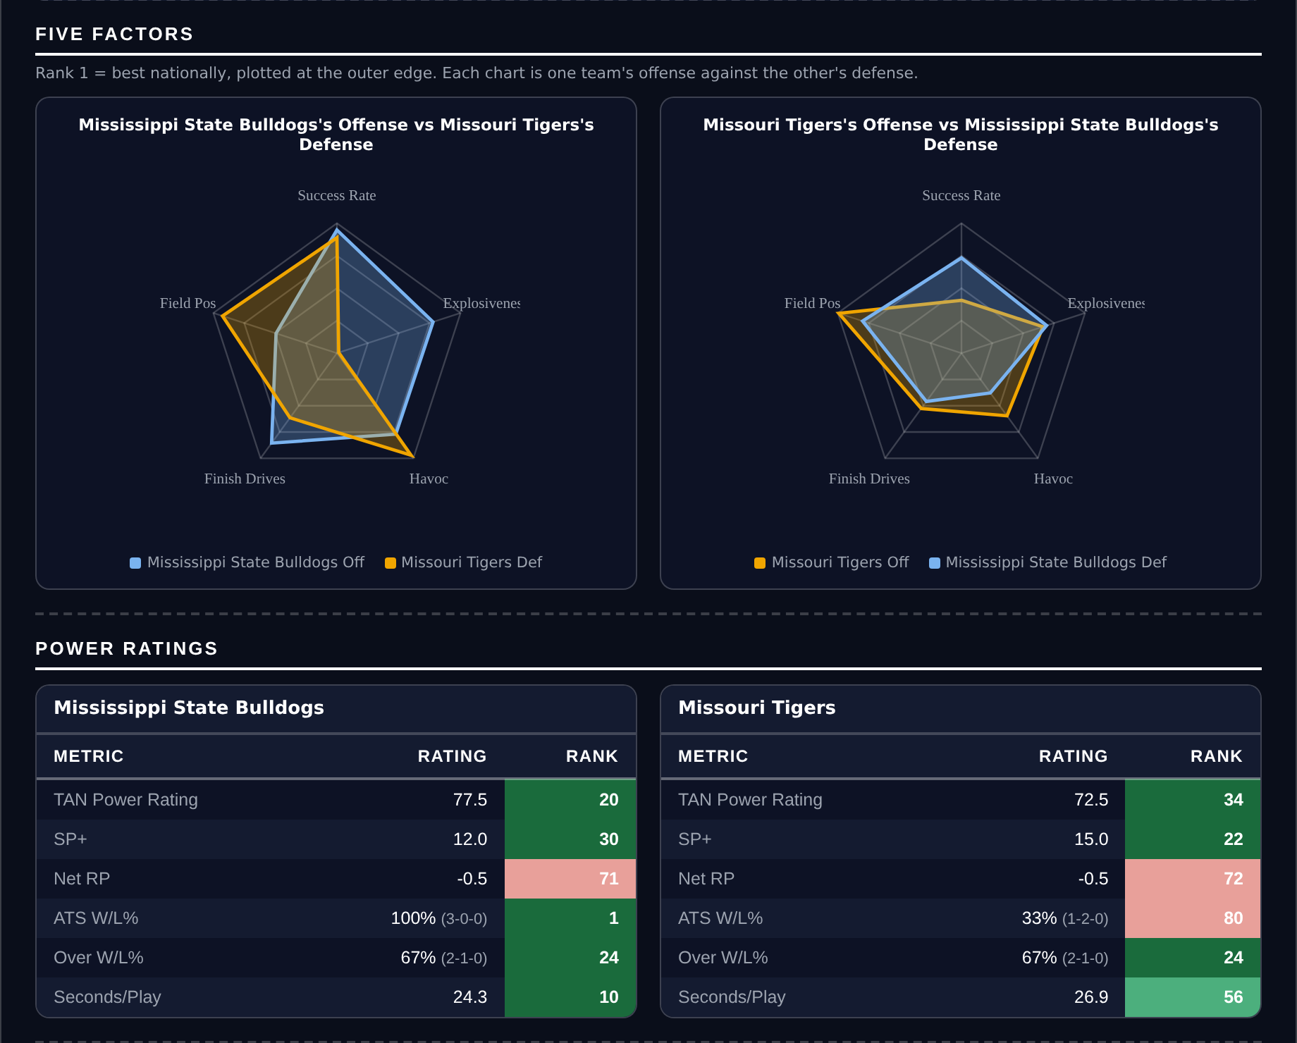
Five Factors and power ratings, captured from the CFB Betting Hub.
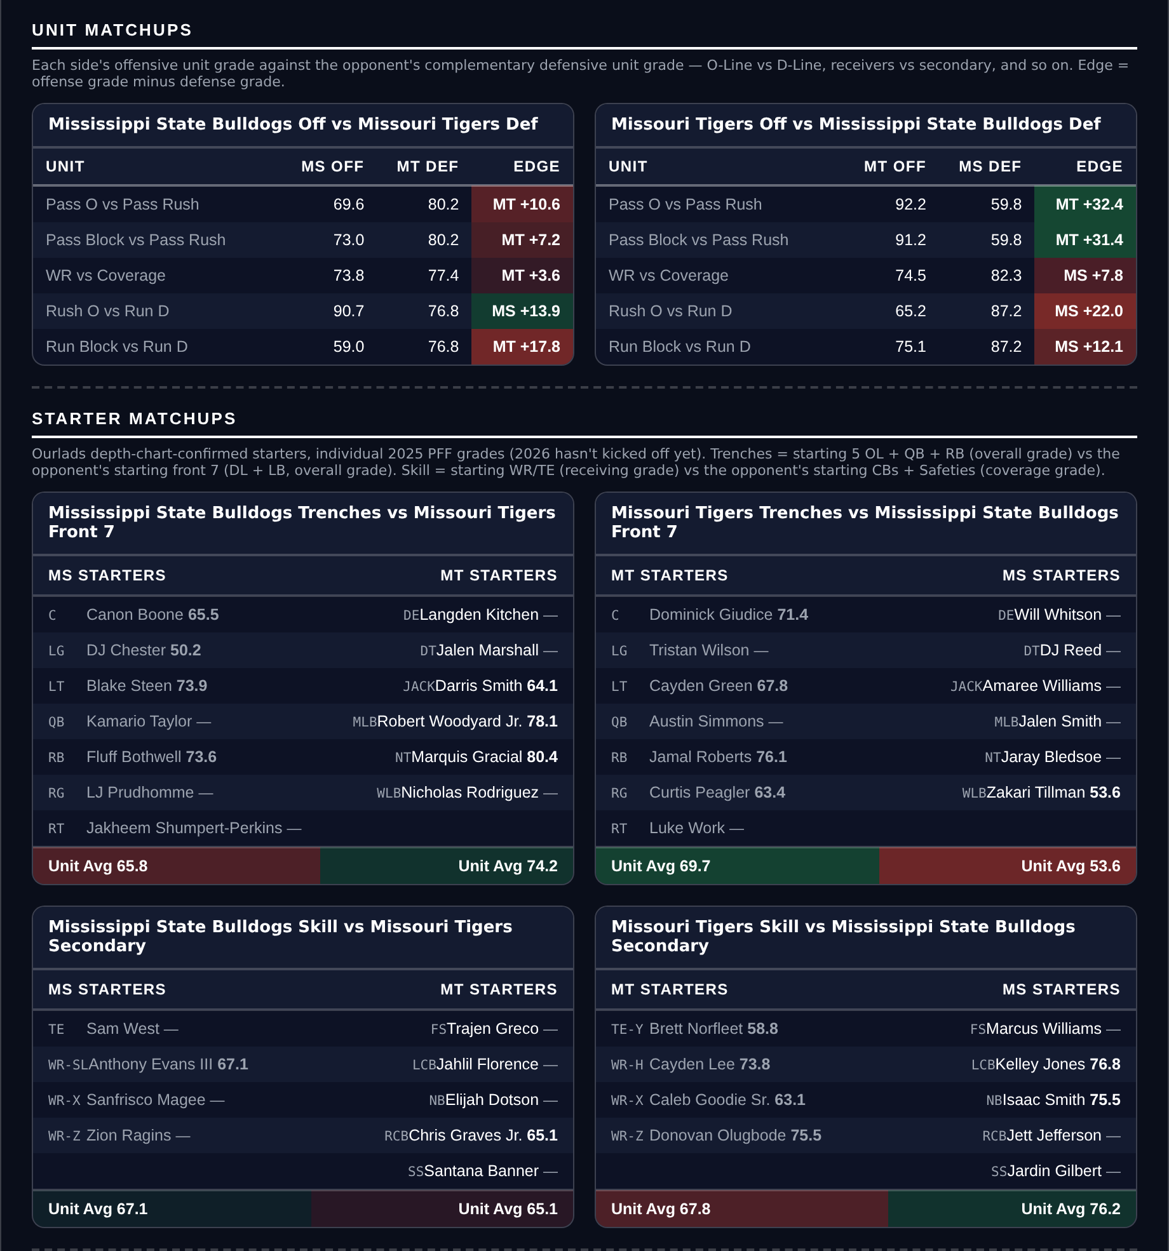
Unit matchups: each offensive unit grade against the opposing defensive unit. Edge = offense minus defense.

Over 44.5
Rice Owls @ Fresno State Bulldogs
Book total | 44.5
Model number | 48.3
Residual | +4.5 pts to the Over
Game spread | Fresno State -13.0
Points allowed | Rice 27.5 a game, Fresno State 21.0
Defensive ranks | Rice 102nd Success Rate, Fresno State 97th
Fresno State pass block | 36.8 grade

Book has 44.5, the model 48.3. With two defenses ranked outside the top 95 the fit expects a slight Under lean, so the residual is +4.5.
What the two teams have allowed is the case: 27.5 a game for Rice and 21.0 for Fresno State, 48.5 combined against a total of 44.5. Rice's defense ranks 102nd in Success Rate and 116th in Finishing Drives; Fresno State's ranks 97th in Success Rate.
Neither offense is good enough to make this comfortable. Rice ranks 87th in Success Rate and 131st in Explosiveness with 31 points in two graded games; Fresno State ranks 129th in Success Rate and has a 36.8 pass block grade, though they rank 20th in Explosiveness, which is the one way this gets to 45 quickly.
This is the thinnest of the five and is sized the same as the rest only because the card is flat. A 13-point spread with two offenses this inefficient is the profile that produces a 24-17 game.
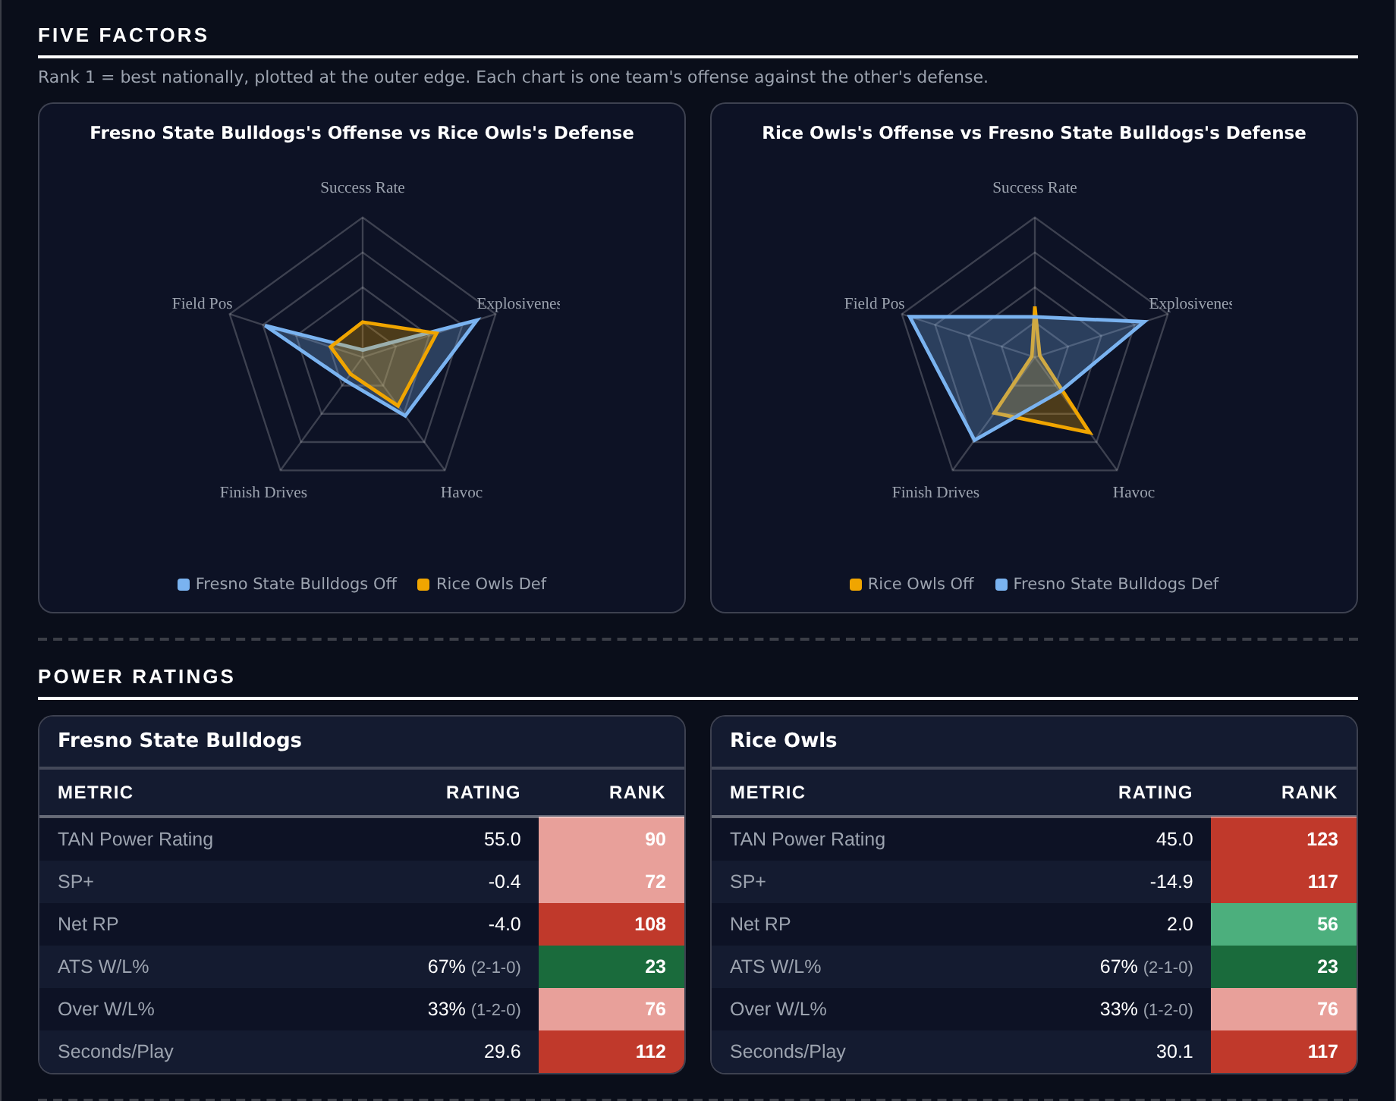
Five Factors and power ratings, captured from the CFB Betting Hub.
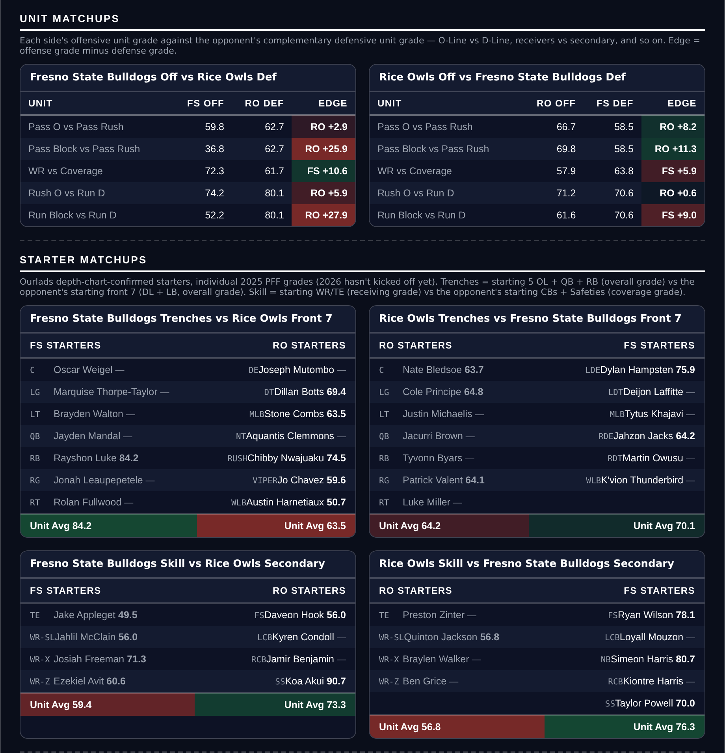
Unit matchups: each offensive unit grade against the opposing defensive unit. Edge = offense minus defense.

