Totals to Target
Week 5 · Saturday October 3, 2026
Every figure below is checked against the source data before it is written. Team grades, five-factor ranks and per-game scoring come from the 2026 PFF team grades and the season-to-date CFBData ranks; each player's role, share and production come from the 2026 PFF season files. Per-game scoring uses each team's own game count, which is three, four or five this week. Where a rank ends in .5 the teams are tied and it is written as “tied Nth”. All fifteen kickoffs are verified Saturday in Eastern time.
Season to date: 18-23-2 and one void, down 7.91 units across 44 picks. Spreads 5-10 (-6.00u), totals 6-6-2 (-0.60u), props 7-7 and one void (-1.31u).
Five totals, ranked on the residual. The predicted total sums two team-total ratings that are not adjusted for the opponent, while the market is, and that single missing adjustment accounts for most of what a raw disagreement with the market actually measures.
The size of it is measurable. Across these 49 games the correlation between a game’s average defensive Success Rate rank and the model’s Over lean is -0.66, after -0.13 in week 2, -0.46 in week 3 and -0.73 in week 4. The mean lean is +1.7 points toward the Over and 31 of 49 games lean Over. Where both defences rank inside the top 45 the model leans Over by 8.9 points; where both sit in the bottom 45 it leans Under by 2.9. The residual is what survives once that tilt is fitted out, and it is what these five are ranked on.
A points-based expectation — each team’s own scoring blended with what its opponent allows — is reported for every pick. It is not used to overrule the residual, and the reason is on the record: in week 4 four totals were replaced after that check disagreed, the four removed went 3-1, the four kept went 1-2-1, and the swap cost 3.10 units. This week the question does not arise. All five picks below have the residual and the points check leaning the same way, which is not usually the case.
The case for these five is agreement, and it is unusually broad this week. All five have the residual and the points-based expectation leaning the same way. Four of the five also have the two teams’ own over/under records agreeing, two of them emphatically: Eastern Michigan and UMass are a combined 2-7 to the Over, California and UNLV 1-7. Tempo supports two more at the extremes, with UMass the slowest team in the country and Stanford and Wake Forest both inside the fastest 35. These are the games where several measures that share no method describe the same afternoon.
Ratings and the Five Factors come from the 2026 workbook: SP+, TAN, implied team totals and the season-to-date CFBData ranks, out of 138 teams. Player lines are 2026 PFF season to date. Records, ATS and over/under records are TeamRankings, 2026 to date. The PFF team grade file covers four games for 120 teams, three for ten and five for eight.

Eastern Michigan Eagles @ UMass Minutemen

Under 48.5
Book total | 48.5
Model number | 46.4
Residual | -4.4
Points check | 47.6, agreeing
Over records | Eastern Michigan 1-4, UMass 1-3
Tempo | UMass 138th of 138, Eastern Michigan 98th
UMass defense | 1st in Finishing Drives allowed, 12.8 points a game
Game spread | UMass -6.0

Book has 48.5, the model 46.4, residual -4.4, and the points check at 47.6. Every reading available points the same way, which is rare enough to be the reason this leads the card.
Tempo is the structural argument. UMass play the slowest pace in the country, 138th of 138, and Eastern Michigan are 98th. Fewer snaps means fewer scoring chances, and the two teams are a combined 2-7 to the Over.
UMass's defense ranks 1st nationally in Finishing Drives allowed and 6th in Explosiveness allowed, on a 92.2 defensive grade and 91.0 coverage, and has conceded 12.8 points a game. Eastern Michigan's offense ranks 122nd in Success Rate on a 58.5 passing grade and scores 19.0. Those two facts have to coexist with a 48.5 total, and they do not sit comfortably together.
The way this loses is UMass themselves, who score 36.3 a game behind an 85.1 run grade. If Eastern Michigan's 52.6 tackling grade gives way early and UMass reach the mid-30s alone, the Under needs Eastern Michigan held near single digits. This card also lays UMass -6.0 in the same game; the two win together on a controlled win and separate only if UMass run away with it at pace, which their 138th-ranked tempo argues against.
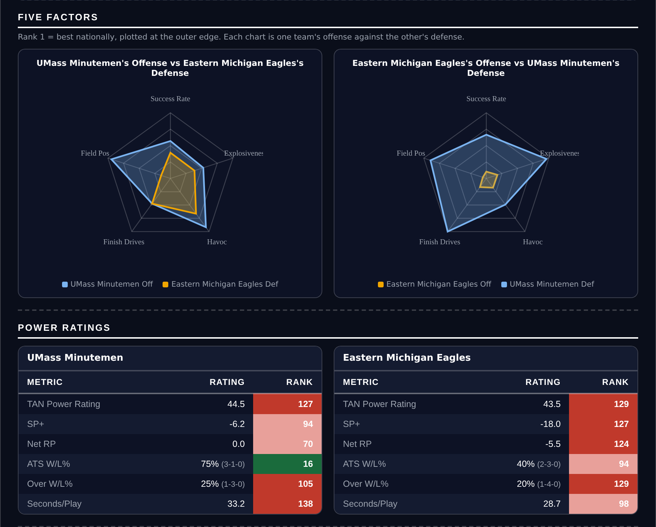
Five Factors and power ratings, captured from the CFB Betting Hub.
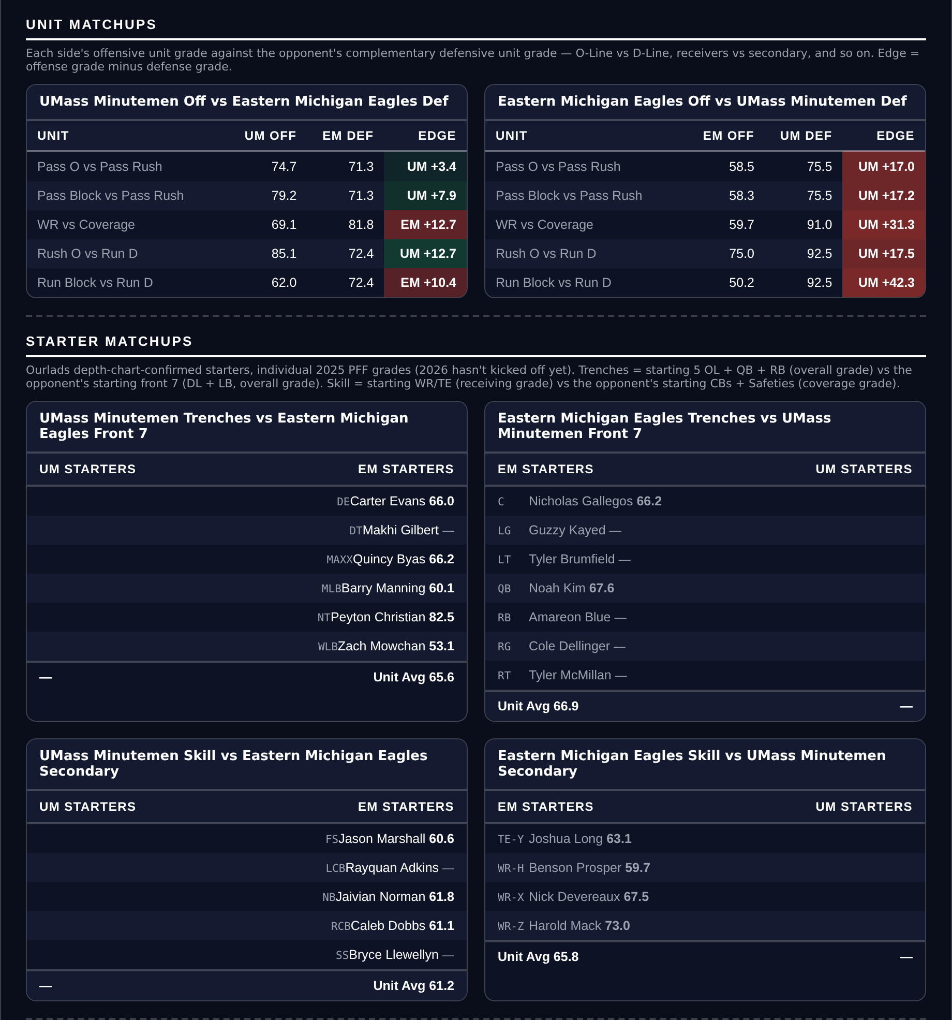
Unit matchups: each offensive unit grade against the opposing defensive unit. Edge = offense minus defense.

California Golden Bears @ UNLV Rebels

Under 53.5
Book total | 53.5
Model number | 52.5
Residual | -3.5
Points check | 46.4, which is 7.1 below the market
Over records | California 1-3, UNLV 0-4
Offenses | California 102nd Success Rate, UNLV 117th
California coverage | 91.2 grade
Game spread | UNLV -2.5

Book has 53.5. Each team's own scoring puts the game at 46.4, a seven-point disagreement with the market, and the model agrees in direction at 52.5 with a -3.5 residual.
The records are blunt. UNLV are 0-4 to the Over and California 1-3, so seven of their eight games have finished under the number. That is not proof, but it is the same signal arriving from a different direction.
Neither offense moves the ball. California rank 102nd in Success Rate, 88th in Explosiveness and 127th in Finishing Drives; UNLV rank 117th, 73rd and 123rd. California's defense carries a 91.2 coverage grade and ranks 25th in Finishing Drives allowed, and UNLV score 21.5 a game.
Tempo is the one thing arguing the other way, with both teams in the faster half at 39th and 50th, so there will be possessions. The other risk is UNLV's 49.2 tackling grade against California's 79.1 run grade, which is also why this card takes Adam Mohammed over his rushing line in the same game. A ground game that controls the clock serves both positions rather than splitting them.
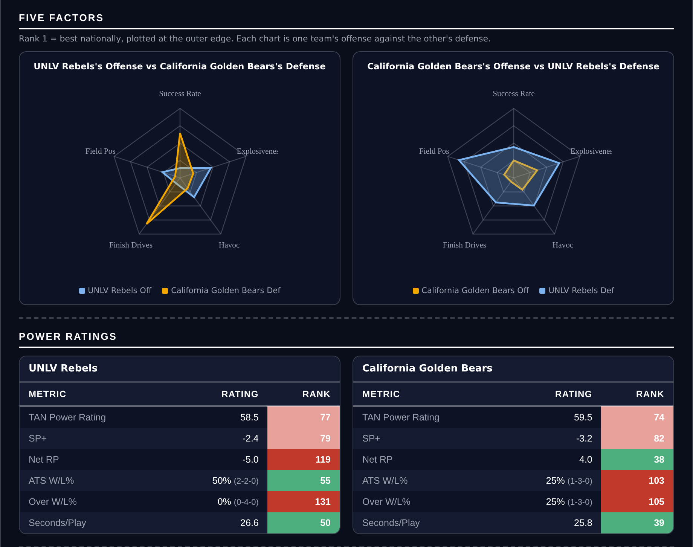
Five Factors and power ratings, captured from the CFB Betting Hub.
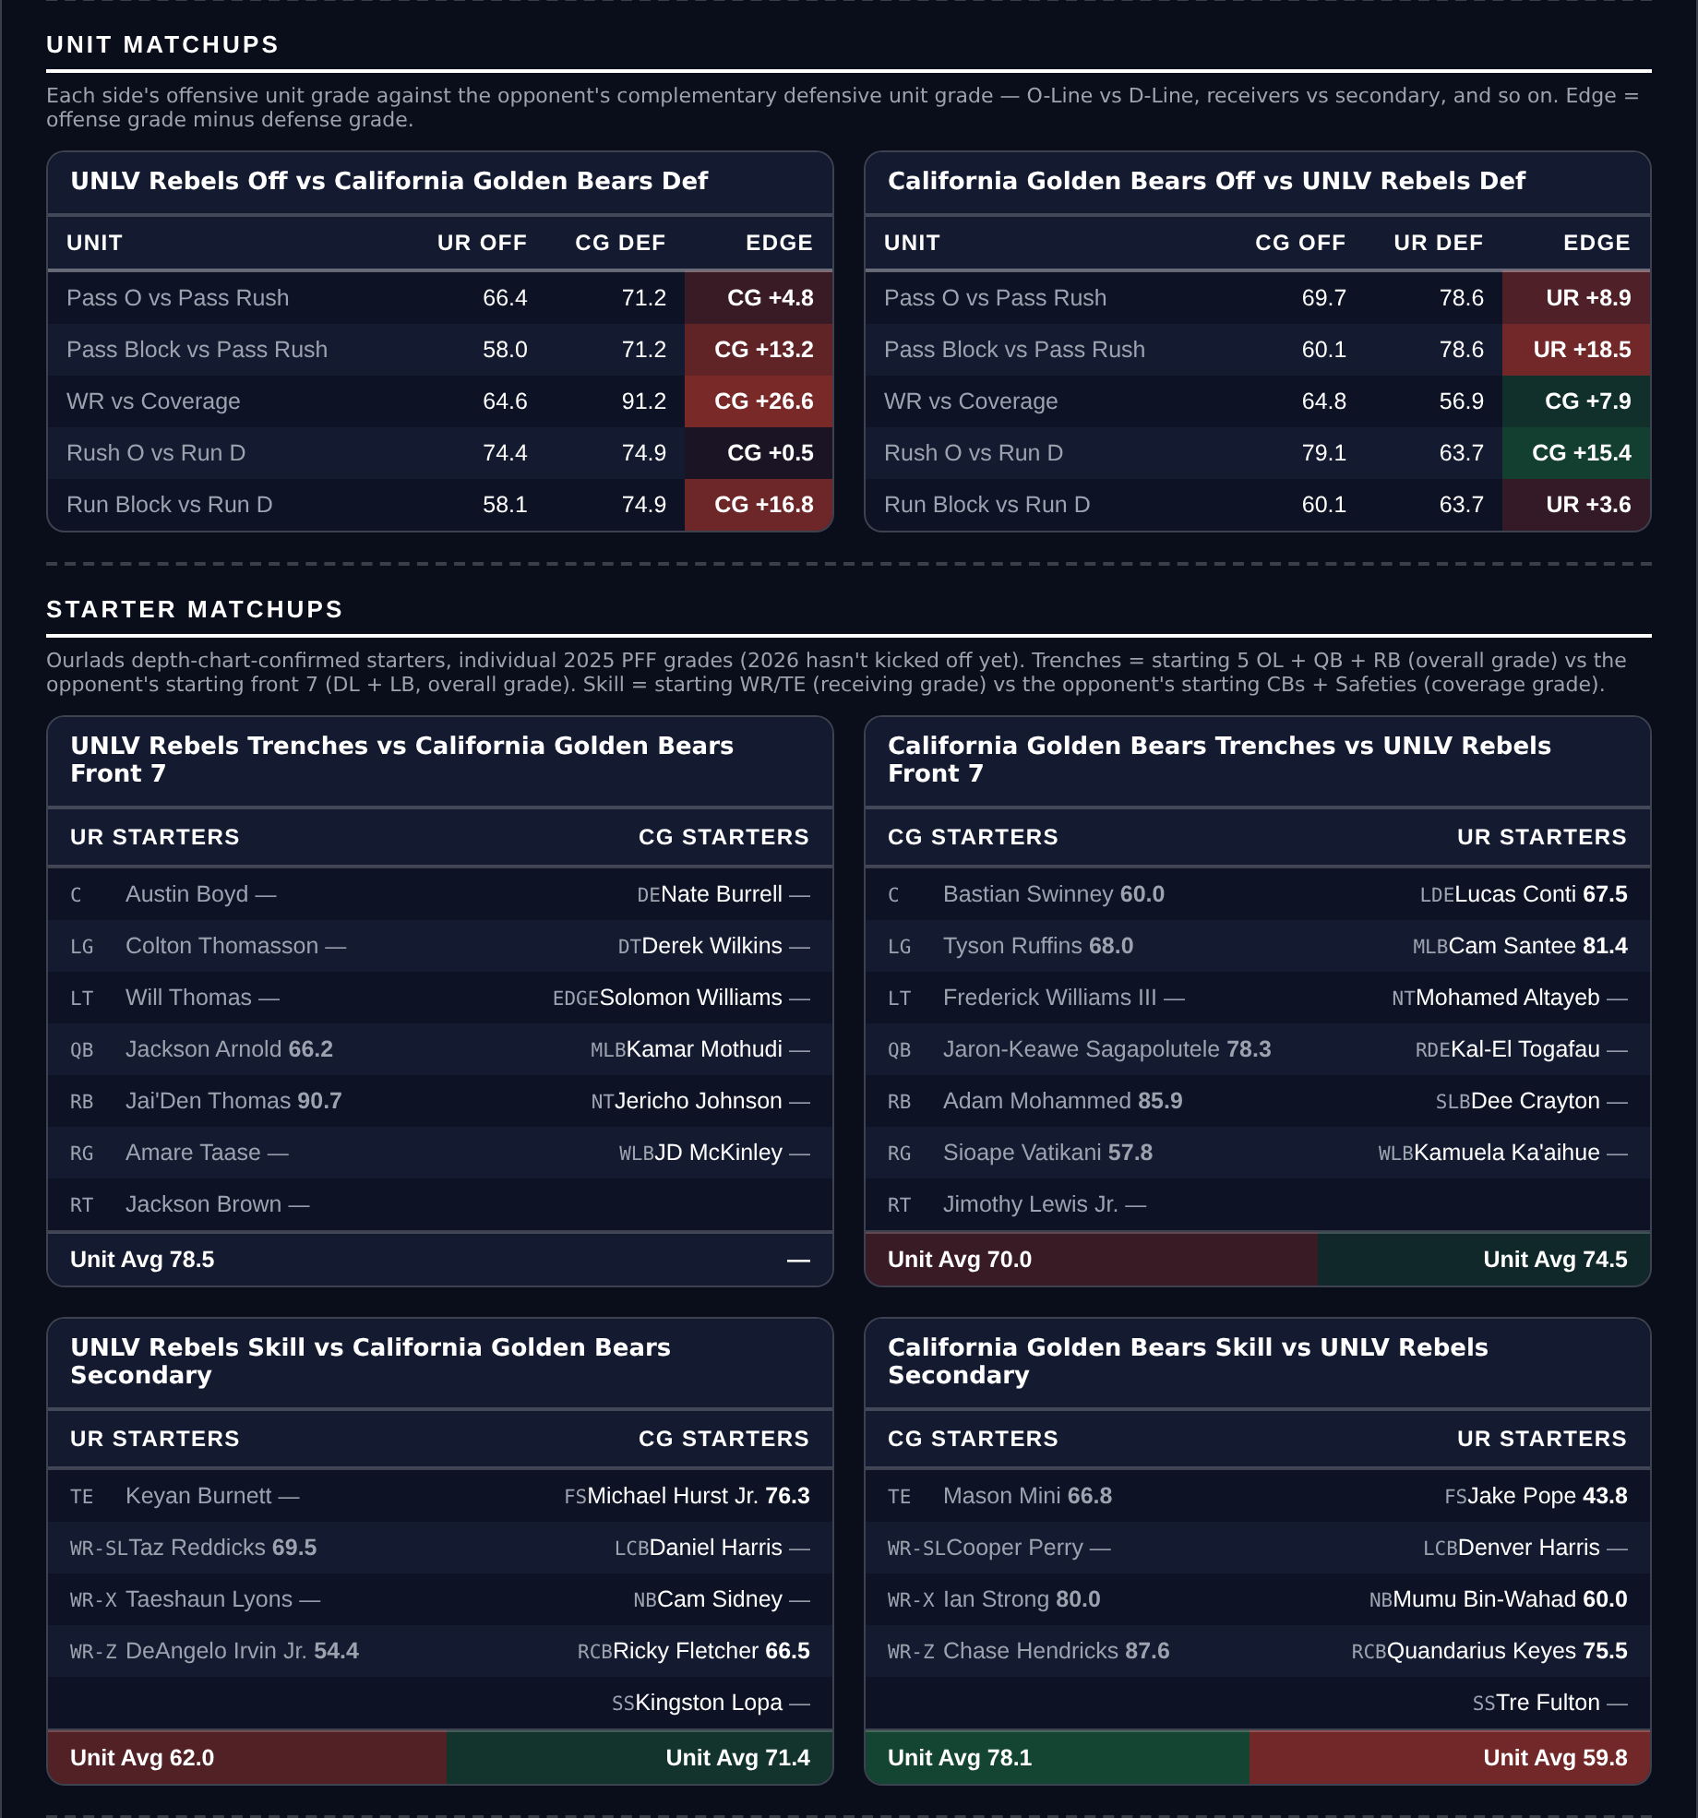
Unit matchups: each offensive unit grade against the opposing defensive unit. Edge = offense minus defense.

Stanford Cardinal @ Wake Forest Demon Deacons

Over 53.5
Book total | 53.5
Model number | 53.0
Residual | +3.2
Points check | 57.0, agreeing
Over records | Stanford 3-1, Wake Forest 2-2
Tempo | Stanford 19th, Wake Forest 34th
Defenses | Stanford 122nd Success Rate, Wake Forest 127th
Game spread | Wake Forest -14.0

Book has 53.5, the residual is +3.2 and the points check lands at 57.0. Both reads want the Over and the structure underneath them is straightforward.
Neither team can get off the field. Stanford's defense ranks 122nd in Success Rate, 118th in Explosiveness allowed and 132nd in Finishing Drives on a 49.6 tackling grade; Wake Forest's ranks 127th in Success Rate. Stanford have conceded 33.5 points a game.
Both play fast, 19th and 34th in tempo, so these are two bad defenses that also hand the ball back quickly. Wake Forest score 31.5 a game on an 81.4 run grade and rank 57th in Success Rate, comfortably the better offense on the field.
The risk is the shape rather than the arithmetic. Wake Forest are 14-point favourites and the model agrees with that number, so a one-sided game in which Stanford stop scoring is live. Stanford's own offense ranks 112th in Success Rate behind a 50.6 pass block grade, and the Over needs them to contribute something.
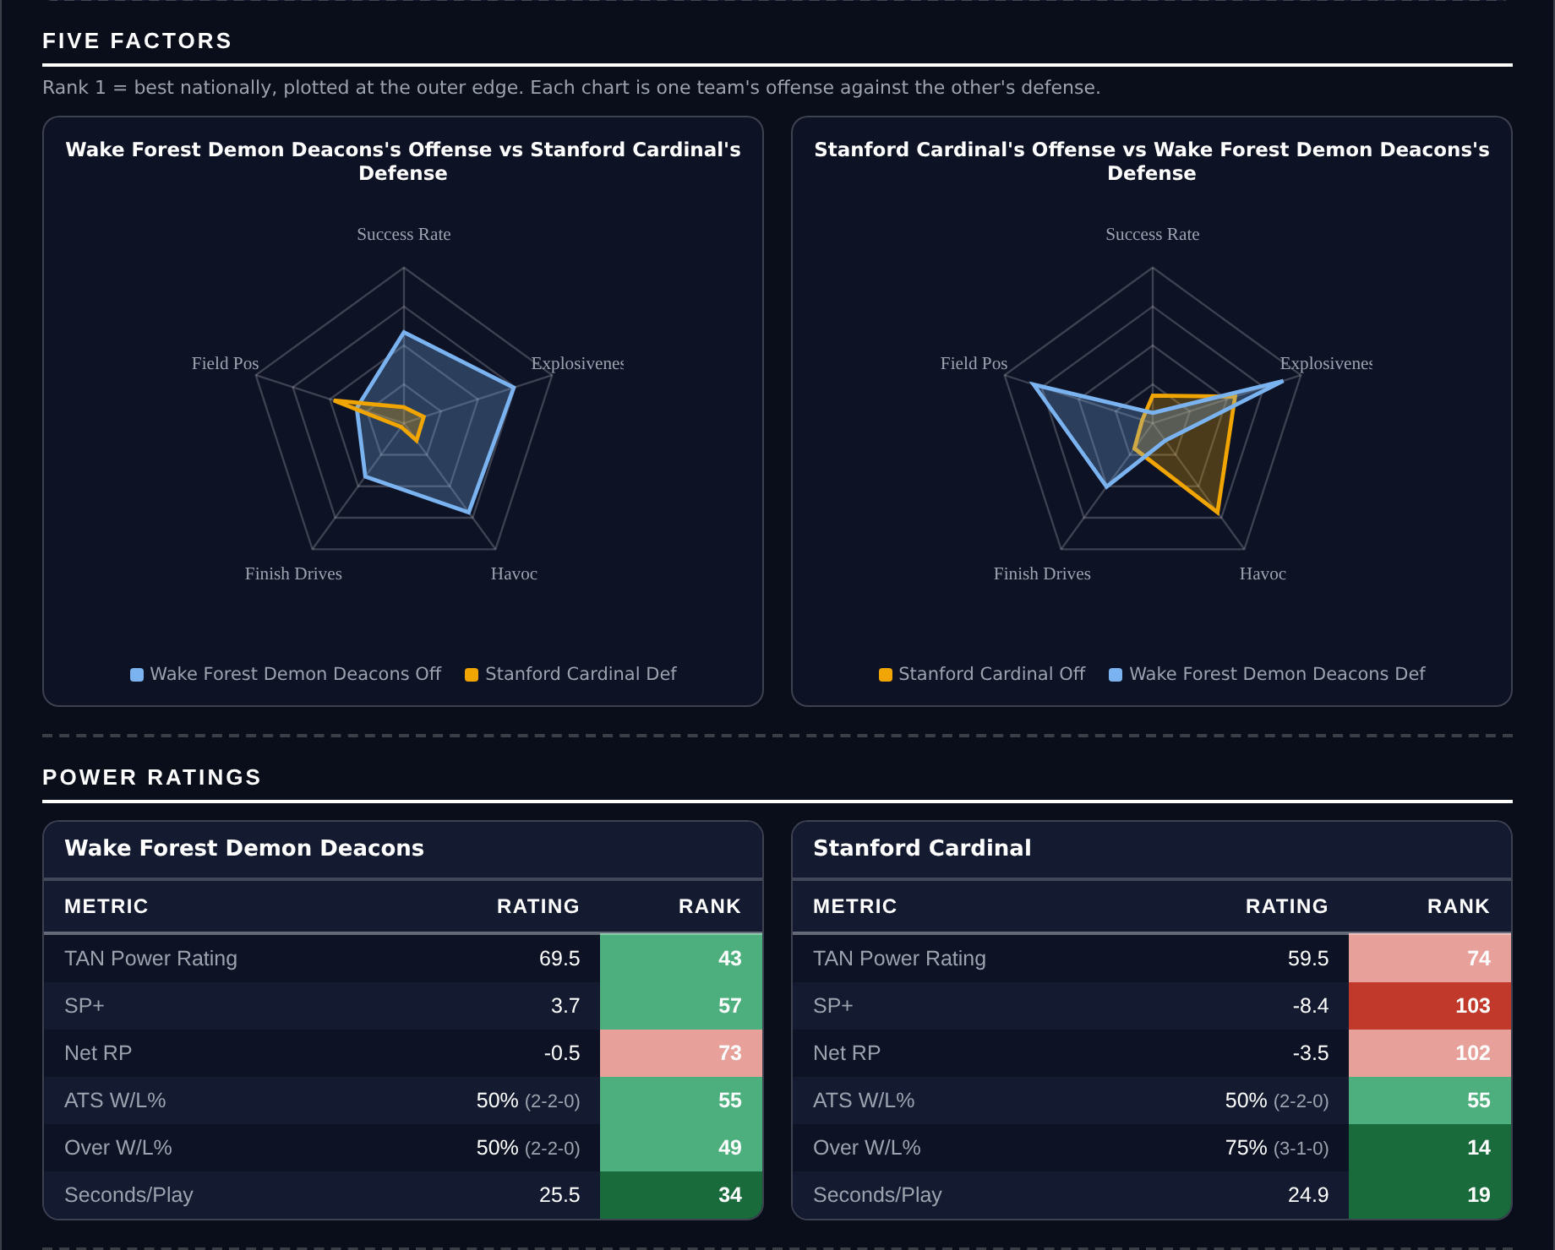
Five Factors and power ratings, captured from the CFB Betting Hub.
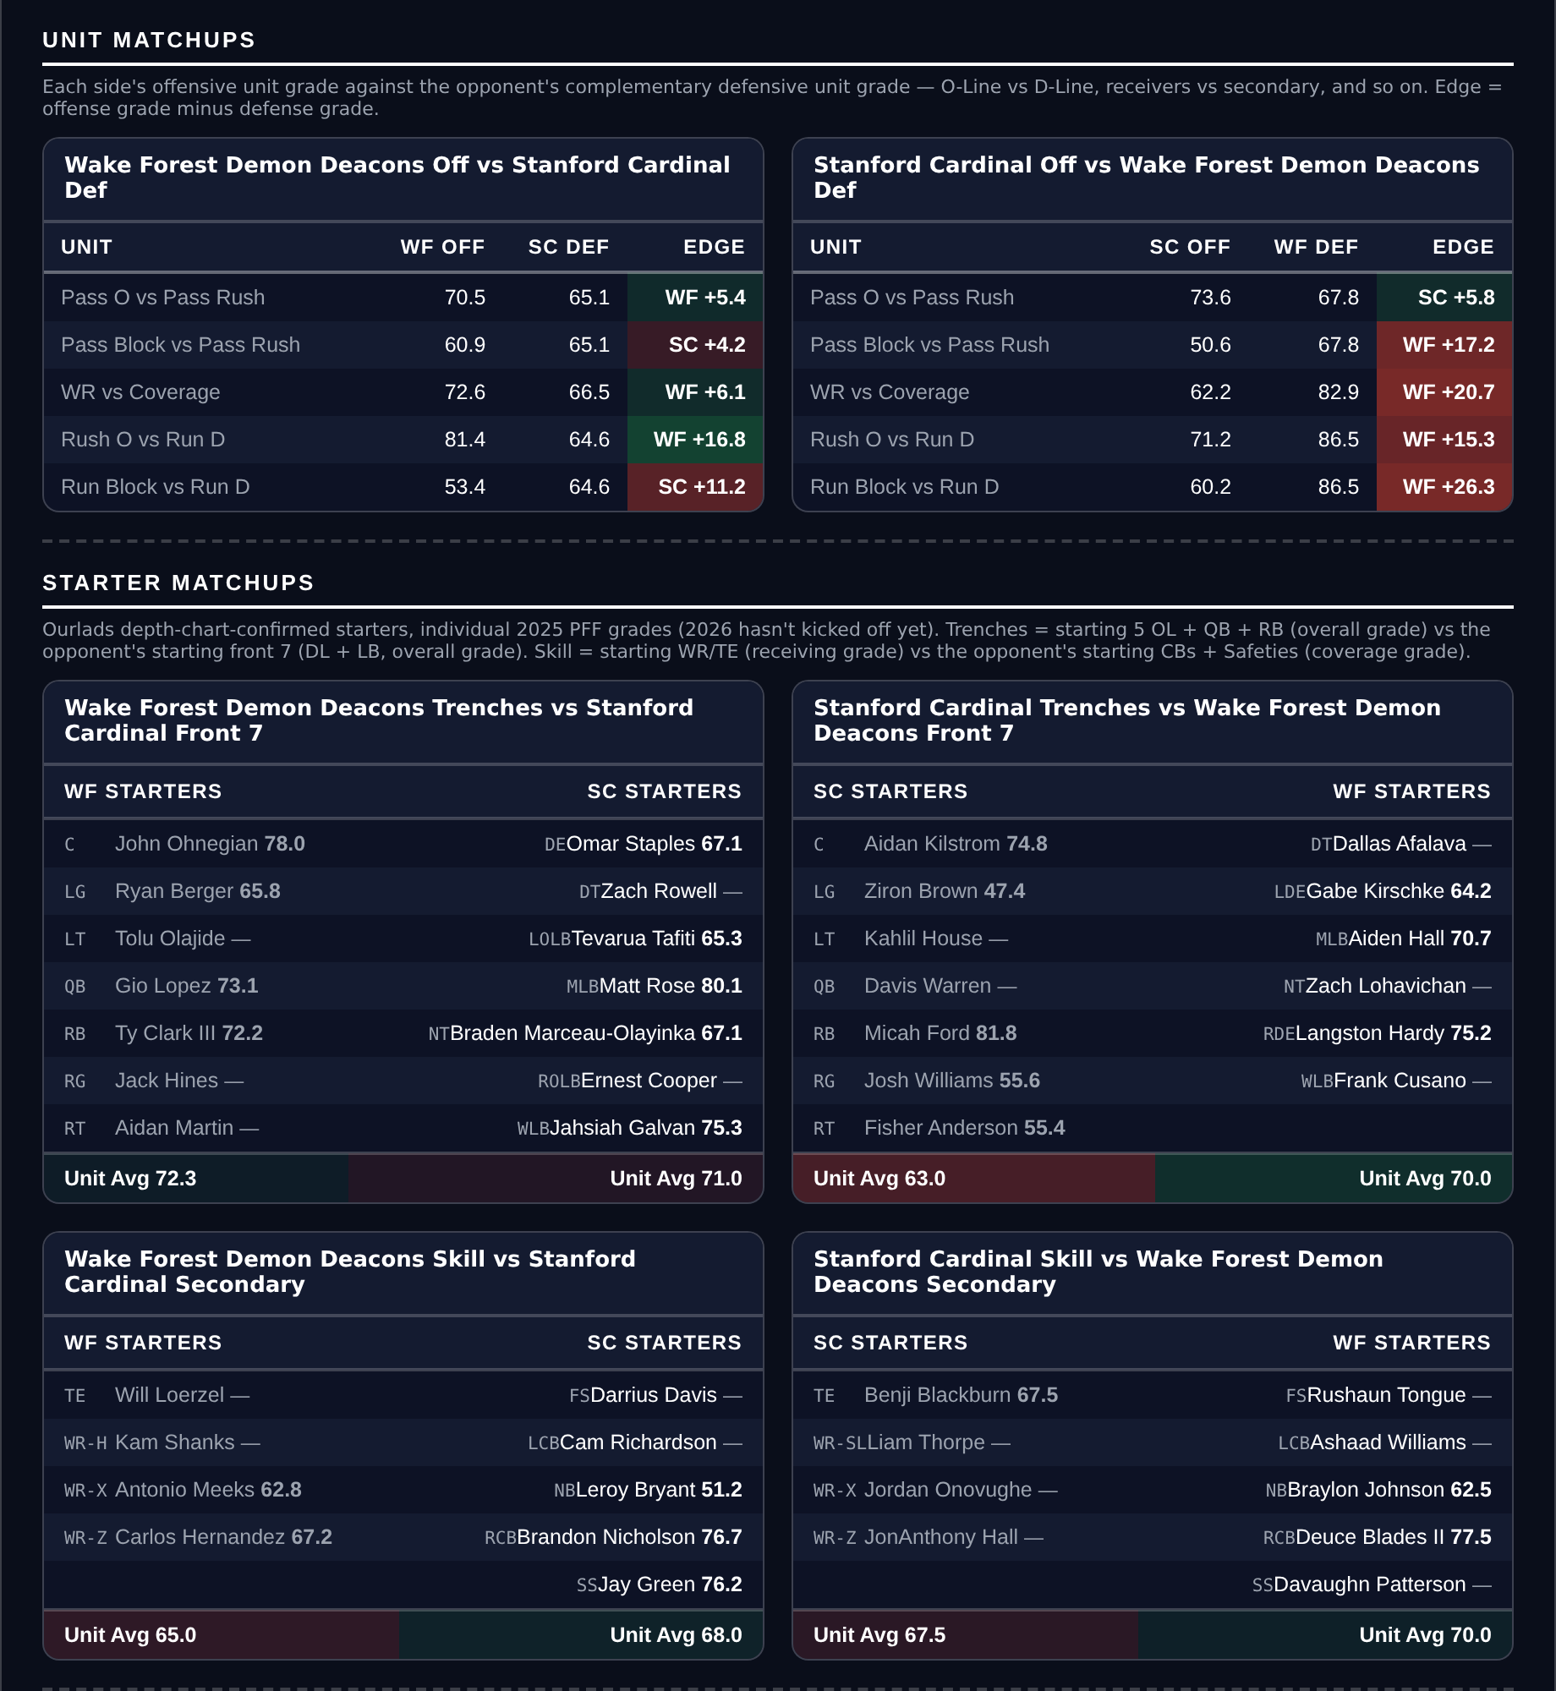
Unit matchups: each offensive unit grade against the opposing defensive unit. Edge = offense minus defense.

Washington Huskies @ USC Trojans

Under 58.5
Book total | 58.5
Model number | 56.2
Residual | -5.2
Points check | 55.5, agreeing
Washington defense | 16.8 allowed a game, 26th Success Rate, 92.0 run defense
USC offense | 5th Success Rate but 91st Explosiveness
Over records | Washington 2-2, USC 4-1
Game spread | USC -9.0

Book has 58.5, the model 56.2 with a -5.2 residual, and the points check at 55.5. Both reads lean Under.
Washington's defense is the argument. They allow 16.8 points a game on a unit ranked 26th in Success Rate, 20th in Havoc and 23rd in Finishing Drives, with a 92.0 run defense grade and an 84.8 coverage grade. Their own offense is ordinary, 64th in Success Rate and 73rd in Finishing Drives, scoring 28.0.
USC are the Over case and a real one: 5th in Success Rate, a 92.9 offensive grade, 90.9 passing, 39.8 points a game and 4-1 to the Over. What tempers it is 91st in Explosiveness, which means long drives rather than quick scores, and both teams sitting in the slower half of tempo at 76th and 81st.
USC's defense is the risk. It ranks 91st in Success Rate, 113th in Explosiveness allowed, 130th in Havoc and 119th in Finishing Drives on a 59.2 coverage grade and 50.7 tackling. If Washington's offense is better than its ranks, this reaches 59 quickly.
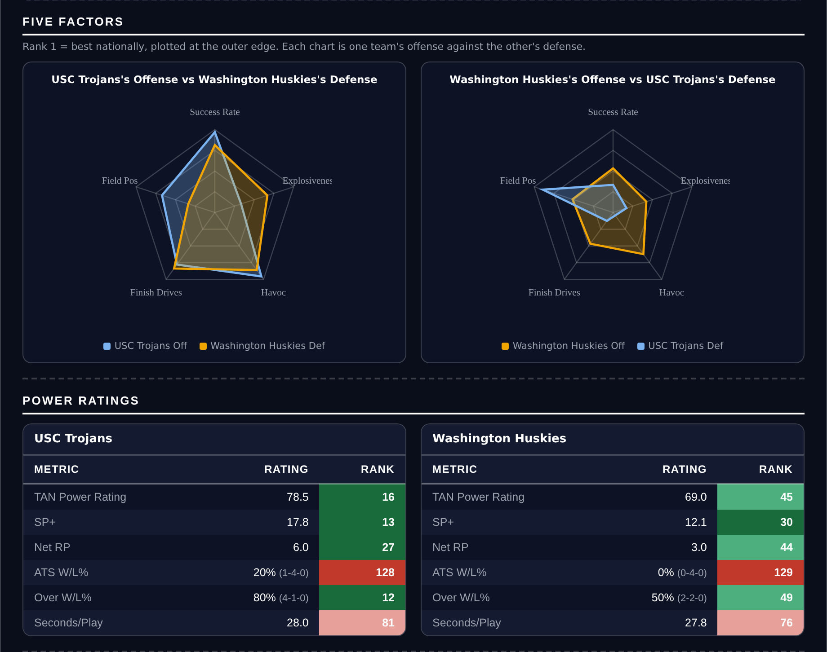
Five Factors and power ratings, captured from the CFB Betting Hub.
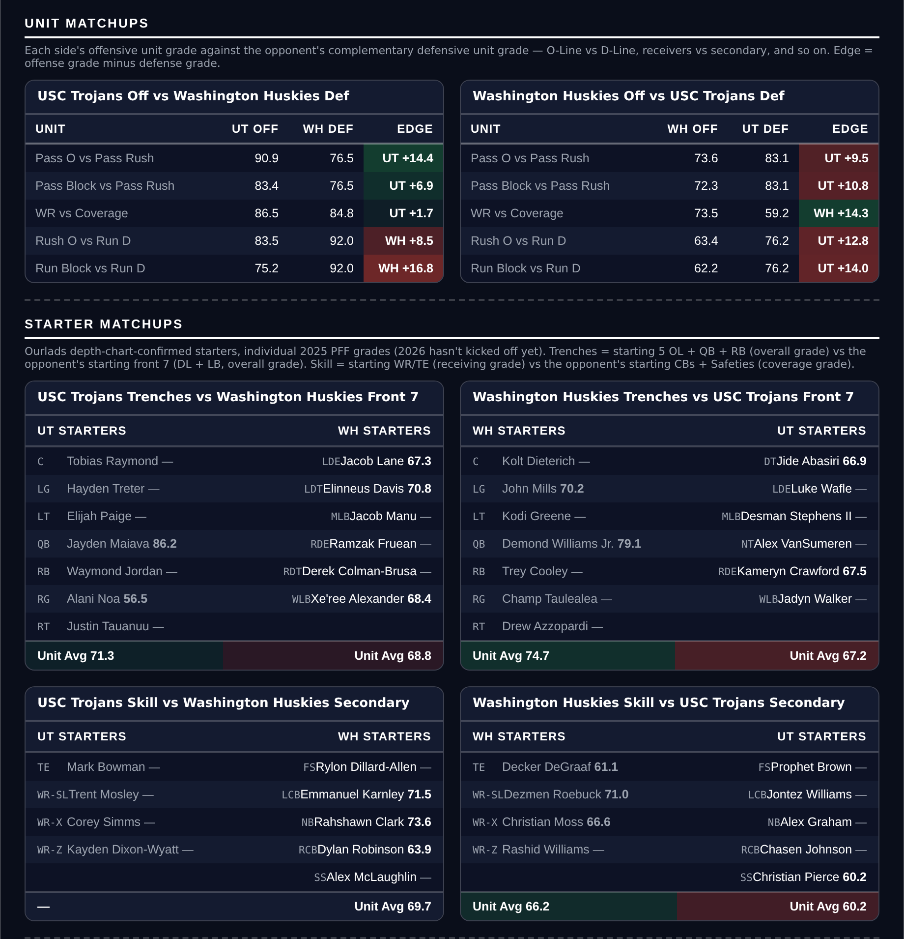
Unit matchups: each offensive unit grade against the opposing defensive unit. Edge = offense minus defense.

Miami Hurricanes @ Clemson Tigers

Over 47.5
Book total | 47.5
Model number | 57.5
Residual | +6.2
Points check | 51.9, agreeing
Miami | 4-0, 51.8 points a game, 3rd in Success Rate, 94.1 offensive grade
Clemson offense | 132nd Success Rate, 117th Finishing Drives, 40.1 passing
Over records | Miami 3-1, Clemson 2-2
Game spread | Miami -16.5

Book has 47.5, the model 57.5, residual +6.2, and the points check at 51.9. Both reads want the Over.
Miami are scoring 51.8 a game. The offense ranks 3rd in Success Rate, 14th in Finishing Drives and 4th in Havoc allowed, on a 94.1 offensive grade, 93.9 passing and 88.0 receiving, and they have put up 207 points in four games while allowing 36.
Clemson are the drag. Despite a 3-1 record their offense ranks 132nd in Success Rate, 117th in Finishing Drives and 127th in Havoc allowed, with a 40.1 passing grade, and they score 21.0 a game. Their defense is better than that, 16th in Finishing Drives on an 88.5 coverage grade, but it ranks 84th in Success Rate, which is the relevant number against this opponent.
So the Over is a bet on one offense, not two. Miami at 16.5-point road favourites raises the blowout risk: 35-7 lands under. The counter is that Miami's own average clears 47.5 with a field goal from Clemson, and Clemson's 50.3 tackling grade is not the unit that slows a 94.1 offense.
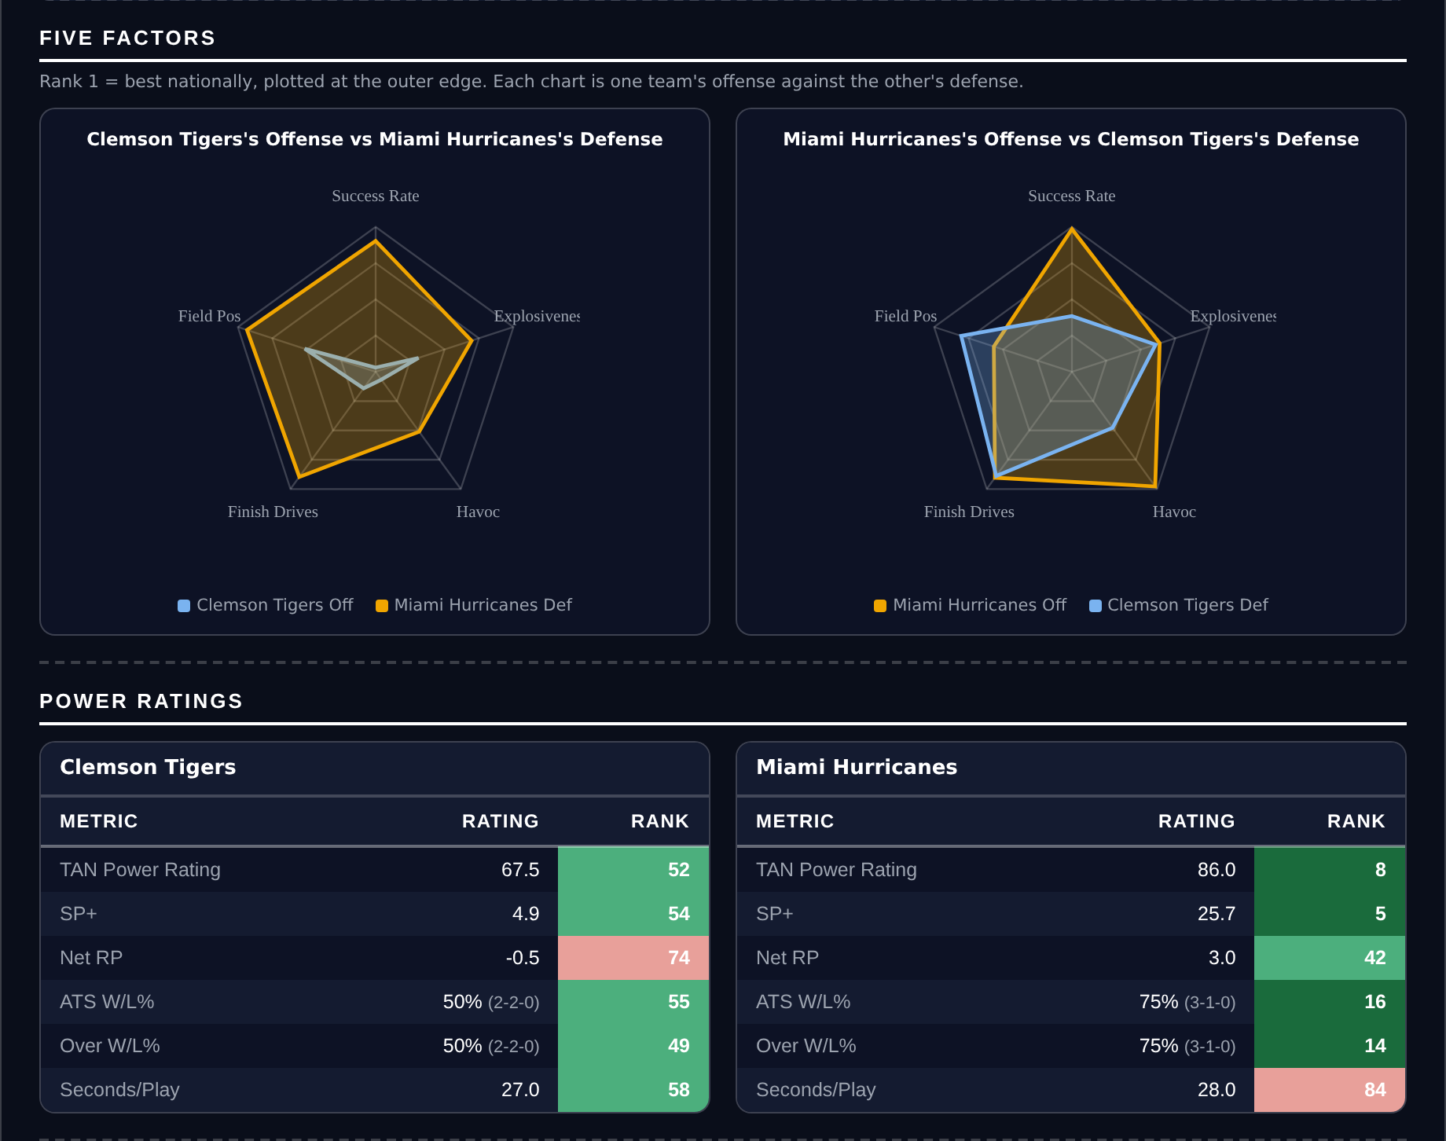
Five Factors and power ratings, captured from the CFB Betting Hub.
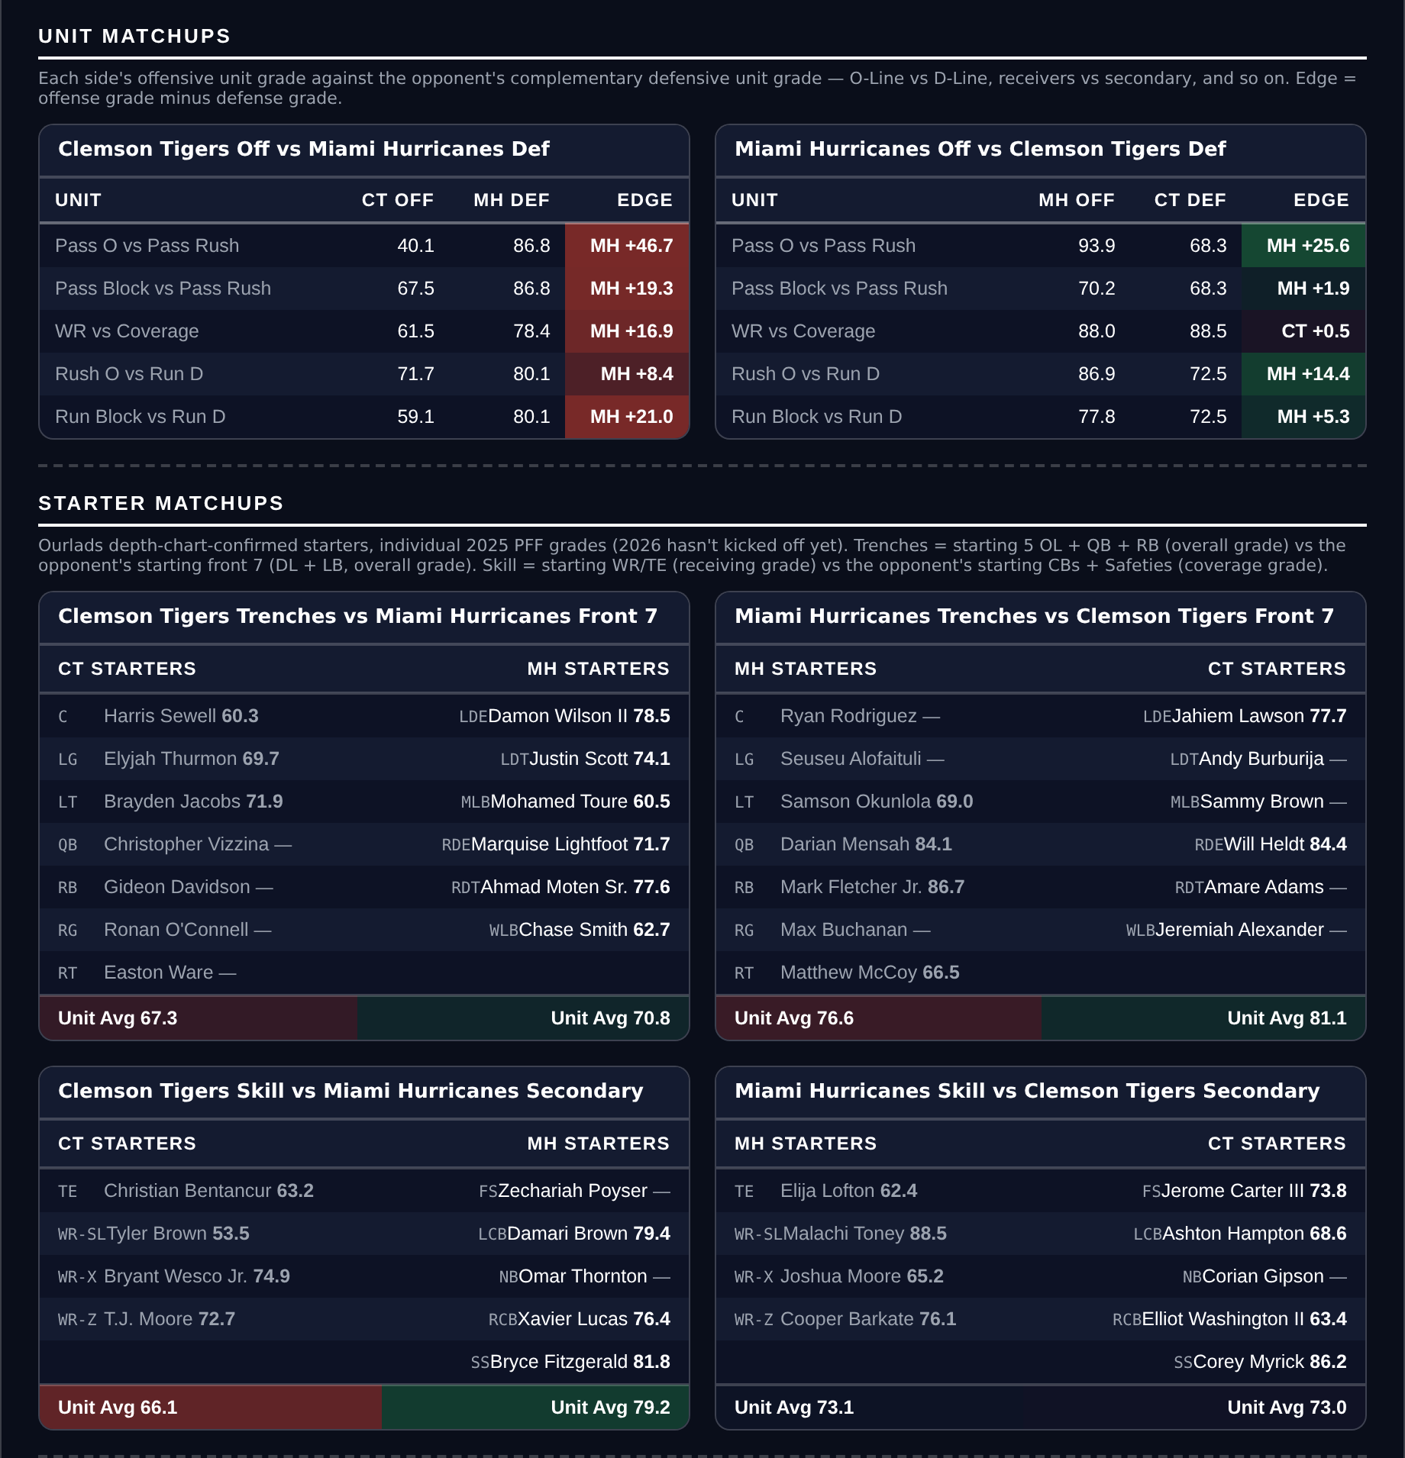
Unit matchups: each offensive unit grade against the opposing defensive unit. Edge = offense minus defense.

