Week 9 Betting Card
Week 9 · Saturday October 31, 2026
Ten positions for Saturday: five spreads and five player props. The slate is 45 rated Saturday games with a posted spread and total, and every pick below is drawn from that pool.
No totals again this week. Week 7's five went 0-5 with the three Overs missing by 19, 25 and 20.5 points in games where both selection measures agreed, and the category stays out until that test has been scored across every game of weeks 6 through 8 rather than the ten that were bet.
Spreads are selected on two measures built for every game: the model number, which is the SP+ differential plus home field, and the points check, which uses nothing but each team's own 2026 scoring and home field and shares no input with SP+. Each is taken relative to where the whole slate sits. A game qualifies only when both land on the same side, and candidates are ranked by the weaker of the two. Twenty of the 45 games had the two agreeing this week.
Every figure in this card is checked against the source data before it is written. Team grades, five-factor ranks and per-game scoring come from the 2026 PFF team grades and the season-to-date CFBData ranks; each player's role, share and production come from the 2026 PFF season files. Per-game scoring uses each team's own game count, which is seven, eight or nine this week. Where a rank ends in .5 the teams are tied and it is written as “tied Nth”. All ten kickoffs are verified Saturday in Eastern time, every prop player was checked against this morning's depth chart, and every venue against the National Weather Service forecast at kickoff.
Season to date: 43-50-3 and two voids, down 12.69 units across 98 picks. Spreads 14-20-1 (-8.00u), totals 12-15-2 (-4.50u), props 17-15 and two voids (-0.19u). Week 8 was the first winning week of the season at 5-4 and +0.60 units, and the first card with no totals on it.

Spreads
Five spreads where the two measures agree on a side, and a better week for them than last. The strongest agreement on the board is 10.2 points against 4.9 last week, and all five positions take points rather than lay them.
Across the 45 rated Saturday games the model sits 0.3 points more toward the home side than the market does, so the raw and adjusted readings are close to identical again.
The standing exclusion applies and nothing triggered it: do not lay a price into a team whose record against the spread is running ahead of its rating. Since every pick here takes points, it could not.
Ratings and the Five Factors come from the 2026 workbook: SP+, TAN, implied team totals and the season-to-date CFBData ranks, out of 138 teams. Player lines are 2026 PFF season to date. Records, ATS and over/under records are TeamRankings, 2026 to date. The PFF team grade file covers seven games for 84 teams, eight for 52 and nine for 2. Futures prices are the week 9 pull except win totals, which are week 7.

Kansas State Wildcats @ Colorado Buffaloes

Kansas State +3.0
Book line | Colorado -3.0
Model number | Kansas State -10.5
Gap | 13.5 pts, 13.8 net
Points check | Kansas State by 8.3, which is 11.3 past the market
SP+ (2026) | Kansas State +8.8 (39th) vs Colorado -4.3 (94th), home edge +2.6
Kansas State 2026 | 4-3, 32.9 points a game and 21.1 allowed
Colorado offense | 20.1 points a game, 115th in Success Rate, 130th in Finishing Drives
Colorado field position | 130th on offense, tied 134th on defense

Book has Colorado laying three at home. The rating has Kansas State winning by 10.5 and the points check, built only from each team's own 2026 scoring and home field, has them by 8.3. The 13.8-point disagreement is the widest this card has seen all season.
Kansas State are the better team by every reading on the sheet. They are 4-3, score 32.9 and allow 21.1; Colorado are 2-5, score 20.1 and allow 30.1. SP+ separates them by thirteen points before home field. The Wildcats' defence ranks 17th in Success Rate and tied 7th in Havoc.
Colorado's problem is the whole field. Their offence ranks 115th in Success Rate, 130th in Finishing Drives and 130th in offensive Field Position, and their defence ranks tied 134th in defensive Field Position, so they start badly at both ends and cannot finish what they do assemble. A team scoring 20.1 a game is being asked to beat a team scoring 32.9 outright.
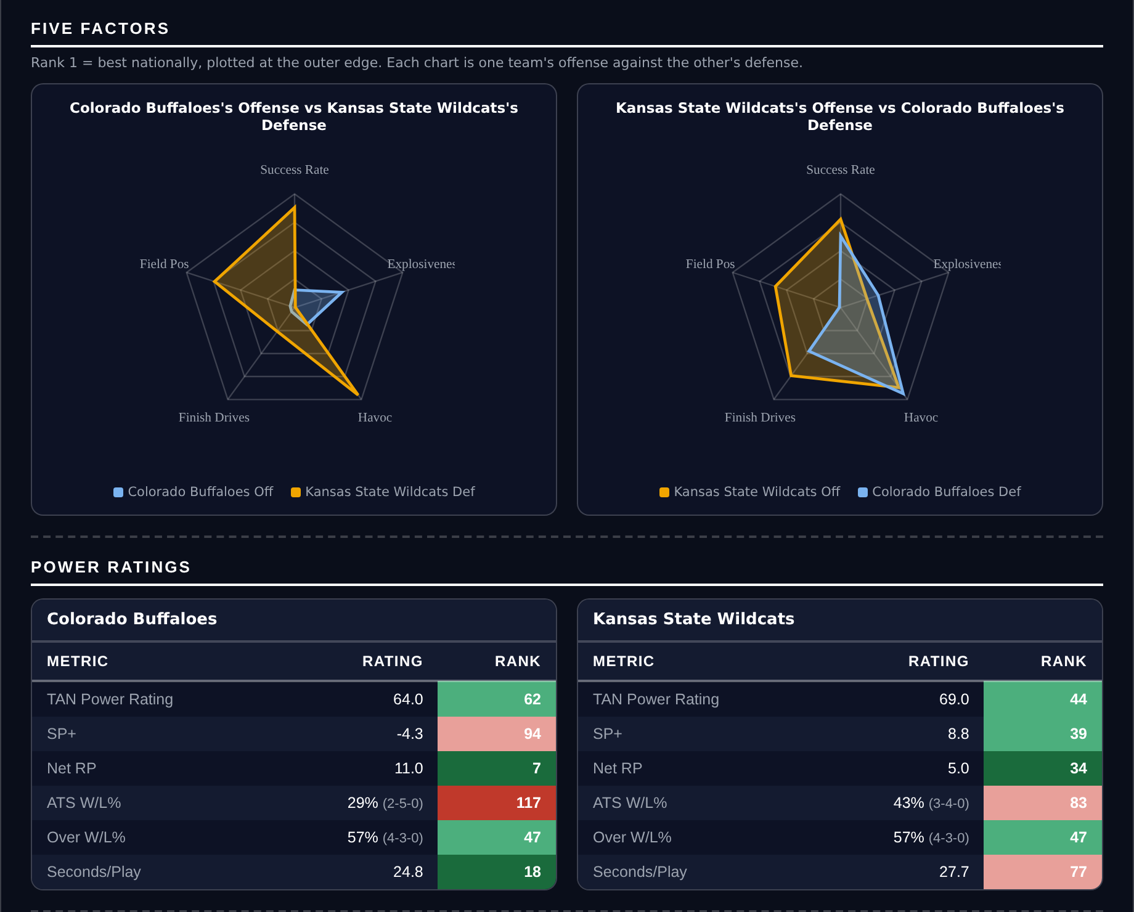
Five Factors and power ratings, captured from the CFB Betting Hub.
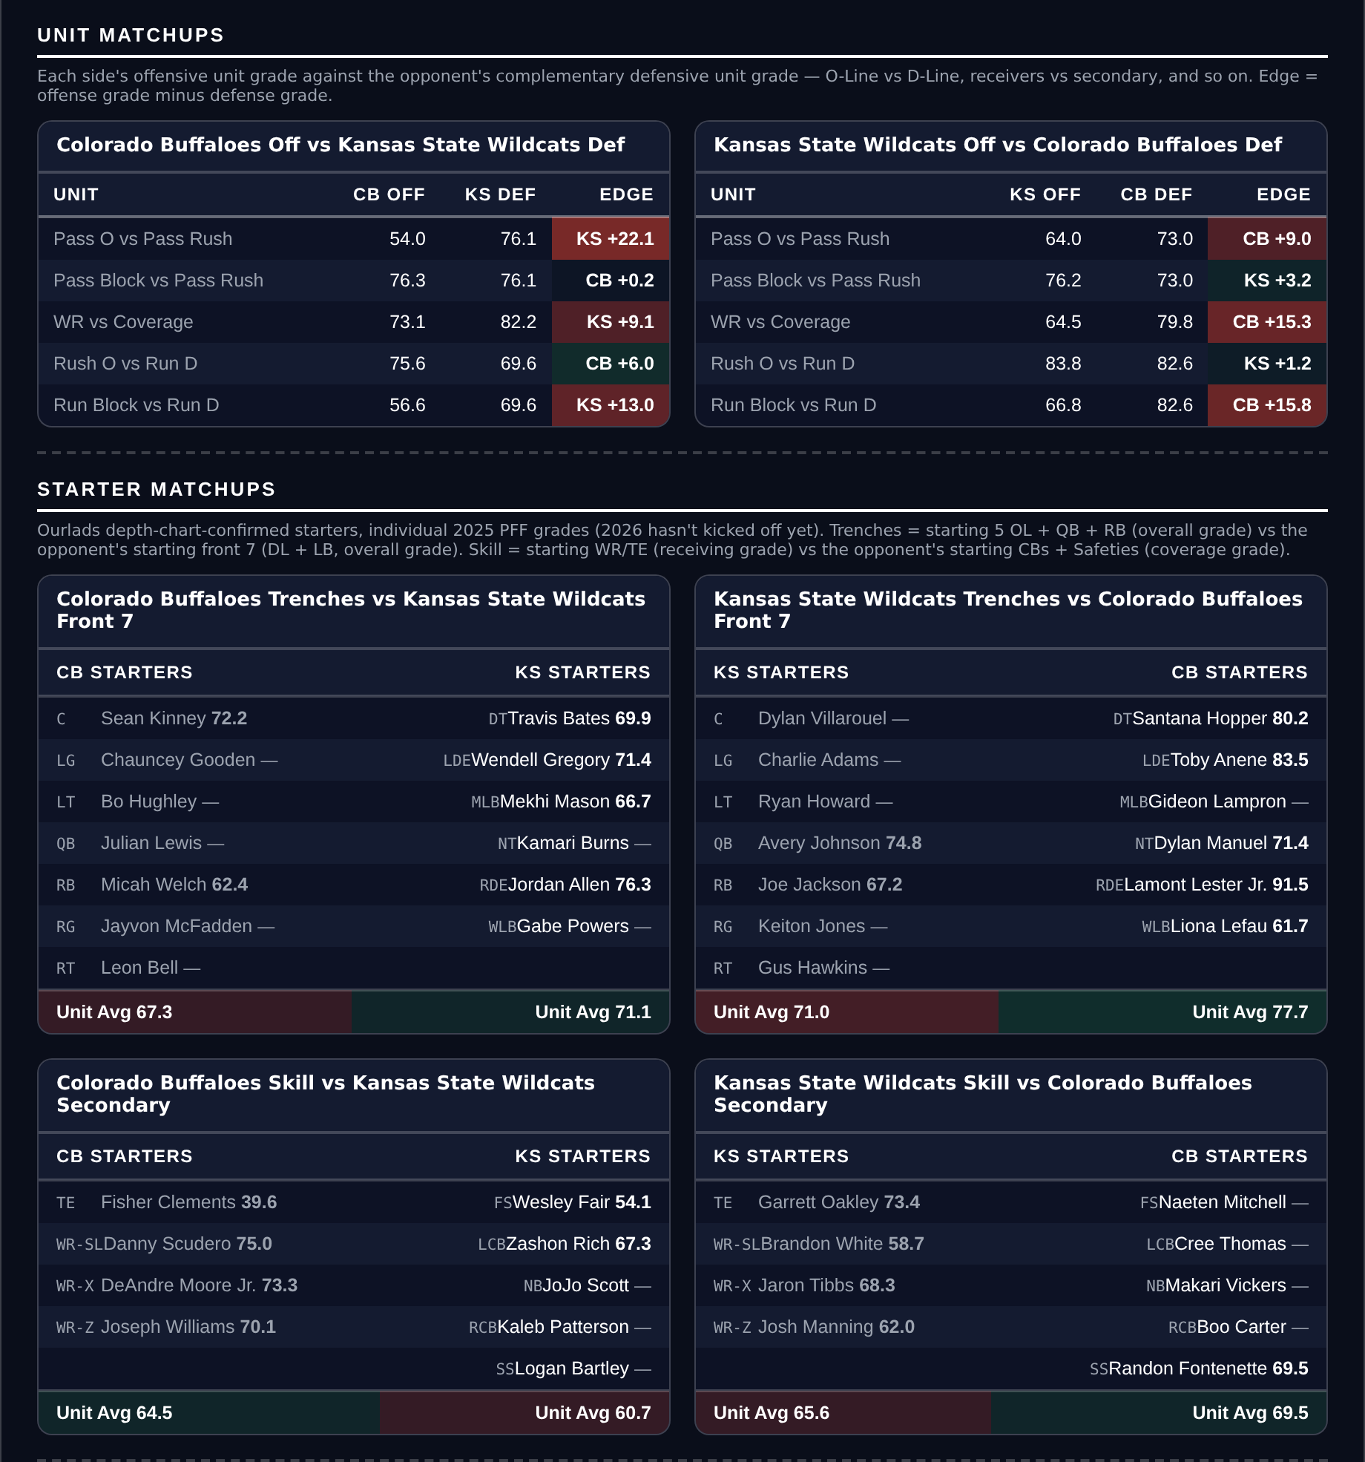
Unit matchups: each offensive unit grade against the opposing defensive unit. Edge = offense minus defense.

Notre Dame Fighting Irish @ Navy Midshipmen

Navy +30.5
Book line | Navy +30.5
Model number | Notre Dame -24.1
Gap | 6.4 pts, 6.1 net
Points check | Notre Dame by 10.8, which is 19.7 past the market
SP+ (2026) | Notre Dame +25.2 (tied 3rd) vs Navy -1.6 (81st), home edge +2.7
Navy 2026 | 2-5 but scoring 29.7 a game, 5-2 to the Over
Navy offense | 27th in Success Rate, 29.7 points a game
Game total | 56.5

Thirty and a half is an enormous number and both measures say it is too many. The rating has Notre Dame by 24.1 and the points check, which uses only each side's own 2026 scoring, has them by 10.8. The gap between the market and the more generous of the two is six points; against the points check it is nearly twenty.
Navy score. They are 2-5 and the record reads badly, but they put up 29.7 points a game on an offence that ranks 27th in Success Rate, and their games have gone over in five of seven. A team that reaches the high twenties does not often lose by five touchdowns, and the 56.5 total says the market expects this game to move.
Notre Dame are rated tied third in the country and will score: Navy's coverage grade of 46.4 ranks 134th and their pass rush of 58.1 ranks 133rd. The position is not that the Irish are overrated. It is that laying 30.5 requires Navy to be held near their floor, and an offence ranked 27th in Success Rate playing at home has a floor well above the one this number implies.
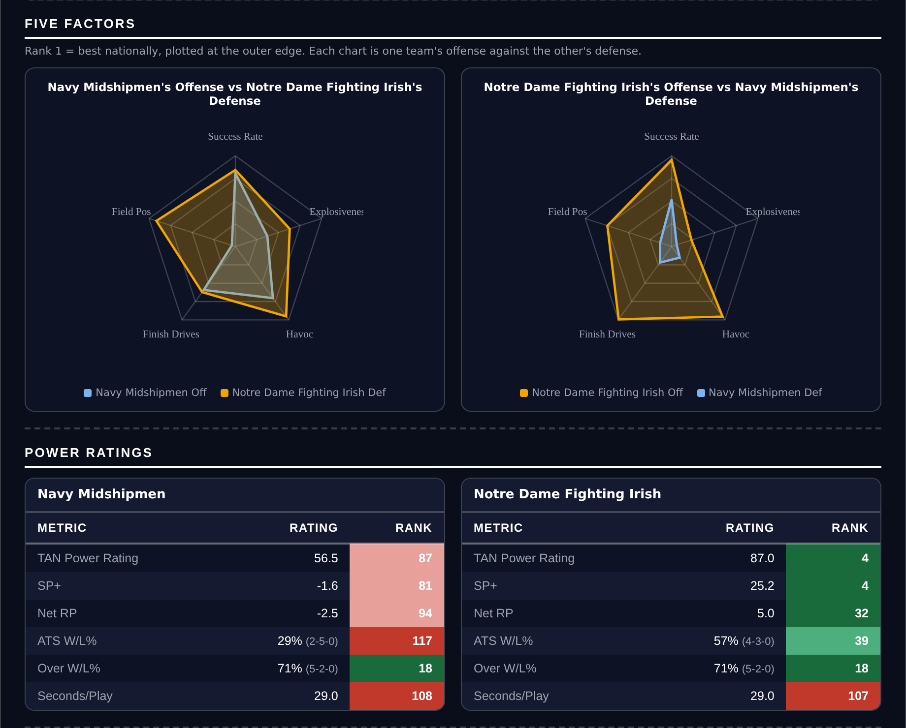
Five Factors and power ratings, captured from the CFB Betting Hub.
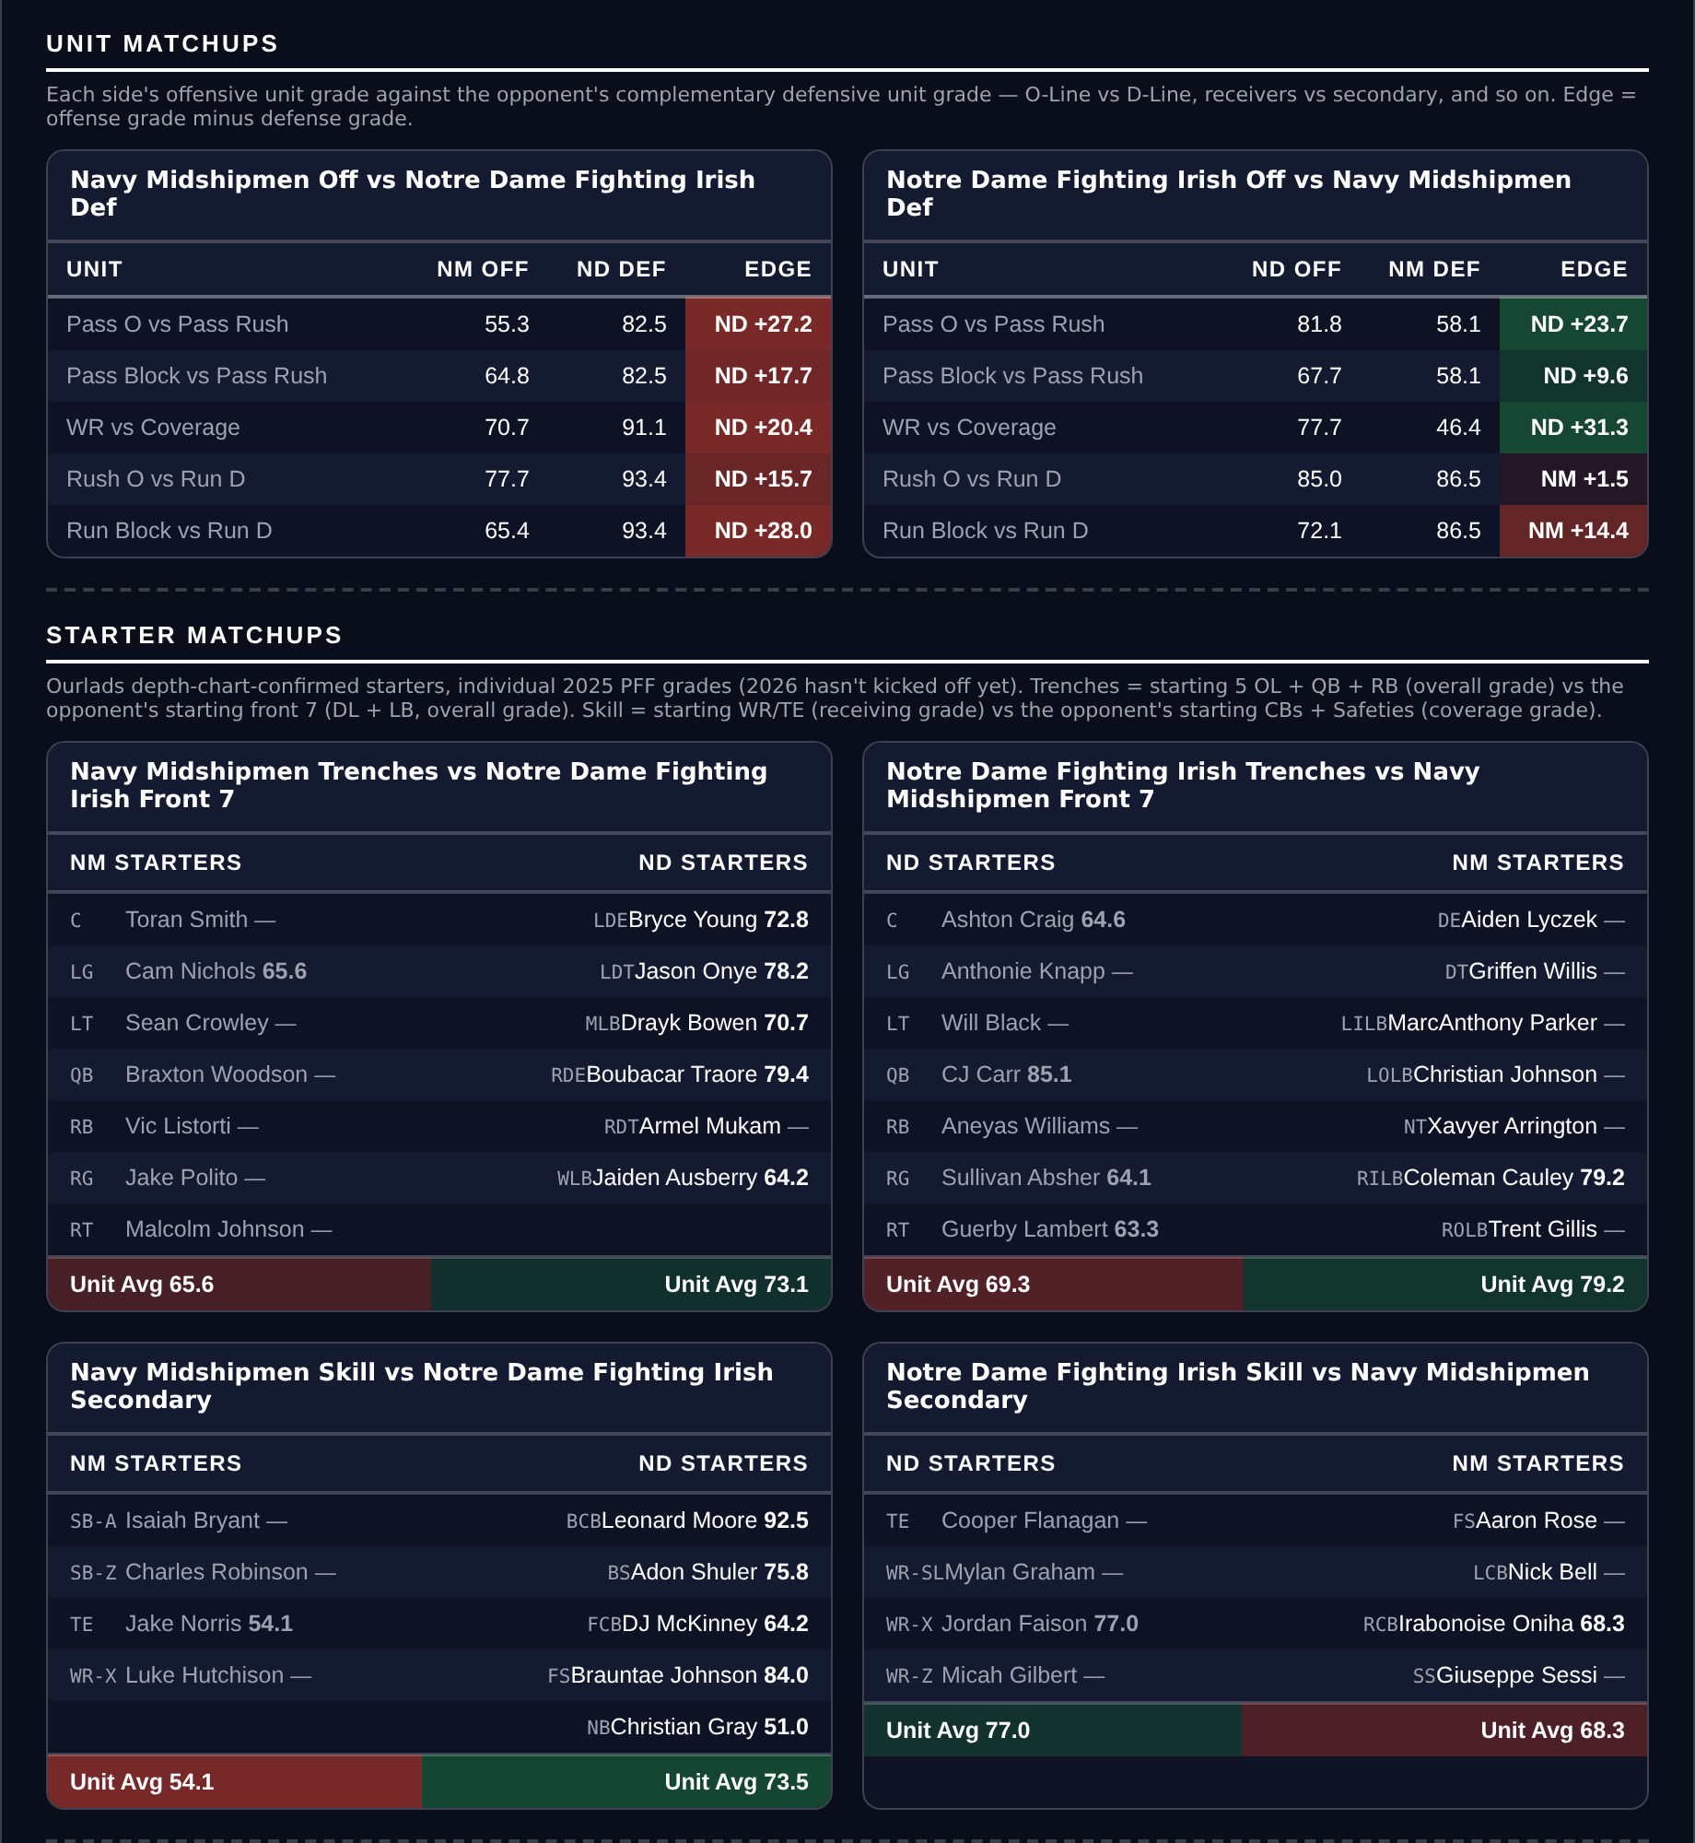
Unit matchups: each offensive unit grade against the opposing defensive unit. Edge = offense minus defense.

Colorado State Rams @ Utah State Aggies

Colorado State +7.5
Book line | Utah State -7.5
Model number | Utah State -1.8
Gap | 5.7 pts, 6.0 net
Points check | Utah State by 1.3, which is 6.2 past the market
SP+ (2026) | Utah State -9.2 (tied 106th) vs Colorado State -8.4 (104th), home edge +2.6
Colorado State 2026 | 3-4, 38.6 points a game, 7-0 to the Over
Colorado State offense | 3rd in Explosiveness, 3rd in Finishing Drives
Utah State offense | 14.9 points a game, 133rd in Success Rate, 136th in Finishing Drives

SP+ rates these two within a point of each other and the market asks for a touchdown and a half. Home field accounts for 2.6, which leaves the rating at Utah State by 1.8 and the points check at Utah State by 1.3. Both sit six points clear of the number.
Utah State cannot score. They put up 14.9 points a game on an offence that ranks 133rd in Success Rate, 136th in Finishing Drives and tied 128th in Havoc allowed. Laying 7.5 asks a team averaging under fifteen to win by eight, which requires their defence to produce most of the margin.
Colorado State score plenty. They average 38.6 points a game and rank 3rd in the country in both offensive Explosiveness and Finishing Drives, and all seven of their games have gone over, a 7-0 Over record that ranks 1st in the country. Their defence is genuinely poor and that is why the total here is 61.5, but a shootout is the shape in which a 7.5-point dog cashes.
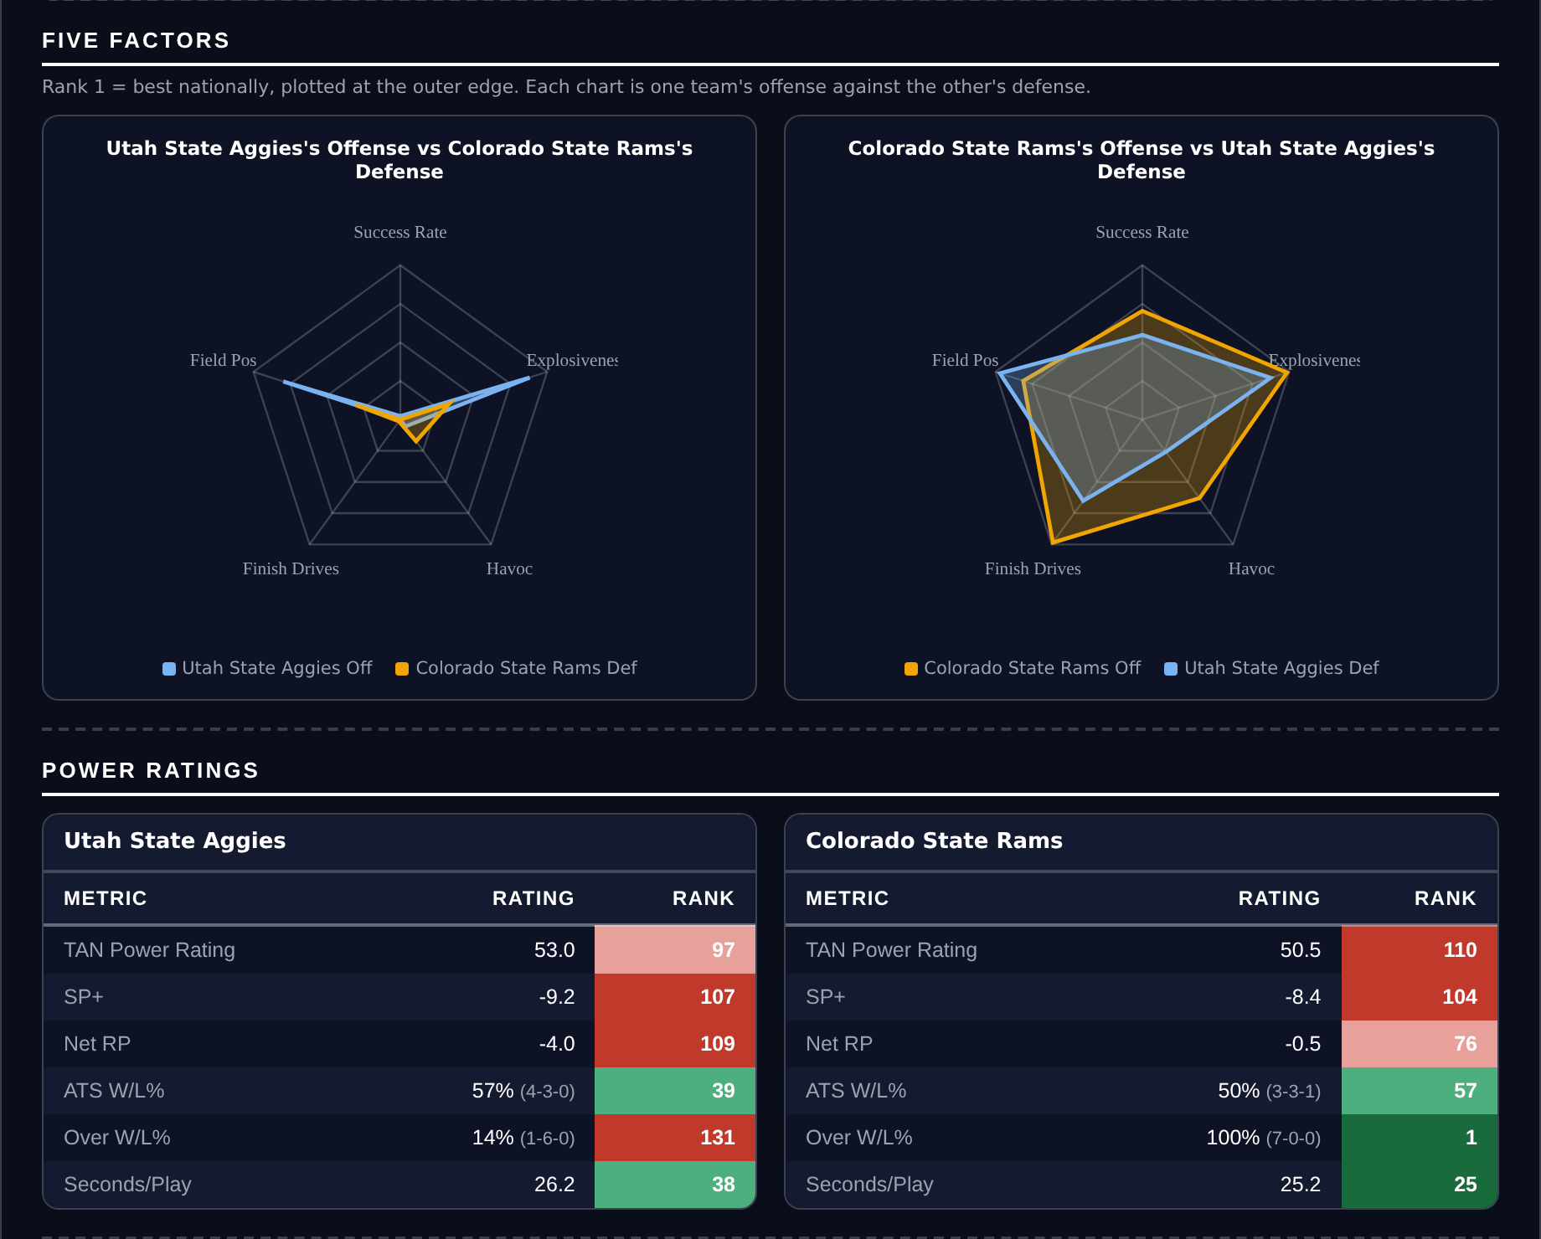
Five Factors and power ratings, captured from the CFB Betting Hub.
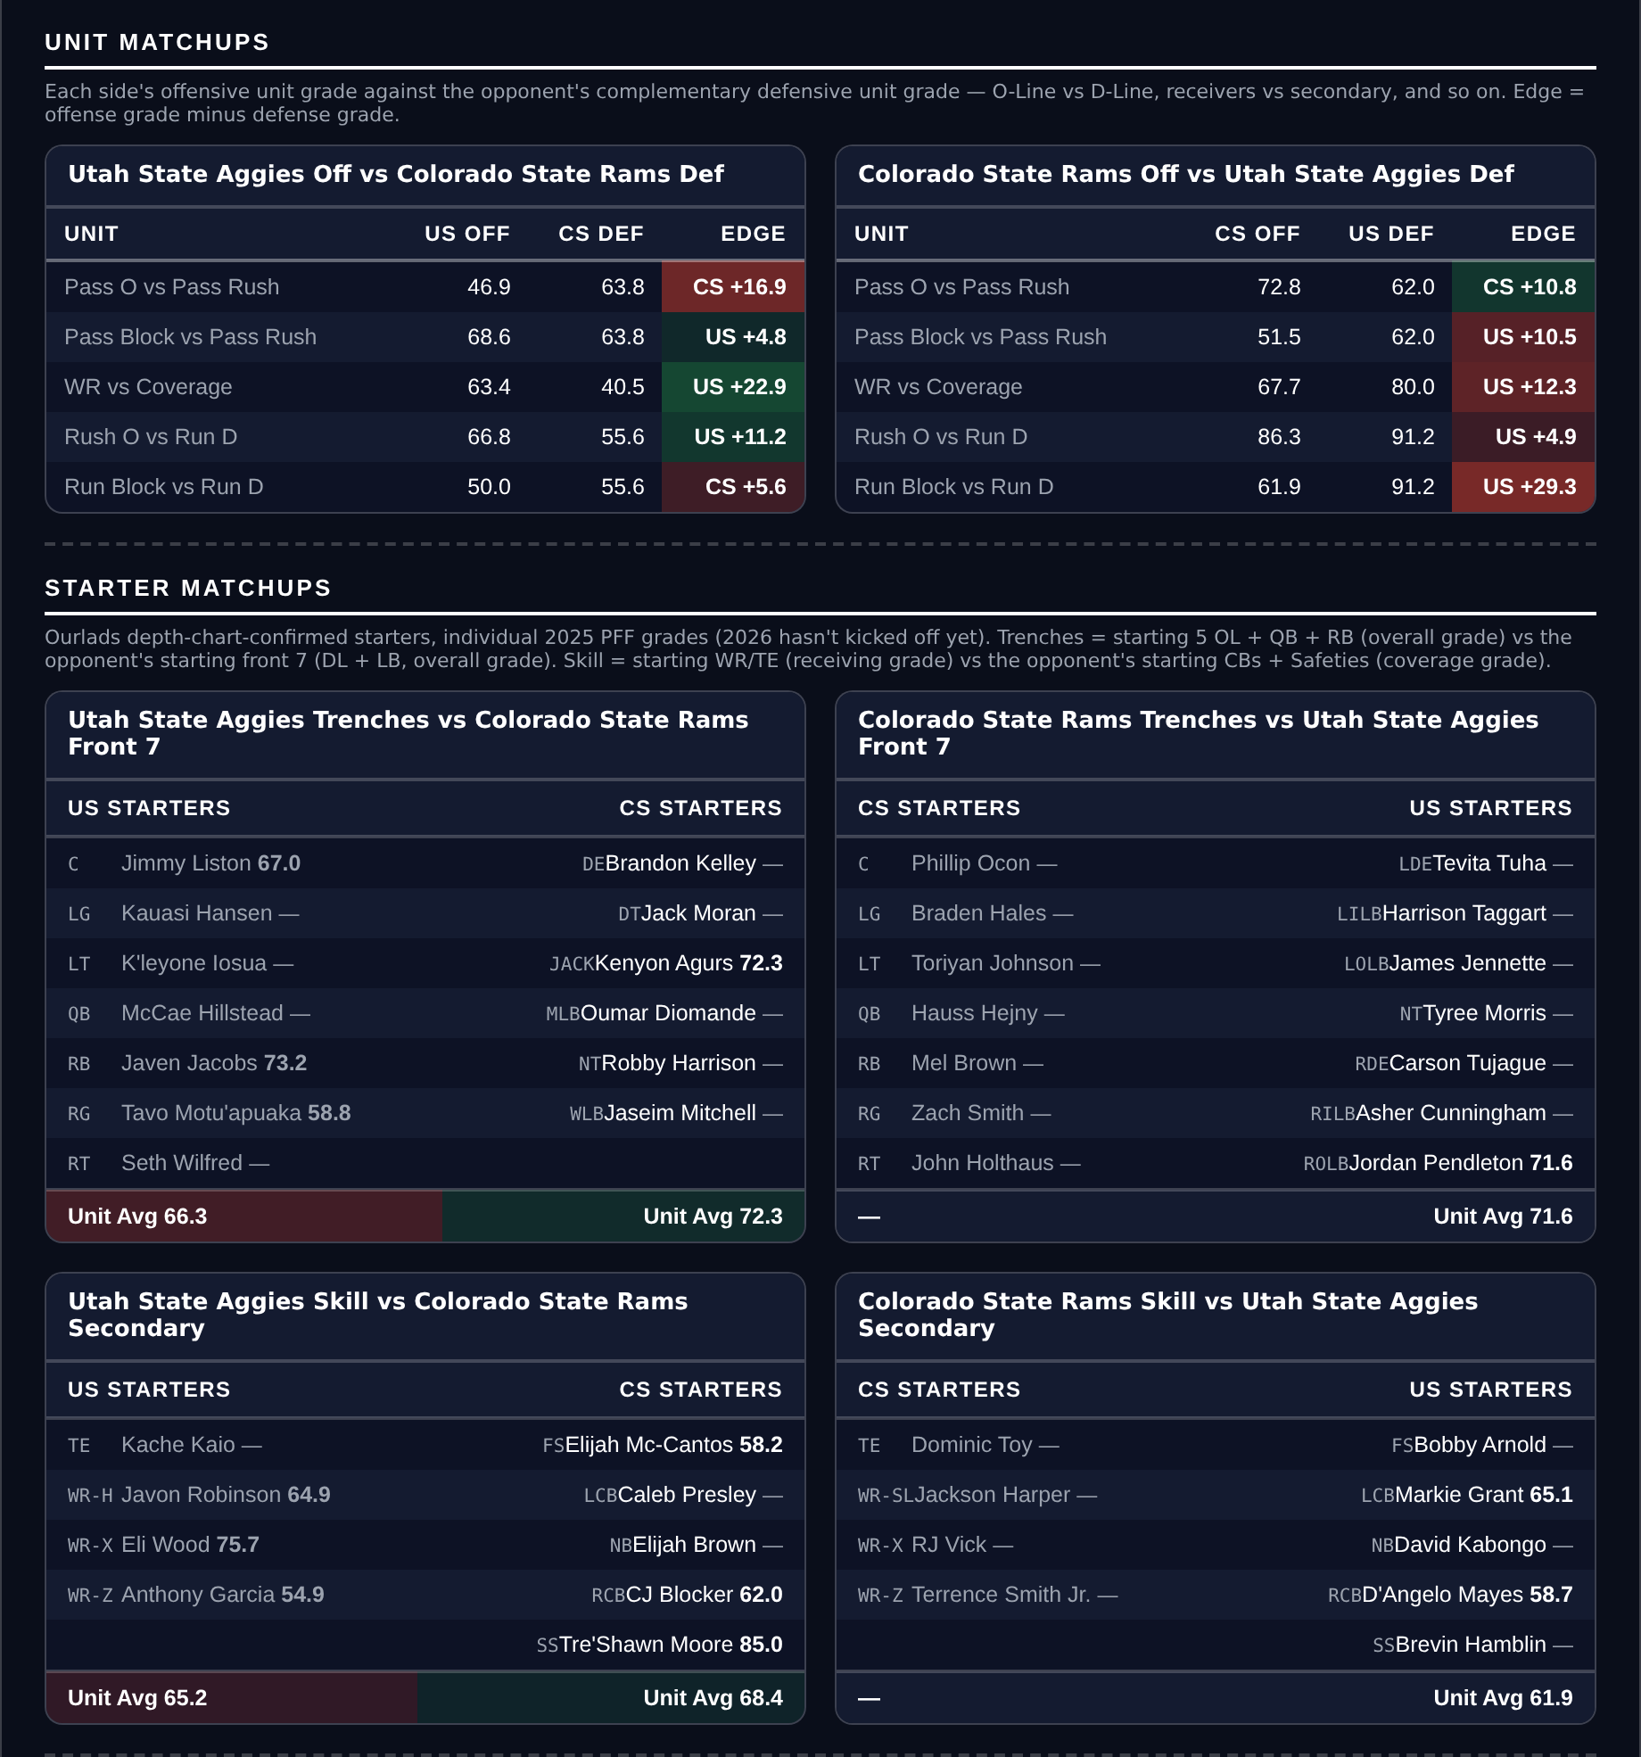
Unit matchups: each offensive unit grade against the opposing defensive unit. Edge = offense minus defense.

Virginia Cavaliers @ Wake Forest Demon Deacons

Virginia +12.5
Book line | Wake Forest -12.5
Model number | Wake Forest -9.0
Gap | 3.5 pts, 3.8 net
Points check | Wake Forest by 7.3, which is 5.2 past the market
SP+ (2026) | Wake Forest +12.2 (tied 25th) vs Virginia +5.8 (tied 53rd), home edge +2.6
Virginia 2026 | 4-4, 28.3 points a game and 19.6 allowed
Virginia defense | 43rd in Success Rate, tied 31st in defensive Field Position
Virginia special teams | 89.4, 13th in the country

Book has Wake Forest -12.5. The rating has it at 9.0 and the points check at 7.3, so both sit on the right side of the number without either calling for an upset. This is a position on the size of a win, not its direction.
Virginia do not get blown out. They are 4-4, score 28.3 and allow 19.6 points a game on a defence that ranks 43rd in Success Rate, tied 54th in Havoc and tied 31st in defensive Field Position, and their special teams grade 89.4, 13th in the country, which is where two-score games are usually decided against a team with nothing left to lose.
Wake Forest are 6-1 and the better side, scoring 37.4 with an offence ranked 24th in Success Rate, 26th in Explosiveness and 12th in Finishing Drives. They are also 5-2 against the spread, 12th nationally, which is exactly the shape of team the market prices forward. Twelve and a half is a number for a mismatch; SP+ separates these two by six.
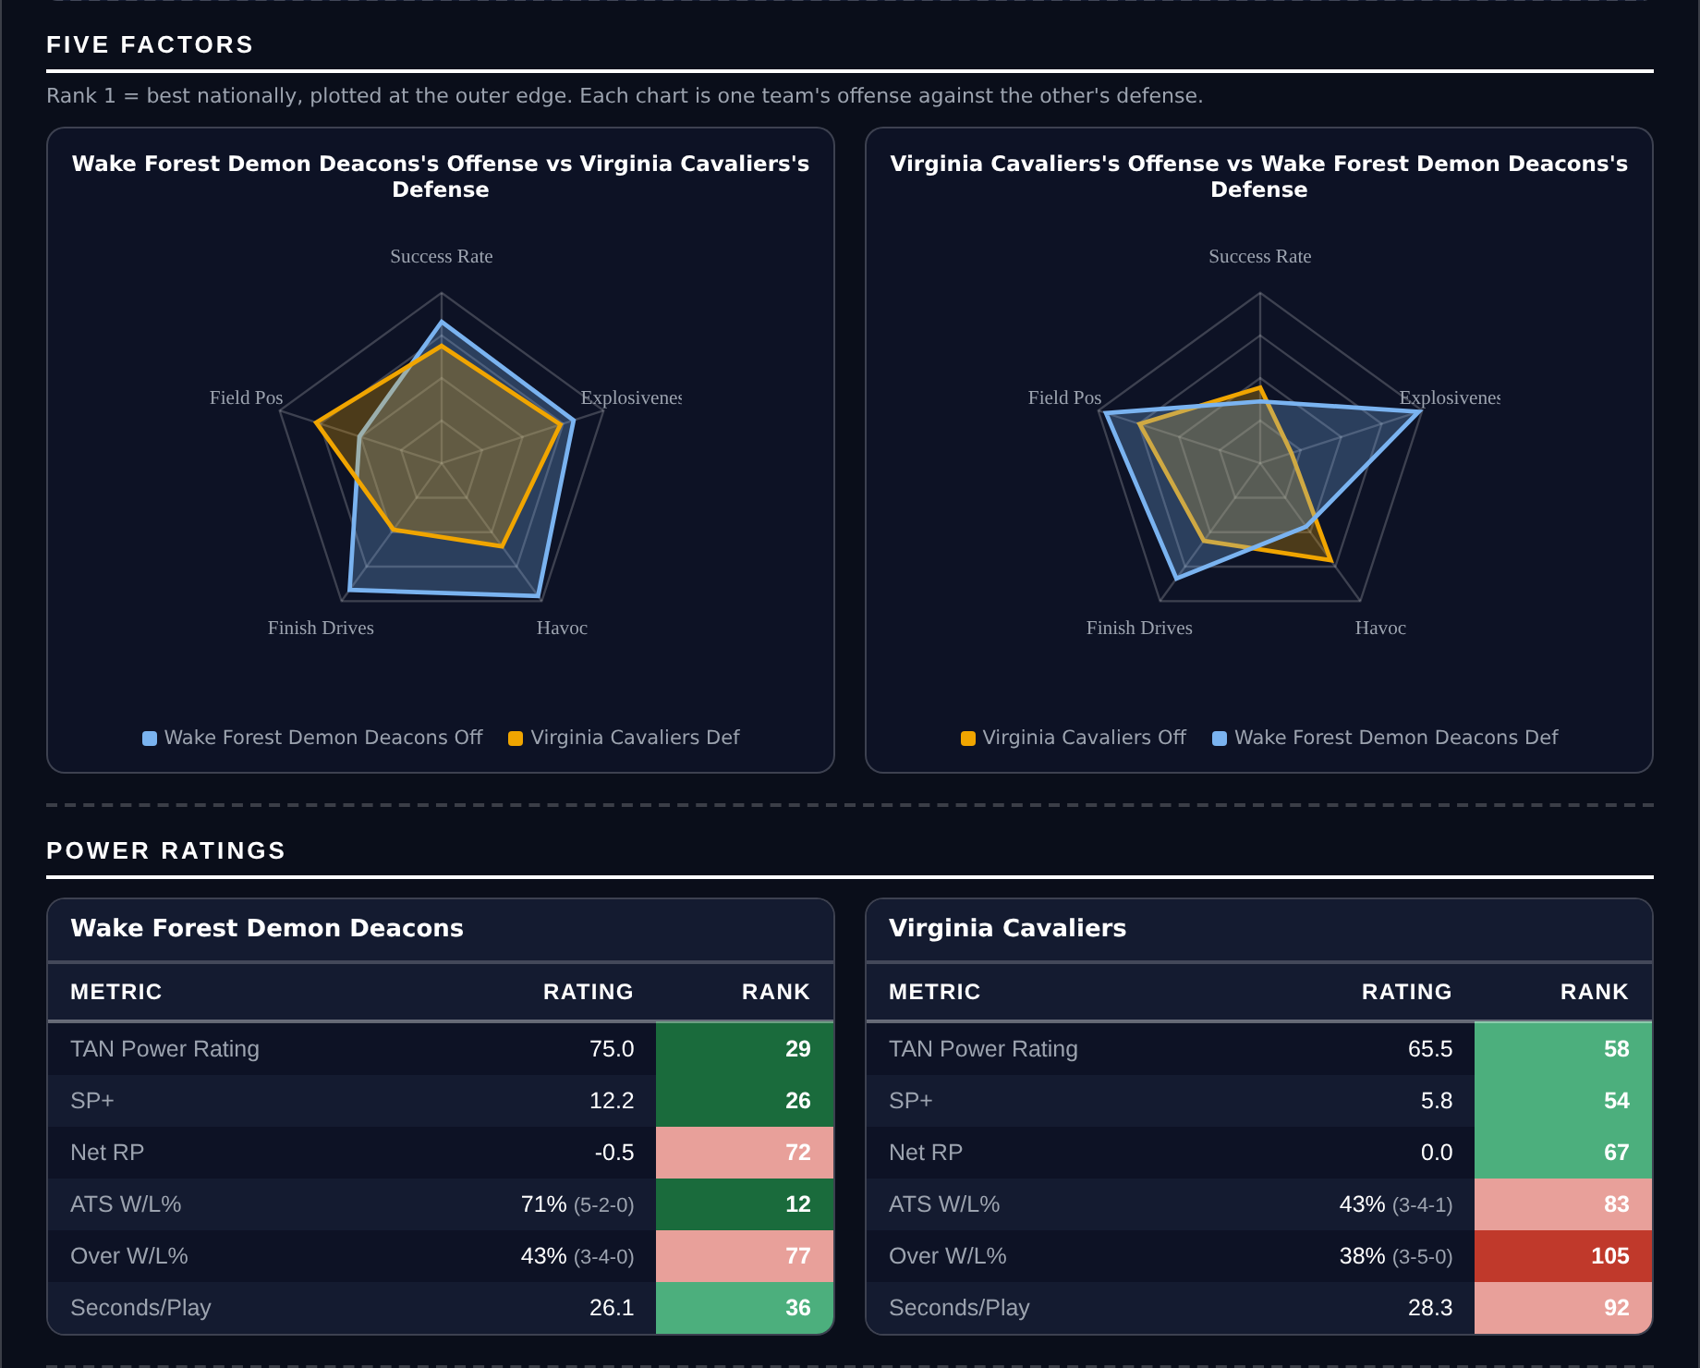
Five Factors and power ratings, captured from the CFB Betting Hub.
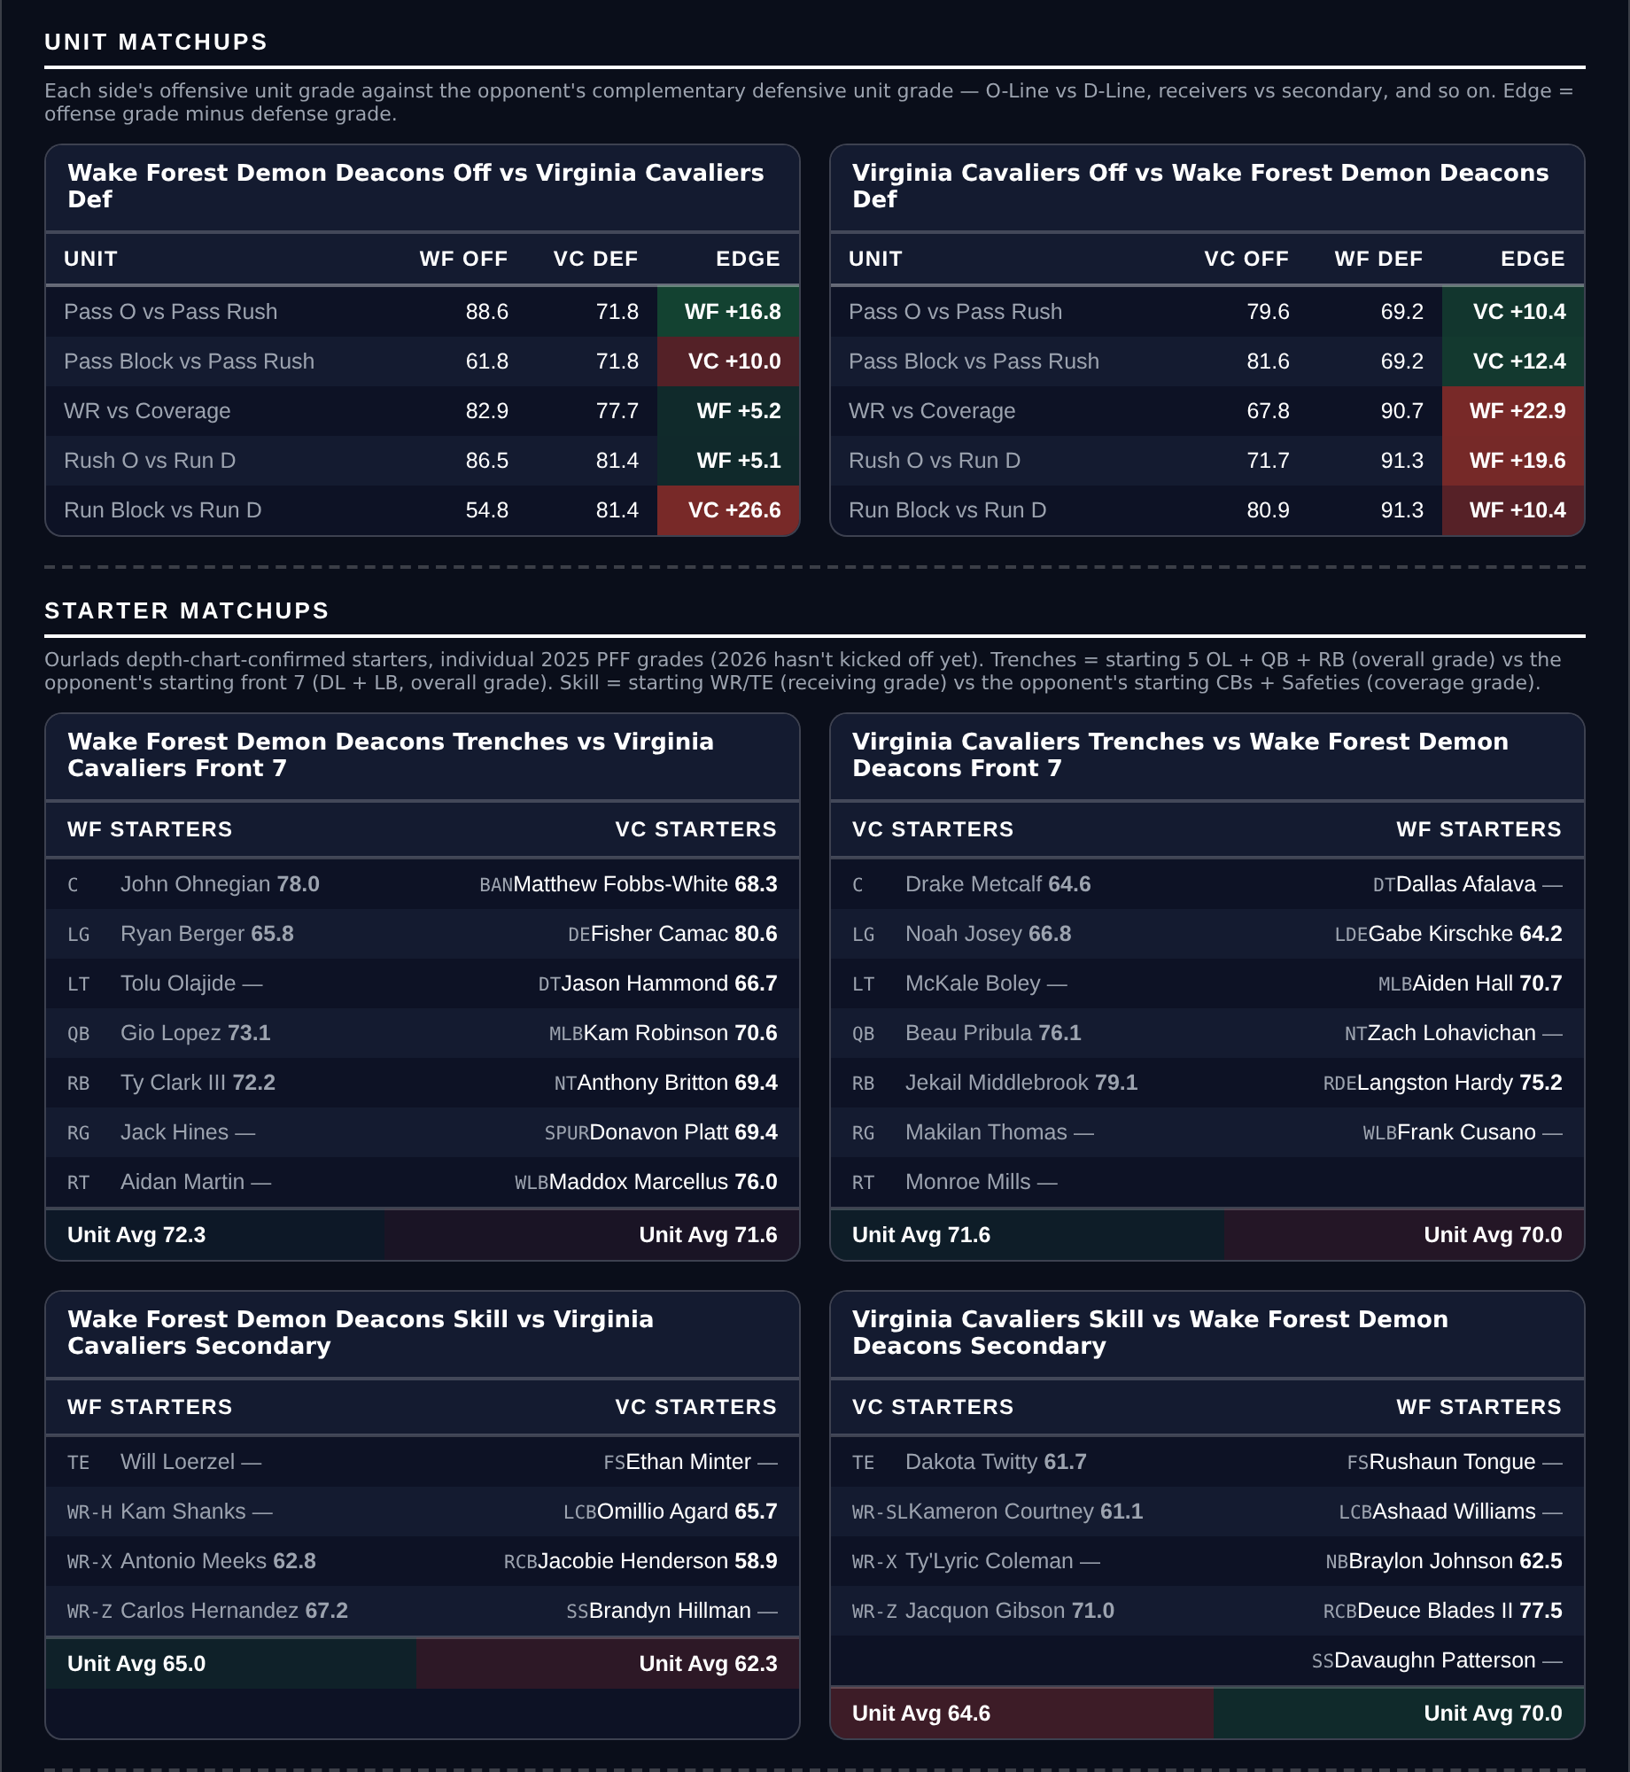
Unit matchups: each offensive unit grade against the opposing defensive unit. Edge = offense minus defense.

Oregon State Beavers @ Fresno State Bulldogs

Fresno State +6.0
Book line | Fresno State +6.0
Model number | Oregon State -1.0
Gap | 5.0 pts, 4.7 net
Points check | Oregon State by 3.4, which is 2.6 past the market
SP+ (2026) | Oregon State +6.6 (50th) vs Fresno State +2.6 (61st), home edge +3.0
Forecast at kickoff | 63F, light rain at 79 percent, wind 5 mph
Fresno State home field | 3.0 points
Fresno State 2026 | 4-3, 5-2 ATS (12th), 20.9 points allowed

Book has Fresno State +6.0. The rating has the game at a point and the points check at 3.4, so both land inside the number and on the same side. The home field here is worth 3.0, and it is most of why the rating is nearly a pick'em.
Fresno State defend. They allow 20.9 points a game on an 86.3 coverage grade that ranks 33rd and rank tied 3rd in the country in defensive Field Position, and their special teams grade 87.5, 16th. They are 5-2 against the spread, 12th nationally, which is a team the market has been consistently pricing short.
Oregon State are the better offence and the card is not arguing with that: 42.7 points a game, 8th in Success Rate, 4th in Finishing Drives. But their defence ranks 85th by grade and 103rd in Finishing Drives, and the National Weather Service has light rain at kickoff with a 79 percent chance and almost no wind. Rain costs the passing offence more than the defence, narrows margins, and this is the one game on the card where the side taking points is also the side that defends. Six is a wide number for a game two measures put inside a field goal.
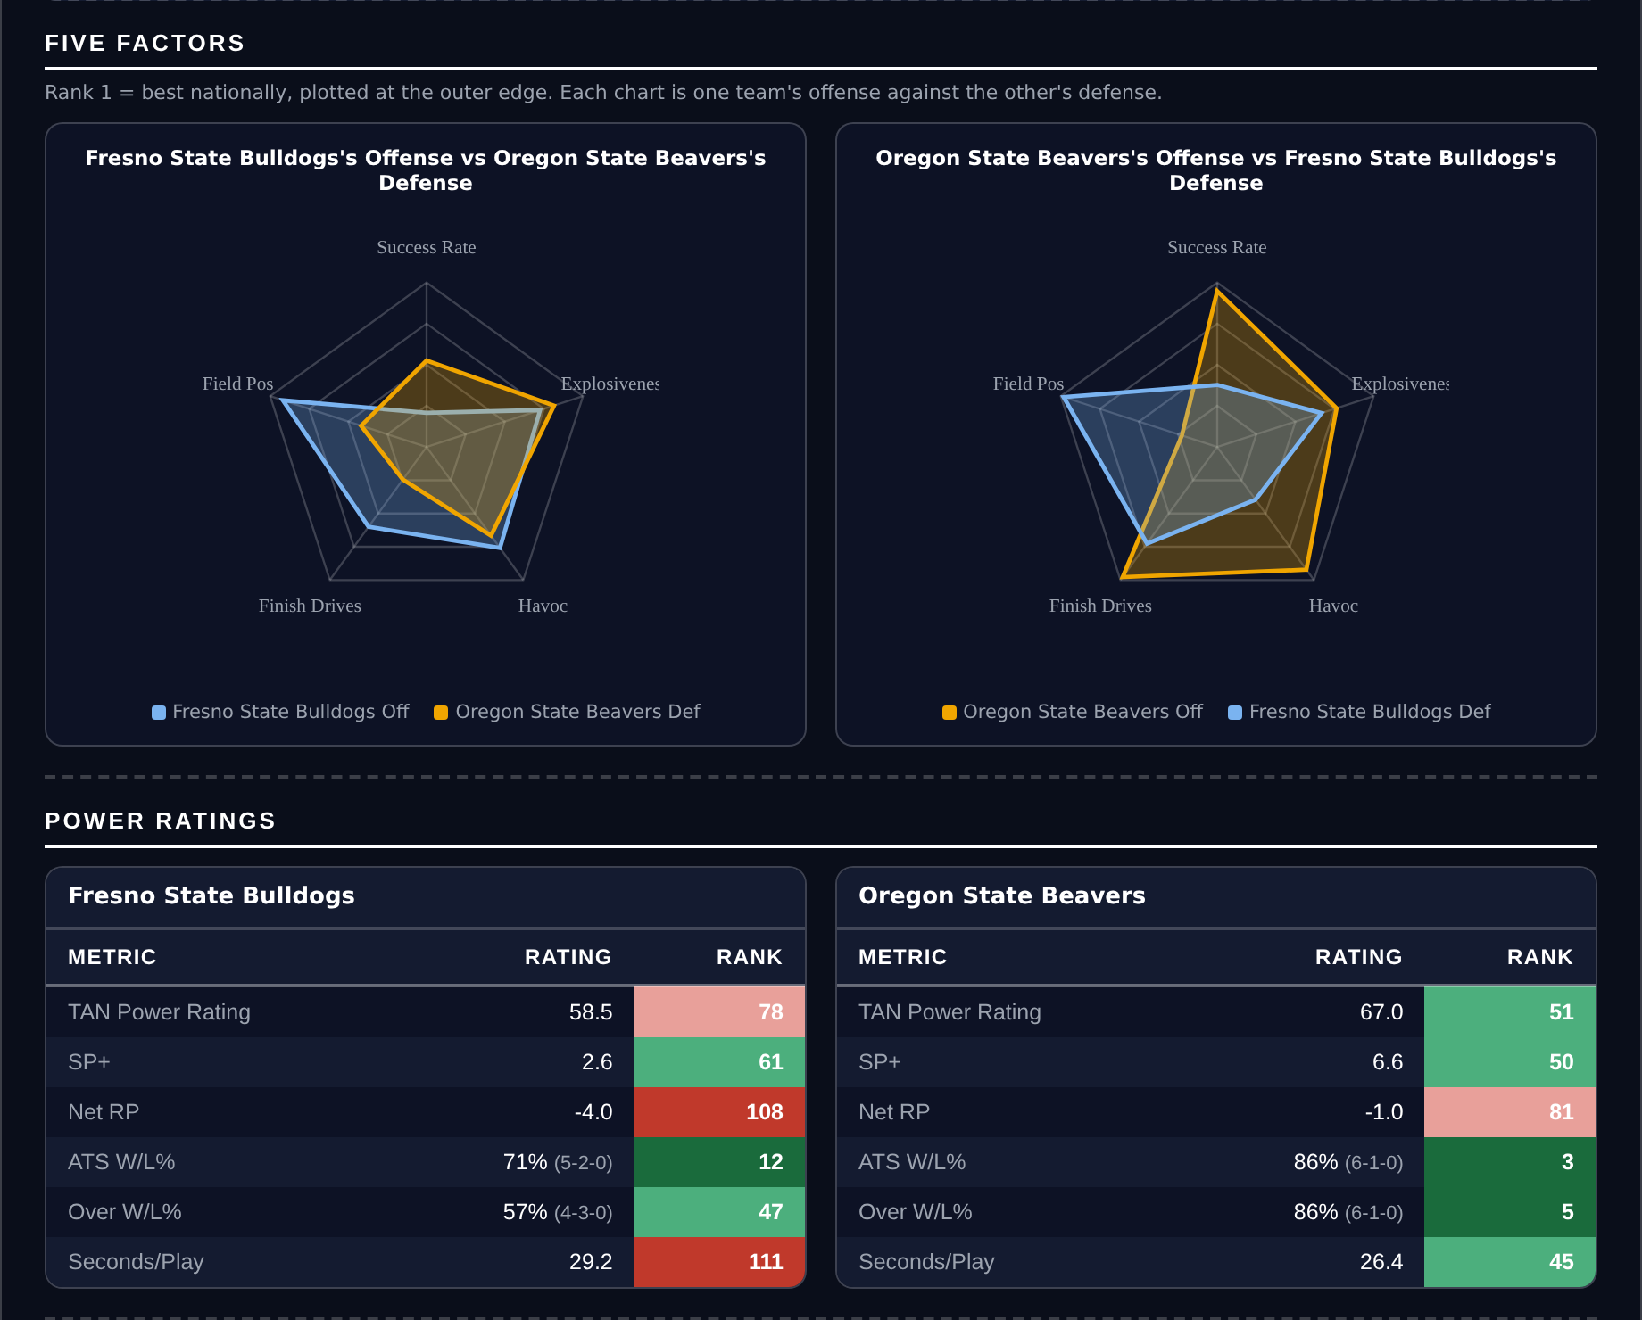
Five Factors and power ratings, captured from the CFB Betting Hub.
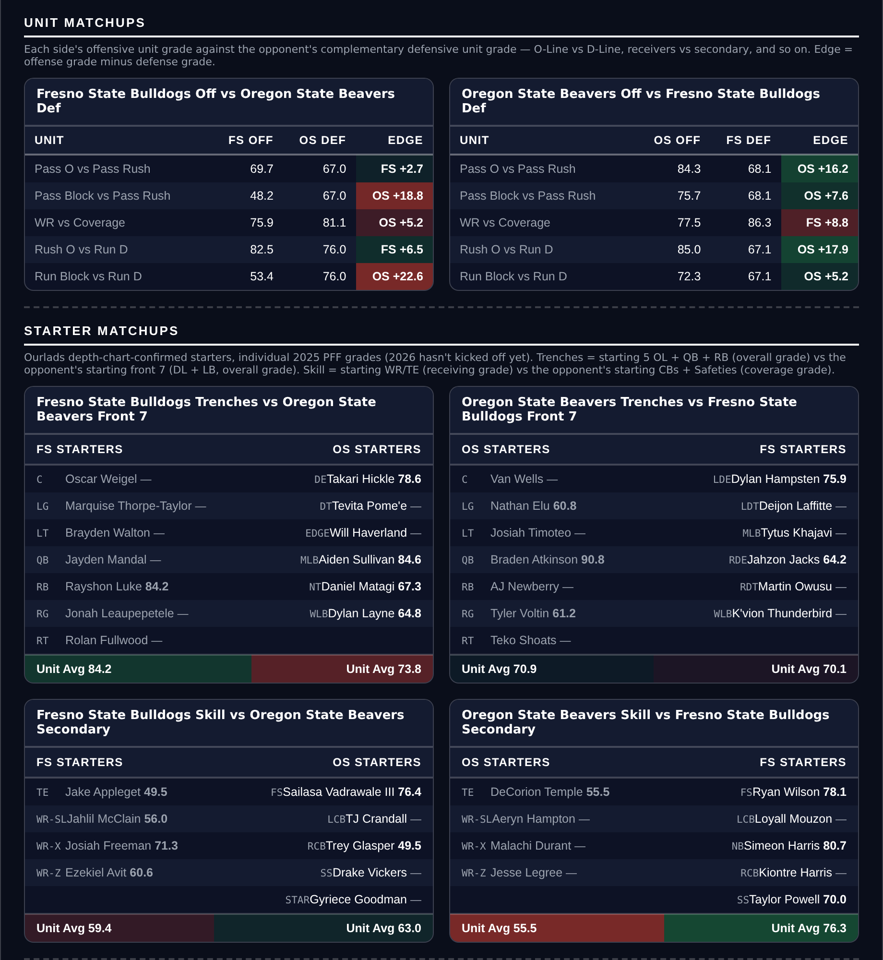
Unit matchups: each offensive unit grade against the opposing defensive unit. Edge = offense minus defense.

Player Props
321 priced rows went through the screens and 22 survived. The screens: a model edge of at least 20 percent; the player’s own 2026 production agreeing with the side by at least 20 percent; a real role, 20+ targets for receivers and 12+ carries a game for backs; 4+ targets a game for any receiving Over; no opponent or pace multiplier outside 0.6 to 1.6; a spread under 28 points with a rated opponent; at least two books posting the number; the player’s own game count level with his team’s; and two added this week.
The two new ones both concern Unders. Yardage Unders are now dropped outright: across the season Overs have gone 15-10 with two voids for +3.46 units while Unders have gone 2-5 for -3.65, and the asymmetry has a reason behind it rather than only a record. The screens ask that a player’s own production agree with the side by 20 percent, which on an Over means he has been beating the number and on an Under means he has been falling short of it — something the market reads as easily as we do. An Over’s downside also stops at zero while an Under’s is one long catch away. The second screen, held in reserve for when Unders are allowed back, requires a receiving Under to carry an average depth of target below 12.
All five below are Overs, all five clear on the player’s own per-game rate before the model is consulted, and all five were checked against this morning’s depth chart and are listed first string at their position.
Quarterback rushing props remain excluded. Sacks count against rushing yards in official college statistics and not in PFF, so the model projects a stat the market is not pricing.
Ratings and the Five Factors come from the 2026 workbook: SP+, TAN, implied team totals and the season-to-date CFBData ranks, out of 138 teams. Player lines are 2026 PFF season to date. Records, ATS and over/under records are TeamRankings, 2026 to date. The PFF team grade file covers seven games for 84 teams, eight for 52 and nine for 2. Futures prices are the week 9 pull except win totals, which are week 7.

Oklahoma State Cowboys @ Iowa State Cyclones

Caleb Hawkins Over 22.5 receiving yards
Book line | Over 22.5 receiving yards
Model projection | 45.5 yards
2026 production | 272 receiving yards in 7 games, 38.9 a game
Role | 32 targets, 4.6 a game, 25 receptions over 160 routes
Profile | 1.5 average depth of target, 1.70 yards per route run, 86.5 route grade, long of 66
Also the lead back | 592-plus rushing yards; he is on the field on every down
Iowa State defense | 80th in Success Rate, 104th in defensive Field Position
Game total | 58.0, Oklahoma State -9.5

Hawkins averages 38.9 receiving yards a game and the line is 22.5. Sixteen yards of margin on his own rate before the model is consulted, and the projection lands at 45.5, a 102 percent edge.
He is a three-down back rather than a receiving specialist, which is what makes a low receiving line reachable: 32 targets and 25 receptions over 160 routes at a 1.5-yard average depth of target, a 78 percent catch rate, an 86.5 route grade and a long of 66. Checkdown volume with one broken tackle behind it clears 22.5 on its own.
Oklahoma State lay 9.5 in a game posted at 58.0, and they score 40.0 a game on an offence ranked 9th in Success Rate. Iowa State rank 80th in defensive Success Rate and 104th in defensive Field Position, so the Cowboys should have the ball in good positions often. He cleared this same line by 48 yards last week.

Army Black Knights @ Memphis Tigers

Hunter Tipton Over 34.5 receiving yards
Book line | Over 34.5 receiving yards
Model projection | 58.8 yards
2026 production | 409 receiving yards in 8 games, 51.1 a game
Role | 40 targets, 5.0 a game, 30 receptions over 139 routes
Profile | 7.3 average depth of target, 2.94 yards per route run, 81.1 route grade, long of 87
Army defense | 135th by grade, 50.7 coverage (132nd), 126th in Havoc
Memphis 2026 | 6-2, 36.1 points a game
Game total | 60.0

Tipton averages 51.1 receiving yards a game across eight and the line is 34.5. He clears it on his own rate by sixteen and a half, and the projection puts him at 58.8.
The efficiency is real rather than volume-driven. His 2.94 yards per route run sits on an 81.1 route grade, a 75 percent catch rate and a long of 87. Five targets a game at a 7.3-yard average depth of target is the intermediate tight-end role that produces the same number most weeks.
Army are the matchup. Their defence grades 59.1, 135th in the country, with a 50.7 coverage grade that ranks 132nd and a Havoc rank of 126th, so there is neither pressure nor coverage to interrupt the middle of the field. The game is posted at 60.0 with Memphis laying six and scoring 36.1 a game.

Mississippi State Bulldogs @ Texas Longhorns

Emmett Mosley V Over 34.5 receiving yards
Book line | Over 34.5 receiving yards
Model projection | 58.1 yards
2026 production | 318 receiving yards in 7 games, 45.4 a game
Role | 33 targets, 4.7 a game, 21 receptions over 190 routes
Profile | 11.0 average depth of target, 1.67 yards per route run, 67.4 route grade, long of 62
Mississippi State defense | 104th in Success Rate, 97th in Finishing Drives
Texas 2026 | 5-2, laying 20.0 at home
Game total | 50.5

Mosley averages 45.4 receiving yards a game and the line is 34.5. Eleven yards of cushion on his own production, and the projection lands at 58.1.
He is Texas's primary intermediate target: 33 targets and 21 receptions over 190 routes at an 11.0-yard average depth of target, with a 67.4 route grade and a long of 62. The catch rate of 64 percent is the soft spot in the profile and the reason this is fourth on the list rather than first, but 4.7 targets a game at eleven yards a throw needs three completions to clear the number.
Mississippi State's defence ranks 104th in Success Rate and 97th in Finishing Drives, which is the combination that gives up sustained drives rather than one-play scores. Texas lay 20 at home, and a favourite that size playing from in front still throws in the first half, which is where this line gets beaten.

Auburn Tigers @ Ole Miss Rebels

Traylon Ray Over 29.5 receiving yards
Book line | Over 29.5 receiving yards
Model projection | 48.7 yards
2026 production | 290 receiving yards in 7 games, 41.4 a game
Role | 28 targets, 4.0 a game, 20 receptions over 131 routes
Profile | 11.8 average depth of target, 2.21 yards per route run, 72.3 route grade, long of 36
Auburn coverage | 54.4 coverage grade, 127th in the country
Ole Miss tempo | 22.8 seconds a snap, 5th in the country
Game total | 57.5, Ole Miss -11.5

Ray averages 41.4 receiving yards a game and the line is 29.5. Twelve yards of margin on his own rate, and the projection puts him at 48.7.
A 71 percent catch rate on 28 targets at an 11.8-yard average depth of target, with 2.21 yards per route run, a 72.3 route grade and a long of 36. Four targets a game is the thinnest volume of the five here, which is the honest weakness, but at that depth three catches clear the number and he has made at least three in most weeks.
Two things point the ball at him. Auburn's coverage grade of 54.4 ranks 127th on a defence that grades 71.7, 112th overall. And Ole Miss play at 22.8 seconds a snap, which ranks 5th nationally for pace, in a game posted at 57.5 — more possessions against the softest coverage unit either team will see.

Arizona Wildcats @ Texas Tech Red Raiders

J'Koby Williams Over 64.5 rushing yards
Book line | Over 64.5 rushing yards
Model projection | 96.5 yards
2026 production | 619 rushing yards in 7 games, 88.4 a game
Role | 86 carries, 12.3 a game, 7.2 yards an attempt
Profile | 54.3 percent breakaway rate, 386 yards after contact, 24 avoided tackles, 79.7 run grade, long of 62
What the line asks | 5.2 yards a carry on his usual volume
Arizona defense | 12th in Success Rate, 106th in run defense by grade
Game total | 54.5, Texas Tech -3.5

Williams has 619 rushing yards in seven games, 88.4 a game, against a 64.5 line. The projection discounts for the opponent and still lands at 96.5.
The efficiency is the case rather than the volume. He averages 7.2 yards a carry on 12.3 attempts a game, with 386 yards after contact, 24 avoided tackles, a 79.7 run grade and a long of 62. His breakaway rate is 54.3 percent: more than half his yardage arrives on runs of fifteen or more, so one carry can clear most of the number.
Arizona's defence ranks 12th in Success Rate and is genuinely good on early downs, but it grades 72.2 against the run, 106th in the country, which is the split a breakaway back is built for. Texas Tech lay 3.5 at home in a game posted at 54.5, a close game they are favoured in, which is the script that keeps a back carrying it into the fourth quarter.

