Spreads to Target
Week 3 · September 18–20, 2026
Checked before publication: every figure in these pages was verified against the underlying data (163 checks, no mismatches), and each player's role, target or carry share and injury status was checked against this week's reports. Corrections are noted in the text rather than quietly fixed. Updated since the first version: the ATS and over/under records in the hub's power table were 2022 figures — they now come from TeamRankings and cover the current season, and the screenshots, fact tables and commentary here were rebuilt on that data.
Five spreads where the book and our power ratings disagree most. Our number is SP+ differential plus home-field edge; the gap is how far the market sits from it.
These are the five largest disagreements on the slate, unfiltered. An earlier cut screened out large lines on the theory that the model handles close games better, but that did not survive testing: across 138 rated games the mean disagreement between book and model is flat by line size (3.40 / 3.67 / 3.90 / 3.06 / 4.28 from pick-em up through 28-point favorites), the correlation is +0.09, and there is no directional bias anywhere on the curve. Line size tells us nothing, so it filters nothing.
Each play below carries the supporting data, the Five Factors and power-rating context from the betting hub, and the full unit-matchup breakdown — plus one honest argument against.

UCF -17.5
Georgia State Panthers @ UCF Knights
Book line | UCF -17.5
Our number | UCF -29.5
Gap | 12.0 pts — largest on the slate
SP+ | UCF +2.3 vs Georgia State -25.1
Home edge | +2.1
2025 points allowed | Georgia State 454

This is the biggest disagreement on the week-3 board and it isn't close. SP+ separates these teams by 27.4 points before you add UCF's 2.1-point home edge, which puts our number at UCF -29.5 against a book line of -17.5. Georgia State grades out 133rd nationally in SP+ at -25.1; UCF sits at +2.3.
The defensive gap is where the twelve points live. UCF's defense grades 90.3 to Georgia State's 68.4, and the unit table below is lopsided in a way that rarely shows up this cleanly — the Panthers' pass block grades 43.1 against a UCF pass rush at 80.2, a 37.1-point edge for the Knights, and their run block grades 48.6 against a 90.7 run defense, a 42.1-point edge. Georgia State surrendered 454 points in 2025. There is no unit on this field where they hold up.
The honest counterpoint: the ATS records that used to sit here are gone. The hub's power table now carries current-season cover rates from TeamRankings rather than the 2022 figures it was built on, and this season UCF and Georgia State are both 2-0 against the number. Two games apiece supports nothing in either direction, so the argument I would have made a week ago — two teams the market has learned to shade — is not one the live data makes. What stands is the shape of the risk: a 17.5-point road dog getting a backdoor cover late is exactly how Kennesaw State beat us last week, and this is the largest number we are laying on the slate.
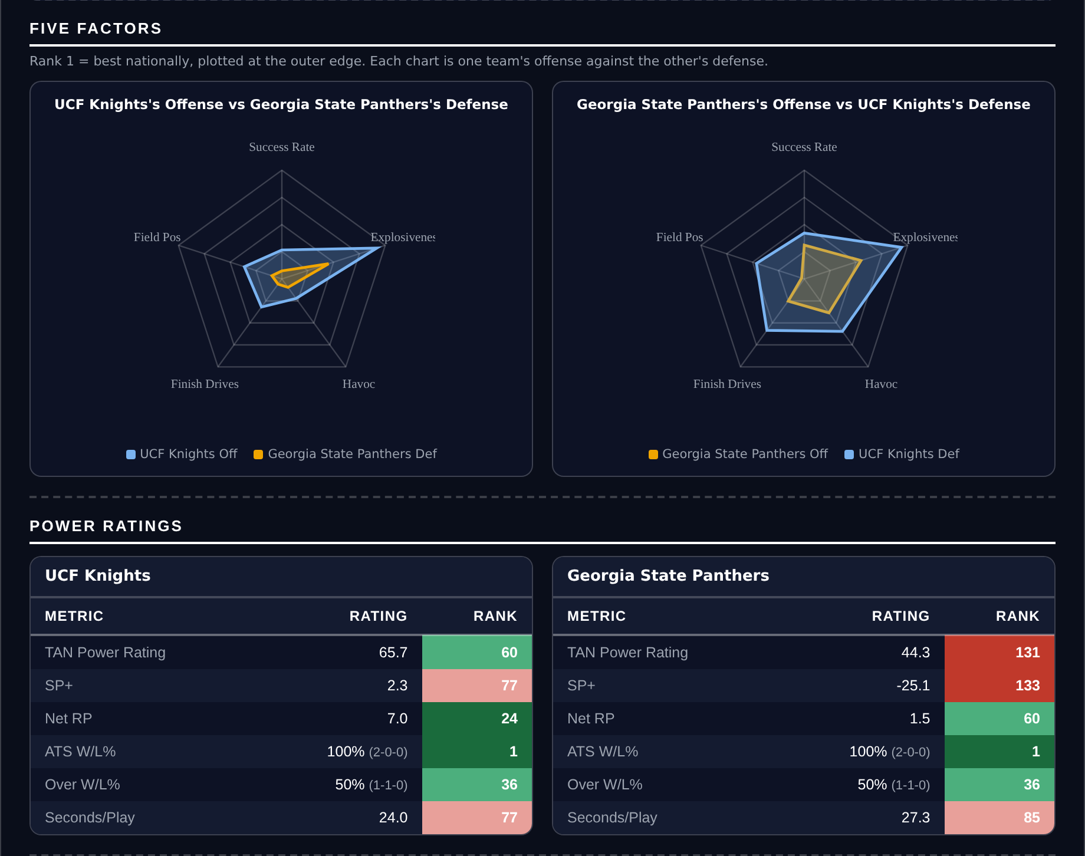
Five Factors and power ratings, captured from the CFB Betting Hub.
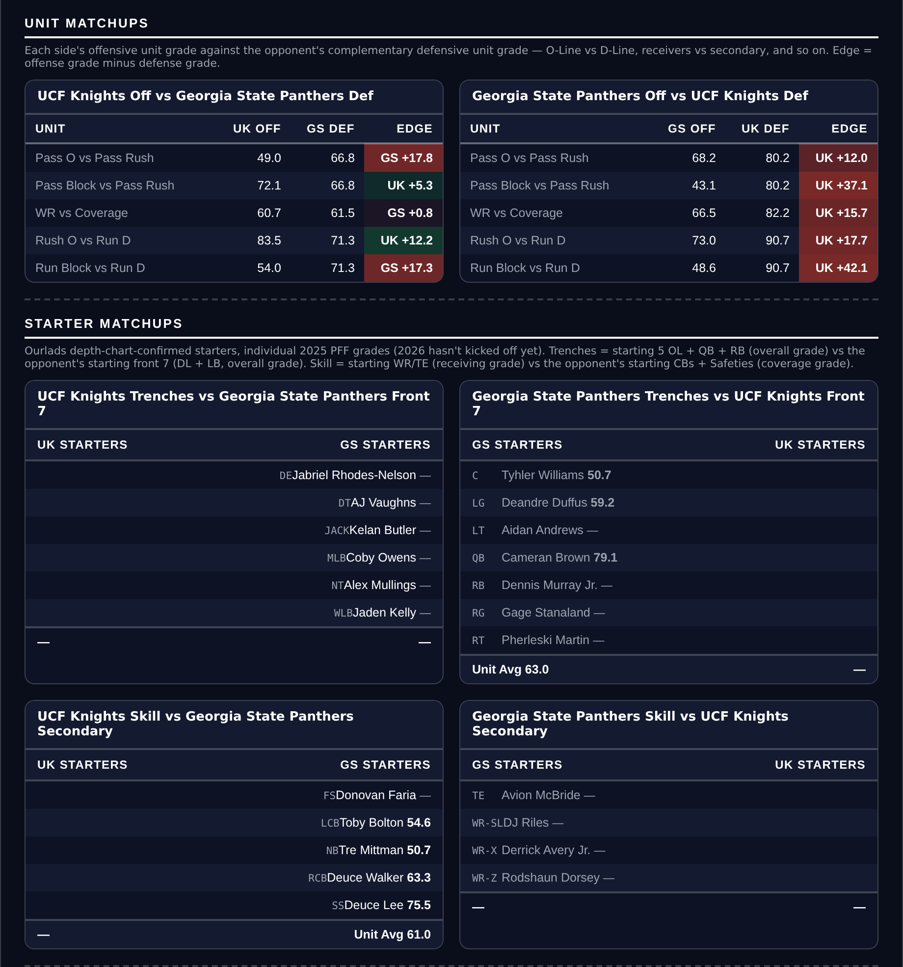
Unit matchups: each offensive unit grade against the opposing defensive unit. Edge = offense minus defense.

Western Kentucky +44.5
Western Kentucky Hilltoppers @ Indiana Hoosiers
Book line | Western Kentucky +44.5
Our number | Indiana -32.6
Gap | 11.9 pts
SP+ | Indiana +24.5 vs WKU -5.3
WKU ATS, this season | 0-2 (0%, 107th)
Indiana 2025 | 532 PF / 131 PA

Indiana is the better team by a distance nobody is disputing — 532 points scored against 131 allowed in 2025, offense and defense both grading north of 94. The question is whether they are 44.5 points better than a Western Kentucky team that SP+ puts at -5.3, which is bad but not catastrophic. Our number says Indiana -32.6, so the market is asking for almost twelve points more than the ratings support.
The ATS history no longer supports this side. On the hub's old 2022 column Western Kentucky showed as a 75% cover team, seventh nationally; on current-season data, which is what the power table now carries, they are 0-2. Indiana is 0-2 as well. Two games each is not a trend and neither record is evidence, but it is the live reading, and the number I leaned on a week ago pointed the other way. The case rests on the grades instead: Western Kentucky's offense grades 74.6 and their defense 79.3 — neither is going to win the game, but both are functional enough to keep a running clock from arriving in the third quarter.
The counterpoint is the obvious one: Indiana's TARP continuity rank is 22 against Western Kentucky's 122, meaning the roster and staff carrying that 532-point offense are largely intact while the Hilltoppers turned over. If Indiana's starters are still on the field in the fourth quarter this number is reachable, and a 44.5-point spread gives the favorite an enormous margin for a single broken coverage.
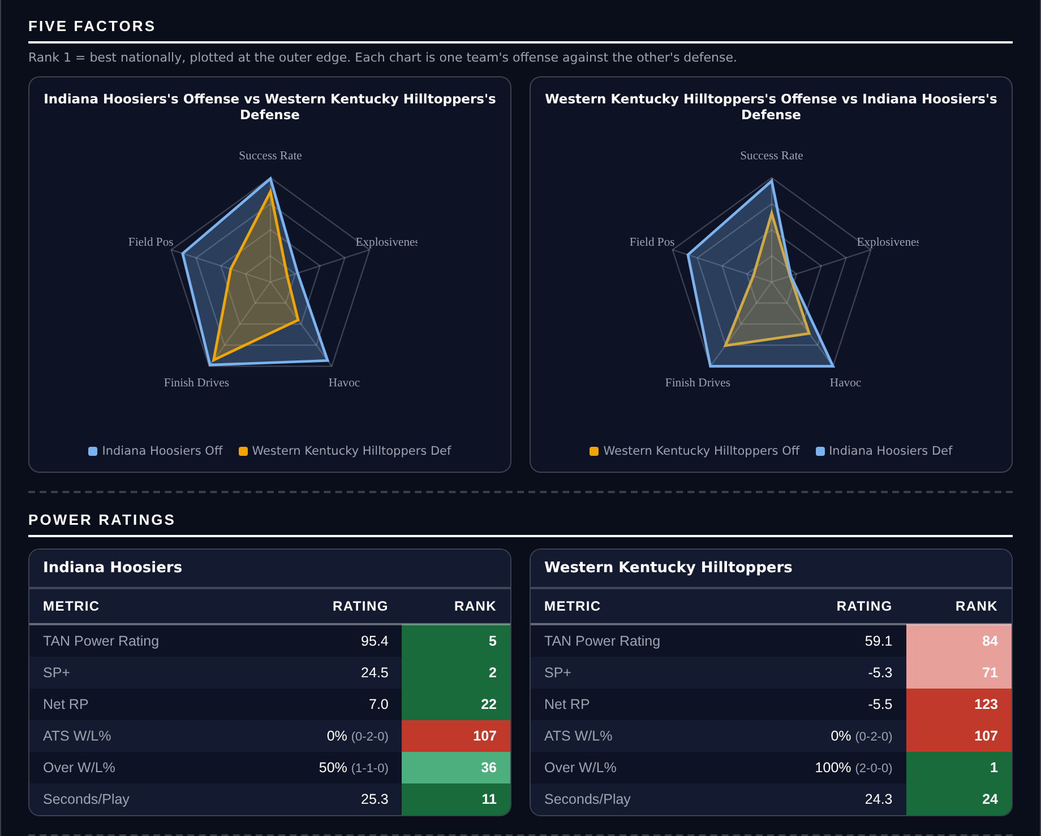
Five Factors and power ratings, captured from the CFB Betting Hub.
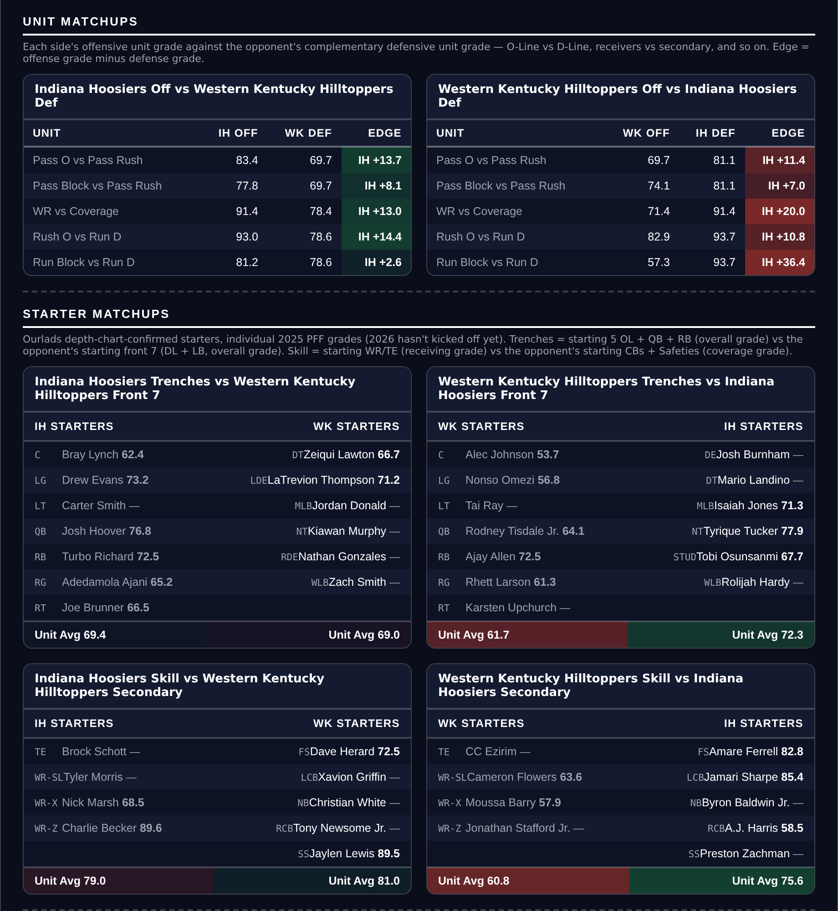
Unit matchups: each offensive unit grade against the opposing defensive unit. Edge = offense minus defense.

Texas Tech -7.5
Houston Cougars @ Texas Tech Red Raiders
Book line | Texas Tech -7.5
Our number | Texas Tech -18.2
Gap | 10.7 pts
SP+ | Texas Tech +23.1 vs Houston +8.2
Home edge | +3.3
Texas Tech ATS, this season | 0-2 (0%, 107th)

Of the five spreads here this is the one I would bet with the least hesitation. Texas Tech grades 85.6 on offense and 96.5 on defense, the best defensive grade on our board this week, and SP+ separates them from Houston by 14.9 points before a 3.3-point home edge. That is a 18.2-point number against a book line of 7.5.
The cover rate cuts the other way now. The 91.7% that made Texas Tech first nationally was a 2022 figure; with the power table on current-season data they are 0-2 against the number, 107th. Two games is not a trend, but it is at least a current reading, and it argues for some caution about laying a number this size with them. The live case rests on the 2025 grades and the SP+ gap, which is where the ten points come from.
Against it: Houston is not a bad team. They grade 90.3 on defense, third-best among the ten games in these two documents, and their own SP+ of +8.2 is solidly positive. This is a good team getting a touchdown-plus at a hostile venue, and tempo cuts against us too — Texas Tech ranks 6th in seconds per play while Houston is 72nd, so the Cougars can shorten this game if they choose to.
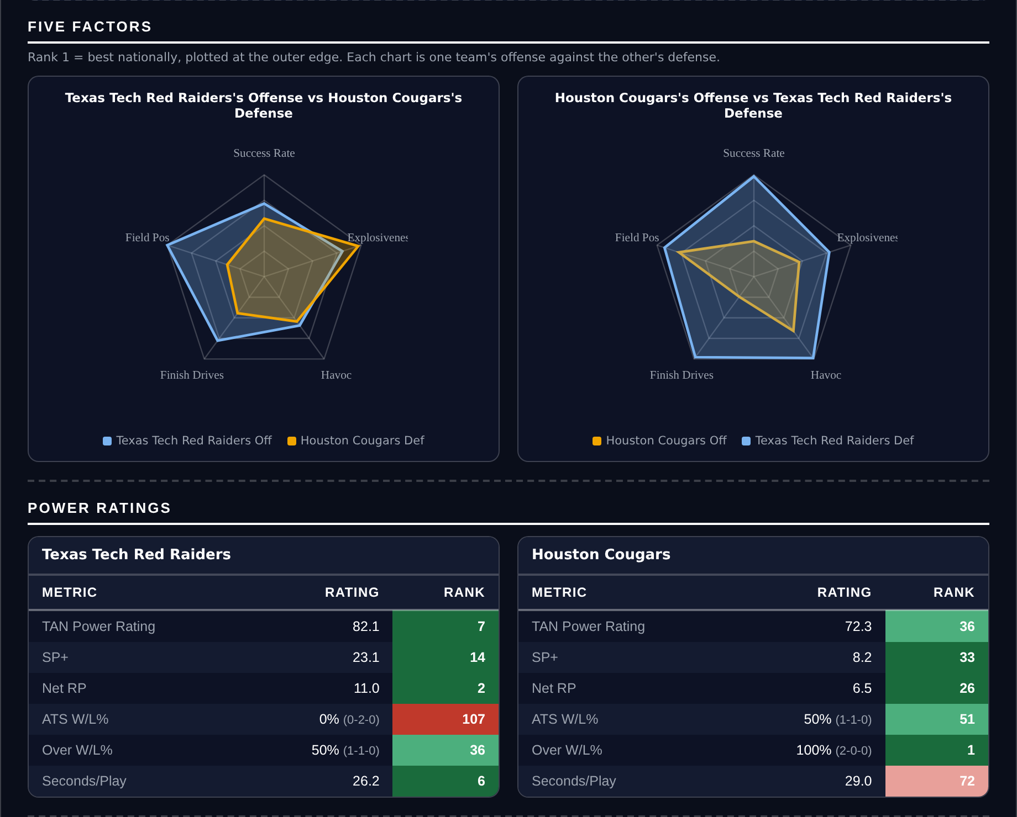
Five Factors and power ratings, captured from the CFB Betting Hub.
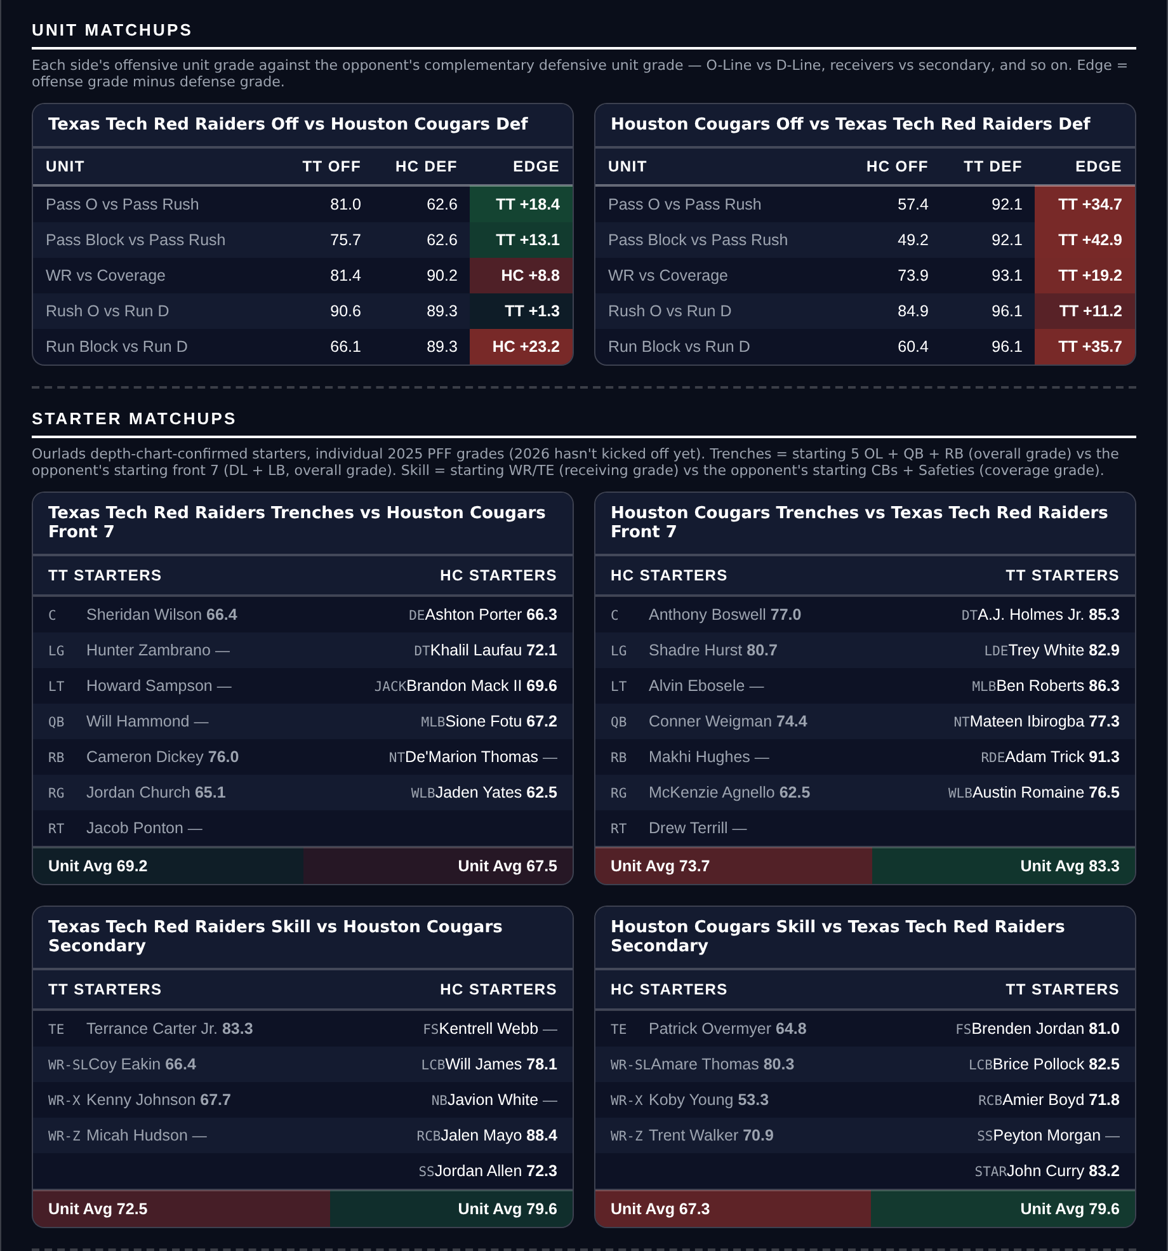
Unit matchups: each offensive unit grade against the opposing defensive unit. Edge = offense minus defense.

Buffalo +41.0
Buffalo Bulls @ Penn State Nittany Lions
Book line | Buffalo +41.0
Our number | Penn State -30.8
Gap | 10.2 pts
SP+ | Penn State +15.7 vs Buffalo -11.9
Buffalo defense grade | 84.6
Penn State ATS, this season | 1-1 (50%, 51st)

Penn State's TARP continuity rank of 1 is the single strongest forward-looking signal in our ratings, and it is the reason the market is willing to lay 41 with them. But SP+ has them at +15.7 against Buffalo's -11.9, a 27.6-point gap, and adding a 3.2-point home edge gets to Penn State -30.8. The book is asking for ten more points than that.
Buffalo's defense is the reason. They grade 84.6, essentially level with Penn State's own 85.4, and they allowed 282 points in 2025 against the Nittany Lions' 257 — a 25-point difference across a full season. The offensive gap is real (81.3 to 72.0) but it is not the kind of gap that produces six-touchdown games. Against the number this season Penn State is 1-1 and Buffalo is 0-2; the power table now carries current-season cover rates rather than the 2022 figures it used to, and at two games apiece neither record argues for or against this side.
The case against: continuity ranks of 1 versus 129 is not nothing, and our SP+ inputs are 2025 numbers describing a Penn State team that has since reloaded while Buffalo did not. If the Nittany Lions are genuinely better than their 2025 rating and Buffalo worse, the true gap is wider than 27.6 and this line is fair. That is the specific risk in every big-dog play on this page.
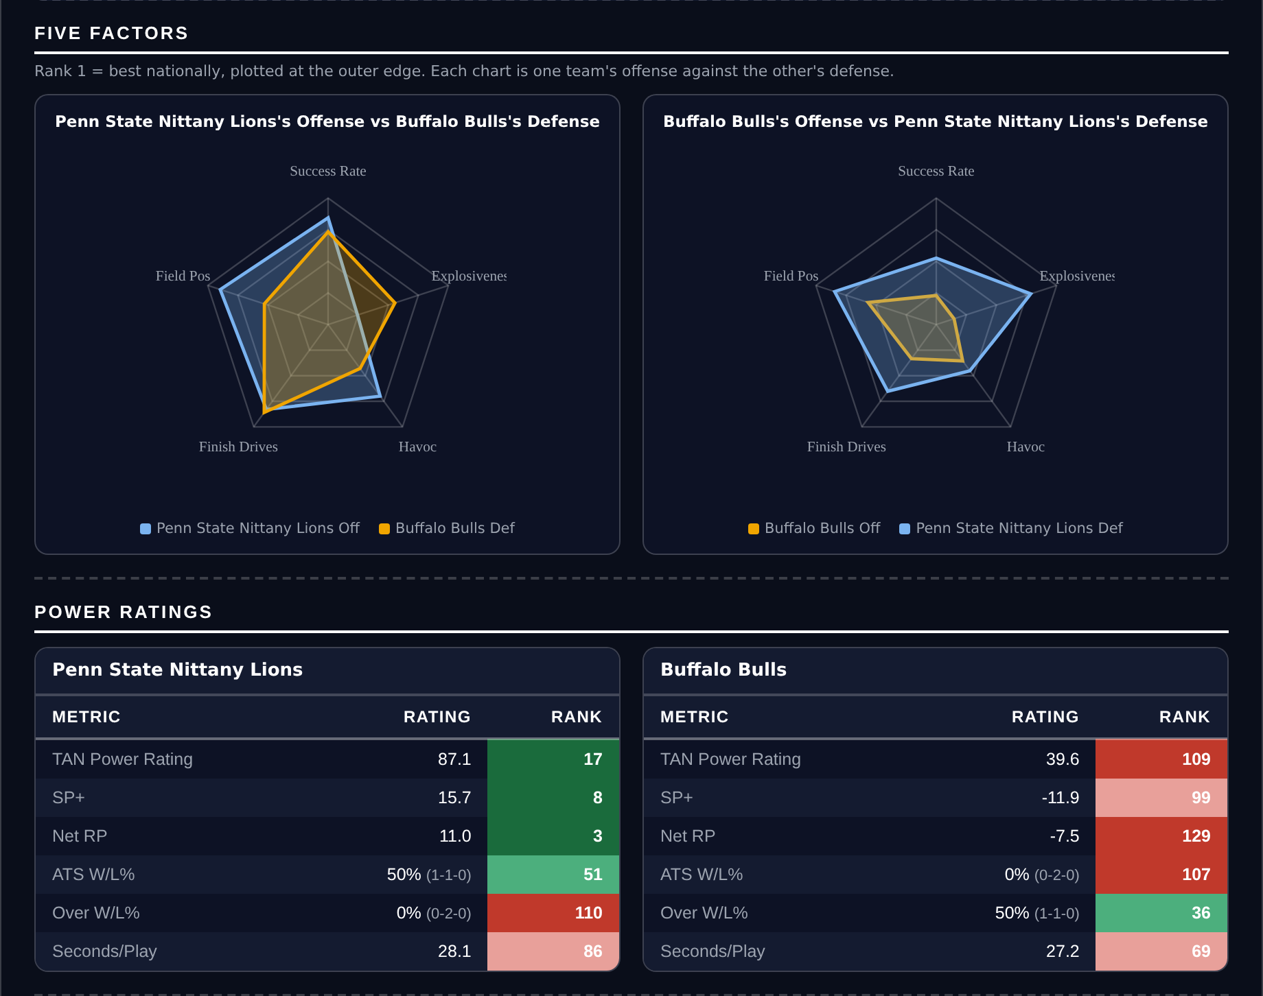
Five Factors and power ratings, captured from the CFB Betting Hub.
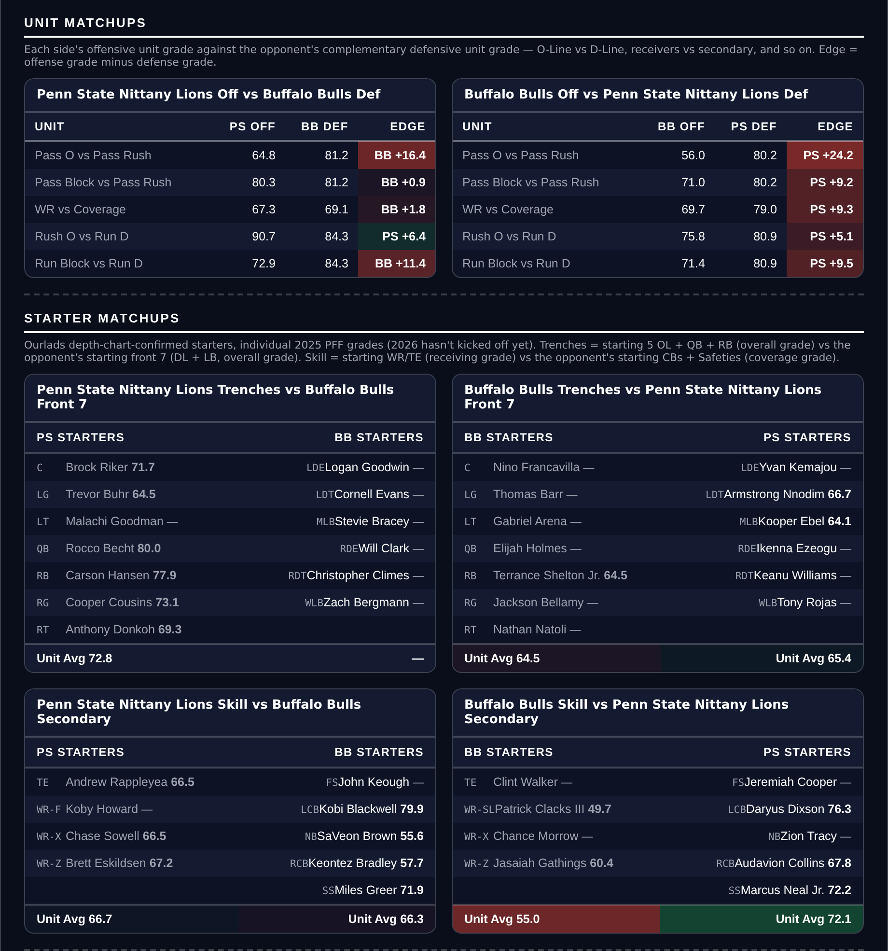
Unit matchups: each offensive unit grade against the opposing defensive unit. Edge = offense minus defense.

Rutgers +21.5
USC Trojans @ Rutgers Scarlet Knights
Book line | Rutgers +21.5
Our number | Rutgers +12.4
Gap | 9.1 pts
SP+ | USC +16.8 vs Rutgers +1.8
Rutgers offense grade | 89.5
USC defense grade | 77.2

Rutgers grades 89.5 on offense, the best offensive grade of any team across these five spread games, and they are getting three touchdowns at home. USC is the better team — SP+ has them +16.8 to Rutgers' +1.8 — but a 15-point rating gap plus a 2.6-point home edge for Rutgers produces our number of +12.4, not +21.5.
The matchup shape supports it. USC's defense grades 77.2, a full twelve points below their own offense, and Rutgers scored 344 points in 2025 against a schedule that included the Big Ten's better defenses. A Rutgers offense that functional against a USC defense that ordinary is a recipe for a game that stays within three scores, which is all this bet needs.
The honest flag: Rutgers allowed 382 points in 2025 and their defense grades 61.2, the worst number in either of these documents. USC scored 438. If this becomes the shootout the grades suggest, the team that can actually stop somebody wins by more than the ratings imply, and 21.5 stops being a large number in a hurry.
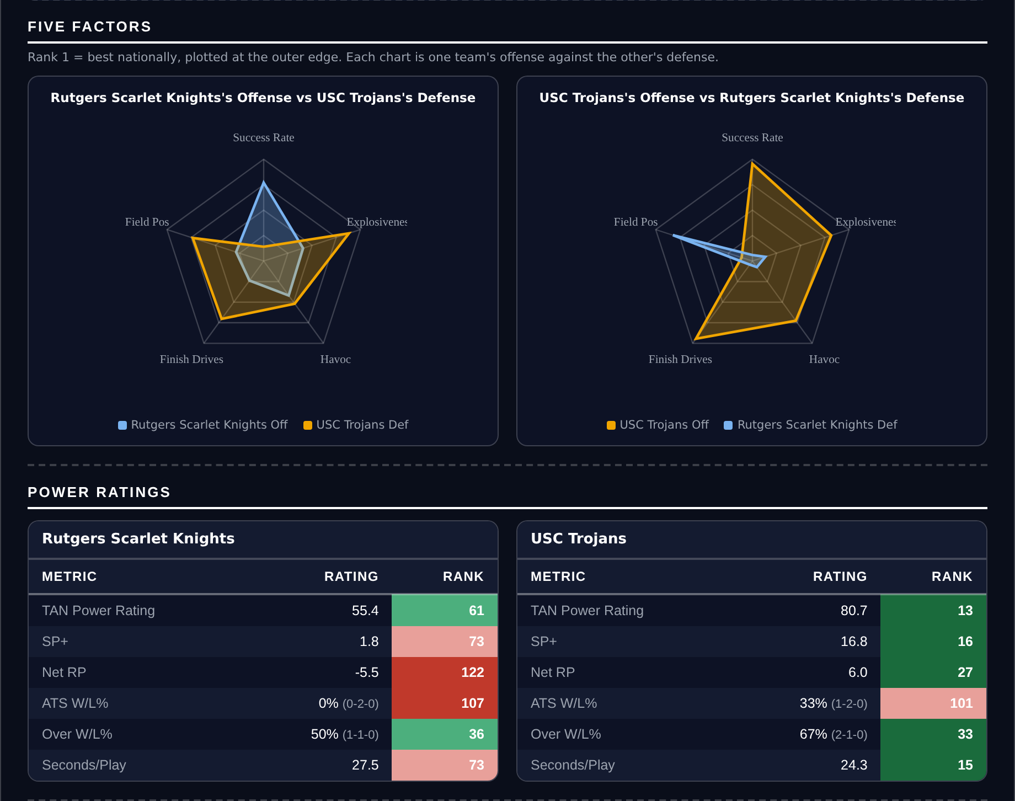
Five Factors and power ratings, captured from the CFB Betting Hub.
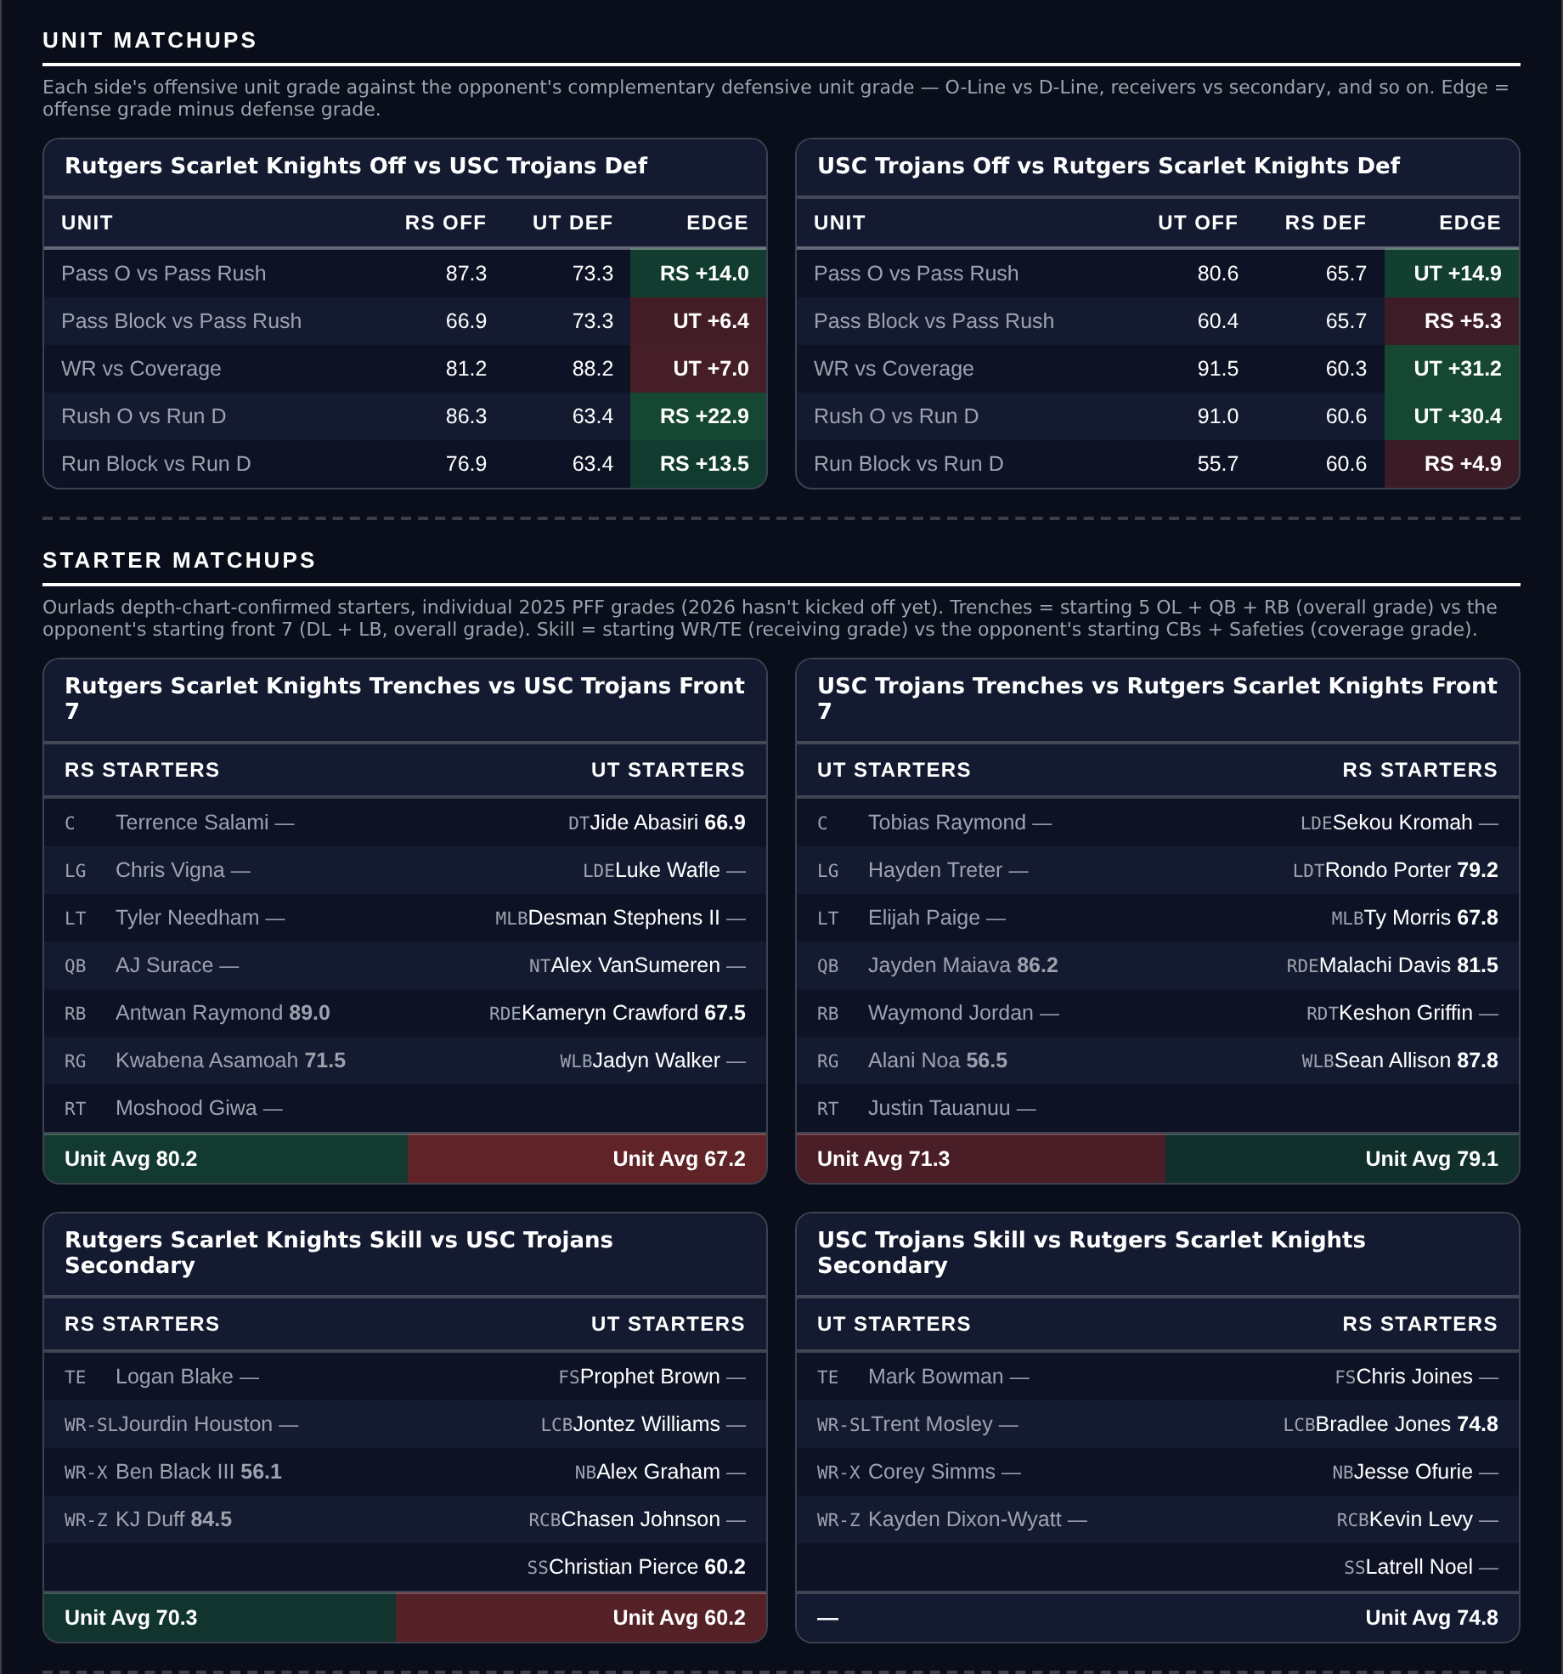
Unit matchups: each offensive unit grade against the opposing defensive unit. Edge = offense minus defense.

