Totals to Target
Week 3 · September 18–20, 2026
Checked before publication: every figure in these pages was verified against the underlying data (163 checks, no mismatches), and each player's role, target or carry share and injury status was checked against this week's reports. Corrections are noted in the text rather than quietly fixed. Updated since the first version: the ATS and over/under records in the hub's power table were 2022 figures — they now come from TeamRankings and cover the current season, and the screenshots, fact tables and commentary here were rebuilt on that data.
Five totals where the market and our number diverge. Our predicted total is the sum of each team’s own expected-points rating, which is a pace-and-scoring-level measure rather than an opponent-adjusted one.
That distinction cost us twice last week, and it is now a filter. Both total losses came in blowouts — Nebraska laying 30.5, LSU laying 35 — where our opponent-blind sum could not see a favorite running up a score its season average never contained. Checking it across 138 rated games: in the 28-point-and-up bucket the model leans Under by 2.22 points on average and 64% of the time, against roughly zero everywhere else. Nothing here is priced at a spread of 28 or more.
One further candidate was dropped because the model’s own note argued against its own pick.

East Carolina at Old Dominion — Over 48.5
East Carolina Pirates @ Old Dominion Monarchs
Book total | 48.5
Our number | 66.7
Gap | 18.2 pts — largest on the board
Tempo ranks | ODU 10th, ECU 8th
2025 scoring | ODU 392 PF, ECU 402 PF
Game spread | -3.0

Both of these teams are top-ten nationally in seconds per play — Old Dominion 10th, East Carolina 8th — and both scored around 400 points in 2025. Our team-total sum comes to 66.7 against a book number of 48.5, the largest total gap on the entire week-3 slate by a wide margin.
The spread is only 3 points, which matters given what we learned last week: our predicted total is an opponent-blind sum of each team's own scoring average, and it goes badly wrong in mismatches where a favorite runs up a score the averages never saw. In a near-pick'em between two fast offenses it is doing the job it was built for. Old Dominion's offense grades 76.0 and East Carolina's 74.6, and neither defense is elite enough to slow the other down.
The reason to be careful is the size of the gap itself. An 18-point disagreement with the market is usually a sign that one of our inputs is stale rather than that we have found something — both team totals here (32.1 and 34.6) are unusually high, and if either is carrying a 2025 number that no longer describes the roster, the whole edge evaporates. Of the five totals here this is the highest-variance play. Old Dominion has gone over once in two games this season; the power table now carries current-season over/under records rather than the 2022 figures it used to, and a 1-1 record neither helps nor hurts the case.
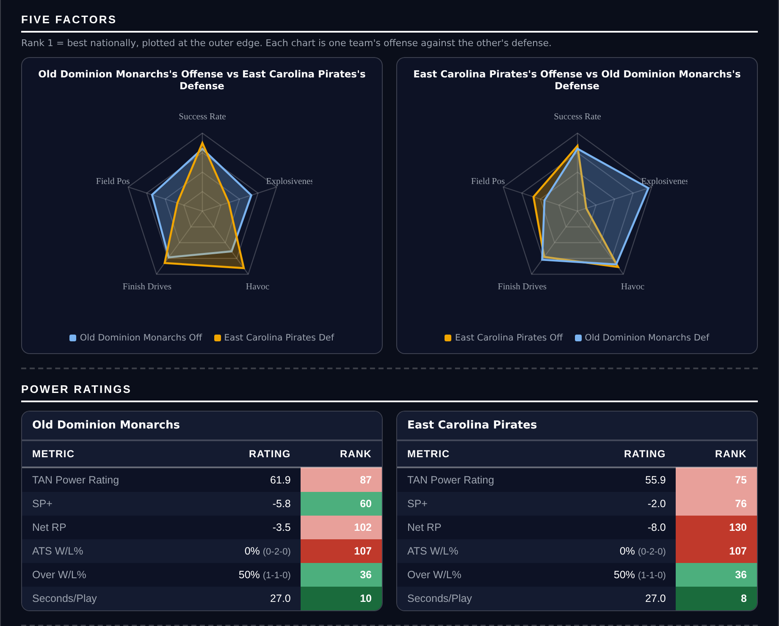
Five Factors and power ratings, captured from the CFB Betting Hub.
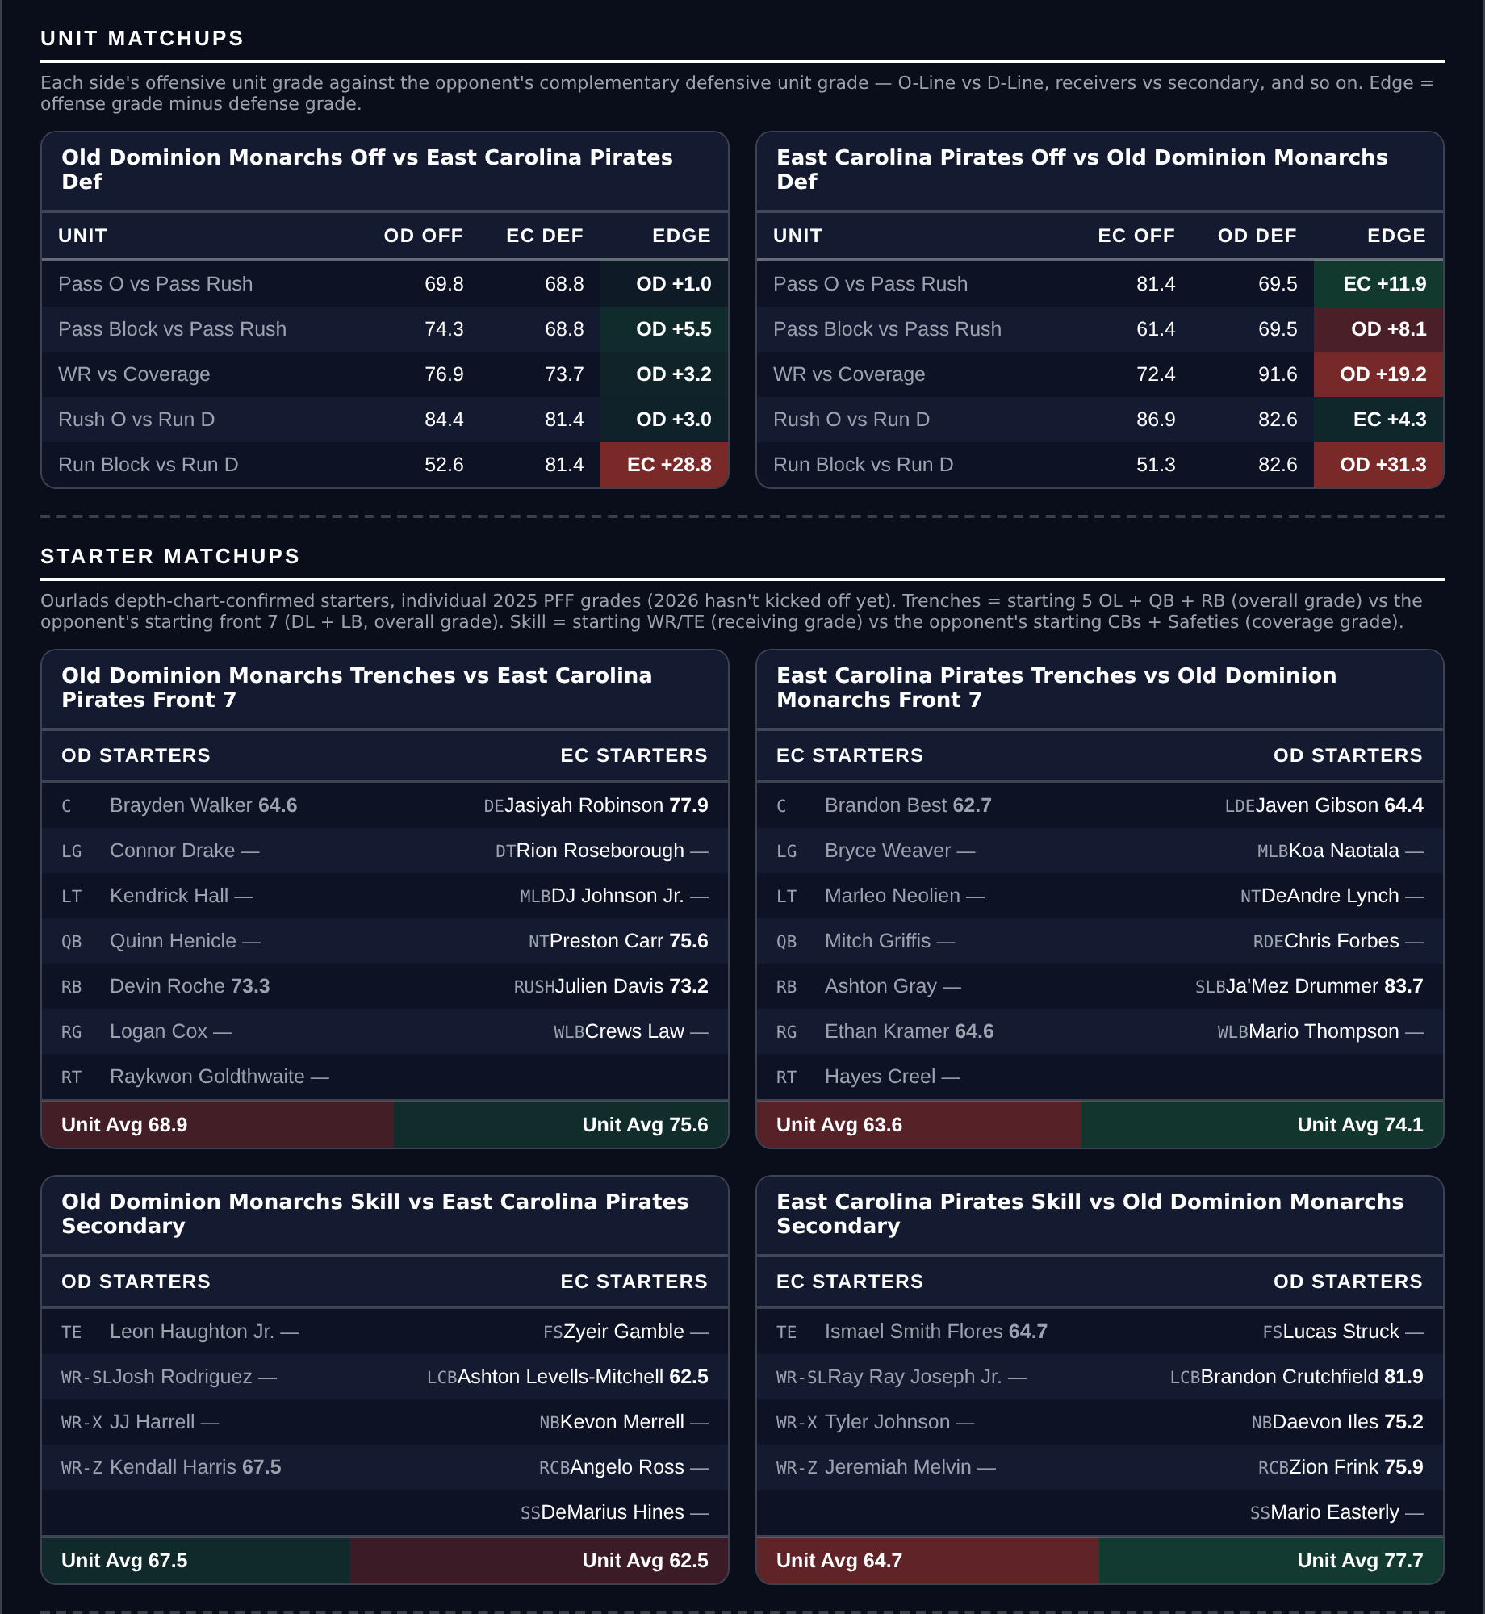
Unit matchups: each offensive unit grade against the opposing defensive unit. Edge = offense minus defense.

Purdue at UCLA — Under 52.5
Purdue Boilermakers @ UCLA Bruins
Book total | 52.5
Our number | 40.7
Gap | 11.8 pts
Tempo ranks | UCLA 125th, Purdue 101st
2025 scoring | UCLA 218 PF, Purdue 225 PF
Game spread | -14.0

Neither of these offenses could score in 2025. UCLA put up 218 points and Purdue 225 — the two lowest figures in this document — and both grade in the mid-60s offensively. Our number lands at 40.7 against a book total of 52.5.
Pace compounds it. UCLA ranks 125th in seconds per play and Purdue 101st, so this is two slow teams who struggle to move the ball, which is the cleanest under profile available. UCLA also ruled receiver Mikey Matthews out for this game with a leg injury, removing a rotation piece from an offence that was already the lower-scoring of the two. Purdue's defense grades 57.4, easily the weakest number here, and that is the one thing arguing the other way — but UCLA's own defense at 68.3 is not good enough to turn a bad opponent into a track meet, and their offense has to actually take advantage of it.
Against the pick: both teams allowed enormous point totals in 2025 (UCLA 401, Purdue 382), and a 14-point spread is enough that garbage time could add a late score or two. Our defense-side inputs are describing units that gave up a lot of points, which is a reason to think 52.5 is not as rich as our number claims.
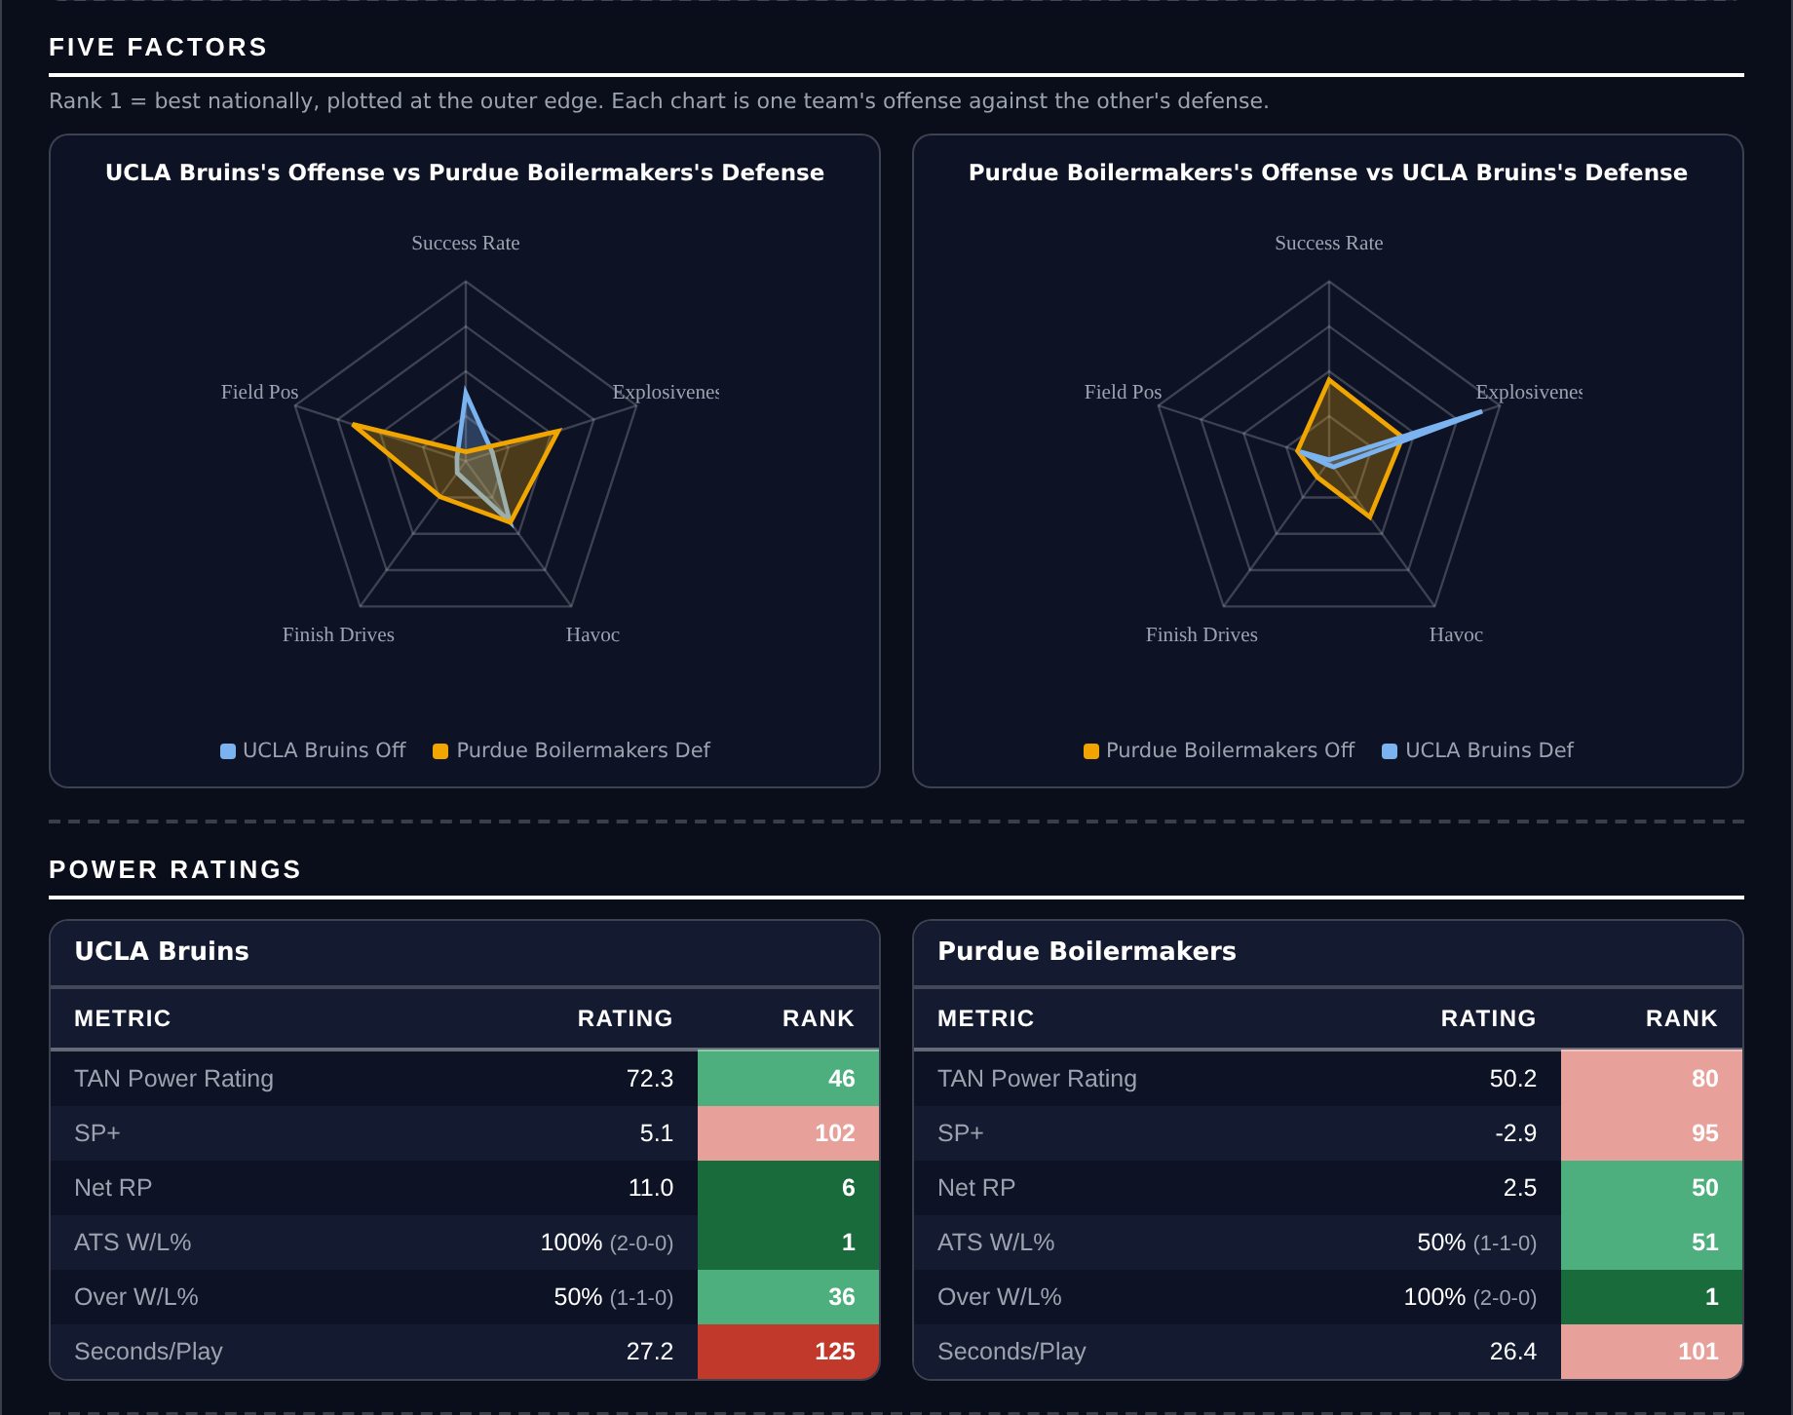
Five Factors and power ratings, captured from the CFB Betting Hub.
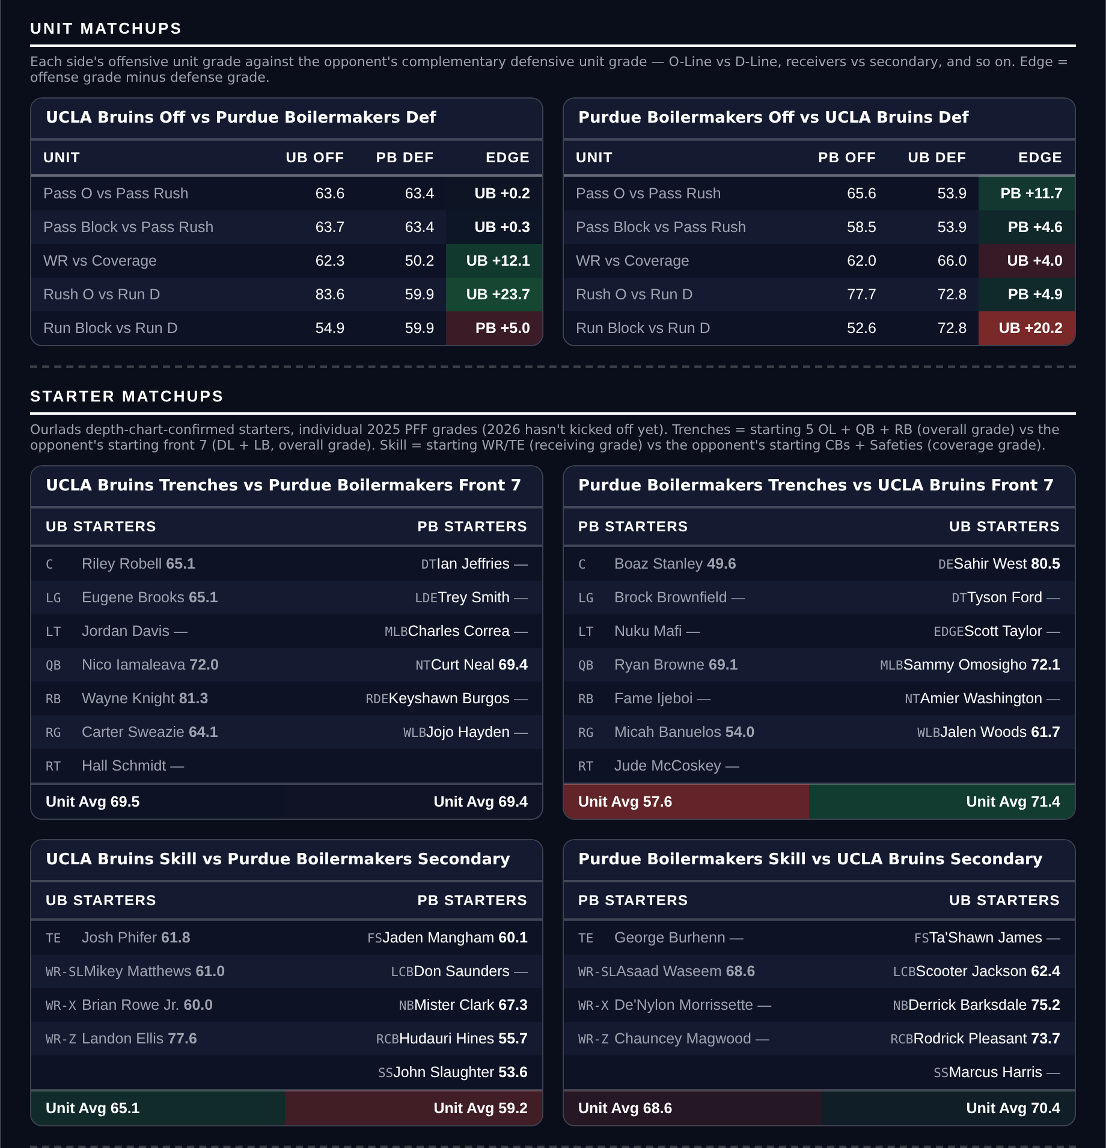
Unit matchups: each offensive unit grade against the opposing defensive unit. Edge = offense minus defense.

Florida State at Alabama — Over 49.5
Florida State Seminoles @ Alabama Crimson Tide
Book total | 49.5
Our number | 58.8
Gap | 9.3 pts
Offense grades | Alabama 83.0, Florida State 84.1
FSU tempo rank | 9th
Game spread | -19.5

This is the best pair of offenses in either document — Florida State grades 84.1 and Alabama 83.0 — and Florida State plays fast, ranking 9th nationally in seconds per play. Our team totals sum to 58.8 against a book number of 49.5. Both teams cleared 390 points in 2025.
The market has priced this as a defensive game, and there is a case for it: Alabama's defense grades 91.1, the best in this document, and they allowed only 222 points last season. But Florida State's 80.4 defensive grade is the weak link, and an offense grading 84.1 with top-ten tempo against it is how totals get cleared. Alabama only needs to hold up their end.
The caveat I want to be straight about: at a 19.5-point spread this is the closest of our five totals to the blowout zone that cost us twice last week, and it cuts the opposite way here — a big Alabama lead means running clock, not more points. The over/under records mostly cancel: with the power table now on current-season data, Alabama is 2-0 to the Over and Florida State is 0-2, two games each and neither worth much. This is the total on this page I hold most loosely.
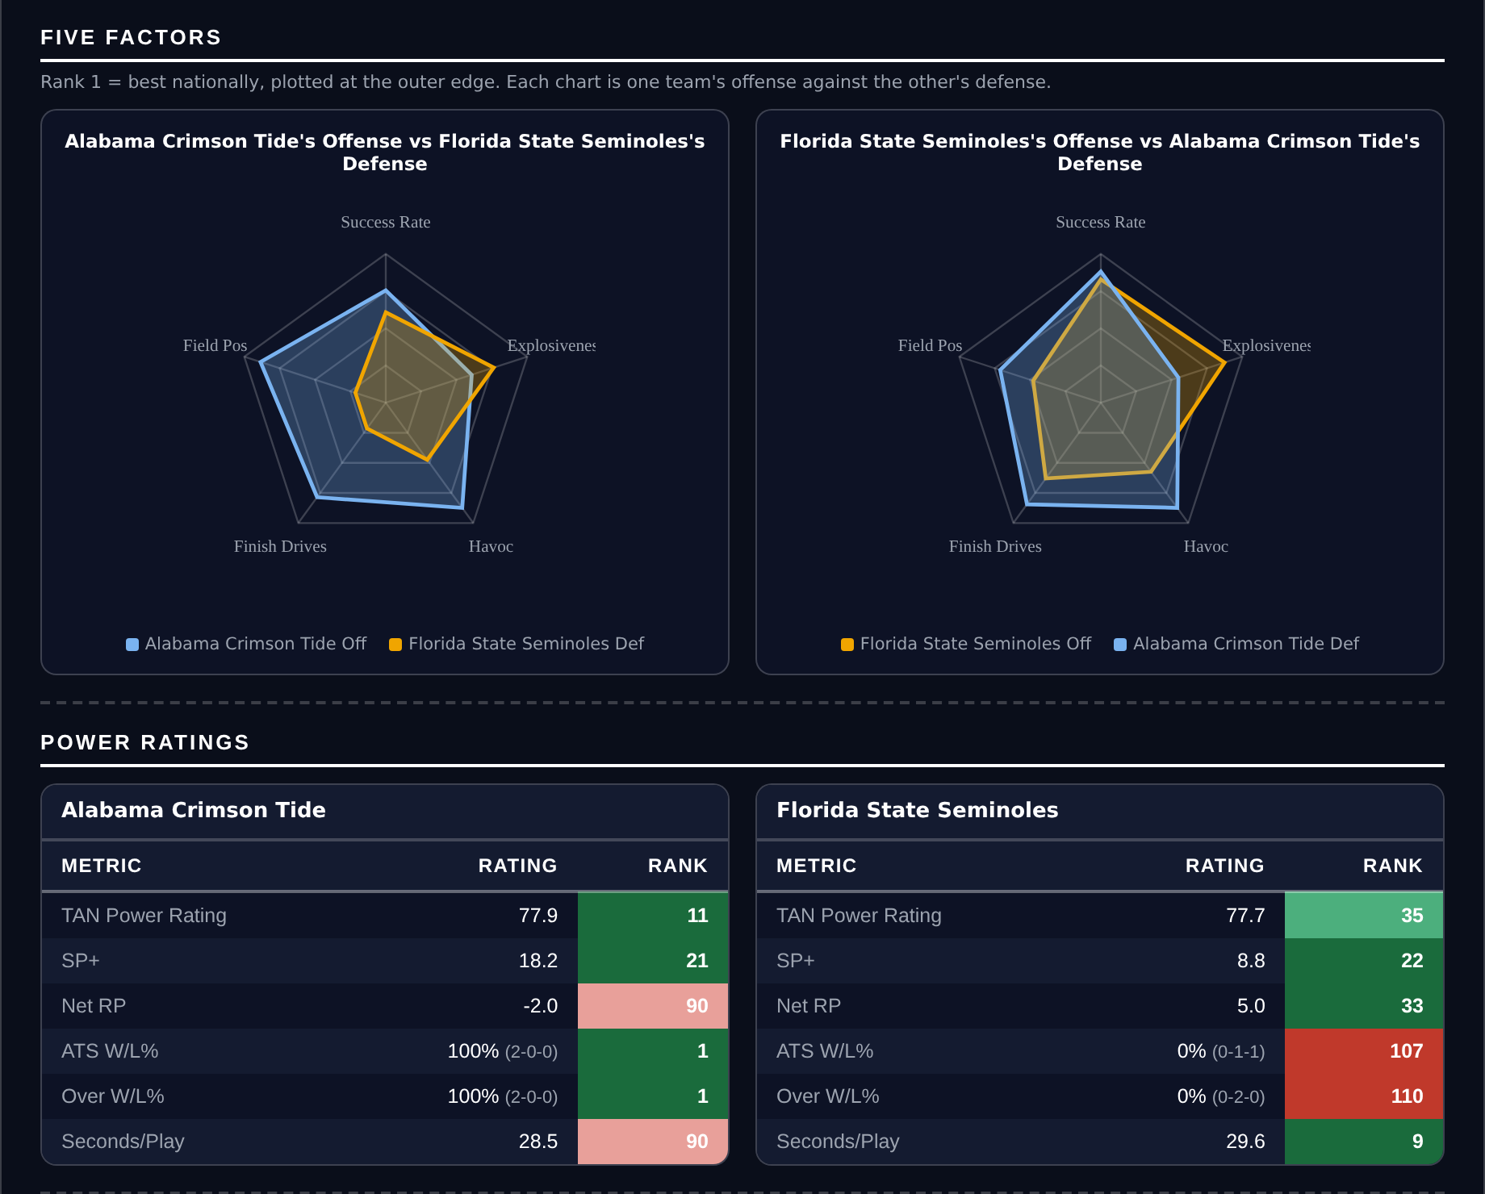
Five Factors and power ratings, captured from the CFB Betting Hub.
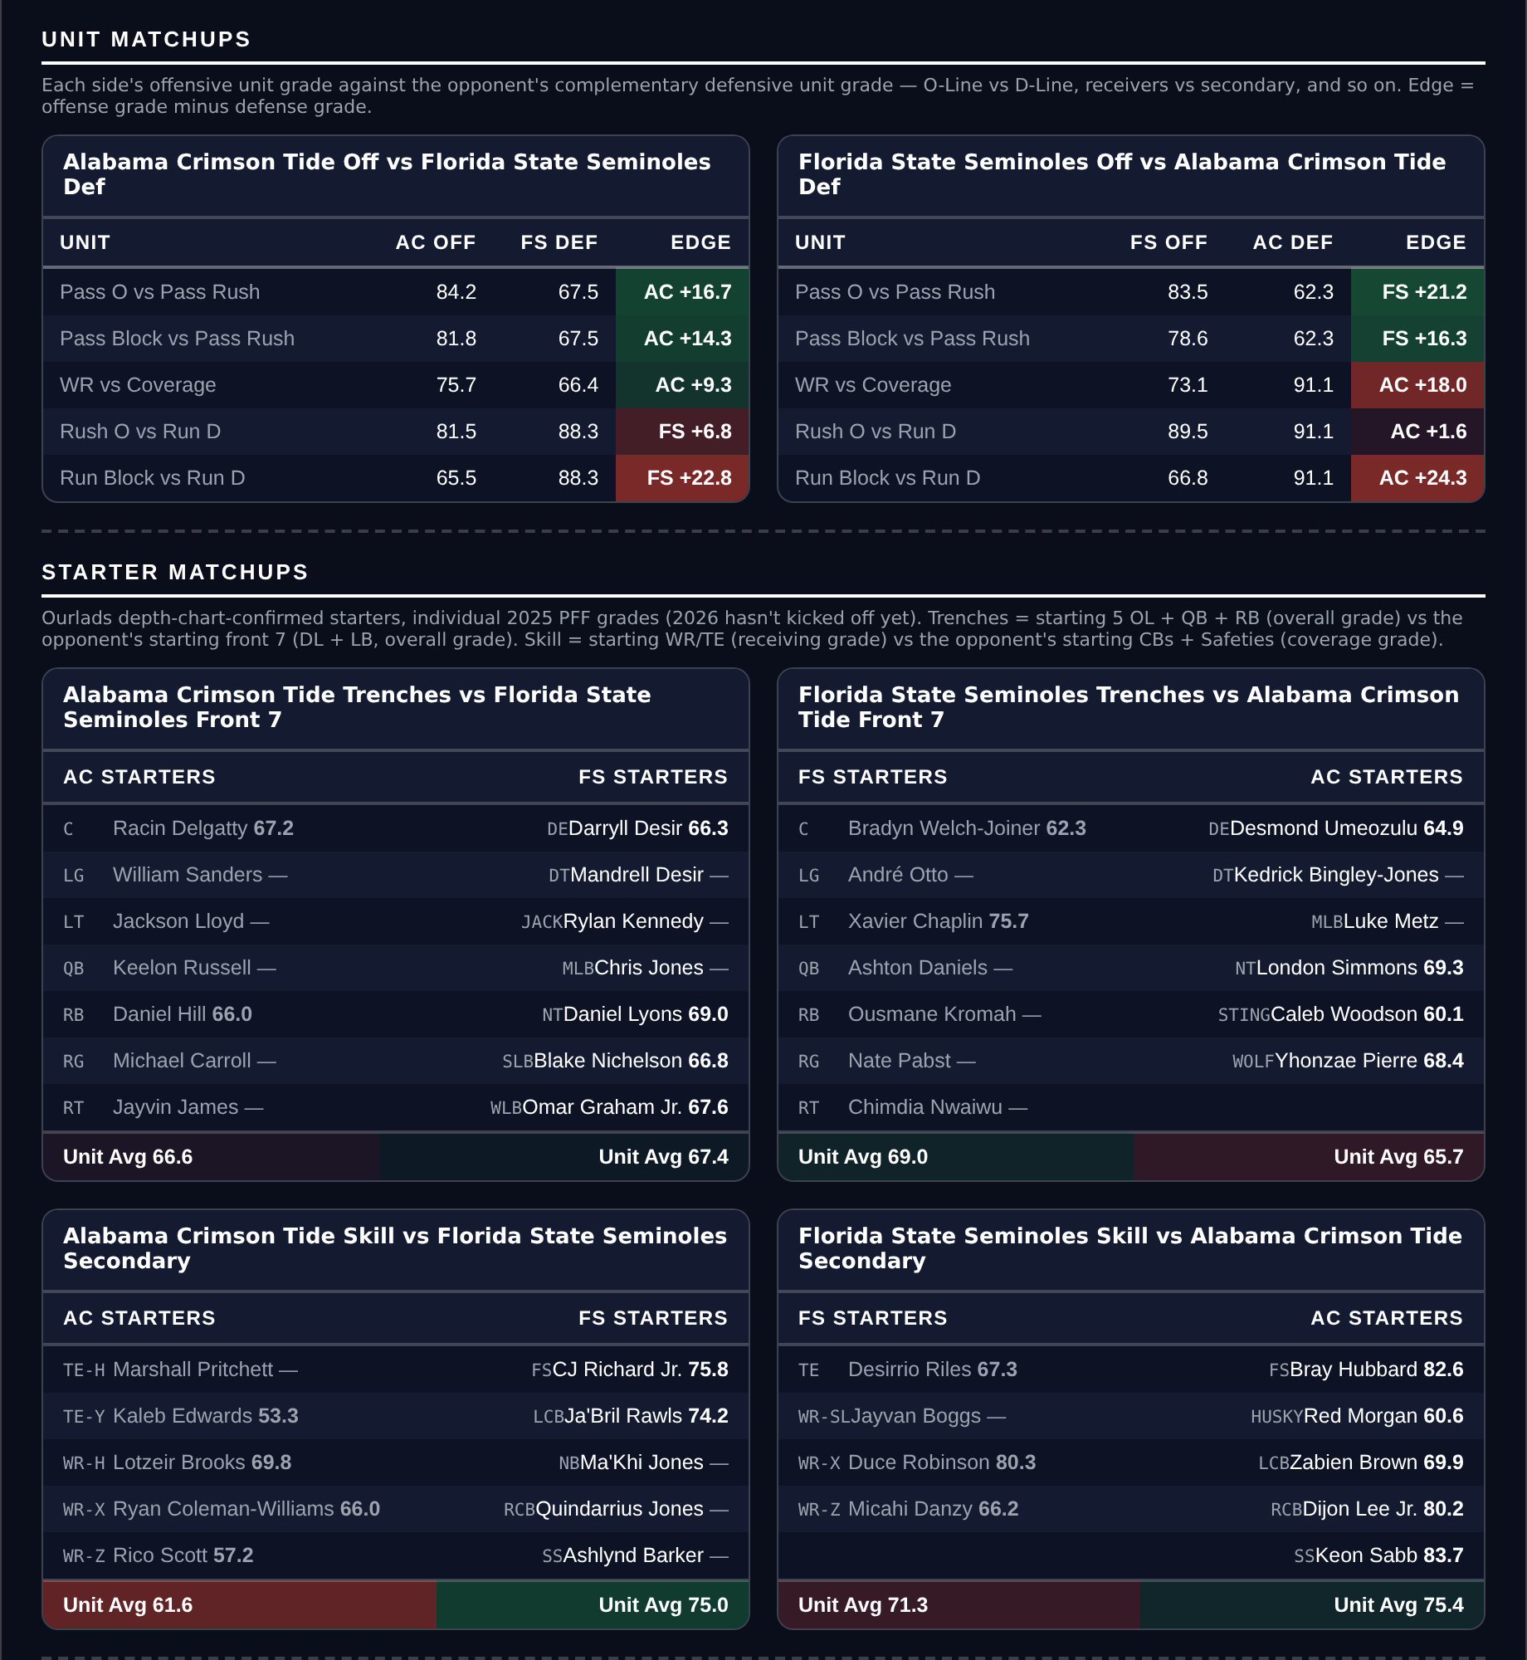
Unit matchups: each offensive unit grade against the opposing defensive unit. Edge = offense minus defense.

Charlotte at Appalachian State — Under 52.5
Charlotte 49ers @ Appalachian State Mountaineers
Book total | 52.5
Our number | 43.5
Gap | 9.0 pts
Charlotte tempo rank | 132nd
App State defense grade | 82.5
Charlotte 2025 | 172 PF, 436 PA

Charlotte scored 172 points in all of 2025. That is the lowest figure anywhere in these documents by a margin of 46 points, and they pair it with the 132nd-ranked tempo — a slow offense that cannot score. Our number is 43.5 against a book total of 52.5.
Appalachian State's defense grades 82.5, comfortably the better of the two units on the field, and their own offense at 67.3 is competent without being explosive. The combination of a good defense facing an offense that managed 14 points a game, with neither side in a hurry, is the shape of a low-scoring afternoon.
The argument against is Charlotte's own defense, which grades 61.2 and allowed 436 points last year. Appalachian State should move the ball freely, and at a 17.5-point spread there is room for the Mountaineers to score more than their average if this turns into a rout. Our total is essentially betting that Charlotte's offense caps the game on its own.
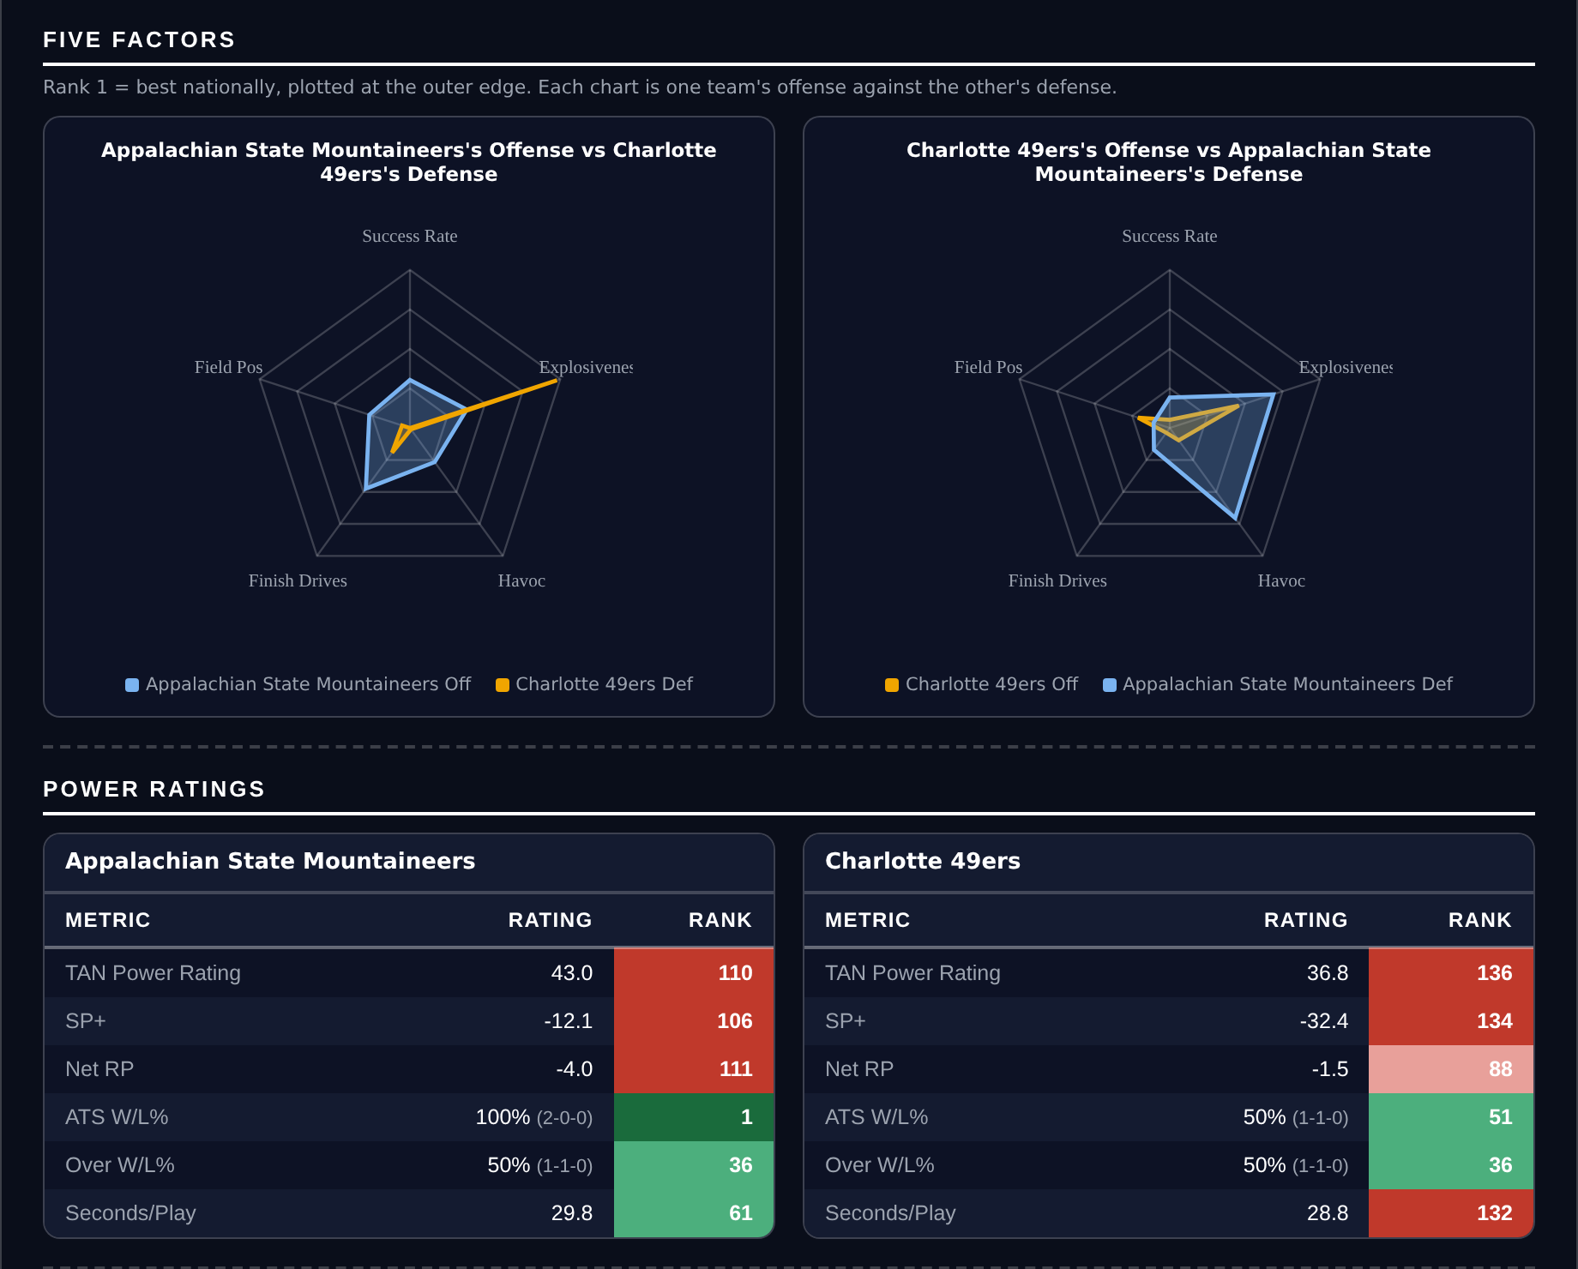
Five Factors and power ratings, captured from the CFB Betting Hub.
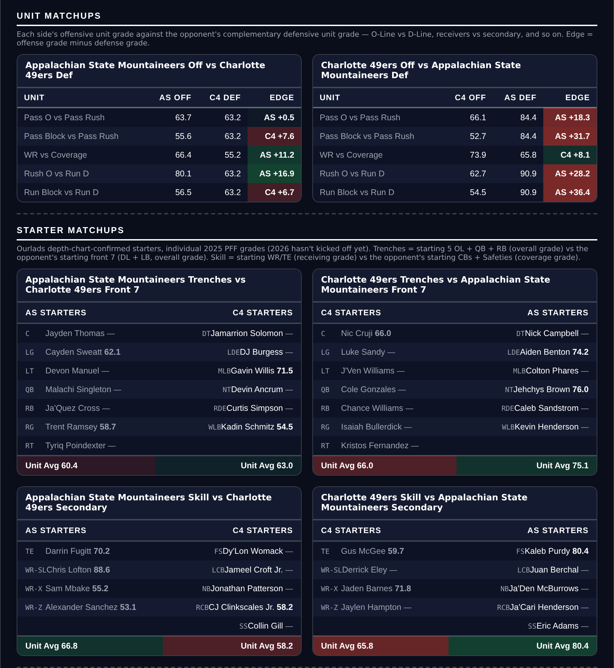
Unit matchups: each offensive unit grade against the opposing defensive unit. Edge = offense minus defense.

UAB at Louisiana — Under 55.25
UAB Blazers @ Louisiana Ragin' Cajuns
Book total | 55.25
Our number | 47.8
Gap | 7.5 pts
Game spread | -7.5
Louisiana over rate, this season | 1-1 (50%, 36th)
UAB defense grade | 55.0

The smallest edge of the five and the one with the most obvious counterargument, but the profile is sound. Our team totals sum to 47.8 against a book number of 55.25, and the spread is a modest 7.5 points, which keeps this well clear of the mismatch zone where our total model is unreliable.
Louisiana's offense grades 65.1 and scored 325 points in 2025 — middling on both counts — and neither team plays especially fast, with tempo ranks of 96 and 71. A seven-point favorite at home against a similarly ordinary opponent does not usually produce 55 points between them.
Now the honest part: UAB's defense grades 55.0, the worst defensive grade in either of these documents, and they allowed 459 points in 2025. That argues the market is right and we are wrong. The over/under record no longer argues against us — the 66.7% that ranked Louisiana 13th was a 2022 figure, and on current-season data they are 1-1, as is UAB — but removing a reason to fade this Under is not the same as adding one to back it. I am taking it because the gap is real and the spread is small, but this is the total here I would drop first if I were only playing four.
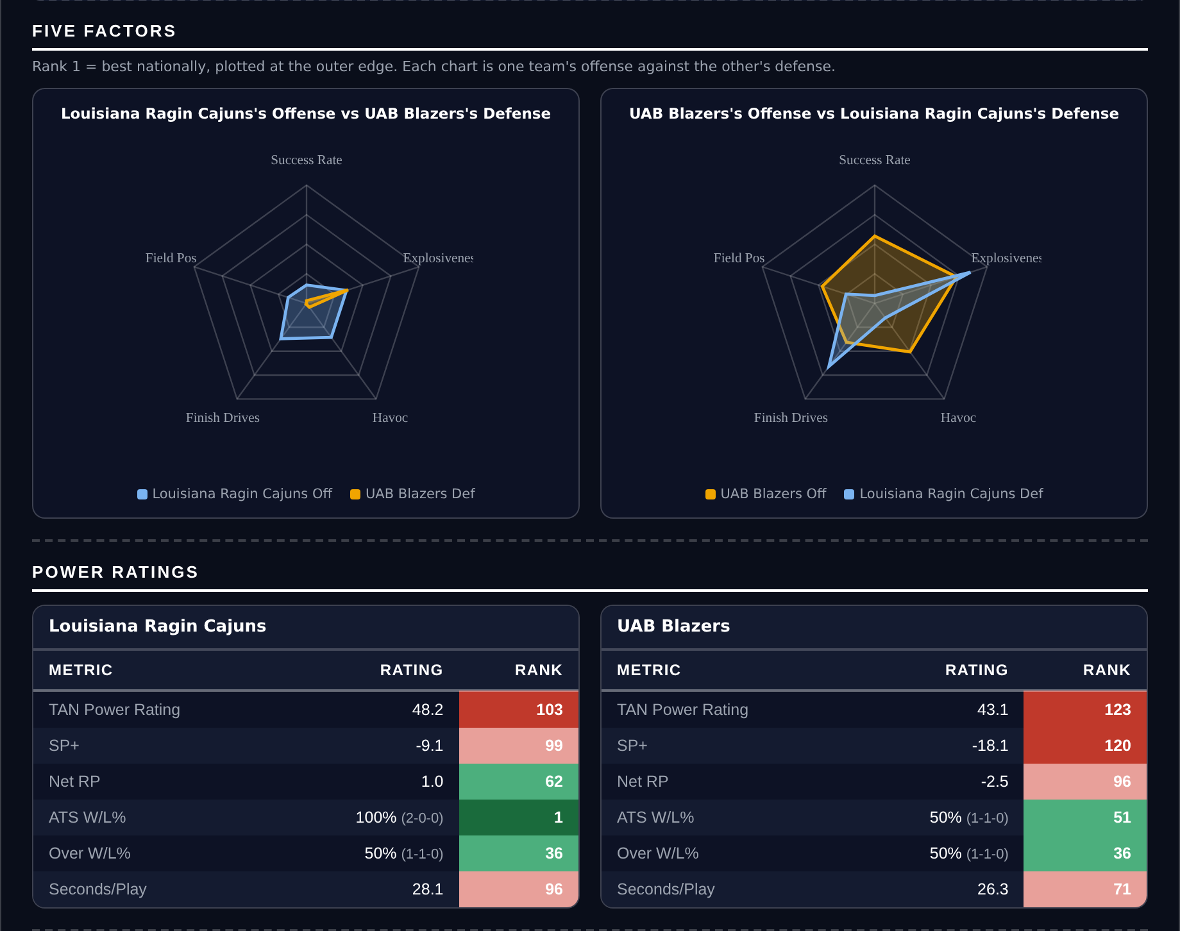
Five Factors and power ratings, captured from the CFB Betting Hub.
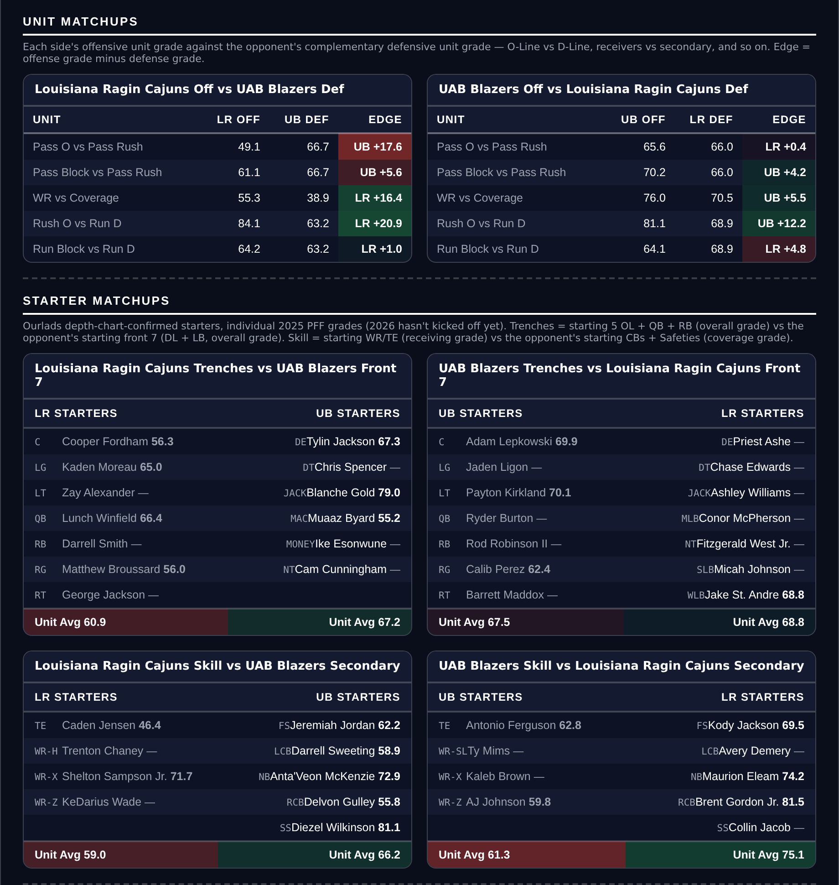
Unit matchups: each offensive unit grade against the opposing defensive unit. Edge = offense minus defense.

