Spreads to Target
Week 6 · Saturday October 10, 2026
Every figure below is checked against the source data before it is written. Team grades, five-factor ranks and per-game scoring come from the 2026 PFF team grades and the season-to-date CFBData ranks; each player's role, share and production come from the 2026 PFF season files. Per-game scoring uses each team's own game count, which is four, five or six this week. Where a rank ends in .5 the teams are tied and it is written as “tied Nth”. All fifteen kickoffs are verified Saturday in Eastern time.
Season to date: 25-30-2 and two voids, down 8.69 units across 59 picks. Spreads 7-13 (-7.30u), totals 9-8-2 (+0.20u), props 9-9 and two voids (-1.59u). Week 5 went 7-7 with a void, -0.78 units, the best week so far.
Five spreads where two measures built from different inputs agree on a side. The model number is the SP+ differential plus home field. The points check uses only each team’s own 2026 point differential plus home field, and shares no input with SP+. Candidates are ranked by the weaker of the two distances, so nothing qualifies on one strong reading alone.
Across the 44 rated Saturday games the model sits 0.8 points more toward the away side than the market does, and each gap is quoted net of that level. The standing exclusion applies: do not lay a price into a team whose ATS record is running ahead of its rating. It removed James Madison -7.5 this week, which was otherwise the fifth pick — Georgia Southern are 4-1 against the spread, and that is the shape that cost this card four times in weeks 2 and 3. UCF +10.5 takes its place.
The record demands a plain statement. Spreads are 7-13 and -7.30 units, the worst of the three categories, and the same 93-game test that condemned the totals residual found nothing in the spread signals either: the model gap net of slate level went 13-12 at the threshold this card bets, and the points check 31-29. Both are coin flips. These five are the least-bad application of a method with no demonstrated edge, and they are sized like everything else rather than backed with any confidence that the category works.
Ratings and the Five Factors come from the 2026 workbook: SP+, TAN, implied team totals and the season-to-date CFBData ranks, out of 138 teams. Player lines are 2026 PFF season to date. Records, ATS and over/under records are TeamRankings, 2026 to date. The PFF team grade file covers five games for 103 teams, four for 25 and six for 10.

North Carolina Tar Heels @ Pittsburgh Panthers

Pittsburgh -3.5
Book line | Pittsburgh -3.5
Model number | Pittsburgh -15.5
Gap | 12.0 pts, 12.8 after the slate's own level
Points check | Pittsburgh -12.9, which is 9.4 past the market
SP+ (2026) | Pittsburgh +14.6 (18th) vs North Carolina +1.8 (tied 64th), home edge +2.7
Pittsburgh 2026 | 5-0, 4-1 ATS, 38.4 points a game and 13.4 allowed
Pittsburgh defense | 7th Success Rate, 14th Finishing Drives, 93.1 run defense
North Carolina | 2-2, 24.0 for and 19.5 against, offense 120th in Explosiveness

Book has Pittsburgh -3.5. The rating says -15.5 and the points check, built only from each team's own 2026 point differential plus home field, says -12.9. Two measures sharing no inputs land nine and twelve points past a field goal.
Pittsburgh are 5-0 and the margin is not an accident. They score 38.4 and allow 13.4, the defense ranks 7th in Success Rate and 14th in Finishing Drives on a 90.2 defensive grade and 93.1 against the run, and the offense grades 84.5 passing behind an 82.8 pass block grade.
North Carolina are 2-2 at 24.0 points a game. The offense ranks 49th in Success Rate but 120th in Explosiveness, so it moves the ball without threatening, and that is the profile a defense ranked 131st in Explosiveness allowed is built to live with. Their own defense ranks 106th in Success Rate.
The risk is the price being short for a reason the numbers cannot see. Three and a half points on a 5-0 team against a .500 opponent is the market saying it does not believe the gap, and a 12-point disagreement with two independent measures usually means someone knows something. Pittsburgh's 59.4 tackling grade is the one soft number to point at.
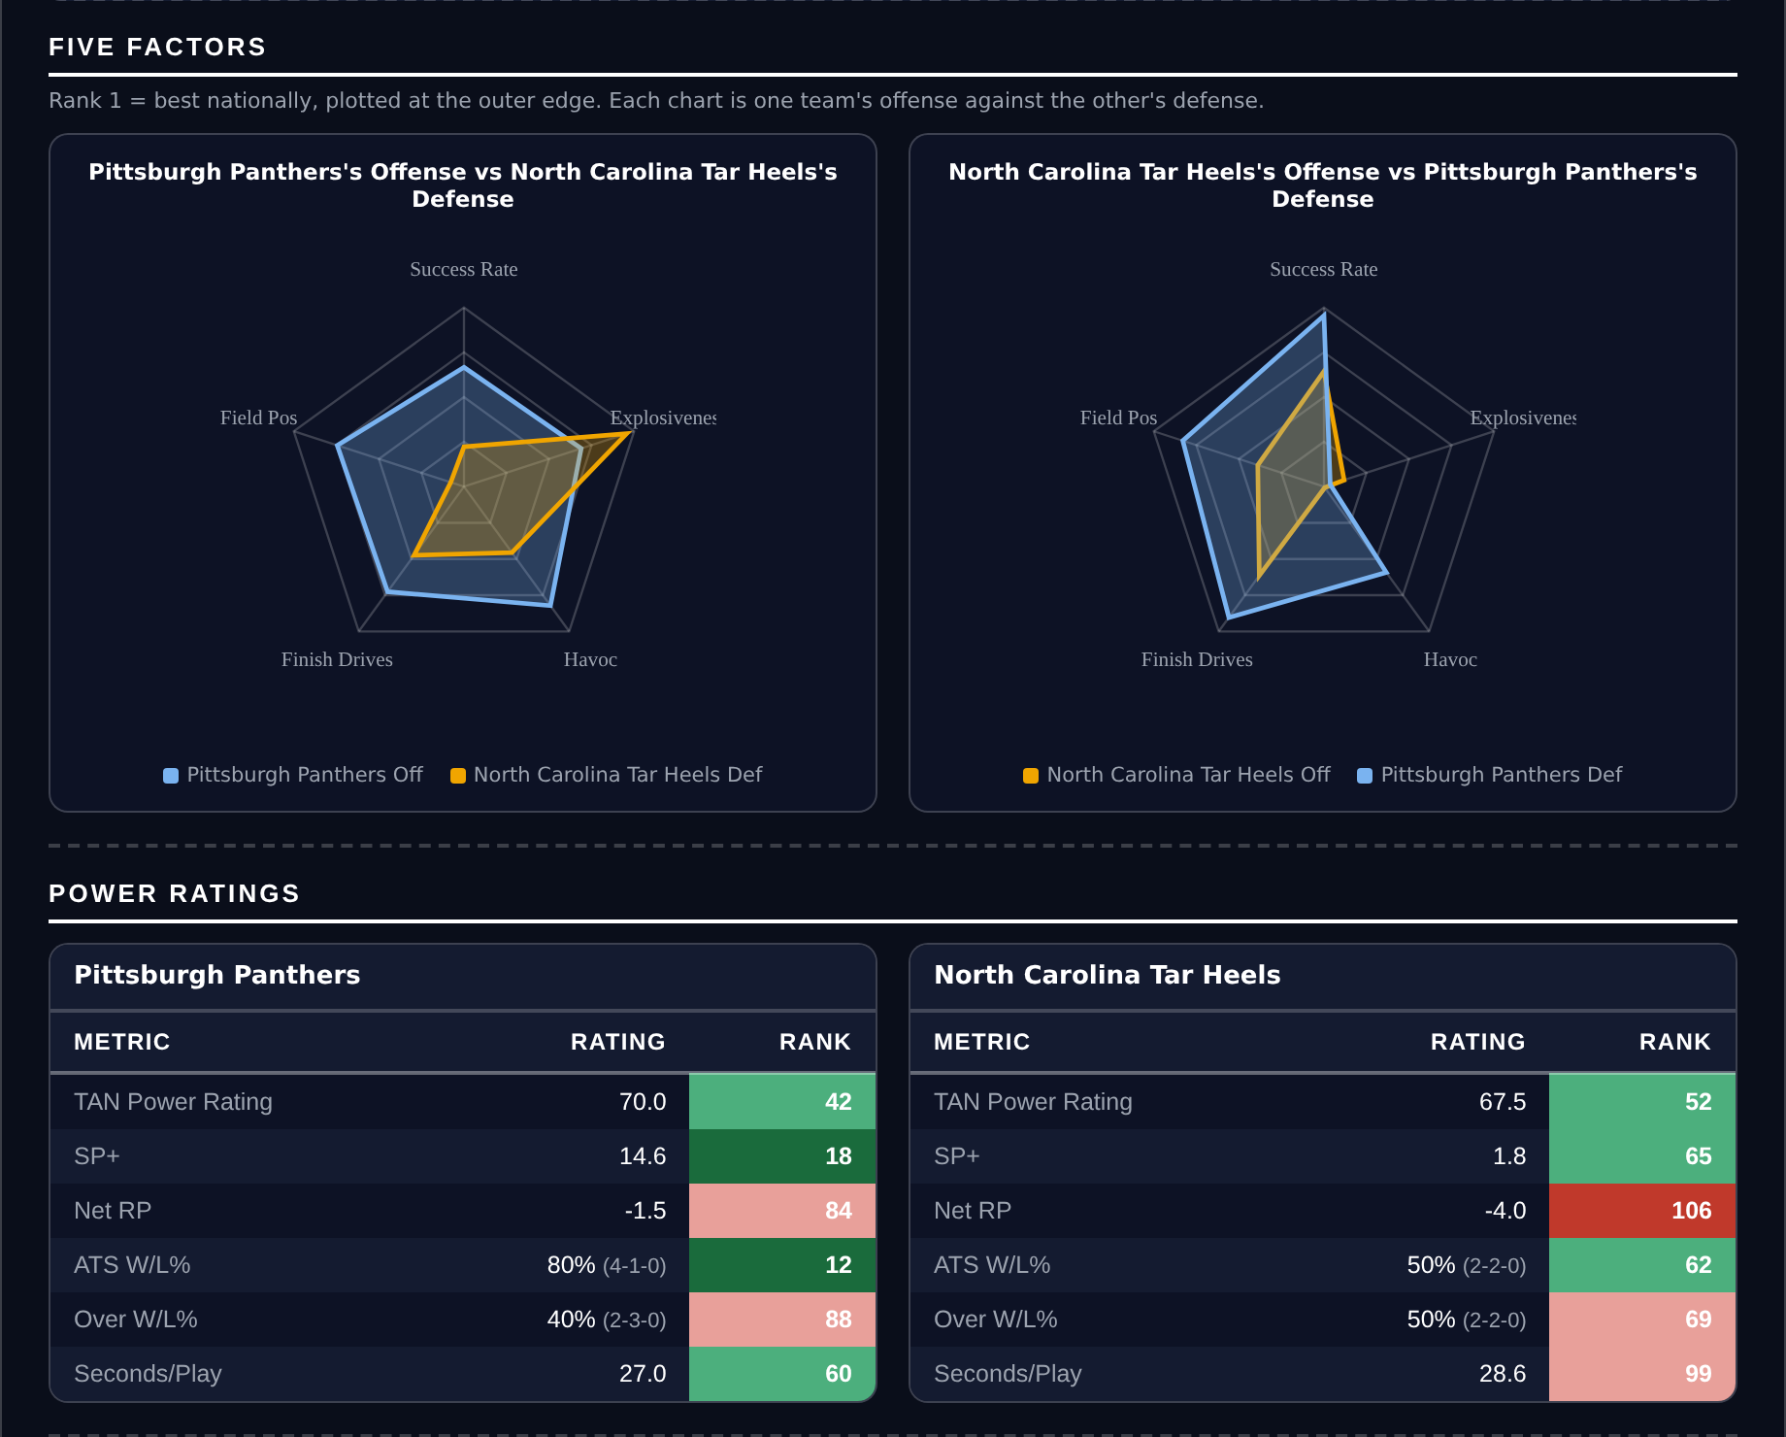
Five Factors and power ratings, captured from the CFB Betting Hub.
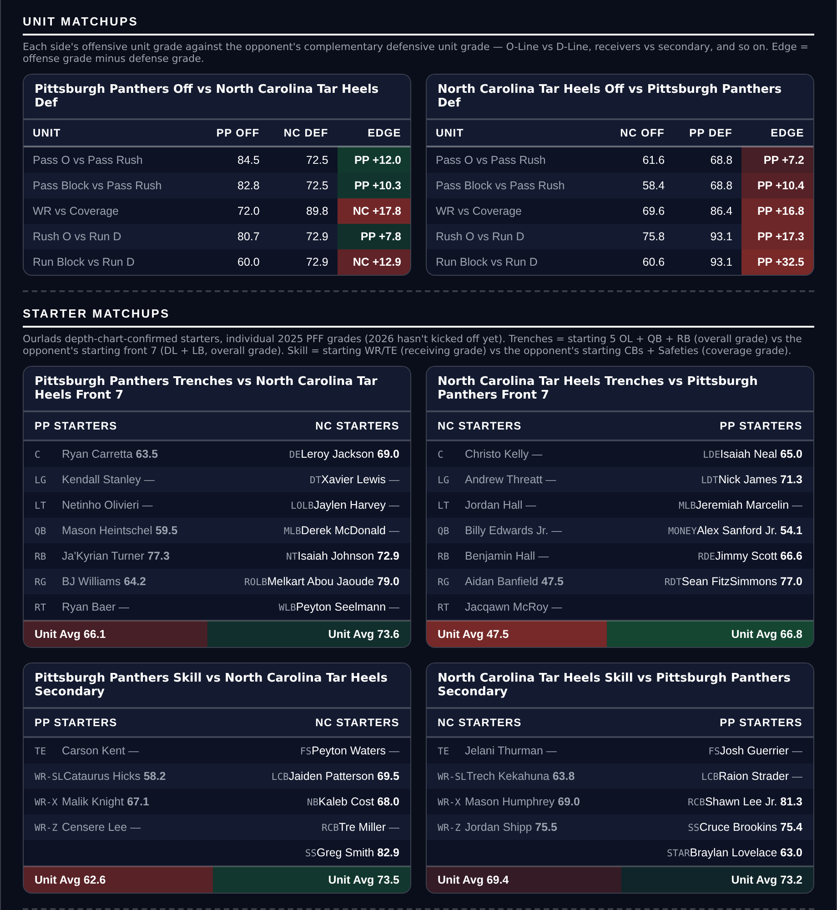
Unit matchups: each offensive unit grade against the opposing defensive unit. Edge = offense minus defense.

Ole Miss Rebels @ Vanderbilt Commodores

Vanderbilt +9.5
Book line | Ole Miss -9.5
Model number | Vanderbilt +3.5
Gap | 6.0 pts, 6.8 after the slate's own level
Points check | Vanderbilt -0.2, effectively a pick'em, 9.7 past the market
SP+ (2026) | Ole Miss +11.0 (36th) vs Vanderbilt +5.1 (tied 56th), home edge +2.4
Scoring | Ole Miss 35.5 for / 30.8 against, Vanderbilt 25.4 / 25.0
Ole Miss defense | 127th Success Rate, 50.5 coverage, 44.7 tackling
Records | Ole Miss 3-1 (1-3 ATS), Vanderbilt 3-2 (3-2 ATS)

Book has Ole Miss -9.5 on the road. The rating still makes Vanderbilt a 3.5-point underdog, so it is not calling an upset, but the points check has the game at a pick'em. Both reads put the fair number well inside a touchdown.
Ole Miss are the better team and also the leakier one. They score 35.5 but concede 30.8, and the defense ranks 127th in Success Rate and 109th in Finishing Drives on a 50.5 coverage grade and a 44.7 tackling grade. A team that gives up 30 a game laying nine and a half on the road is the whole position.
Vanderbilt are ordinary on offense, 104th in Success Rate and 116th in Finishing Drives behind a 50.9 pass block grade, which is why this is taking points rather than backing a winner. What they do have is a defense ranked 69th with an 82.3 coverage grade against a passing offense that grades 86.2.
The pace argument cuts against. Ole Miss play the 6th-fastest tempo in the country against Vanderbilt's 110th, so there are more possessions than a home underdog wants. Ole Miss being 1-3 against the spread is the counterweight: the market has already been asking too much of them.
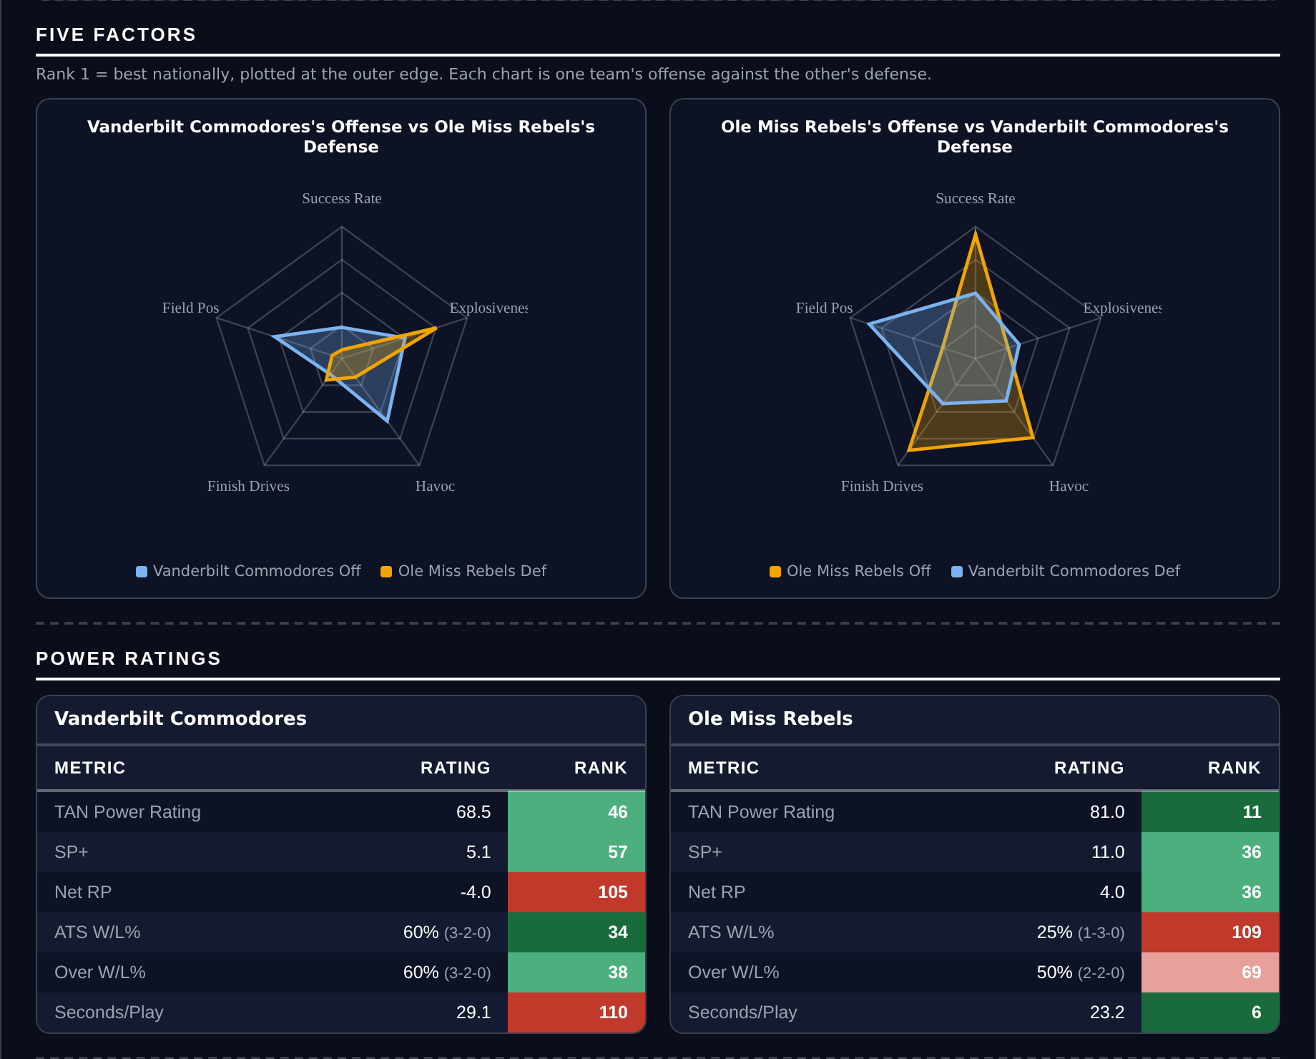
Five Factors and power ratings, captured from the CFB Betting Hub.
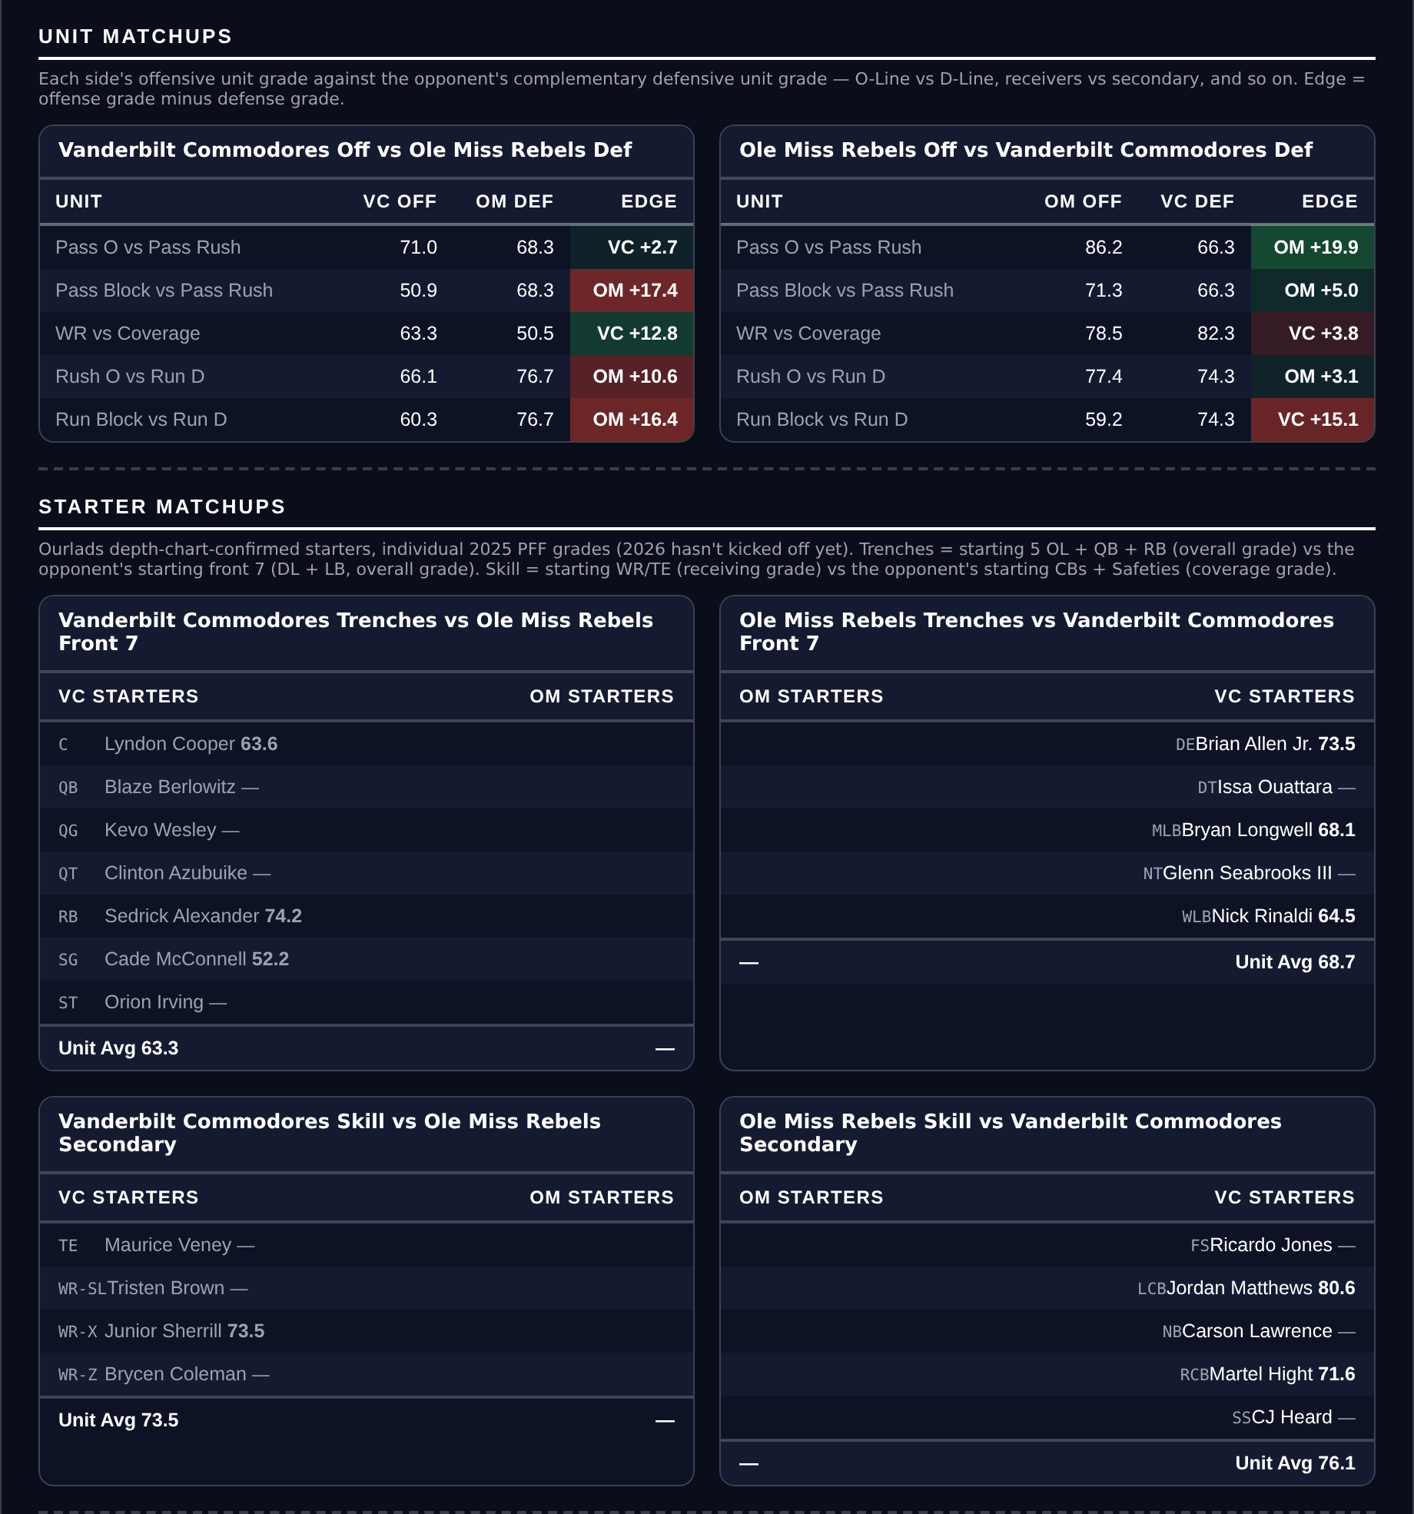
Unit matchups: each offensive unit grade against the opposing defensive unit. Edge = offense minus defense.

Air Force Falcons @ Northern Illinois Huskies

Air Force -7.5
Book line | Air Force -7.5
Model number | Air Force -21.3
Gap | 13.8 pts, 13.0 after the slate's own level
Points check | Air Force -13.7, which is 6.2 past the market
SP+ (2026) | Air Force -0.1 (tied 71st) vs Northern Illinois -23.4 (133rd), home edge +2.0
Northern Illinois | 0-4, 13.8 points a game and 36.3 allowed
Northern Illinois offense | 126th Success Rate, 137th Finishing Drives, 47.0 run block
Air Force defense | 14th Success Rate, 79.3 coverage

Book has Air Force -7.5 on the road. The rating says -21.3 and the points check says -13.7. This is the largest model gap on the board and the two reads still agree on direction with six points to spare.
Northern Illinois are 0-4, score 13.8 a game and concede 36.3. The offense ranks 126th in Success Rate and 137th in Finishing Drives behind a 47.0 run block grade, and the defense ranks 110th, 107th and 94th across Success Rate, Explosiveness and Finishing Drives.
Air Force are not good either and the position does not need them to be. They are 3-1 at 29.0 points a game with a defense ranked 14th in Success Rate on a 79.3 coverage grade, against the worst scoring offense on this card.
The honest risk is the shape of an Air Force game. Their offense ranks 129th in Explosiveness, so they grind rather than pull away, and a triple-option team that leads comfortably stops throwing and lets the clock run. Northern Illinois's 82.0 tackling grade is their one competent unit, and it is the one that keeps a game like this closer than the ratings say.
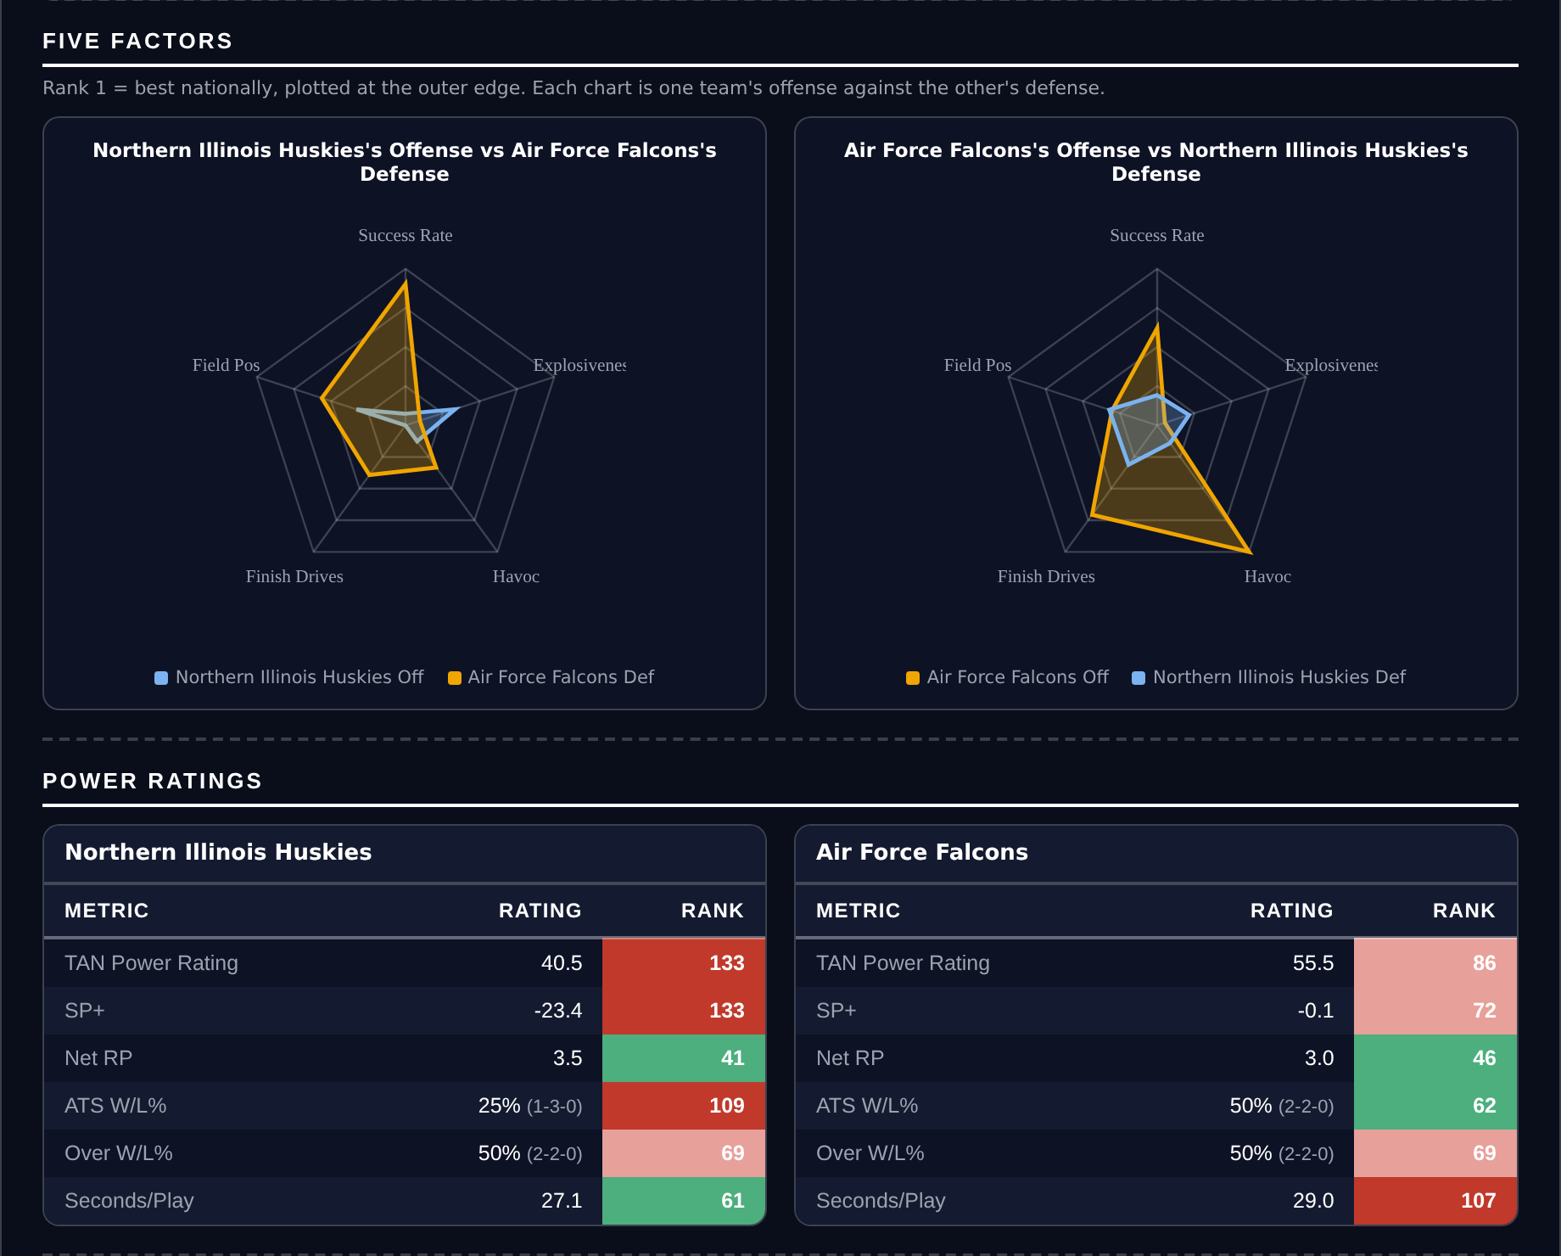
Five Factors and power ratings, captured from the CFB Betting Hub.
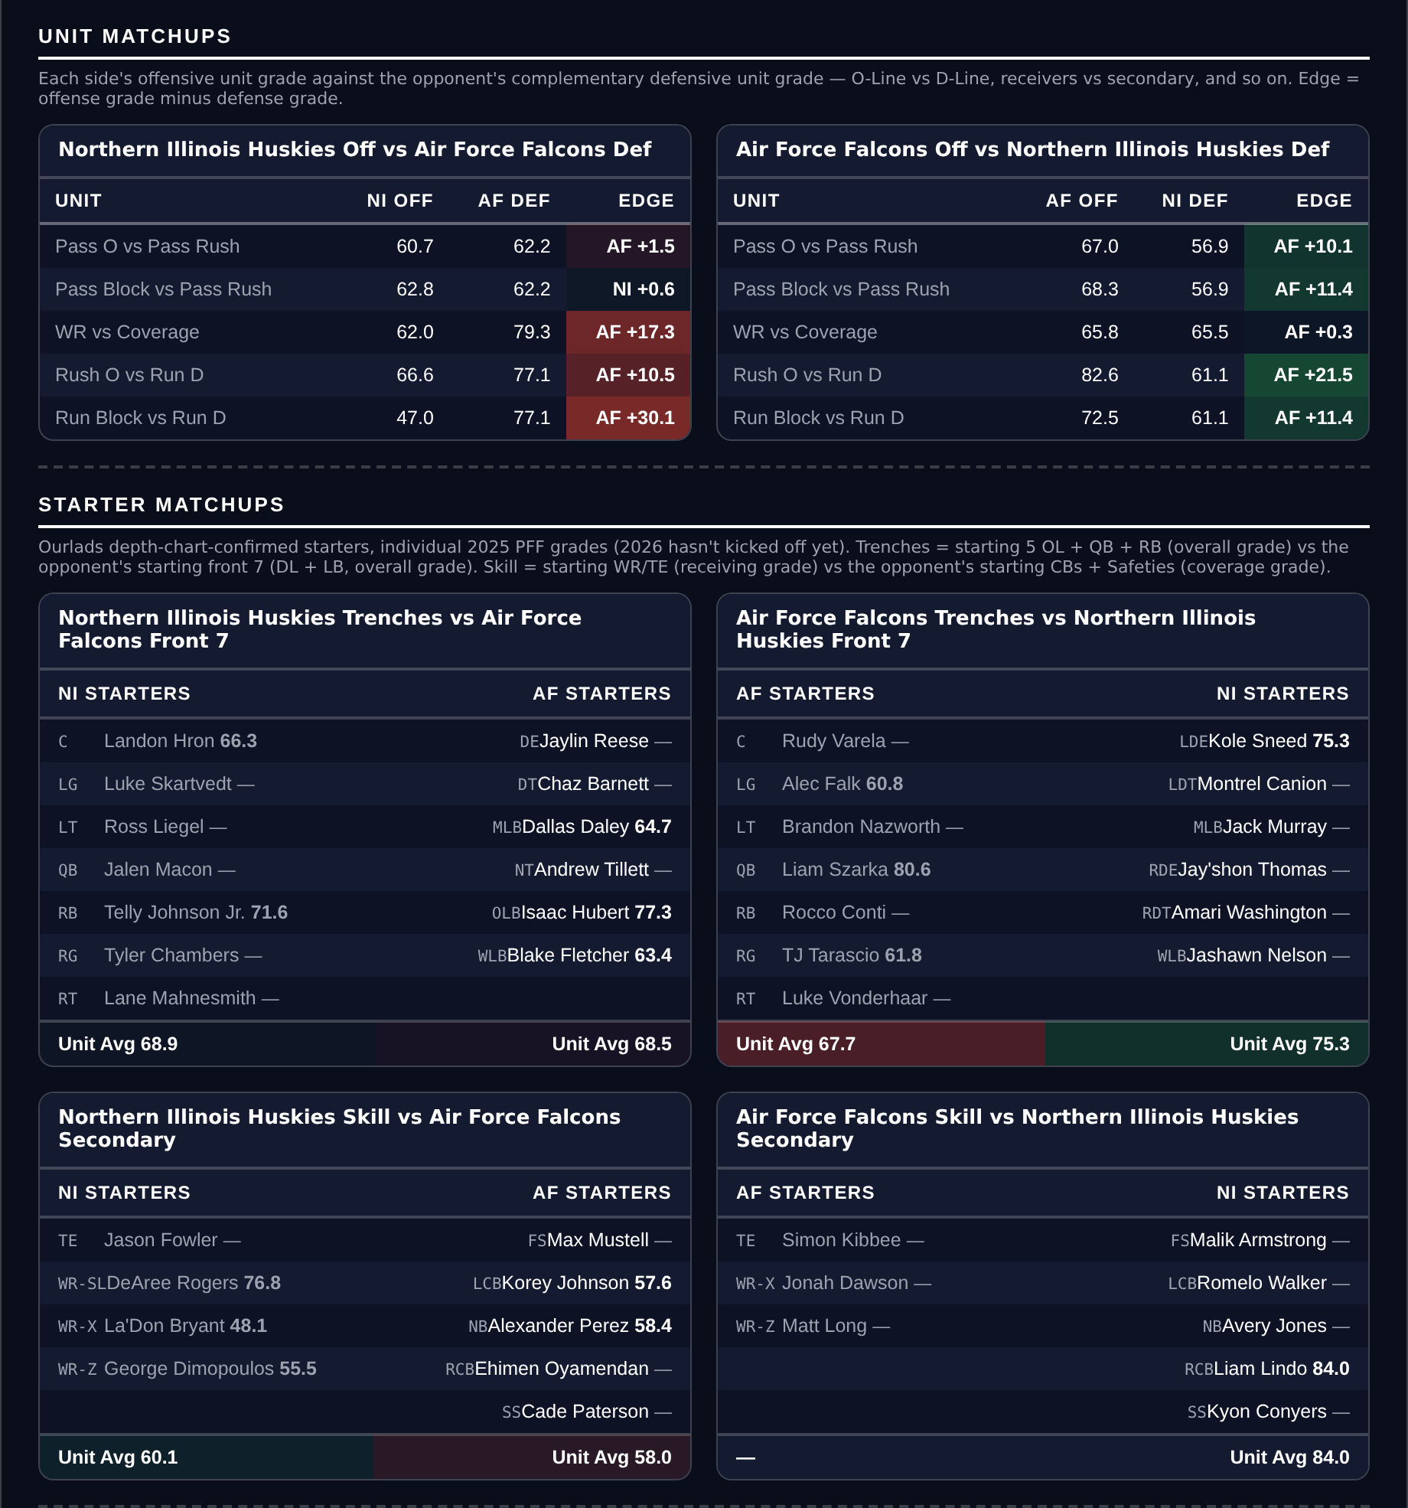
Unit matchups: each offensive unit grade against the opposing defensive unit. Edge = offense minus defense.

Tulane Green Wave @ Army Black Knights

Army -3.0
Book line | Army -3.0
Model number | Army -8.4
Gap | 5.4 pts, 6.2 after the slate's own level
Points check | Army -12.1, which is 9.1 past the market
SP+ (2026) | Army -1.4 (79th) vs Tulane -6.7 (97th), home edge +3.0
Scoring | Army 33.3 for / 19.8 against, Tulane 18.8 / 23.3
Army offense | 4th Success Rate, 92.9 offensive grade, 87.7 run block
Tulane offense | 135th Success Rate, 132nd Finishing Drives, 54.6 pass block

Book has Army -3.0 at home. The rating says -8.4 and the points check, which knows only what each side has scored and allowed, says -12.1. The second measure is the more emphatic of the two here, which is unusual.
Army's offense is the case. It ranks 4th nationally in Success Rate on a 92.9 offensive grade, 89.9 passing and 87.7 run blocking, and they score 33.3 a game. Against a Tulane defense ranked 66th with a 56.6 coverage grade and a 51.8 tackling grade, that is a unit mismatch the three points does not price.
Tulane cannot move the ball. They rank 135th in Success Rate and 132nd in Finishing Drives behind a 54.6 pass block grade and score 18.8 a game. Their one distinction is ranking 1st in Explosiveness, which is the warning attached to this: a team that cannot sustain anything but can hit a long one is exactly the profile that steals a backdoor cover.
Army's defense is the reason this is only three: 117th in Success Rate and 121st in Havoc on a 61.5 coverage grade. Tulane at 1-3 against the spread is running behind its rating rather than ahead of it, which is the shape this card wants to be on the right side of.
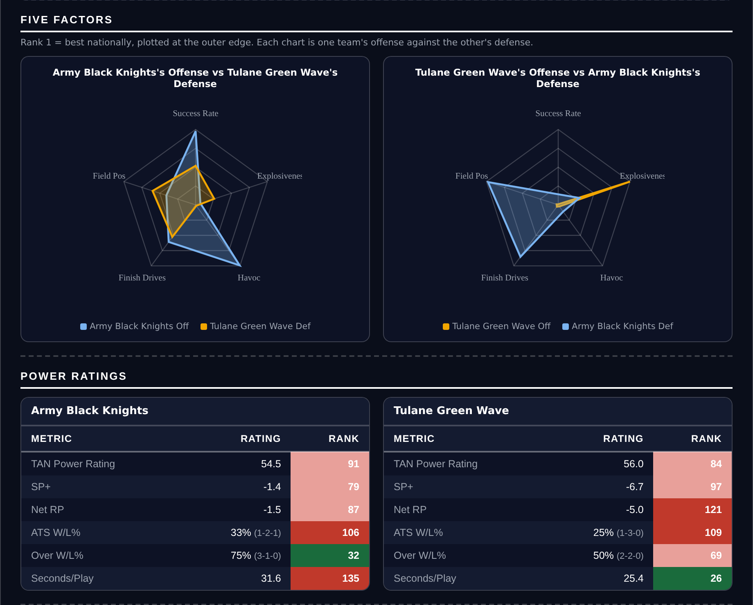
Five Factors and power ratings, captured from the CFB Betting Hub.
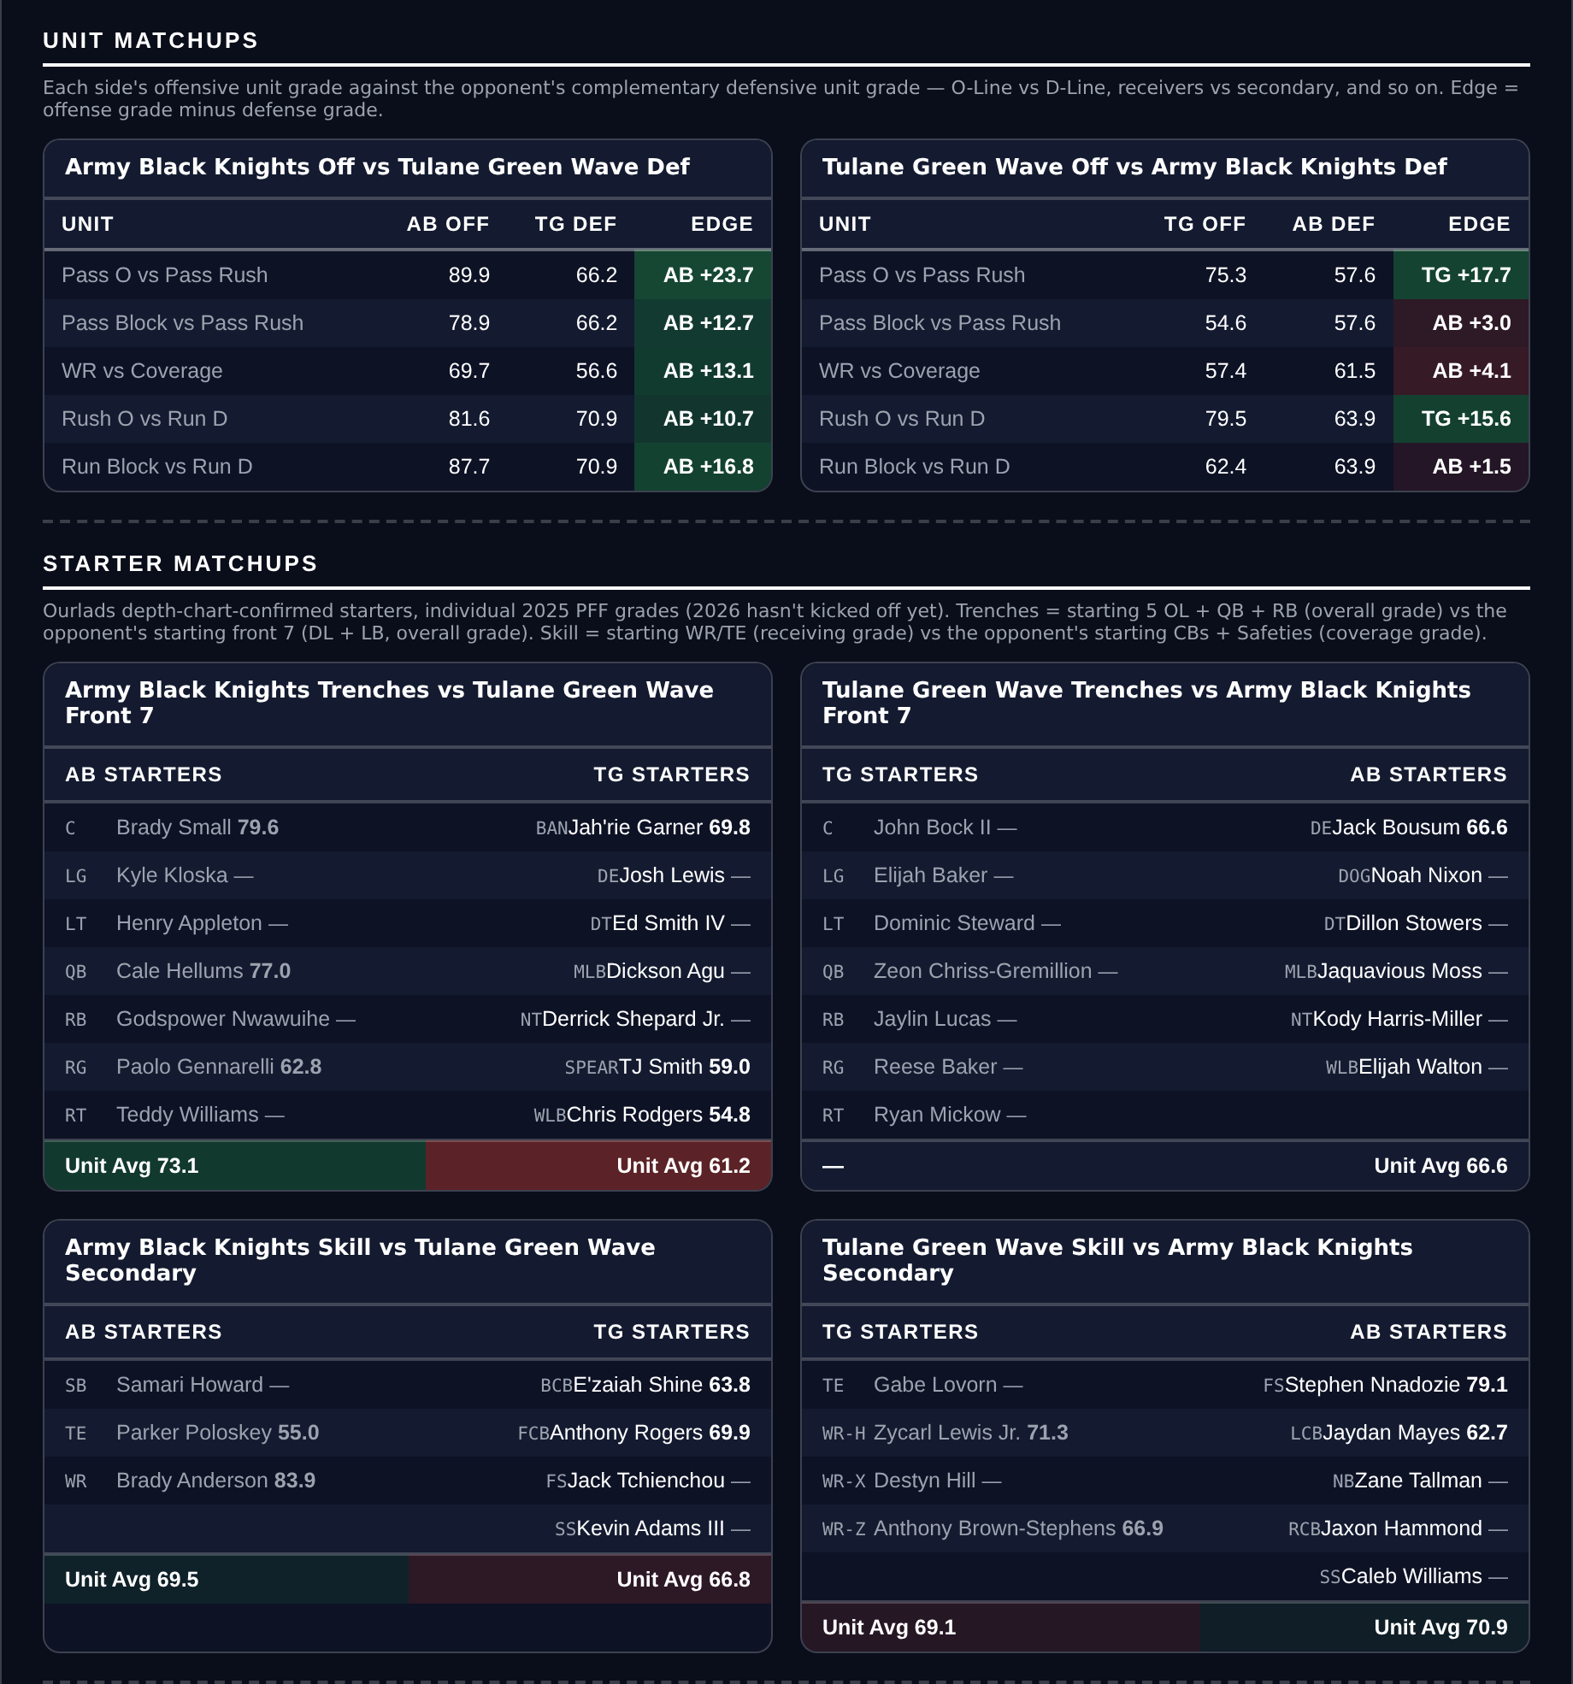
Unit matchups: each offensive unit grade against the opposing defensive unit. Edge = offense minus defense.

UCF Knights @ Oklahoma State Cowboys

UCF +10.5
Book line | Oklahoma State -10.5
Model number | Oklahoma State -4.8
Gap | 5.7 pts, 4.9 after the slate's own level
Points check | Oklahoma State -4.0, which is 6.5 past the market
SP+ (2026) | Oklahoma State +10.5 (42nd) vs UCF +8.4 (49th), home edge +2.7
Scoring | UCF 32.4 for / 17.6 against, Oklahoma State 37.3 / 19.8
UCF defense | 51st Success Rate, 13th Finishing Drives, 89.0 run defense, 81.7 tackling
Records | UCF 3-2 (4-1 ATS), Oklahoma State 3-1 (3-1 ATS)

Book has Oklahoma State -10.5. The rating says -4.8 and the points check says -4.0. Two measures put the fair number at under a touchdown and the market is asking for a touchdown and a half more.
The two teams are closer than the price suggests. SP+ separates them by two points, 42nd against 49th. UCF concede 17.6 a game behind a defense ranked 51st in Success Rate and 13th in Finishing Drives, on an 89.0 run defense grade and 81.7 tackling, which is the best defensive unit in the game.
Oklahoma State are the better offense, 26th in Success Rate on an 82.3 grade, and that is the honest case for laying the points. What undercuts it is 124th in Explosiveness: they move the ball steadily and do not break games open, which is the profile that struggles to cover double digits.
UCF's own offense is the problem, 102nd in Success Rate on a 55.1 passing grade, and a team that cannot score can lose by three touchdowns as easily as by seven points. Taking the points rather than the side is how the position survives that. UCF are 4-1 against the spread, so the market has been underrating them rather than the reverse.
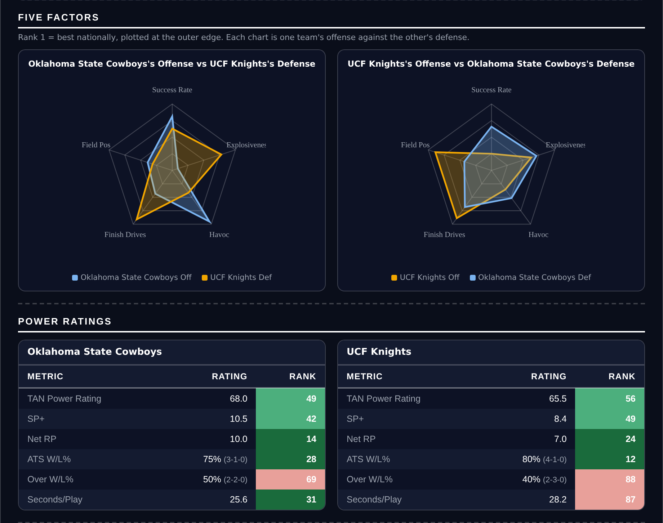
Five Factors and power ratings, captured from the CFB Betting Hub.
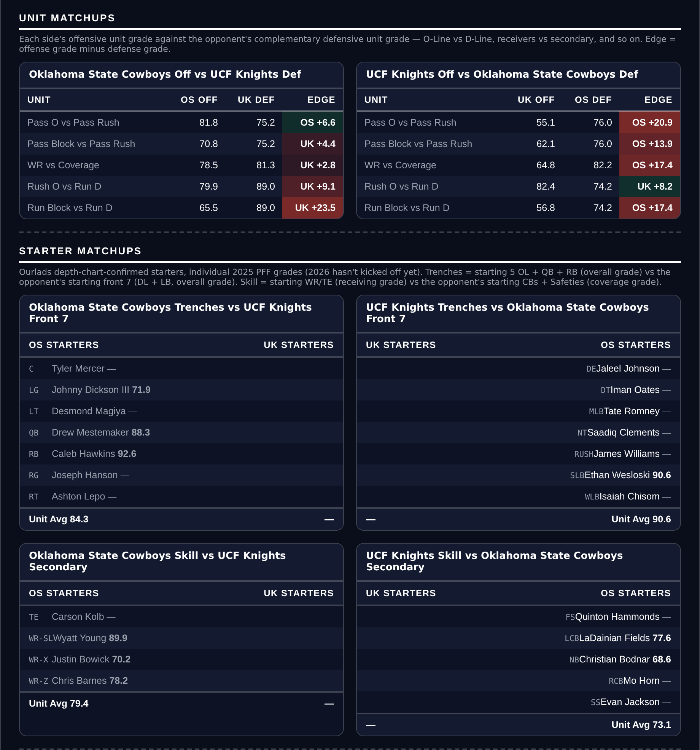
Unit matchups: each offensive unit grade against the opposing defensive unit. Edge = offense minus defense.

