Totals to Target
Week 6 · Saturday October 10, 2026
Every figure below is checked against the source data before it is written. Team grades, five-factor ranks and per-game scoring come from the 2026 PFF team grades and the season-to-date CFBData ranks; each player's role, share and production come from the 2026 PFF season files. Per-game scoring uses each team's own game count, which is four, five or six this week. Where a rank ends in .5 the teams are tied and it is written as “tied Nth”. All fifteen kickoffs are verified Saturday in Eastern time.
Season to date: 25-30-2 and two voids, down 8.69 units across 59 picks. Spreads 7-13 (-7.30u), totals 9-8-2 (+0.20u), props 9-9 and two voids (-1.59u). Week 5 went 7-7 with a void, -0.78 units, the best week so far.
A change this week, forced by the first proper test of the method. Every game of weeks 4 and 5 now has a verified final score, recovered by differencing the PFF points-for and points-against columns, so each signal could be scored on all 93 games rather than only the fifteen that were bet. The residual — the measure this card selected totals on for three weeks — went 42-49 across those games and lost money at every threshold. It is the worst of the three signals tested and it is no longer used for selection. It is still reported on every pick, because it was the stated method and because hiding a measure that disagrees would be the wrong lesson to take.
What replaces it: the points check and the model gap, each with the slate’s own level removed, required to agree on a side and ranked by the weaker of the two. De-meaning matters more than it sounds. The raw points check runs +3.2 across this slate and is positive in 36 of 44 games, so ranking on it unadjusted would simply find the biggest Overs — and blind Overs went 51-40 across weeks 4 and 5, which is the same 56% the unadjusted check posted. Subtracting the slate level is what separates a signal from the base rate.
The opponent-blindness the residual was built to correct is real and still growing. The correlation between a game’s average defensive Success Rate rank and the model’s Over lean is -0.77 this week, after -0.13, -0.46, -0.73 and -0.66 in weeks 2 through 5, and the slope has steepened every single week. The bias exists. Removing it also removed whatever signal sat alongside it, which is the finding, and it suggests the market over-adjusts for defensive quality rather than the model under-adjusting.
Honest about the sample: 93 games across two weeks, and nothing tested reached statistical significance. The strongest result had a one-in-nine chance of arising from coin flips. What the test does establish is a ranking, and the residual is last. Totals are 9-8-2 and +0.20 units on the season, the only category in the black.
Ratings and the Five Factors come from the 2026 workbook: SP+, TAN, implied team totals and the season-to-date CFBData ranks, out of 138 teams. Player lines are 2026 PFF season to date. Records, ATS and over/under records are TeamRankings, 2026 to date. The PFF team grade file covers five games for 103 teams, four for 25 and six for 10.

Coastal Carolina Chanticleers @ Marshall Thundering Herd

Under 59.0
Book total | 59.0
Points check | 53.5, which is 8.7 below the market once the slate's own level is out
Model number | 50.9, which is 9.7 below once de-meaned
Residual | -3.7, agreeing but smaller
Scoring | Coastal Carolina 24.8 for / 25.0 against, Marshall 22.2 / 35.0
Offenses | Coastal Carolina 99th Success Rate, Marshall 75th and 127th in Finishing Drives
Over records | Coastal Carolina 3-2, Marshall 3-2
Game spread | Marshall -4.0

Book has 59.0. Each team's own scoring puts the game at 53.5 and the rating at 50.9, and both sit eight to ten points below the market once the slate's level is removed. This is the widest agreement on the totals board.
Neither offense justifies a 59. Coastal Carolina score 24.8 a game on an offense ranked 99th in Success Rate and 91st in Finishing Drives; Marshall score 22.2 on one ranked 75th and 127th. Between them that is 47 points of recent form against a number asking for 59.
Marshall's defense is what built the number and it is genuinely bad: 133rd in Success Rate, 126th in Finishing Drives and 132nd in Havoc on a 49.9 coverage grade and a 50.1 tackling grade. They concede 35.0 a game. The question is whether Coastal Carolina can exploit it, and a 99th-ranked offense on a 51.2 run block grade is not the unit to assume will.
The way this loses is Marshall's defense doing what it has done all season while Coastal Carolina find 35 of their own. Both teams are 3-2 to the Over, so the records give no help in either direction.
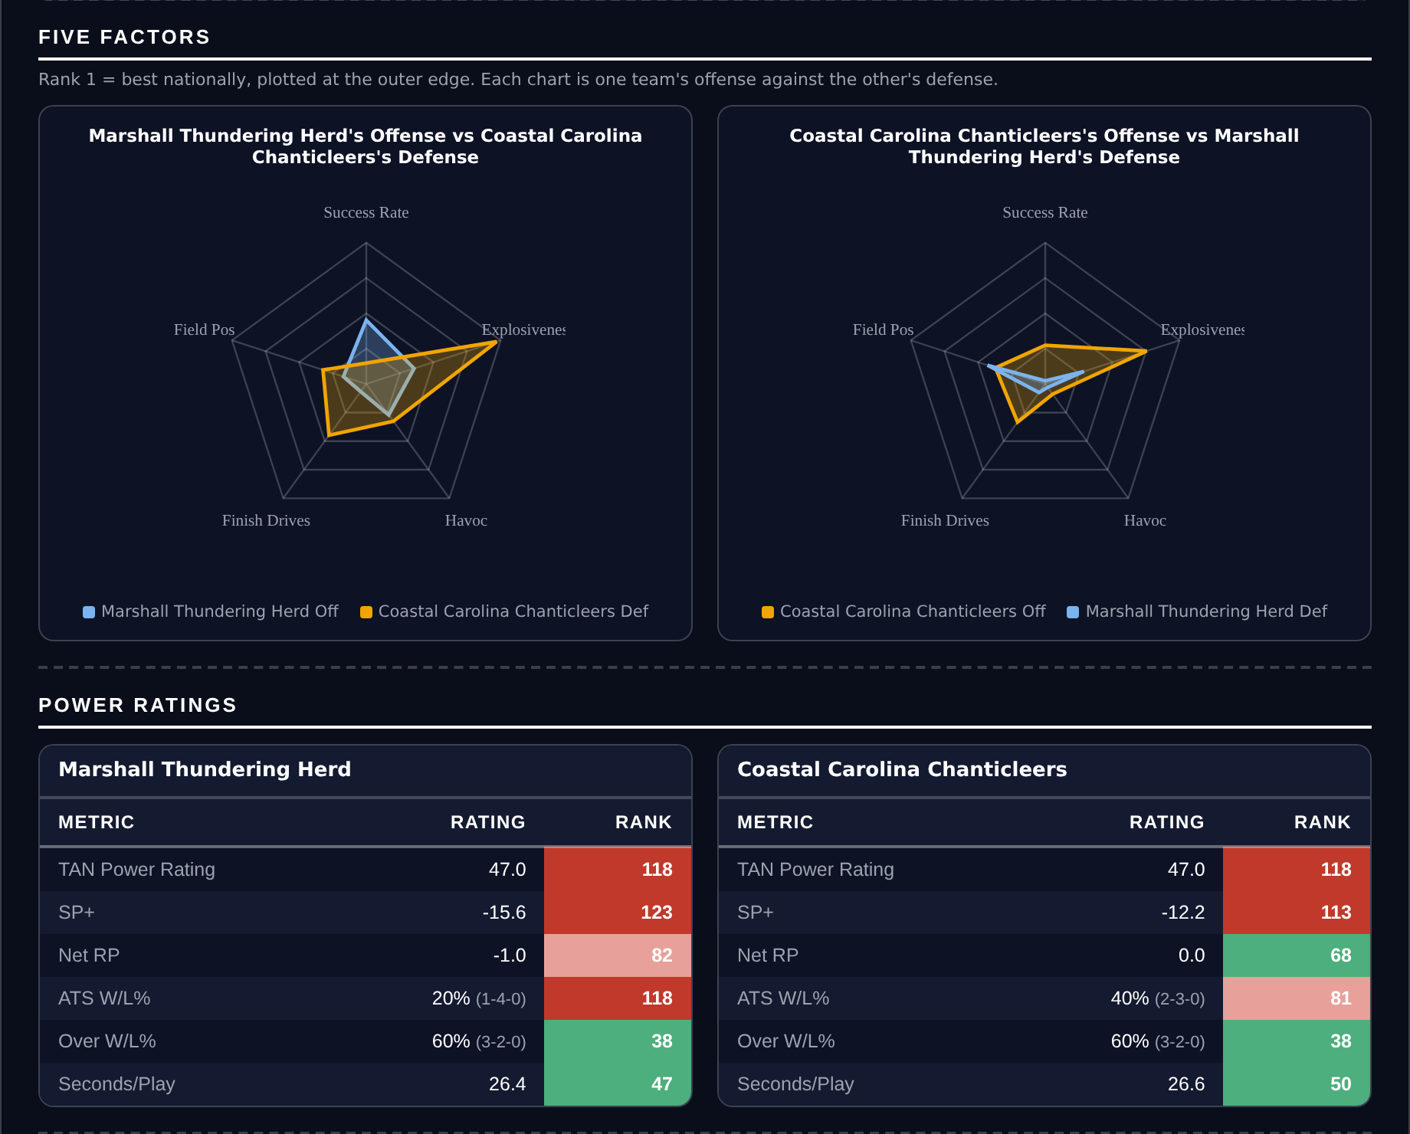
Five Factors and power ratings, captured from the CFB Betting Hub.
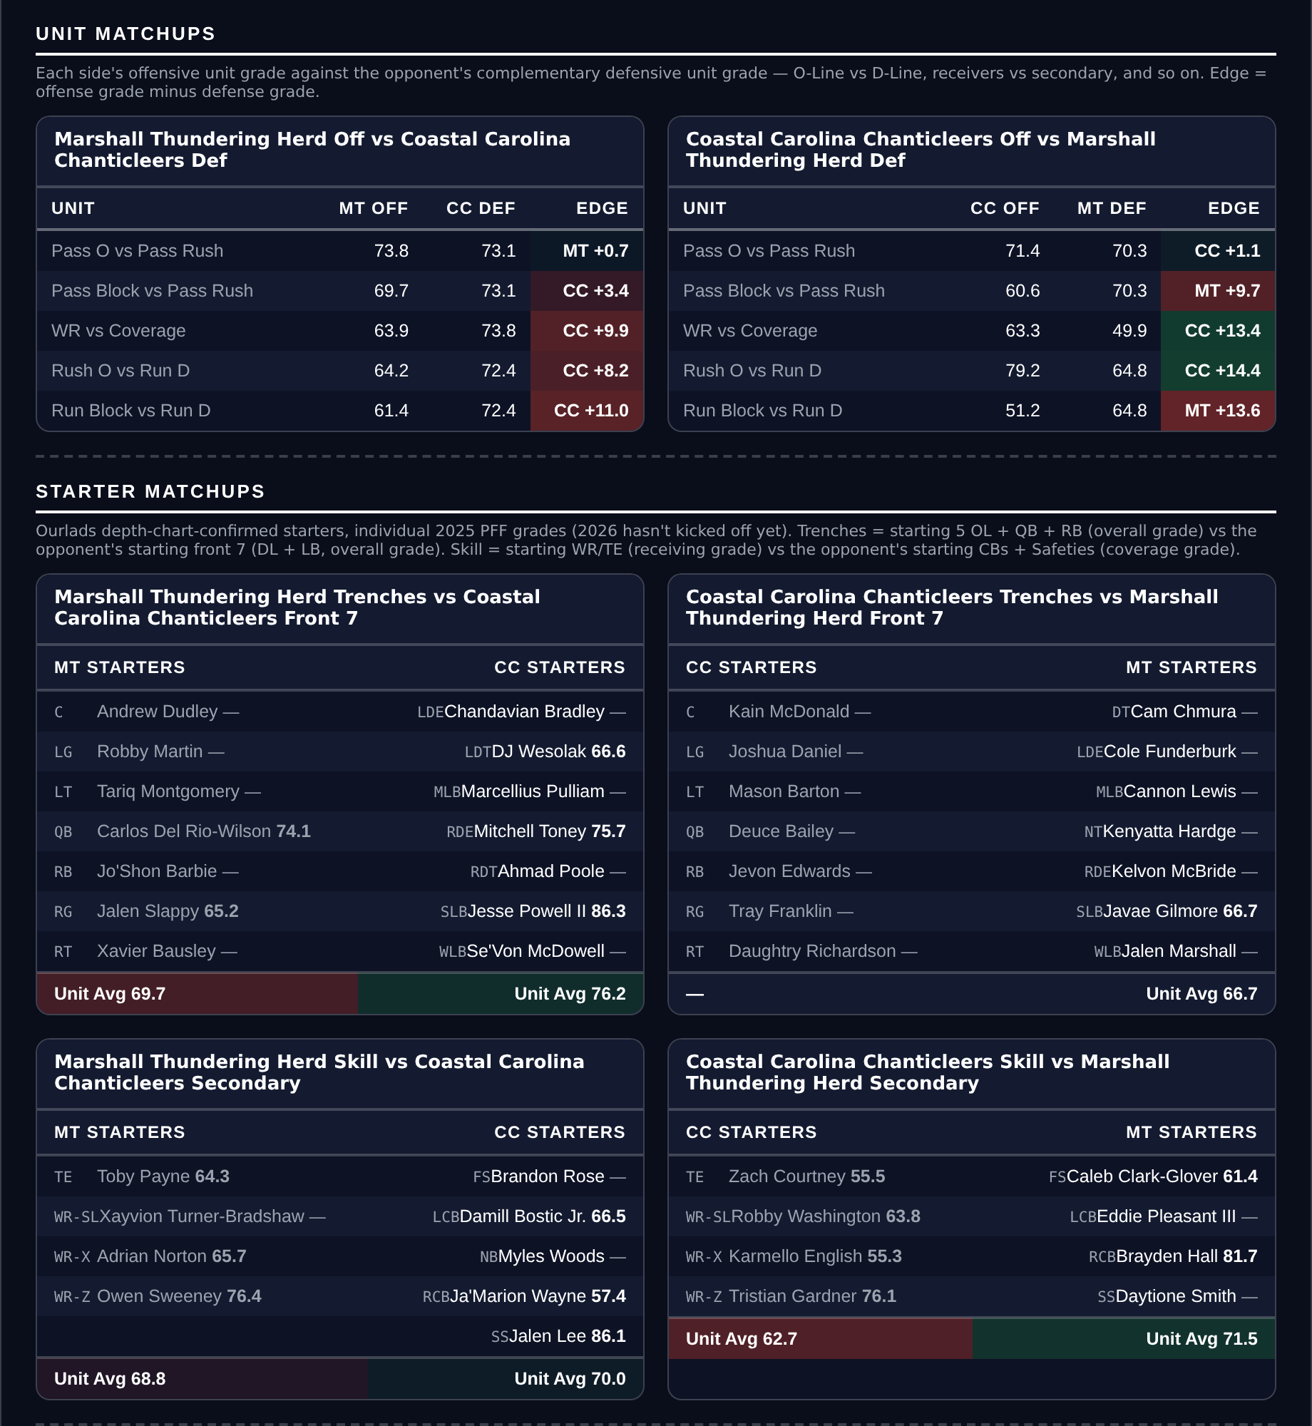
Unit matchups: each offensive unit grade against the opposing defensive unit. Edge = offense minus defense.

LSU Tigers @ Kentucky Wildcats

Over 51.5
Book total | 51.5
Points check | 60.1, which is 5.4 above the market de-meaned
Model number | 60.0, 6.9 above de-meaned
Residual | +5.2, agreeing
LSU | 4-1, 43.6 points a game, 15th Success Rate offense, 90.6 passing
Kentucky | 4-1, 34.6 for and 26.8 against, 13th Success Rate offense, 4-1 to the Over
Kentucky defense | 104th Success Rate, 52.2 tackling
Game spread | LSU -8.5

Book has 51.5. The points check lands at 60.1 and the rating at 60.0, two measures built from different inputs arriving within a tenth of each other, and both are five to seven points clear of the market once the slate's level is out.
Both offenses are top fifteen in Success Rate, LSU 15th and Kentucky 13th, and both are scoring: 43.6 and 34.6. LSU grade 90.6 passing and 85.4 running, Kentucky 87.2 running behind a 79.4 pass block grade.
Kentucky's defense is the opening. It ranks 104th in Success Rate and 96th in Finishing Drives on a 52.2 tackling grade, against the better of the two offenses. They are 4-1 to the Over, the strongest Over record among these five games.
LSU's defense is the risk and it is a serious one: 2nd in Success Rate, 5th in Havoc, a 93.5 defensive grade and 93.7 in coverage, conceding 15.2 a game. If Kentucky are held to 14, LSU have to reach 38 alone. That is the single assumption this pick rests on.
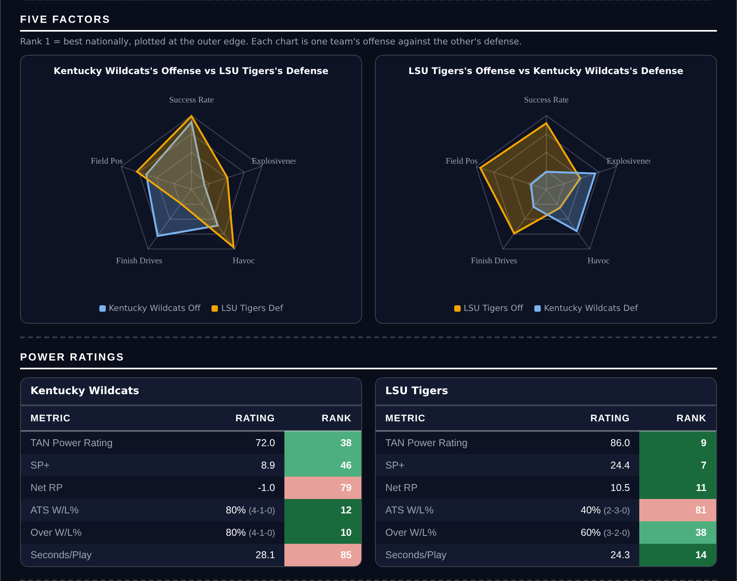
Five Factors and power ratings, captured from the CFB Betting Hub.
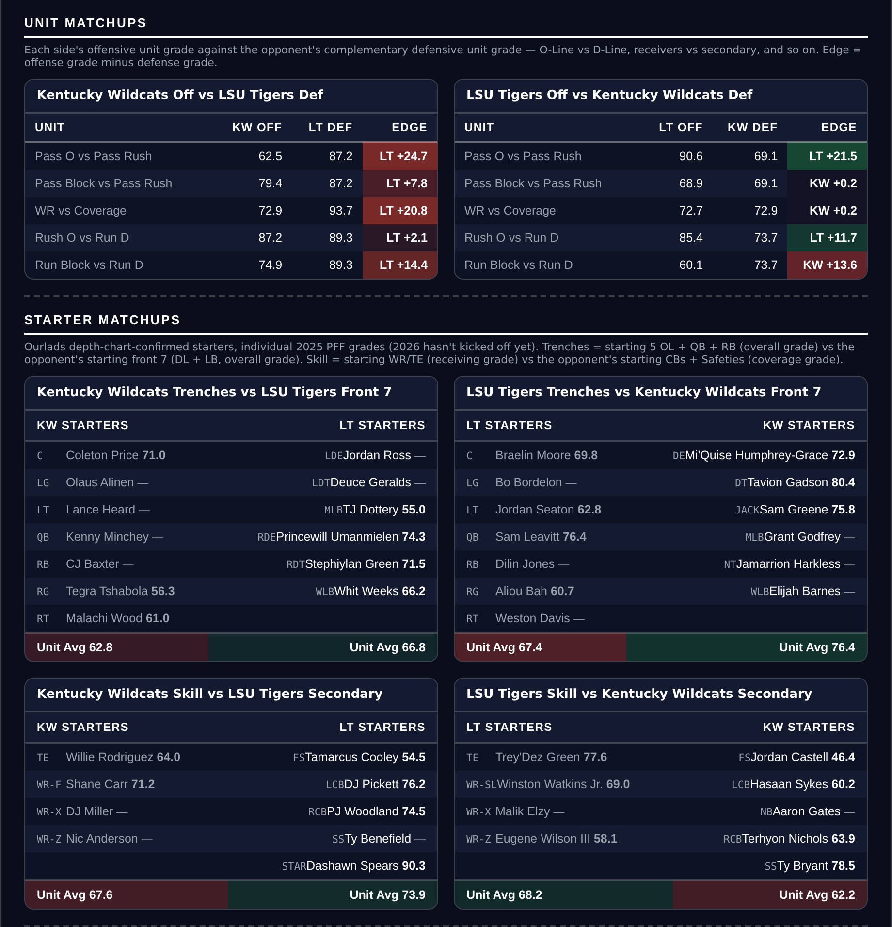
Unit matchups: each offensive unit grade against the opposing defensive unit. Edge = offense minus defense.

Eastern Michigan Eagles @ Akron Zips

Under 52.0
Book total | 52.0
Points check | 49.9, which is 5.3 below the market de-meaned
Model number | 46.1, 7.5 below de-meaned
Residual | -3.9, agreeing
Scoring | Eastern Michigan 22.2 for / 25.0 against, Akron 19.0 / 33.6
Offenses | Eastern Michigan 108th Success Rate and 110th Explosiveness, Akron 135th Explosiveness
Eastern Michigan defense | 86.1 coverage, 83.4 defensive grade
Over records | Eastern Michigan 2-4, Akron 3-2

Book has 52.0. The points check says 49.9 and the rating 46.1, both below the market once the slate's level is removed, and the residual agrees at -3.9.
Neither team can score. Eastern Michigan manage 22.2 a game on an offense ranked 108th in Success Rate and 110th in Explosiveness; Akron manage 19.0 on one ranked 135th in Explosiveness with a 59.5 passing grade. Their combined 41.2 is a long way under 52.
Eastern Michigan's defense is the better unit on the field by some distance, grading 83.4 overall and 86.1 in coverage against an Akron passing attack that grades 59.5. Eastern Michigan are 2-4 to the Over, the most Under-leaning record on this card.
Akron's defense is the counter-argument: 111th in Success Rate, 122nd in Explosiveness allowed and 121st in Finishing Drives on a 52.7 coverage grade, conceding 33.6 a game. If Eastern Michigan's offense is better than its ranks against that, the number is reachable.
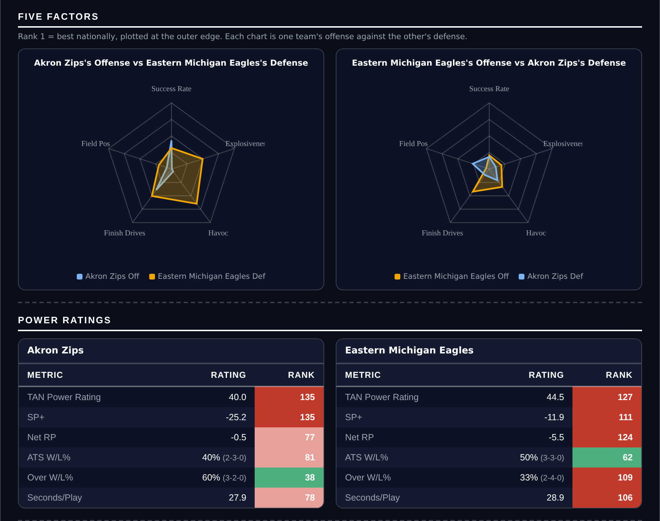
Five Factors and power ratings, captured from the CFB Betting Hub.
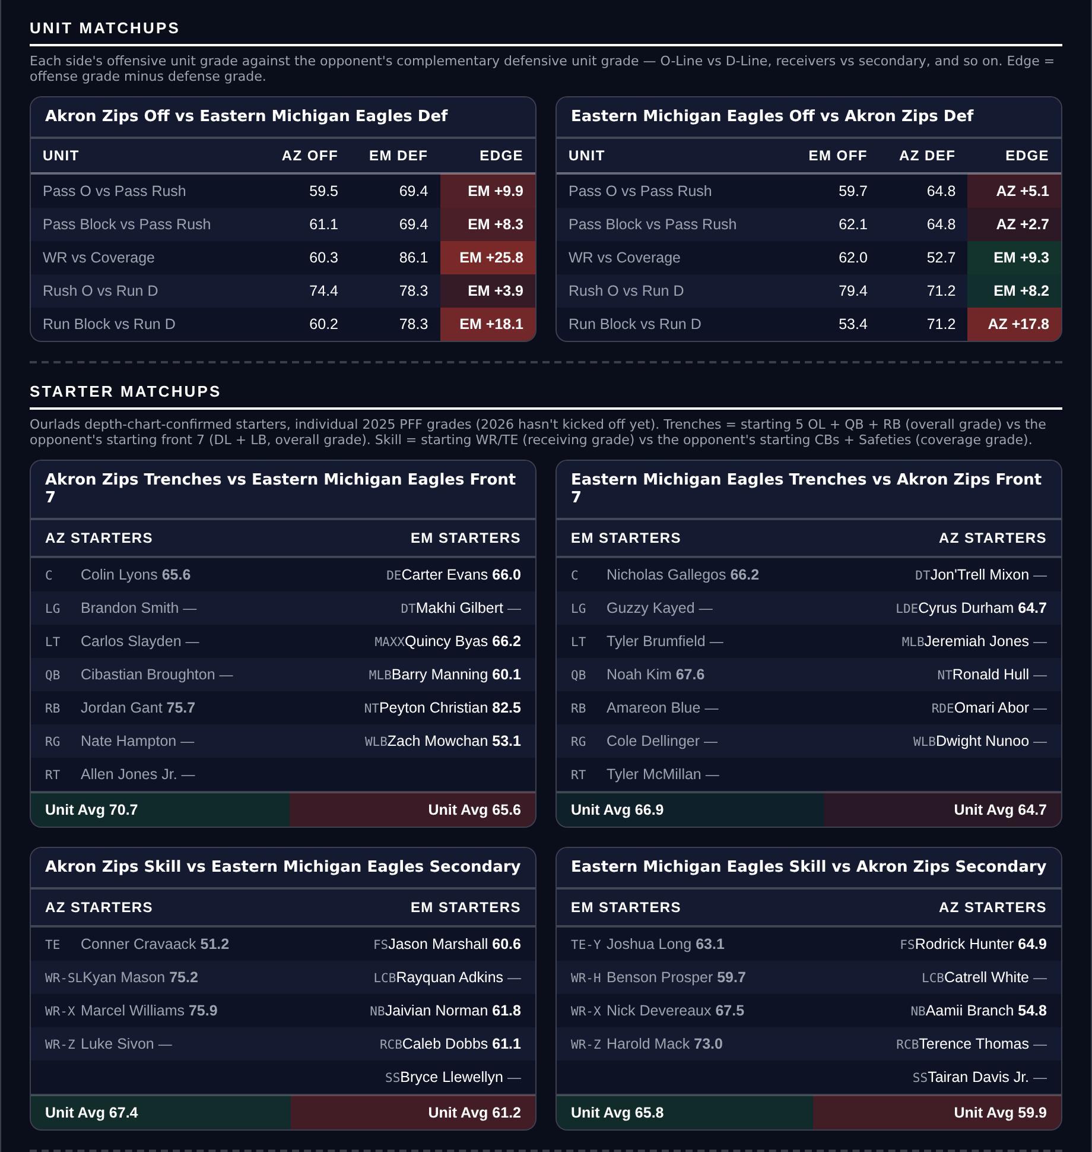
Unit matchups: each offensive unit grade against the opposing defensive unit. Edge = offense minus defense.

Indiana Hoosiers @ Nebraska Cornhuskers

Over 48.0
Book total | 48.0
Points check | 56.4, which is 5.2 above the market de-meaned
Model number | 60.0, 10.4 above de-meaned
Residual | +4.6, agreeing
Indiana | 5-0, 44.2 points a game, 7th Success Rate, 16th Explosiveness, 5th Finishing Drives
Nebraska | 5-0, 43.6 points a game, 21st Success Rate, 14th Explosiveness, 7th Finishing Drives
Both defenses | Indiana 3rd Success Rate, Nebraska 28th
Game spread | Indiana -7.5

Book has 48.0. The points check says 56.4 and the rating 60.0, both well above the market, and the residual agrees at +4.6 even after the defensive tilt is removed.
Two unbeaten teams scoring 44.2 and 43.6 a game are being asked for 48 between them. Indiana rank 7th in Success Rate, 16th in Explosiveness and 5th in Finishing Drives on a 92.2 offensive grade; Nebraska rank 21st, 14th and 7th on an 83.6 grade. Both finish drives, which is the factor that converts yards into the points a total needs.
This is the game where the method change matters most. Indiana's defense ranks 3rd in Success Rate and Nebraska's 28th, so the old residual approach discounted this heavily for having two good defenses. Those defenses have also faced nobody like these offenses.
The honest risk is exactly that: 48 is low because both defenses are real, Indiana concede 10.8 a game and Nebraska 14.2. A 20-17 game is entirely available and would beat this comfortably.
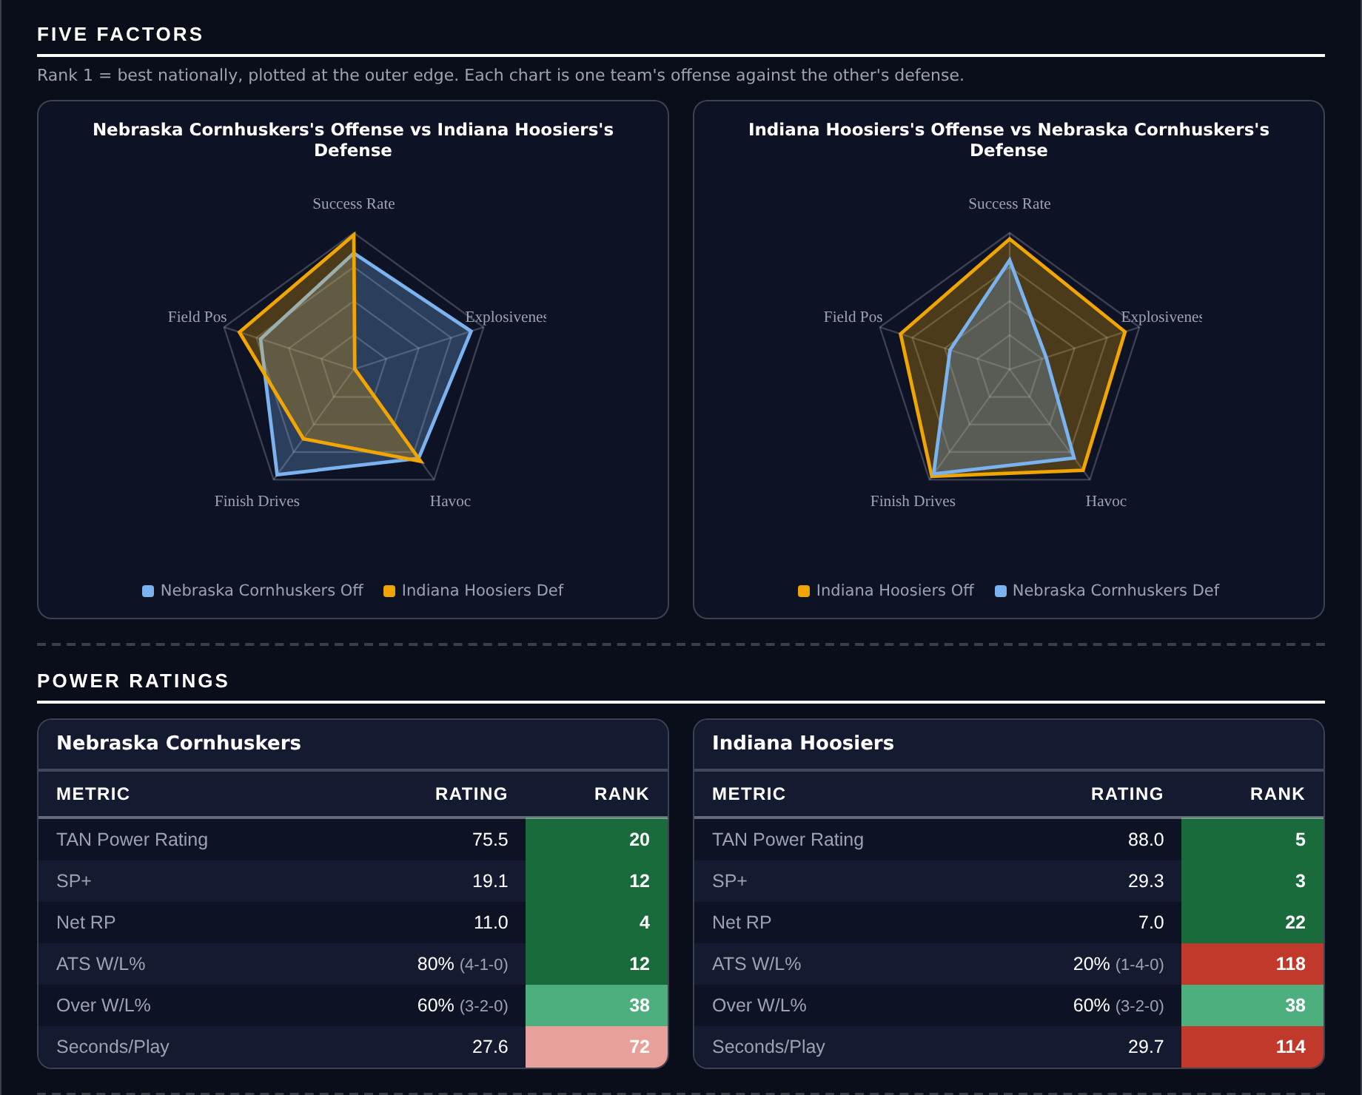
Five Factors and power ratings, captured from the CFB Betting Hub.
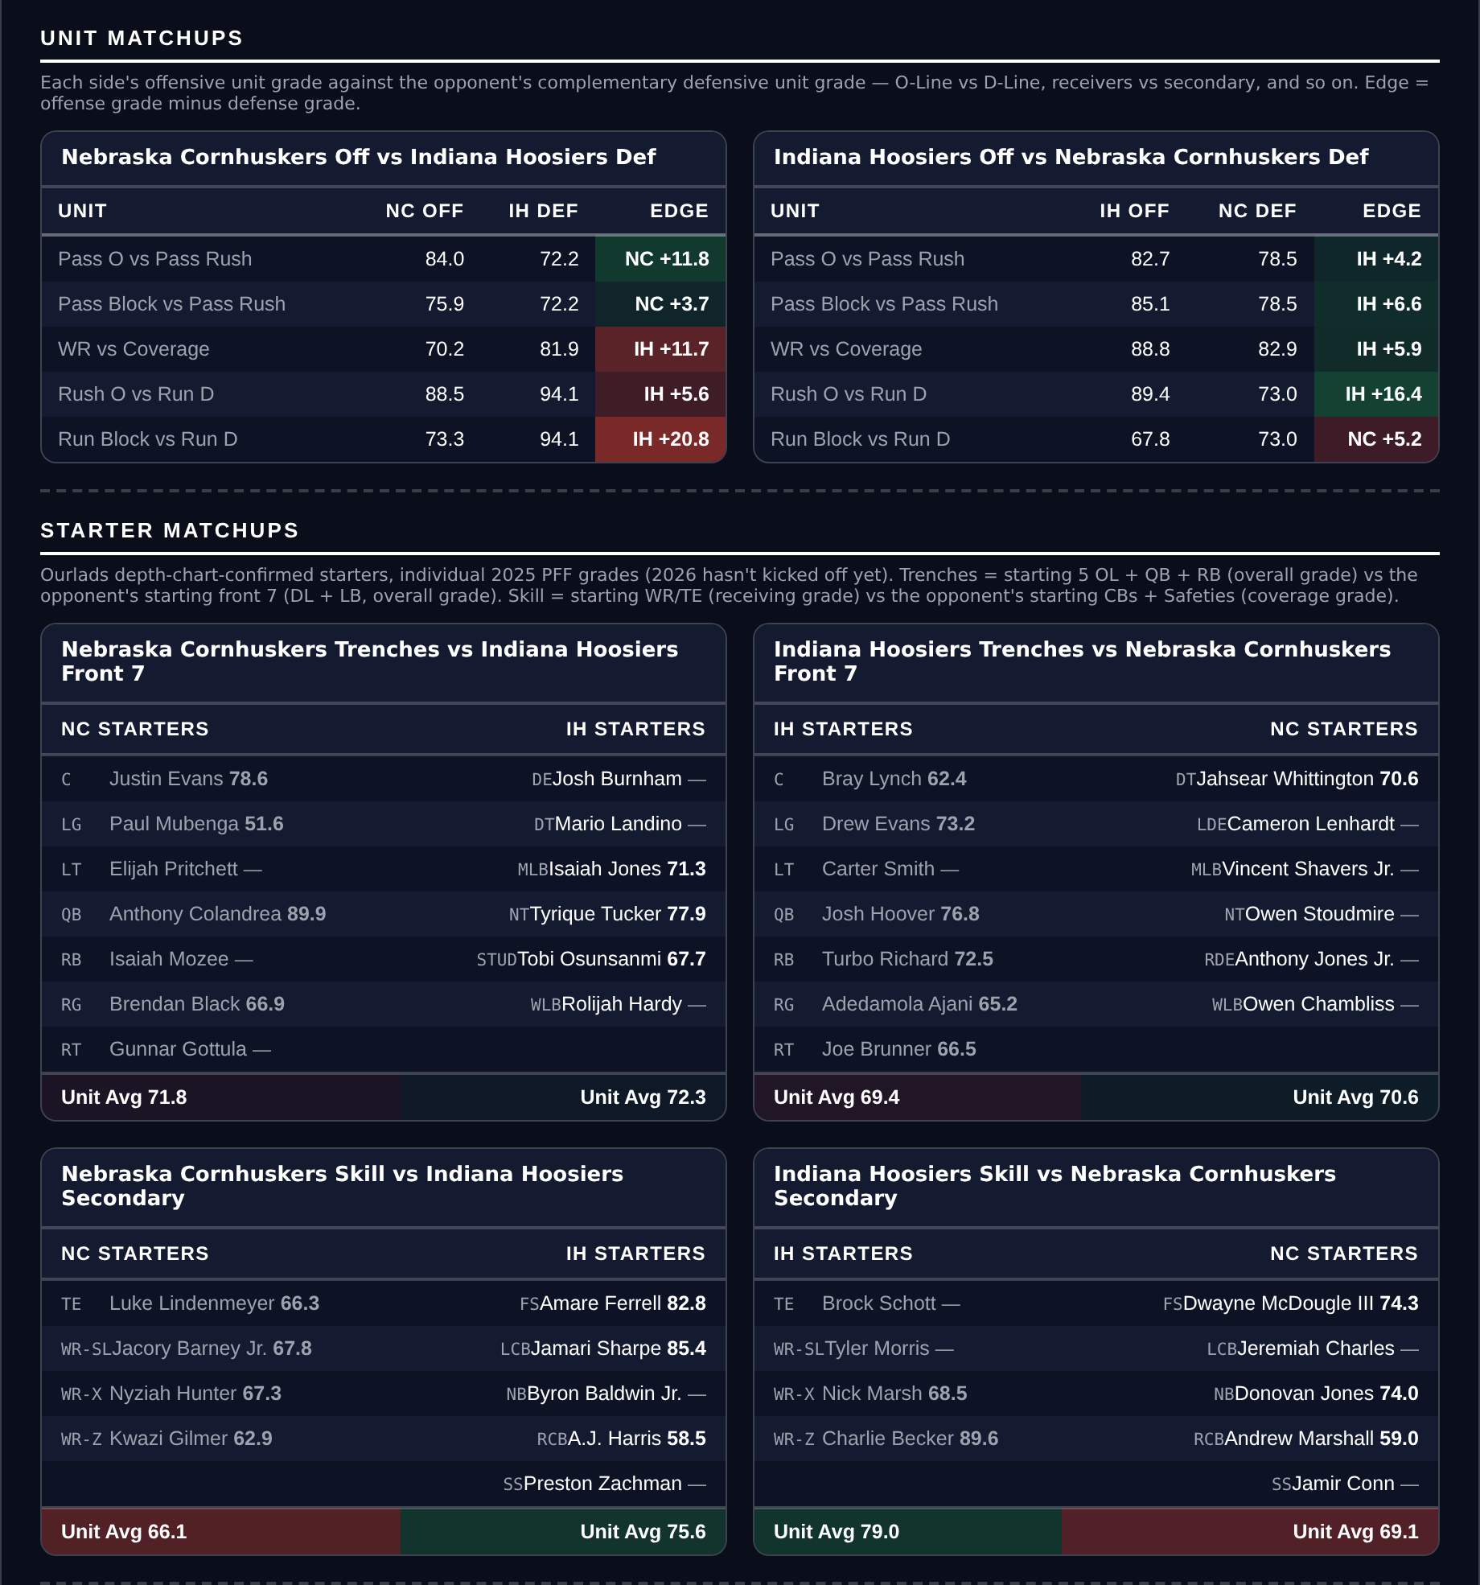
Unit matchups: each offensive unit grade against the opposing defensive unit. Edge = offense minus defense.

Georgia Bulldogs @ Alabama Crimson Tide

Over 51.5
Book total | 51.5
Points check | 67.6, which is 12.9 above the market de-meaned
Model number | 58.1, 5.0 above de-meaned
Residual | -0.7, which says nothing either way
Georgia | 5-0, 51.4 points a game, 3rd Success Rate, 1st in Finishing Drives, 5-0 to the Over
Alabama | 5-0, 49.6 points a game, 11th Success Rate, 2nd in Finishing Drives, 5-0 to the Over
Over records | both 5-0, one of two such pairs on the board
Game spread | Alabama -1.5

Book has 51.5. The points check lands at 67.6, sixteen points above the market and the largest disagreement on the slate, and the rating agrees in direction at 58.1.
Both teams are 5-0 and both are scoring more than 49 a game. Indiana at Nebraska is the only other game this week pairing two unbeaten sides, and it is also on this card. Georgia rank 3rd in Success Rate and 1st nationally in Finishing Drives; Alabama rank 11th and 2nd. Georgia grade 93.5 on offense and 90.8 passing, Alabama 89.7 and 91.4. Every one of their ten games this season has gone Over.
The residual is flat here at -0.7, and this is the clearest illustration of why this card stopped selecting on it. Both defenses rank inside the top 20 in Success Rate, so the tilt correction wipes out the entire signal in a game where two unbeaten offenses are averaging 50 and the market is asking for 51.5 between them.
The case against is the obvious one: this is the biggest game of the weekend between two elite defenses, Georgia grading 93.9 and Alabama 91.0, and marquee matchups tighten up. Alabama's 66.8 tackling grade and 116th rank in Explosiveness allowed is the crack in that argument.
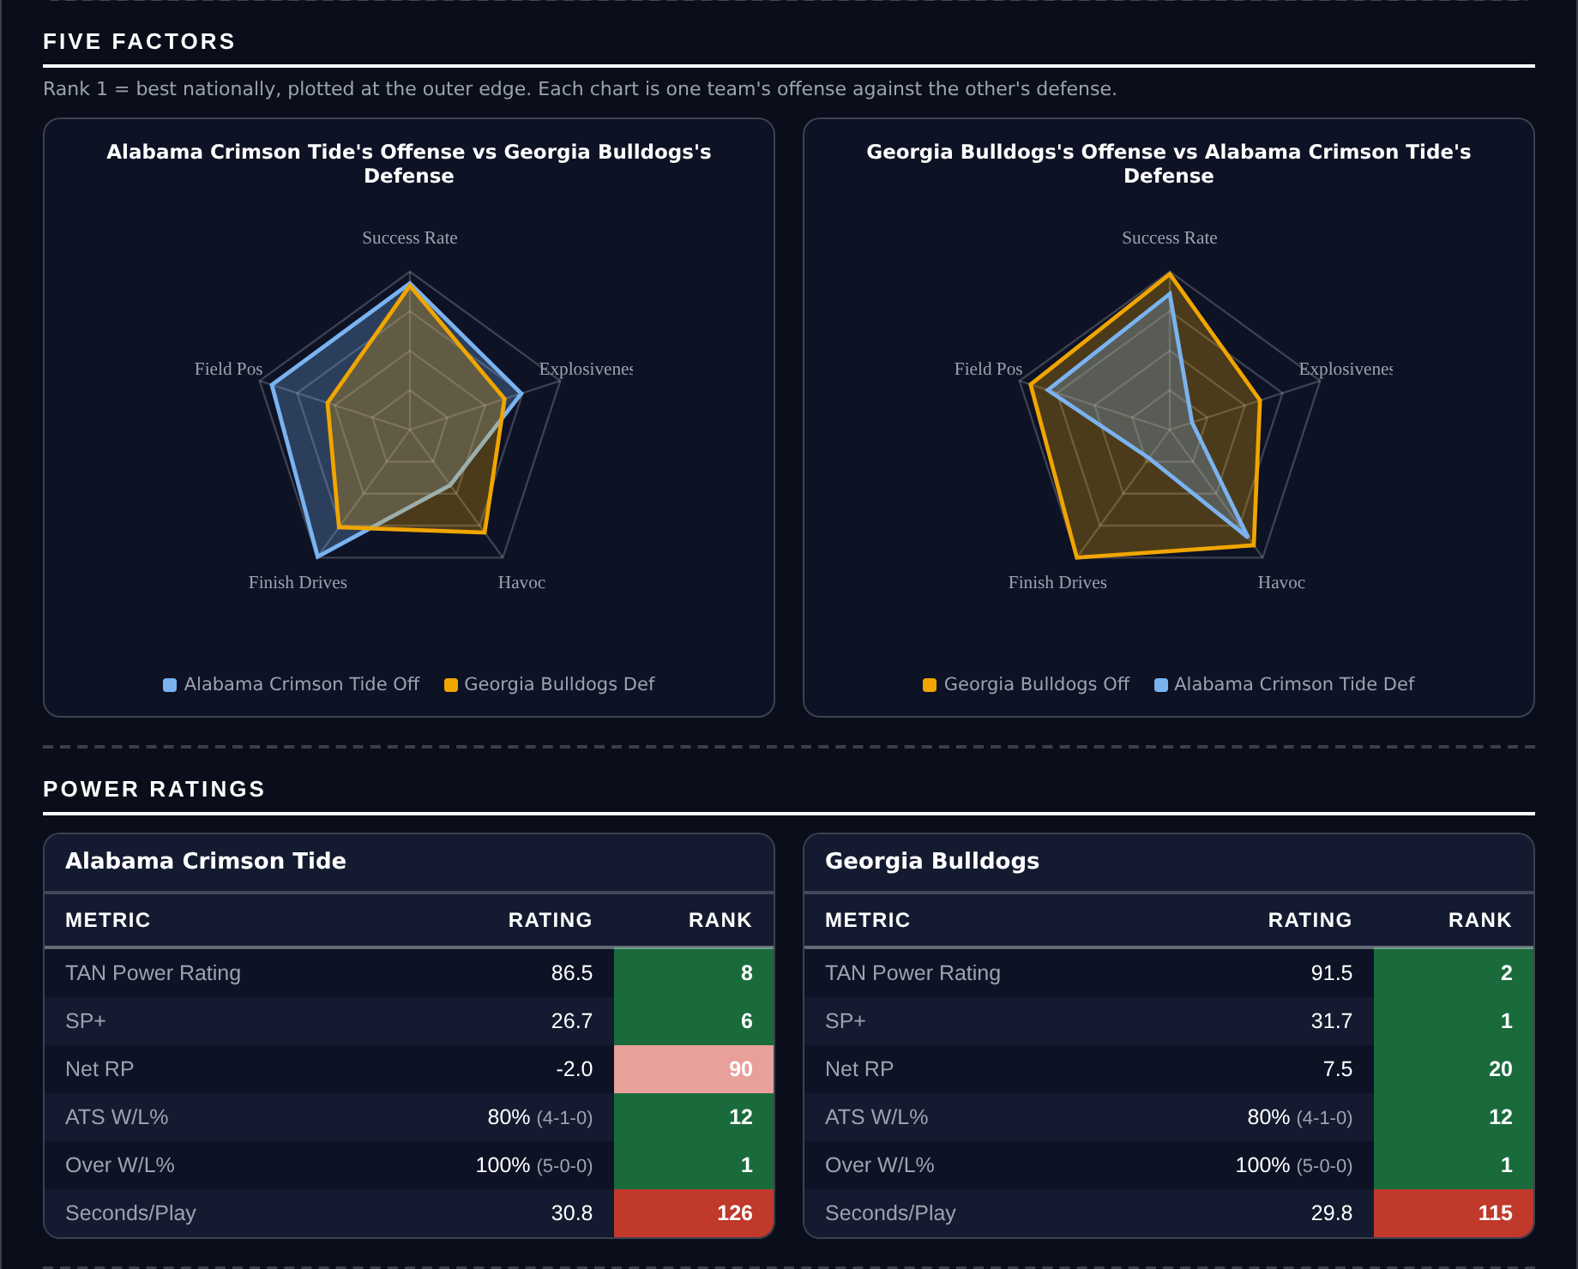
Five Factors and power ratings, captured from the CFB Betting Hub.
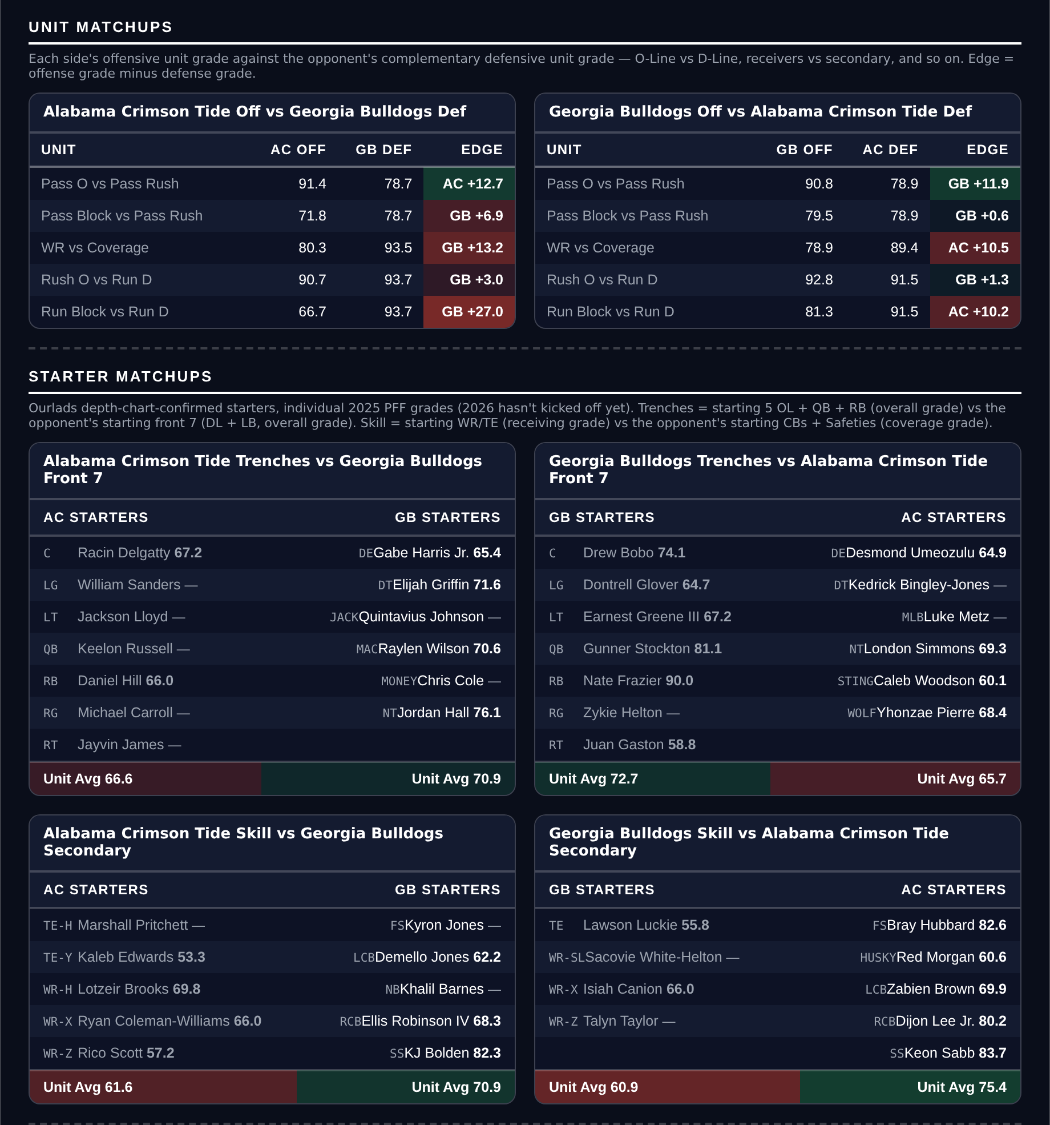
Unit matchups: each offensive unit grade against the opposing defensive unit. Edge = offense minus defense.

