Spreads to Target
Week 5 · Saturday October 3, 2026
Every figure here is checked against the underlying data before it is written. Grades, ranks and per-game scoring are re-derived from team_pff_grades_2026.csv and the built board; each player's role, carry or target share and production come from the 2026 PFF season files; the model numbers, residuals and points checks are recomputed from diversions_2026wk5.json rather than carried over from the draft. That check caught real errors this week: a record off by a game, a set of truncated per-game averages, two carry shares that were wrong, and five spread cross-check figures that had been computed two different ways. All are corrected below. Kickoffs verified: all picks are Saturday in Eastern time.
Season to date: 18-23-2 and one void, down 7.91 units across 44 picks. Spreads 5-10 (-6.00u), totals 6-6-2 (-0.60u), props 7-7 and one void (-1.31u).
Five spreads where the book and the 2026 power ratings disagree most. The model number is SP+ differential plus home field edge; the gap is the distance between it and the market.
Across the 49 rated Saturday games the model sits 0.4 points more toward the home favorite than the book does, so each gap is quoted raw and after that level is removed. Last week the same figure was 1.57. This slate is close to neutral, and the de-meaning barely reorders anything.
The selection rule is explicit. Candidates are ranked by the model gap once the slate level is out, and a second measure — built only from each team’s own 2026 point differential plus home field, independent of SP+ — has to agree on which side. It screens direction and nothing else; it is not allowed to reorder the card. Two candidates fail it and are not here: Texas Tech -13.0, where the points measure has them by 7.8 rather than 13, and Memphis -20.5, where it has them by 9.8 rather than 20.5. Last week’s exclusion also stands — do not lay a price into a team whose ATS record is running ahead of its rating, which cost this card four times in weeks 2 and 3 — and this week it removes nothing, because none of the top candidates is that shape.
The honest caveat is the record. Spreads are the worst category on this card at 5-10 and -6.00 units, and the rule behind them has changed more than once already this season. What is different about this one is that it is written down before the results arrive and the number that drives it is reported for every pick, including the one where it says there is nothing to win.
Ratings and the Five Factors come from the 2026 workbook (SP+, TAN, team totals, and the CFBData26 season-to-date ranks, out of 138 teams). Player lines are 2026 PFF season to date. Records, ATS and over/under are TeamRankings, 2026 to date. The PFF team grade file now covers four games for 120 teams, three for ten and five for eight, so points for and against are quoted per game against each team's own count. Where a rank ends in .5 the teams are tied and it is written as “tied Nth”.

Miami Ohio -13.5
Bowling Green Falcons @ Miami (OH) RedHawks
Book line | Miami Ohio -13.5
Model number | Miami Ohio -25.3
Gap | 11.8 pts, 11.4 after the slate's own level
Points check | Miami Ohio -16.2: agrees, 2.7 clear of the line
SP+ (2026) | Miami Ohio -4.3 (89th) vs Bowling Green -26.4 (136th), home edge +3.2
Bowling Green 2026 | 0-4, 8.3 points a game, 36.3 allowed
Bowling Green offense | 135th Success Rate, 138th Explosiveness, 138th Finishing Drives

Book has Miami Ohio -13.5. The 2026 rating puts it at -25.3: Miami Ohio -4.3 (89th) against Bowling Green -26.4 (136th), plus a 3.2-point home edge. An 11.8-point gap, 11.4 after the slate's level is removed, and the largest on the board.
Bowling Green have scored 33 points in four games. Eight a game. The offense ranks 135th in Success Rate, 138th in Explosiveness and 138th in Finishing Drives, dead last in the latter two, on a 37.3 pass block grade and a 51.2 passing grade. They are 0-4 and have been outscored by 28.0 a game.
Miami Ohio are not good and do not need to be. They score 28.5 and allow 30.5, and their own defense ranks 116th in Success Rate with a 44.7 coverage grade. What they have is a 12th-ranked Explosiveness offense and an 81.4 passing grade against a defense ranked 135th in Success Rate.
The points check, which knows nothing except what each team has scored and allowed, has Miami Ohio by 16.2. That is well short of the rating's 25.3, and it is still 2.7 points past the market. The ATS records point the same way: Miami Ohio 2-1-1, Bowling Green 1-3. This is not the shape that cost this card in weeks 2 and 3, which was laying a price into a team covering ahead of its rating; Bowling Green are covering behind theirs.
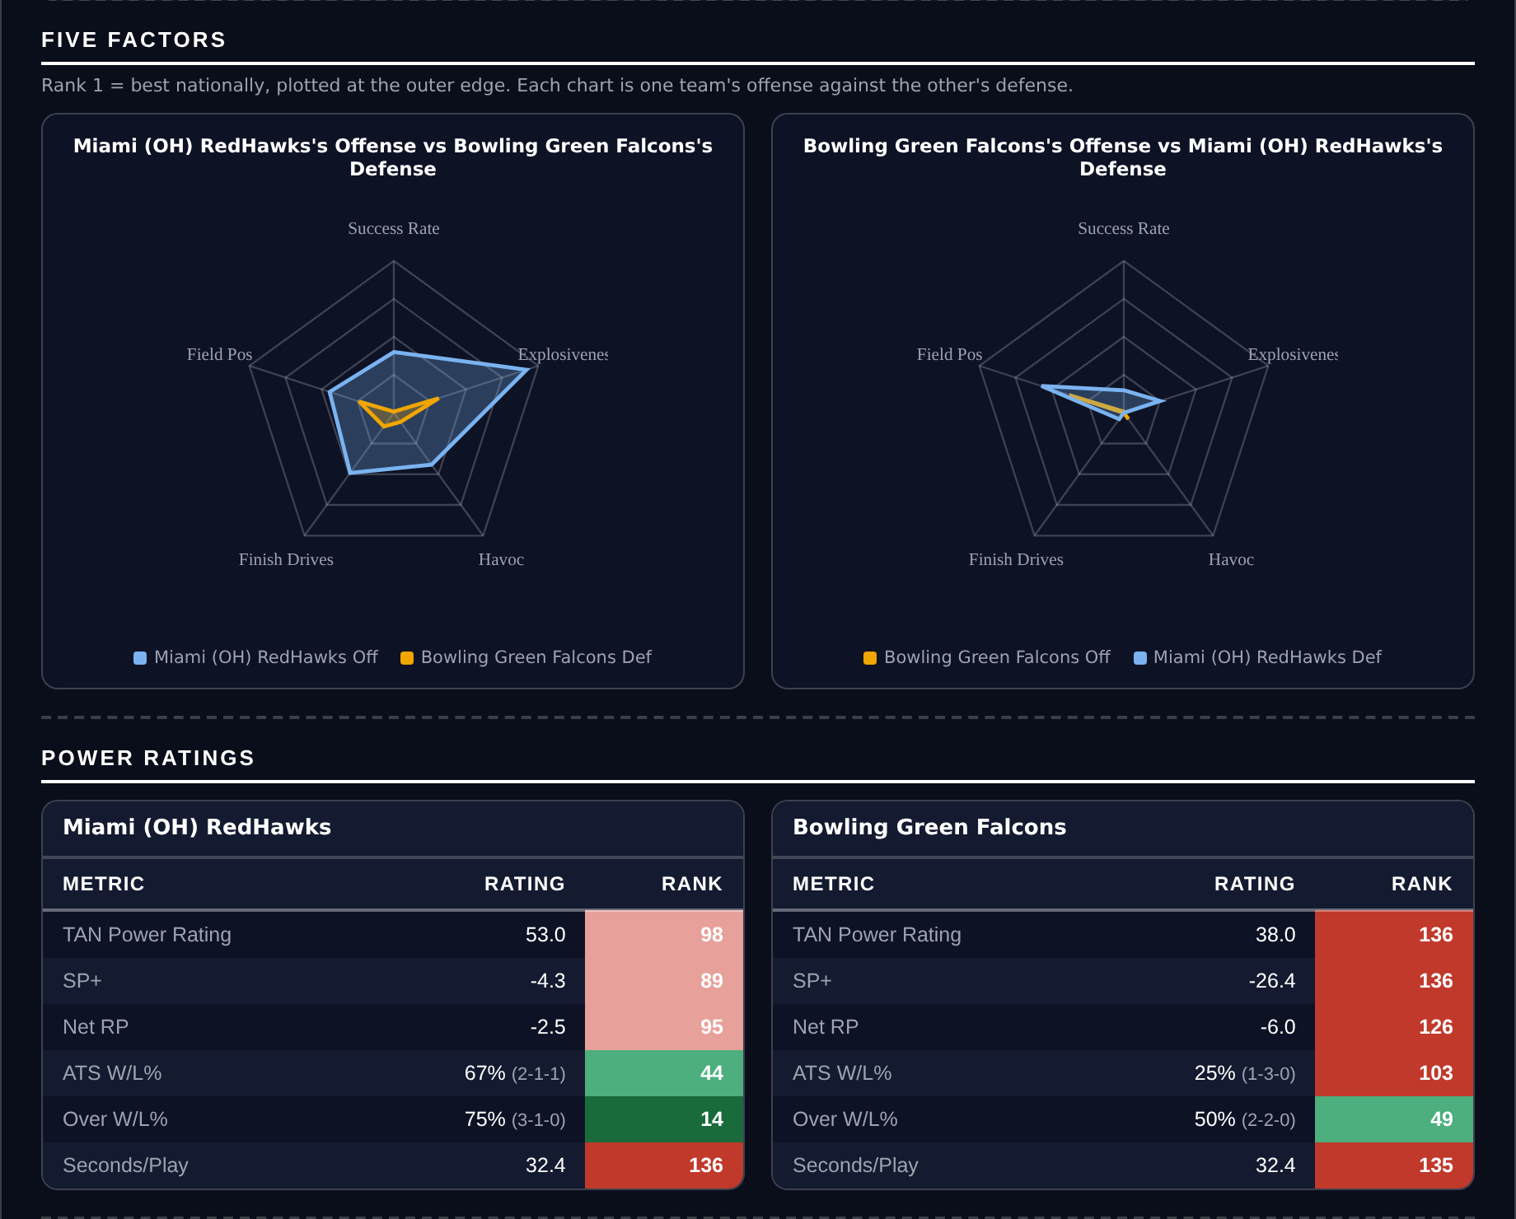
Five Factors and power ratings, captured from the CFB Betting Hub.
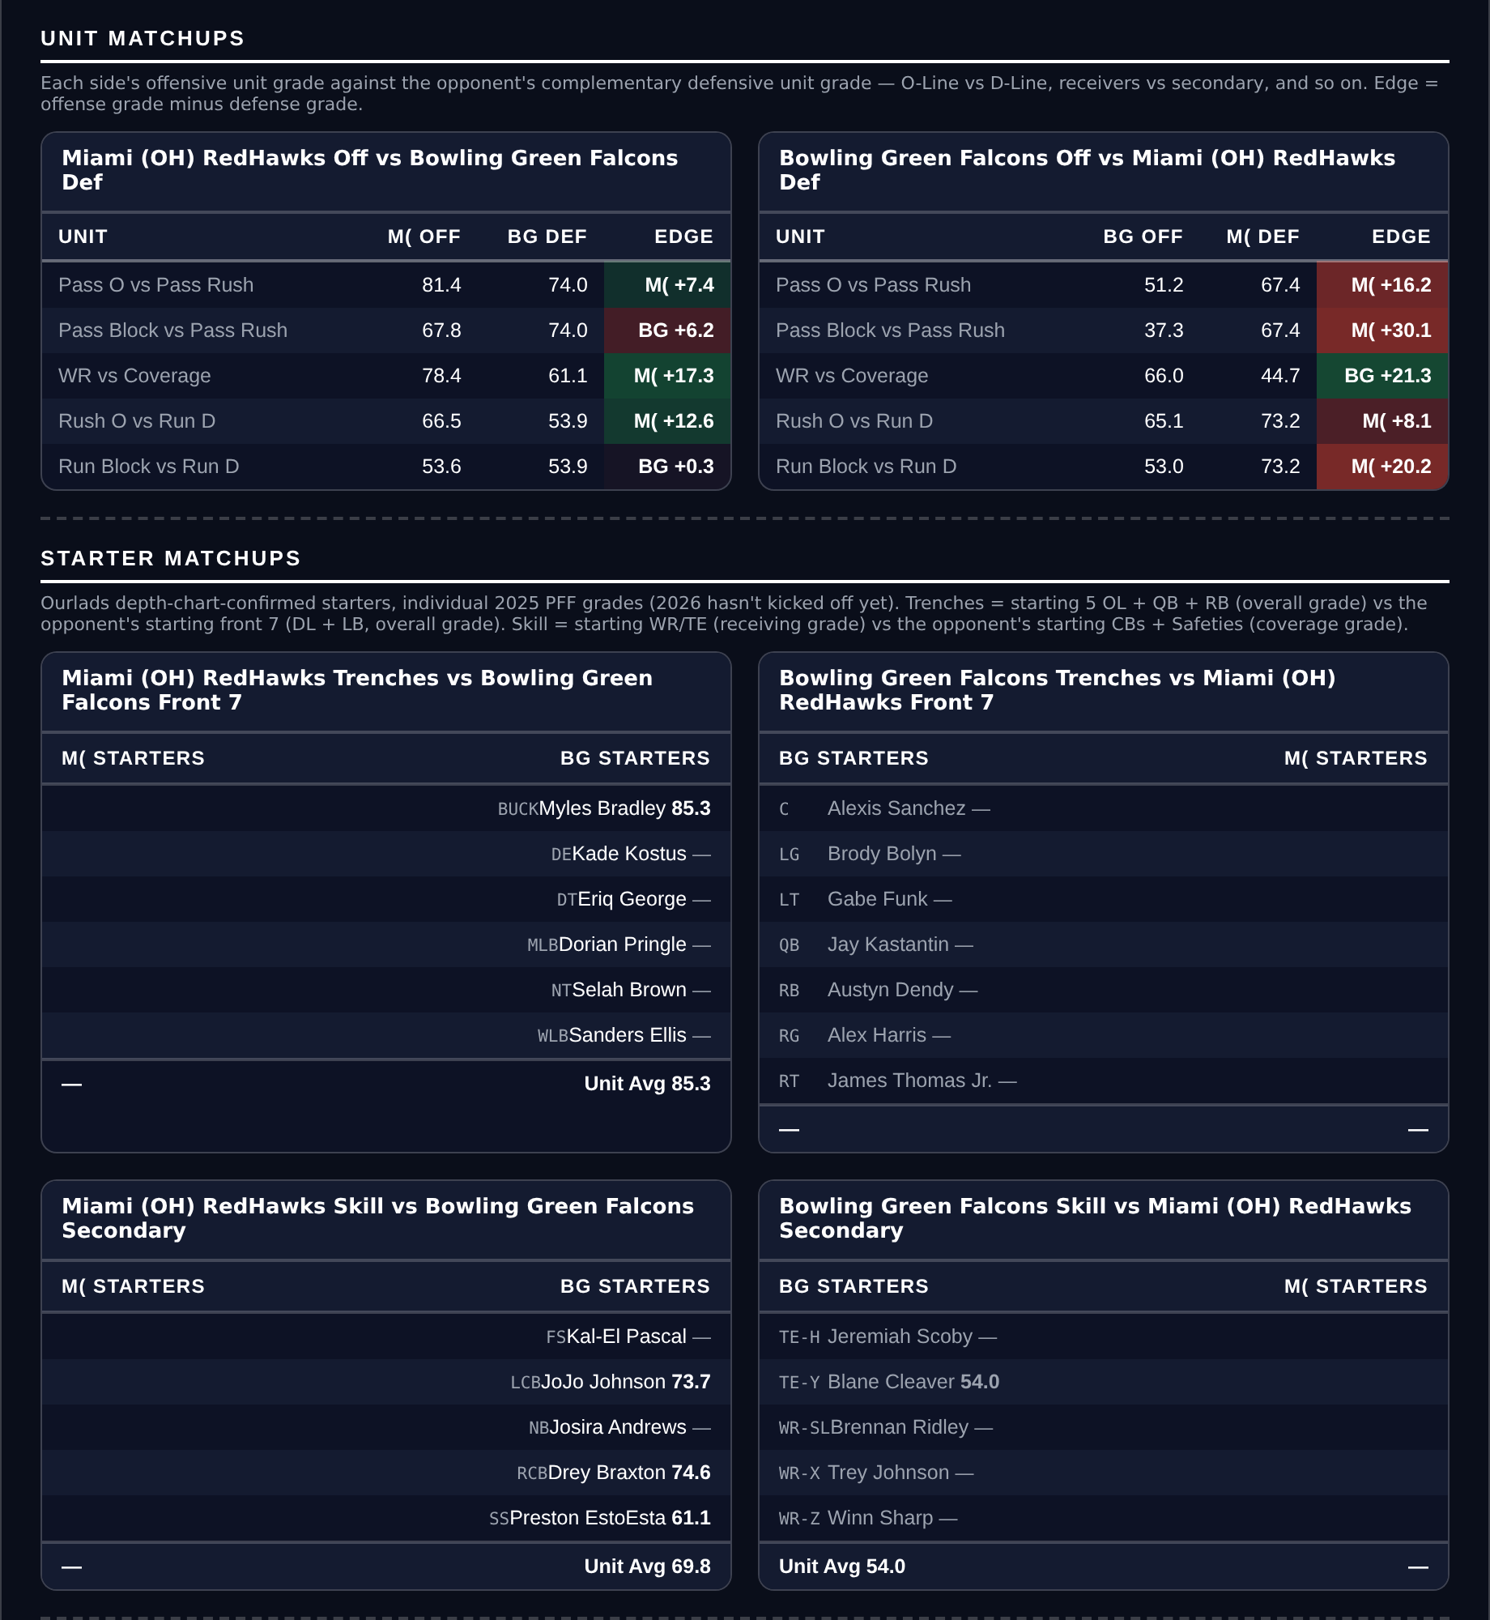
Unit matchups: each offensive unit grade against the opposing defensive unit. Edge = offense minus defense.

New Mexico -22.5
UTEP Miners @ New Mexico Lobos
Book line | New Mexico -22.5
Model number | New Mexico -33.5
Gap | 11.0 pts, 10.6 after the slate's own level
Points check | New Mexico -24.4: agrees, but only 1.9 clear of the line
SP+ (2026) | New Mexico +7.7 (46th) vs UTEP -24.0 (134th), home edge +1.8
New Mexico 2026 | 3-1, 4-0 ATS, 39.0 points a game and 11.5 allowed
UTEP offense | 124th Success Rate, 136th Finishing Drives, 43.7 pass block

Book has New Mexico -22.5. The rating puts it at -33.5, and the points check, built only from each team's own 2026 point differential plus home field, lands at -24.4. Both reads want more than the market is asking, but the second one barely: 1.9 points is the thinnest cushion any spread on this card has on that measure.
New Mexico are 3-1 and 4-0 against the spread, covering by a wide margin every week, and the rating agrees with the record rather than lagging it. They allow 11.5 points a game on a defense ranked 12th in Success Rate, 2nd in Havoc, 21st in Finishing Drives and 4th in Field Position, with an 86.3 coverage grade and an 88.4 defensive grade.
UTEP have scored 75 points in four games. The offense ranks 124th in Success Rate, 126th in Explosiveness, 137th in Havoc allowed and 136th in Finishing Drives behind a 43.7 pass block grade. Their defense ranks 131st, tied 121st, 128th and 129th across Success Rate, Havoc, Finishing Drives and Field Position.
Laying 22.5 is the uncomfortable part and the honest risk: a three-score number needs the favorite to stay interested. New Mexico's own tempo is 134th, the slowest on this card, which shortens the game and cuts both ways. The counterweights are a 4-0 ATS record already built on numbers this size, and a home edge the model puts at only 1.8 points, so almost none of the 33.5 is a venue assumption.
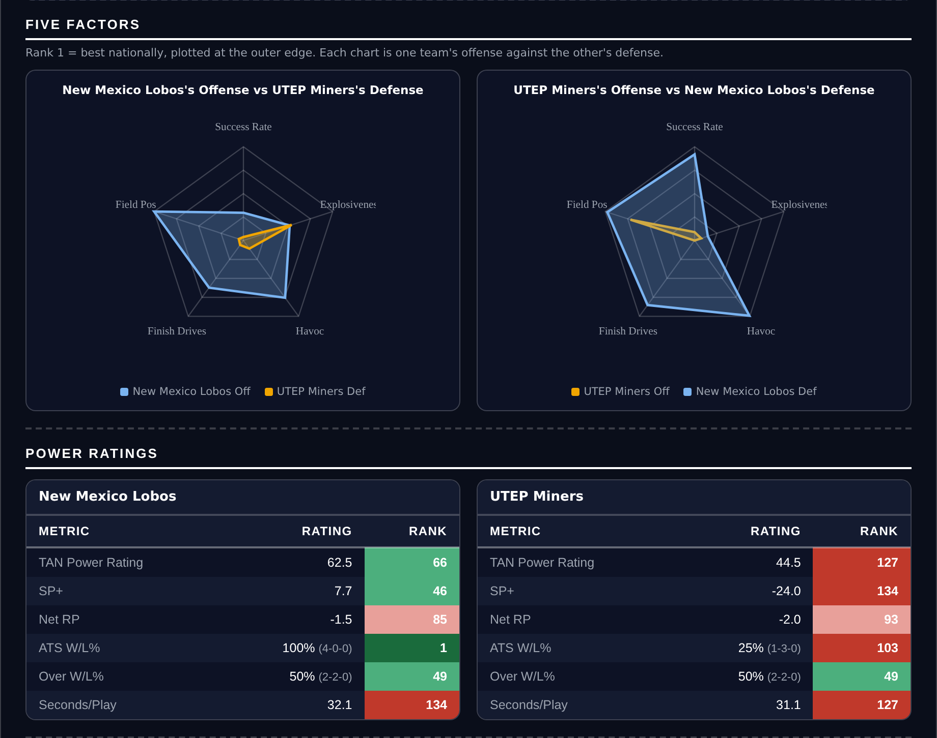
Five Factors and power ratings, captured from the CFB Betting Hub.
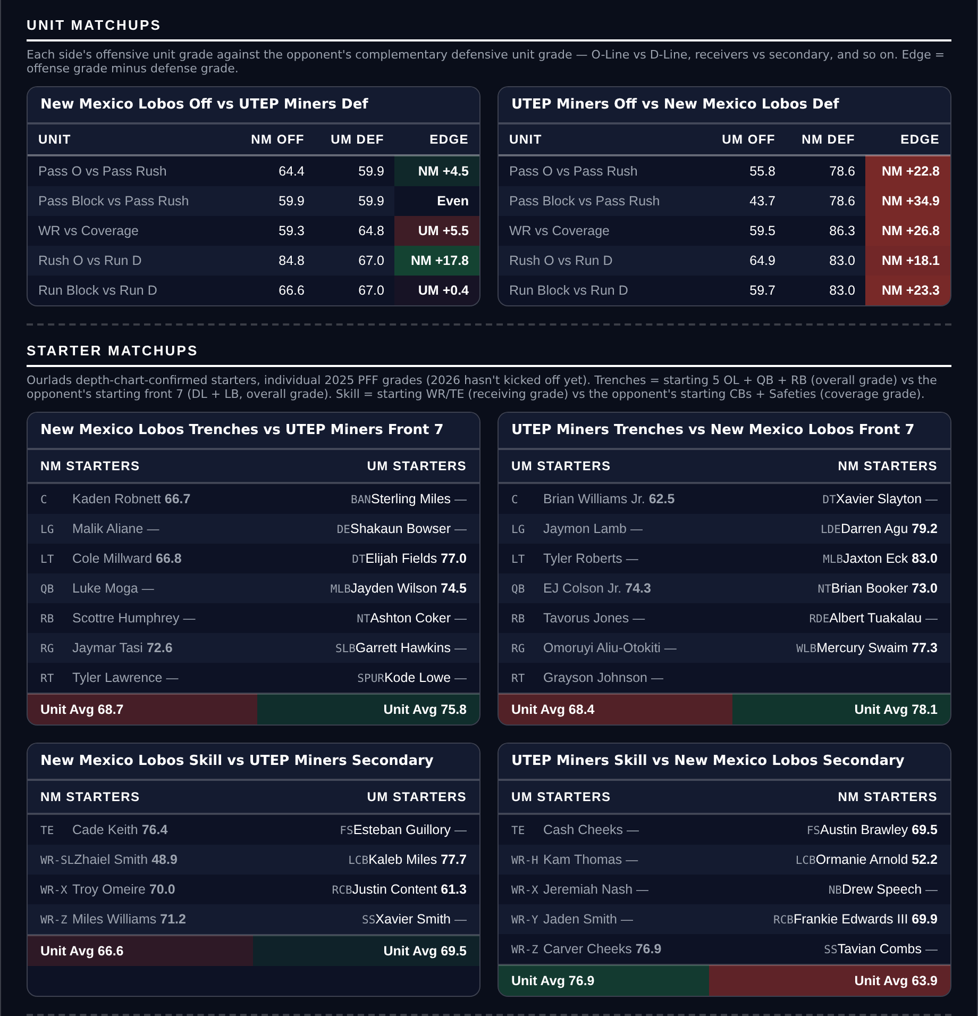
Unit matchups: each offensive unit grade against the opposing defensive unit. Edge = offense minus defense.

Fresno State +1.5
Fresno State Bulldogs @ Washington State Cougars
Book line | Washington State -1.5
Model number | Fresno State -5.9
Gap | 7.4 pts, 7.8 after the slate's own level
Points check | Fresno State -2.8: agrees, 4.3 clear of the line, the most on this card
SP+ (2026) | Fresno State -0.3 (tied 71st) vs Washington State -9.3 (tied 105th), home edge +3.1
Records | Fresno State 3-1 (3-1 ATS), Washington State 1-3 (3-1 ATS)
Scoring | Fresno State 28.3 for / 19.0 against, Washington State 22.3 / 24.8

Book has Washington State -1.5 at home. The rating has Fresno State by 5.9, and the points check, which is independent of SP+, has them by 2.8. The check is the weaker of the two reads here, and it still puts the fair number 4.3 points past the market, which is the most room any pick on this card has on that measure.
The records are the thing to look at carefully. Both teams are 3-1 against the spread, but one is 3-1 straight up and the other 1-3. Fresno State score 28.3 and allow 19.0; Washington State score 22.3 and allow 24.8.
Fresno State's offense ranks 123rd in Success Rate and 11th in Explosiveness, so the scoring arrives in chunks rather than drives, behind a 43.1 pass block grade. That is a volatile profile, and in a near-pick'em it is an argument for taking the points rather than laying them. Washington State's pass protection is worse still at 35.0, and their offense ranks 135th in Havoc allowed.
Washington State covering in three of four is the live counter-argument. Taking points is not a safety rule and this card should not pretend otherwise: of week 4's three spread losses, two were positions where it took points and one was a lay. The case here is the 4.3-point cushion on the independent read, not the direction of the ticket.
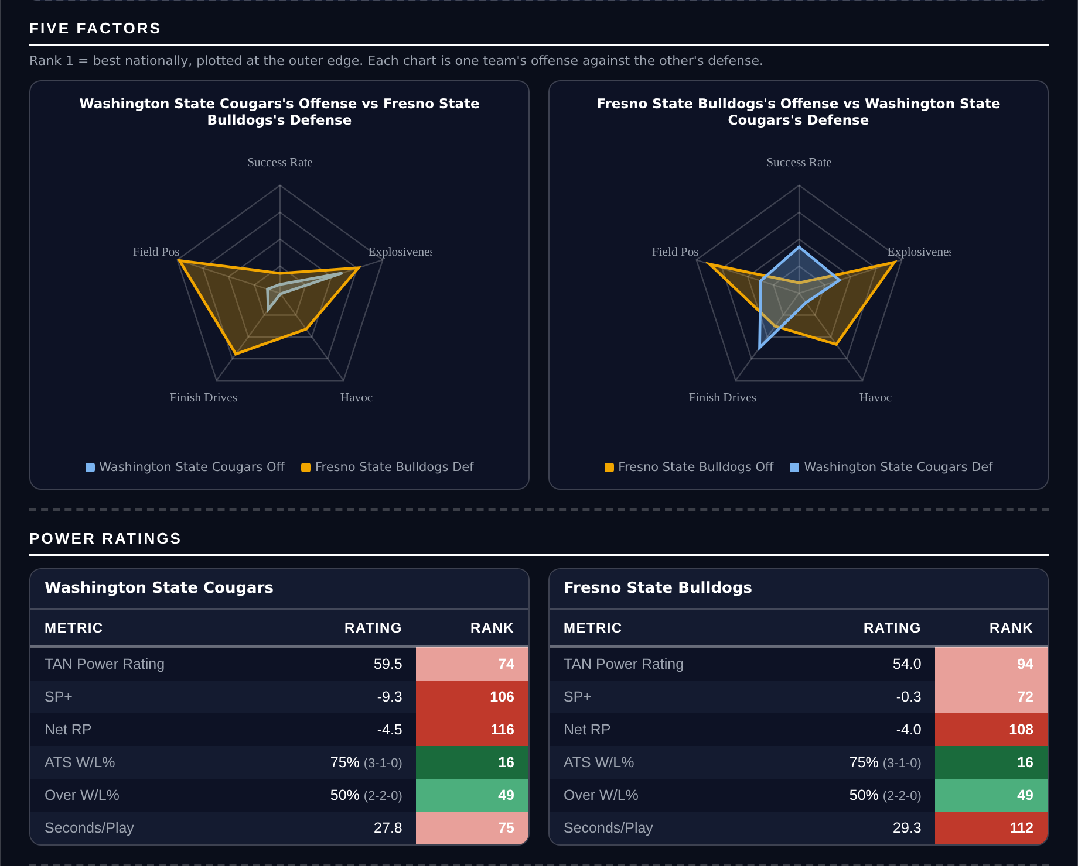
Five Factors and power ratings, captured from the CFB Betting Hub.
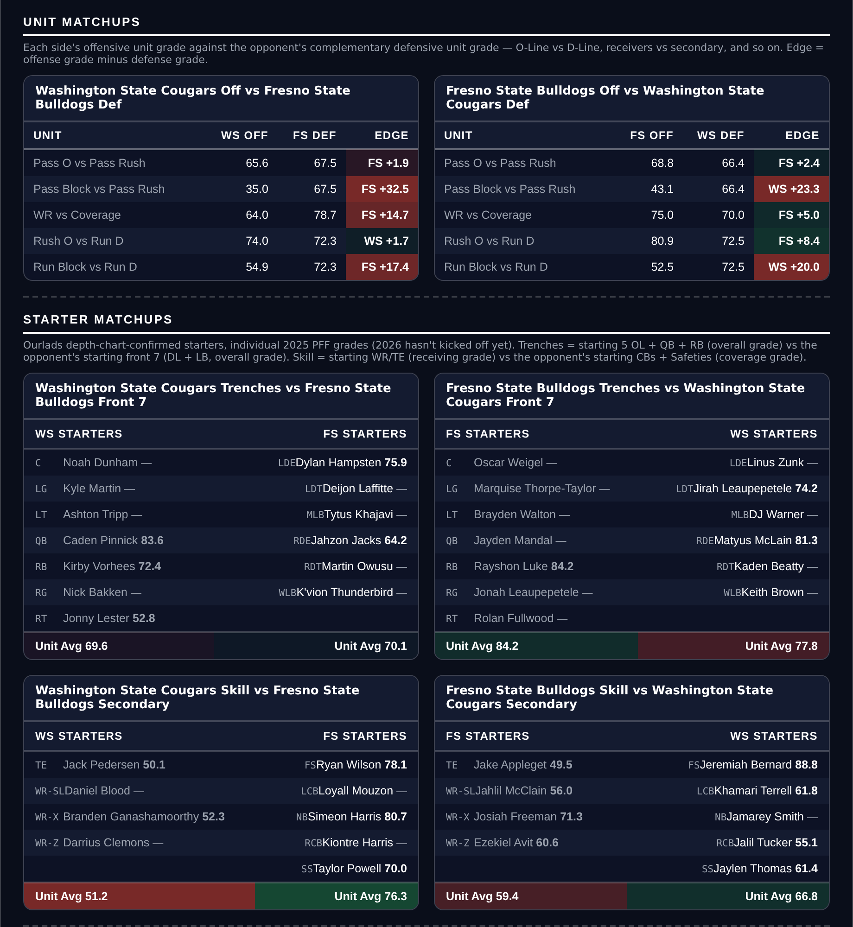
Unit matchups: each offensive unit grade against the opposing defensive unit. Edge = offense minus defense.

Illinois -10.0
Purdue Boilermakers @ Illinois Fighting Illini
Book line | Illinois -10.0
Model number | Illinois -17.6
Gap | 7.6 pts, 7.2 after the slate's own level
Points check | Illinois -10.2: agrees on the side, says the line is already right
SP+ (2026) | Illinois +8.5 (41st) vs Purdue -6.4 (95th), home edge +2.7
Purdue defense | 136th Success Rate, 136th Finishing Drives, 45.1 coverage
Scoring | Illinois 34.0 for / 26.5 against, Purdue 32.0 / 39.5

Book has Illinois -10.0 and the rating says -17.6. The points check says -10.2, which is the line to a fifth of a point. That makes this the weakest-supported spread on the card: the two reads agree on the side and disagree completely about whether there is anything to win. It is here because the model gap is the fourth largest on the board and the rule is to rank on the model rather than on the check.
Purdue's defense is the number. They rank 136th in Success Rate and 136th in Finishing Drives out of 138, on a 45.1 coverage grade and a 61.5 defensive grade, and they are allowing 39.5 points a game. Their one real strength is a 79.9 pass rush grade.
Illinois have a 10th-ranked Success Rate offense and an 88.4 passing grade, which is the half of this matchup that matters most against a secondary grading 45.1. Illinois are 2-2 against the spread and Purdue 1-3, so neither record is running ahead of its rating.
Illinois's own defense is a genuine problem and the reason this is -10 and not more: 113th in Success Rate, 105th in Finishing Drives, a 49.9 tackling grade. Purdue are scoring 32 a game themselves. This is a bet on the better offense in a game where neither side stops anybody, which is also why the same game appears on the totals card. The two positions overlap rather than contradict, and that overlap is spelled out there.
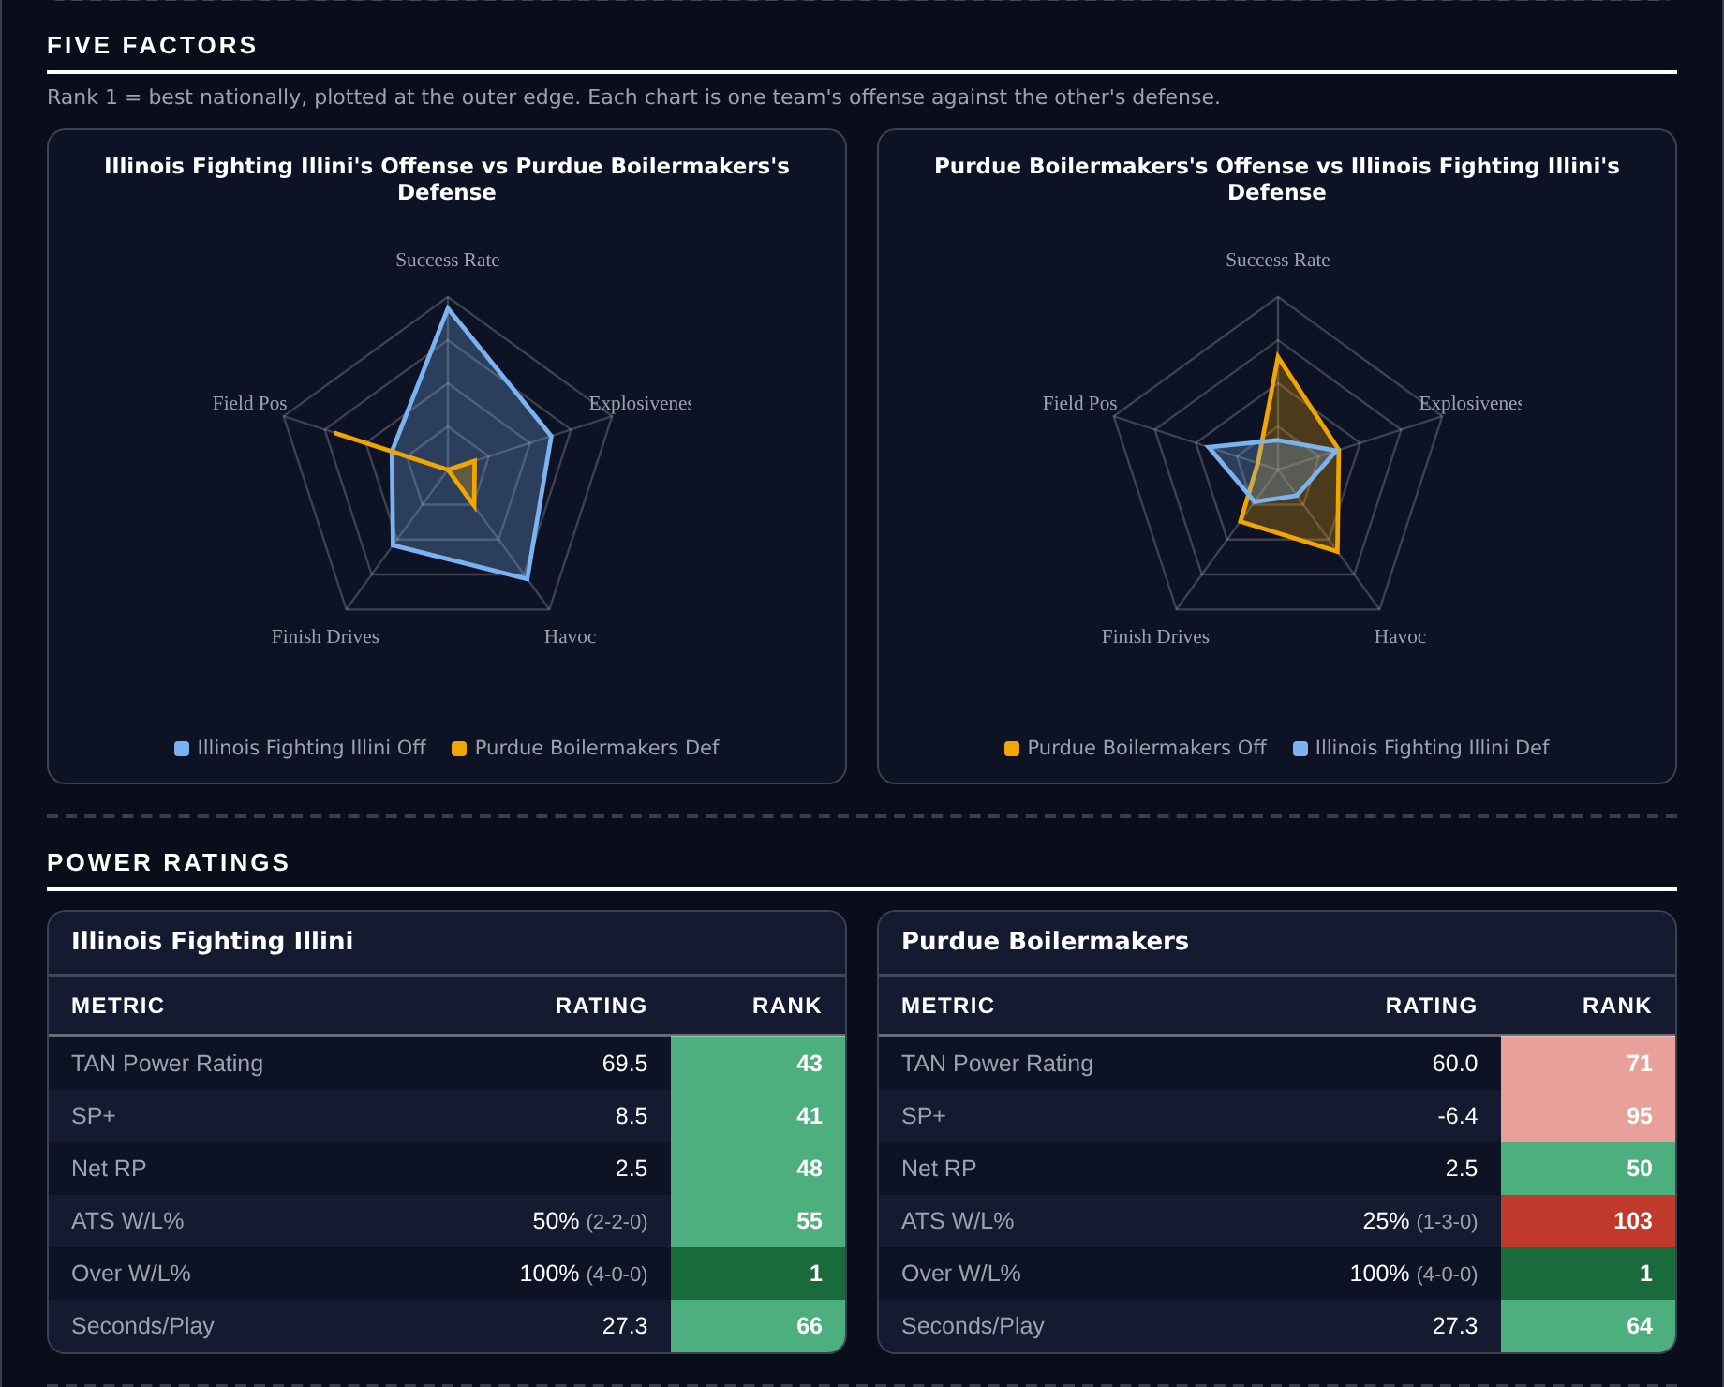
Five Factors and power ratings, captured from the CFB Betting Hub.
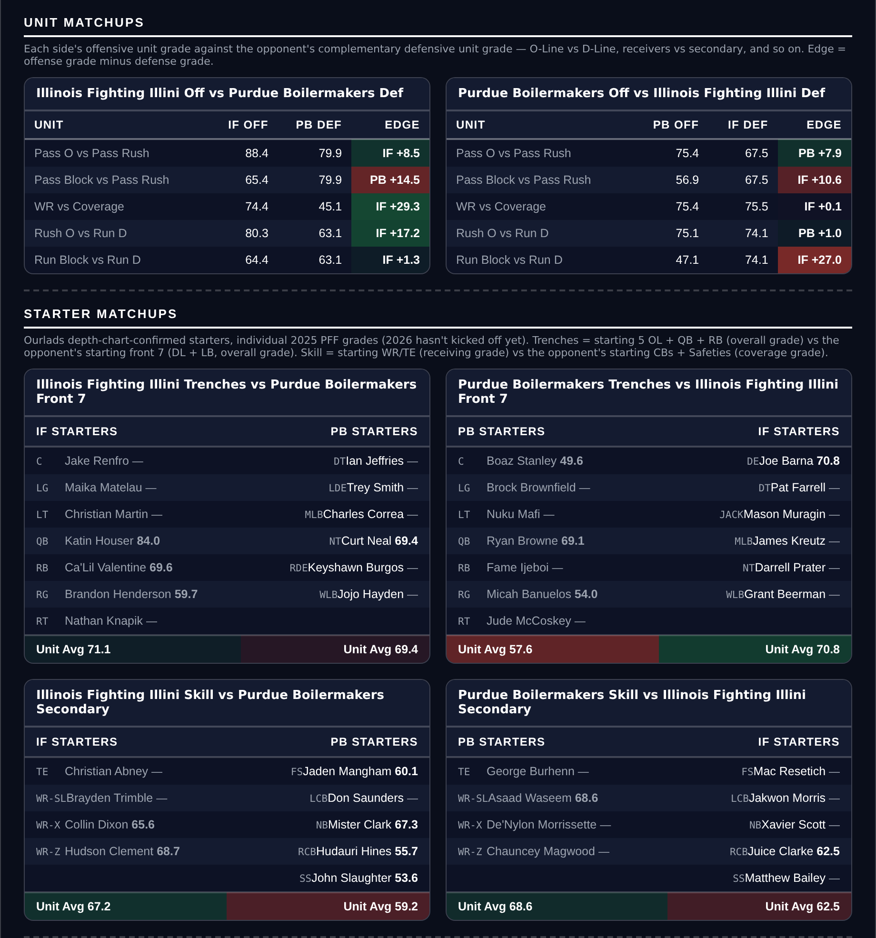
Unit matchups: each offensive unit grade against the opposing defensive unit. Edge = offense minus defense.

Ohio -3.5
Ohio Bobcats @ Kent State Golden Flashes
Book line | Kent State +3.5
Model number | Ohio -10.1
Gap | 6.6 pts, 7.0 after the slate's own level
Points check | Ohio -7.7: agrees, 4.2 clear of the line
SP+ (2026) | Ohio -10.5 (109th) vs Kent State -22.4 (130th), home edge +1.8
Scoring | Ohio 30.3 for / 31.0 against, Kent State 16.3 / 36.0
Kent State offense | 137th Success Rate, 125th Finishing Drives, 42.8 run block

Book has Ohio -3.5 on the road. The rating says -10.1 and the points check says -7.7. Both want roughly a touchdown more than the market, and after Fresno State this is the second-largest point-based edge on the card at 4.2.
Kent State have scored 16.3 a game and allowed 36.0. The offense ranks 137th in Success Rate, 125th in Finishing Drives and 126th in Field Position behind a 42.8 run block grade and a 44.7 pass block grade. The defense ranks 133rd in Success Rate and 137th in Finishing Drives.
Ohio are mediocre rather than good, 2-2 at 30.3 points a game with a 69th-ranked Success Rate offense, and their own defense ranks 138th of 138 in Finishing Drives allowed, which is as bad as that metric gets. The case is entirely relative.
Both teams are 2-2 against the spread, so neither record is running ahead of its rating, and this is a road favorite of under a touchdown rather than a large lay. Kent State at home is the risk, and 3.5 is a short number to have to cover: Ohio winning by exactly three is the single likeliest way this loses.
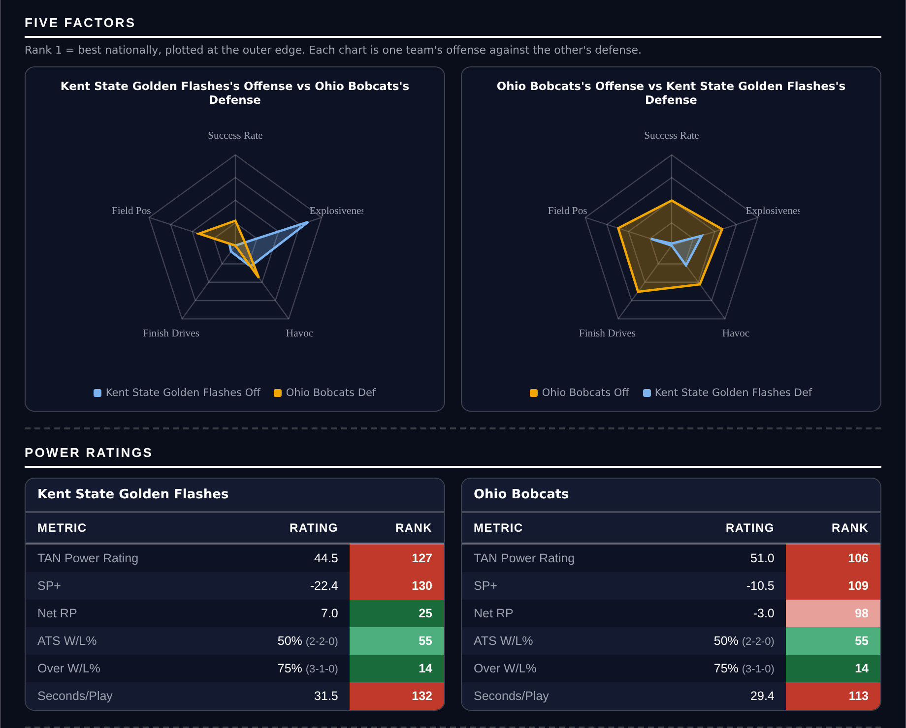
Five Factors and power ratings, captured from the CFB Betting Hub.
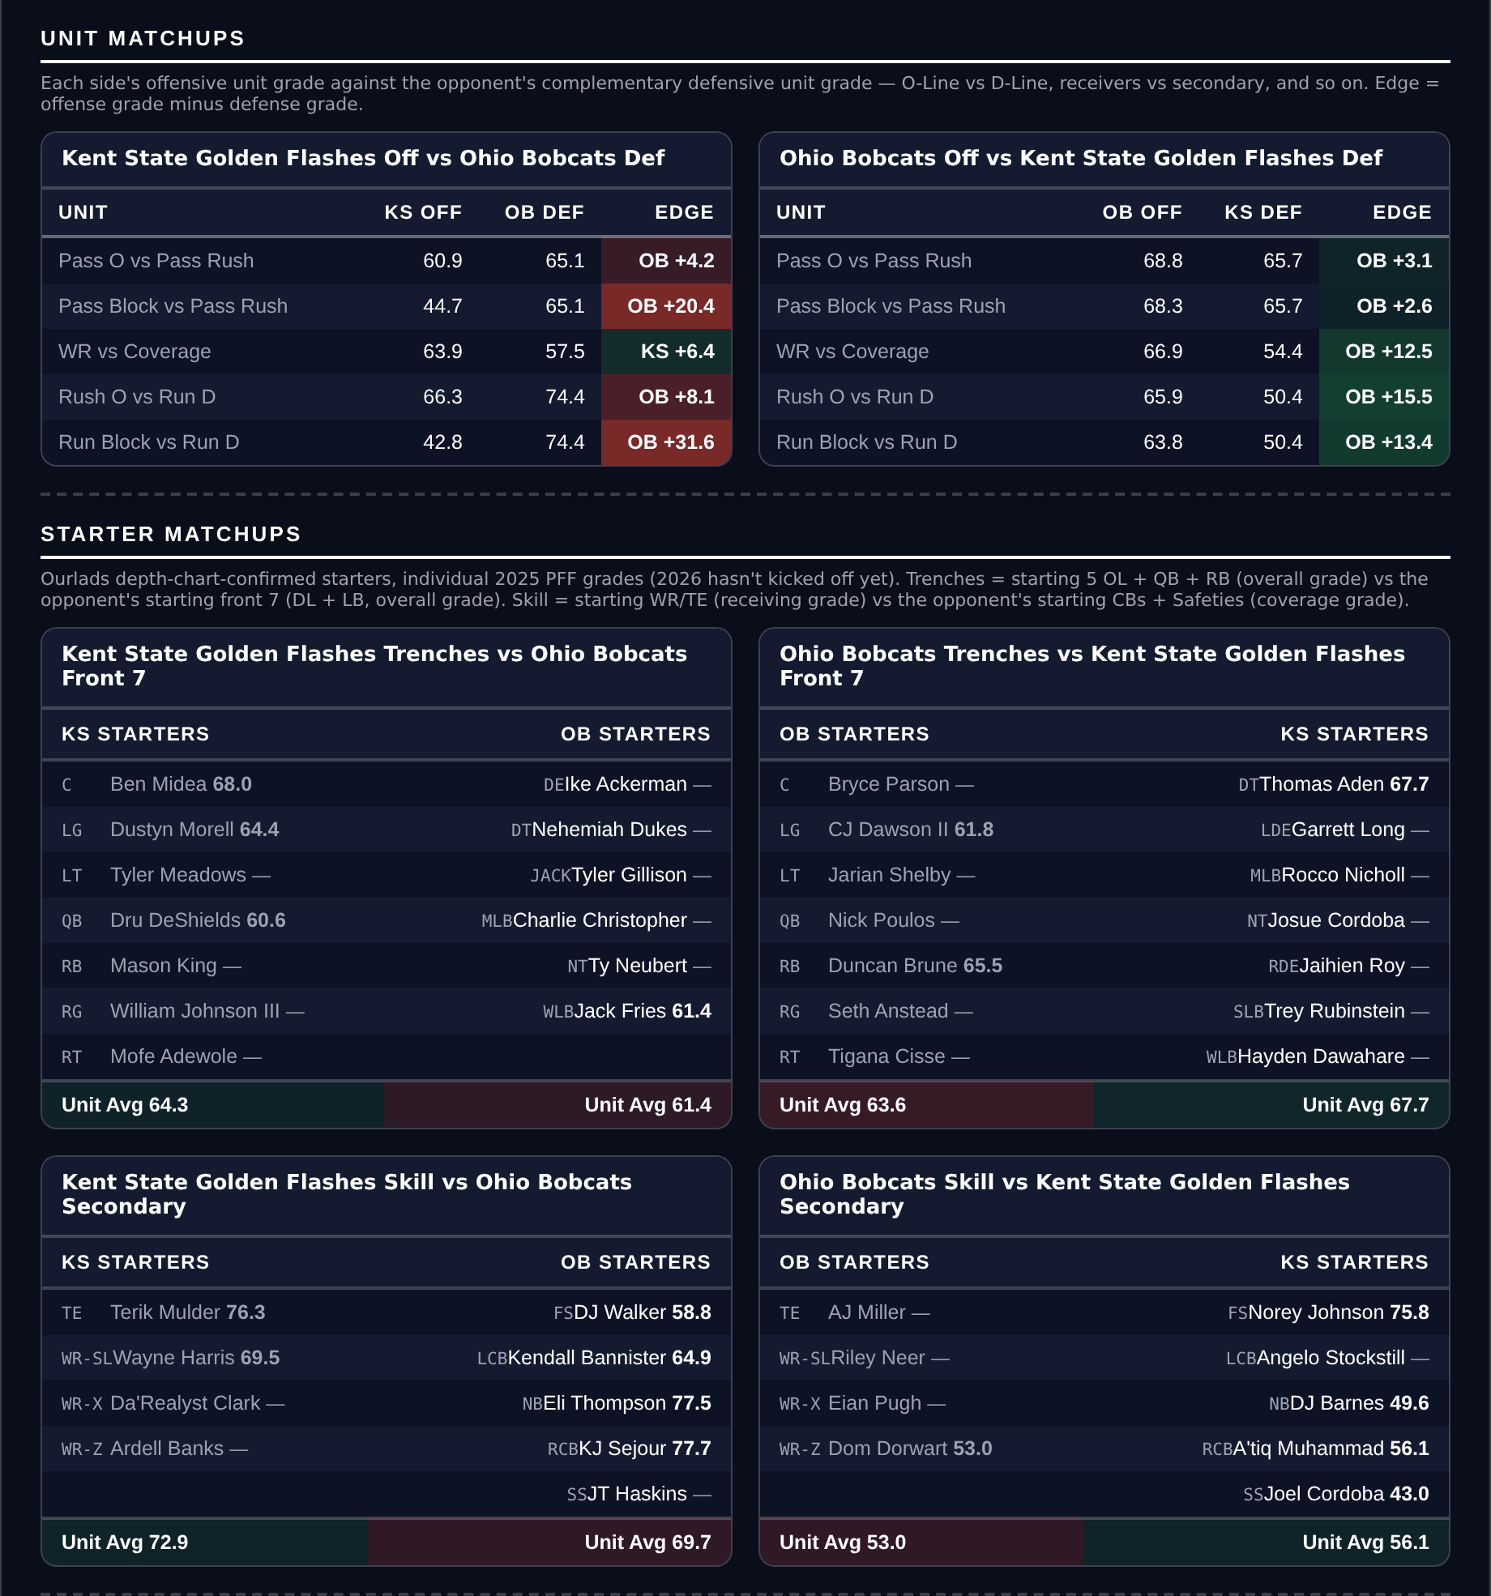
Unit matchups: each offensive unit grade against the opposing defensive unit. Edge = offense minus defense.

