Week 10 Betting Card
Week 10 · Saturday November 7, 2026
Ten positions for Saturday: five spreads and five player props. The slate is 48 rated Saturday games with a posted spread and total, and every pick below is drawn from that pool.
No totals for the third week running. Week 7's five went 0-5 with the three Overs missing by 19, 25 and 20.5 points in games where both selection measures agreed, and the category stays out until that test has been scored across every game of weeks 6 through 9 rather than the fifteen that were bet.
Spreads are selected on two measures built for every game: the model number, which is the SP+ differential plus home field, and the points check, which uses nothing but each team's own 2026 scoring and home field and shares no input with SP+. Each is taken relative to where the whole slate sits. A game qualifies only when both land on the same side, and candidates are ranked by the weaker of the two. Thirty-one of the 48 games had the two agreeing this week, the most of any slate this season.
Every figure in this card is checked against the source data before it is written. Team grades, five-factor ranks and per-game scoring come from the 2026 PFF team grades and the season-to-date CFBData ranks; each player's role, share and production come from the 2026 PFF season files. Per-game scoring uses each team's own game count, which is eight, nine or ten this week. Where a rank ends in .5 the teams are tied and it is written as “tied Nth”. All ten kickoffs are verified Saturday in Eastern time, every prop player was checked against this morning's depth chart, and every venue against the National Weather Service forecast at kickoff.
Season to date: 49-53-4 and two voids, down 9.99 units across 108 picks. Spreads 16-22-2 (-8.20u), totals 12-15-2 (-4.50u), props 21-16 and two voids (+2.71u). The last two weeks were the only winning weeks of the season, +0.60 and +2.70 units, and both were cards with no totals on them.

Spreads
Five spreads where the two measures agree on a side. Four take points and one lays them, and the standing exclusion was checked on that one: do not lay a price into a team whose record against the spread is running ahead of its rating. Colorado are 2-5-1 against the number, 127th, so it does not apply.
Across the 48 rated Saturday games the model sits 0.7 points more toward the home side than the market does, the widest that gap has been this season, so the adjusted readings here differ a little more from the raw ones than usual.
Ratings and the Five Factors come from the 2026 workbook: SP+, TAN, implied team totals and the season-to-date CFBData ranks, out of 138 teams. Player lines are 2026 PFF season to date. Records, ATS and over/under records are TeamRankings, 2026 to date. The PFF team grade file covers eight games for 99 teams, nine for 36 and ten for 3. Futures prices are the week 10 pull except win totals, which are week 7.

North Carolina Tar Heels @ UConn Huskies

UConn +8.0
Book line | North Carolina -8.0
Model number | North Carolina -1.8
Gap | 6.2 pts, 5.5 net
Points check | UConn by 5.5, which is 13.5 past the market
SP+ (2026) | North Carolina +3.9 (53rd) vs UConn -0.2 (72nd), home edge +2.3
UConn 2026 | 4-4, 5-2-1 ATS (17th), 34.4 points a game
UConn offense | 23rd by grade, 6th in Explosiveness, 45th in Success Rate
North Carolina offense | 25.8 points a game, 125th in Explosiveness

Book has North Carolina laying eight on the road. The rating has them winning by 1.8 and the points check, built only from each team's own 2026 scoring and home field, has UConn winning by 5.5. The two disagree about who wins and agree completely about the number.
UConn score more than the team laying eight points on them. They put up 34.4 a game against North Carolina's 25.8, their offence grades 82.3 and ranks 23rd nationally and 6th in Explosiveness, and they are 5-2-1 against the spread, 17th in the country. Both teams are 4-4.
North Carolina's case rests on defence — 87.1 coverage, 27th, and 5th in Explosiveness allowed — and that is a real edge against a UConn passing game that lives on big plays. But their own offence ranks 125th in Explosiveness and scores under 26 a game. Eight points asks a team that struggles to pull away to pull away on the road.
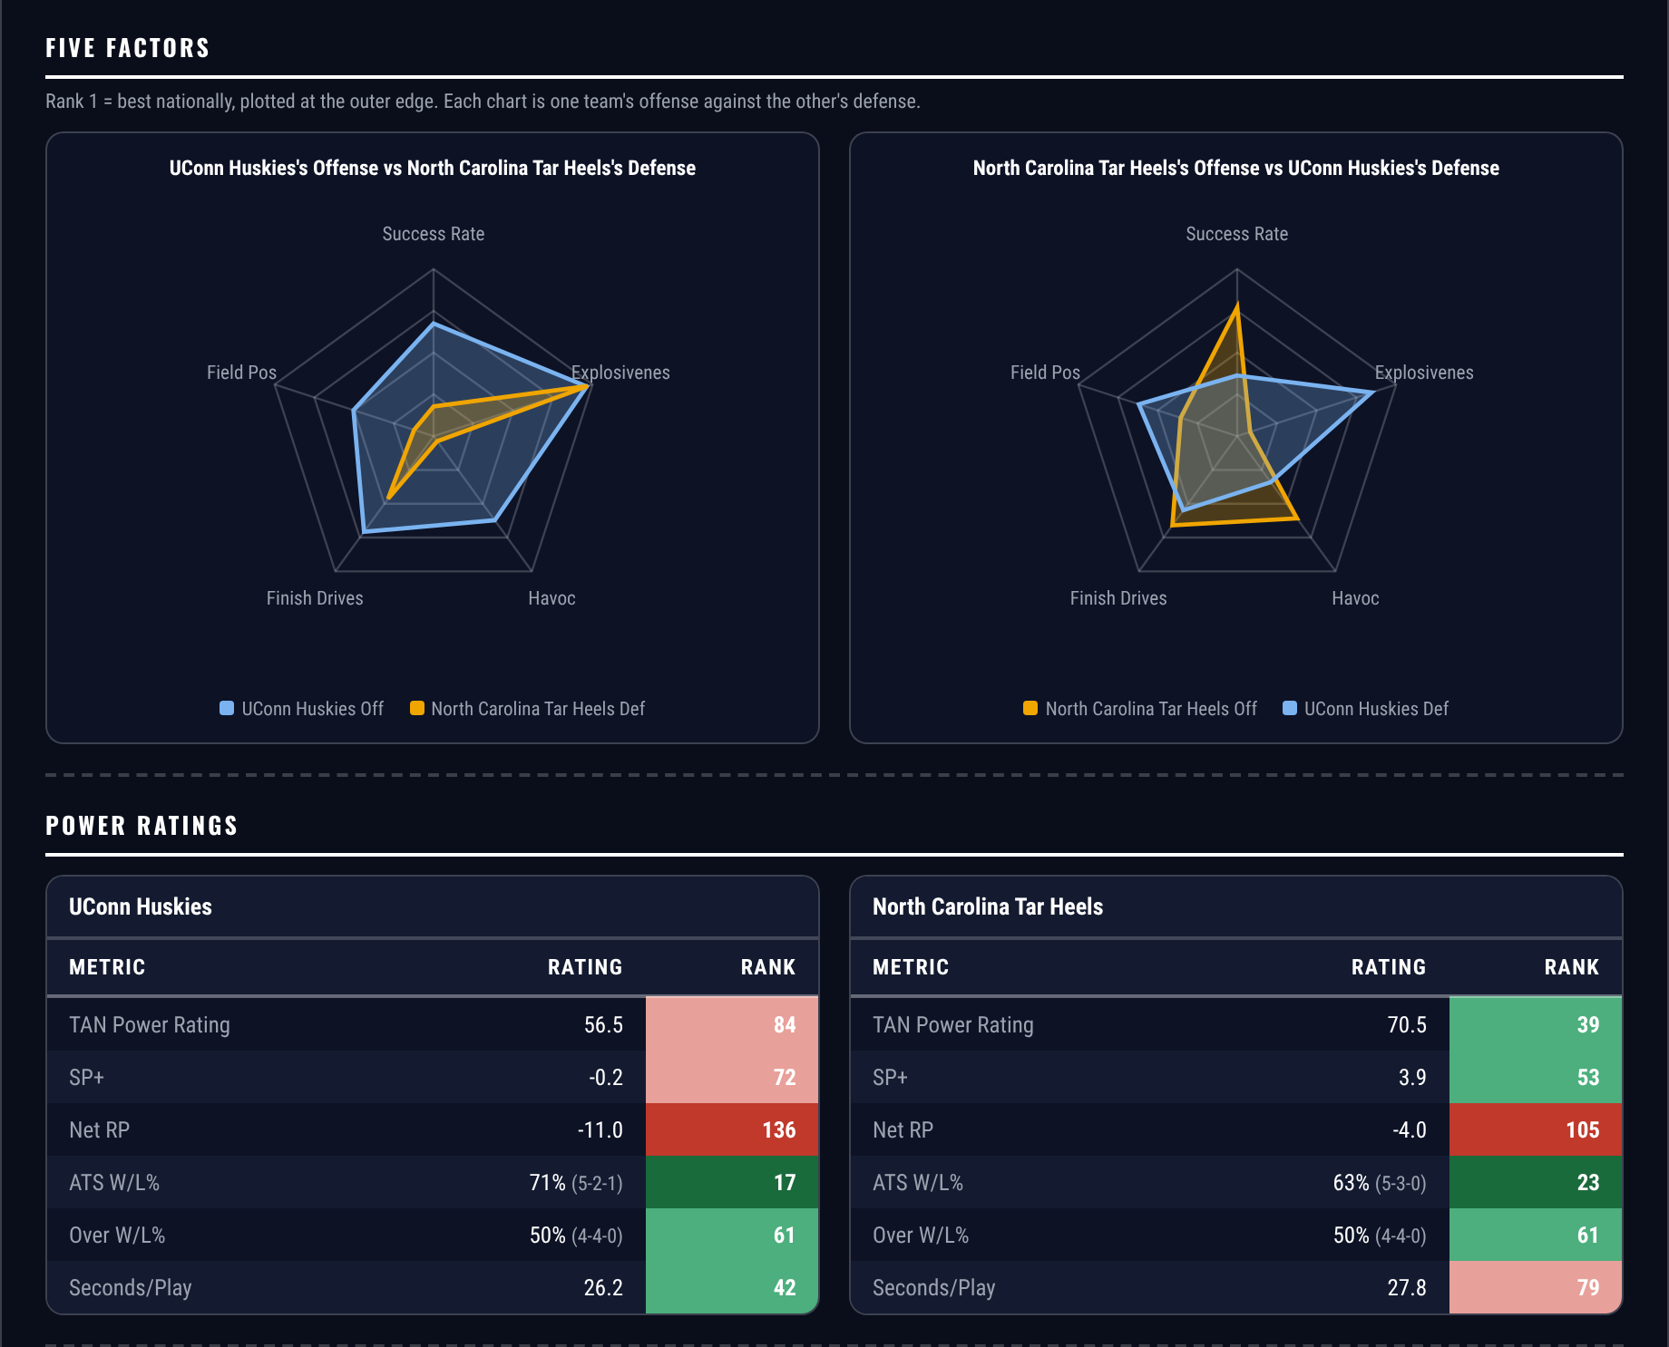
Five Factors and power ratings, captured from the CFB Betting Hub.
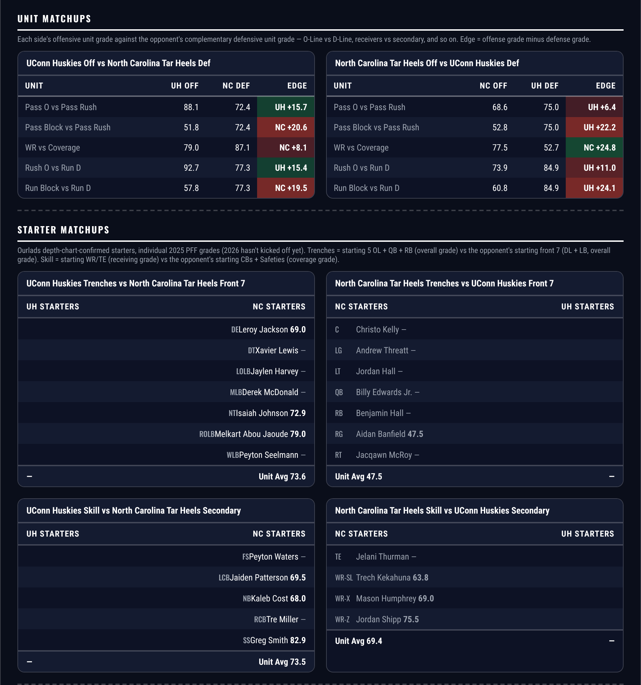
Unit matchups: each offensive unit grade against the opposing defensive unit. Edge = offense minus defense.

Rutgers Scarlet Knights @ Wisconsin Badgers

Rutgers +18.5
Book line | Wisconsin -18.5
Model number | Wisconsin -15.0
Gap | 3.5 pts, 4.2 net
Points check | Wisconsin by 8.1, which is 10.4 past the market
SP+ (2026) | Wisconsin +6.0 (48th) vs Rutgers -6.6 (97th), home edge +2.4
Rutgers 2026 | 2-6 but scoring 27.8 a game, 6-2 to the Over
Rutgers offense | 9th in Explosiveness, 54th by grade
Wisconsin offense | 23.6 points a game, 115th in Success Rate, 110th in Finishing Drives

Book has Wisconsin -18.5. The rating has it at 15.0 and the points check at 8.1, and both sit clear of the number on the same side. Eighteen and a half is a number for a team that scores, and Wisconsin do not.
Wisconsin average 23.6 points a game on an offence ranked 115th in Success Rate and 110th in Finishing Drives. Their defence is outstanding — 94.2, second in the country, second in run defence, first in Explosiveness allowed — but a defence cannot cover three touchdowns on its own, and covering 18.5 while scoring 23.6 means holding Rutgers to five.
Rutgers are 2-6 and the record is the reason the number is this big, but they score 27.8 a game and rank 9th nationally in offensive Explosiveness. They have gone over in six of eight. A team that reaches the high twenties with big plays available is not the profile that gets held to a field goal.
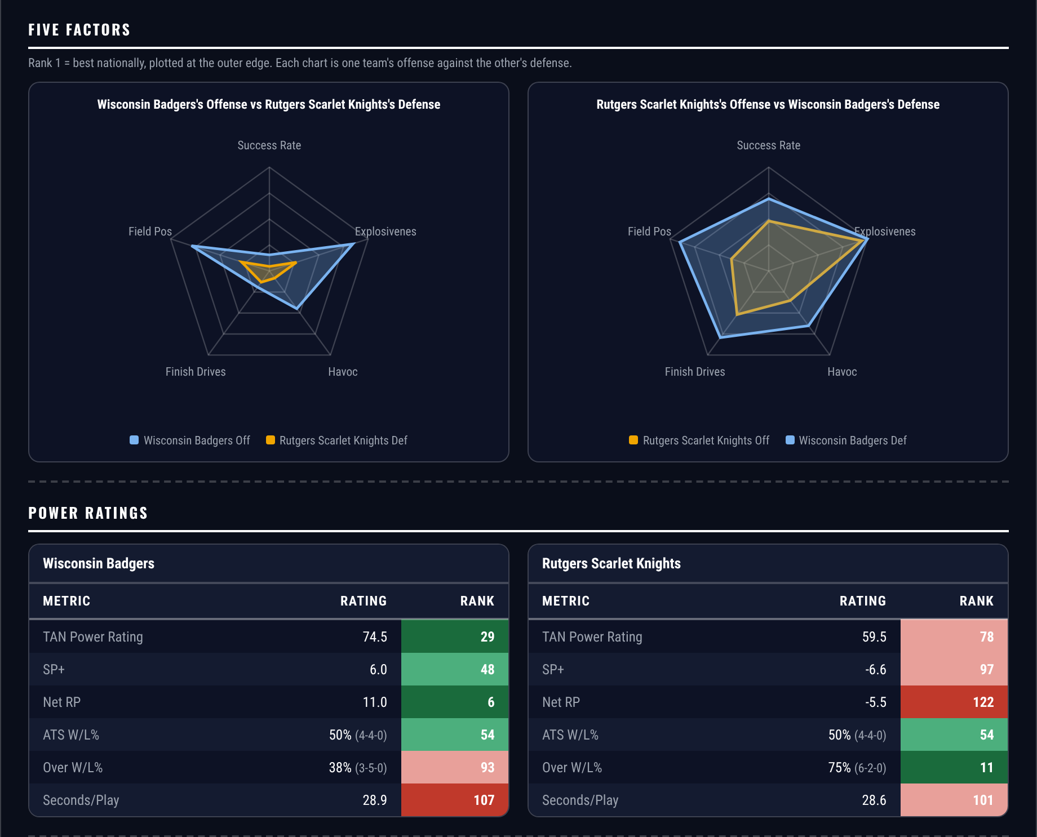
Five Factors and power ratings, captured from the CFB Betting Hub.
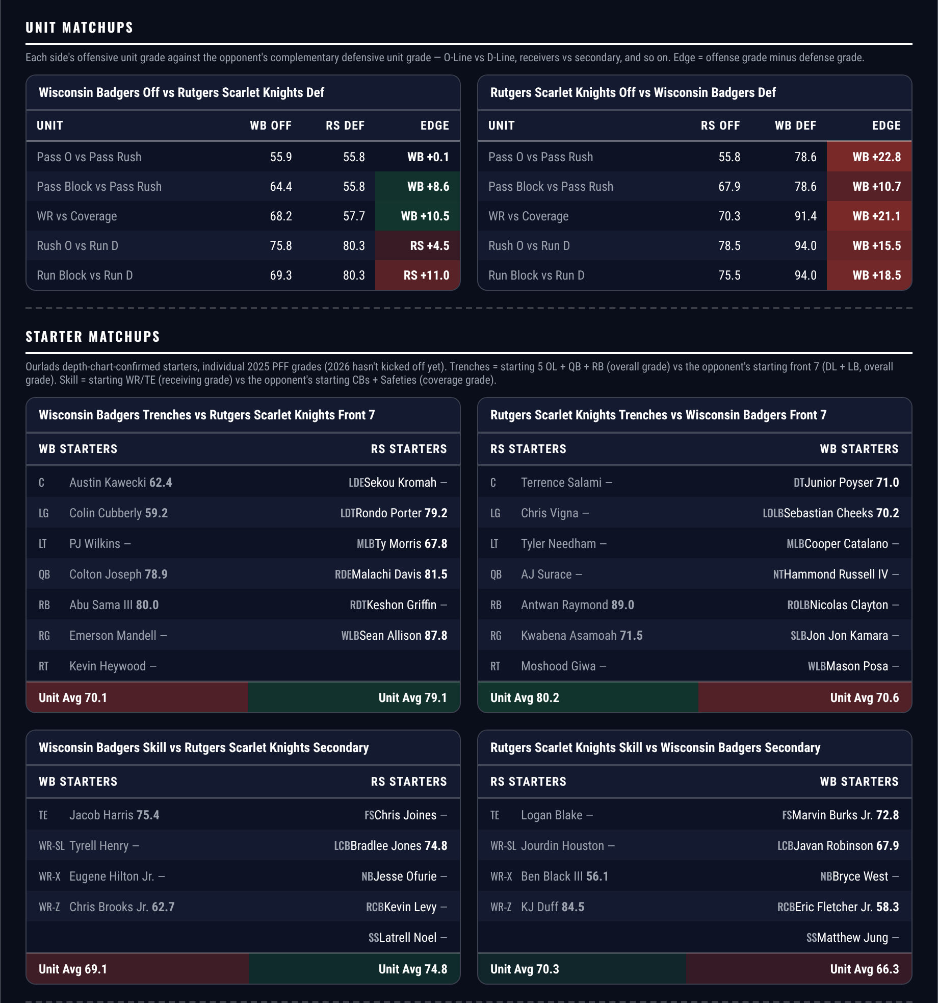
Unit matchups: each offensive unit grade against the opposing defensive unit. Edge = offense minus defense.

Oklahoma State Cowboys @ Kansas State Wildcats

Kansas State +6.5
Book line | Kansas State +6.5
Model number | Oklahoma State -1.8
Gap | 4.7 pts, 4.0 net
Points check | Kansas State by 0.7, which is 7.2 past the market
SP+ (2026) | Oklahoma State +12.1 (27th) vs Kansas State +7.5 (45th), home edge +2.8
Kansas State home field | 2.8 points, the largest of the five
Kansas State defense | 20th in Success Rate, 17th in Havoc, 135th in Explosiveness allowed
Oklahoma State offense | 41.1 points a game, 6th in Success Rate, 100th in Explosiveness

Book has Kansas State +6.5 at home. The rating has Oklahoma State by 1.8 and the points check has Kansas State winning by 0.7. Both land inside the number, and the home field here is worth 2.8 points, the largest in this group.
Kansas State defend the thing Oklahoma State do. The Cowboys rank 6th in offensive Success Rate nationally and score 41.1 a game. They rank 100th in Explosiveness — they move methodically. Kansas State rank 20th in defensive Success Rate and 17th in Havoc, which is the unit built to interrupt exactly that, and they allow 21.9 points a game against Oklahoma State's 27.1.
The market is pricing the records. Oklahoma State are 5-3 and 6-2 against the spread, 7th in the country; Kansas State are 4-4 and 3-4-1 against it. That is the shape of team the number follows rather than leads, and both measures say six and a half is at least four points too many.
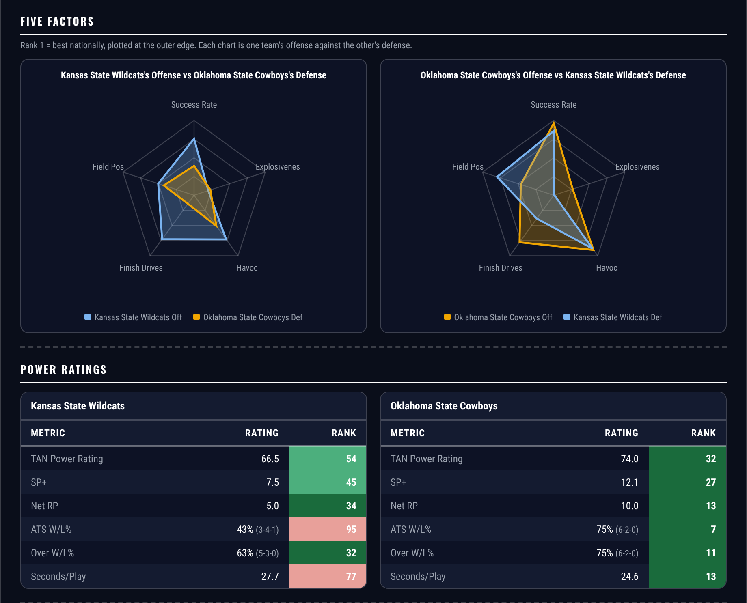
Five Factors and power ratings, captured from the CFB Betting Hub.
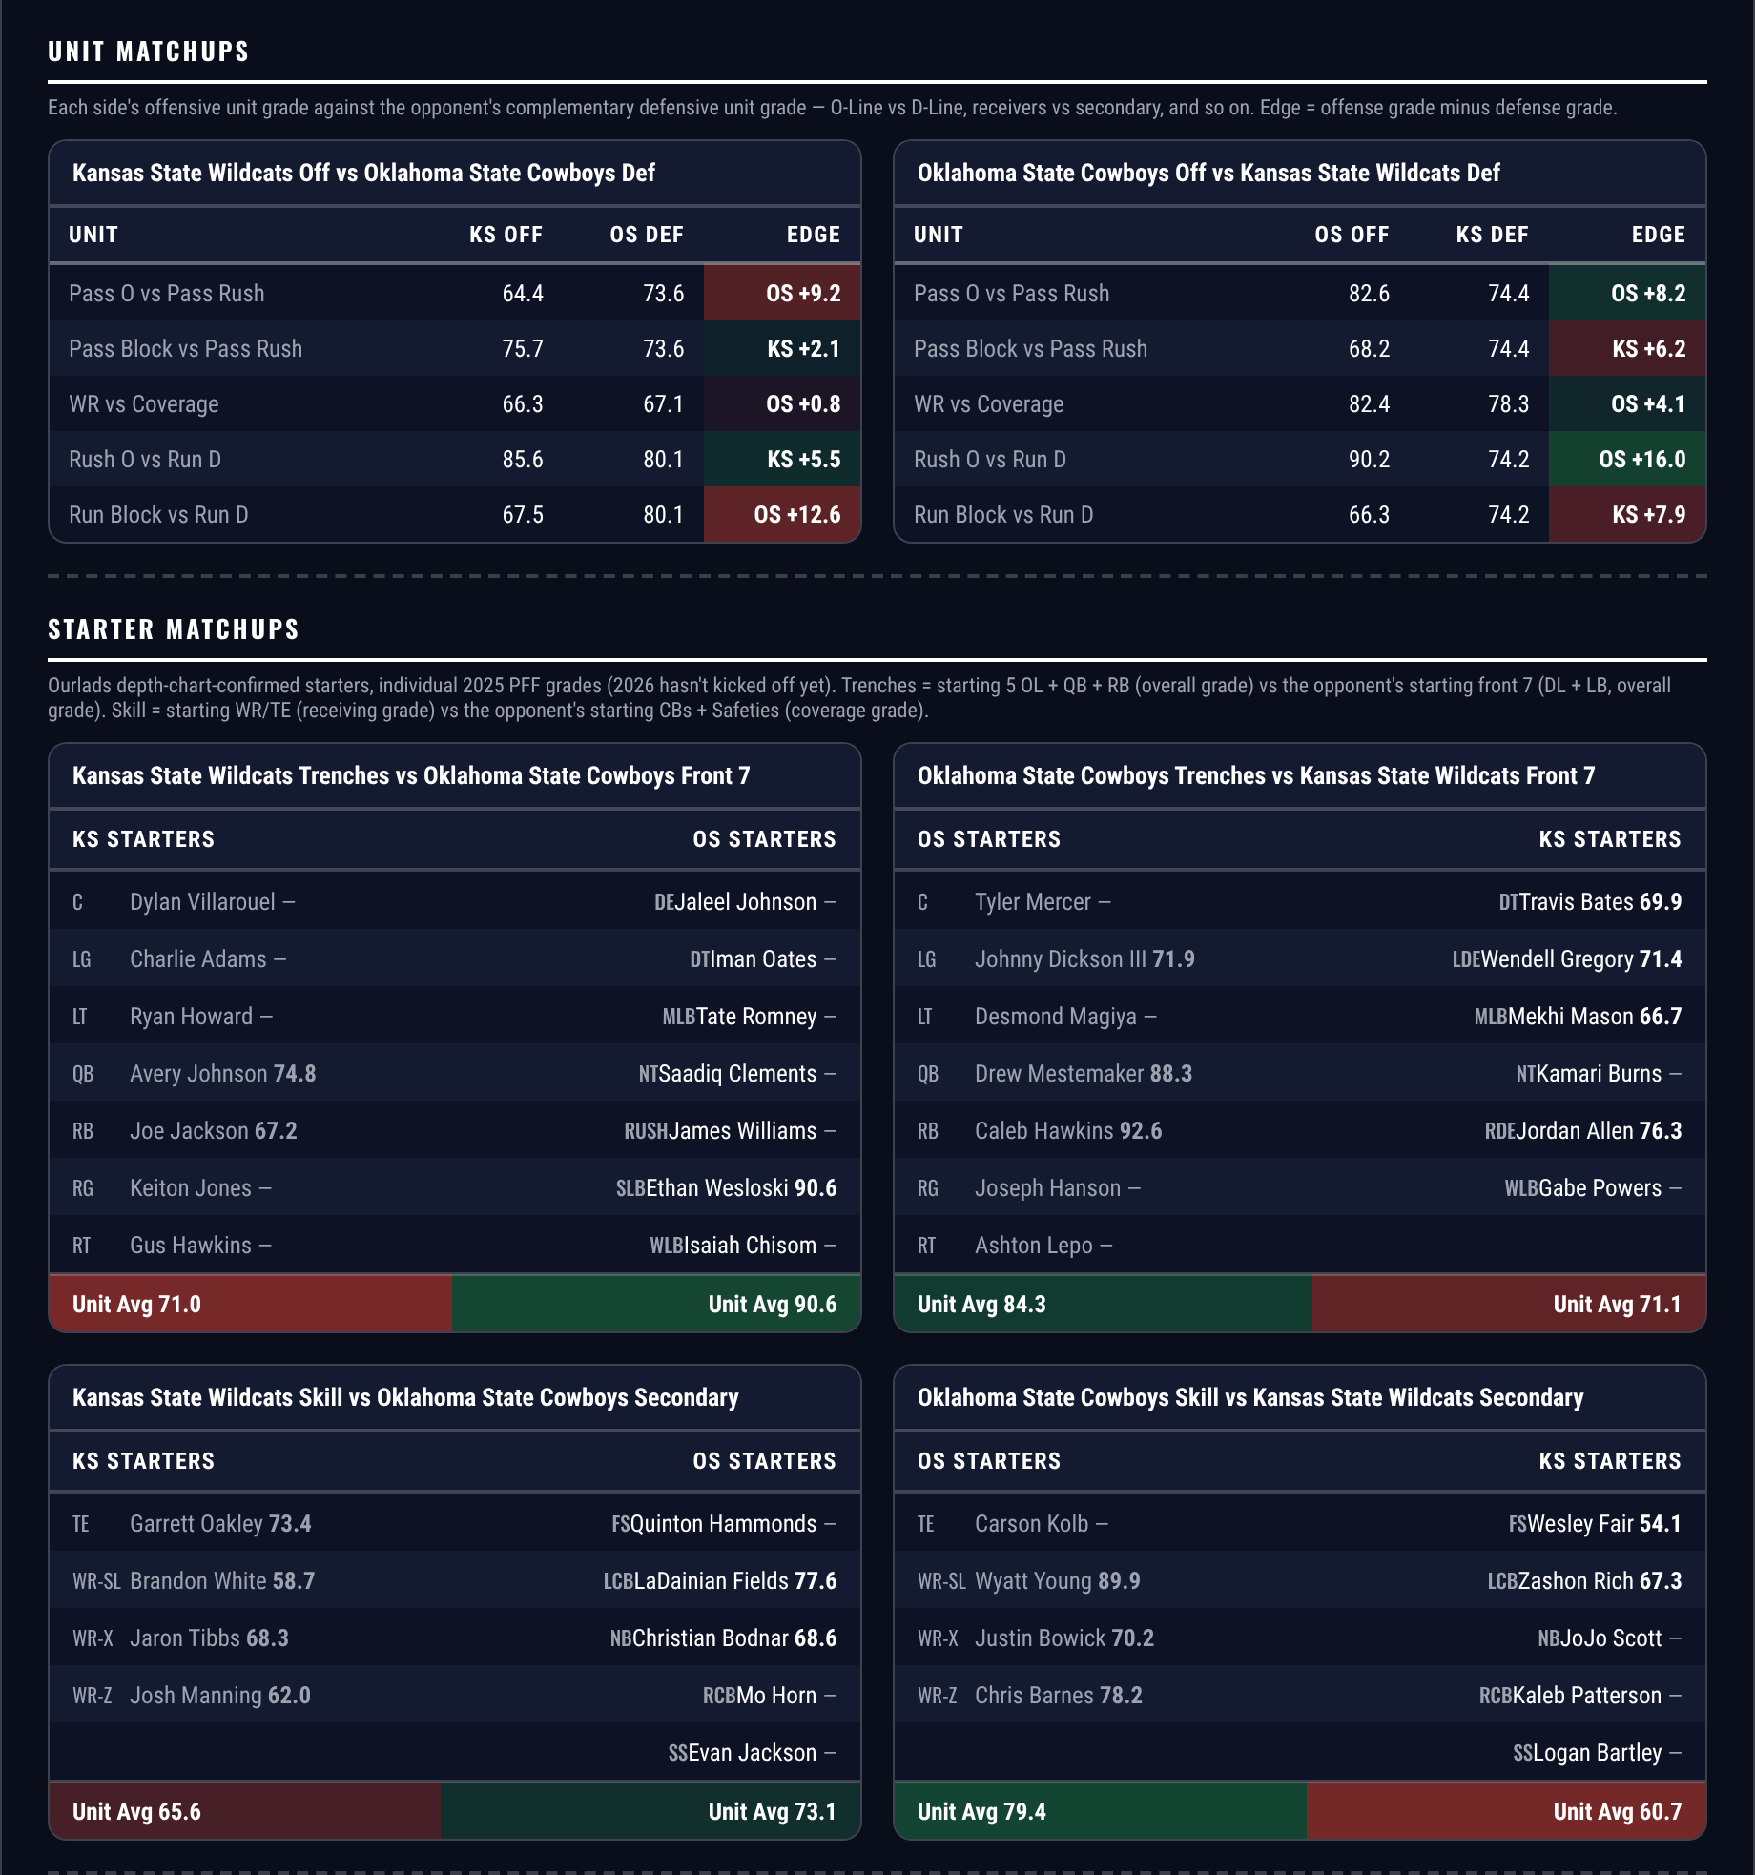
Unit matchups: each offensive unit grade against the opposing defensive unit. Edge = offense minus defense.

Colorado Buffaloes @ Arizona State Sun Devils

Arizona State -3.5
Book line | Arizona State -3.5
Model number | Arizona State -8.6
Gap | 5.1 pts, 4.4 net
Points check | Arizona State by 7.2, which is 3.7 past the market
SP+ (2026) | Arizona State +1.4 (64th) vs Colorado -4.2 (90th), home edge +3.0
Arizona State home field | 3.0 points
Colorado offense | 21.0 points a game, 108th in Success Rate, 132nd in Finishing Drives
Colorado field position | 134th on offense, tied 126th on defense

The one position here that lays a price. Book has Arizona State -3.5, the rating has it at 8.6 and the points check at 7.2, so both sit several points past the number on the same side.
Colorado cannot score. They put up 21.0 points a game on an offence ranked 108th in Success Rate and 132nd in Finishing Drives, and they rank 134th in offensive Field Position and tied 126th on defence, so they begin badly at both ends. Their 55.6 tackling grade ranks 123rd.
Arizona State are not a strong team and the card is not claiming otherwise at 4-4 and 29.5 points a game. What they are is better than this opponent in the places that decide a three-and-a-half-point game: 88.2 on defence against Colorado's 82.6, 79.3 tackling against 55.6, and three points of home field. The standing exclusion does not apply — Colorado are 2-5-1 against the spread, 127th, so this is not laying into a team the market has been underrating.
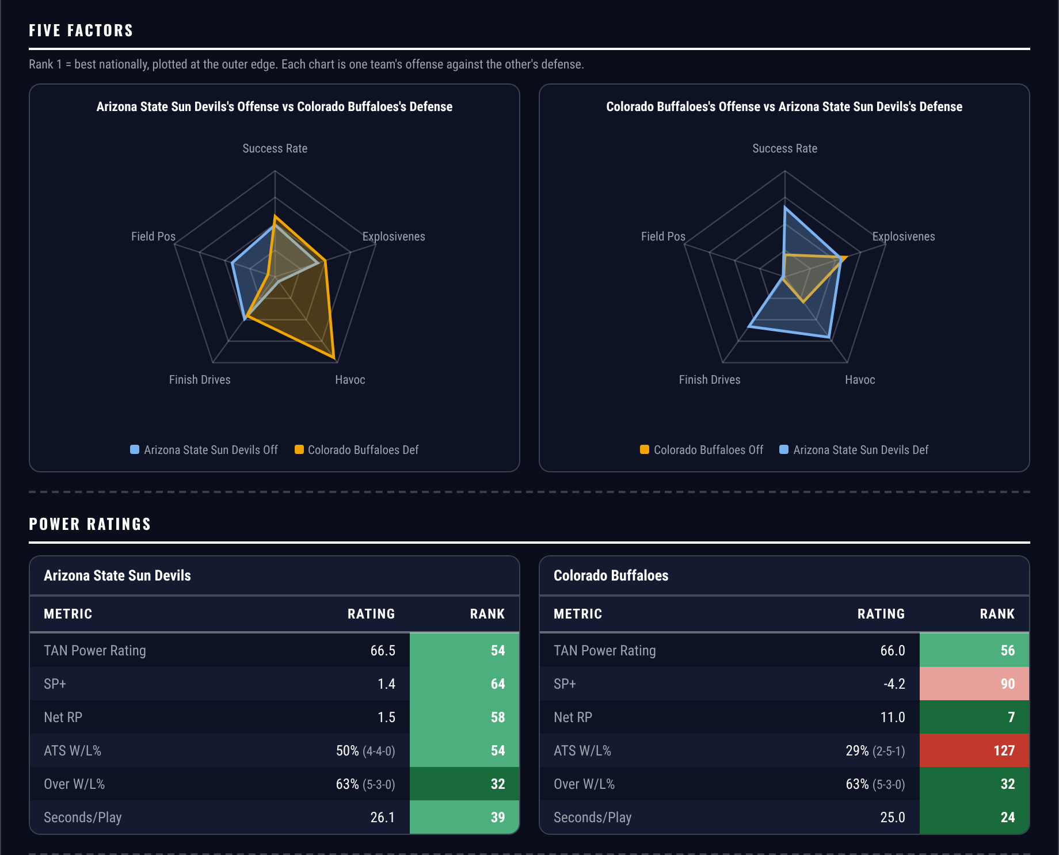
Five Factors and power ratings, captured from the CFB Betting Hub.
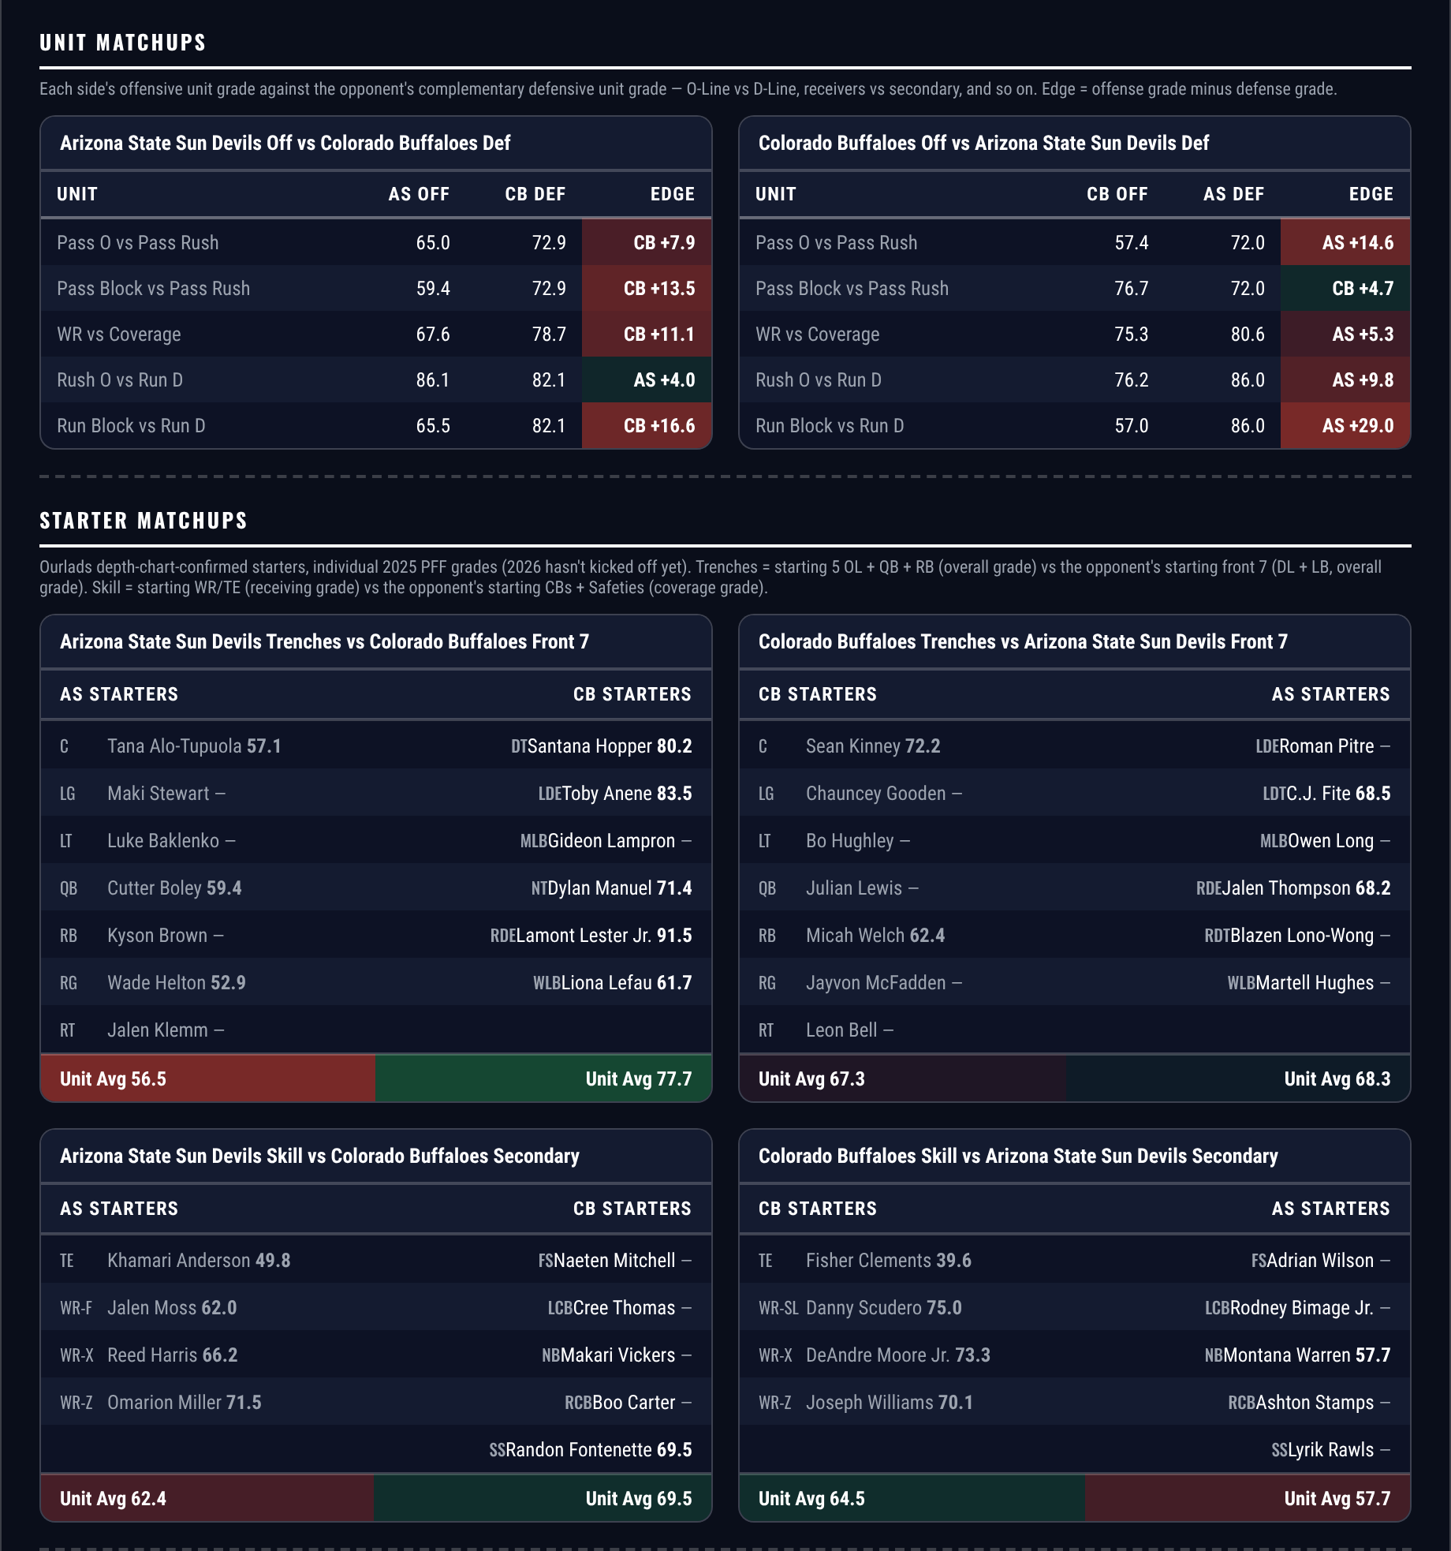
Unit matchups: each offensive unit grade against the opposing defensive unit. Edge = offense minus defense.

Maryland Terrapins @ Purdue Boilermakers

Maryland +5.5
Book line | Purdue -5.5
Model number | Purdue -3.2
Gap | 2.3 pts, 3.0 net
Points check | Purdue by 2.9, which is 2.6 past the market
SP+ (2026) | Purdue -1.6 (79th) vs Maryland -3.0 (85th), home edge +1.8
Purdue home field | 1.8 points
Maryland pass rush | 83.1, 15th in the country
Purdue coverage | 46.3, 135th; the defense grades 68.9, 125th

SP+ separates these two by 1.4 points and the market asks for five and a half. Home field at Purdue is worth only 1.8, which leaves the rating at Purdue by 3.2 and the points check at 2.9. Both sit inside the number.
Purdue are the nominal favourite and the weaker team on the sheet. They grade 72.1 overall, 118th in the country, with a defence at 68.9 that ranks 125th and a coverage grade of 46.3 that ranks 135th. They are 3-5 and allow 32.1 points a game.
Maryland bring the one unit that exploits that. Their pass rush grades 83.1, 15th nationally, against a Purdue offence ranked 62nd in Success Rate, and their special teams grade 90.2, 4th in the country, which is where a one-score game between two 100th-ranked teams usually turns. Both sides are 3-5 against the spread, so neither is being carried by its record.
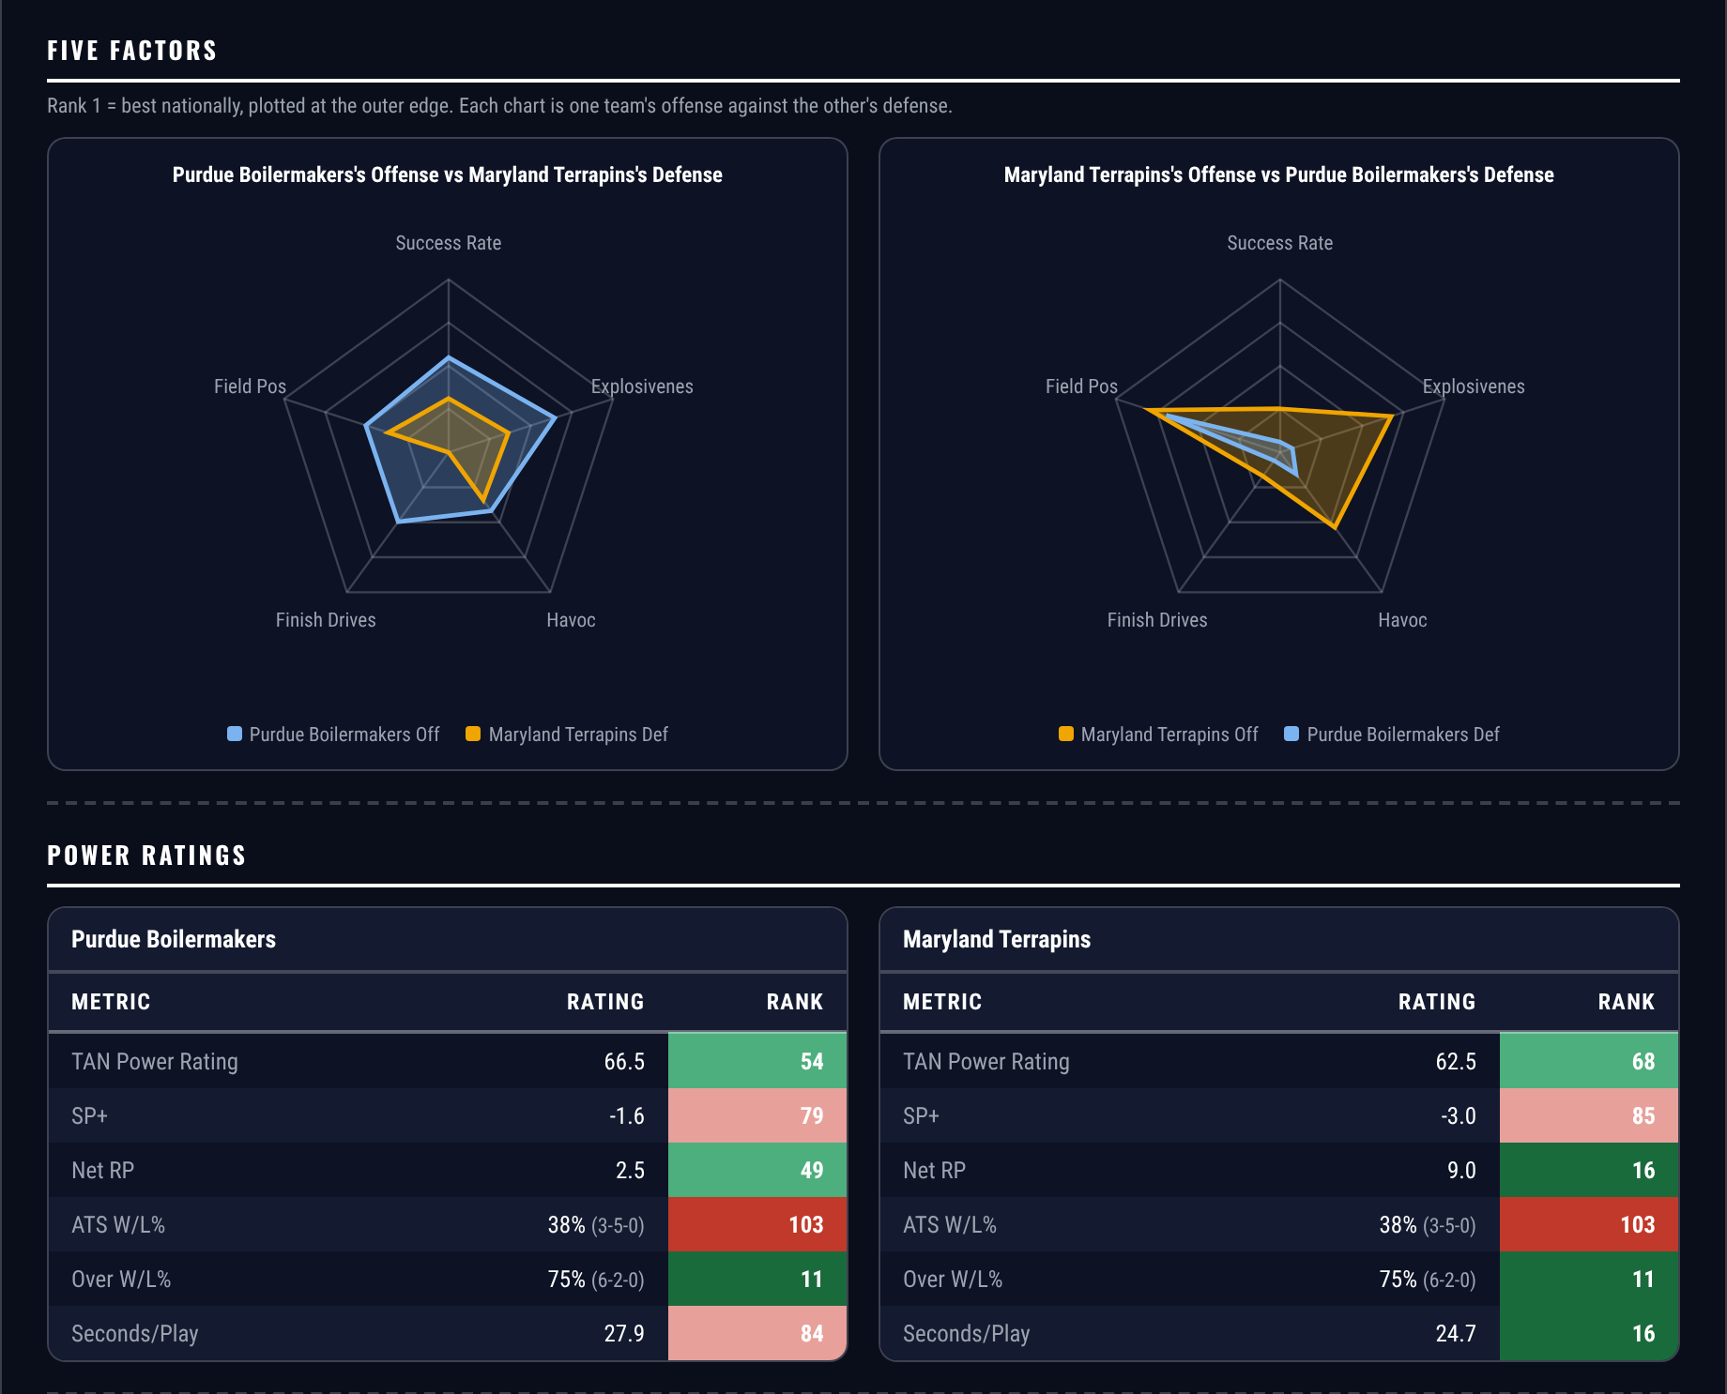
Five Factors and power ratings, captured from the CFB Betting Hub.
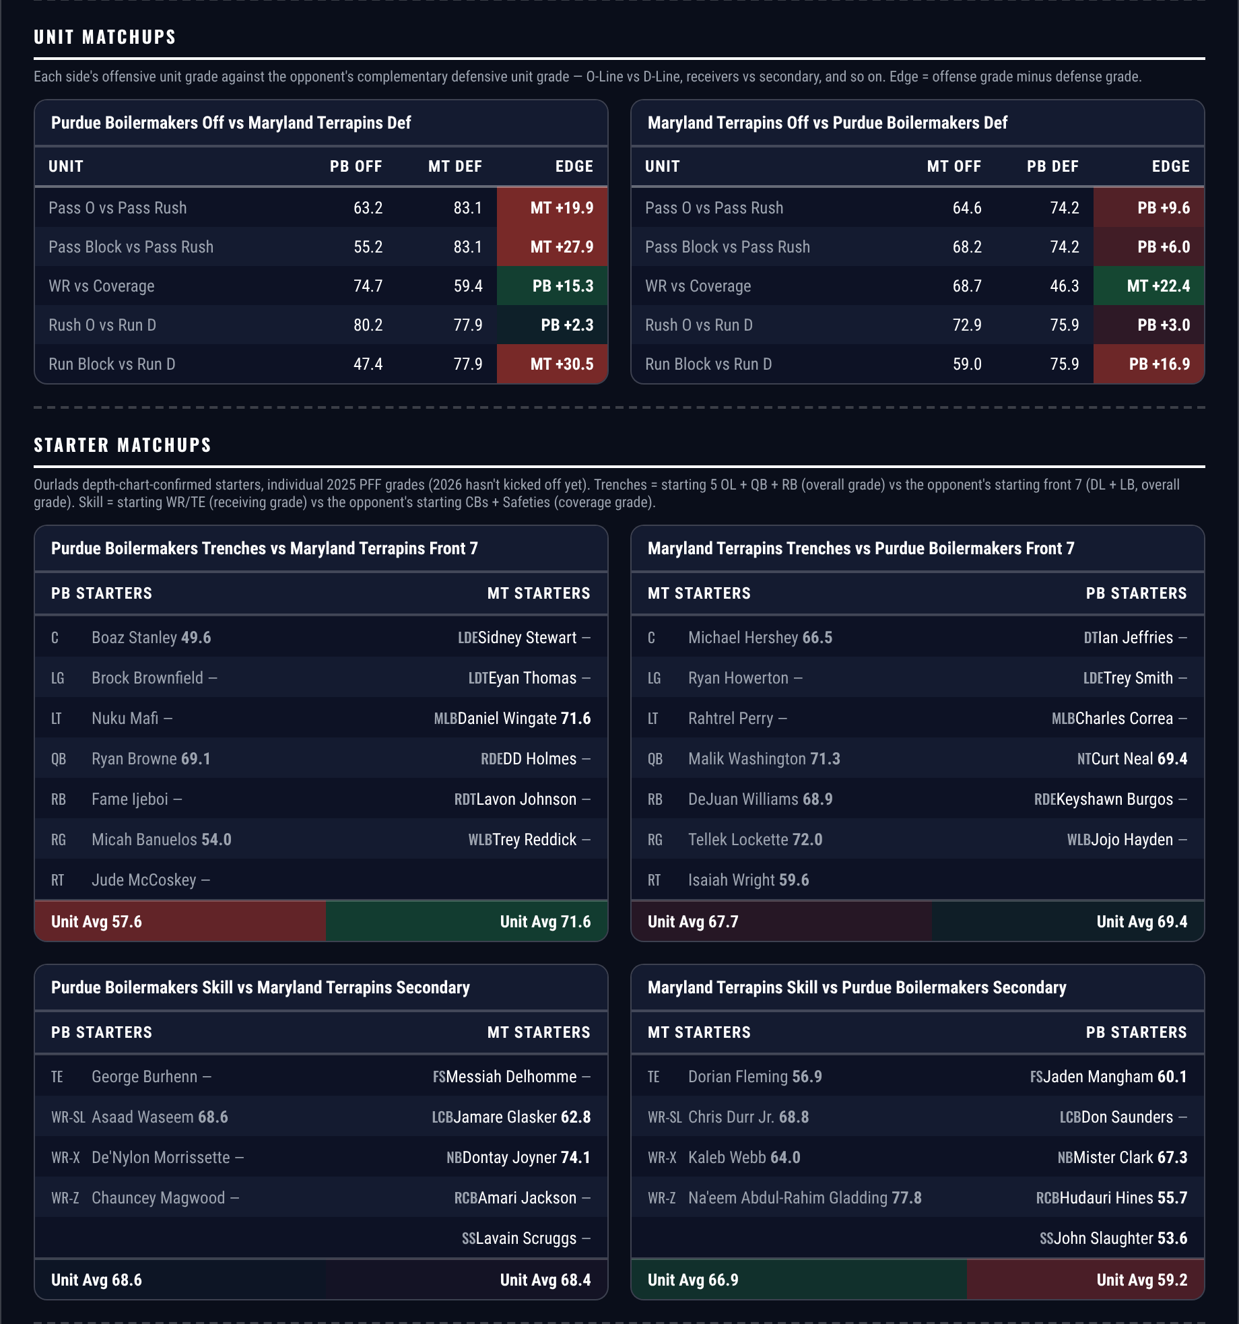
Unit matchups: each offensive unit grade against the opposing defensive unit. Edge = offense minus defense.

Player Props
350 priced rows went through the ten screens and 19 survived. The screens: a model edge of at least 20 percent; the player’s own 2026 production agreeing with the side by at least 20 percent; a real role, 20+ targets for receivers and 12+ carries a game for backs; 4+ targets a game for any receiving Over; no opponent or pace multiplier outside 0.6 to 1.6; a spread under 28 points with a rated opponent; at least two books posting the number; the player’s own game count level with his team’s; no yardage Unders; and no receiving Under above a 12-yard average depth of target.
The survivors were then checked against this morning’s depth charts and two were not listed starters — one receiver second at his position, and another second behind a teammate who is himself on the survivor list. Both came off. Of the eight checked, six cleared.
One caution carried over from last week rather than buried. Traylon Ray was first string on the morning of week 9, played the whole game and was targeted zero times; the same thing happened in week 8. Both were receivers at four targets a game, which is the floor screen 4 allows. Two of the five below sit at 4.1, and that is the risk they carry: the depth chart confirms a role, not a workload.
Quarterback rushing props remain excluded. Sacks count against rushing yards in official college statistics and not in PFF, so the model projects a stat the market is not pricing.
Ratings and the Five Factors come from the 2026 workbook: SP+, TAN, implied team totals and the season-to-date CFBData ranks, out of 138 teams. Player lines are 2026 PFF season to date. Records, ATS and over/under records are TeamRankings, 2026 to date. The PFF team grade file covers eight games for 99 teams, nine for 36 and ten for 3. Futures prices are the week 10 pull except win totals, which are week 7.

Boise State Broncos @ Colorado State Rams

Akeem Wright Over 30.5 receiving yards
Book line | Over 30.5 receiving yards
Model projection | 49.7 yards
2026 production | 321 yards in 8 games, 40.1 a game
Role | 33 targets, 4.1 a game, 21 receptions over 172 routes
Profile | 11.6 average depth of target, 1.87 yards per route run, 69.3 route grade, long of 40
Colorado State defense | 50.5 overall, 138th of 138; coverage 36.4, also 138th
Colorado State scoring allowed | 42.4 points a game
Game total | 68.5

Wright averages 40.1 receiving yards a game and the line is 30.5. He clears it on his own rate before the model is consulted, and the projection lands at 49.7.
Thirty-three targets in eight games is 4.1 a game, which is the thinnest volume of the five here and the honest weakness. What offsets it is depth and efficiency: an 11.6-yard average depth of target, 1.87 yards per route run, a 69.3 route grade and a long of 40. Two catches at his average clear the number.
The matchup is as soft as this season offers. Colorado State's defence grades 50.5, last of all 138 teams, with a coverage grade of 36.4 that is also last, and they allow 42.4 points a game. The total is 68.5 and Boise State's offence ranks 13th by grade.

Colorado Buffaloes @ Arizona State Sun Devils

Omarion Miller Over 39.5 receiving yards
Book line | Over 39.5 receiving yards
Model projection | 58.1 yards
2026 production | 422 yards in 8 games, 52.8 a game
Role | 68 targets, 8.5 a game, 41 receptions over 299 routes
Profile | 8.2 average depth of target, 1.41 yards per route run, 59.2 route grade, long of 49
Target share | 8.5 targets a game
Colorado coverage | 78.7, 65th, on a defense ranked 72nd
Game total | 48.5, Arizona State -3.5

Miller averages 52.8 receiving yards a game and the line is 39.5. Thirteen yards of margin on his own rate, and the projection puts him at 58.1.
This is a volume position and the volume is substantial: 68 targets in eight games, 8.5 a game, 41 receptions across 299 routes. His 1.41 yards per route run and 59.2 route grade are modest and the card should say so — he is not efficient, he is simply thrown at more than anyone else here. At 8.5 targets a game, five catches at his 10.3-yard average clears the number.
Arizona State are laying 3.5 in a game posted at 48.5, which this card also backs on the spread. A close game keeps the passing volume live, and Colorado's coverage grade of 78.7 ranks 65th on a defence that is 72nd overall — adequate rather than the sort that takes a primary receiver away.

Texas State Bobcats @ Oregon State Beavers

AJ Newberry Over 24.5 receiving yards
Book line | Over 24.5 receiving yards
Model projection | 35.1 yards
2026 production | 312 receiving yards in 8 games, 39.0 a game
Role | 36 targets, 4.5 a game, 27 receptions over 170 routes
Profile | 1.8 average depth of target, 1.84 yards per route run, 64.9 route grade, long of 88
Oregon State offense | 17th by grade, 10th in Finishing Drives, 40.1 points a game
Texas State defense | 108th in Success Rate, 126th in Finishing Drives
Game total | 71.0

Newberry averages 39.0 receiving yards a game and the line is 24.5. Fourteen and a half yards of cushion on his own rate, and the projection lands at 35.1.
He is a back catching checkdowns rather than a receiver, which is what makes a low line reachable: 36 targets and 27 receptions over 170 routes at a 1.8-yard average depth of target with 1.84 yards per route run, a 64.9 route grade, a 75 percent catch rate and a long of 88 that shows what happens when one of them springs. Four catches at his average gets there.
The setting helps. This game is posted at 71.0, the highest total on the slate this week, with Oregon State scoring 40.1 on an offence ranked 17th by grade and 10th in Finishing Drives. Texas State rank 108th in defensive Success Rate and 126th in Finishing Drives, so the possessions and the red-zone trips should both be there.

UCF Knights @ Kansas Jayhawks

Nik McMillan Over 45.5 receiving yards
Book line | Over 45.5 receiving yards
Model projection | 64.5 yards
2026 production | 466 yards in 8 games, 58.3 a game
Role | 45 targets, 5.6 a game, 25 receptions over 204 routes
Profile | 17.1 average depth of target, 2.28 yards per route run, 78.0 route grade, long of 46
Yards per catch | 18.6, the deepest profile on this card
UCF coverage | 64.0, 112th, on a defense ranked 55th
Game total | 47.5, Kansas -3.0

McMillan averages 58.3 receiving yards a game and the line is 45.5. The projection puts him at 64.5 after the opponent and pace adjustments.
He is the deep threat on this card: a 17.1-yard average depth of target, 18.6 yards a catch, 2.28 yards per route run and a 78.0 route grade on 5.6 targets a game. The 56 percent catch rate is the cost of that usage and the reason the variance here is real — but at 18.6 a catch, three receptions clear the number outright.
UCF's coverage grade of 64.0 ranks 112th, and Kansas are laying three at home in a game posted at 47.5. A tight game between two teams around .500 keeps both offences throwing, and Kansas have no one else at his depth.

Miami Hurricanes @ Notre Dame Fighting Irish

Micah Gilbert Over 31.5 receiving yards
Book line | Over 31.5 receiving yards
Model projection | 44.1 yards
2026 production | 430 yards in 8 games, 53.8 a game
Role | 33 targets, 4.1 a game, 24 receptions over 184 routes
Profile | 12.1 average depth of target, 2.34 yards per route run, 72.7 route grade, long of 61
Yards per catch | 17.9 on a 73 percent catch rate
Miami coverage | 62.5, 119th, on a defense ranked 71st
Game total | 54.5, Notre Dame -7.0

Gilbert averages 53.8 receiving yards a game against a 31.5 line, 22.3 yards of margin on his own rate. The projection discounts heavily for the opponent and still lands at 44.1.
Four targets a game is modest, but almost all of them count: 24 receptions on 33 targets is a 73 percent catch rate at a 12.1-yard average depth of target, producing 17.9 yards a catch with 2.34 yards per route run and a long of 61. Two catches clear the number.
Miami arrive 8-0 with the top-ranked offence in the country by grade, but their defence ranks 71st and their coverage grade of 62.5 ranks 119th — by some distance the weakest part of an otherwise excellent team. Notre Dame are laying seven in a game posted at 54.5, and this card also takes Miami to cover that number; a close, high-scoring game is the script both positions want.

