Week 7 Betting Card
Week 7 · Saturday October 17, 2026
Fifteen positions for Saturday: five spreads, five totals and five player props. The slate is 45 rated Saturday games with a posted spread and total, and every pick below is drawn from that pool.
Both categories are selected the same way. Two measures are built for every game: the model number, which is the SP+ differential plus home field, and the points check, which uses nothing but each team's own 2026 scoring and home field and shares no input with SP+. Each is taken relative to where the whole slate sits, because the raw readings run toward the Over and toward the road side and ranking them unadjusted would just find the biggest favourites and the biggest Overs. A game qualifies only when both measures land on the same side, and candidates are ranked by the weaker of the two, so nothing reaches this card on one strong reading alone.
Every figure in this card is checked against the source data before it is written. Team grades, five-factor ranks and per-game scoring come from the 2026 PFF team grades and the season-to-date CFBData ranks; each player's role, share and production come from the 2026 PFF season files. Per-game scoring uses each team's own game count, which is five, six or seven this week. Where a rank ends in .5 the teams are tied and it is written as “tied Nth”. All fifteen kickoffs are verified Saturday in Eastern time.
Season to date: 32-37-3 and two voids, down 9.39 units across 74 picks. Spreads 8-16-1 (-9.60u), totals 12-10-2 (+1.00u), props 12-11 and two voids (-0.79u). Week 6 finished 7-7-1 at -0.70 units, with the props going 3-2.

Spreads
Five spreads where the two measures agree on a side. Across the 45 rated Saturday games the model sits 0.2 points more toward the home side than the market does, so the raw and adjusted readings barely differ this week.
The standing exclusion still applies: do not lay a price into a team whose record against the spread is running ahead of its rating. Nothing triggered it this week. Four of the five positions take points, and the one that lays them is laying into a 1-4 team against the number.
Ratings and the Five Factors come from the 2026 workbook: SP+, TAN, implied team totals and the season-to-date CFBData ranks, out of 138 teams. Player lines are 2026 PFF season to date. Records, ATS and over/under records are TeamRankings, 2026 to date. The PFF team grade file covers five games for 47 teams, six for 87 and seven for 4.

UMass Minutemen @ Buffalo Bulls

UMass +7.5
Book line | Buffalo -7.5
Model number | UMass -1.7
Gap | 9.2 pts, 9.4 net
Points check | UMass by 6.0, which is 13.5 past the market
SP+ (2026) | UMass -9.5 (106th) vs Buffalo -13.9 (123rd), home edge +2.7
UMass 2026 | 4-2, 4-2 ATS, 29.7 points a game and 18.2 allowed
UMass defense | 17th in Success Rate, 90.5 coverage grade (16th), 75.7 tackling (22nd)
Buffalo offense | 20.8 points a game, 130th in Success Rate, 89th in Finishing Drives

Book has Buffalo -7.5. The rating has UMass winning the game by 1.7, and the points check, which uses nothing but each team's own 2026 scoring and home field, has UMass by 6.0. Two measures sharing no inputs both put the Minutemen on the right side of the number, and the 9.4-point disagreement is the widest on the board.
UMass are the better team on every line of the sheet. They are 4-2 and score 29.7 while allowing 18.2; Buffalo are 3-3 and score 20.8 while allowing 26.8. The UMass defense ranks 17th in Success Rate on a 90.6 grade, with a 90.5 coverage mark that ranks 16th nationally and 75.7 tackling that ranks 22nd. Buffalo's offense grades 65.8, 114th, and ranks 130th in Success Rate and 89th in Finishing Drives.
The market is pricing reputation and conference order rather than this season's play. UMass are 4-2 against the spread, 25th in the country; Buffalo are 2-4, 104th. A Buffalo offense that cannot stay on schedule is being asked to beat the 16th-ranked coverage unit in the country by more than a touchdown, and the Minutemen's own 31.7-second pace keeps the number of possessions low enough that one Buffalo scoring run cannot run away with the margin.
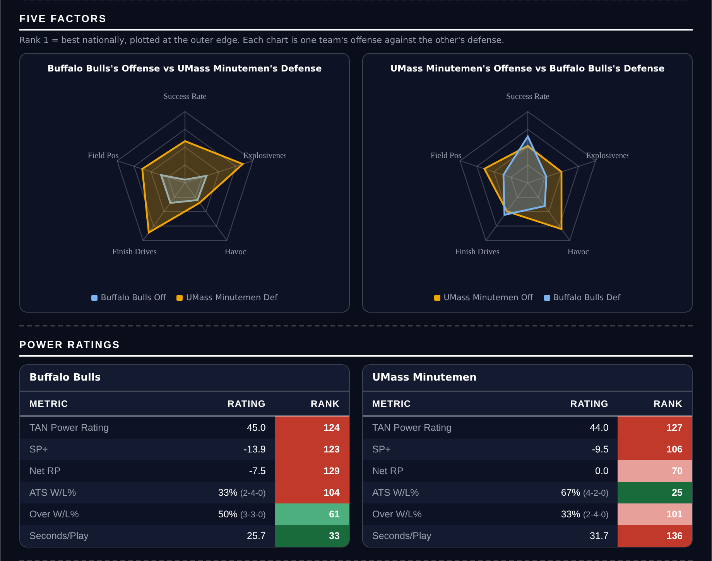
Five Factors and power ratings, captured from the CFB Betting Hub.
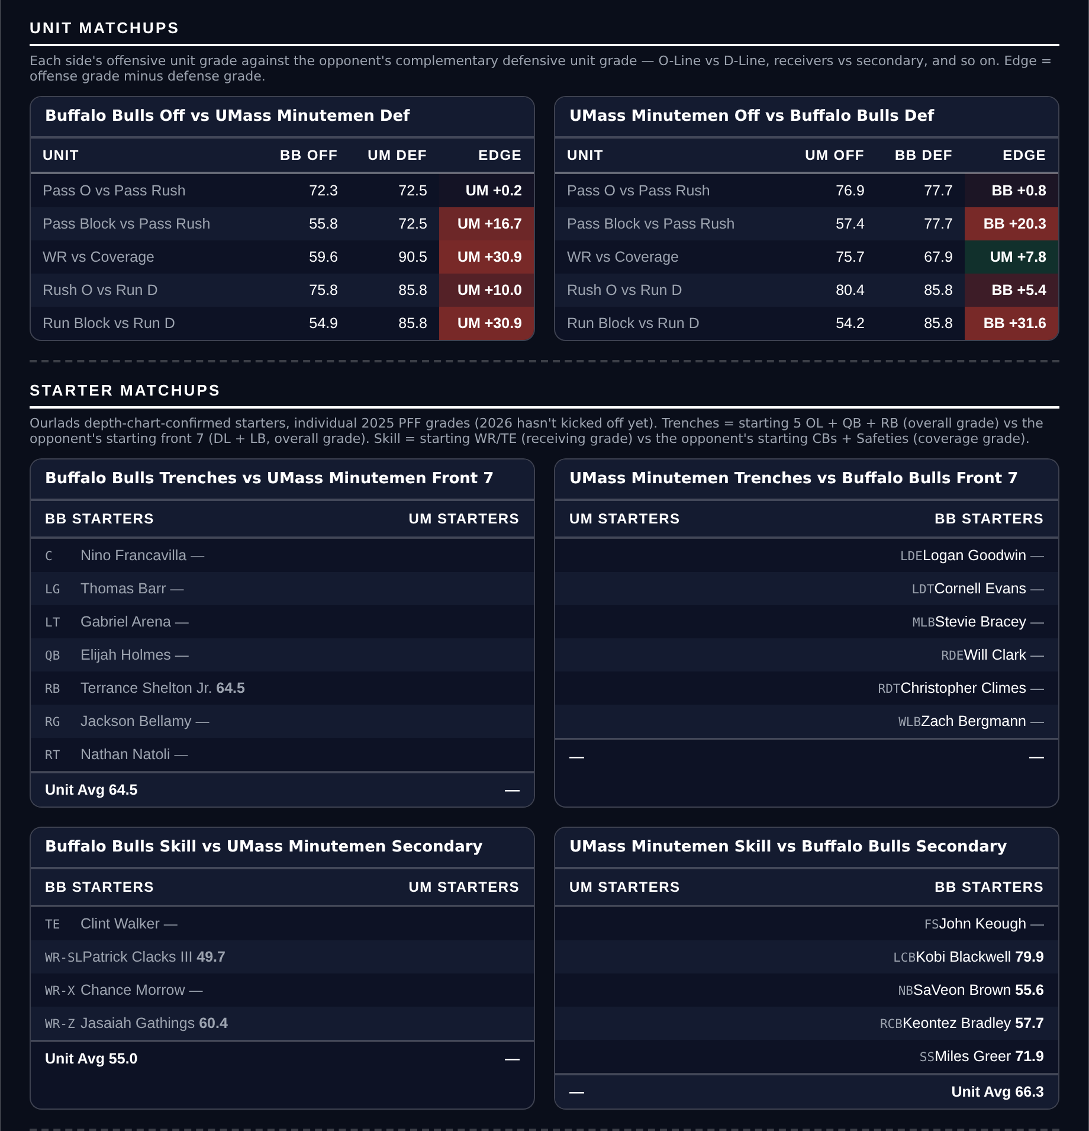
Unit matchups: each offensive unit grade against the opposing defensive unit. Edge = offense minus defense.

Notre Dame Fighting Irish @ BYU Cougars

BYU +10.5
Book line | BYU +10.5
Model number | Notre Dame -3.5
Gap | 7.0 pts, 6.8 net
Points check | Notre Dame by 2.9, which is 7.6 past the market
SP+ (2026) | Notre Dame +28.0 (3rd) vs BYU +21.5 (11th), home edge +3.0
BYU 2026 | 5-0, 5-0 ATS, 34.6 points a game and 13.4 allowed
BYU offense | 88.3 offensive grade (7th), 7th in Success Rate, 91.0 coverage on the other side
Notre Dame | 6-0, 44.0 for and 11.0 against, 1st in run defense and 4th in pass rush

Two unbeaten teams and a double-digit line. The rating has Notre Dame by 3.5 and the points check has them by 2.9, so both measures say this is a one-score game and the market is asking for nearly eleven. Seven to eight points of cushion sits between the number and either estimate.
BYU are 5-0 and have not been priced like it. They grade 94.9 overall, sixth in the country, with an 88.3 offense that ranks seventh and a 91.0 coverage grade that ranks tenth; they score 34.6 and allow 13.4. The home field here is worth 3.0 points and BYU are 5-0 against the spread, first in the country.
Notre Dame are the better team and the card is not arguing otherwise. They are 6-0, score 44.0, allow 11.0, and own the top-ranked run defense and the fourth-ranked pass rush in the country. The argument is about price: a top-ten offense at home, unbeaten, with the country's best cover record, getting double digits. BYU's 52.6 tackling grade is where the Irish will find their yards, and even allowing for that, both measures want the points.
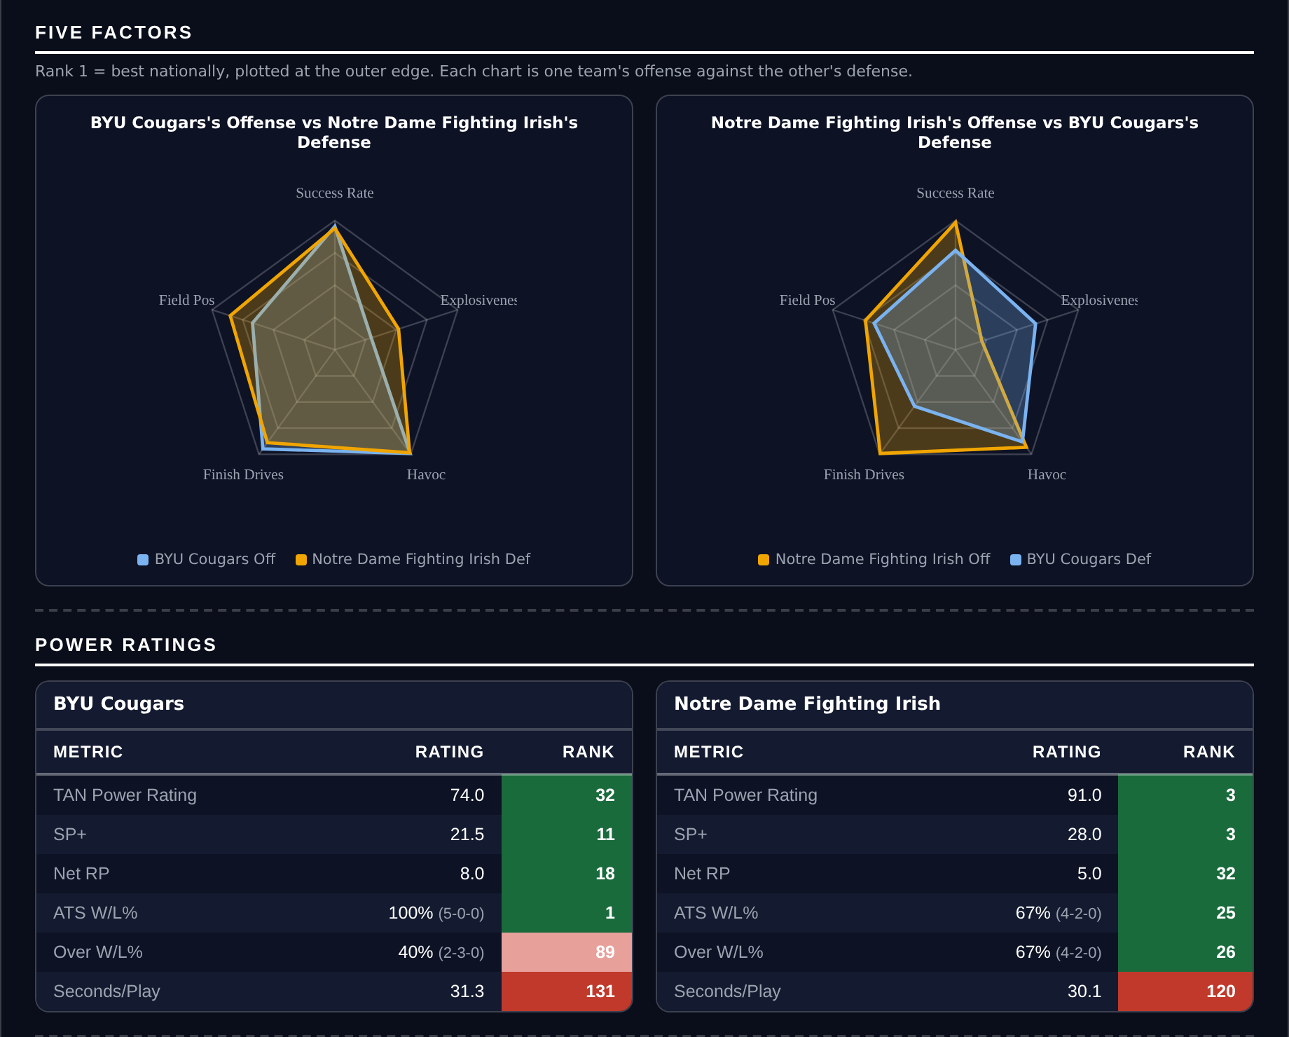
Five Factors and power ratings, captured from the CFB Betting Hub.
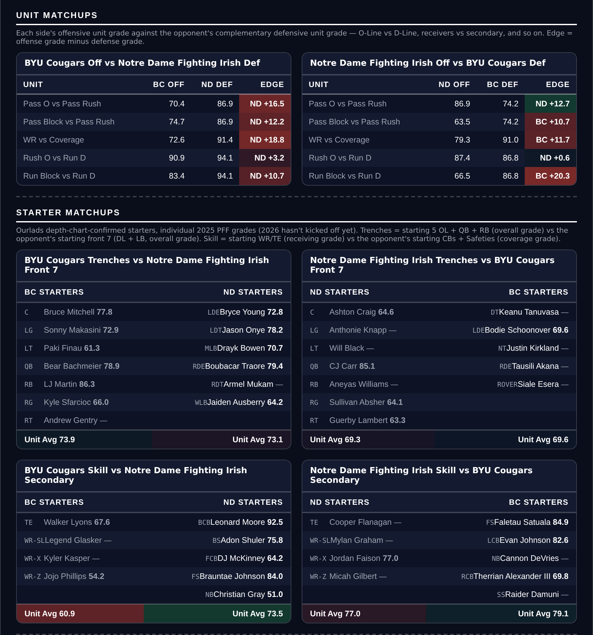
Unit matchups: each offensive unit grade against the opposing defensive unit. Edge = offense minus defense.

Mississippi State Bulldogs @ LSU Tigers

Mississippi State +17.5
Book line | LSU -17.5
Model number | LSU -11.7
Gap | 5.8 pts, 6.0 net
Points check | LSU by 8.8, which is 8.7 past the market
SP+ (2026) | LSU +21.7 (9th) vs Mississippi State +12.6 (28th), home edge +2.6
Mississippi State 2026 | 4-1, 4-1 ATS, 39.0 points a game
Mississippi State offense | 29th in Success Rate, 27th in Explosiveness, tied 22nd in Finishing Drives
LSU | 4-2, 2-4 ATS, 42.0 for and 18.5 against

Book has LSU -17.5. The rating has it at 11.7 and the points check at 8.8, so the market is asking for six to nine more points than either measure produces. Seventeen and a half is a number for a mismatch, and neither input says this is one.
Mississippi State are 4-1 and score 39.0 points a game on an offense that ranks 29th in Success Rate, 27th in Explosiveness and tied 22nd in Finishing Drives. They are 4-1 against the spread, 13th in the country, while LSU are 2-4 against it, 104th. The Bulldogs play at 23.2 seconds a snap, which ranks 6th in the country and adds possessions and with them the chance to cover a large number late.
LSU are the stronger side and the defense is genuinely excellent, grading 93.6 with the country's best coverage unit at 93.8. But a defense that good tends to produce a controlled win rather than a rout, and LSU's own 2-4 record against the number this year is what happens when a team is consistently asked to win by more than it does. An offense that finishes drives at a top-25 rate does not get shut out of a 17.5-point cushion.
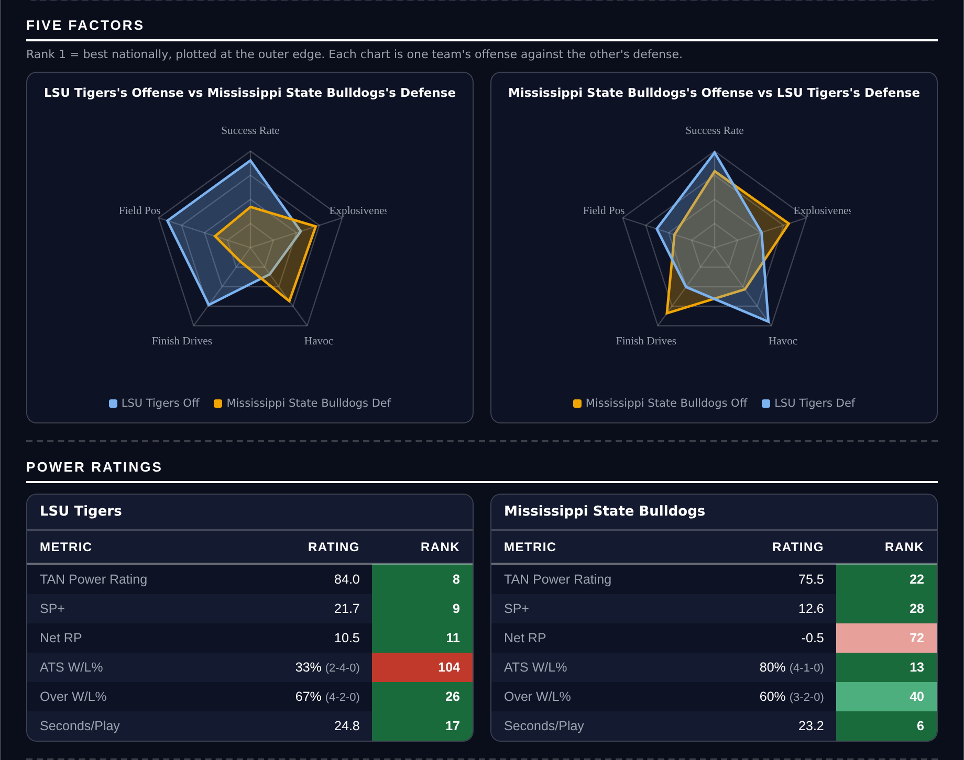
Five Factors and power ratings, captured from the CFB Betting Hub.
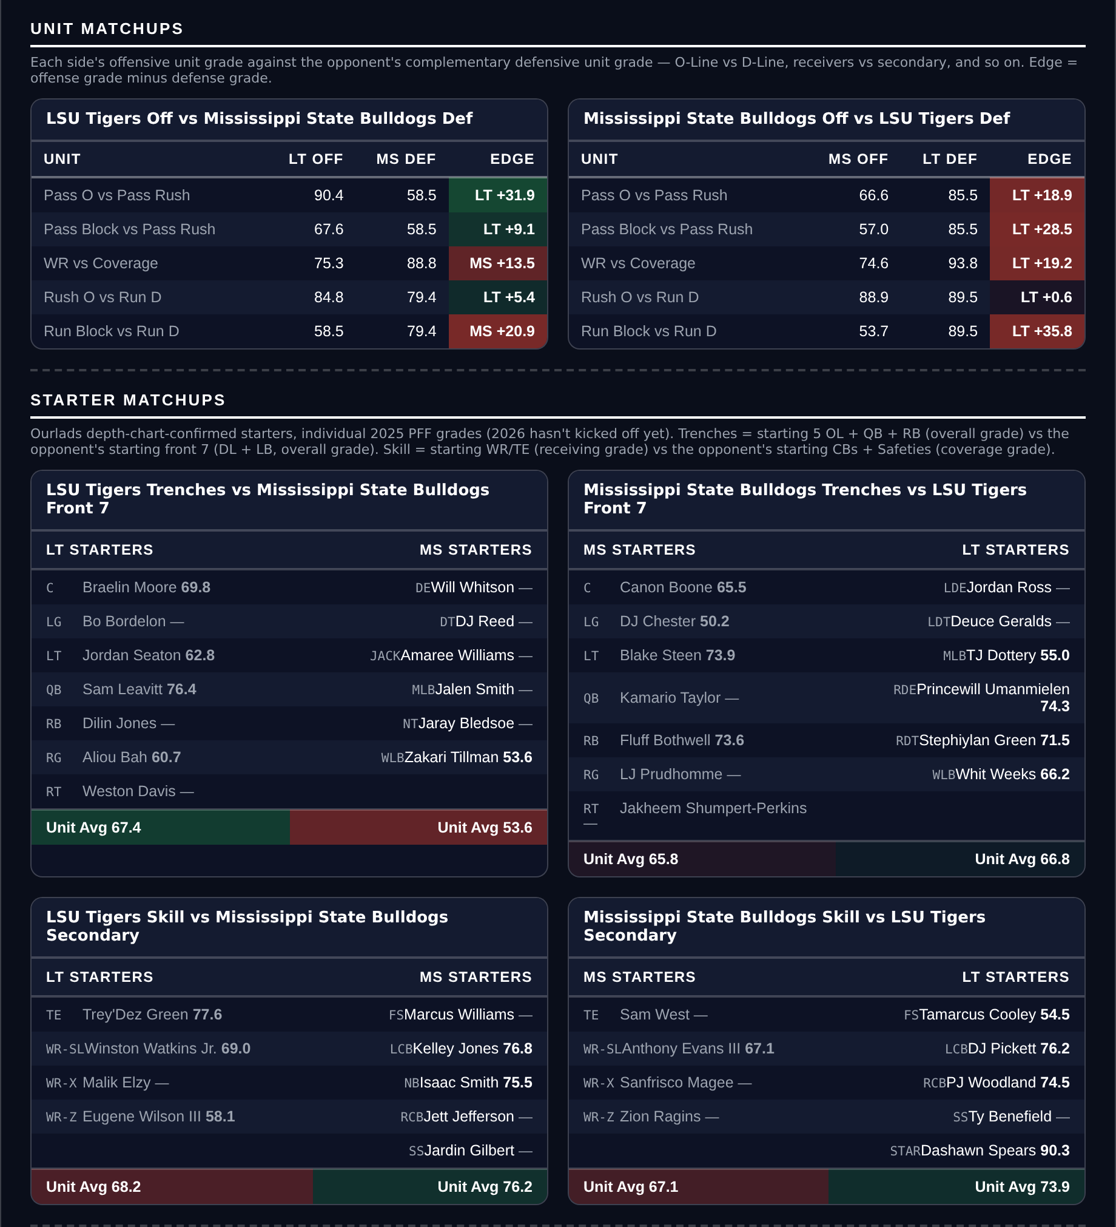
Unit matchups: each offensive unit grade against the opposing defensive unit. Edge = offense minus defense.

Missouri Tigers @ Ole Miss Rebels

Missouri +5.0
Book line | Ole Miss -5.0
Model number | Ole Miss -0.5
Gap | 4.5 pts, 4.7 net
Points check | Missouri by 1.1, which is 6.1 past the market
SP+ (2026) | Missouri +18.0 (13th) vs Ole Miss +15.9 (16th), home edge +2.6
Missouri 2026 | 5-1, 35.8 points a game and 17.7 allowed
Missouri defense | 18th in Success Rate, 87.6 pass rush (2nd), 4th in defensive Havoc
Ole Miss defense | 105th overall, 55.9 coverage (125th), 52.6 tackling (123rd)

SP+ rates Missouri higher than Ole Miss, 18.0 against 15.9, and the market still asks Missouri to take five points on the road. Home field accounts for 2.6 of that, which leaves the rating at Ole Miss by half a point and the points check at Missouri by 1.1. Both land four to six points clear of the number.
Missouri's defense is the reason. It ranks 18th in Success Rate and fourth in Havoc, grades 90.5 overall and 90.6 against the run, and its 87.6 pass-rush grade ranks 2nd in the country. They are 5-1 and allow 17.7 points a game, and that pressure is pointed at an Ole Miss offense that is excellent on early downs but ranks 115th in Explosiveness, meaning it has to assemble long drives against the unit least likely to let it.
Ole Miss are 4-1 but the defensive half of the sheet is where this game is decided. They grade 73.6 overall, 105th, with a 55.9 coverage grade that ranks 125th and 52.6 tackling that ranks 123rd, and they rank 116th in defensive Success Rate and 95th in Finishing Drives. Missouri score 35.8 a game. Five points is a thin cushion between two teams SP+ separates by two, and the thinner half of the matchup belongs to the favourite.
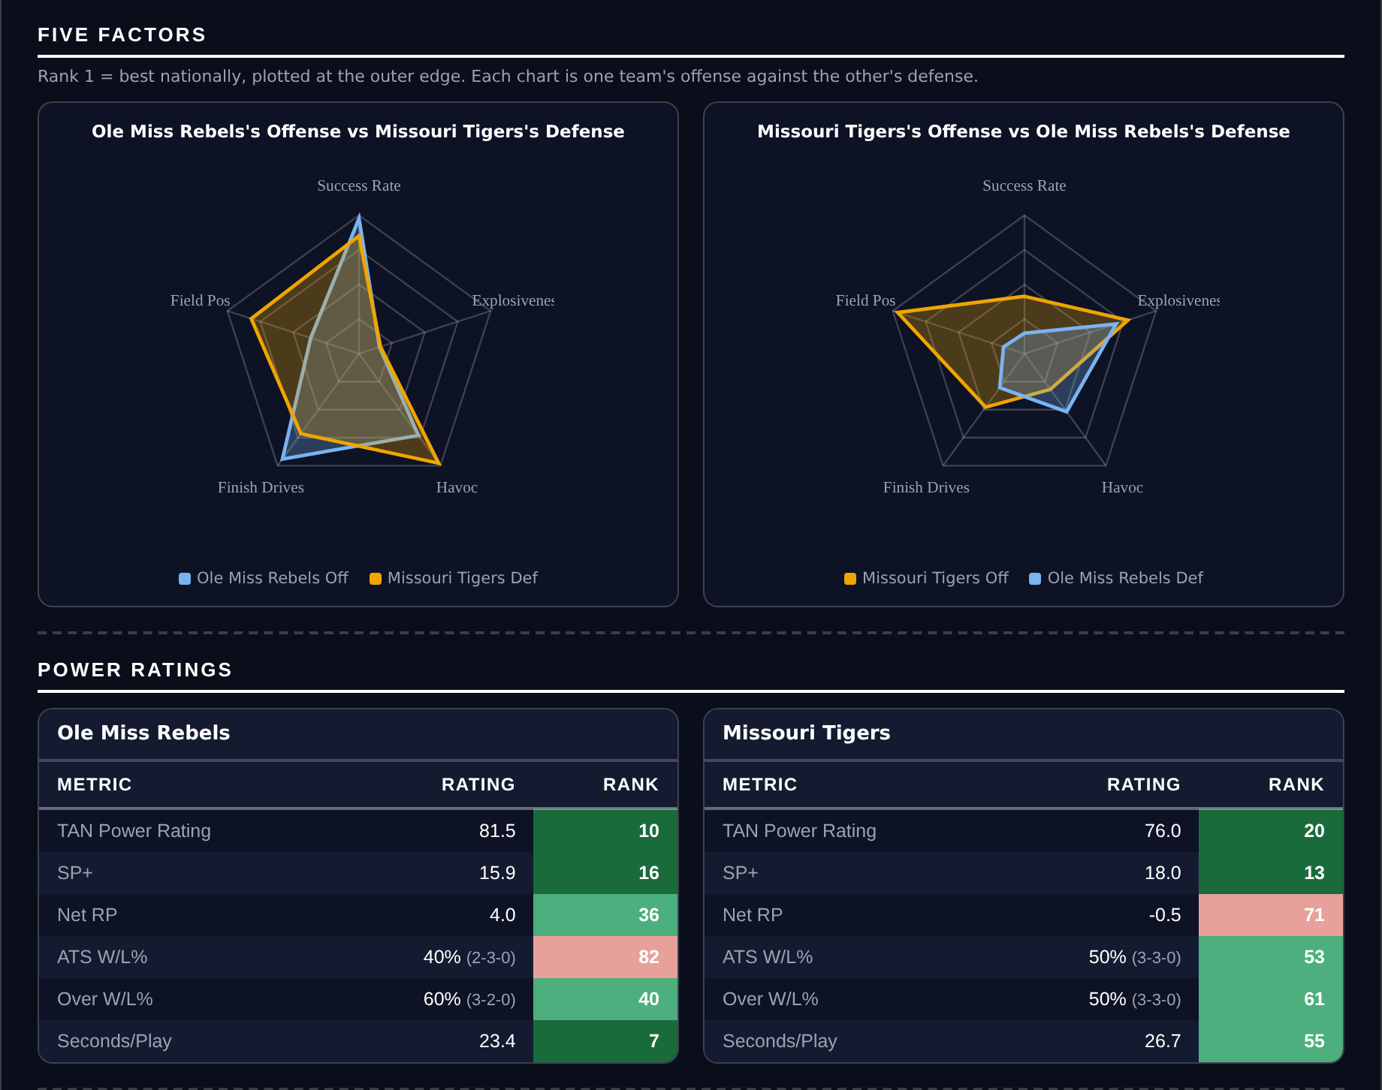
Five Factors and power ratings, captured from the CFB Betting Hub.
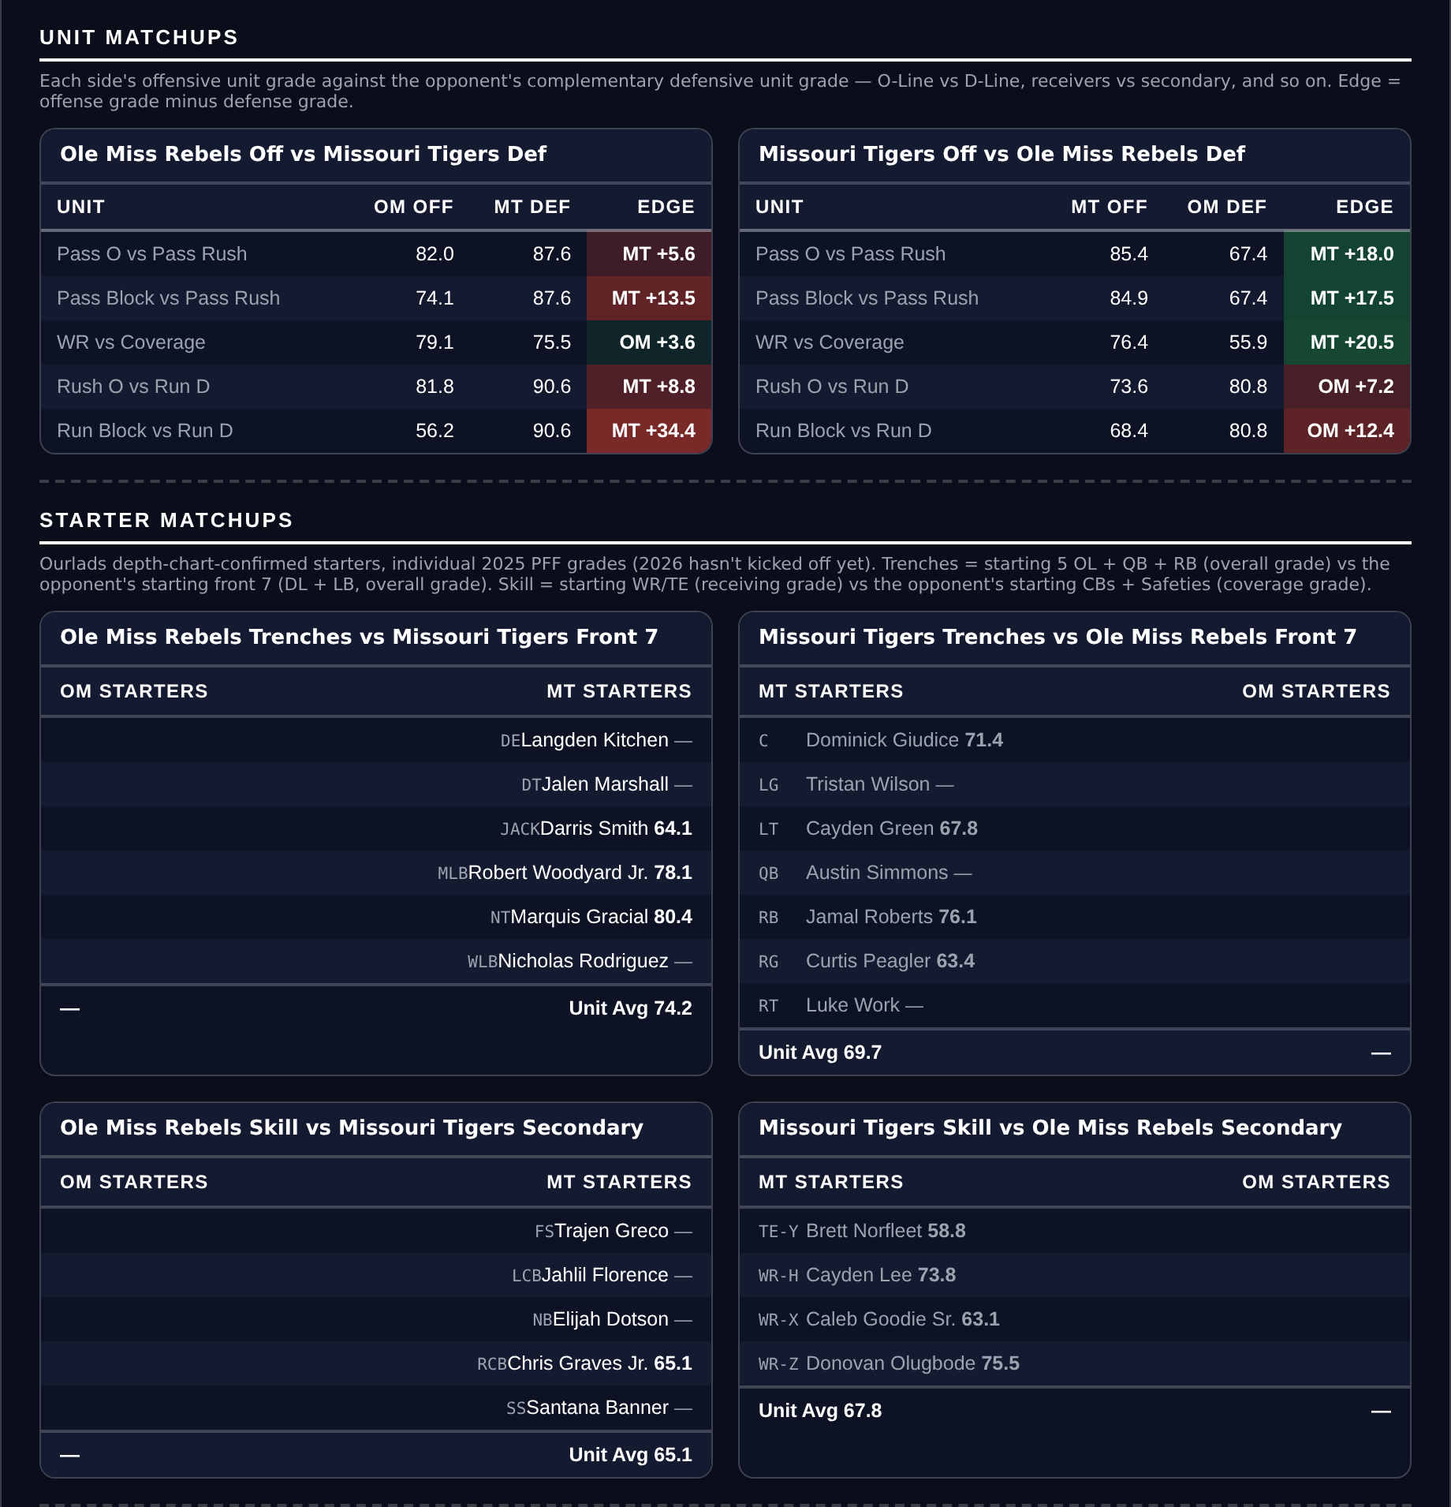
Unit matchups: each offensive unit grade against the opposing defensive unit. Edge = offense minus defense.

Northern Illinois Huskies @ Wyoming Cowboys

Wyoming -7.5
Book line | Wyoming -7.5
Model number | Wyoming -12.4
Gap | 4.9 pts, 4.7 net
Points check | Wyoming by 10.8, which is 3.3 past the market
SP+ (2026) | Wyoming -13.8 (122nd) vs Northern Illinois -23.5 (133rd), home edge +2.7
Northern Illinois 2026 | 0-5, 12.4 points a game and 34.6 allowed
Northern Illinois offense | 125th in Success Rate, 137th in Finishing Drives, 138th special teams
Wyoming defense | 22nd in Success Rate, 90.0 run defense (27th), 83.8 pass rush (12th)

Book has Wyoming -7.5. The rating has it at 12.4 and the points check at 10.8, and both sit clear of the number on the same side. This is the one spread on the card where the model and the market disagree about the size of a mismatch rather than its direction.
Northern Illinois are 0-5 and the profile is comprehensive. They score 12.4 points a game, fewest in the country, and allow 34.6. The offense ranks 125th in Success Rate and 137th in Finishing Drives; the defense ranks 131st in Success Rate and 136th in Havoc; the special teams grade 48.0, which is last of all 138 teams. The pass rush grades 57.2, 137th.
Wyoming win this with defense, which is the half of their team that works. They grade 90.2 defensively, 22nd in Success Rate, with 90.0 against the run and an 83.8 pass-rush grade that ranks 12th. They allow 20.5 points a game. Against an offense that ranks 138th of 138 in scoring, that unit does not need much help, and a special-teams unit ranked 138th hands over field position in a game where Wyoming's own offense will not have to travel far.
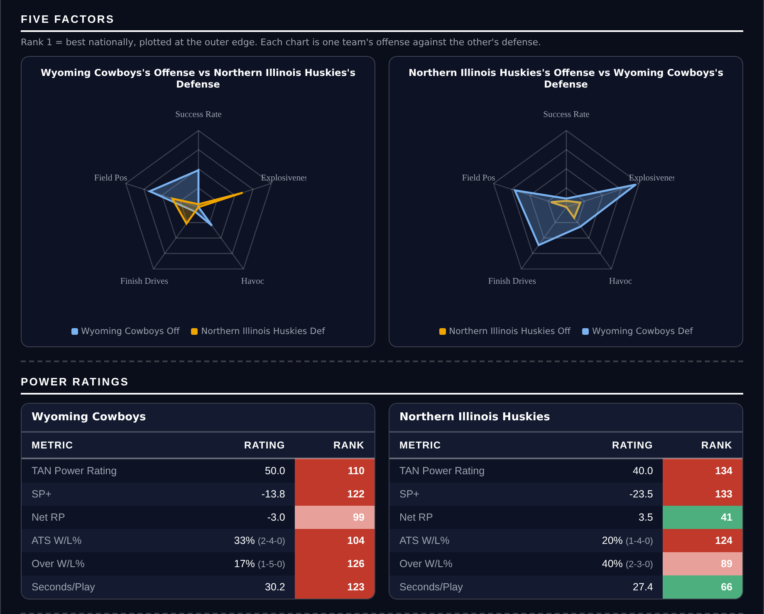
Five Factors and power ratings, captured from the CFB Betting Hub.
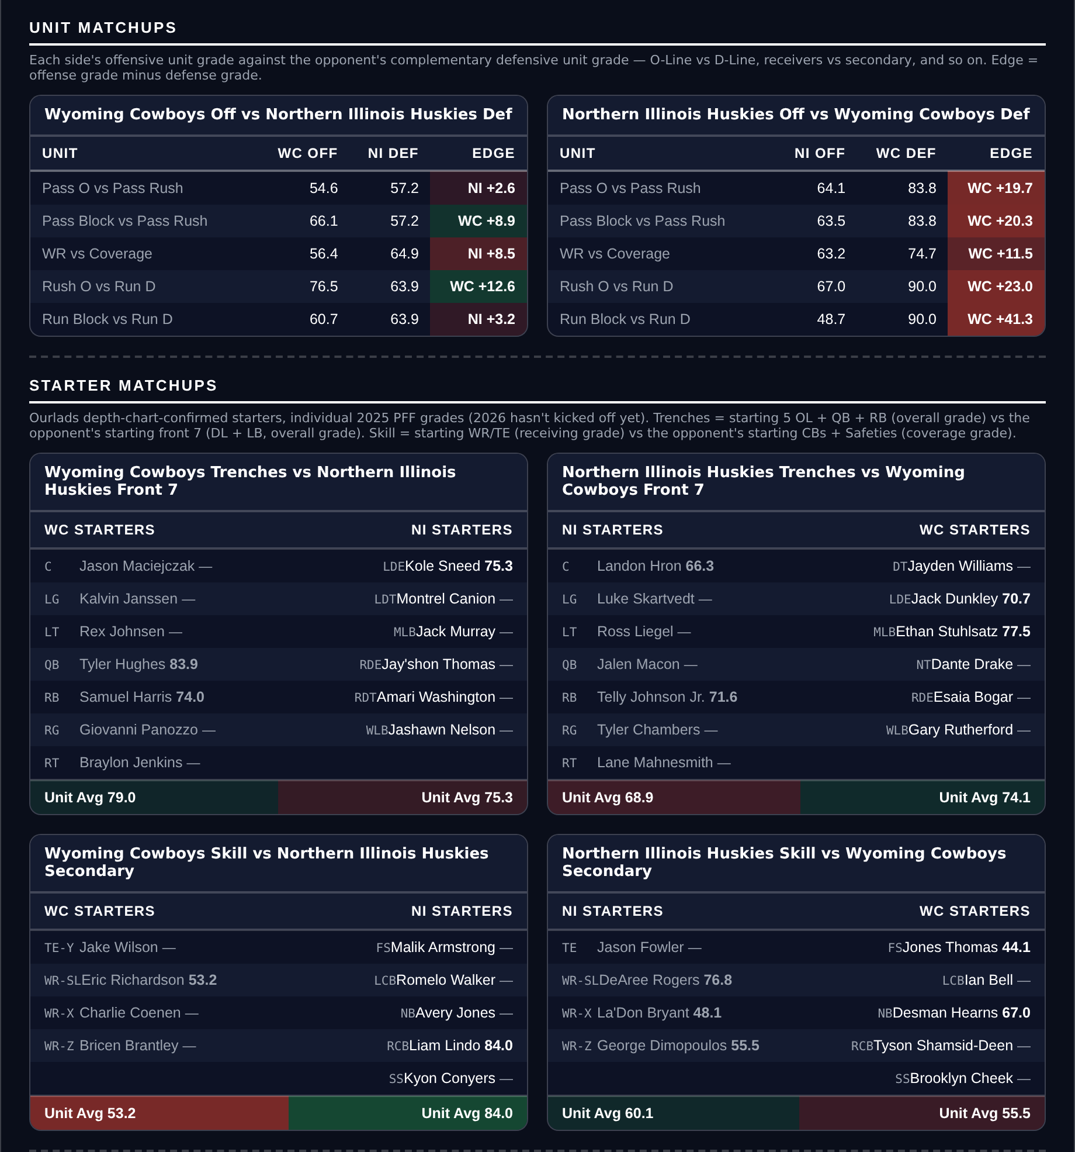
Unit matchups: each offensive unit grade against the opposing defensive unit. Edge = offense minus defense.

Totals
Five totals, selected on the same agreement test and ranked by the weaker of the two readings. Three Overs and two Unders, which is close to the split the slate itself offers: 32 of the 45 games lean Over before any adjustment, and that tilt is removed before anything is ranked.
The residual is reported on every pick and selected on none. It is the measure this card used for three weeks, and when all 93 games of weeks 4 and 5 were scored it went 42-49 and lost at every threshold. It is kept in view because it was the stated method, and on two of the five totals here it agrees anyway.
Ratings and the Five Factors come from the 2026 workbook: SP+, TAN, implied team totals and the season-to-date CFBData ranks, out of 138 teams. Player lines are 2026 PFF season to date. Records, ATS and over/under records are TeamRankings, 2026 to date. The PFF team grade file covers five games for 47 teams, six for 87 and seven for 4.

Wisconsin Badgers @ UCLA Bruins

Over 43.0
Book total | 43.0
Model number | 53.2
Points check | 52.7
Gap | 10.2 points above the market
Residual | +3.0, agreeing
Scoring | Wisconsin 31.6 for / 16.6 against, UCLA 39.2 / 18.0
Combined scoring | 70.8 points a game between them against a 43.0 line
Over records | Wisconsin 3-2, UCLA 3-2

Book has 43.0. The rating produces 53.2 and each team's own scoring produces 52.7, within half a point of each other and ten points above the market. Ranked by the weaker of the two readings, this is the first total on the board.
The scoring averages are the argument. Wisconsin put up 31.6 a game and UCLA 39.2, which is 70.8 between them, and the market is asking for 43. Even crediting both defences fully, the points check already discounts for them: it pairs each offence against what the other side actually allows and still arrives at 52.7. UCLA are 5-0 and rank second in the country in offensive Field Position; Wisconsin rank second in offensive Explosiveness.
A 2.5-point spread is the other half of it. Neither team is expected to control this game, which means four quarters of both offences on the field rather than a second half of clock-killing. Both teams have gone over in three of five, and a 43 in a game between a 5-0 team scoring 39 and a 4-1 team scoring 31 is a number built for a defensive struggle that neither offence's record supports.
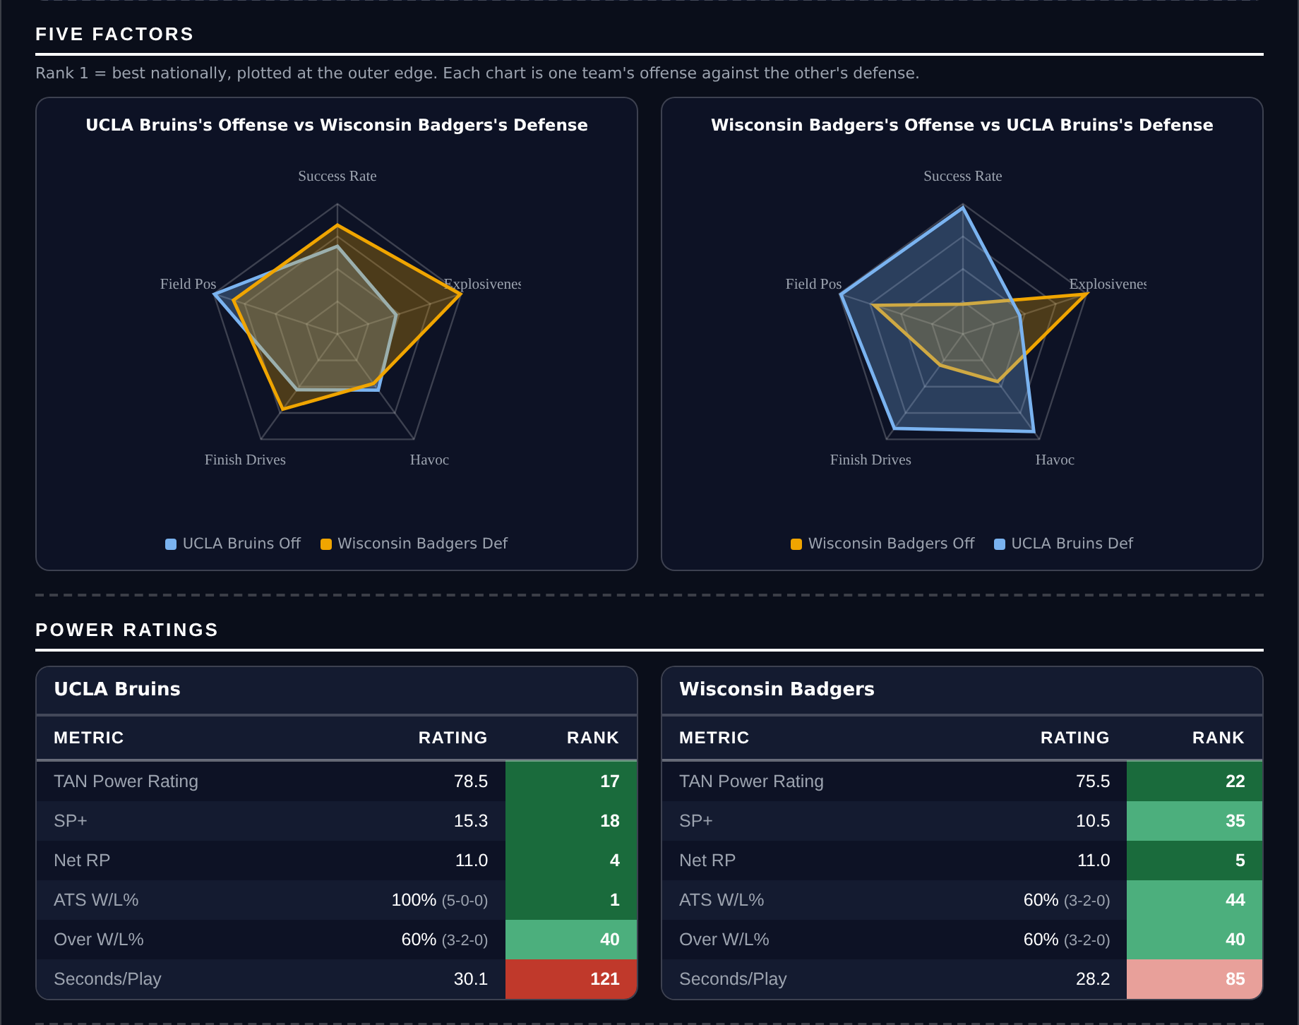
Five Factors and power ratings, captured from the CFB Betting Hub.
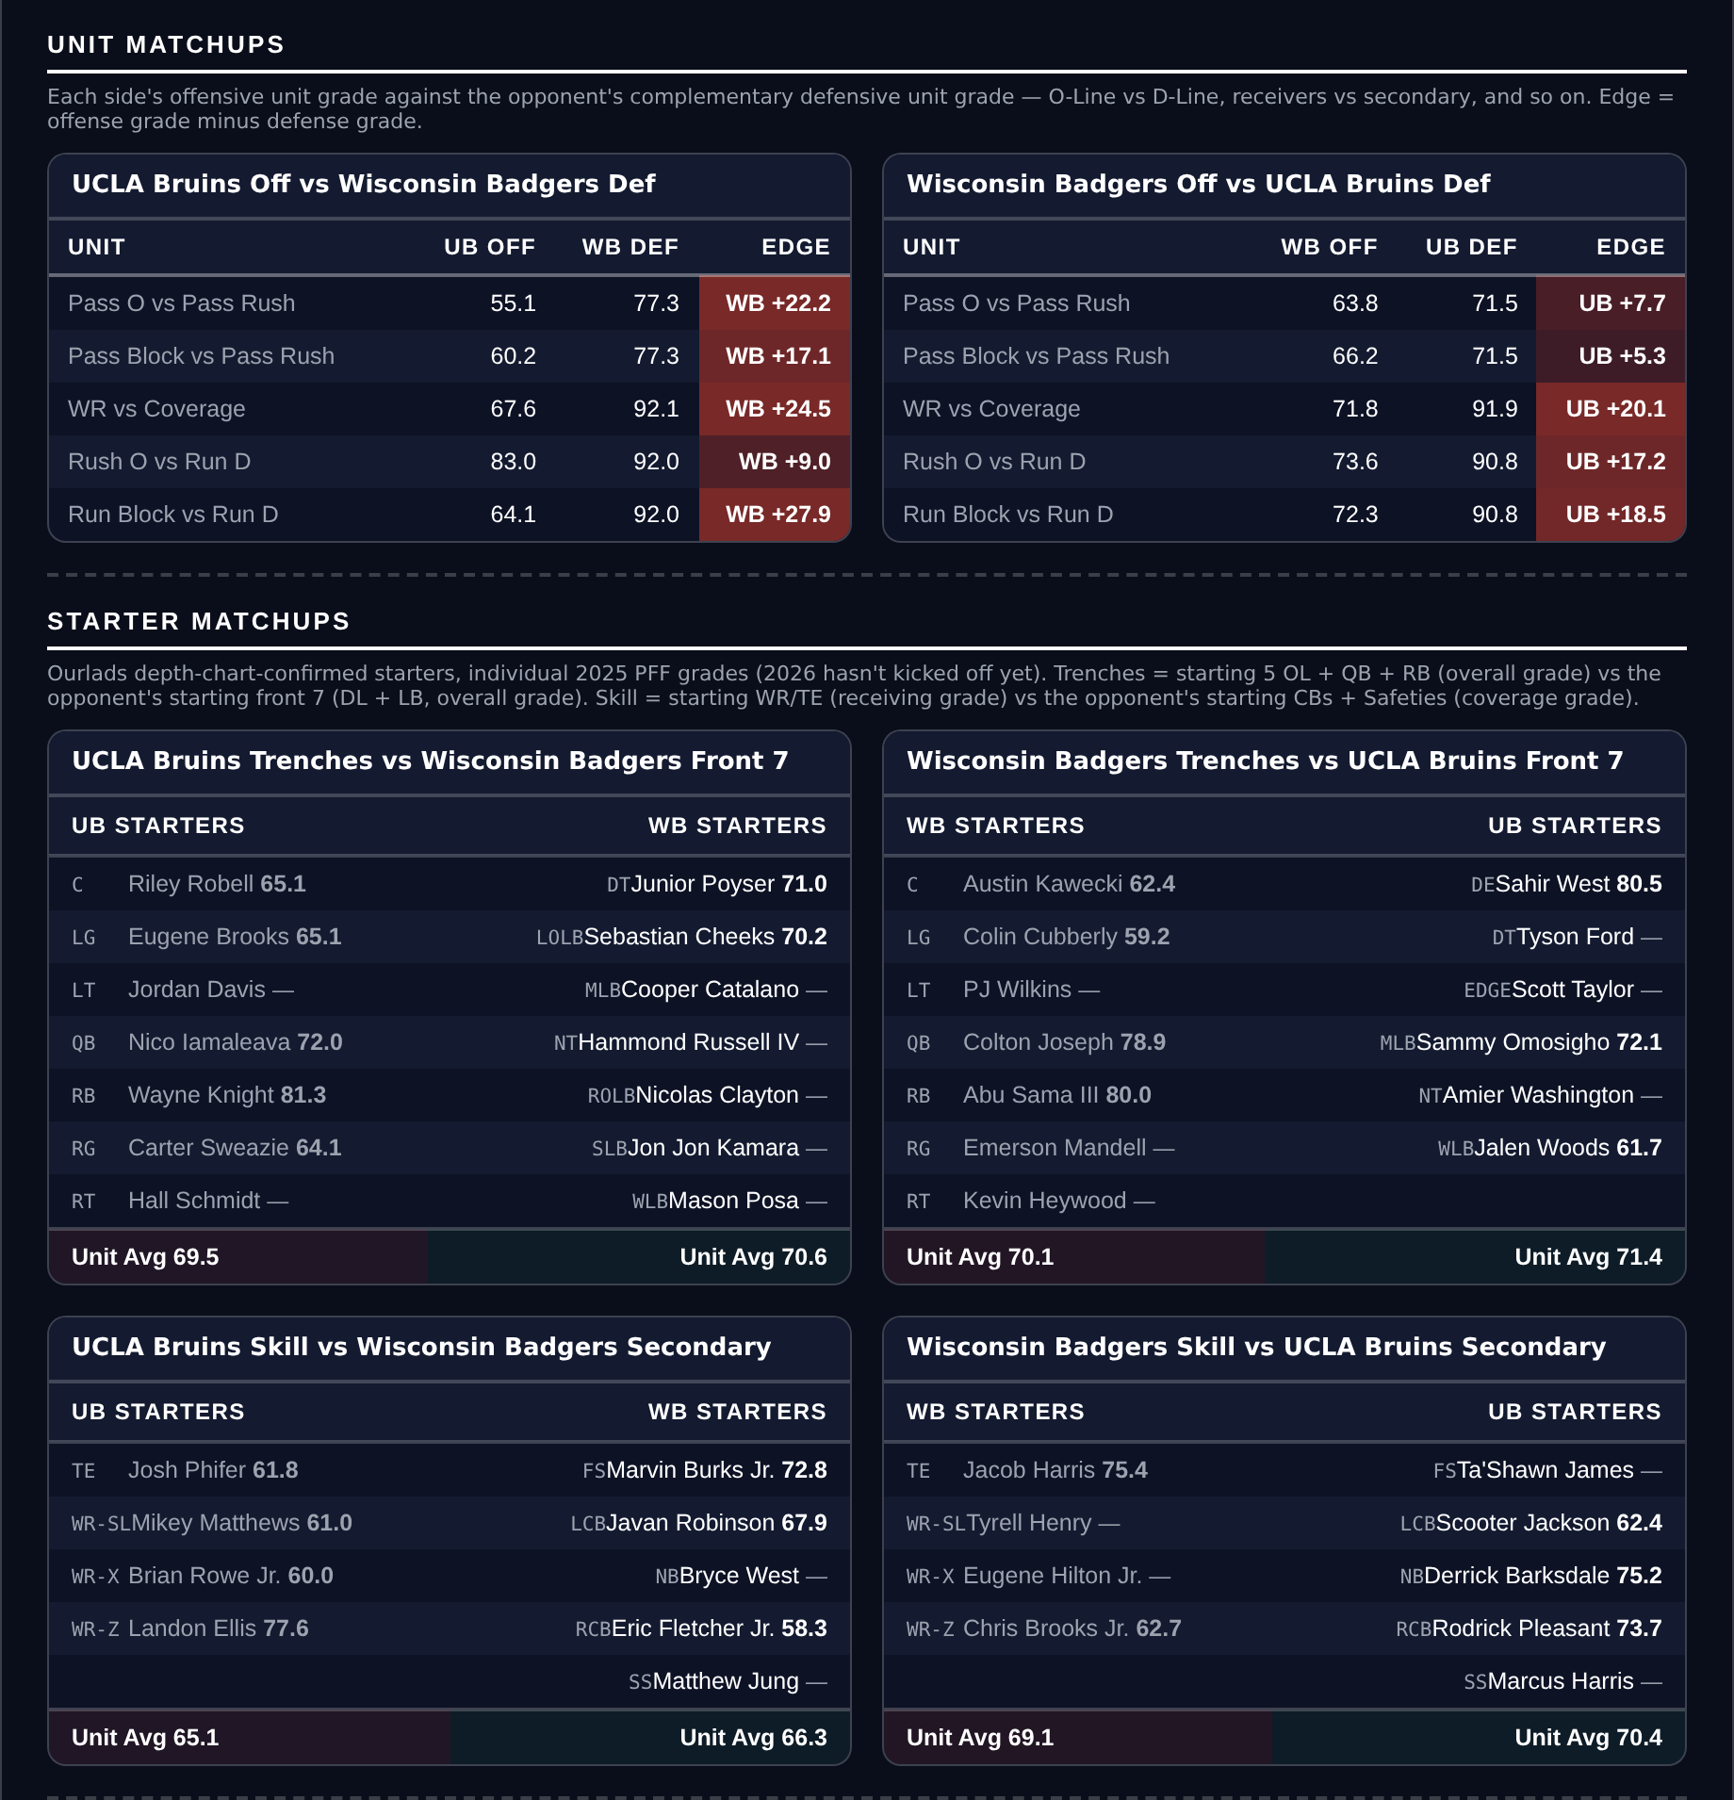
Unit matchups: each offensive unit grade against the opposing defensive unit. Edge = offense minus defense.

Mississippi State Bulldogs @ LSU Tigers

Over 56.0
Book total | 56.0
Model number | 63.6
Points check | 63.8
Gap | 7.6 points above the market
Residual | +3.0, agreeing
Scoring | Mississippi State 39.0 for / 28.0 against, LSU 42.0 / 18.5
Tempo | Mississippi State 23.2 seconds a snap (6th), LSU 24.8 (17th)
Over records | Mississippi State 3-2, LSU 4-2

Book has 56.0. The rating produces 63.6 and the points check 63.8, two tenths apart and both nearly eight points above the market. When the two measures converge this tightly they are usually describing the same thing, and here it is a game that should produce points.
Both offences arrive scoring. LSU put up 42.0 a game and rank 14th in offensive Success Rate; Mississippi State put up 39.0 and rank 29th in Success Rate, 27th in Explosiveness and tied 22nd in Finishing Drives. Mississippi State also allow 28.0 a game on a defence that grades 78.3, 82nd, and ranks 112th in Finishing Drives, so the side of the ball most likely to hold this total down is the one least equipped to.
Pace does the rest. Mississippi State snap it every 23.2 seconds and LSU every 24.8, ranking 6th and 17th in the country. Both rank inside the top twenty for pace nationally. That adds possessions to a game already projected to produce points on a high share of them. LSU have gone over in four of six.
Five Factors and power ratings, captured from the CFB Betting Hub.
Unit matchups: each offensive unit grade against the opposing defensive unit. Edge = offense minus defense.

Nebraska Cornhuskers @ Oregon Ducks

Over 51.5
Book total | 51.5
Model number | 59.6
Points check | 58.7
Gap | 8.1 points above the market
Residual | +2.2, agreeing
Scoring | Nebraska 39.2 for / 15.2 against, Oregon 41.0 / 22.0
Combined scoring | 80.2 points a game between them against a 51.5 line
Over records | Nebraska 3-3, Oregon 4-1

Book has 51.5. The rating produces 59.6 and each team's own scoring produces 58.7, both eight points or so above the market and agreeing on the side.
Oregon average 41.0 points a game, 13th in the country, and Nebraska 39.2, tied 18th; between them that is 80.2 a game against a line asking for 51.5. Nebraska's offence ranks 14th in Explosiveness and 12th in Finishing Drives, which is the combination that turns possessions into touchdowns rather than field goals, and Oregon have gone over in four of five.
The number looks like it has been set on reputation for two good defences rather than on what either has actually allowed. Oregon give up 22.0 points a game and Nebraska 15.2, which averages out well short of what either offence is scoring. A seven-point spread also keeps both sides playing: this is not a game either team is expected to put away.
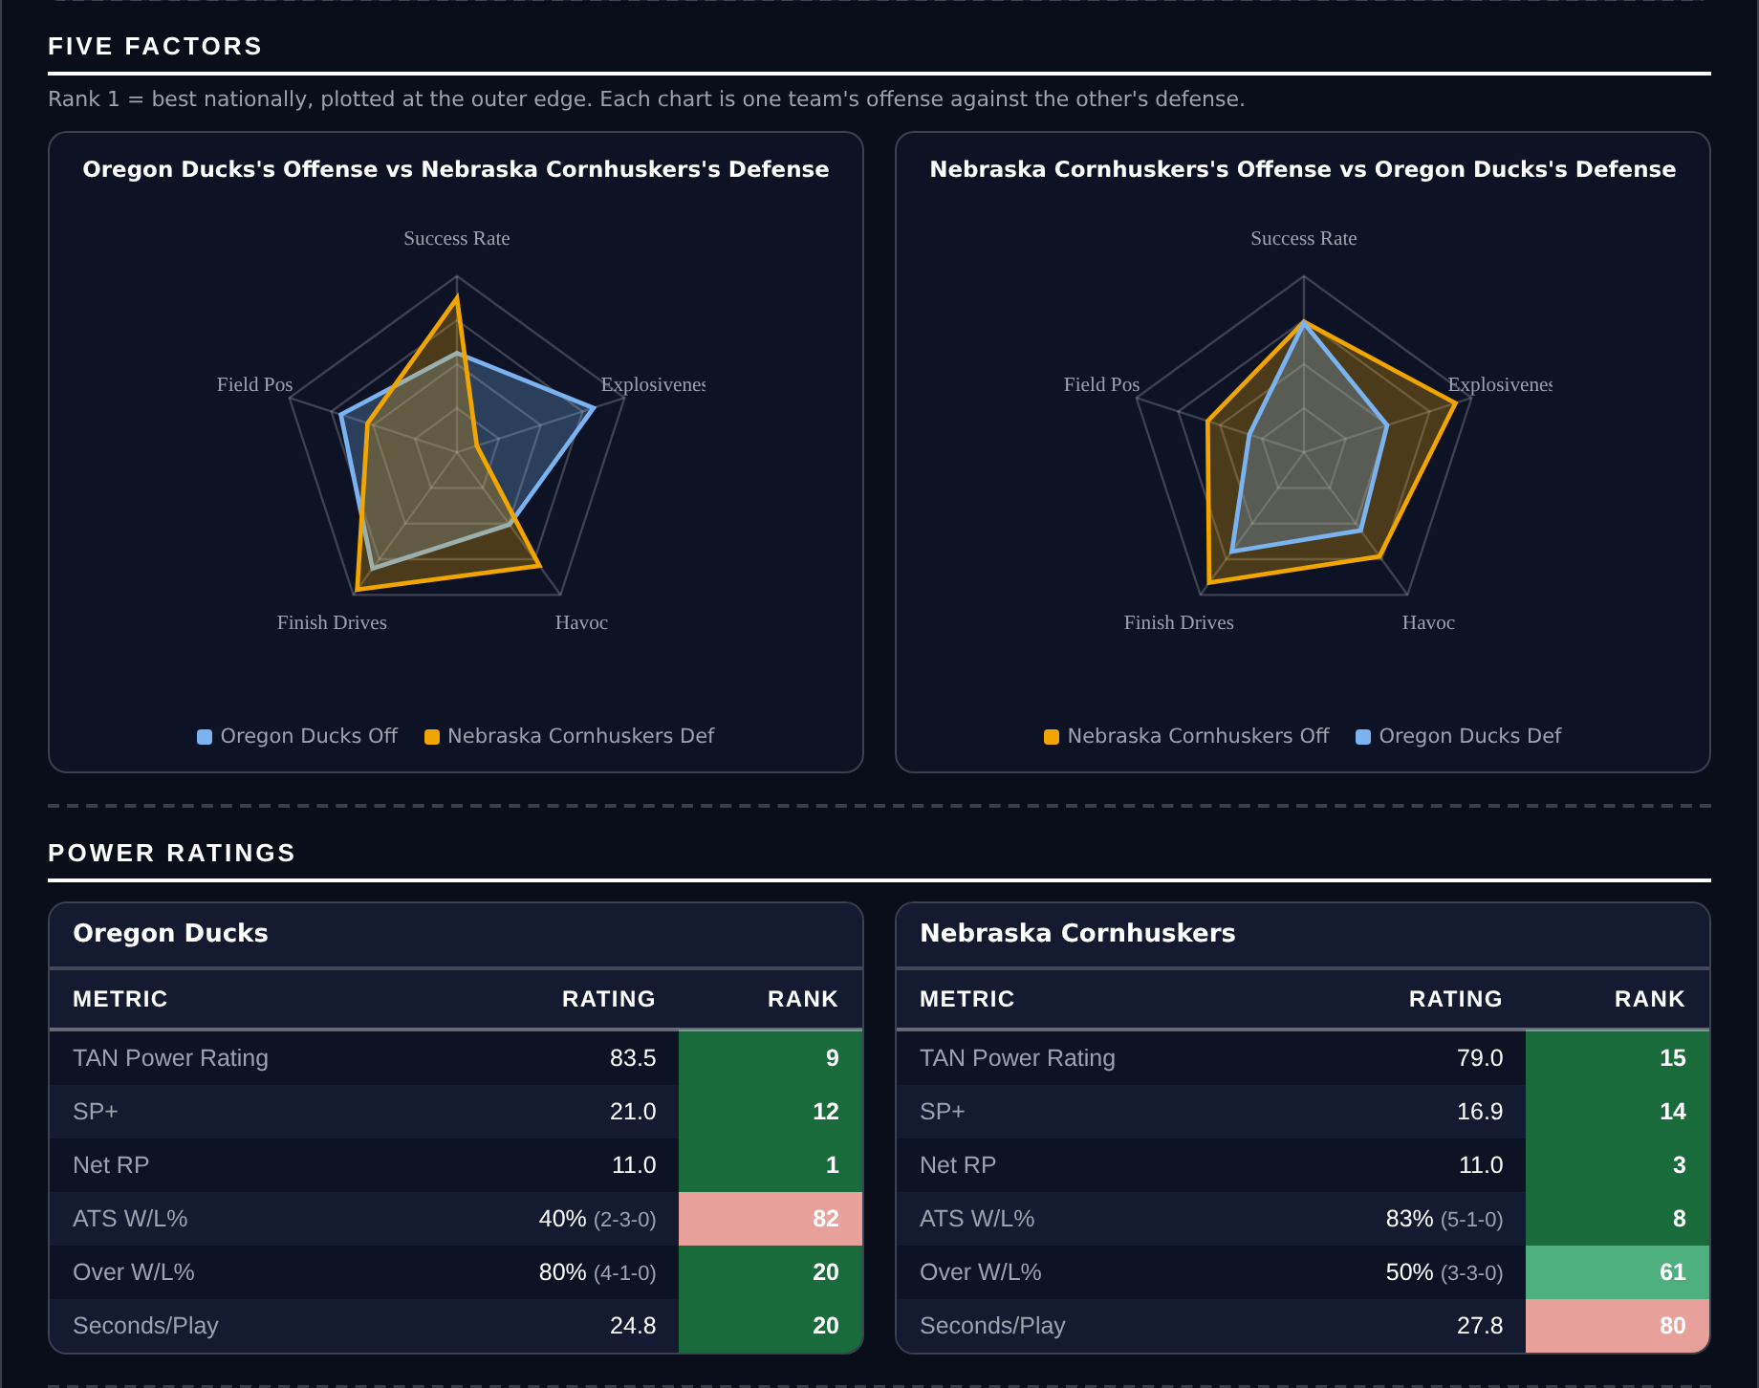
Five Factors and power ratings, captured from the CFB Betting Hub.
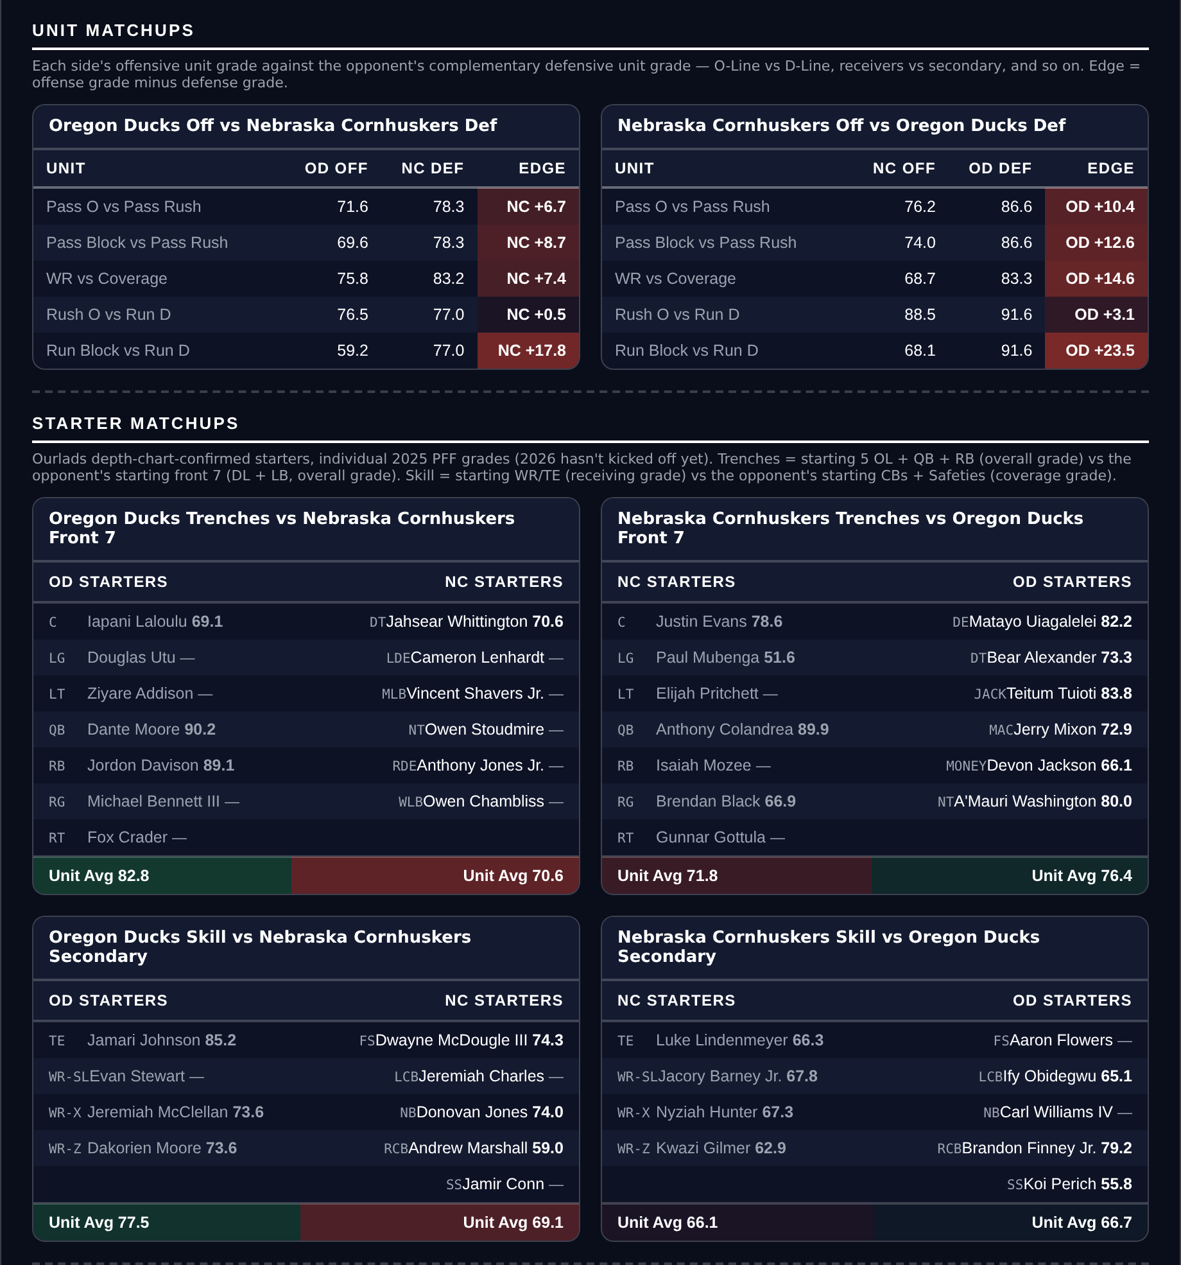
Unit matchups: each offensive unit grade against the opposing defensive unit. Edge = offense minus defense.

Oklahoma State Cowboys @ Houston Cougars

Under 62.5
Book total | 62.5
Model number | 60.6
Points check | 59.4
Gap | 3.1 points below the market
Residual | -5.2, agreeing
Scoring | Oklahoma State 38.2 for / 21.4 against, Houston 40.0 / 19.2
Explosiveness | Oklahoma State 128th, Houston 127th
Over records | Oklahoma State 3-2, Houston 4-2

Book has 62.5. The rating produces 60.6 and the points check 59.4, both below the number, and the residual agrees at -5.2. All three available measures point the same way on the highest total the card touches.
Both offences are efficient and neither is explosive. Houston rank second in the country in offensive Success Rate and Oklahoma State 19th, so both move the ball; but Houston rank 127th in Explosiveness and Oklahoma State 128th, which means they move it in increments. That is the profile that eats clock rather than scoreboard, and it is the reason two offences averaging 38.2 and 40.0 project under a number set as though they trade big plays.
62.5 is among the highest totals posted anywhere this week and it needs both teams at their ceiling to land. Oklahoma State allow 21.4 a game and Houston 19.2; the points check pairs each offence against what the other actually gives up and lands at 59.4. Houston play at 27.3 seconds a snap, outside the top sixty, which limits how many possessions this adds up over.
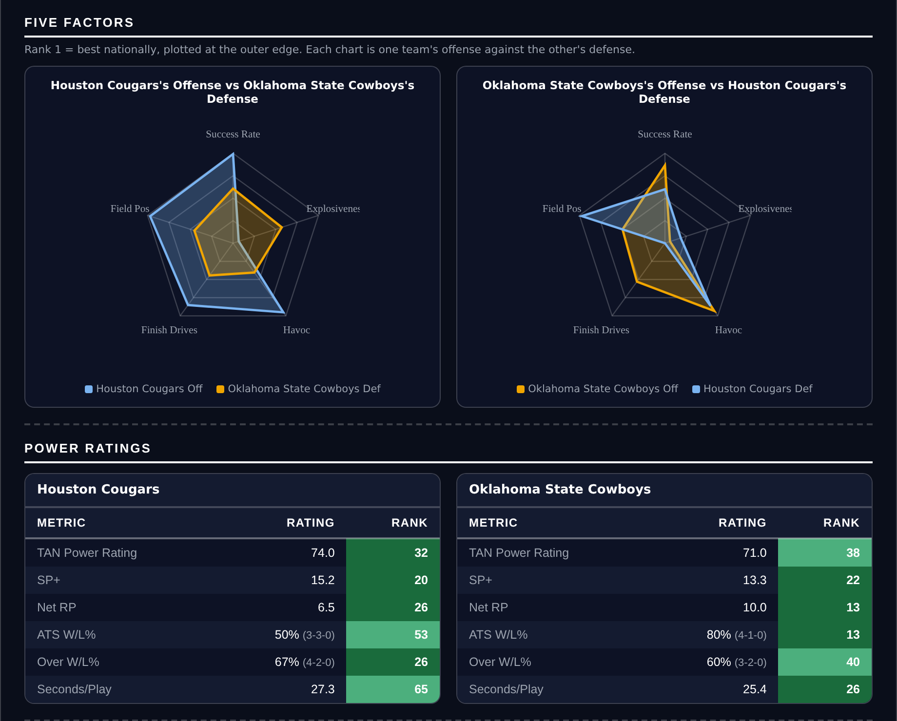
Five Factors and power ratings, captured from the CFB Betting Hub.
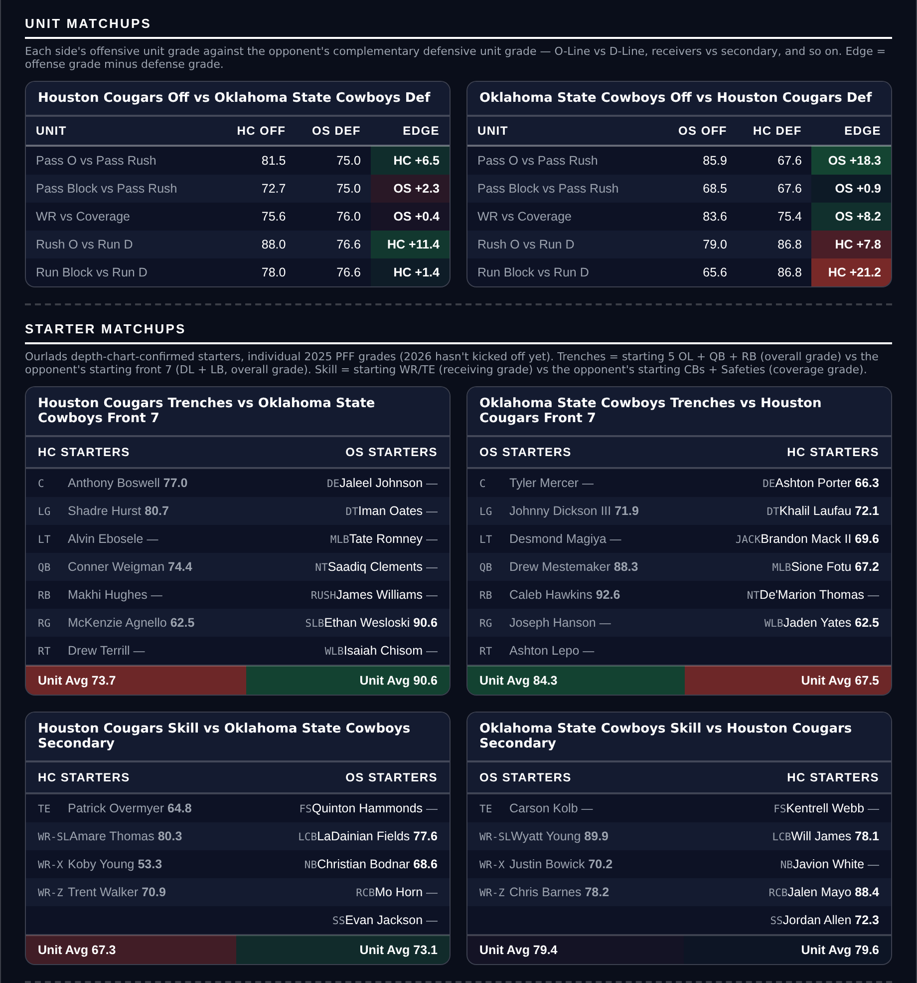
Unit matchups: each offensive unit grade against the opposing defensive unit. Edge = offense minus defense.

Georgia Tech Yellow Jackets @ Virginia Tech Hokies

Under 56.5
Book total | 56.5
Model number | 54.7
Points check | 55.7
Gap | 4.2 points below the market
Residual | -5.6, agreeing
Scoring | Georgia Tech 27.2 for / 25.8 against, Virginia Tech 37.7 / 20.7
Virginia Tech defense | 15th in Success Rate, 2nd in Havoc, 91.4 run defense (13th)
Game spread | Virginia Tech -8.5

Book has 56.5. The rating produces 54.7 and the points check 55.7, both under the number, and the residual agrees at -5.6. Three measures, all on the same side.
Georgia Tech are the problem for this total. They score 27.2 a game on an offence that ranks 59th in Success Rate and 93rd in Finishing Drives, and they are 2-3. Reaching 56.5 asks them for something close to 30 against a Virginia Tech defence that ranks 15th in Success Rate, second in the country in Havoc, and grades 91.4 against the run, 13th. Havoc at that level turns drives into punts rather than field goals.
The spread supports it too. Virginia Tech are laying 8.5 at home, and a favourite that size playing from in front against a struggling offence is a recipe for a shortened second half. Virginia Tech score 37.7, so their side of the total is real; the Under is a position on Georgia Tech's half of the scoreboard rather than on both.
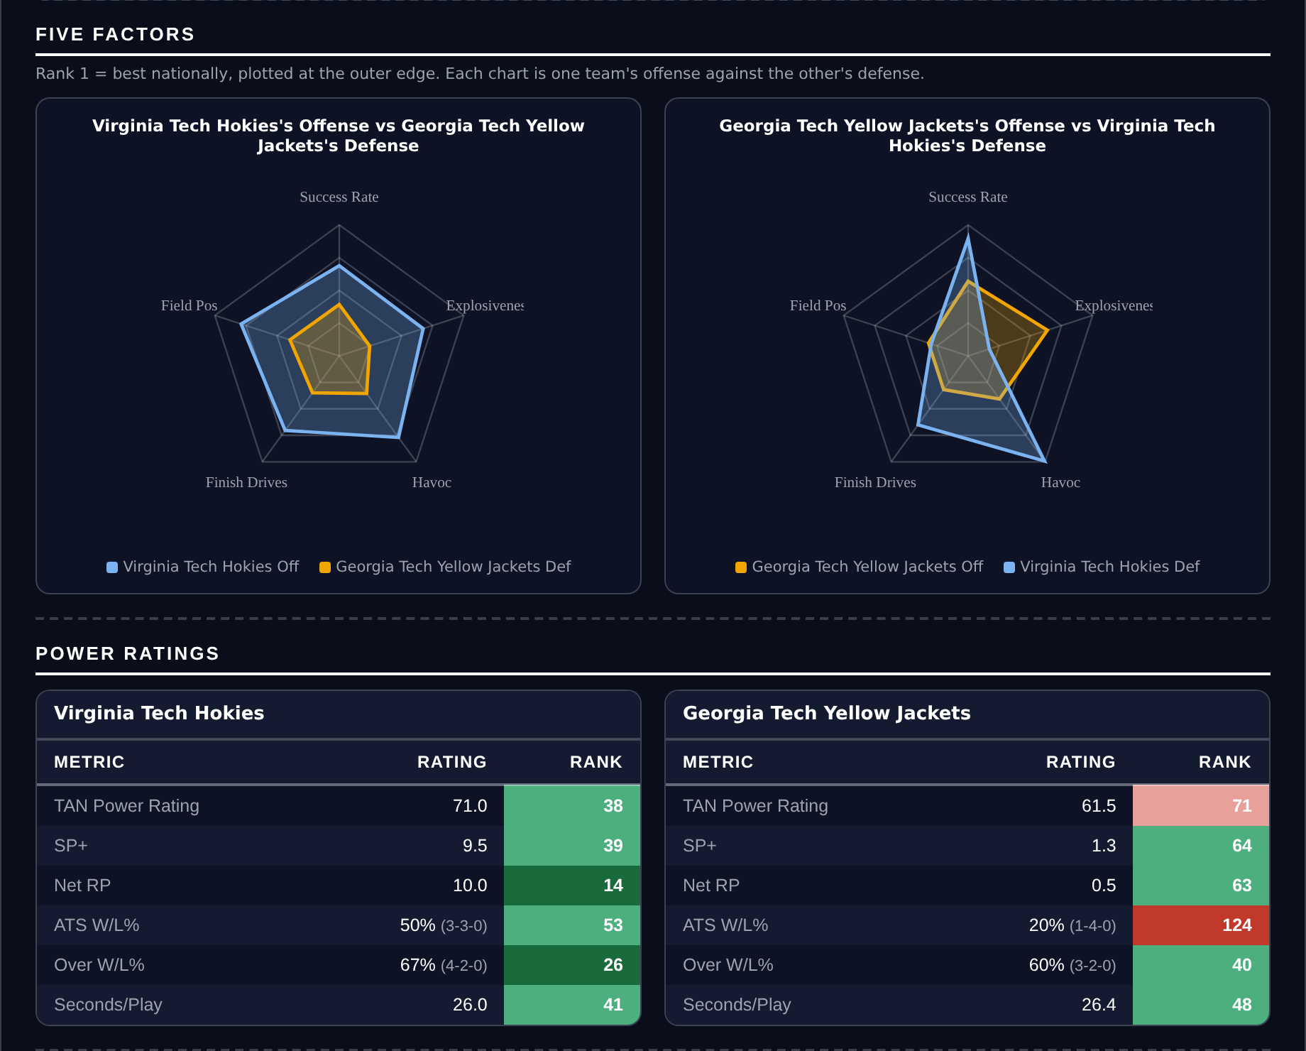
Five Factors and power ratings, captured from the CFB Betting Hub.
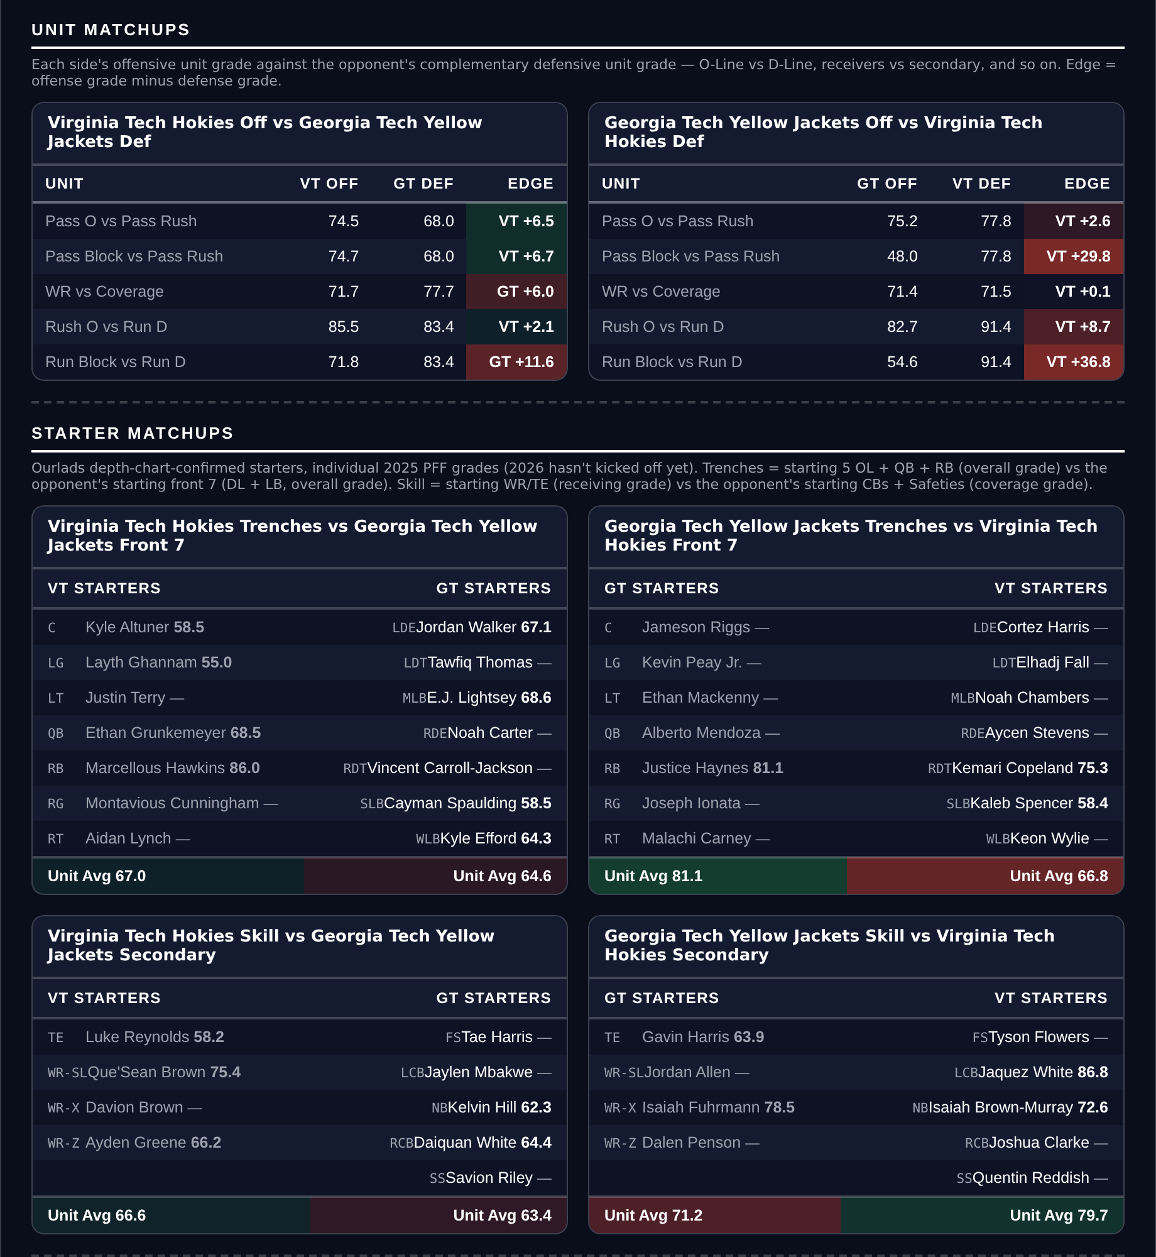
Unit matchups: each offensive unit grade against the opposing defensive unit. Edge = offense minus defense.

Player Props
Five props, each cleared through eight screens rather than taken off raw projected edge. A model edge of at least 20 percent; the player’s own 2026 production agreeing with the side by at least 20 percent; a real role, 20+ targets for receivers and 12+ carries a game for backs; 4+ targets a game for any receiving Over; no opponent or pace multiplier outside 0.6 to 1.6; a spread under 28 points with a rated opponent; at least two books posting the number; and the player’s own game count level with his team’s. 277 priced rows came in and 17 came out.
Every position below clears on the player’s own per-game rate before the model is consulted, and each is stated that way first. Props are the category closest to level on the season at 12-11, and the screens are the reason: the eight of them removed 260 of the 277 rows that were priced.
Quarterback rushing props remain excluded. Sacks count against rushing yards in official college statistics and not in PFF, so the model projects a stat the market is not pricing.
Ratings and the Five Factors come from the 2026 workbook: SP+, TAN, implied team totals and the season-to-date CFBData ranks, out of 138 teams. Player lines are 2026 PFF season to date. Records, ATS and over/under records are TeamRankings, 2026 to date. The PFF team grade file covers five games for 47 teams, six for 87 and seven for 4.

Cincinnati Bearcats @ West Virginia Mountaineers

DJ Epps Over 35.5 receiving yards
Book line | Over 35.5 receiving yards
Model projection | 65.0 yards
2026 production | 393 yards in 6 games, 65.5 a game
Role | 27 targets, 4.5 a game, 14 receptions
Profile | 17.8 average depth of target, 28.1 yards a catch, 3.30 yards per route run
Cincinnati defense | 103rd in Success Rate, 1tied 22nd in Finishing Drives
Game total | 63.5
West Virginia over record | 6-0, over in every game

Epps has 393 receiving yards in six games, an average of 65.5, and the line is 35.5. His own season rate clears the number by 30 yards before the model is consulted; the projection, which discounts for pace and opponent, still lands at 65.0.
The profile is a deep threat and the yardage comes in chunks. He has 14 receptions on 27 targets over 119 routes, an average depth of target of 17.8 yards, and a long of 59. His 3.3 yards per route run ranks 61st among all receivers in the country and his route grade is 74.5. Four and a half targets a game is modest volume, but at that depth two receptions clear the number on their own.
The setting is right for it. This game is posted at 63.5, and West Virginia have gone over in all six of their games. Cincinnati's defence ranks 103rd in Success Rate and 122nd in Finishing Drives, so West Virginia should have the ball in scoring position often.

Mississippi State Bulldogs @ LSU Tigers

Jackson Harris Over 49.5 receiving yards
Book line | Over 49.5 receiving yards
Model projection | 82.3 yards
2026 production | 371 yards in 6 games, 61.8 a game
Role | 33 targets, 5.5 a game, 21 receptions
Profile | 11.8 average depth of target, 2.36 yards per route run, 75.1 route grade
Mississippi State defense | 79th in Success Rate, 112th in Finishing Drives
Mississippi State pass rush | 58.5, 135th of 138
Game total | 56.0, with this card on the Over

Harris averages 61.8 receiving yards a game across six games and the line is 49.5. He cleared a 46.5 line last week with 54 yards on seven targets, and the number has moved only three yards since.
The volume is stable and the role is clear: 33 targets and 21 receptions over 157 routes in six games, 5.5 targets a game, on an 11.8-yard average depth of target that puts him in the intermediate range rather than on low-value underneath work. His 2.36 yards per route run and 75.1 route grade are solid rather than spectacular, and his long of 57 shows the ceiling is there when the coverage breaks.
Mississippi State are the softest pass defence on this card. They rank 79th in Success Rate and 112th in Finishing Drives, and their 58.5 pass-rush grade ranks 135th of 138 teams, so LSU's quarterback should have time to work. This card also has the Over in this game at 56.0, and the two positions are built on the same reading.

Washington State Cougars @ Oregon State Beavers

Aeryn Hampton Over 30.5 receiving yards
Book line | Over 30.5 receiving yards
Model projection | 46.9 yards
2026 production | 245 yards in 6 games, 40.8 a game
Role | 29 targets, 4.8 a game, 20 receptions
Oregon State offense | 11th in Success Rate, 10th in Finishing Drives, 41.8 points a game
Washington State defense | 56th in Success Rate, 128th in defensive Field Position
Oregon State 2026 | 4-2, 6-0 ATS, over in five of six
Game total | 52.5

Hampton averages 40.8 receiving yards a game and the line is 30.5. The gap is ten yards on his own rate, and the projection puts him at 46.9 after the opponent and pace adjustments are applied.
He is a steady part of a good offence rather than a star of it: 29 targets and 20 receptions over 138 routes, 4.8 targets a game, a 9.5-yard average depth of target, 1.78 yards per route run and a 67.0 route grade. His long is 28, so this is not a position that needs a big play — it is the kind of role that produces the same number most weeks, which is what a 30.5 line asks him to beat.
Oregon State are the reason the floor is high. They score 41.8 points a game on an offence that ranks 11th in Success Rate and 10th in Finishing Drives, they are 6-0 against the spread, and they have gone over in five of six. Washington State rank 128th in defensive Field Position, which hands the Beavers short fields and the volume of possessions that comes with them.

Penn State Nittany Lions @ Michigan Wolverines

Andrew Rappleyea Under 30.5 receiving yards
Book line | Under 30.5 receiving yards
Model projection | 15.7 yards
2026 production | 146 yards in 6 games, 24.3 a game
Role | 25 targets, 4.2 a game, 6.6 average depth of target
Michigan defense | 4th overall, 7th in Success Rate, 3rd in Finishing Drives
Michigan coverage | 90.9 coverage grade (11th), 93.1 run defense (4th)
Michigan over record | 1-4, 122nd in the country
Game total | 42.5

The line is 30.5 and Rappleyea has averaged 24.3 receiving yards a game across six games. The market is asking him to beat his own season rate by six yards against the best defence he has faced, and the projection has him at 15.7.
His work is short and it does not scale. A 6.6-yard average depth of target across 25 targets and 115 routes, 17 receptions, 1.27 yards per route run and a 66.7 route grade. His long for the season is 20 yards, so there is no deep element to the role that could clear 30.5 on a single play; he needs five catches to approach the number on volume alone.
Michigan are the fourth-ranked defence in the country by grade, ranking seventh in Success Rate and third in Finishing Drives, with a 90.9 coverage grade that ranks 11th. Their games have gone under in four of five, 122nd in the country in Over rate, and this one is posted at 42.5. Low-scoring games shorten every receiving line in them.

Missouri Tigers @ Ole Miss Rebels

Horatio Fields Over 26.5 receiving yards
Book line | Over 26.5 receiving yards
Model projection | 37.4 yards
2026 production | 190 yards in 5 games, 38.0 a game
Role | 24 targets, 4.8 a game, 17 receptions
Ole Miss offense | 4th in Success Rate, 9th in Finishing Drives, 38.8 points a game
Missouri coverage | 75.5, 70th, the weakest unit on an otherwise strong defense
Game total | 58.5
Catch rate | 71 percent on an 8.3-yard average depth of target

Fields averages 38.0 receiving yards a game across five games and the line is 26.5. That is an eleven-yard cushion on his own production before any adjustment, and the projection lands at 37.4.
The role is dependable: 24 targets and 17 receptions over 120 routes in five games, 4.8 targets a game, a 71 percent catch rate at an 8.3-yard average depth of target, 1.58 yards per route run and a 63.0 route grade. His long of 31 already clears the line on its own. He is part of an Ole Miss offence that ranks fourth in the country in Success Rate and ninth in Finishing Drives and scores 38.8 points a game.
Missouri's defence is excellent in most respects and the exception is the one that matters here. They rank second in the country in pass rush and fourth in Havoc, but their coverage grade is 75.5, 70th, by far the softest unit on the sheet. A quick passing game at 8.3 yards a throw is also the standard answer to pressure, which points the ball at exactly this role.

