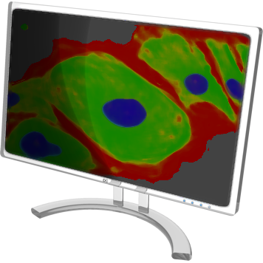
INSTRUCTIONS TO START bioWall

Step 1. If it is completely powered off (skip otherwise)

a. Power on the main machine.

b. Power on all the wall nodes.
Nodes will use the main machine to load the operational system and their configuration.

Step 2. If the main node is logged out (skip otherwise)

a. Log in as: bwall

Step 3. If the wall application is not started

a. Start the wall application by “Start Wall” on the desktop
Wait for about 30 sec allowing wall to start, you will see small terminal window that will show up on the wall. Also you will see the new window on the desktop with the outline of the monitor-tiled all which will allow mouse input to the wall display.

b. Start the viewer application
This will open a viewer window on the wall display and also the wall controller window on the desktop. You can load and manipulate images on the wall through the controller window.

Complete all steps and be a Happy User, good luck!!!
