Vokes et al., Supplemental Material

Supplemental Tables

Table S1. Statistical properties of the binding regions obtained from Gli3 ChIP-on-chip analysis using a probe boundary cutoff of 3 standard deviations.
Table S2. Genomic location of GBRs indicates enrichment at the transcriptional start site.

Table S2. Binding regions that do not contain a Gli motif have distinct genomic distribution compared to peaks that do contain Gli motifs.

Table S3. Transfac motifs mapped to GBRs. As in Table 1, we identified 205 Gli target genes in the limb that contained at least one Gli-motif containing binding region and mapped all human and mouse TRANSFAC motifs, dividing these into binding regions with a Gli motif and binding regions with no Gli motif as well as all remaining ChIP binding regions (not associated with differentially expressed limb genes). This table reports all values with a relative enrichment of 2 and ≥10 motifs (a threshold that gave no motifs in simulated datasets), and removes all redundant motifs that would correspond to the same transcription factor. The relative enrichment is presented on the left, with the total number of identified motifs in parentheses. Significant values are underlined.

Table S4. Clustered ChIP binding regions in 100kb windows (Fig. 1F) were used to identify longer-range binding region – gene assignments. The table shows the maximal distance for a predicted binding region with a FDR≤0.5 with varying numbers of intervening transcriptional start sites.

Table S5. Enrichment of KEGG pathways was determined for the 205 direct Gli target genes versus mouse Ref_Seq genes using WebGestalt (Zhang et al., 2005). Significantly enriched pathways are underlined (minimum of 4 genes, P=0.01, Fisher’s exact test). O=observed, E=expected.

Table S6. Detection of polarized gene expression in the limb bud. The initial gene set contains posterior genes (Post.), ranked by fold change of posterior average expression over anterior average expression. The second gene set contains anterior genes (Ant.) ranked by the fold change of anterior average over posterior average. Genes associated with Gli3-binding regions are underlined. Anteriorly polarized genes satisfy two conditions 1) fold change >1.5 and difference >50 in the comparison of anterior limb bud versus posterior limb bud, where fold change is defined as the ratio of the anterior average (from 3 replicates) over the posterior average, and difference is obtained by subtracting the posterior average from the anterior average and 2) fold change >2 and difference >100 in the comparison of Shh versus SmoM2. With the same thresholds for fold changes and differences, we also define posteriorly polarized genes with high expression specifically in the posterior and SmoM2 samples.

Table S1
SD | FDR (%) | No. of Regions
4.42 | <0.1 | 8798
3.94 | 1 | 14106
3.15 | 5 | 19732
3.00 | 9.9 | 20587

Table S2
Data | Total (%) | Intergenic | Intragenic | Exon | Intron | CDS | UTR | 5’UTR | 3’UTR | TSS +1k | TES –1k | TSS +/- 2k
All | 100 | 64.3 | 35.7 | 2.9 | 33.0 | 1.3 | 1.6 | 1 | 0.6 | 4.0 | 0.6 | 11.3
+GLI | 100 | 62.3 | 37.7 | 4.1 | 33.8 | 1.8 | 2.3 | 1.5 | 0.9 | 5.7 | 0.8 | 16.3
NoGLI | 100 | 66.8 | 33.2 | 1.3 | 31.9 | 0.6 | 0.7 | 0.4 | 0.3 | 1.9 | 0.4 | 5.1
Rand | 100 | 63.6 | 36.4 | 2.9 | 33.6 | 1.7 | 1.2 | 0.2 | 1.0 | 1.1 | 1.0 | 3.9

Table S3: Transfac mapping to Gli binding sites.
Motif | Logo | Limb + Gli | Limb no Gli | Remaining binding sites
M01037_GLI | 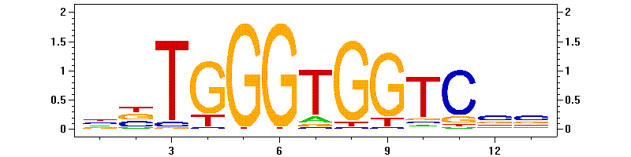 | 3.23 (474) | 1.01 (52) | 2.52 (3305)
M01047_AP2ALPHA | 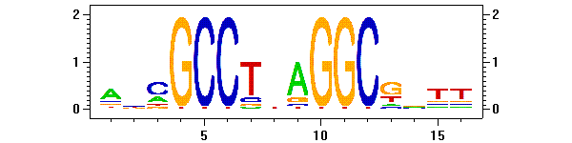 | 2.32 (76) | 0.70 (8) | 1.36 (398)
M00425_E2F | 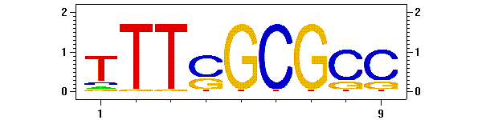 | 2.25 (165) | 0.81 (21) | 1.66 (1088)
M00189_AP2 | 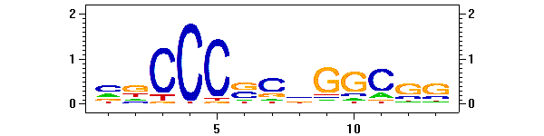 | 2.18 (1064) | 0.93 (160) | 1.37 (5983)
M00512_PPARG | 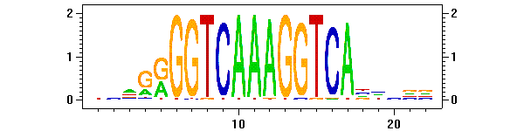 | 2.16 (11) | 1.12 (2) | 1.46 (66)
M00243_EGR1 | 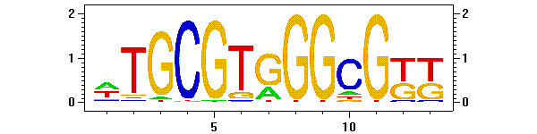 | 2.13 (78) | 0.93 (12) | 1.61 (526)
M00716_ZF5 | 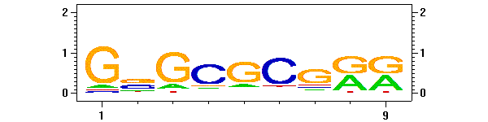 | 2.11 (943) | 0.92 (145) | 1.42 (5677)
M01100_LRF | 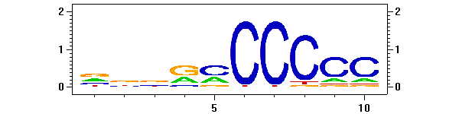 | 2.11 (538) | 1.25 (112) | 1.57 (3577)
M00196_SP1 | 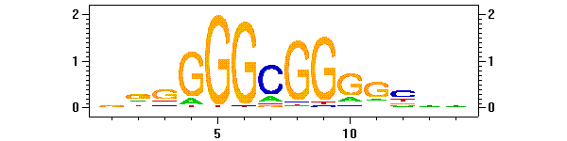 | 2.05 (1044) | 0.92 (165) | 1.39 (6322)
M00068_HEN1 | 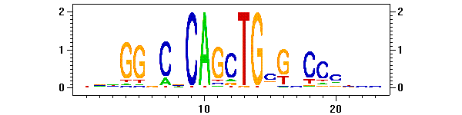 | 2.04 (99) | 1.35 (23) | 1.53 (663)
M00652_NRF1 | 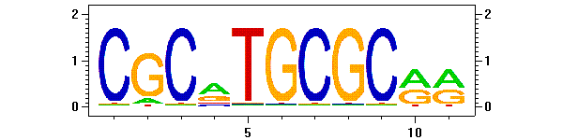 | 2.01 (228) | 0.75 (30) | 1.35 (1377)
M00437_CHX10 | 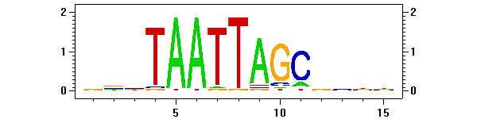 | 1.39 (130) | 2.29 (75) | 1.78 (1481)
M00232_MEF2 | 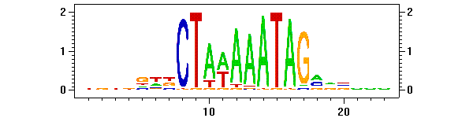 | 0.70 (27) | 2.06 (28) | 1.01 (350)
M00256_NRSF | 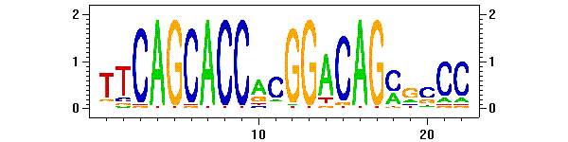 | 0.85 (4) | 0.00 (0) | 3.67 (154)
M00532_RP58 | 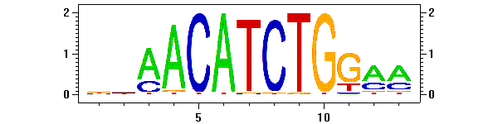 | 1.76 (88) | 1.88 (33) | 2.05 (915)

Table S4. Clustered binding region assignments to differentially expressed genes.
No. of Intervening TSS | FDR≤0.5 range (from TSS)
0 | -5Mb~+5Mb
1 | -5Mb~+750kb
2 | -750kb~+300kb
3 | -300kb~+200kb
≥4 | -100kb~+200kb

Table S5. Pathway enrichment in Gli3 limb target genes.
KEGG pathway | Genes | Gene Symbols | Enrichment
TGF-beta signaling pathway | 8 | Id3 Sp1 Dcn Smad7 Ltbp1 Bmp2 Bmpr1b Bmp4 | O=8;E=0.3942;R=20.2943;P=1.32e-8
Hedgehog signaling pathway | 8 | Wnt11 Hhip Smo Gli1 Bmp2 Bmp4 Ptch1 Ptch2 | O=8;E=0.2548;R=31.3972;P=5.65e-10
Tight junction | 4 | Prkce Cldn9 Cldn11 Ppp2r4 | O=4;E=0.5336;R=7.4963;P=2.32e-3
Wnt signaling pathway | 4 | Fzd7 Sfrp2 Wnt11 Cxxc4 | O=4;E=0.6874;R=5.819;P=5.58e-3
Neuroactive ligand-receptor interaction | 4 | Pmch Ednrb Drd3 Avpr2 | O=4;E=1.4133;R=2.8303;P=5.56e-2
Cytokine-cytokine receptor interaction | 4 | Kit Cntfr Bmp2 Bmpr1b | O=4;E=1.1104;R=3.6023;P=2.68e-2
Purine metabolism | 3 | Aprt Enpp1 Polr2k | O=3;E=0.6441;R=4.6577;P=2.83e-2
Notch signaling pathway | 3 | Jag1 Maml3 Ncor2 | O=3;E=0.2163;R=13.8696;P=1.59e-3
Axon guidance | 2 | Epha3 Efna1 | O=2;E=0.6009;R=3.3283;P=1.24e-1
Leukocyte transendothelial migration | 2 | Cldn9 Cldn11 | O=2;E=0.5336;R=3.7481;P=1.02e-1
Colorectal cancer | 2 | Fzd7 Igf1r | O=2;E=0.3942;R=5.0736;P=6.15e-2
Glioma | 2 | Igf1r Cdk6 | O=2;E=0.298;R=6.7114;P=3.78e-2
Cell adhesion molecules (CAMs) | 2 | Cldn9 Cldn11 | O=2;E=0.6153;R=3.2504;P=1.29e-1
Glycan structures - biosynthesis 1 | 2 | Ust Alg13 | O=2;E=0.4855;R=4.1195;P=8.75e-2
PPAR signaling pathway | 1 | Apoa2 | O=1;E=0.3317;R=3.0148;P=2.85e-1
Calcium signaling pathway | 1 | Ednrb | O=1;E=0.8268;R=1.2095;P=5.65e-1
Chondroitin sulfate biosynthesis | 1 | Ust | O=1;E=0.0865;R=11.5607;P=8.71e-2
N-Glycan biosynthesis | 1 | Glt28d1 | O=1;E=0.1971;R=5.0736;P=1.83e-1
Cell cycle | 1 | Cdk6 | O=1;E=0.5095;R=1.9627;P=4.02e-1
Starch and sucrose metabolism | 1 | Enpp1 | O=1;E=0.25;R=4;P=2.25e-1
Pyrimidine metabolism | 1 | Polr2k | O=1;E=0.3942;R=2.5368;P=3.29e-1
Chronic myeloid leukemia | 1 | Cdk6 | O=1;E=0.3557;R=2.8114;P=3.02e-1
Focal adhesion | 1 | Igf1r | O=1;E=0.8845;R=1.1306;P=5.89e-1
Adherens junction | 1 | Igf1r | O=1;E=0.3509;R=2.8498;P=2.99e-1
Oxidative phosphorylation | 1 | Atp6v1g3 | O=1;E=0.5288;R=1.8911;P=4.13e-1
Jak-STAT signaling pathway | 1 | Cntfr | O=1;E=0.697;R=1.4347;P=5.04e-1
Hematopoietic cell lineage | 1 | Kit | O=1;E=0.3798;R=2.633;P=3.19e-1
Fc epsilon RI signaling pathway | 1 | Prkce | O=1;E=0.3605;R=2.7739;P=3.06e-1
Long-term depression | 1 | Igf1r | O=1;E=0.3557;R=2.8114;P=3.02e-1
Taste transduction | 1 | Tas2r119 | O=1;E=0.2884;R=3.4674;P=2.54e-1
Adipocytokine signaling pathway | 1 | Slc2a1 | O=1;E=0.3413;R=2.93;P=2.92e-1
Type II diabetes mellitus | 1 | Prkce | O=1;E=0.2163;R=4.6232;P=1.98e-1
Pancreatic cancer | 1 | Cdk6 | O=1;E=0.3461;R=2.8893;P=2.96e-1
Riboflavin metabolism | 1 | Enpp1 | O=1;E=0.0817;R=12.2399;P=8.27e-2
Protein export | 1 | Srp19 | O=1;E=0.0433;R=23.0947;P=4.68e-2
RNA polymerase | 1 | Polr2k | O=1;E=0.0961;R=10.4058;P=9.58e-2
Porphyrin and chlorophyll metabolism | 1 | Hccs | O=1;E=0.1106;R=9.0416;P=1.09e-1
Retinol metabolism | 1 | Aldh1a2 | O=1;E=0.024;R=41.6667;P=2.84e-2
Pyruvate metabolism | 1 | Haghl | O=1;E=0.1971;R=5.0736;P=1.83e-1
Nicotinate and nicotinamide metabolism | 1 | Enpp1 | O=1;E=0.1779;R=5.6211;P=1.67e-1
Pantothenate and CoA biosynthesis | 1 | Enpp1 | O=1;E=0.0913;R=10.9529;P=9.15e-2

Table S6: Association of AP polarized gene expression with Gli binding sites
Post. Gene | Post. Fold Change | Ant. Gene | Ant. Fold Change
Shh | 4.576621 | Pax1 | 9.843045
Ptch1 | 4.292573 | Nmu | 4.964595
Gli1 | 4.081334 | Alx4 | 4.193388
Dlk1 | 4.009698 | Zic3 | 3.850606
Hand2 | 3.868065 | Pax9 | 3.620613
Cntfr | 3.418174 | Alx3 | 2.927533
Ptch2 | 3.20754 | Rprm | 2.905993
Foxc2 | 2.84707 | Atp6v1g3 | 2.703342
Tmem30b | 2.771841 | Irx5 | 2.681768
Pcp4 | 2.579146 | 9030619P08Rik | 2.62412
Osr2 | 2.481057 | Dlx5 | 2.368027
Sall1 | 2.004099 | Irx3 | 2.356957
Tbx2 | 1.938241 | Cdo1 | 2.194522
Hoxd13 | 1.914717 | Mme | 2.190429
Phlda1 | 1.910329 | Slitrk6 | 2.072877
Lypd6 | 1.900442 | Mogat2 | 2.003944
Pam | 1.89847 | Krt15 | 1.921555
Cited1 | 1.804184 | a | 1.920164
Evx2 | 1.789021 | Hoxc5 | 1.898935
Hnt | 1.787541 | AW548124 | 1.88852
Bmp2 | 1.757419 | Nqo1 | 1.880385
Ltbp1 | 1.733438 | Asb4 | 1.866066
Tspan18 | 1.73115 | Hoxc6 | 1.734693
Foxc1 | 1.723497 | Lhx9 | 1.718797
Cck | 1.721821 | Wif1 | 1.687585
Smoc1 | 1.716824 | Agtr2 | 1.676508
Tmtc1 | 1.714064 | Pthr1 | 1.596759
Efna1 | 1.63875 | Ahnak | 1.560003
Rasgef1b | 1.619083 | Col1a2 | 1.550442
Tbx4 | 1.597601 | Krt16 | 1.546158
Hoxd11 | 1.583312 | Adk | 1.542167
Grem1 | 1.573926
Rspo3 | 1.54749
Snai1 | 1.540043
Ust | 1.509189

Supplemental Figure Legends:

Supplemental Figure 1:
(A) Schematic showing the inducible RosaGli3T FLAG construct. This construct was knocked into the Rosa26 locus of YFP3.1 ES cells that contain a tamoxifen inducible Cre. (B) Cre dependent activation of Gli3T^{FLAG} in ES cells visualized by FLAG (Green) and anti-GFP (blue). Note that Gli3T is predominately nuclear. (C) Western blot analysis of Cre dependent activation of Gli3T ^{FLAG} in ES cells and E11.5 mouse limb buds in Prrx1Cre +/-;R26Gli3T ^{FLAG}/+embryos. Gli3T^{FLAG} (asterisk) runs at a higher molecular weight than endogenous Gli3-rep protein (present in limb samples). Levels of Gli3T ^{FLAG} are comparable to wild-type Gli3 levels in control limbs.

Supplemental Figure 2:
(A) A random sampling of GBRs were tested for enrichment by quantitative PCR using independent, unamplified E11.5 limb ChIP sample. The blue shading denotes the sampled ChIP peaks, while the number on the X-axis denotes the ranking of that particular binding region. The regions indicated in gray indicate negative control regions – the values were normalized to SVO811. The regions shaded in red indicate positive control regions or regions that were previously shown to be Gli1 neural binding sites. The dashed horizontal line indicates the significance cutoff value of 2.13, which is three standard deviations from the mean value of negative controls, excluding SVO811 ((p-value=0.0013). When compared with the fold-change values determined in TileMap, these values are highly correlated (r = 0.7317). The dashed vertical line indicates the cutoff for binding regions deemed biologically significant. (B) Histogram showing the distribution of binding region sizes over the 5,274 biologically significant binding regions. The mean length = 854bp; [5th, 25th, 50th, 75th, 95th] percentile = [380, 564, 747, 1009, 1693]bp.

Supplemental Figure 3:
GBRs tend to be clustered. (A, C, E) Clustering within 0.5, 1, and 2Mb windows respectively showing the number of observed clusters (red) compared to randomly distributed sites (blue). The corresponding false positive rate at each level (B,D,F) is shown on the right. The number of significant clusters was determined using a cutoff false positive rate of 0.5. (A,B) Window Length = 500kb, cutoff=6, No. of Significant Clusters = 108 (vs. 4.6 clusters if peaks are randomly distributed in the genome ), No. of peaks in the cluster = 1213 (23.00% of all peaks, vs. 0.67% of all peaks are covered by 4.6 random clusters). Total length of DNA covered by clusters = 64,588,215bp (2.44% of whole genome). (C,D) Window Length = 1Mb, No. of Significant Clusters = 138 (cutoff = 7, vs 21.2 random clusters), No. of peaks in the cluster = 1917 (36.35% of all peaks, vs. 3.66% of all peaks are covered by 21.2 random clusters). Total length of DNA covered by clusters = 183,118,487bp (6.93% of whole genome). (E,F) Module Length = 2Mb, No. of Significant Clusters = 96 (cutoff = 11,vs. 12.8 random clusters), No. of peaks in the cluster = 2082 (39.48% of all peaks vs. 3.32% of all peaks covered by 21.2 random clusters. The total length of DNA covered by clusters = 289,751,322bp (encompassing 10.96% of the genome).

Supplemental Figure 4: (A) False discovery rate for the association of binding sites with differentially expressed genes over distance. The number of peaks located within Wbp of the transcriptional start site of differentially expressed genes was compared with the number of peaks associated with 753 randomly chosen genes. The FDR(W)=[No. of peaks located within Wbp of random gene TSS]/[No. of peaks located within Wbp of differentially expressed gene TSS]. The FDR is plotted as a function of W. (B) Gli3 binding peaks associated with differentially expressed genes are more highly conserved. To perform the test, for each binding region i, we obtained the sum of phastCons scores S_{i} across all base pairs where the phastCons score ≥40 (Note: phastCons score was linearly scaled to 0~255. A score ≥40 corresponds to the highest top 10% of the genome). We then collected all peaks that are located within W bp of the TSS of differentially expressed genes, and we computed the 75th percentile of their S_{i}s. We compared this 75th percentile with random expectation. To obtain the random distribution, we collected 753 randomly chosen genes. We replaced the 753 differentially expressed genes by these randomly chosen genes and repeated the same computation. The figure below shows the results for different values of W. The two black thin lines correspond 3*SE as determined by repeating the random gene selection procedure 10 times. The result indicates that at 1Mb distance from the TSS there is still low level enrichment of functional enhancers. (C) Differentially expressed genes have fewer intervening TSS (red) between their associated peaks than do randomly chosen genes (blue). (D) False Discovery Rate for transcript-binding region annotations that incorporates both the number of intervening TSS from (C) and the distance of the binding region from the differentially expressed genes (B).

Supplemental Figure 5:
Shh-regulated Gli target genes are enriched for transcription factors and genes involved in development. The 205 target genes were compared with mouse reference sequences using GO ontology terms. The number of genes indicated in red is the expected number of terms, while the number indicated in blue is the observed number in each category. The comparison used Fisher’s exact test to calculate the statistic for each category in WebGestalt (Zhang et al., 2005). Terms reported here have a significance level of P=0.001 with a minimum of 5 genes in the category.
Supplemental Methods

Limb Dissection and ChIP-on-chip
Rosa Gli3T^{FLAG c/c} females mice were crossed with Prrx1Cre homozygous male drivers and litters were assayed at E11.5. Embryos (generally 9) were dissected and forelimbs and hindlimbs were dissected into PBS, trypsinized in 300μl trypsin-EDTA for 5 minutes at 37º, inactivated by adding 700μl of DMEM with 10% calf serum, and cross-linked with 1% formaldehyde for 30 minutes. ChIP and LMPCR was performed as described previously (Vokes et al., 2007) with the following modifications. Chromatin was sonicated in 2ml of buffer 3 using 10x30 second pulses on a Branson 450 Sonifier (3 pulses on setting 4, then 7 on setting 5). For whole genome arrays, three ChIP reactions were set up in parallel with 500μl each (with 15μl of each biological sample reserved for an input control) – single promoter arrays used a single ChIP sample. At the final step, the samples were pooled and enrichment was validated using qPCR. For LMPCR, the pooled samples were divided into three and processed in parallel using 0.25mM dATP, dCTP, dGTP, 0.2mM dTTP and 0.05mM dUTP with 27 total cycles and then re-pooled after PCR cleanup. Each pooled set of reactions yielded >38μg of amplified sample. The linearity of amplification was confirmed by comparing qPCR values with the values from the unamplified samples. Samples (37.5-44μg of DNA) were enzymatically fragmented and labeled using the WT Labeling Kit (Affymetrix) and ~8.25μg of DNA was hybridzed per array using the Mouse Tiling 2.0R 7 array set or Mouse Promoter 1.0R array (single samples). For each 7 array set, 4 arrays were hybridized for 16 hours at 45° at 60rpm. The probe was removed from these arrays and reused to hybridize the remaining three arrays.
The Histone H3K27Me3 (Abcam ab6002) ChIPs were processed as above using a single non-pooled ChIP from one litter of wild-type (Swiss-Webster) anterior or posterior limb fractions (two biological replicates). These were assayed on Mouse Promoter 1.0R arrays incubated with mouse beads and using the identical protocol. Pan-Histone H3 (Abcam ab1791) were incubated with anti-rabbit IgG beads (Dynal #112.03).
Probes in Affymetrix tiling arrays were remapped to the mm8 build 36 version of the mouse genome – all coordinates in this study are reported in mm8. Raw data were quantile normalized and binding regions were determined using the new version of TileMap incorporated into CisGenome using a moving average (MA) (Ji and Wong, 2005). Probes whose MA statistics were three times standard deviations away from the global mean were used to form binding regions. Two regions, if separated by less than 300bp or 5 non-significant probes were merged. After merging, regions that were shorter than 100bp or contained fewer than 5 significant probes were discarded. This procedure produced 20587 potential GLI binding regions in total, with an estimated false discovery rate (FDR) 9.8%. The FDR were estimated from the left tail of the MA statistic distribution. To determine Gli enrichment, regions were divided into subgroups of size 100. The enrichment was computed for each subgroup and was compared to GLI enrichment in negative control regions. The negative controls regions were chosen as matched genomic controls to the 7107 first tier Gli binding regions.
To determine Gli motif enrichment, the 20,587 regions were binned according to their ranks. Each bin contained 100 GBRs. The Gli motif was mapped to each bin, and the motif occurrence rate (motifs per 1kb) was computed. For each bin, the Gli motif occurrence rate was compared to the Gli occurrence rate in negative control regions, and a fold enrichment was computed and was shown in Fig. 1A. The negative control regions were chosen to match the physical distribution of Gli binding regions as described previously (Ji et al., 2006). These matched controls were used wherever needed for determining levels of motif enrichment.
We tested the correlations between Gli+ and Gli- GBRs as well as the correlations between Gli- GBRs and peak clusters, but we did not find any statistically significant correlation. In all, there are 123 GBR clusters in the genome, covering 13.06% (689/5247) GBRs. Among the 2,367 Gli- GBRs, 324 (13.69%) were covered by the 123 clusters. Among the 2,907 Gli+ GBRs, 365 (12.56%) were covered by the 123 clusters. No significant association was found between Gli- GBR and GBR clusters (hypergeometric p-value = 0.12), and between Gli+ GBR and GBR clusters (hypergeometric p-value = 0.12). Among the 2,367 Gli- GBRs, 970 contained ≥1 Gli+ GBR within the 100kb neighborhood, almost equal to what was expected by chance (987.5). Therefore, there is no enrichment of GLI+ GBRs in the neighborhood of Gli- GBRs. To get the expected GBR number, we permuted the GLI+/- labels of all the GBRs, then we counted how many Gli- GBRs had ≥1 Gli+ GBR within the 100kb. The same conclusion was obtained when we change 100kb neighborhood to 1kb, 10kb and 1Mb. Finally, we sorted all 5,274 GBRs according to their genomic coordinates and counted how often GLI+ (or GLI-) GBRs switch to the GLI- (or GLI+) GBRs when we move along the chromosomes. In total, there were 2,514 switches between GLI+ and GLI- peaks. By permuting GLI+/GLI- peak labels, 2,597 switches were expected. Therefore, there was no excess of switches between the two types of GBRs.
For homology sequence comparison, the span of sequence depends on the actual size of the GBR. For each peak i, we count how many base pairs have phastCons score ≥ certain cutoff, we divide it [ denoted by c(i)] by the peak length l(i) to get the conservation measure x(i). In other words, x(i) = c(i)/l(i). If a peak is 400bp long, l(i)=400. If a peak is 1200bp long, l(i)=1200. For each bin, median(x(i)) was plotted.

Exon gene expression arrays
All gene expression experiments used E11.5 forelimbs. To obtain wild-type anterior and posterior fractions, dissected forelimbs were microdissected into an anterior 1/3d and posterior 2/3d fragment and pooled with a total of 9 embryos from a single litter per sample. Shh mutant phenotypes were manually identified as wild-type or mutants. All other samples were snap frozen in liquid N₂ and genotyped. Either single or dual samples of equivalent genotyped samples (2-4 forelimbs) were used for all other samples. All samples contained 5μg of carrier glycogen and were prepared using Trizol. Samples were then treated with the RiobMinus™ rRNA reduction kit (Invitrogen), cDNA synthesis and amplification was performed using the WT cDNA synthesis and amplification kit (Affymetrix). Samples were enzymatically fragmented and biotinylated using the WT Terminal Labeling Kit (Affymetrix) and hybridized to Mouse Exon 1.0ST arrays (Affymetrix).

Assignment of Gli Target Genes
To calculate an initial intersection of binding regions with expression data, we collected 753 genes that are differentially expressed in at least one of the pairwise or multi-variable comparisons in our exon array experiment. We counted the number of peaks located within Wbp of their TSS, and we compared the observed number with random expectations. To compute the random expectation, we randomly chose 753 genes and counted the number of peaks located within Wbp of their TSS. Using the random expectation, we computed FDR(W)=[No. of peaks located within Wbp of random gene TSS]/[No. of peaks located within Wbp of differentially expressed gene TSS] – see Fig S4A.
To incorporate information about intervening transcripts (gene density), we collected our 753 differentially expressed genes and associated each of the 5274 peaks to the closest differentially expressed transcripts. We counted the number of peak-gene pairs separated by ≤Wbp and ≤K intervening promoters and compared the observed number with random expectations. To compute the random expectation, we randomly chose 753 genes and counted the number peak-gene pairs separated by ≤Wbp and ≤K intervening promoters. Using the random expectation, we computed FDR(W, K)=[No. of simulated peak-gene pairs separated by ≤Wbp and ≤K intervening promoters]/[ No. of observed peak-gene pairs separated by ≤Wbp and ≤K intervening promoters]. We performed simulation 10 times and takes the average as our estimates – see Fig. S4D. Using this method, we obtain 542 peaks with an FDR ≤0.5.
In order to explore binding regions located further away from genes, we collected the 689 regions in the 123 binding clusters reported in Fig. 1F and repeated the same peak-gene association procedure for these 689 regions. Table S4 shows the distance of peak-gene association with an FDR≤0.5. We added these additional peak-gene pairs to the original 542 peaks, resulting in a final list of 656 peak-gene pairs and 261 unique genes.

Motif Discovery and Mapping
We performed further motif discovery by identifying all binding regions that were associated with differentially expressed limb genes that contained at least one associated binding region with a Gli motif, reasoning that this were the highest confidence direct target genes – a total of 656 binding regions. We subdivided this into (1) binding regions that contained Gli motifs, and (2) binding regions with no Gli motifs. All peaks not identified with differentially expressed genes (5,274-656) were collected in a third list (3). Gibbs motif sampler (GMS) was run on data set (1) (2) and (3). For each datasets, GMS was run 3 times independently, with each run searching for 40 motifs simultaneously. After GMS, relative enrichment levels (r1) of all reported motifs were obtained by comparing to matched genomic controls, and motifs with r1≥2 in at least one of the dataset were reported.

As a complementary motif analysis, we further mapped all TRANSFAC human and mouse motifs to GLI binding regions and computed the relative enrichment r1 compared to matched genomic controls. We listed all motifs with r1≥2 and with at least 10 sites. When we performed the same motif selection procedure on simulated datasets, there are no motifs that have both ≥10 sites and r1≥2. Therefore, the cutoff chosen here are significant even after accounting for multiple testing. After the motifs are selected, motifs corresponding to the same transcription factor are considered to be redundant and are removed.

Transgenic experiments
To generate transgenic embryos, regions were PCR amplified and inserted into pHSP68lacZ2XINS (Vokes et al., 2007). GO transgenic embryos were assayed at E11.5. All limb phenotypes are reported based on presence in the forelimb although virtually identical results were seen in the hindlimbs. The Gli1 transgenic: chr10:126741859-126745263 was amplified from BAC PR24-213L12. The two Ebox motifs were present at chr10:126743991-126743998 and chr10:126744149-126744156 and were mutated from CACATCTG to CAAATCTT and CGCACCTG to CGAACCTT . All other transgenics were PCR amplified and sequenced using C57Bl6/J DNA. Coordinates are: Prdm1 transgenic: chr10:44097138-44098133; Gremlin transgenic: chr2:113441682-113442119; Hand2-10K: chr8:60225808-60226240; Hand2-85K (used only in combination with Hand2-10K): chr8:60,297,209-60,298,058. The Hand2 constructs were tested in pSilencer, a modified version of pBSMhox – a precursor construct for Prx1Cre (Logan et al., 2002) - where a LacZ expression cassette was inserted downstream of the Prrx1 regulatory sequences that drive limb expression (Fig. 4P). The Hand2-10K+85K module was cloned directly upstream of Prrx1.

Western Blots
Protein samples from ES cells containing Cre-inducible Gli3T^{Fla} and single litters of wild-type (Swiss-Webster) or Prrx1Cre+/-;Gli3T^{Flag} E11.5 limb buds were run out on an 8% SDS PAGE gel (100μg per lane), and assayed by Western blot with M2 anti-Flag (Sigma, 1:2000), anti-Gli3 (a gift from Baolin Wang, 1:200) and anti-Actin (Sigma A2066, 1:500). Images were adjusted to enhance contrast in Adobe Photoshop.

