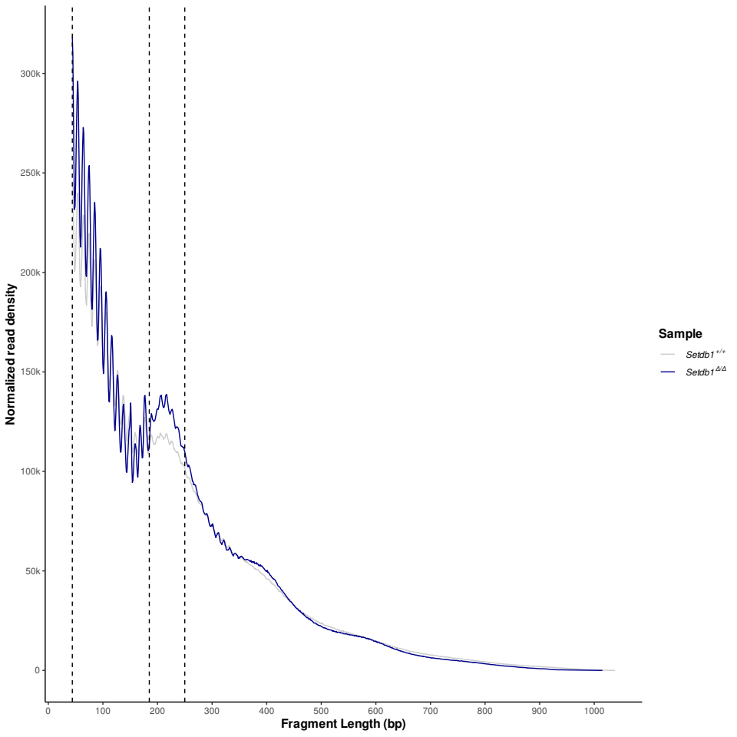

Figure 1 : Comparison of nucleosomal landscape for each samples group.
ATAC-seq fragment sizes from nuclei show the chromatin-dependent periodicity with a spatial frequency consistent with nucleosomes. High frequency periodicity indicate the pitch of the DNA for fragment less than 183 bp. We filtered fragments less 40 bp. The first parts indicate the nucleosome-free region The second part indicate the nucleosome occupancy.
Setdb1 +/+ (grey) and Setdb Δ/Δ (blue) shown the same distribution. The difference displayed comes from the number of peaks found after peak calling.

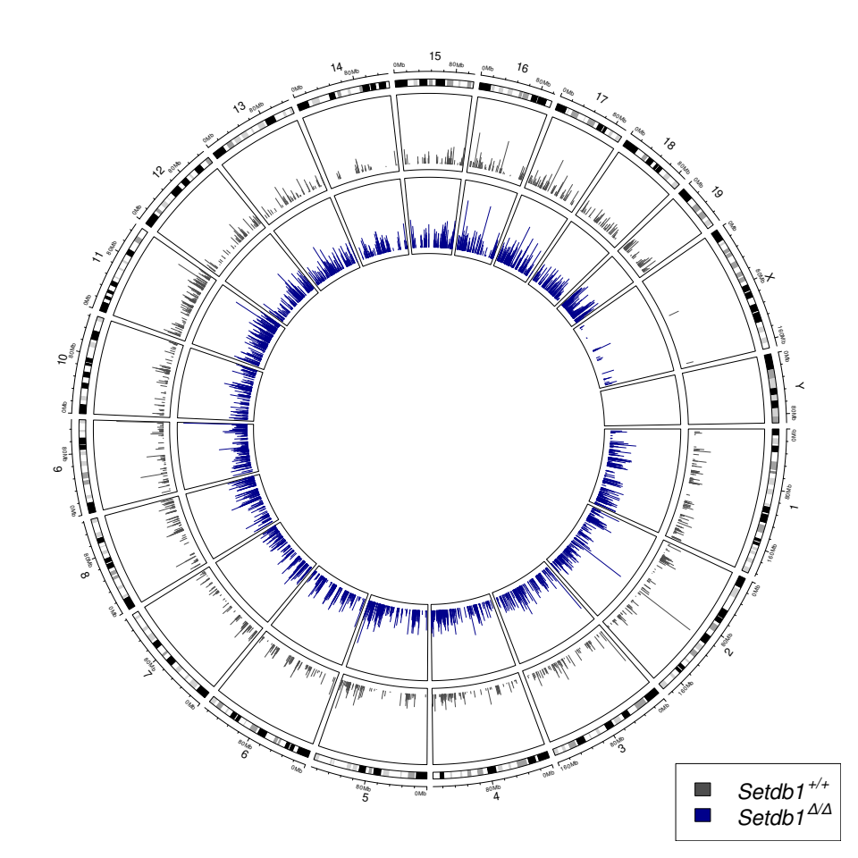

Figure 2 : Genomic view of ATAC-seq peaks
We displayed high ATAC-seq peaks with a minimum score calling superior to log10(score)>3,1. Every chrosomom (except mitochondria) are counted. In details, Setdb1 +/+ (grey) has less peaks than Setdb Δ/Δ (blue) and for the same regions, Setdb Δ/Δ (blue) presents a higher score calling.

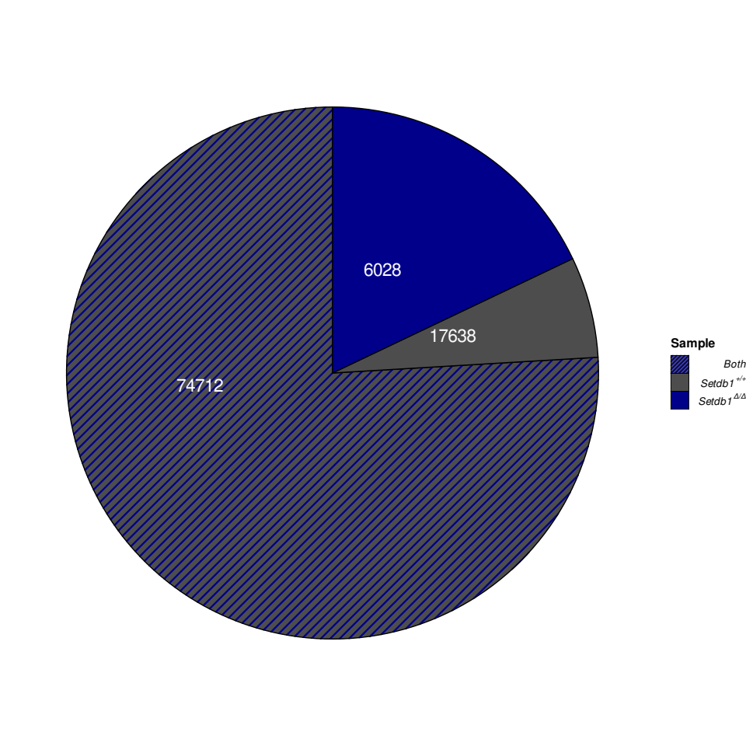

Figure 3 : Distribution of ATAC-seq peaks.
We counted three situations : there are ATAC-seq peaks in same regions in all samples (Setdb1 +/+ (grey) and Setdb Δ/Δ (blue and blue stripe), only in Setdb1 +/+ samples and only in Setdb Δ/Δ. ~76 % of ATAC-seq peaks shared in same regions between all samples. ~ 6 % of ATAC-seq peaks are only present in Setdb1 +/+. ~ 18 % of ATAC-seq peaks are only present in Setdb Δ/Δ.

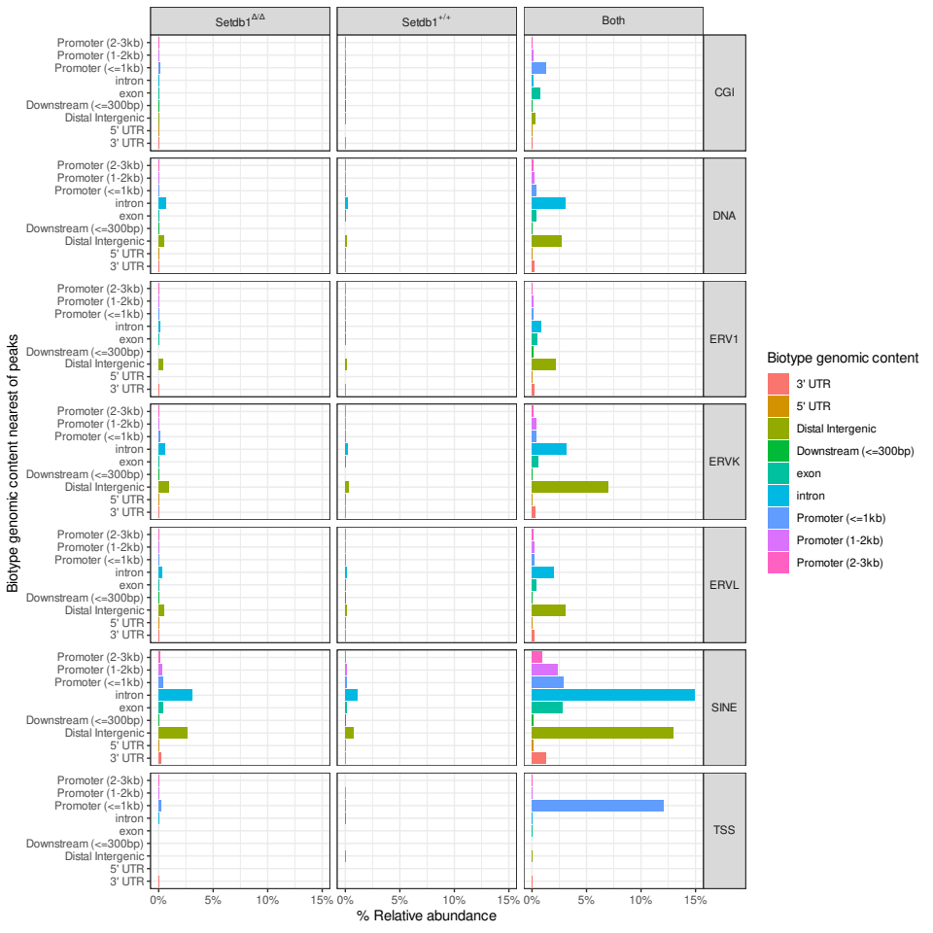

Figure 4 : Distribution of transposable element nearest ATAC-seq peaks annotated.
Each ATAC-seq peak annotated about the distance between it and the nearest gene. Annotations has defined to distance between center of peaks and the biotype genomic content. Distal intergenic is used for ATAC-seq peaks which distance is superior to 3kb. We shown that large quantities of ATAC-seq peaks annotations fall into enhancer regions (introns and distal intergenic) and promoter regions (Promoter <=1 kb to Promoter (2-3kb)). For the same regions in all samples, top3 annotations associated introns, distal intergenic and TSS. For ATAC-seq peaks specific to Setdb1 Δ/Δ, we shown that more enriched in promoter regions than ATAC-seq peaks specific to Setdb +/+.
We associated differents structures : CpG islands (CGI), different transposable element (DNA, LTR (ERV1, ERVK, ERVL), SINE, Transcription Starting Site (TSS)).
For the same regions in all sample, ATAC-seq peaks present a large quantities of transposable elements in introns and distal intergenics localisations. ATAC-seq peaks specific to Setdb1 Δ/Δ has more enriched in transposable element than ATAC-seq peaks specific to Setdb +/+.

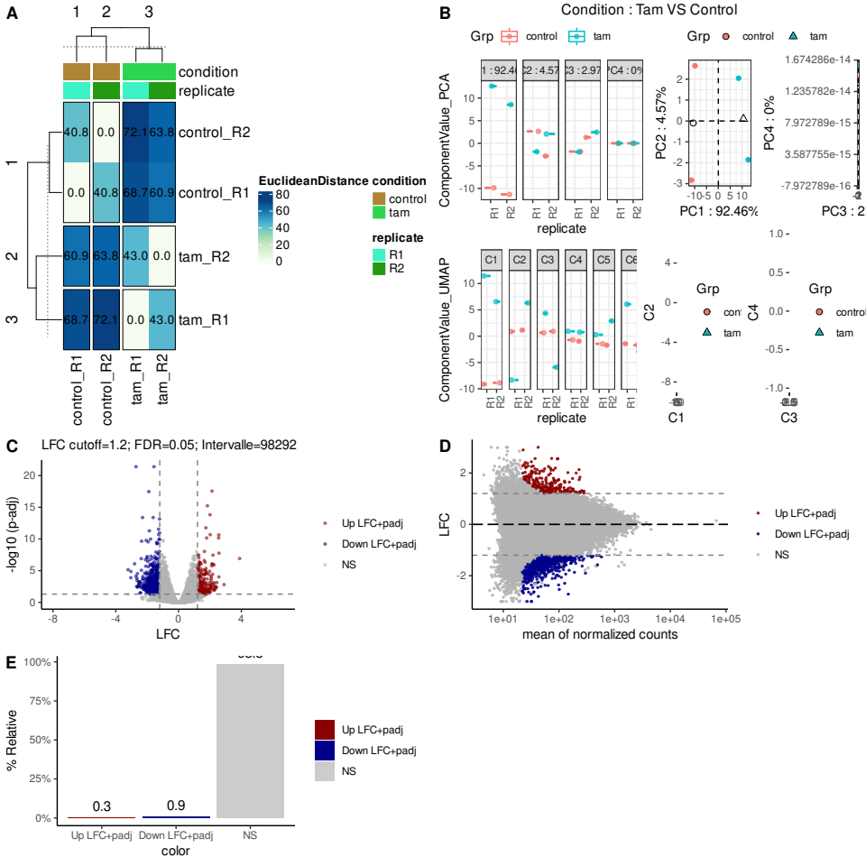

Figure 5 : a. Unsupervised clustering on samples. b. Quality Control of first dimensions in PCA and UMAP reduction dimension of samples. c. VolcanoPlot of differential analysis betwen Setdb +/+ versus Setdb1Δ/Δ. We merged peaks aligned and we do a differential analysis with DESeq2 on quantities of reads counted mapped on regions. We applied different filters to maximise informations and reduce the noise. We displayed the down-open regions in blue, the up-open regions in red according to p-adjusted (BH) < 0,05 and log2FoldChange >=1,2. Regions didn’t match with these filters are not significant (NS). d. Adaptation of MAplot. e. Barplot of differents regions categories : up-regions, down-regions and NS.

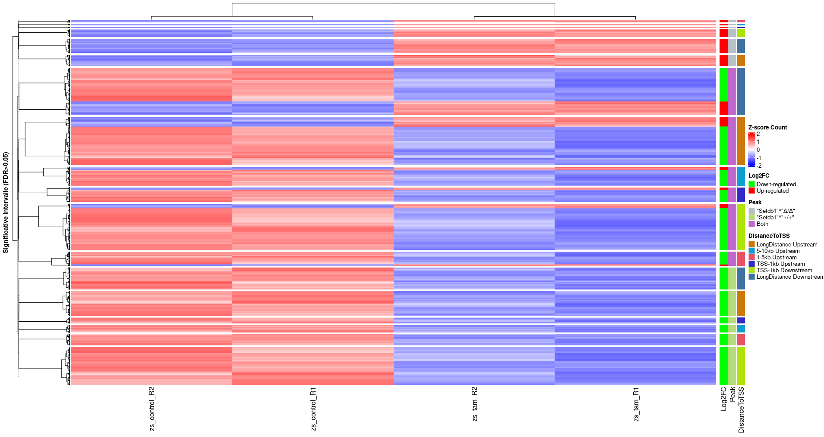

Figure 6 : Heatmap of regions from differential analysis which matched with filters. We sorted rows to show at the top Setdb1 Δ/Δ specific regions mapped (grey), at middle regions mapped shared by all samples (lightgreen) and at the bottom Setdb1 +/+ (lightpurple). Columns are samples, to the right : Setdb1 +/+ samples and to the left : Setdb1 Δ/Δ samples. Enrichment of count mapped for a region are displayed with a Z-score scale : high counts in red, low counts in blue.
The most of regions mapped concern all samples and the large majority present a high enrichment of count mapped in Setdb1 +/+ samples.

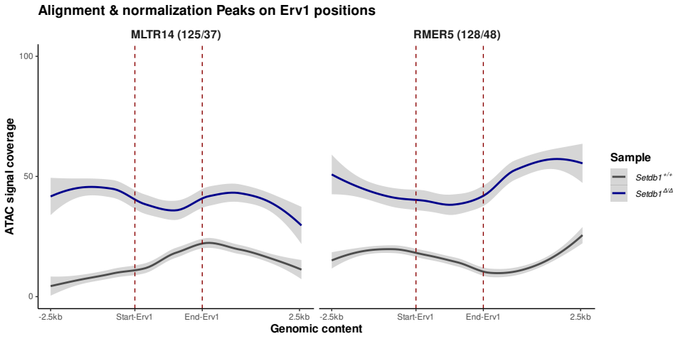
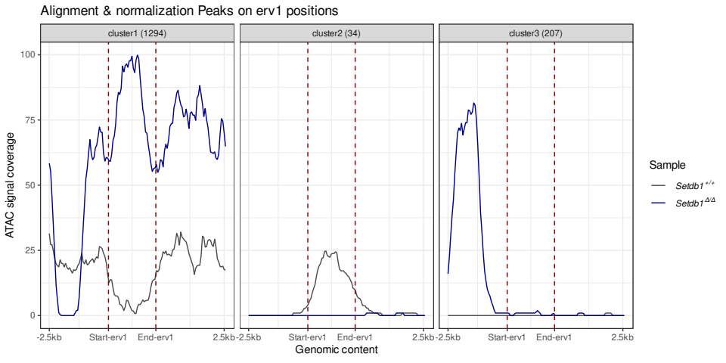

Figure 7 : a. Coverage of ATAC-seq peaks for the transposable element MLTR14. After alignment of ATAC-seq peaks, we merged data to create a global dataset for each region shared or not for all samples. We calculated the coverage for each region for each sample. We normalized coverage signal on target regions contains MLTR14 and RMER5. We displayed only transposable element with 100 regions matched to one sample at min. We shown an enriched of Setdb1 Δ/Δ regions for MLTR14 comparing to Setdb1 +/+. b. We normalized coverage signal on target regions contains ERV1. We splitted matrix to find pattern. We shown 3 patterns founds between Setdb1 Δ/Δ and Setdb1 +/+. The first shown an enrichment of ERV1 in Setdb1 Δ/Δ with the majority of regions considerated. The second shown an enrichment of ERV1 in Setdb1 +/+ but with a lower quantities of regions considerated and lower coverage. The third shown a upstream signal coverage in Setdb1 Δ/Δ and doesn’t matched to ERV1 pattern.

