
GAME-SPECIFIC FACULTY GUIDE

The Economy’s Edge
  - A branching PPF experience built around scarcity, tradeoffs, production, and growth.
Use this guide to help students explain how their choices in Calder produced the outcome they saw. Their experience gives you a starting point for teaching the production possibilities frontier (PPF), also called the production possibilities curve (PPC).

Why This Game Exists
I wanted students to experience the choices behind a PPF before I showed them a graph or asked for a calculation. That led me to an RPG/dungeon-crawler structure. Students make a decision, conditions change, and what they did earlier affects the choices they face next. Different paths can lead to different endings.
It’s easy to learn which points on a PPF are efficient, inefficient, or unattainable without thinking much about the resource choices behind them. I wanted students to make those choices in Calder: decide what to produce, deal with a disruption, and work out how to recover and prepare for the future.
Once students have an outcome in front of them, you can ask what happened and build the graph from their account. That’s the moment I wanted to make possible. The PPF gives a formal explanation of something they’ve already experienced.

What Students Do
Students direct economic planning in the fictional country of Calder. They make six decisions, choosing among two or three available options at each stage. A run generally takes about 5–10 minutes. Allow additional time if you want to use discussion, follow-up questions, or applications in class.
They allocate fully employed workers and equipment between household goods and capital goods, reconsider that mix under pressure, respond to a delivery and job-matching disruption, and balance recovery with preparation for future production. The students’ earlier choices affect later options, so they have to follow the economic story across the run.
Each choice brings a consequence and an explanation of its economic tradeoff. Four indicators track current consumption, capital production, resource utilization, and future growth, while the illustration changes with the economy’s condition.
The five ending categories are continuing slack, expanded capacity, a household-oriented mix, a capital-oriented mix, and balanced recovery. With no answer score or universally best path, students need to explain what they achieved and what it cost. The six-choice history supplies the evidence behind the ending headline.

What the Game Is Really Teaching
Calder begins with its workers and equipment fully used. Producing more household goods means producing fewer capital goods, and the reverse is also true. Even keeping the existing mix forgoes what another allocation could provide. Ask students to identify the best alternative use they sacrificed: that is the opportunity cost of their decision.
As students push farther toward one sector, specialized workers and equipment move into less suitable uses. Each further shift gives up more of the other output. They encounter increasing opportunity cost through the production Calder loses along the way.
Several mixes can use Calder’s resources efficiently. On the frontier, increasing one output requires giving up some of the other. Which efficient mix to choose depends on what society values; a balanced mix is not automatically better.
When Calder prepares equipment, infrastructure, training, and improved methods, households give up goods they could have received today. That work can support later production, but the opportunity cost remains even when the investment pays off.

Four changes to keep separate
What changes in Calder | PPF interpretation
Fully used resources move between household and capital production. | Movement along a given frontier: one current output rises as the other falls.
Delivery and job-matching problems leave resources unused, without destroying them. | Production moves inside the existing frontier. Capacity remains intact.
Idle workers and equipment return to production. | Recovery toward the existing frontier. Both outputs may rise without a larger frontier.
Prepared improvements are completed and enter use. | Productive capacity expands. An outward shift permits previously unattainable combinations; choosing a mix still involves tradeoffs.

The Future growth indicator tracks improvements still in preparation. Producing capital goods and preparing projects today builds this pipeline; expansion occurs when completed improvements enter use. In Calder, that happens on the branch with fully used resources and sufficient preparation. The indicator can then fall as projects leave the pipeline and become usable capacity. A strong pipeline can also coexist with idle resources.
The four indicators summarize scenario conditions on simplified 0–8 scales. Their numbers describe states of the scenario, so use the written consequences to interpret them. Future growth measures preparation, with no numerical conversion to a growth rate or a third current output. The game compresses time and project completion to illustrate the mechanisms; its pace offers no forecast for a real economy.

Reading the imagery as a hidden PPF
Four regions recur in all six scene variants, making economic changes visible before students work with a conventional graph.
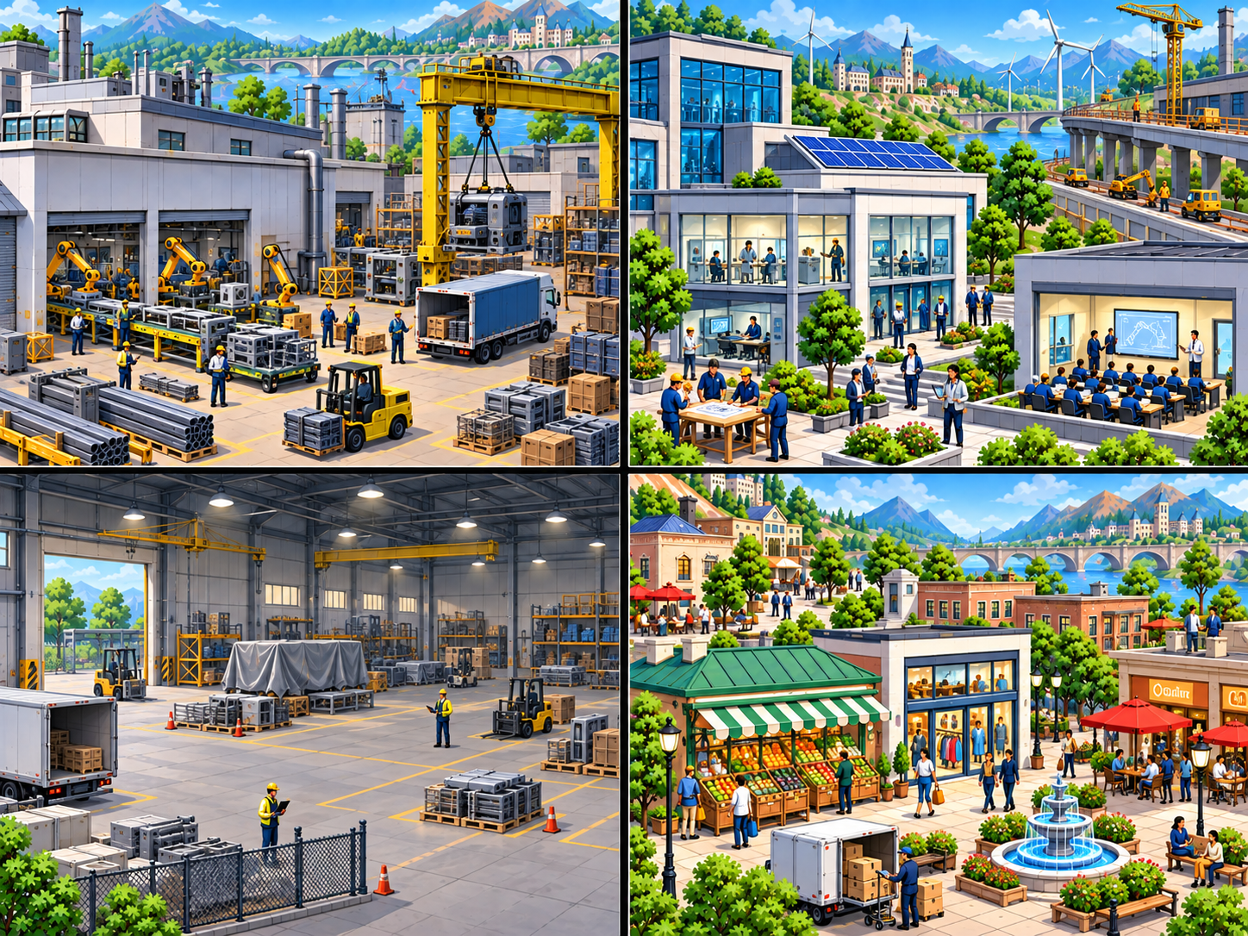
The balanced scene from the game. The four regions provide a visual analogy for production possibilities and changes in the economy’s condition.
- Upper left — capital goods and investment: machinery and equipment production becomes more prominent in capital-oriented scenes.
- Lower right — consumer goods and current consumption: household-facing shops and activity receive greater emphasis in consumption-oriented scenes.
- Lower left — idle or underutilized resources: inactive workers and equipment become more evident during the slowdown and return to use during recovery. Stored materials are not an unemployment count.
- Upper right — future improvements and expanded capacity: training, technology, and infrastructure show preparation. The growth scene appears only when completed improvements enter use.
After play, students can connect changes in the regions to the four changes in the table. The opening text identifies the regions, and consequences explain tradeoffs. The later discussion adds a formal PPF interpretation to this visual analogy, which supplies no numerical graph coordinates.

The Educational Loop
At the outcome, What changed overall and Your path help students trace the result back to their six choices. Read the economics and Alternative decisions explain the tradeoffs. Read the frontier adds a schematic PPF and three applications in new settings, with explanations and retries before Application complete.
Experience → Consequence → Economic Explanation → Formalization → Transfer

Bringing in the PPF Graph
- Have students choose a moment from their path and describe the economy’s condition at that point.
- Draw a bowed-out PPF with household consumer goods on the horizontal axis and capital goods on the vertical axis. Keep the diagram schematic, with no invented numerical output scales.
- Ask students to place their chosen moment using allocation, utilization, and capacity evidence. Identify efficient and inefficient positions with reference to Four changes to keep separate.
- Add a point outside the original frontier. Establish why it is currently unattainable and what would have to change to make it feasible.
- Trace a reallocation along the curve and ask what the economy gives up. Compare a small shift with a more concentrated production mix.
- Add the disruption and subsequent choices to the sketch. Have students distinguish recovery within existing capacity from expansion that requires a new frontier.
The built-in diagram labels efficient use of the original frontier A, slack B, and expanded capacity C. It highlights the category matching the student’s outcome and explains when the dashed frontier was not reached. These are illustrative categories; the four indicators cannot supply numerical coordinates for the graph.
For a brief extension, compare Calder’s disruption, which leaves productive assets intact, with a disaster that destroys factories or infrastructure. Students can contrast production inside the existing frontier with an inward shift caused by lost capacity.

Using It in Class
These are possible starting points; choose what fits your course.

Before formal instruction
Give students the link and explain how to choose and continue. Ask them to keep one decision and its consequence in mind as they play. To draw the graph together before students see the built-in version, have them pause at the outcome before Read the frontier.

During PPF instruction
Use a run between introducing the model and working through further examples. Collect a few outcomes for the graph procedure above, or draw on Questions to Consider where students need more practice.

After instruction
You might assign the game as transfer practice with a short explanation of the ending. The students’ reasons for choosing a consumption–investment mix let you assess how they use the model and evidence from their path.

Independent/student review
Students can review their path and work through the follow-up independently. If you want evidence of completion, you can request a reflection or screenshot through your usual course workflow; the game has no automatic instructor report.

Questions to Consider
Select any of these prompts for discussion or a short reflection.
- What did your final economy look like, and which earlier choices most strongly explain it? Use evidence from your six-choice history.
- Which decision had the clearest opportunity cost? Identify the gain and the best alternative output or recovery you gave up.
- Where did your path move along a frontier, move inside it, recover toward it, or expand it? What evidence separates those changes?
- How did the delivery and job-matching disruption change what Calder could produce versus what it actually produced? How would your analysis change if factories had been destroyed?
- Why might the Future growth indicator fall as productive capacity increases? What does that reveal about what the indicator tracks?
- How could two fully utilized economies choose different mixes and both be productively efficient? What would you need to know before judging one mix preferable?
- What did households give up while capital goods and improvements were being prepared? How would you weigh that sacrifice against benefits arriving later?
- Another country reports that both household and capital output have risen. What evidence would you ask for before deciding whether it has recovered idle capacity or expanded its productive capacity?

Common Misconceptions
- “More capital goods mean the PPF has already shifted.” Ask whether the improvements are still being prepared or have entered use.
- “If both outputs rise, the economy must be growing.” Check utilization first: recovery can raise both outputs within existing capacity.
- “A point inside the PPF is unattainable.” Inside points are feasible but inefficient in this model. Outside points are currently unattainable.
- “One efficient production mix is inherently better than another.” Ask whose priorities the mix serves. Efficiency alone cannot settle that choice.
- “The indicators are literal output measures, percentages, or graph coordinates.” They summarize scenario states. Ask students to support their interpretation with the written consequences.

Replay and Comparison
For an optional second run, have students record their first result, deliberately change a priority or decision, and predict the consequence and likely sacrifice before replaying.
Once they finish, ask them to compare the two histories at a similar point in the story and explain why the outcome changed or stayed similar. Their earlier choices may also have changed later options, which they should account for when evaluating the prediction.
Students can also compare with a partner. Similar endings can reveal different histories and opportunity costs, giving each student a chance to reconsider the explanation behind their prediction.
General teaching and implementation resources are available at Mastery Quests Faculty Resources.

