
GAME-SPECIFIC FACULTY GUIDE

Takeout Taco: Lunch Rush
  - A short-run production game built around specialization, crowding, marginal product, and capacity.
Use the students’ experience inside a busy food truck to introduce the production function. Their staffing choices give the later numbers and graphs a setting they can explain.

Why This Game Exists
This game comes from a lecture video I use in my online courses. The food truck is an MS Paint design that was enhanced by AI. In designing Takeout Taco, I wanted students to experience production before I showed them a production function. They begin with a lunch rush and a staffing problem. At first, adding workers helps because tasks can be divided. Eventually the truck gets crowded. When the production record and graphs appear, students can connect them to something they have already seen happen.
Students often learn that marginal product eventually falls without having a clear picture of why. The truck supplies that picture: more people share the same grill, counter, prep space, and equipment. The formal model then explains their experience, including why production can keep rising even as each additional worker contributes less.

What Students Do
Students start service with one worker. Each management choice runs another equal-length service window: call in a worker, keep the current crew, or send a worker home when the crew has more than one person. Staffing stays between one and six, and the rush allows up to ten windows. The display reports output for the current window and its change from the previous crew. A Production Log records the crew sizes they have tested.
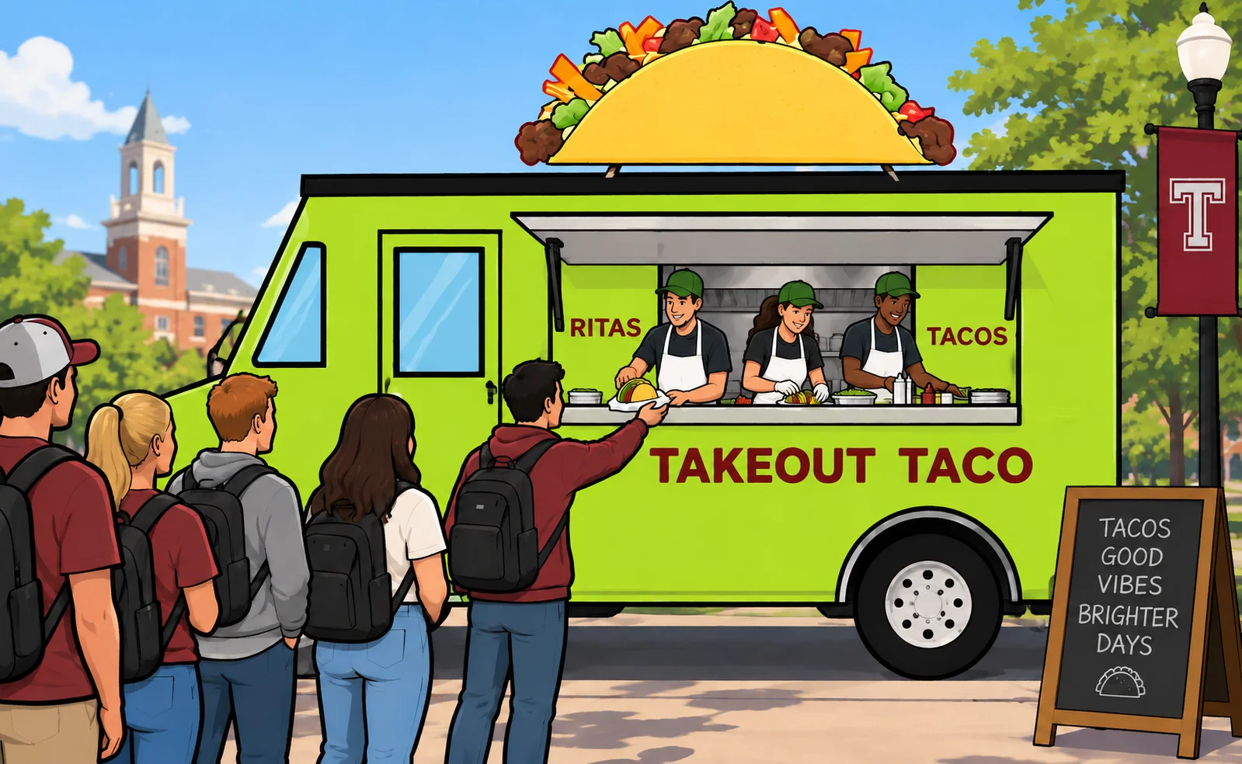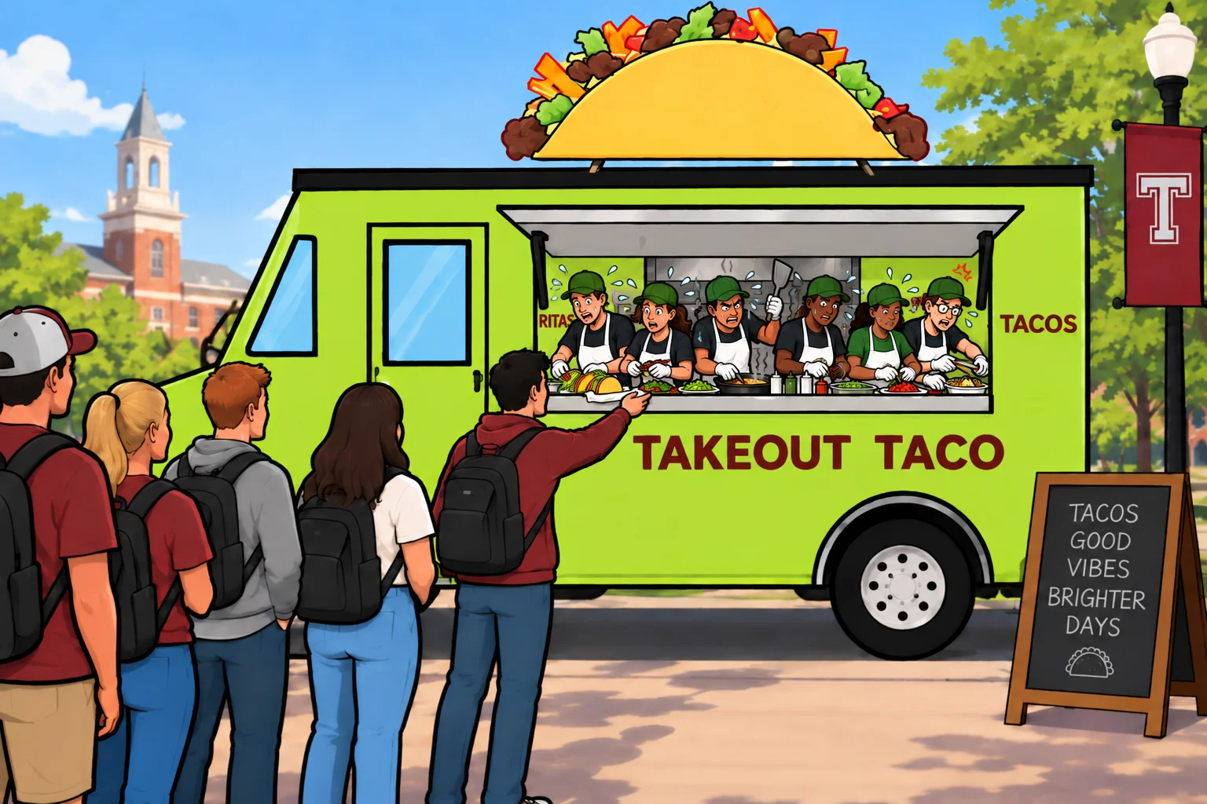
Three workers, left, and six workers, right. Labor changes while the truck and its equipment stay fixed; the scenes make specialization and crowding visible.
The scene and operational text change with staffing. One person handles everything; two and three workers divide preparation and service. Four begin sharing tighter space, and five or six increasingly crowd the same kitchen. Demand stays strong. The waiting-order state and customer line illustrate operational pressure; they do not estimate demand or determine the production schedule. Exact output comes from the record, not from counting objects in the artwork.
Production Review opens after four distinct crew sizes have been tested, or at the ten-window limit. Students can therefore reach it without trying every staffing level. The review asks about the first smaller addition to output, an added-output calculation, and the fixed-input explanation. Further questions depend on whether the run reached five or six workers. A run with limited exploration receives a labeled partial kitchen reference. Each answer receives an explanation, and students continue even after an incorrect response.
The total-product graph first plots the students’ observed staffing levels. After their interpretation attempt, it fills in the complete record, distinguishing observed and revealed points. A marginal-product graph and its question follow, then a paired view connects the two graphs. The full production table and diminishing-marginal-returns explanation appear afterward. This gradual reveal lets you ask what the students recognize from the truck before naming the relationship formally.
The next rush introduces a second identical truck and six workers to allocate between them. Students compare a chosen split with the one-truck baseline and can try other allocations. Finding the balanced allocation opens two questions: why more capacity raises output with the same labor, and why that result is consistent with diminishing marginal returns. Explanations follow both correct and incorrect answers. The final screen compares the one-truck and two-truck results and brings together specialization, crowding, and capacity.

What the Game Is Really Teaching
Think back to the first few additions to the crew. One worker handles everything, but the next arrivals let people divide cooking, preparation, assembly, and service. The first three workers add 8, 10, and 13 tacos, respectively. Students have watched specialization make the truck work better before they put a name to the pattern. Those additions are each worker’s marginal product: the extra output from one more worker using the same truck, grill, prep space, and equipment.
By the fourth worker, the kitchen is beginning to feel much more constrained. That worker adds 11 tacos, following the third worker’s 13; the fifth and sixth add 8 and 3. This is where diminishing marginal returns begins: Worker 4 is the first to contribute less than the previous worker. Yet the crew keeps making more tacos. Total output rises from 31 to 42 to 50 to 53, because even the crowded sixth worker makes a positive contribution.
Once the complete record appears, you can connect that experience to a short-run production function. With 0, 1, 2, 3, 4, 5, and 6 workers, the truck produces 0, 8, 18, 31, 42, 50, and 53 tacos per equal-length window. Labor changes across the record; the production setup stays fixed. Zero supplies the reference for the first worker’s contribution, and the opening scene precedes the first service window.
When students read the two graphs together, they can follow the same story in the total and in each addition. The total-product curve keeps rising but becomes flatter after three workers. The marginal-product graph makes the reason visible: each later worker adds fewer tacos. Ask students to point to the crowded crews in both graphs and explain how smaller, positive additions produce that flattening.
The second truck gives those six workers more room to work. For this challenge, everyone compares with the one-truck baseline of 6 + 0: 53 tacos, even if their earlier run ended with a smaller crew. Each truck uses the same schedule: 5 + 1 gives 50 + 8 = 58, 4 + 2 gives 42 + 18 = 60, and 3 + 3 gives 31 + 31 = 62. Students can try different splits without having to test them all. With three workers in each kitchen, they get nine more tacos from the same labor by putting more space and equipment at the crew’s disposal.
You can carry that comparison onto a production-function diagram. Put labor on the horizontal axis and total product on the vertical axis, then place 53 and 62 at the same six-worker input. Adding workers to one truck meant moving along the original short-run production function. Adding capital gives the crew a different production relationship, higher at that labor input. The second curve is a faculty extension; the game itself does not draw it. Diminishing marginal returns can still operate within either truck as more workers share its fixed space and equipment.

The Educational Loop
Students manage labor during the rush and see the consequences in output and crowding. Production Review asks them to explain the additional output and the fixed-space constraint. The graphs and complete record formalize the production function they experienced. The two-truck challenge then changes a fixed input and asks them to transfer that reasoning to a new production environment with the same six workers.
Experience → Consequence → Economic Explanation → Formalization → Transfer

Using It in Class
These are possible starting points; choose what fits your course.

Before formal production-function instruction
Let students manage the truck before introducing total product or marginal product. During the review and graph reveal, ask which changes they recognize. You can then name what they were watching: a short-run production function.

During instruction
Use the run after introducing fixed and variable inputs. Before the graph reveal, ask students to predict the shapes of the total-product and marginal-product graphs from their staffing observations.

After instruction
Ask students to locate the first decline in marginal product and explain why total product still rises afterward. On replay, they can test crews they skipped, explore heavier crowding, or stop earlier and compare their observations with the complete record. The production schedule stays the same across runs.

Capacity and capital extension
Use the two-truck comparison to distinguish changing labor from changing capital. Ask students to place the 53-taco and 62-taco outcomes at the same labor quantity on a diagram and explain why they belong to different production setups.

Independent/student review
Students can complete the management run, review, graph questions, and capacity extension independently. You can request a final-screen screenshot and short explanation through your usual course workflow; the game provides no automatic faculty report.

Questions to Consider
Select any of these prompts for discussion or a short reflection.
- Why can the second and third workers add more output than the first worker?
- Where does marginal product first fall, and what change inside the truck helps explain it?
- How can a total-product curve keep rising while becoming flatter?
- What does the sixth worker’s contribution tell you about crowding and total output?
- Which inputs stay fixed during the first rush? How do they constrain additional labor?
- Why can the same six workers make more tacos across two trucks? What changed besides their allocation?
- Why is the two-truck result consistent with diminishing marginal returns?
- How would you distinguish adding a worker from adding a truck on a production-function diagram?

Common Misconceptions
- “Diminishing returns begins with the second worker.” Specialization raises marginal product initially; the first decline occurs with Worker 4.
- “Falling marginal product means falling total product.” Positive additions still raise the total, even when those additions become smaller.
- “Later workers must be less skilled.” More labor shares the same fixed kitchen and equipment. Skill differences do not explain this schedule.
- “Crowding means demand fell.” Demand remains strong. The constraint is inside the truck’s production space.
- “The sixth worker contributes nothing.” Output rises from 50 to 53; the contribution is small and positive.
- “A second truck disproves diminishing marginal returns.” Additional capital changes the fixed-input condition. The original one-truck relationship describes a different setup.

