Connection Diagram
Red wires of servo motor go to 5V supply
Black wires of servo motor go to ground pin
White pins are connected as shown below.
Pin 9 or Pin 11
Pin 9 or Pin 11
Pin 6 or Pin 10
Pin 6 or Pin 10

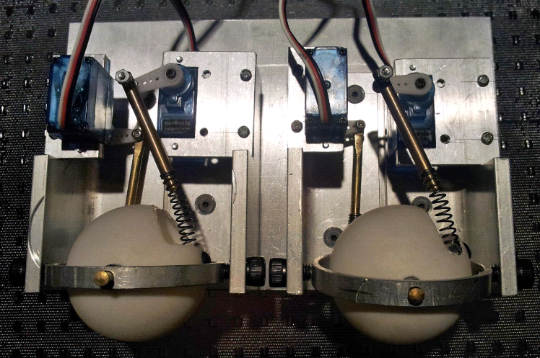

Connection is neater and can be done easier if Arduino Sensor Shield v4.0 is purchased. As long as the 4 pins are connected at the right spot, the result should look something like the figure below.
