We developed the software using Matlab as the computational programming language, as Matlab integrates data processing, visualization, and other functions into a unified platform while offering robust graphical user interface (GUI) design capabilities. The GUI (Graphical User Interface) of the developed software consists of four sections (see Fig.1).

**(1) Input data panel:** First, users must select either gravitational attraction (Gz) or gravitational gradient (Gzz) as the input data. Then, click the ‘Load’ button in the ‘Gravity data’ subpanel to import the selected data. In addition, the upper and lower boundaries data of the layers have to be load, we can do it by click the ‘Load’ button in the ‘Boundary’ subpanel to import the boundary data.

**(2) Input parameters panel:** in this section, users have to input the parameters of computational area such as the range of the longitude and latitude. Moreover, we have to input the parameter of the observation height, the maximum iterations, the tolerance, the damping factor and the maximum spherical harmonic degree.

**(3) Results panel:** In this section, we present the table and statistical analysis of the inversion apparent density results.

**(4) Plot panel:** This section presents the RMS error map and the final apparent density map.

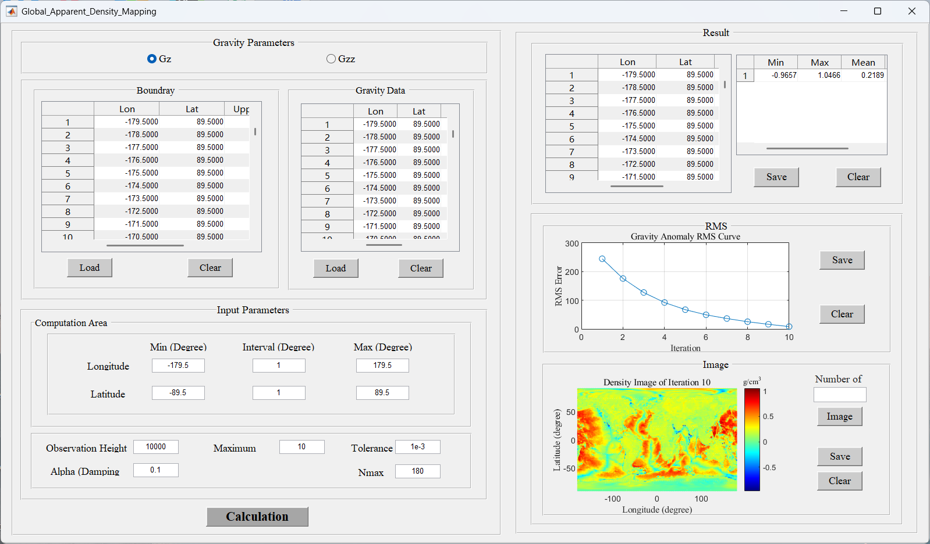

**Fig.1** GUI of the developed software