**1.0 Run “Focusing_Inversion.m” will popu up the GUI of the software**

**1.1 Main GUI interface of the software**

The main GUI interface of the software consists of three sections (see Fig.1). Section one is the “Parameters Settings,” which includes the focusing factor (see Equation 4), the iteration parameters such as maximum iterations, the adaptive factor and tolerance, and the depth weighting parameters. Additionally, there is a checkbox for selecting constraints, which includes depth weighting, data weighting, reference model, and solution bounds. Section two is the “Subsurface Model,” which defines the parameters for the x, y, and z axis ranges. If the reference model checkbox is checked, additional parameters for the reference model are also provided. Section three is the “Observation Data.” In this section, we can select which gravity component to use as the observation data. A button is provided to load the corresponding gravity grid data. After data loading is complete, there is another button to display the map of the input data.

**1.2 Result GUI interface of the software**

After inputting all the parameters and loading the observation data in the main GUI interface of the software, click the “Inversion” button to start the inversion process. Once the inversion process is complete, a pop-up window will appear to display the inversion results (see Fig.2). As shown, the results GUI interface of the software consists of two parts. Part one displays a table of the 3D density solution along with statistics of the solution. Additionally, there is a subsection for result visualization, where the solution slice can be shown along the x, y, and z axes at the defined positions. Part two provides functionality for using the 3D density solution to predict gravity components, compute the forward modeling results’ statistics, and display the corresponding maps.

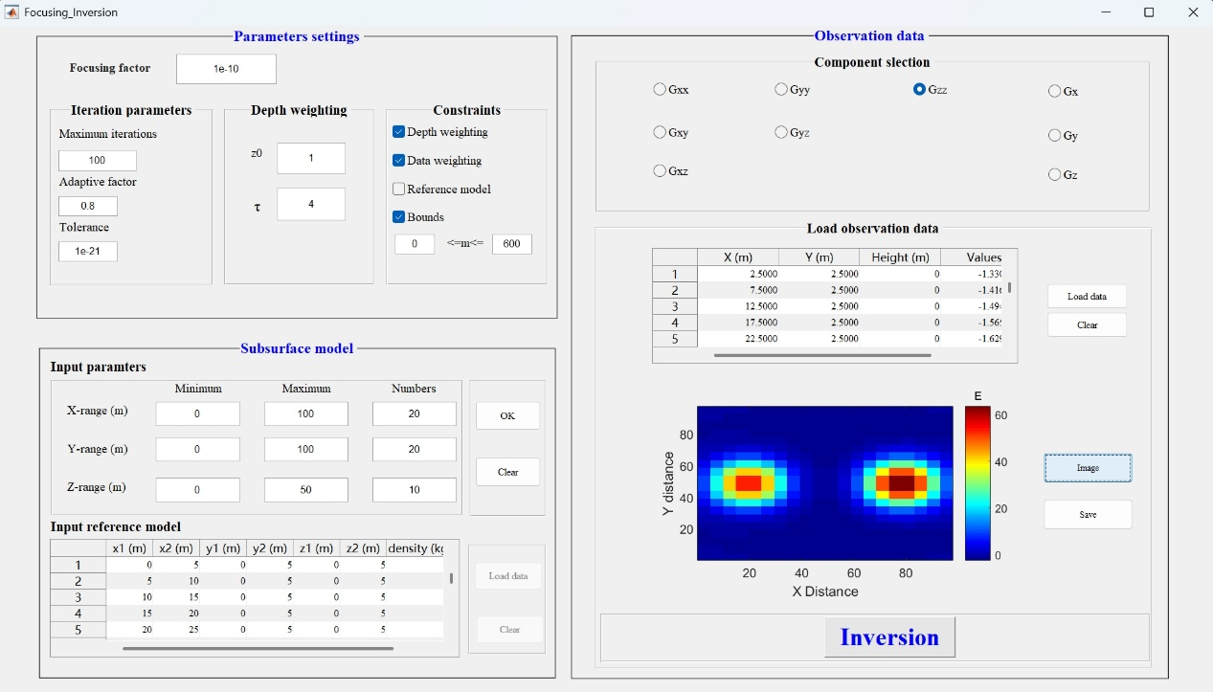

**Fig. 1** The Main GUI interface of the Focusing inversion software

图形用户界面, 应用程序

AI 生成的内容可能不正确。

**Fig. 2** The Result GUI interface of the Focusing inversion software