B275 points:

1.one more value missing in the detailed view of a product
its the price p.p.in $

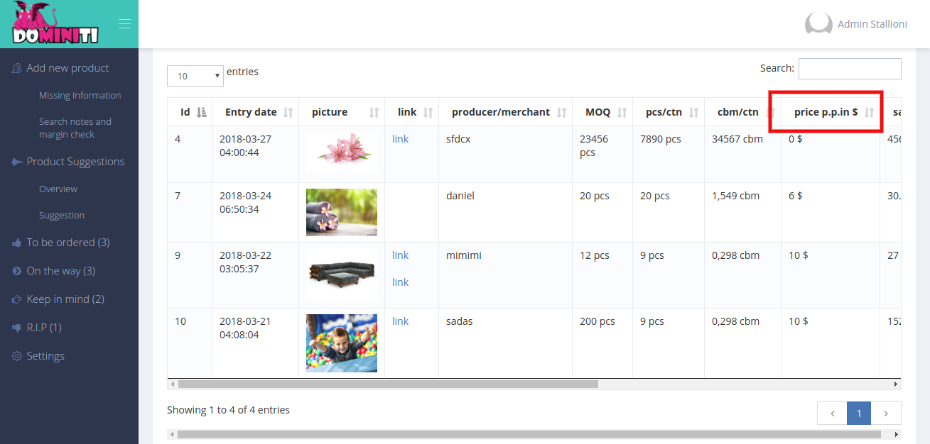

2. also one more thing, i checked the margins in the lists. they are correct everywhere, accept with the first product in the product suggestion overview
the little babyblanket
somehow the result doesnt add up with the one in excel. all the others do
not sure if it is because its not calculating with exactt number or so

++ Which product did you mentioned.

3. The moving works fine. only one product in "keep in mind" i wanted to move to "product suggestions" that doesnt work somehow. but it could also just be a little bug on my end. not sure. maybe you could check if you can move it from there to "product suggestions"
i think it is because thats the first thing is being suggested.
++ Its work correctly please clear cache check once again.

4. thats being suggested in the drop down. and when you wanna move it to the list thats already suggested in the drop down, it doesnt work.

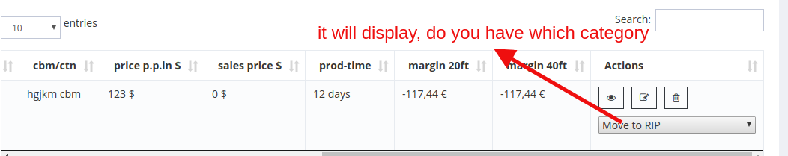

5. last but not least, right now i have 9 products in the product suggestion list.

++ In product suggestion and suggestion are viewed in same products only.

Clarifications:
when i click the green thumb the product needs to go into "to be ordered" and not into "on the way"

++what are the products to be viewed in on the way page

