环境搭建
- 机器学习环境搭建
打开Anaconda Navigator
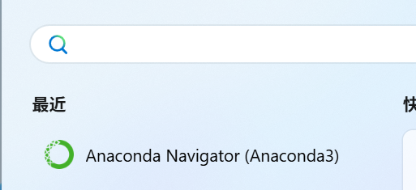
新建一个虚拟环境
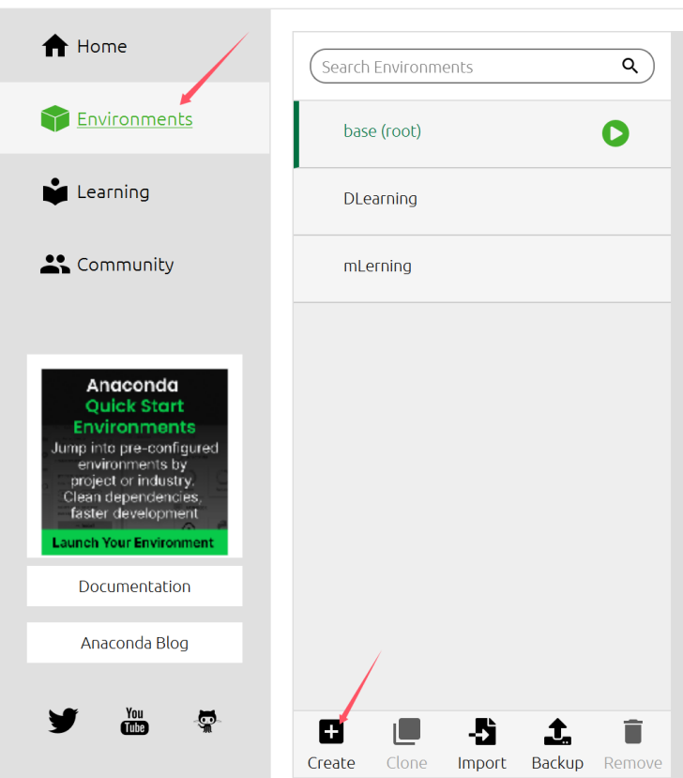
选择python的版本，这里选择的python 3.11版本
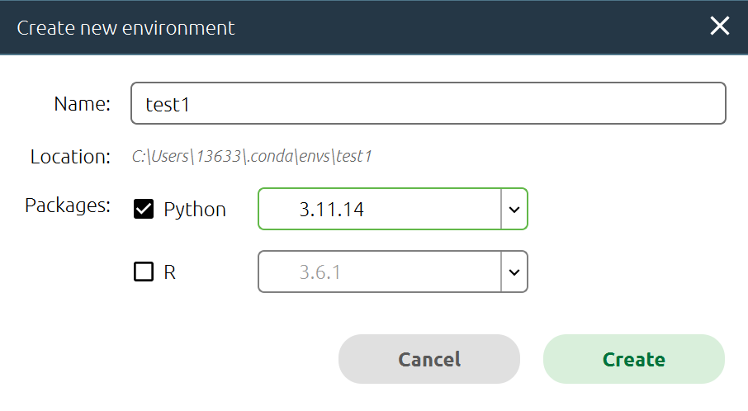
等待创建完毕
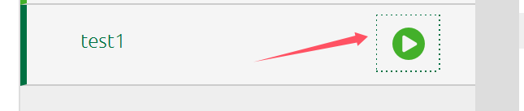
左键点击按钮进入open on terminal，进行一下库的安装。

1. 基础科学计算库
pip install numpy -i https://pypi.tuna.tsinghua.edu.cn/simple
pip install pandas -i https://pypi.tuna.tsinghua.edu.cn/simple
pip install matplotlib -i https://pypi.tuna.tsinghua.edu.cn/simple
pip install seaborn -i https://pypi.tuna.tsinghua.edu.cn/simple
pip install pyecharts -i https://pypi.tuna.tsinghua.edu.cn/simple

机器学习库
pip install scikit-learn -i https://pypi.tuna.tsinghua.edu.cn/simple

自然语言处理库
pip install jieba -i https://pypi.tuna.tsinghua.edu.cn/simple
pip install wordcloud -i https://pypi.tuna.tsinghua.edu.cn/simple
pip install snownlp -i https://pypi.tuna.tsinghua.edu.cn/simple
pip install pyttsx3 【安装会慢，失败的话多试几次】

操作MySQL的数据
pip install pymysql -i https://pypi.tuna.tsinghua.edu.cn/simple

爬虫库
pip install requests -i https://pypi.tuna.tsinghua.edu.cn/simple
pip install beautifulsoup4 -i https://pypi.tuna.tsinghua.edu.cn/simple

Open CV库
pip install -i https://pypi.tuna.tsinghua.edu.cn/simple opencv-python

web框架
pip install -i https://pypi.tuna.tsinghua.edu.cn/simple flask
- 深度学习框架搭建
（一）环境一库的安装
- 深度学习库
pip install -i https://pypi.tuna.tsinghua.edu.cn/simple tensorflow==2.13.0
pip install matplotlib==3.7.5 -i https://pypi.tuna.tsinghua.edu.cn/simple
对一些高版本的包进行降级
pip uninstall numpy
pip install numpy==1.24.3 -i https://pypi.tuna.tsinghua.edu.cn/simple
pip install contourpy==1.1.0 -i https://pypi.tuna.tsinghua.edu.cn/simple
重新安装 保证包正常
pip install --upgrade matplotlib==3.7.5
- 环境二库的安装
pip install -i https://pypi.tuna.tsinghua.edu.cn/simple tensorflow==2.13.0
pip install -i https://pypi.tuna.tsinghua.edu.cn/simple opencv-python==4.10.0.84
pip install -i https://pypi.tuna.tsinghua.edu.cn/simple opencv-contrib-python==4.10.0.84
pip install -i https://pypi.tuna.tsinghua.edu.cn/simple PyAutoGUI==0.9.54
pip install -i https://pypi.tuna.tsinghua.edu.cn/simple Mediapipe==0.10.11
pip uninstall numpy
pip install numpy==1.24.3
pip install contourpy==1.1.0
pip install jax==0.4.14 jaxlib==0.4.14 scipy==1.11.3 -i https://pypi.tuna.tsinghua.edu.cn/simple

