Final Project Report
Project name | Korean Sign Language Site
Team name | 아지들
Team member | Department | Student number | Name
Team member | Software | 2017038062 | 정해경
Team member | Software | 2017038049 | 차송희
Team member | Software | 2016039006 | 문재식
Development period | 2020.10.01 ~ 2020.11.30
Project definition | 1. definition  It is a system where you can see the meaning, pictures, and videos of sign language and save them on my page to study sign language.  2. Development Purpose  The reason for choosing a topic is for everyone to learn sign language easily.  The goal is to make it easier for people to access and learn about Korean sign language. Also, we wanted to make it more memorable through the function of wordbook.  3. perform requirement analysis  1) Login  2) Sign Up  3) My Page-Terminal Dictionary Custom  4) Search by word  6) Search by category  7) Show today’s signlanguage  8) To print  9) Output result (dictionary and video)  10) Google Maps  11) Google Chart  12) Remote control (Recent searches)  13) Move Sites  4. Major functions  1) Search for sign language: When a user enters a word, only the specific sign language corresponding to it is imported from the DB and printed.  2) Search for sign language belonging to the category user select: When a user selects type of the sign language, user can see all of information about the category’s signlanguage.  3)Show today’s sign language: when a user enters the search page, the user can see three sign language that is shown randomly selected by the database.  4) Sign Language vocabulary note: When a user adds a user-searched sign language to the vocabulary note, the user can always enter the vocabulary note and check the information on the sign language that I added.
Project Development Environment | Language of use: Html, CSS, JS, EJS  Database: MySQL  Utilization Open API  https://www.culture.go.kr/data/openapi/openapiView.do?id=367&category=G&keyword=%EC%88%98%EC%96%B4&searchField=all&gubun=A
Development Schedule and Roles | 1. Development schedule  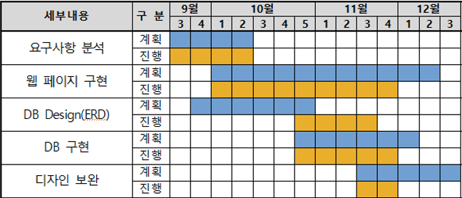  2. Roles
  Name | Roles
  정해경 | DB Design (ERD), Search Page, Wordbook Page
  차송희 | DB Management, Schema Design, Main Page
  문재식 | Requirements Analysis, DB Implementation,  Login & Signup Page
Development Results | - Database design  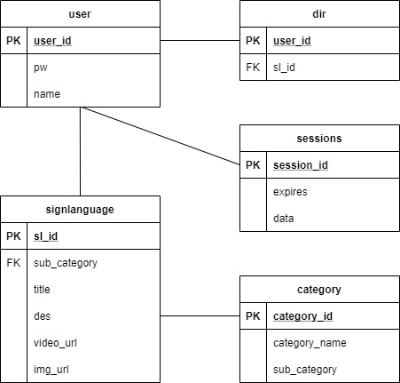  -E-R diagram  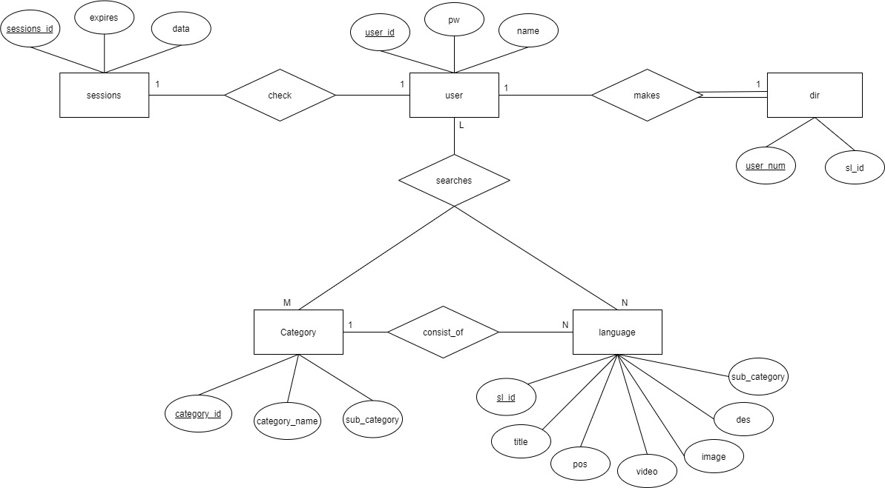  -Mapping result  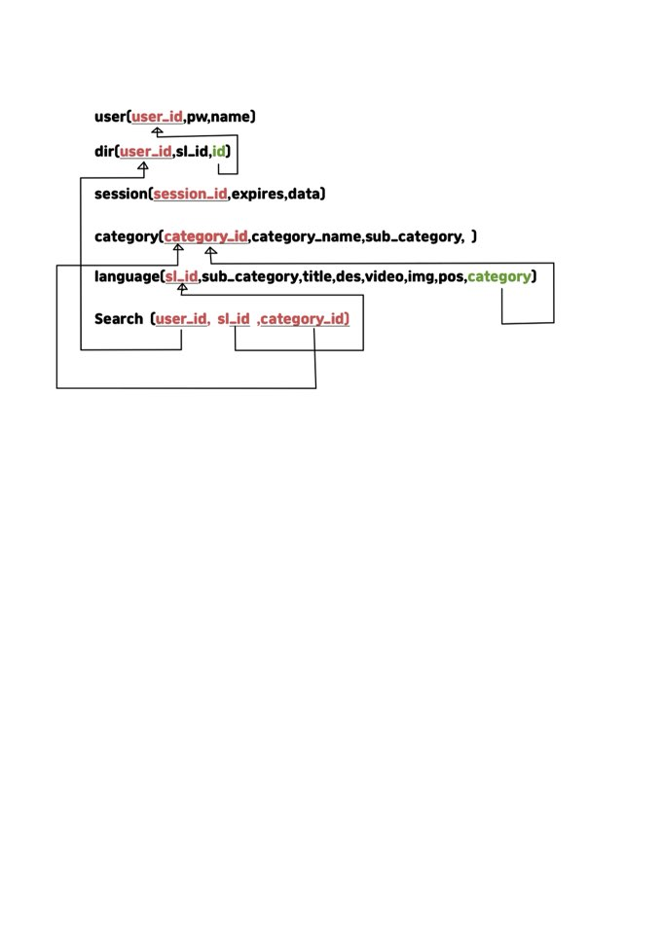  - Main page  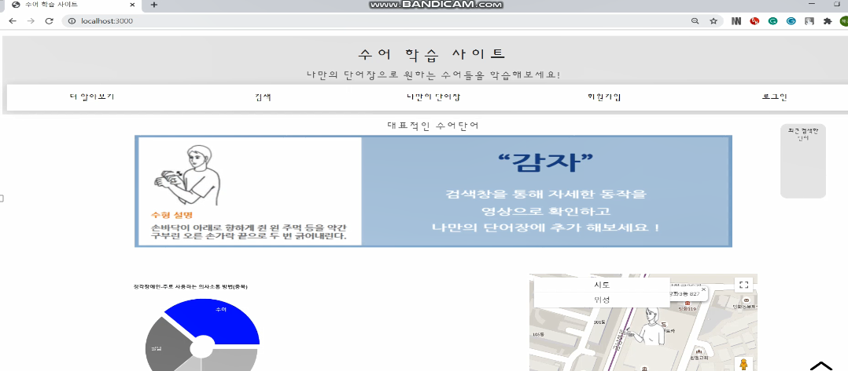  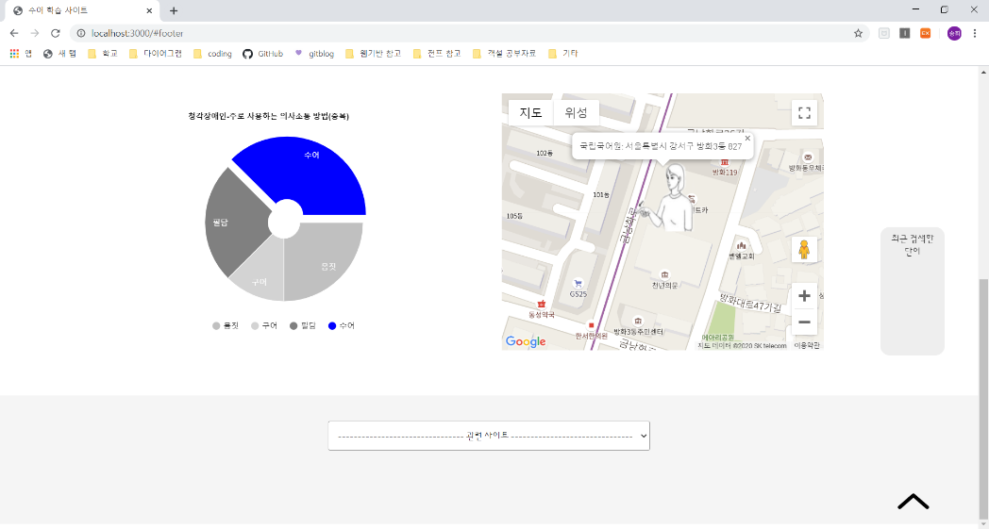  Google map, Google chart, Move site, Remote control(Recent searches)  - Login page  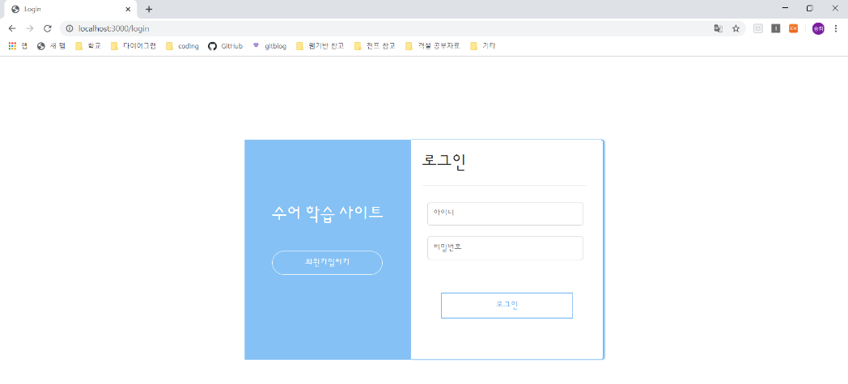  When accessing mydir page without loggin in,  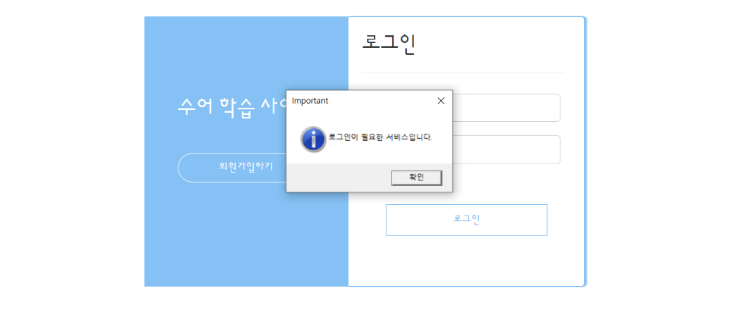  - Sign page  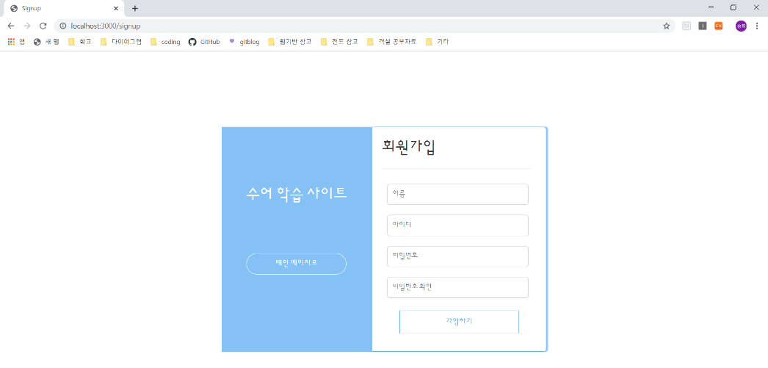  If the same ID exists in the DB,  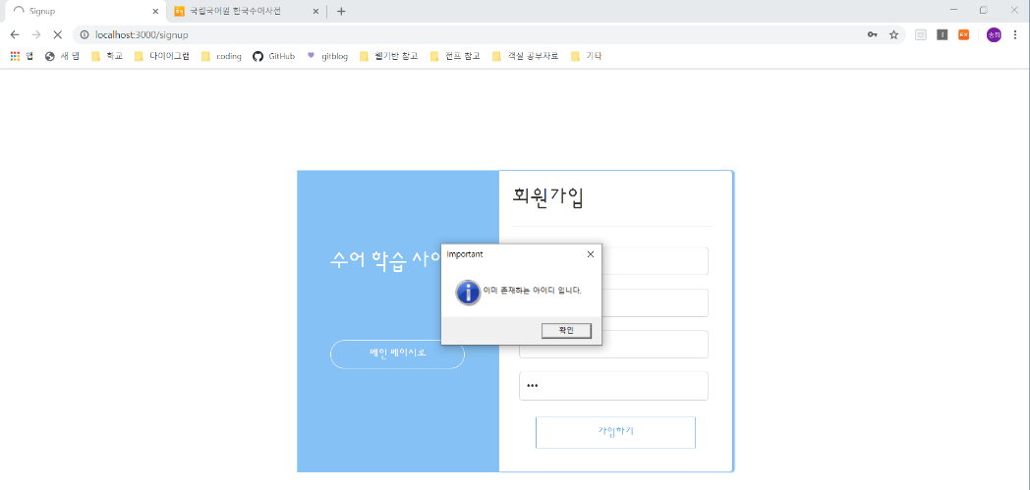  -Select category  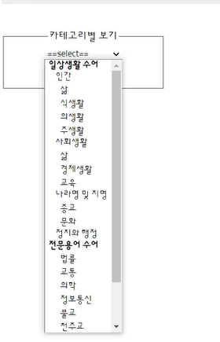  - Show signlanguage belonging to the category user select  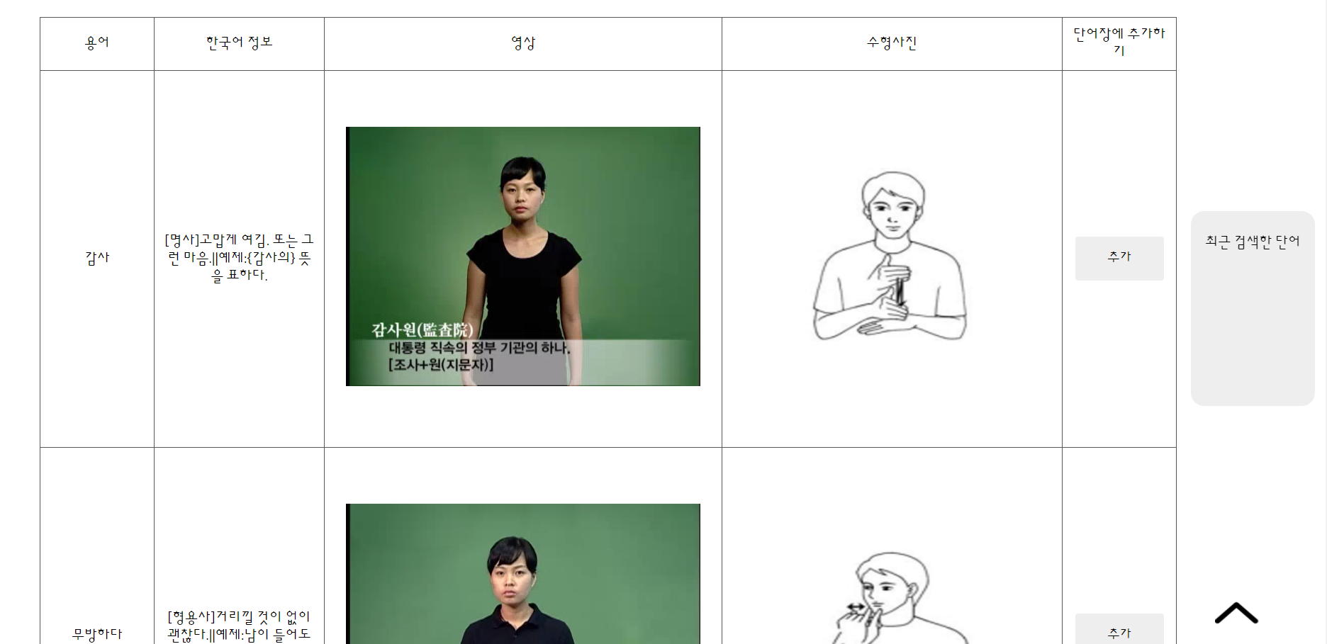  -Search signlanguage  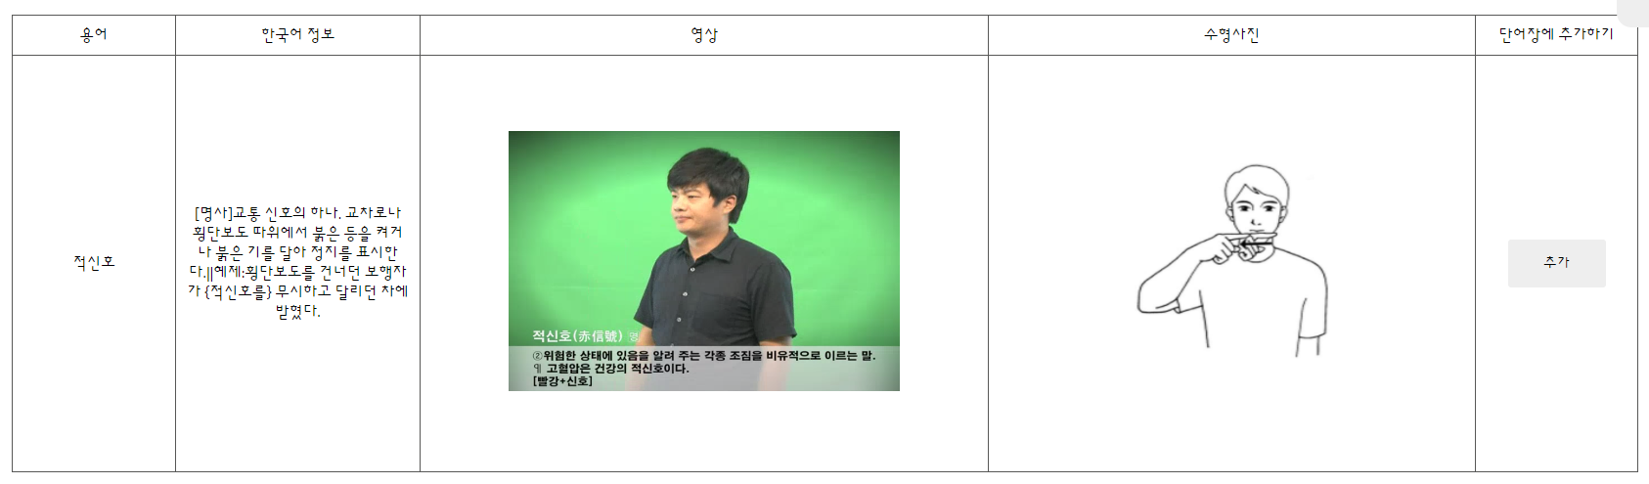  -Today’s signlanguage  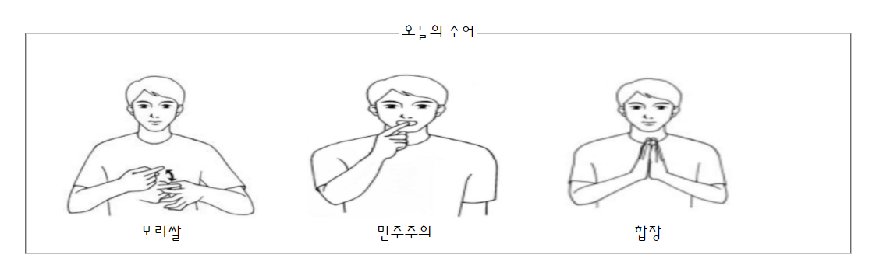  - Show Mydir page(Delete,Print)  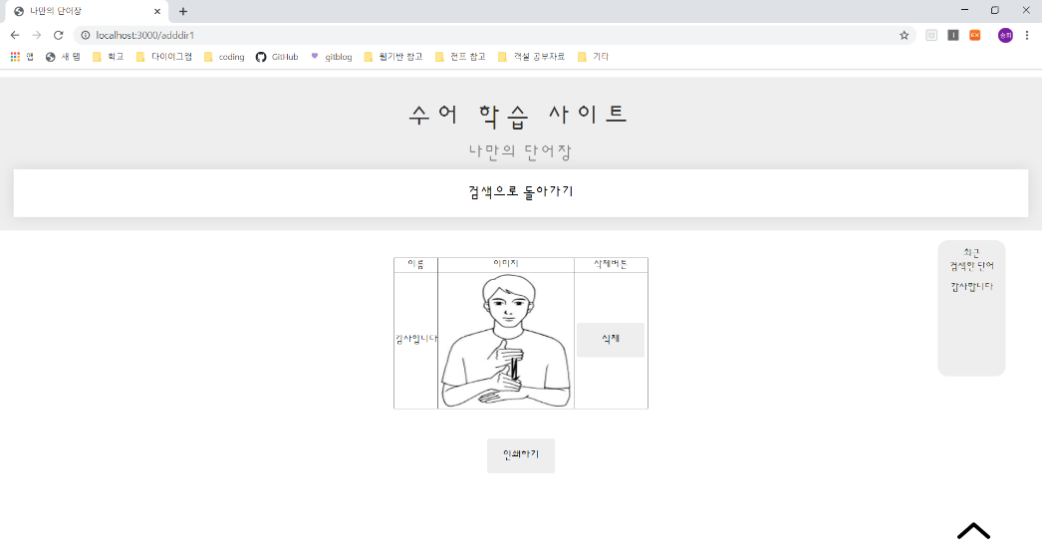  To print  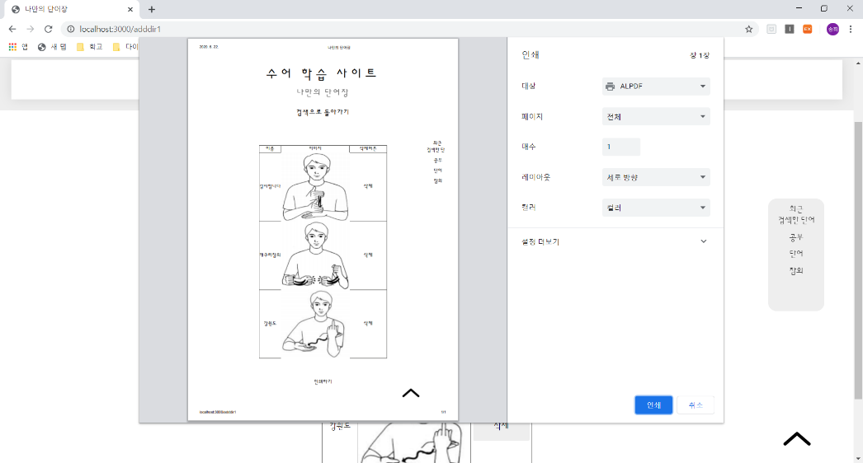
GitHub | https://github.com/wjdgoruds2/Databasesystem/tree/master

