HW#13 디지털 회로 설계 및 언어 월수 9:00~10:15 2015104027 박정진

**Separate code to next_state and output from ASMD**

module Sequential_Binary_Multiplier

#(parameter dp_width = 5 parameter BC_size = 3) (

output [2*dp_width-1:0] Product,

output Ready,

input [dp_width-1:0] Multiplicand, Multiplier,

input Start, clock, reset_b

);

parameter S_idle = 3'b001, S_add = 3'b010, S_shift=3'b100;

reg [2:0] state, next_state;

reg [dp_width-1:0] A, B, Q; //Sized for datapath

reg C;

reg [BC_size-1:0] P;

reg Load_regs, Decr_P, Add_regs, Shifth_regs;

//Miscellaneous combinational logic

assign Product = {A, Q};

wire Zero = (P==0); // counter is zero

wire Ready=(state == S_idle); // controller status

//control unit

always@(posedge clock, negedge reset_b)

if(~reset_v) state <= S_idle;

else state <= next_state;

// next state logic

always@(state, Start, Q[0], Zero) begin

next_state <= S_idle;

case(state)

S_idle: if(Start) next_state <= S_add;

S_add: next_state <= S_shift;

S_shift:

begin

if(Zero) next_state <= S_idle;

else next_state <= S_add;

end

default: next_state <= S_idle;

end

// output logic

always@(state, Start, Q[0], Zero) begin

Load_regs <= 0;

Decr_P <= 0;

Add_regs <= 0;

Shift_regs <= 0;

case(state)

S_idle: if(Start) Load_regs <= 1;

S_add:

begin

Decr_P <= 1;

if(Q[0]) Add_regs <= 1;

end

S_shift:

Shift_regs <= 1;

end

//datapath unit

always@(posedge clock) begin

if(Load_regs) begin

P <= dp_width;

A <= 0;

C <= 0;

B <= Multiplicand;

Q <= Multiplier;

end

if(Add_regs) {C,A} <= A+B;

if(Shift_regs) {C,A,Q} <= ({C,A,Q} >> 1);

if(Decr_P) P <= P-1;

end

endmodule

**Design LD Driver**

Design LD Driver with

1 12-bits binary counter I_Out (Predefined value of I_out is 2000)

1 structured module Counter_1E6

3 External input(main input) SW_ON, LD_ON, 12-bits I_set

2 12 bits Flip-Flop I_set_reg, I_incr

1 Flip-Flop LD_ON_reg

1 Master Clock 100MHZ (period = 10ns)

States

initial state :

increase I_out :

decrease I_out :

keep I_out :

set high value from :

set low value from :

Module Structure

ASM Chart of Counter_1E6

ASM Chart of LD_Driver

Verilog

top.v

module top(

output [12:0] I_out,

input [12:0] I_set,

input SW_ON, LD_ON,

input CLK, Clrn

);

wire Start_C, Clr_C, C_out;

Counter_1E6_ASM_v_jin C1 (

.C_out(C_out),

.Start_C(Start_C),

.Clr_C(Clr_C),

.CLK(CLK),

.Clrn(Clrn));

LD_Driver_ASM_v_jin LD1 (

.I_out(I_out),

.Start_C(Start_C),

.Clr_C(Clr_C),

.I_set(I_set),

.SW_ON(SW_ON),

.LD_ON(LD_ON),

.C_out(C_out),

.CLK(CLK),

.Clrn(Clrn));

endmodule

Counter_1E6_ASM_v_jin.v

module Counter_1E6_ASM_v_jin(

output reg C_out,

input Start_C, Clr_C,

input CLK, Clrn

);

reg [19:0] A; //Counter_1E6

reg [1:0] pstate, nstate; // state

//S0 : initial state, S1 : count

parameter S0 = 2'b00, S1=2'b11;

//state transition for control logic

always @(posedge CLK, negedge Clrn) begin

if(~Clrn) begin

pstate <= S0;

A <= 20'b0;

C_out <= 1'b0;

end

else begin

pstate <= nstate; //clocked operation

//Register Transfer operation controlled by external input

case(pstate)

S0:

begin

if(Start_C) begin

A <= 20'b0;

C_out <= 1'b0;

end

end

S1:

begin

if(Start_C) begin

if(Clr_C) begin

A <= 20'b0;

C_out <= 1'b0;

end

else begin

if(A==20'd999999) begin

A <= 20'b0;

C_out <= 1'b1;

end

else begin

A <= A + 1'b1;

C_out <= 1'b0;

end

end

end

end

endcase

end

end

// decide next state

always@(pstate, Start_C) begin

case(pstate)

S0:

begin

if(Start_C) nstate <= S1;

else nstate <= S0;

end

S1:

begin

if(Start_C) nstate <= S1;

else nstate <= S0;

end

endcase

end

endmodule

LD_Driver_ASM_v_jin.v

module LD_Driver_ASM_v_jin(

output reg [12:0] I_out,

output reg Start_C,

output reg Clr_C,

input [12:0] I_set,

input SW_ON, LD_ON, C_out,

input CLK, Clrn

);

reg LD_ON_reg; // store LD_ON

reg [12:0] I_set_reg; //store i_set value

reg [12:0] I_incr; // setting incremental

reg [2:0] pstate, nstate;

//Encode the states

parameter S0=3'b000, S1=3'b001, S2=3'b010, S3=3'b011, S4=3'b100, S5=3'b101;

//state transition

always @(posedge CLK, negedge Clrn) begin

if(~Clrn) begin

pstate <= S0;

I_out <= 13'b0;

Start_C <= 1'b0;

Clr_C <= 1'b0;

LD_ON_reg <= 1'b0;

I_set_reg <= 13'b0;

I_incr <= 13'b0;

end

else begin

pstate <= nstate; //clocked operation

// if SW_ON == 0, set LD_ON_reg 1'b0

if(SW_ON) LD_ON_reg <= LD_ON;

else LD_ON_reg <= 1'b0;

// store i_set

I_set_reg <= I_set;

// make incr

I_incr <= (I_set >> 10); // divide by 1024(approx 1000)

//Register Transter operation

case(pstate)

S0:

begin

I_out <= 13'b0;

if(SW_ON) begin

Start_C <= 1'b1;

Clr_C <= 1'b0;

end

else Start_C <= 1'b0;

end

S1:

begin

if(SW_ON) begin

if(LD_ON_reg) begin

Clr_C <= 1'b0;

if(I_out < I_set_reg) begin

if(C_out == 1'b1) begin

I_out <= I_out+I_incr;

end

end

end

else Clr_C <= 1'b1;

end

else Clr_C <= 1'b1;

end

S2:

begin

if(SW_ON) begin

if(!LD_ON_reg) begin

Clr_C <= 1'b0;

if(I_out >= 4'b1010) begin

if(C_out == 1'b1) begin

//multiple by 2

I_out <= I_out-(I_incr << 1);

end

end

end

else Clr_C <= 1'b1;

end

else begin

if(I_out >= 4'b1010) begin

Clr_C <= 1'b0;

if(C_out == 1'b1) begin

I_out <= I_out-(I_incr << 1);

end

end

else Clr_C <= 1'b1;

end

end

S3:

begin

Clr_C <= 1'b1;

end

S4:

begin

if(SW_ON) begin

if(LD_ON_reg) begin

Clr_C <= 1'b0;

if(I_out < I_set_reg) begin

if(C_out == 1'b1) begin

I_out <= I_out+I_incr;

end

end

end

else Clr_C <= 1'b1;

end

else Clr_C <= 1'b1;

end

S5:

begin

if(SW_ON) begin

if(LD_ON_reg) begin

Clr_C <= 1'b0;

if(I_out > I_set_reg) begin

if(C_out == 1'b1) begin

I_out <= I_out-(I_incr<<1);

end

end

end

else Clr_C <= 1'b1;

end

else Clr_C <= 1'b1;

end

endcase

end

end

always @(SW_ON, LD_ON_reg, pstate, I_out, I_set_reg) begin

case(pstate)

S0:

begin

if(SW_ON & LD_ON_reg) nstate <= S1;

else nstate <= S0;

end

S1:

begin

if(SW_ON & LD_ON_reg) begin

if(I_out >= I_set_reg) nstate <= S3;

else nstate <= S1;

end

else nstate <= S2;

end

S2:

begin

if(SW_ON) begin

if(LD_ON_reg) nstate <= S1;

else nstate <= S2;

end

else

if(I_out <= 4'b1010) nstate <= S0;

else nstate <= S2;

end

default:

begin

if(SW_ON & LD_ON_reg) begin

if (I_out != I_set_reg) begin

if(I_out < I_set_reg) nstate <= S4; //i_set incr

else nstate <= S5;

end

else nstate <= S3;

end

else nstate <= S2;

end

endcase

end

endmodule

sti.v

`timescale 1ns/1ns

module sti;

reg CLK, Clrn;

reg [12:0] I_set;

wire [12:0] I_out;

reg SW_ON, LD_ON;

//set end time

initial begin

#40E6 $finish;

end

initial

begin

CLK <= 1'b0;

Clrn <= 1'b0;

SW_ON <= 1'b1;

LD_ON <= 1'b1;

I_set <= 13'd1024;

#20 Clrn <= 1'b1; // reset two clock edge

#5E6 I_set <= 13'd2048;

#2E6 I_set <= 13'd1024;

#4E6 I_set <= 13'd2048;

#8E6 I_set <= 13'd1024;

#6E6 LD_ON <= 1'b0; //start decreasing

#3E6 I_set <= 13'd2048;

#2E6 I_set <= 13'd1024;

#2E6 LD_ON <= 1'b1; //again start increasing

#2E6 SW_ON <= 1'b0; //turn off the switch

#1E6 SW_ON <= 1'b1; //again swithch on

end

always #5 CLK <= ~CLK; //clock generator

top t1 (

.I_out(I_out),

.I_set(I_set),

.SW_ON(SW_ON),

.LD_ON(LD_ON),

.CLK(CLK),

.Clrn(Clrn));

always @(I_out) begin

$monitor("I_out = %d, time = %0d", I_out, $time);

end

endmodule

RTL Simulation

1) Increasing I_out

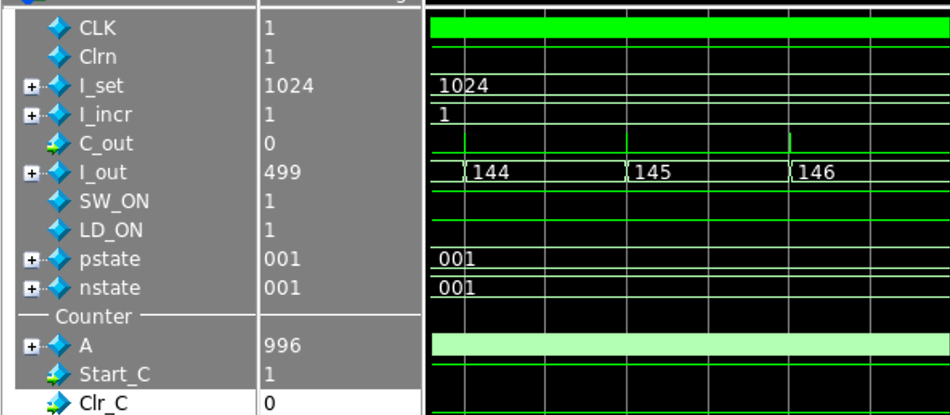

SW_ON = 1

LD_ON = 1

LD_ON_reg = 1

I_set = 1024

I_incr = 1

State : S1 (001)

2) change I_set during increasing I_out

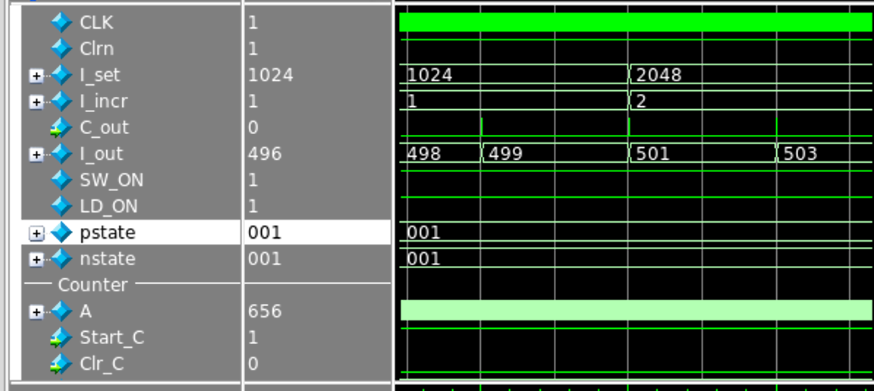

SW_ON = 1

LD_ON = 1

LD_ON_reg = 1

I_set = 2048

I_incr = 2

State : S1 (001)

3) change again I_set during increasing I_out

SW_ON = 1

LD_ON = 1

LD_ON_reg = 1

I_set = 1024

I_incr = 1

State : S1 (001)

4) reach I_set value

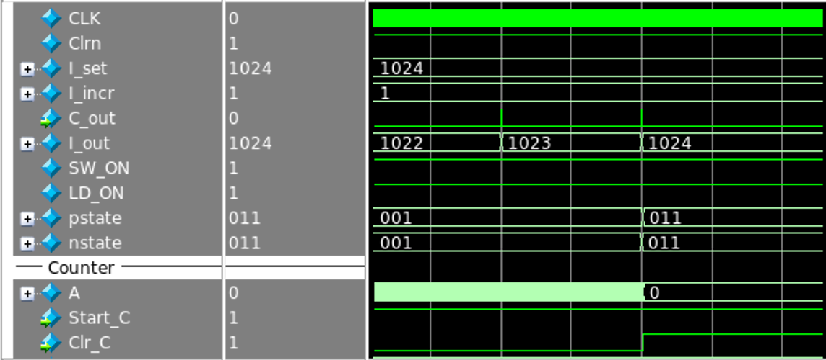

SW_ON = 1

LD_ON = 1

LD_ON_reg = 1

I_set = 1024

I_incr = 1

State : S3 (011)

5) change High value of I_set when keep I_out

SW_ON = 1

LD_ON = 1

LD_ON_reg = 1

I_set = 2048

I_incr = 2

State : S4 (100)

6) reach High value of I_set

SW_ON = 1

LD_ON = 1

LD_ON_reg = 1

I_set = 2048

I_incr = 2

State : S3 (011)

7) change low value of I_set when keep I_out

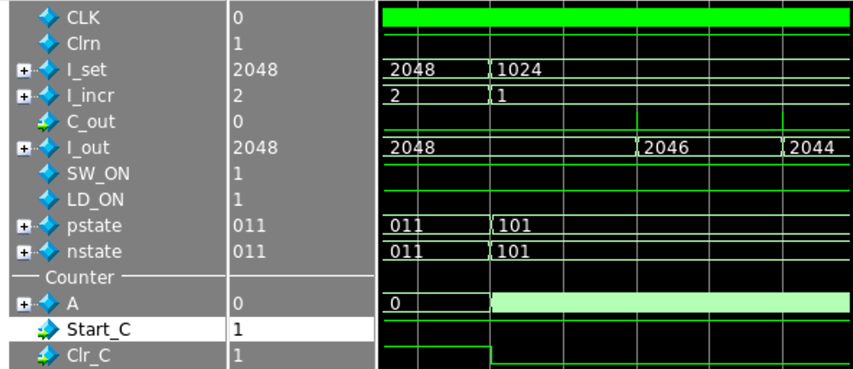

SW_ON = 1

LD_ON = 1

LD_ON_reg = 1

I_set = 1024

I_incr = 1 (I_decr : 2)

State : S5 (101)

8) Decreasing I_out when LD_ON is 0

SW_ON = 1

LD_ON = 0

LD_ON_reg = 0

I_set = 1024

I_incr = 1 (I_decr : 2)

State : S2 (010)

9) change I_set during decreasing I_out

SW_ON = 1

LD_ON = 0

LD_ON_reg = 0

I_set = 2048

I_incr = 2 (I_decr : 4)

State : S2 (010)

10) keep I_out below 10 and stay in switch on

SW_ON = 1

LD_ON = 0

LD_ON_reg = 0

I_set = 2048

I_incr = 2 (I_decr : 4)

State : S2 (010)

11) change LD_ON to 1

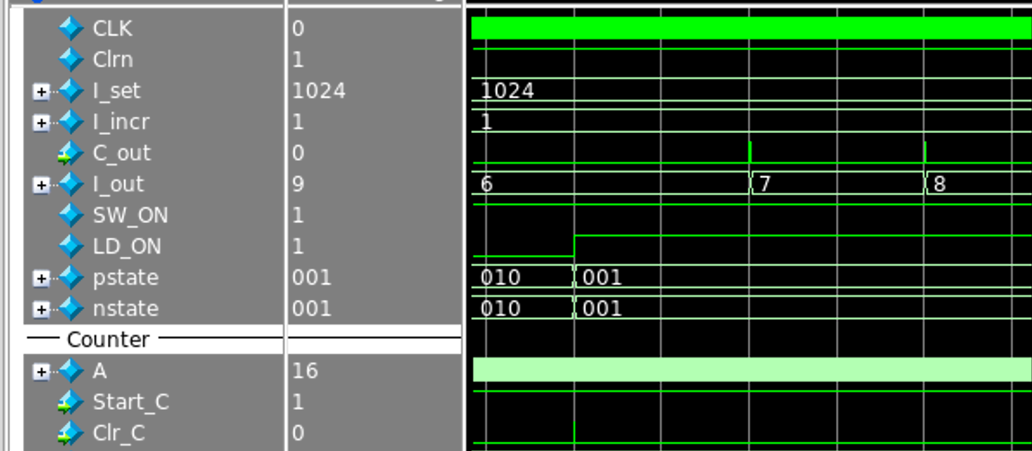

SW_ON = 1

LD_ON = 1

LD_ON_reg = 1

I_set = 1024

I_incr = 1 (I_decr : 2)

State : S1 (001)

12) Switch off

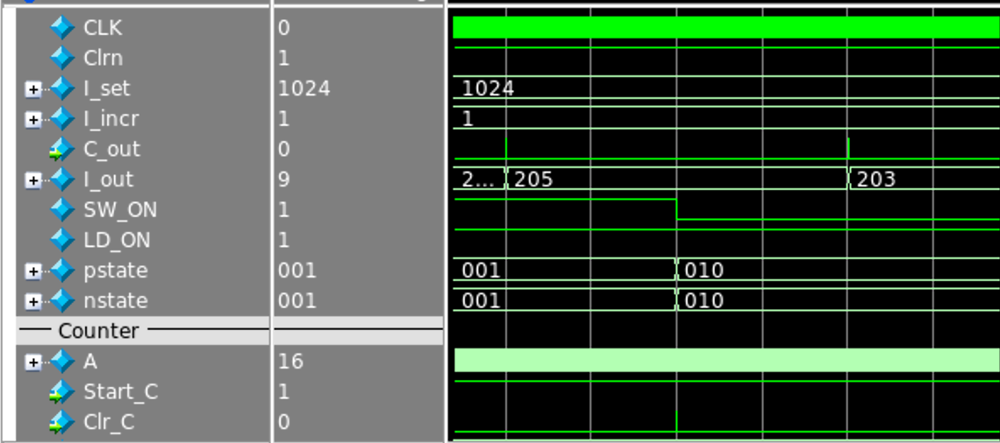

SW_ON = 0

LD_ON = 1

LD_ON_reg = 0

I_set = 1024

I_incr = 1 (I_decr : 2)

State : S2 (010)

13) When I_out reaches below 10, initialize I_out to 0 and go to initial state

SW_ON = 0

LD_ON = 1

LD_ON_reg = 0

I_set = 1024

I_incr = 1 (I_decr : 2)

State : S0 (000)

14) Switch on again

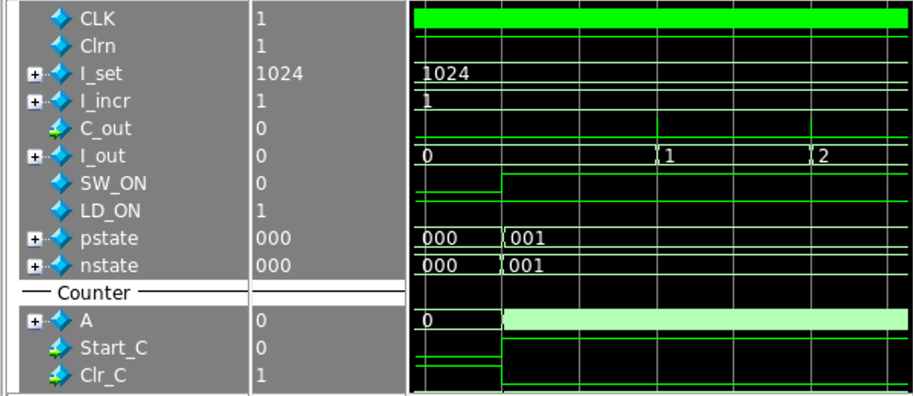

SW_ON = 1

LD_ON = 1

LD_ON_reg = 1

I_set = 1024

I_incr = 1

State : S1 (001)