HW#11 디지털 회로 설계 및 언어 월수 9:00~10:15 2015104027 박정진

**Design LD Driver (minor 0.1)**

Design LD Driver with

1 12-bits binary counter I_Out (Predefined value of I_out is 2000)

1 11-bits binary counter Counter_1000

2 External input(main input) SW_ON, LD_ON

1 Flip-Flop LD_ON_reg

1 Master Clock 100MHZ (period = 10ns)

Operation

/*

If design the circuit which satisfy the condition that take 10 seconds to fully increase, it takes too long time to simulate it, so I scale it down to 10ms. If you want to design the circuit acting like original assignment condition, just count 10e^6. It means change the condition that on state S1, if Counter == 999999 then increase I_out, and on state S2, if Counter == 499999 then decrease I_out.

However it is not efficient that storing 10e^6 decimal because it requires a lot of bits. Another way to count 10e^6 more efficient is design asynchronous counter. But in condition all register operates by master clock edge, it is not proper with given condition.

*/

If SW_ON=1, initiate the system operation by clearing I_out and Counter_1000 then

If LD_ON=1, start increasing I_out by counting Counter_1000.

If Counter_1000 == 11’d999, I_Out I_out+2

Else Counter_1000 Counter_1000+1’b1

I_out increase linearly and time to fully increase is 10ms. when I_out reaches 2000, stop increasing , keep its value before SW_ON or LD_ON change to 0.

If LD_ON = 0, start decreasing I_out value to twice about the rate of increase, and stop when I_out becomes less equal than 1. (maintain the system switch on which means that remain the state on S2)

During increasing or decreasing, if LD_ON switches to opposite value, increase or decrease value from that time and the rate of increase or decrease is same as before that we designated.

If SW_ON = 0 after on any state except initial, change value of LD_ON to 0 (For this reason, we need to declare reg type LD_ON_reg to store LD_ON) and decrease I_out value to twice the rate of increase, finally stop the system. On this state, operation is independent of LD_ON.

If SW_ON=1, LD_ON=0 on initial state, the operation cycle repeats by clearing I_out and Counter_1000.

If SW_ON = 0 on initial state, the system remains in the initial state

States

initial state :

increase I_out :

decrease I_out :

keep I_out :

State diagram

Register Transfer Operation

S0 : LD_ON_reg LD_ON

if (SW_ON) then I_out 0, Counter_1000 0

S1 : if (SW_ON)

then LD_ON_reg LD_ON

if (LD_ON_reg)

if(I_out < 2000)

if(Counter_1000 == 999) then I_Out I_out+2, Counter_1000 0

else then Counter_1000 Counter_1000+1’b1

else then Counter_1000 0

else then LD_ON_reg 1’b0

S2 : if (SW_ON)

then LD_ON_reg LD_ON

if (LD_ON_reg) then Counter_1000 0

else

if(I_out > 1)

if(Counter_1000 == 499) then I_Out I_out-2, Counter_1000 0

else then Counter_1000 Counter_1000+1’b1

else then LD_ON_reg 0

if(I_out > 1)

if(Counter_1000 == 499) then I_Out I_out-2, Counter_1000 0

else then Counter_1000 Counter_1000+1’b1

S3 : if (SW_ON)

then LD_ON_reg LD_ON

if (LD_ON_reg = 0) then Counter_1000 0

ASM Chart

Verilog

Testbench

RTL Simulation

1) Increasing I_out

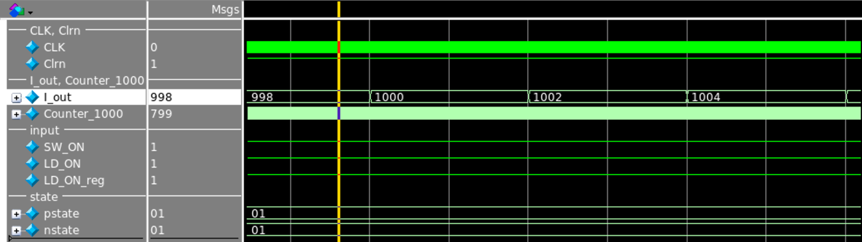

SW_ON = 1

LD_ON = 1

LD_ON_reg = 1

State : S1 (01)

I_out increase in 2 unit time blocks

2) Keeping I_out

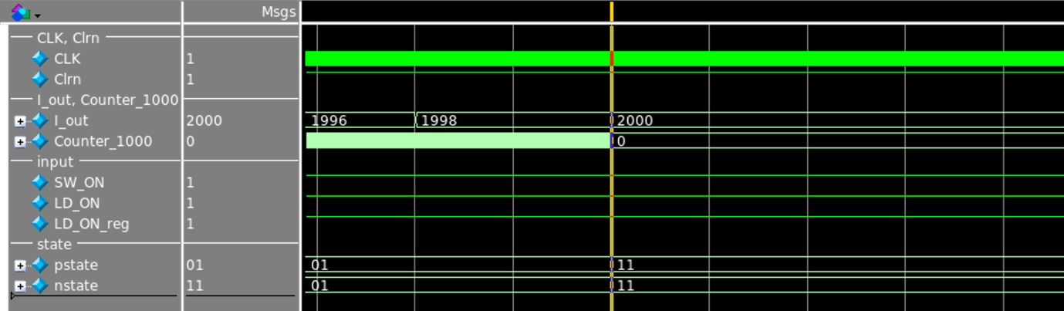

SW_ON = 1

LD_ON = 1

LD_ON_reg = 1

State : S3 (11)

Keeping I_out (from 10ms)

3) Decreasing I_out

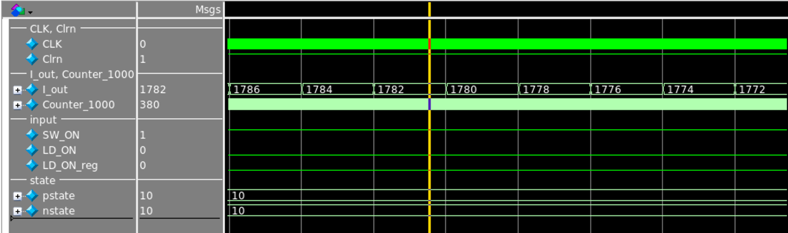

SW_ON = 1

LD_ON = 0

LD_ON_reg = 0

State : S2 (10)

I_out decrease in 1 unit time block

4) Increasing I_out again

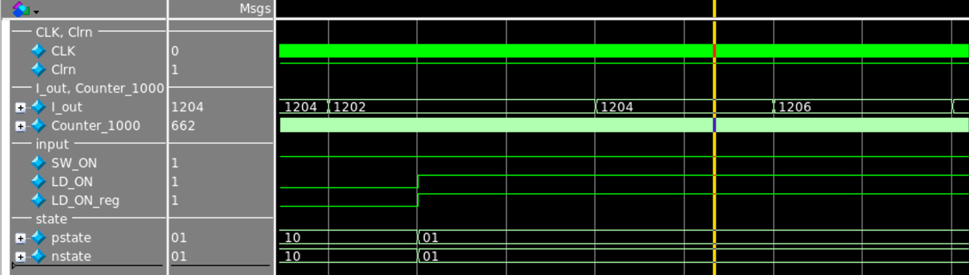

SW_ON = 1

LD_ON = 1

LD_ON_reg = 1

State : S1 (01)

I_out increase in 2 unit time blocks again

5) Switching Off

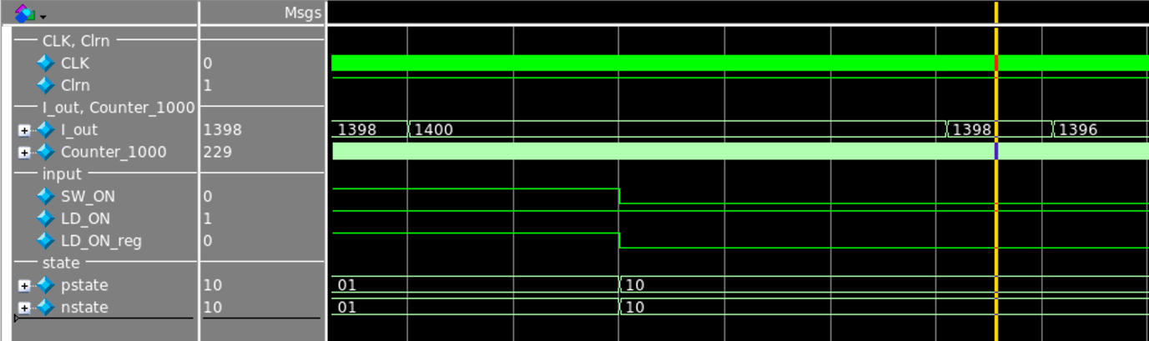

SW_ON = 0

LD_ON = 1

LD_ON_reg = 0

State : S2 (10) (decreasing I_out first)

I_out decrease in 1 unit time block

6) After end of decreasing, system is on initial state

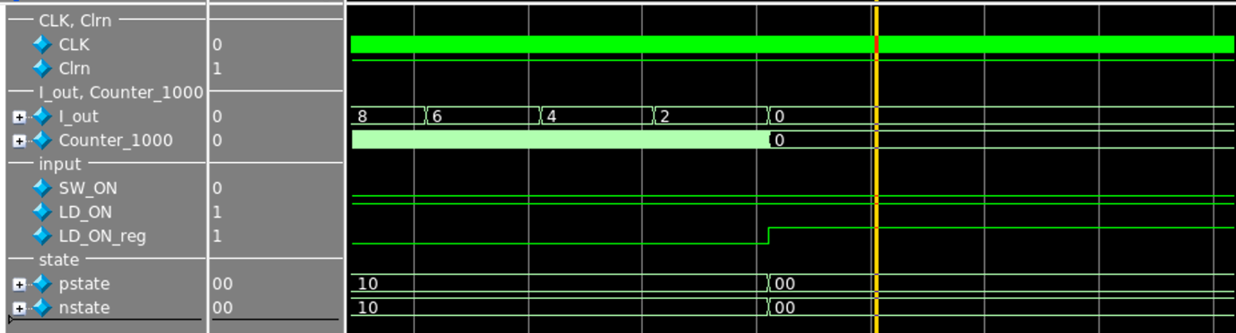

SW_ON = 0

LD_ON = 1

LD_ON_reg = 1

State : S0 (00) (initial state)

Stay on initial state

7) Restart

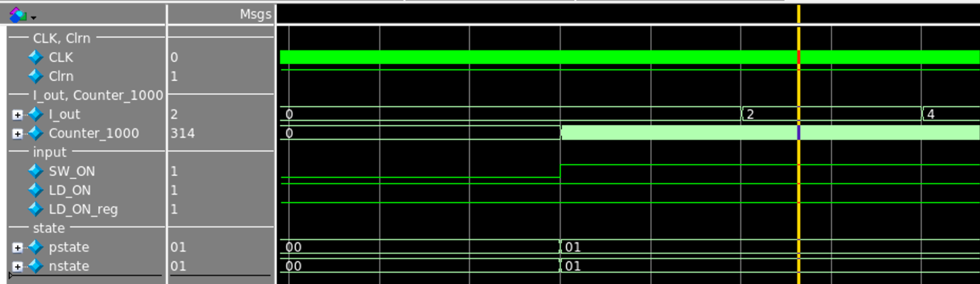

SW_ON = 1

LD_ON = 1

LD_ON_reg = 1

State : S1 (01)

I_out increase in 2 unit time blocks