#### Project code address：<https://github.com/wjear/sport>

#### The configuration steps are as follows:

1. Create a new database,called sport or others,then import the .sql file,choose the right one and click start ,wait it finished;

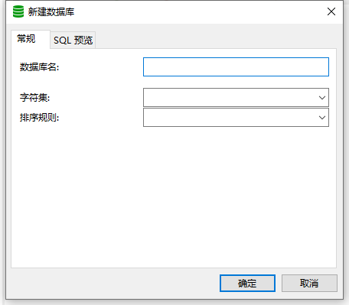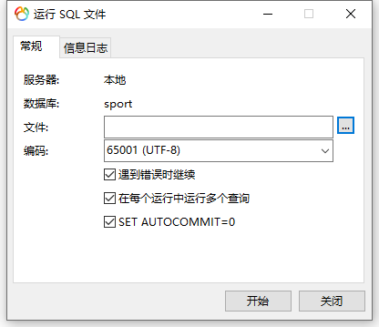

1. Clone code through Git and put it into a new foled under the local www ,change the “.env.example” file to “.env” file,then configure the database,such like localhost database sport and it’s username and password;

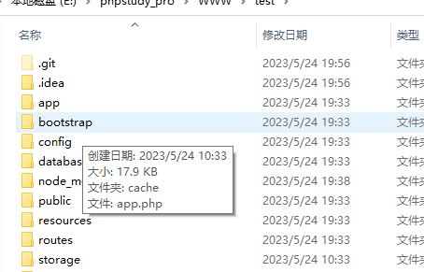

1. Create new site like sport in phpstudy_pro,set the root directory to the public folder;

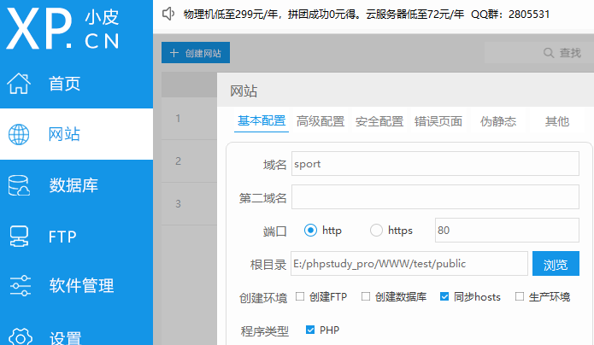

#### **The use steps are as follows:**

1. The ftont-end access address is <http://sport/sport> ,click the bar chart then display the headcount and various of activity type of this activity item on current date;

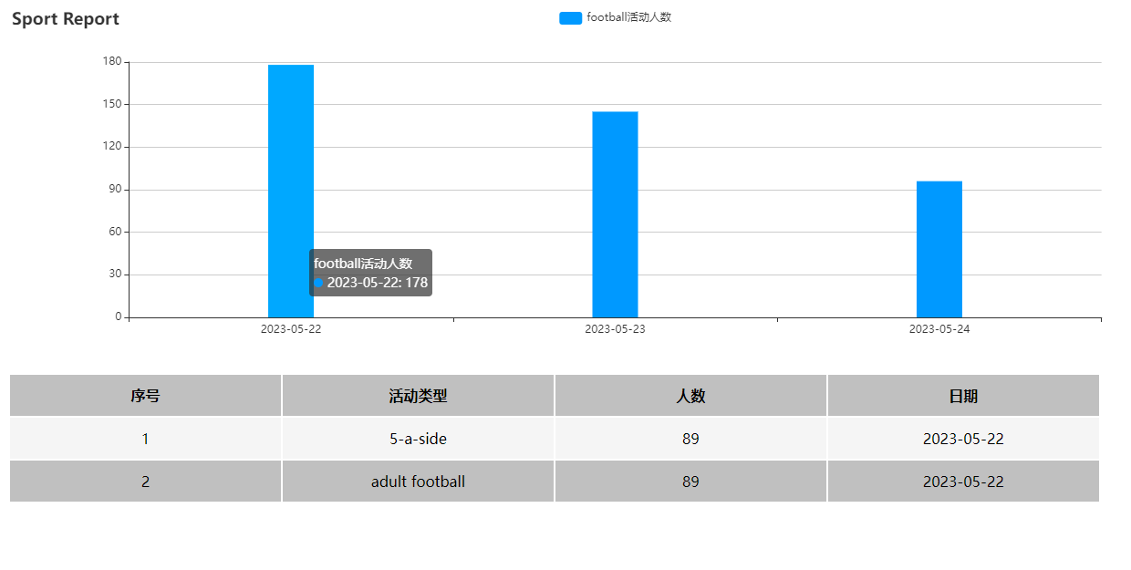

1. Background management system access address is <http://sport/admin/auth/login> , and the account and password are admin;
2. After successful login in,click left menu which named sport report,you can review/update/delete/create the data.

