STRUCTURAL DESIGN METHODOLOGY FOR LARGE PASSENGER
AND RORO/PASSENGER SHIPS

VEDRAN ŽANIĆ¹, TOMISLAV JANČIJEV¹,GIORGIO TRINCAS²,
RADOSLAV NABERGOJ², JEROLIM ANDRIĆ¹

¹ Faculty of Mech. Eng. and Naval Architecture, University of Zagreb, CROATIA
²Department of Naval Architecture, Ocean and Enviromental Eng.University of Trieste, ITALY

ABSTRACT

Concept and preliminary structural design methods, including large scale FEM analysis and optimisation, for large passenger ships, car passenger and roro / passenger ships are discussed. Applications and experiences in practical design usage are presented.

1. INTRODUCTION
A very competitive market of passenger and roro passenger ships as well as a number of novel concepts has created a need for improvement in design methods. Stringent demands for safety [1] and comfort including noise and vibration levels, combined with conflicting demands for light and efficient structure, require sophisticated design approach. The modern design procedures include:
(a) design load determination; (b) 3D FEM response analysis based on ‘direct calculation’ approach; (c) large scale optimization of ‘control structure’ with respect to design scantlings; (d) sensitivity analysis with respect to design parameters such as web frame spacing, etc. Improvements should be made both in analysis and in synthesis techniques (decision making) to form a balanced design procedure for those (as a rule) high cost ships.
Methodologies developed (Table 1) and used over past 20 years [2, 8], in deterministic concept design (C), reliability based concept design (R) and deterministic preliminary design (P) capable of accommodating design requirements for passenger and roro ships will be considered in the sequel together with examples of their application to designed and built ships :
- Concept design process presented (Table 1, column 1) is defined as the phase in structural design when geometry and topology are open to modification and structural variants are analyzed in accordance with the needs of head designer. Applied loads are usually taken as deterministic. Selection of appropriate scantlings is only important for approximate assessment of structural weight, achievable clearances (regarding height of beams and girders in structure etc.) with a goal to define acceptable structural layout.
- Higher threshold of realism in design [1] can be achieved by performing reliability-based design (Table 1, column 2) with aim only to compare designs, while value of failure probability is only approximate. The requirement on such analysis is that design variants maintain mutual order w.r.t. failure probability.
- Preliminary (basic) design (Table 1, column 3) is the phase in structural design when most scantlings and some topological variables are determined to obtain the approval of the structure from classification societies. Problem dimensionality is high (hundreds or thousands of design variables).
Classical finite element modeling, giving good insight into stresses and deformations is not capable of giving efficient and fast answers regarding feasibility criteria particularly in structural optimization context. But it is feasibility of design that is of primary interest to the designer, not stresses and deformations. Most of the local failure criteria, e.g. different buckling failure modes of stiffened panels, require specified force and displacement boundary conditions. They are available only if logical structural parts such as complete stiffened panels between girders and frames are modeled. Superelement modeling may help in this respect but it is usually impractical except for some particularly complex parts where stress or deformation levels are needed. Specially developed macroelements, combining numerical and analytical approaches to logical metastructures (stiffened panels, bracketed and locally reinforced girders, cell elements) could be a fruitful alternative. Their use greatly simplifies and speeds up design work in all described design procedures, particularly if structural modeling is based on general arrangement plans and follows process of design development from early stage. This is absolutely required when the yard time constraints are imposed on design work.
Practical design methodology applied is further elaborated through three case studies of design analysis and optimization of ships built or designed in Croatia and Italy. Examples include: (1) car/passenger ships (2200 pass., 600 cars.- four built) and novel designs :(2) a first class passenger ship (800 pass., 40000 GRT) and (3) RoPax vessel (3200 lanemeters/ 350 passengers).
Presented case studies show that structural optimization is a mature tool offering significant savings to the shipyard and shipowner : (a) increase of deadweight, (b) decrease in price and weight of construction steel, (c) obtaining of special class with classification societies regarding maintenance and (d) rational approach to structural modifications and refit based on developed mathematical model of the structure.

2 DESCRIPTION OF APPLIED DESIGN PROCEDURES AND SOFTWARE USED

The developed basic calculation blocks ( Table 1, rows 1-6) for all three procedures (columns 1-3) are labeled, discussed and compared in Sections 3-5. Applicability of simplified 2D and 3D models for concept exploration and / or generation of force boundary conditions for optimization of key portions of ship structure is presented in Section 6.
- Software used to demonstrate concept and preliminary design blocks 2.1 to 6.4 is a variant of program SHIPOPT. It is developed for American Bureau of Shipping and its philosophy is given in [2]. It is further developed as SHIPOPT ZAGREB. Detailed stress analysis, general superelements, graphic output, AFOSM reliability analysis are added and used [3],[4].
- Programs SHIPOPT and MAESTRO are respectively used to demonstrate preliminary design blocks P3.1 to P5.3 for design and analysis of two passenger ships. MAESTRO is developed by O.F. Hughes [6],[7]. It is an extension of SHIPOPT to multi structure, multimodule capability with excellent graphic pre and post-processing. The sound philosophy of SHIPOPT / MAESTRO is best illustrated on complex calculations needed for passenger ships.
- Calculation blocks C/R2.1 to C/R6.5 are demonstrated on software system OCTOPUS developed in Zagreb and extended to parallel processing at Glasgow University [8].
Concept and preliminary designs are performed at the University of Zagreb as order from shipyards or design companies. Loads calculations for example 6.2 is preformed at the University of Trieste.

3 MODELING OF DESIGN LOADS

Determination of design loading is always the most difficult and far reaching part of structural analysis since its unrealistic determination leads to either oversized and heavy structure that decreases ship's carrying capacity or to the unsafe structure of passenger ship. In blocks C2, R2 and P2 of Table 1 main load procedures are outlined. C2, R2 and P2 are calculated sequentially and cross checked. P2 is usually an extended version of R2. The method of equivalent design waves, causing maximal response of different types, is used to transform dynamic problem of 6DOF linear or nonlinear oscillator with stochastic excitation (ship in a seaway) into quasistatic design loadcases. Their amplitudes are obtained from the (long term) most probable extreme values of response based upon prescribed probability of occurrence and maximal response in the frequency domain for excitation in regular waves. In Section 6.2 quasi-static load cases are obtained from 6 DOF seakeeping analysis for extreme sea states. The ship motions have been calculated using linear theory, which was used as a basis for suitable extension to nonlinear wave loading. The computational method accounts for 3D shape of the hull and the effects of tumbled in/out sections. Different design waves are selected with periods which resulted in maximum values of vertical midship bending moment or in maximum values of shearing forces at relevant stations along the ship. Head wave conditions are considered by computing the resulting 6DOF kinematics, bending moments, shearing forces and pressure distribution at each section.
Racking loads for the heeled ship and other relevant loadcases are also considered.

Table 1: Structural design methods
 | CONCEPT D ESIGN | RELIABILITY BASED DESIGN | PRELIMINARY DESIGN
M  O  1. D  E  L | C.1: STRUCTURAL IDEALIZATION  C.1.1:2D FEM models (longitudinal)  C 1.2 :2D FEM models ( transverse)  C.1.3: Partial 3D FEM models | R.1: STRUCTURAL IDEALIZATION  R.1.1:2D FEM models (longitudinal)  R 1.2 :2D FEM models ( transverse)  R.1.3: Partial 3D FEM models | P.1: STRUCTURAL IDEALIZATION  P1.1: partial 3D FEM models  P1.2: full ship 3D FEM models
L  2. O A  D  S | C.2.1: STATIC STANDARD  LOADS  C.2.2:STANDARD WAVE LOADS  PRESSURES,  MOMENTS,  SHEAR FORCES | R.2.1: STATIC LOADS  R.2.2: SHIP MOTIONS (STRIP  METHOD FOR REGULAR  WAVES), PRESSURES,  ACCELERATIONS  R.2.3: DESIGN LOAD COMBINATIONS  -SHIP’S RESP. AMPLITUDE  OPERATORS  -SHIP OPERAT. MATRIX | P.2.1: EXTREME MOTIONS  AND LOADS :  EQUIVALENT WAVE  ACCELERATIONS,  PRESSURES, MOMENTS  SHEAR FORCES  P.2.2: DYNAMIC LOADS AND  PHASING BETWEEN  EXTREME LOADS
R  E  S  3. P  O  N  S  E | C.3.1 APPROXIMATE  STRESS ANALYSIS :  -FEM SHEAR FLOW  (EXT. BEAM THEORY) FOR  LONGITUD. STRENGTH  -FEM FRAME MODEL  FOR TRANSVERSE  STRENGTH CALC. | R.3.1 APPROXIMATE  STRESS ANALYSIS :  -FEM SHEAR FLOW  (EXT. BEAM THEORY) FOR  LONGIT. STRENGTH CALC.  -FEM FRAME MODEL  FOR TRANSVERSE  STRENGTH CALCULATIONS | P.3.1: COMBINATION OF :  -SHIP (FULL/PART) 3D FEM  MACROELEMENT  RESPONSE  -LOCAL RESPONSE OF  STIFFENED PANELS  (ANALYTICAL METHODS)  -MICROMESH STRESS CONC.
F  E  A  S  I  4. B  I  L  I  T  Y | C.4.1 LIBRARY OF DESIGN  FEASIBILITY CRITERIA :  -ULTIMATE STRENGTH  (buckling, yielding, fract.)  -FABRICATION  CONSTRAINTS  -SERVICEABILITY  CONSTRAINTS | R.4.1: OCEAN WAVE STATISTICAL ANALYSIS  R.4.2 - DYNAMIC STRESS FREQ.  DISTRIBUTION  -EXTREME STRESSES PROBAB.  DISTRIBUTION SUPERIMPOSED ON  MOST PROB. EXTREME VALUE  -CORRELATION ESTIMATES  R.4.3: LIBRARY (C4.1) OF DESIGN  FEASIBILITY CRITERIA + RAND.  VARIABLES INFORMATION  R.4.4: FAILURE PROBAB. CONSTRAINT | P.4.1 LIBRARY OF DESIGN  FEASIBILITY CRITERIA :  -ULTIMATE STRENGTH  (buckling, yielding, fract.)  -FABRICATION  CONSTRAINTS  -SERVICEABILITY  CONSTRAINTS
Q  U  A  5. L  I  T  Y | C.5.1 MINIMISED COST AND  WEIGHT OF STRUCTURE  C.5.2 MAXIMISED SAFETY  MEASURE BASED ON  DETERMINISTIC AND/OR  PARTIAL SAFETY  FACTORS LEVELS  C.5.3 MAXIMISED COLLAPSE  CAPABILITY FOR:  -SYMMETRIC AND NON-  SYMMETRIC (racking)  LOADCASES | R.5.1 MINIMISED COST AND  WEIGHT OF STRUCTURE  R.5.2 MAXIMISED SAFETY  MEASURE BASED ON  DETERMINISTIC SAFETY  FACTORS LEVELS  R.5.3 MAXIMISED COLLAPSE  CAPABILITY FOR  SYMMETRIC AND NON-  SYMMETRIC LOADCASES  R.5.4 MINIMISED PROBABILITY OF  -COMPONENT FAILURES  -SYSTEM FAILURE (FOSM AND AFOSM) | P.5.1 MINIMISED COST AND  WEIGHT OF STRUCTURE  P.5.2 SATISFIED PRESCRIBED  SAFETY MEASURE  BASED ON  DETERMINISTIC AND/OR  PARTIAL SAFETY  FACTORS LEVELS  P.5.3 SATISFIED PRESCRIBED  MINIMAL COLLAPSE  CAPABILITY FOR SYMMETRIC AND NON-SYMMETRIC  (racking) LOADCASES
S  Y  N  T  6. H  E  S  I  S | C.6.1: ELIMINATION OF  INFEASIBLE DESIGNS  C.6.2: GLOBAL - SHIP TRANS.  SECTION OPTIMISATION  (SEQ. LIN. POGRAMING)  C.6.3: LOCAL- MULTICRITER.  OPTIMIZATION FOR C5.1-3  (FRACT. FACTORIAL  EXPERIMENTS - FFE)  C.6.4: COORDINATION OF  C.6.2 AND C.6.3 AND  CONFLICT RESOLUTION  C.6.5: MULTICRITERIAL DESIGN  SELECTION IN METRIC SPACE  (GOAL PROGRAMING) | R.6.1: ELIMINATION OF INFEASIBLE DESIGNS  R.6.2 GLOBAL - SHIP TRANSV.  SECTION OPTIMIMISATION  (SEQ. LIN. POGRAMING)  R.6.3: LOCAL - MULTICRITERIAL  OPTIMIZATION FOR R5.1-3  (FRACT. FACTORIAL  EXPERIMENTS - FFE)  R.6.4: COORDINATION OF R.6.2  AND R.6.3 AND CONFLICT  RESOLUTION  R.6.5: MULTICRITERIAL  DESIGN SELECTION IN  METRIC SPACE (GOAL  PROGRAMING) | P.6.1: ELIMINATION OF INFEASIBLE DESIGNS  P.6.2 GLOBAL - SHIP TRANS.  SECTION OPTIMISATION  (SEQ. LIN. POGRAMING)  P.6.3: LOCAL OPTIMIZATION  OF SHIPS PARTS OR  SUBSTRUCTURES ( SEQ.  LINEAR PROGRAMING, FFE)  P.6.4: COORDINATION OF  P.6.2 AND P.6.3 AND  CONFLICT RESOLUTION  P.6.5: MINIMISATION OF  MULTICRITERIALVALUE  FUNCTION
Figure 1a

<----------2 D Full Ship C.L. Model C1.2 , Analysis blocks C2-C3 ---------------->
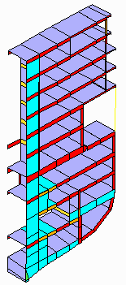
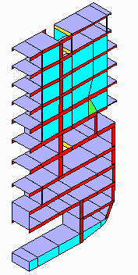

CONCEPT DESIGN

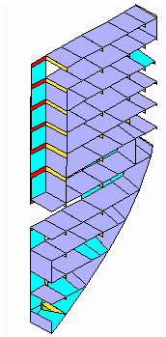
(initial optimised
scantlings)

LOADS:
C2

2D Transverse structure: C1.1 R/C1.1 C.1.1
Automated Design : C3-6 R/C3-6 C3-6
CONCEPT/PRELIM.
3D Peaks: P1.1 Figure 1b P1.1

Control structures (C.S.) : CS1 CS2 CS3
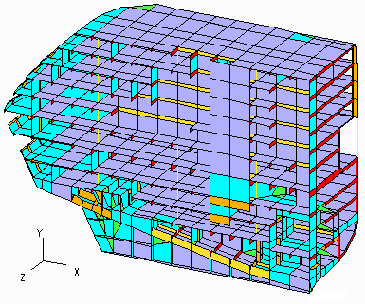
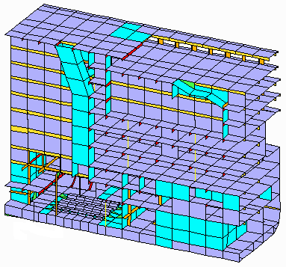
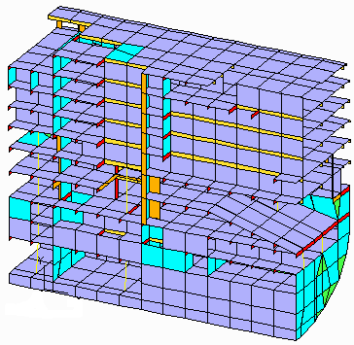
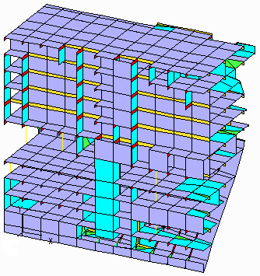
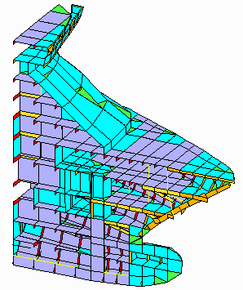
DESIGN

(optimal scantlings)

LOADS:
P2

3 3D Partial models : fixed P1.1 interpolated P1.1 interpolated P1.1 fixed
Automated Design :scantlings P3-6 scantlings P3-6 scantlings P3-6 scantlings

Figure 1c
<-----------------Full Ship Model: P1.2 , Analysis P3-4 -------------------------> PRELIMINARY DESIGN
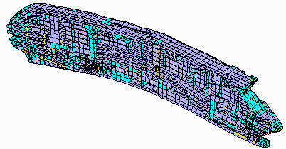
(final scantlings)

LOADS P2

Local Automated Redesign P3-6 for selected parts
Figure 1: Overall design procedure

They are transformed into equivalent nodal loading on wetted surface of the ship and into corresponding acceleration factors multiplying ship's masses. Wave induced slamming pressures also have to be investigated to obtain full definition of dynamic loads at sea. To obtain free floating ship, a balancing of all loads has to be performed and reactions at artificial supports brought to zero. Extreme pressures are in most cases used only as design pressures [4] for stiffened panel design while FEM loading of the panel corresponds to given design loadcase with usually only one loadcase component being at its extreme value. More details of loading are given in examples of Section 6. Specially for passenger ships ISSC-1997 suggests [1] that due to rather uniform distribution of lightship weight and concentrations of buoyancy toward the midship portion, the cruiser vessels usually experience very high water hogging bending moments. If the Rule loads are used in block C2, combination of the rule hogging wave moment and the maximum still water hogging gives the maximum longitudinal stress, while the combination of the rule sagging wave moment and the minimum still water hogging can still result in buckling problems on upper decks. Deck loading on cruise ships is lower than tweendeck loading on roro ships.Special loadcases should be included into load set like eg. ice, racking and docking loads.

4 MACROELEMENT BASED STRUCTURAL RESPONSE

For concept design structural models are given in Figure 1:
- 2D FEM idealization of the ship projected onto longitudinal symmetry plane (example 6.1)
- 2D frame FEM and 2D shear flow FEM for transverse structure response(examples 6.1 and 6.3)
In this way approximate distribution of stresses due to bending of entire ship is obtained and then redistributed using 2D idealization of the transverse structure. Feasibility is checked for failure criteria based on superimposed response fields. However such approach is only applicable for symmetric loadcases and for rather monotonous structure without large interruptions. Otherwise simplified 3D models should be used. Reliability based design requirements on speed of FEM model are especially strong. Careful assessment of random variables is done to simplify the model.
Sufficient FEM models for preliminary design are partial 3D and the full ship 3D models. Since 2D models are used for generation of boundary conditions at structural “cuts” accuracy is strongly dependent on these data. Therefore large partial 3D models have to be created. However for preliminary design of passenger ships with large lifeboat recess only full ship 3D FEM analysis is considered sufficient according to [1] for the correct assessment of the structural static and dynamic response i.e.:(a) global deformations, (b) effectiveness of upper decks and distribution of longitudinal stresses at each level with control of buckling of upper decks, (c) transfer of forces between lower hull and upper superstructure, (d) shear stress in way of the intermediate recess,(e) shear lag in the relevant decks level, (f) stress concentrations around openings in longitudinal substructures, (g) local deformations around doors, windows, etc., (h) compression or tension forces in pillar lines.
These responses are needed to evaluate structural failure criteria for yield, buckling, ultimate strength, vibration and fatigue. They also provide accurate boundary conditions for the fine mesh FEM models of structural details.
The most efficient way to deal with the mesh size for such complex ships is to develop suitable finite elements compatible with macromesh. Macroelements used or tested are summarized bellow:
- A bracketed beam macroelement is combining axial superelement and rigid length beam.
- A family of isoparametric quadrilateral stiffened shell elements is in development. It consists of eight and nine-node elements with 48 and 54 d.o.f. respectively. The eight-node element is plane element and nine-node element can be of the plane or cylindrical/conical shape. The stiffeners are modeled at their right position but they follow plate shape function. The element developed on the base of this approach is especially good for coarse mesh modeling of ship’s structures [12] as well as for creating cell superelements in preliminary design.
- A new nine-node quadrilateral Reissner-Mindlin plate element with 27-d.o.f. valid for the analysis of thick (double bottom structure) to very thin isotropic and orthotropic plates has been developed [13]. Response field in upper and lower plating is adequate for failure analysis
Full ship 3D FEM modeling, using standard elements, macroelements and superelements, permits response, safety evaluation, optimization and vibration analysis to be performed on a single model.
In preliminary design, detail stress analysis is an obligatory part and it is fully automated in postprocessing assessment of final design. Boundary conditions obtained on macroelement level are transferred to local micromesh solver and subjected to local loads. It is demonstrated in Section 6.2 when PATRAN/NASTRAN is used as micromesh solver using all of its processing capabilities.

5 AUTOMATED STRUCTURAL SYNTHESIS

Regarding structural synthesis emphasis is given to the absolutely simplest approaches capable of solving multilevel, multicriteria, optimization problem. The objective functions (weight and/or cost of labour and material) are monotonous in design variables and appropriate optimization methods are selected for local and global optimization level. Sensitivity analysis, as standard part of any good engineering procedure, is performed to obtain the material and workmanship cost differential with respect to the variable web frame spacing, stiffener orientation and material / labor cost in examples 6.1 and 6.3.
While evaluation of structure is a straightforward procedure, the design process has many mathematical problems, particularly if requirements on discrete values of variables are to be satisfied or if criterial ‘functions’ are actually procedures. Long experience with structural optimization in number of practical problems have shown that during the design process a number of design alternatives has been investigated, each requiring execution of non-linear programming modules with sophisticated convergence checks, linearisation techniques, etc. However, the increased speed of workstations provides the opportunity to model the complex design problem (at least in concept design phase and in local optimization subproblems in preliminary design) as a multiple evaluation process by intentionally creating a large number of design variants. If sufficient density of non-dominated (efficient, Pareto optimal) designs is generated it is possible to replace the optimization oriented approach with a much simpler one which implies only simple evaluation and selection procedure [8].
The concept design process is divided into two phases, that is, the phase of design generation in affine space (where no relationship among design attributes (cost, safety, weight,..) is specified (blocks C6.1-C6.4), and the phase where design selection is performed (block C6.5) which may require introduction of distance in the attribute space, (e.g. ‘distance’ of design from the given goal design). It is important that the set of designs obtained in the first phase is sufficient for application of different goals and the head designer's preferences in the second phase.
In preliminary design experience proves that for large scale structural problems, portion of failure surface contributed by each failure function is small and can be successfully linearised. Therefore, the envelope of feasible designs is transformed into a piecewise linear hypersurface. If the design objectives are monotonous in the structural scantlings the optimal designs would lie in that surface. The objective functions (weight and/or cost of labor and material) are monotonous in design variables which opens a possibility to use the most simple and efficient method of operations research i.e. linear programming. Its dual formulation [2] is used since number of constraints greatly surpasses number of design variables. Sequential linearizations are needed to solve nonlinear design problem and sequential linear programming is used in both examples of preliminary design. For the particular case of optimization of ship scantlings it is sufficient to include only those costs which are directly dependent on scantlings. Linear programming and fractional factorial experiments are also efficient in concept design of transverse section of the vessel since they can be used for optimal distribution of material regarding structural safety.

6 CASE STUDIES IN DESIGN PROCEDURES

6.1 Structural Optimization[3] and Sensitivity[4] Analysis of Large Passenger/Car Ferry
The four ships of this type have been built in Croatia and they operate in Baltic. The optimization was performed due to the owner's conflicting requirements on ship weight and vibration criteria. Cost sensitivity study with respect to frame spacing (800, 850 and 900 mm) was performed during design updates for the third and fourth ship.
Model(C1/P1) :The main particulars of Passenger/Car Ferry structure are (Fig. 2.):
L_{OA}=176.0m Speed trial: 22 Kn Capacity : 2200 passengers, 600 cars
L_{pp} =169.0m Breadth max: 32.0m Design draft: 10.0m
Normal strength structural steel is used as a basic material in the whole optimization process. Only in the highly stressed regions high strength steel is used.
3D FEM SHIPOPT ZAGREB model is generated for 12 frame spacings, dominating scantlings for 0.6L of the ship in accordance with DnV requirements for direct calculation. 2D center plane FEM model and 2D FEM shear flow model are used for determination of cross section loads (Fig 1a). By use of these auxiliary models the realistic influence of the rest of the ship on P1.1 design model (Figure 1b) for midportion of the ship is included in calculation.
Loads (C2): The whole calculation procedure is performed for model subjected to three quasi static loadcases. The loadcases are combined from:
- static hydrostatic pressures at the ship’s design draught,
- dynamic pressures acting on bottom and side,
- design pressures acting on decks for passengers and crew,
- design pressures for decks with cars and trucks,
- structure weight increased by vertical acceleration caused by ship’s motion and
- global bending moment for hogging condition which consists of still water and wave bending moments.
All of load parameters are calculated according to DnV requirements.

Figure 2 : Longitudinal Section Figure 3: Optimization Procedure
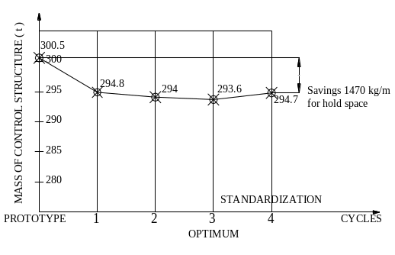
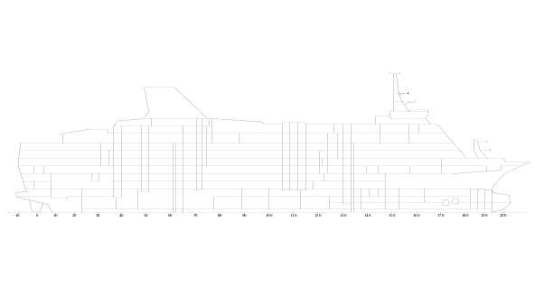

Response(P3): Plated areas such as decks, shell, bulkheads are represented by special stiffened membrane macroelements. The bending stiffness of primary transverse frame or girder is modeled with special bracketed beam macroelement. Membrane triangular elements with appropriate thickness are applied for modeling of bulkheads and non-standard ship’s parts.
The final structural model is defined by 1490 degrees of freedom (1076 active), 485 macroelements, 5 superelements and 34 ordinary elements. In centerline plane symmetry restraints are generated. To prevent singularity of the free ship stiffness matrix two nodes in side shell at model’s ends are restrained in the global Y (vertical) direction and one of them is restrained in global X (longitudinal) direction. The whole model has to be balanced by means of loads and consequently the reaction forces in these three nodes have to be negligible.
Feasibility (P4) model is generated with 19404 safety criteria in 49 strakes. Safety factors are adjusted to DnV requirements for direct calculation.
Synthesis (P5-6): Performed design process can be divided into two parts. The first part is optimization for weight critical design and the second part is the cost sensitivity study with respect to frame spacing. The optimization model included 492 scantlings of structural elements as design variables. On the basis of designers decision 291 variables are fixed and excluded from further optimization process and 141 blocked at minimal or maximal prescribed values.
Results of performed calculations are:
- Problem of structural adequacy is solved by simultaneously resolving 49 unsatisfied failure criteria of the very sophisticated prototype.
- Weight decrease of 600 kg/m has been achieved for critical weight constrained design, as compared to the minimal weight prototype, giving 60 tons of weight reserve to the designer (Fig. 3) to be used in satisfying vibration criteria etc.
- Sensitivity study shows that the cost of structure per meter is rather insensitive to frame spacing, in given interval, due to cancellation of the effects of structural modifications and smaller number of web frames.

6.2 Full Ship Safety Analysis of First Class Passenger Ship [10]
The objective of the analysis is to investigate the structural strength of the first class passenger vessel in fulfillment of requirements for direct calculation of the classification society Registro Italiano Navale (RINA) [11]. DnV modified design was also developed .Coordination between ship design firm and automated design support teams was investigated. Interface processing was developed to enable fast and reliable response to the head designers requests when support was given from different experts and institutions. This is particularily important w.r.t. loading data.
Model(P1) :The main particulars of the first class passenger vessel (Fig. 4.) are:
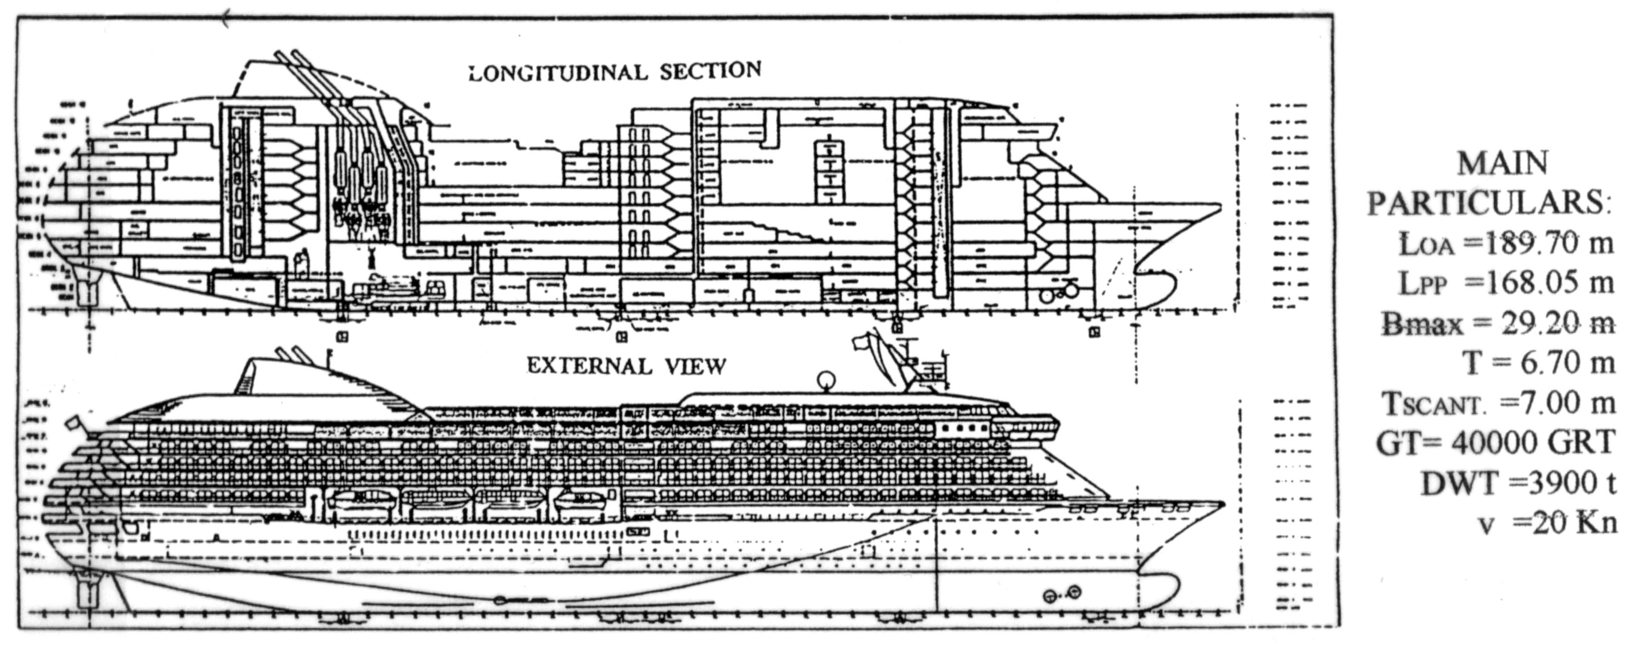
Figure 4 : General Plan of First Class Passenger Ship

Full ship model was selected for the ship due to large lifeboat receses and was also requested by R.I.N.A and [1]. This single model enables class. society evaluation, optimisation and vibration analysis as well as input to the detail stress analysis. Two R.I.N.A approved materials are used: Steel Grades A and ER 36. Mesh size is generated in accordance with: (1) R.I.N.A requirements for direct calculation, (2) recommendations from [1]. Software used : MAESTRO and PATRAN/NASTRAN.
Loads (P2): are generated using given weights adjusted to the GHS longitudinal weight distribution Each loadcase comprised four loadsets: (1) structure weight, (2) outfit weight, (3) deadweight items corrected to fit GHS data, (4) buoyancy loading. They are factored to suit the needs of pressure and acceleration data supplied from seakeeping analysis. Loadcases selected correspond to M_{v,max} or Q_{v,max} in hogg and sagg at respective locations. Locally critical loadcases are also considered.
The reference loadcase 1 represents loading for full load-departure with base plane draft 7.114 m at x=–0.750 m and trim angle –0.2976334°. Corresponding maximal still water hogging bending moment reads: M_{S,H} = 970 867 kNm .
Loadcase 2 (used in Figures 5-8) represents ship with loading for full load-departure, balanced on superimposed sinusoidal head wave λ/L=1.1, h = 11.1 m with crest at x =87.75 m from frame 0.
Required total hogging bending moment (at x=84 m) reads: M_{TOT,H} = 1 968 516 kNm
Response(P3): Plated areas such as decks, shell, bulkheads are represented by special Q4 stiffened shell macroelements. TRIA membrane triangular elements are also applied with appropriate thickness. Each primary transverse frame or girder is modeled with special bracketed beam macroelement. The final MAESTRO half model comprised of approx. 5000 grid points having approximately 30 281 degrees of freedom. 7615 stiffened shell macroelements, 8208 bracketed beam macroelements, 357 bar and pillar elements, 442 triangles, 90 brackets and 108 superelements are generated in the half model. The preliminary fine mesh NASTRAN model for windows comprised 15935 grid points and 16947 Q4 elements.It can be further expanded in detail design phase. To prevent singularity of the free ship stiffness matrix, two nodes in centerline at collision bulkheads at keel level are restrained in the global Y direction. One node in intersection of transverse bulkhead and side shell is restrained in global X direction for half model. Symmetry restraints in centerplane are generated automatically.
Feasibility (P4) model :502 590 safety criteria checks in 5 substructures having in total 31 3D-FEM modules. Safety factors are adjusted to RINA requirements. Minimal value of adequacy parameters achieved in loadcase 2 for all its failure modes are presented for bottom and side shell in Fig. 6 and for longitudinal bulkhead in Fig.8. Plot of the deformed complete ship is shown in Fig.1c.
Synthesis (P5-6): Design objective is maximization of structural safety. The behavior of the ship's structure in terms of global deformation is considered satisfactory from the structural aspect in loading cases considered. General distribution of longitudinal stresses obtained confirms the fact stated by ISSC’97 in [1] that all continuous decks participate in global hull bending for large cruise ships and that 'a complete 3-D FEM model of the hull seems to be the only practical and effective method to obtain accurate results as stated in Section 4.
Results : This preliminary analysis shows that:
- regarding longitudinal strength the effectiveness of upper decks considerably reduces longitudinal stresses in bottom structure compared to the stresses obtained from analysis of structure up to 'strength' deck 8 only. Savings in hull material may be achieved.
- stresses in longitudinal bulkhead at 2080 from centerline, in areas of maximal shear force, may cause shear buckling. Increase of the plating thickness or introduction of more vertical stiffeners is needed in these regions to meet RINA buckling requirement.
- Overall adequacy parameter in side structure between decks 6 and 8 in area of maximal shear force is lowered compared with average value. Careful analysis of windows between decks 7 and 8 has to be performed. Deck beams in way of pillars in recess require special consideration.
- Deck 12 is stressed in region surrounding the pool so that a careful shaping should be done to avoid stress concentrations.
- The redesign of any of structural modules can now be performed like in case study 6.1 as well as overall vibration calculation using automatic generation of added and other masses.
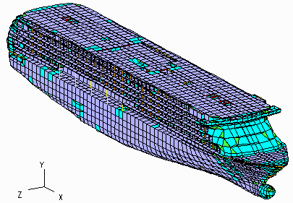
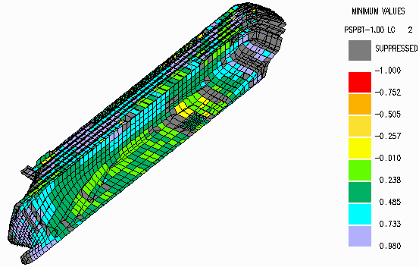

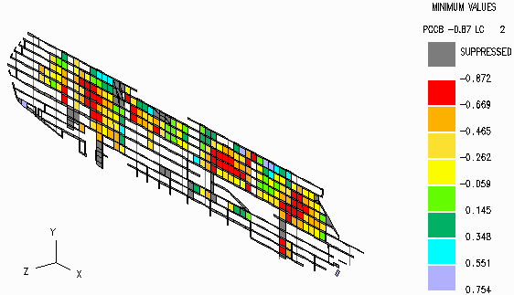
Figure 5: 3-D Full Ship FEM Model Figure 6: Adequacy parameters for Macroelements
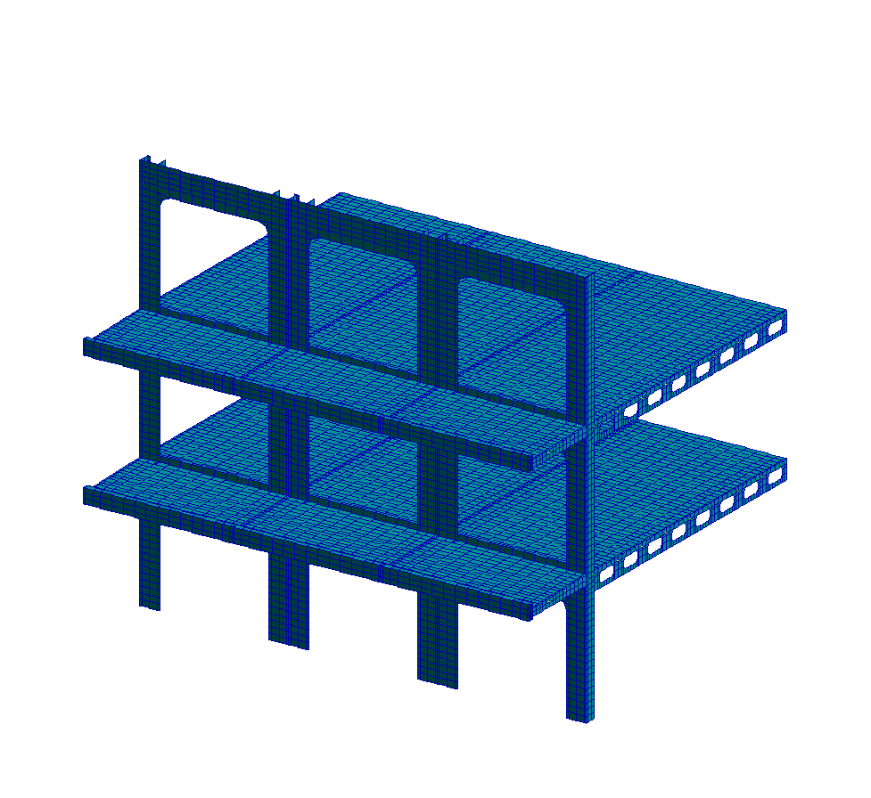

Figure 7: PATRAN-NASTRAN model of windovs Figure 8: Adequacy parameters for long.bulkhead
6.3 Case Study in Structural Design, Analysis and Optimization of Ro-Pax Ship [5]

The objective of the case study is to demonstrate possible achievements of modern structural optimization in concept design phase of Ro-Pax ships. Initial design of the ship (LOA = 221.2 m, Lanemeters = 3500 m SPT-Project 966) under DnV requirements was produced by very experienced designers. To increase competitiveness of its offer, Yard ordered (1) weight/cost optimisation, (2) racking analysis, (3) sensitivity analysis of ship structural weight with respect to design parameters. The results for variation of web frame spacing (2400, 2800 and 3000 mm) are presented. Other possibilities were also successfully investigated within very demanding time constraint.
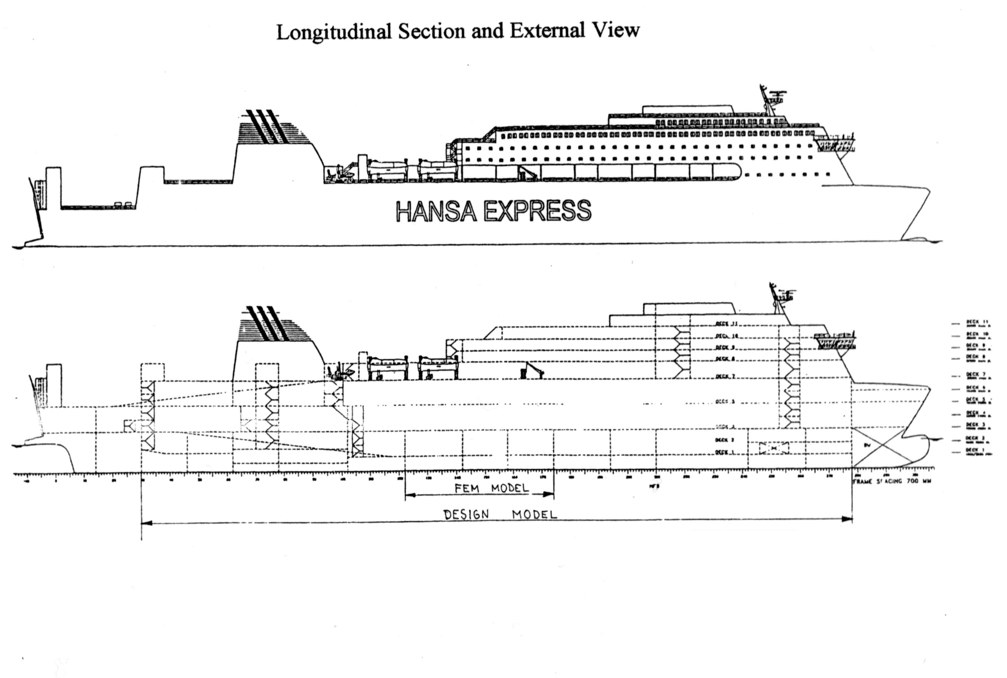

Figure 9 : General Plan of Ro-Pax Ship
Model (C1/P1) includes 12 web frame spacings that are dominating ship structure scantlings between frames 30 and 278. Program MAESTRO is used.
Loads (C2): 7 loadcases are defined according to DnV and designers requests.
Table 2 : Load case description - LC7

Ref.  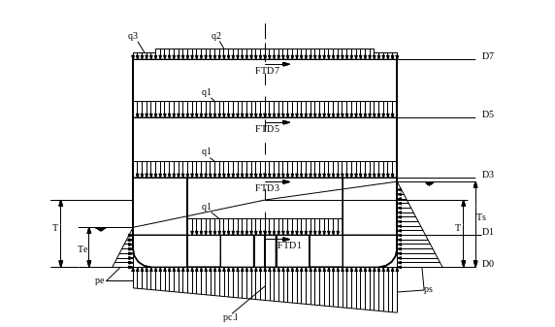 Figure 10 : Load case description - LC7 | Value | Ref. | Value
T_{e} | 4.38 m | a_{h} | 3.14 m/s²
T_{s} | 9.42 m | F_{TD1} | 155.82 kN/sec.
p_{e} | 43.84 kN/m² | F_{TD3} | 256.97 kN/sec.
p_{cl} | 74.00 kN/m² | F_{TD5} | 280.25 kN/sec.
p_{s} | 94.21 kN/m² | F_{TD7} | 44.51 kN/sec.
q1 | 21.57 kN/m² | M_{TOTS} | 2.25*10⁶ kNm
q2 | 34.32 kN/m² | Type | HOGGING
q3 | 5.00 kN/m²
a_{v} | 12.42 m/s²

Response (P3): 3D FEM model includes 5850 degres of freedom for model capable of solving non-symmetric loadcases. 1067 macroelements and 212 ordinary elements are used for response .
Feasibility (P4) : 52416 safety checks are performed on each model of webframe spacing. with safety factors adjusted to DnV requirements.
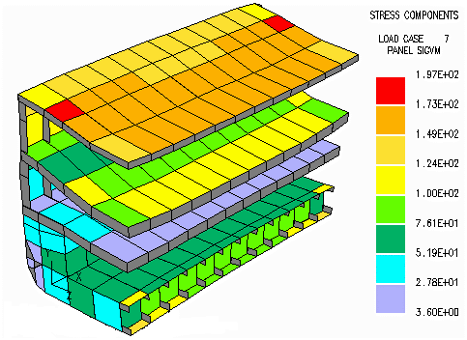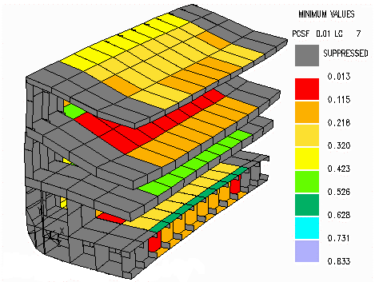

Figure11 : 3-D plot of deformation and HMH stress Figure12: 3-D plot of adequacy parameters stiffened panels for LC7 (min value) of stiffened panels for LC7
Synthesis (P5-6):Designer identified 264 design variables and has given min-max and proportionality requirements. Active constraints are recorded and discussed with the designer.

Table 3: Optimization results
MODEL | Geometry  s_{w} L_{FEM}  (mm) | Weight of optimization  model (t)  W_{start} W_{opt} | Weight per length  W_{opt} / L_{FEM}  ( t / m) | Savings before final standard.  (W_{start} - W_{opt} )  W_{start} | Global safety  (adequacy)  measure | Weight of design model  W=L*k*w_{L}  ( t ) | Increased deadweihgt =  decreased steel weight ( t )
PROTOTYPE | 2800 33600 | 1355 - | 40.33 | - | 0.9622 | 5646 | -
PROPOSAL 1 | 2800 33600 | 1355 1220 | 36.31 | 9.97% | 0.9905 | 5083 | 563 t
PROPOSAL 2 | 2400 28800 | 1202 1046 | 36.32 | 9.94% | 0.9889 | 5085 | 561 t
PROPOSAL 3 | 3000 36000 | 1416 1282 | 35.61 | (11.70%) | 0.9719 | 4985 | 661 t
PROPOSAL 4 | 2800 33600 | 1382 1139 | 33.90 | experiment | 0.9683
s_{w}-web frame spacing; L_{FEM}-length of FEM model; w_{L} - weight per length; Wopt - weight before final standardization;
Estimated length of design model (cargo space): L= 175 m; Estimated reduction factor for structural shape: k= 0.8
PROP 3 - after 3 design cycles,no standardization; PROP 4 - model with stiffener spacing 305mm/central part of deck 5

Results of performed calculations show that savings in weight are obtained by simultaneously resolving structural problems of given prototype and increasing safety:
- For cargo space length material savings and increased deadweight of about 560t are possible
- Parallel increase in safety is demonstrated through increased adeqacy parameter and increased minimal safety factors for structural elements w.r.t P4.1 failure criteria.
- Parallel gain of at least -300 mm in ship height.
Standardization of profiles (plate and frame /girder thickness are standardized ) will somewhat decrease the savings but sensitivity study shows further possible savings with change of other structural parameters eg.PROPOSAL 3 and 4.

7 CONCLUSIONS

Main areas of implementation and benefits of the procedure are outlined in the introduction. Problem of structural adequacy starting from infeasible design/prototype is solved in all case studies together with simultaneous weight decrease giving the deadweight reserve to the designer. The case studies have proved the following additional points:
- Considerable modifications of the structural model, even changes in cross section geometry are quickly performed following the head designer’s requests.
- Sensitivity study regarding change in cost due to some modification of the structure can be produced in short time (eg. one day) even during negotiations with ship owner.
- Full ship analysis does not require modeling of loads at structural “cut” end sections. Gross-errors due to unknown normal and shear stress distribution are thus avoided.
- The complex full ship macroelement model can be generated simultaneously with development of classification documentation starting from general arrangement. This means that structural modeling and loadcase selection should start as soon as possible and analysis can constantly follow, support and simplify the decision making to the designer.
- Yard design team should include support of experienced head ship and structural designer in defining design loadcases, upper and lower bounds on design variables and proportionality criteria regarding balanced scantlings in accordance with Yard practice, two structural designers trained in automated structural design and QA and an assistant help.
We can thus safely conclude that implementation of automated design procedures, as a part of standard design procedure (concept and preliminary) is a necessity rather than an option and that owners, shipyards, operators and passengers should benefit from these developments and presented experiences.

Acknowledgments: Authors express their thanks to all cited authors of the software and illustrating examples used. Thanks are also due to PROTEUS engineering, Zagreb and Trieste Universities, Mr.J.Biskupović, Mr.I.Belamarić, Mr.P.Čudina and Mr.M.Pavičević from BRODOSPLIT Shipyard, Split and Mr.S.Reljić and Mr.M.Pulišić NVC-NAVIS CONSULT, Rijeka for software license or permission to use their designs in this article.

8 REFERENCES

- Proceedings of 13th International Ship and Offshore Structures Congress, Edited by T. Moan, S.Berge , Trondheim, Norway, (1997).
- Hughes, O.F., Mistree, F., Žanić, V., (1980)," A Pratical Method for the Rational Design of Ship Structures ", Journal of Ship Research, 24., p.p101-113.
- Žanić, V., Jančijev, T., (1986)," Structural Design and Analysis of Passenger/Car Ferry "Amorella" Newbuilding Split 357/358, Tehnical Report, Faculty of Mechanical Engineering and Naval Architecture, Univesity of Zagreb.
- Žanić, V., Jančijev, T., (1989),"Safety Analysis & Parametric Sensitivity Analysis for Passenger - Car ferry for Baltic", Internal report, for "Split" Shipyard, Faculty of Mech. Eng. and Naval Arch., Zagreb.
- Žanić, V., Jančijev, T., Andrić, J., (1998),"Hull Structure Analysis and Optimisation of Ro-Pax Ship", SPT-Project 966, Tehnical report, for "Split" Shipyard, Faculty of Mech. Eng. and Naval Arch., Zagreb.
- Hughes, O.F., (1983),: Ship Structural Design, John Wiley & Sons, Inc.
- MAESTRO Version 7.1.2, (1998), Program documentation, Proteus engineering, Stensville, MD, USA.
- Žanić, V., Das, P.K., Pu,Y. and Faulkner, D.,(1993), "Multiple criteria synthesis techniques applied to reliability based design of SWATH ship structure", Intergrity of Offshore Structures 5, Faulkner, Das, Incecik, Cowling, editors, EMAS Scientific Publications, Glasgow, pp. 387-415.
- Žanić, V., (1985), " Determinazione Degli Sforzi Principali - Flessione e Torsione - Sollo Scafo di una nave Applicando Particolari Elementi Finiti", Technica Italiana (Rivista D'Ingegneria), no. 3., p.p. 105-113.
- Žanić, V., Jančijev, T., Andrić, J., Bralić, S., Hozmec, J., (1998), "Global Finite Element Model of Large Passenger Ship", for Nuovi Cantieri Apuania, Marina di Carrara, Italia and NVC-Navis consult-Rijeka, Faculty of Mech. Eng. and Naval Arch., Zagreb.
- Guide relevant to criteria for the check of structural strength of ship hulls by means of direct calculation, R.I.N.A. (1997).
- Jančijev, T., (1999): DSc Thesis (in preparation), University of Zagreb.
- Tonković, Z., Sorić, J., Heidl, I., . (1997)," A formulation of assumed strain nine-node plate element based on Reissner-Mindlin type kinematic model", Engineering modelling 10, p.p. 47-56.
- Žanić, V., Žiha, K., (1998), " Sensitivity to Correlation in Multivariate Models", Computer Assisted Mechanics and Engineering Sciences 5, p.p. 75-84, Polska Akademia Nauk, Varšava.

