ODI Wicket Predictor — Write‑up

1. Dataset overview
Goal. Build a ball‑by‑ball model that estimates the probability of a wicket falling on the next legal delivery in an ODI, using match context (over/ball, score pressure, wickets in hand) and a simplified bowling ‘profile’ (pace vs spin, arm, style group, and tactical match‑up labels).
1.1 Source and scope
The raw data comes from ODI ball‑by‑ball YAML scorecards (Cricsheet-style structure). Each YAML file represents one match, containing deliveries with runs, extras, and dismissals recorded at ball level.
To keep the analysis consistent with a standard ODI innings, the working dataset was filtered to normal 50‑over innings (e.g., ‘1st innings’ and ‘2nd innings’) and excludes Super Overs. For modelling and headline rates, only legal deliveries are treated as ‘balls’ (wides/no‑balls are not counted as legal balls).
Time range: 2014-06-15 → 2025-06-12
1.2 What a “row” represents
A single row corresponds to a delivery event from the YAML feed. Conceptually, this is “one attempted ball”, which may be a legal ball or an illegal delivery (wide/no‑ball). Key fields used later in the project include:
- match_id and innings label (1st/2nd innings).
- over number and delivery number within the over (delivery number can be 7/8/9 in overs with wides/no‑balls).
- is_legal flag to identify legal deliveries.
- runs_total and (derived) runs_innings_before for state before the ball.
- wicket indicator (target variable for the model: wicket on this ball).
- bowler/batter attributes and engineered ‘tactical’ labels (pace vs spin, arm, style group, match‑up type).
1.3 Size, class balance, and base wicket rate
After filtering to standard innings, the dataset contains ~603k deliveries. This is large enough to fit a supervised model, but wickets are still relatively rare events.
Across the full filtered dataset, the overall wicket rate is 2.7723 wickets per 100 balls (≈2.77% per ball). That implies roughly one wicket every 36.1 balls on average.
2. Key EDA findings
This section summarises the headline patterns found in the ball-by-ball dataset before building any predictive model. The aim of the EDA was not to “prove” causation, but to establish (1) whether the data behaves like real ODI cricket, and (2) which factors are large enough and consistent enough to be worth encoding as model features.
2.1 Pace vs spin (overall)
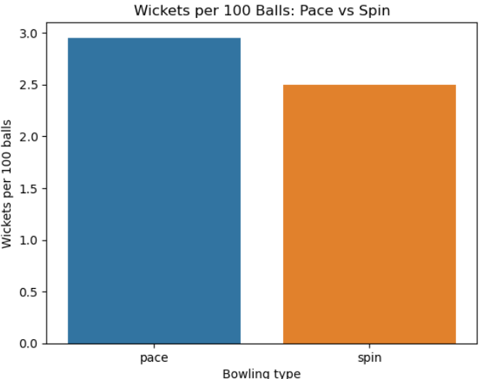
Across the full dataset, the overall wicket rate is about 2.77 wickets per 100 balls, as stated before. When splitting by broad bowling type:
- Pace: ~2.95 wickets per 100 balls
- Spin: ~2.50 wickets per 100 balls
So pace has a higher wicket rate overall in this dataset.
Why this makes sense: ODI wickets are strongly tied to batters taking more risks and bowlers creating mistakes, and pace bowling tends to produce more “high-speed error” dismissals (edges, LBWs, bowled) especially when the ball is harder/newer and when batters are forced to hit hard at the end. Spin is still effective, but often trades wickets for control, especially in the middle overs.
2.2 Phase effects (powerplay vs middle vs death)
When you break wicket rates down by phase, the biggest pattern is that death overs are far more wicket-dense than earlier phases for both pace and spin:
Pace
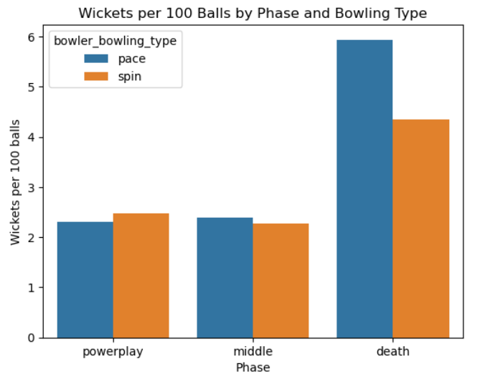
- Powerplay: ~2.31 wickets per 100 balls
- Middle: ~2.39 wickets per 100 balls
- Death: ~5.94 wickets per 100 balls
Spin
- Powerplay: ~2.47 wickets per 100 balls
- Middle: ~2.27 wickets per 100 balls
- Death: ~4.35 wickets per 100 balls
This says two things:
- Death overs are the wicket phase, regardless of bowling type.
- The death-over wicket spike is stronger for pace than for spin in this dataset.
Why this makes sense: the death overs are where batters deliberately increase risk (to maximise runs before the innings ends). That increases the probability of dismissal even if bowlers are not “better” in a pure skill sense. Pace bowling is also tactically specialised at the death (yorkers, hard lengths, slower balls), and many death wickets come from mistimed big shots, edges under pressure, or miscued slogs.
2.3 Batter handedness (left vs right)
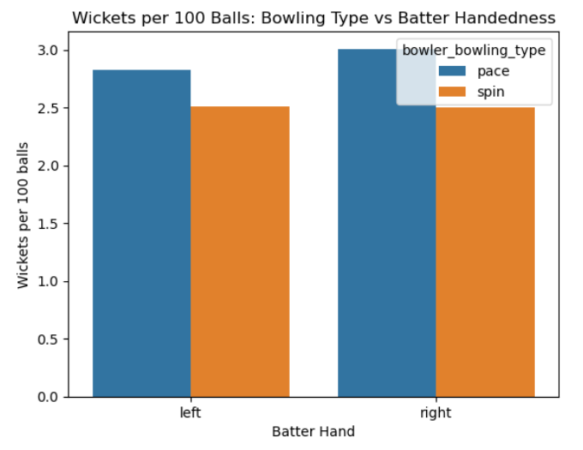
Looking at wicket rates per 100 balls by bowler type and batter hand:
- Pace vs Left-hand batters: ~2.83
- Pace vs Right-hand batters: ~3.01
- Spin vs Left-hand batters: ~2.51
- Spin vs Right-hand batters: ~2.50
So in this dataset:
- Pace takes slightly more wickets vs right-handers than vs left-handers (small difference).
- Spin is almost unchanged by batter hand at this level of aggregation.
Why this makes sense (and why the effect is small here): batter handedness matters, but usually through matchups (angle, spin direction, field setting, which side boundaries are, etc.), not as a global “left-handers are safer/less safe” rule. When you pool all bowlers and all conditions together, the directional and matchup advantages can cancel out. That’s why the model later uses matchup-type features (e.g., spin into/away the batter, pace angle groups) rather than relying on batter hand alone.
2.4 Bowling style group (arm + pace/spin grouping)
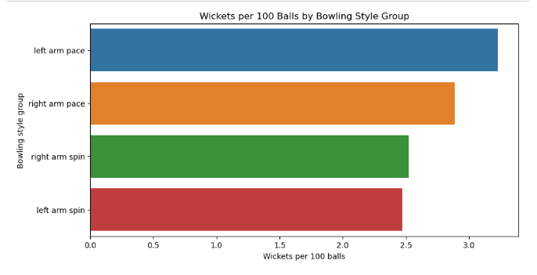
At a slightly richer grouping level (bowler “style group”), wicket rates per 100 balls looked like:
- Left-arm pace: ~3.23
- Right-arm pace: ~2.89
- Right-arm spin: ~2.52
- Left-arm spin: ~2.47
Why this makes sense: left-arm pace often creates awkward angles and different lines of attack (especially to right-handers), which can increase edges, LBWs and miscued shots in some conditions. But this should be read cautiously: it’s still aggregated across many bowler qualities and match contexts, and selection effects can exist (e.g., who gets to bowl which overs).
The key takeaway wasn’t “left-arm pace is always best”, but that style group is predictive enough to include, because it captures meaningful differences in wicket generation patterns.
2.5 Spin direction (into vs away)
For spin, the dataset included spin direction relative to batter handedness. In the more granular form:
- away_LHB: ~2.35
- away_RHB: ~2.57
- into_LHB: ~2.65
- into_RHB: ~2.35
And when collapsed into a simpler “into batter” vs “away from batter” feature:
- away_batter: ~2.53
- into_batter: ~2.45
So the “into vs away” story is not one single universal rule. It varies by handedness, and when you collapse it, the net effect becomes smaller.
Why this makes sense: “into/away” changes the batter’s shot map and the common dismissal modes. For example:
- Spin away can increase edges and catches in the ring/slips in some contexts.
- Spin into can increase LBWs/bowled and miscues when batters play across the line.
But the effect depends heavily on phase, field, pitch, and batter intent. That’s why the analysis later treated spin direction as a contextual feature, not a standalone decision rule.
2.6 Tactical groups: runs, boundaries, dots, and “impact score”
I also compared tactical style groups (e.g. left arm pace, right arm pace, spin_into, spin_away) on scoring outcomes by phase. Across powerplay / middle / death, the visuals showed consistent patterns:
- In death overs, pace groups tended to allow higher runs per over and higher boundary rates than spin groups on average.
- In powerplay and middle, the differences were smaller, but spin groups often looked more controlling (fewer runs/boundaries) depending on the exact grouping.
This type of result is common: the death overs produce extreme run rates because batters swing harder, and pace is often used there because it’s harder to line up consistently — but that can come with more boundaries.
To combine wicket-taking and run control into one measure, I built an “impact score” (using z-scores of wickets, runs/over, boundaries, dots within each phase, then combining them). The overall ranking came out roughly:
- spin_away (highest overall impact)
- left arm pace
- right arm pace
- spin_into (lowest overall impact)
How to interpret this properly: that ranking is not saying “spin away is always the best option”. It’s saying that in the way the score was defined, spin_away had a strong balance of wicket-taking and/or limiting damage relative to the other tactical groups when standardised across phases. Because z-scoring is relative, the ranking can shift if you change the weighting (e.g., if you care more about wickets than runs, or if you only care about death overs).
The important modelling takeaway is: tactical style group is meaningfully associated with both wickets and scoring outcomes, so it’s a sensible feature candidate — but any “best tactic” claim must be conditioned on match situation.
2.7 EDA takeaway: what was learned before modelling
The EDA established a few robust truths that directly motivated the later feature set:
- Phase matters a lot (death overs are fundamentally different).
- Pace vs spin differs in wicket rate, but the difference changes by phase.
- Handedness effects are subtle in aggregate, so we need matchup-style features rather than a single batter_hand rule.
- Tactical choices also trade off wickets vs runs/boundaries, which is exactly why a probabilistic model is useful: it can quantify how wicket probability changes with situation and bowling plan, rather than relying on one-size-fits-all heuristics.
3. Feature engineering summary
This section explains how the raw YAML ball-by-ball data was converted into model-ready features, and why those transformations were necessary. The key idea is: the model should be given information that would be known before the ball is bowled, expressed in a way that is consistent across innings and matches.
3.1 Target definition (what we’re predicting)
The target wicket is a binary label per delivery:
- wicket = 1 if a wicket fell on that ball
- wicket = 0 otherwise
To keep the modelling consistent, I filtered to legal deliveries when constructing the core training data, because wides/no-balls created complications around “ball in over” indexing and often didn’t represent a standard ball faced by the batter.
3.2 “Ball indexing” features (why the legal-ball logic exists)
The YAML data contains:
- over (1–50 within an innings)
- ball_in_over (delivery index, which can be > 6 because of wides/no-balls)
But the match-state features (balls faced, balls remaining, current run rate) should be based on legal balls only.
So I created logic that:
- allows a user to input delivery numbers like 7/8/9 (realistic, because overs can have extra deliveries),
- but converts that into a stable legal-ball index used for calculations.
The key derived quantities are:
(a) Legal ball used for calculation
- legal_ball_for_calc = min(ball_in_over, 6)
So balls 7/8/9 are treated as “the 6th legal ball” for the purposes of ball count features. This is a compromise that keeps the app usable and prevents absurd states (e.g., claiming 309 balls have been bowled in a 50-over innings due purely to delivery numbering).
(b) Balls faced before this ball
- balls_faced_before = (over_in_innings - 1) * 6 + (legal_ball_for_calc - 1)
(c) Ball number in innings
- ball_num_in_innings = balls_faced_before
This is a clean monotonically increasing index from 0 to 299 (for a standard 50-over innings) and is much more reliable than using raw ball_in_over.
(d) Balls remaining
- balls_remaining = 300 - balls_faced_before
This is the main “time left” feature, and it’s tightly linked to phase and match pressure.
Why this matters: early testing showed mismatches when using raw delivery numbers. Converting to a legal-ball index eliminated the majority of inconsistencies and prevented negative balls remaining.
3.3 Phase feature (coarse game segmentation)
I created a categorical phase variable derived from the over number:
- powerplay if over <= 10
- middle if 11 <= over <= 40
- death if over >= 41
In practice, phase is one of the strongest predictors because batter intent changes sharply at the death.
3.4 Current run rate (before the ball)
The run rate feature is computed as “runs scored so far per over” before the current delivery:
- curr_rr = (runs_innings_before / balls_faced_before) * 6
With a guard for the first ball:
- if balls_faced_before == 0, then curr_rr = NaN
3.5 Required run rate and RR pressure (chase-only logic)
In ODI cricket, required run rate is only meaningful in the 2nd innings when chasing. This was handled explicitly, rather than always forcing a value.
Define:
- is_chase = (innings == "2nd innings") and (req_rr_input > 0)
Then:
- req_rr_val = req_rr_input if chasing, else NaN
- rr_pressure_val = req_rr_val - curr_rr if chasing and curr_rr exists, else NaN
So:
- If you are not chasing, both req_rr and rr_pressure are missing (NaN) rather than zero.
- This prevents the model from learning a false signal where “0 required RR” means something cricket-related, when it really just means “not applicable”.
Why RR pressure helps: two situations can have the same over/wickets/runs but different targets in a chase, which changes batter risk. RR pressure is a compact way to encode “how urgently we need runs beyond current pace”, which often correlates with wicket probability (more urgency → more risk → more wickets).
3.6 Categorical “bowling plan” features
These are the controllable/contextual features intended to reflect the bowling matchup:
- bowler_bowling_type (pace vs spin)
- bowler_arm (left vs right)
- batter_hand (left vs right)
- tactical_style_4 (e.g., left arm pace, right arm pace, spin_into, spin_away)
- bowler_style_group (finer label like right arm legbreak, slow left arm orthodox, etc.)
- matchup_type (a combined label that encodes batter hand + tactical style, e.g. “spin away vs RHB”)
Why both tactical_style_4 and bowler_style_group?
- tactical_style_4 captures the strategic intent (angle/direction group).
- bowler_style_group captures a more specific type (e.g., legbreak vs offbreak), which can change wicket mechanisms.
Even if they overlap conceptually, tree-based models can benefit from both when each adds slightly different structure..
3.7 Final v2 feature set (what the model actually uses)
The “v2” model takes a compact, situation-aware set of 14 total features (7 categorical + 7 numeric):
Categorical
- phase
- tactical_style_4
- bowler_bowling_type
- bowler_arm
- bowler_style_group
- matchup_type
- batter_hand
Numeric
- ball_num_in_innings
- balls_remaining
- wkts_in_hand_before
- runs_innings_before_cap
- curr_rr_cap
- req_rr_cap
- rr_pressure_cap
This feature set is a good balance between:
- match context (time, score, wickets),
- chase pressure (when applicable),
- matchup/tactical bowling plan.
It’s also intentionally deployable: every feature can be derived from information available live during a match (or entered manually by a user), without needing future knowledge.
4. Streamlit app explanation (Tab 1 + Tab 2, and limitations)
The end product is a Streamlit app designed to make the model usable in a practical way. Instead of exposing a raw notebook, the app turns the model into two “tools” a user can interact with:
- Tab 1: predict wicket probability for a single next ball (given a match situation + bowling plan)
- Tab 2: compare several bowling options in the same match situation and rank them by predicted wicket chance
The key design principle is that the app only uses deployable inputs — information that would be known before the ball is bowled.
4.1 Tab 1 — Single Ball Predictor
Purpose:
Given a match situation and a proposed bowling plan, Tab 1 outputs:
- Predicted wicket probability for the next ball (as a percentage)
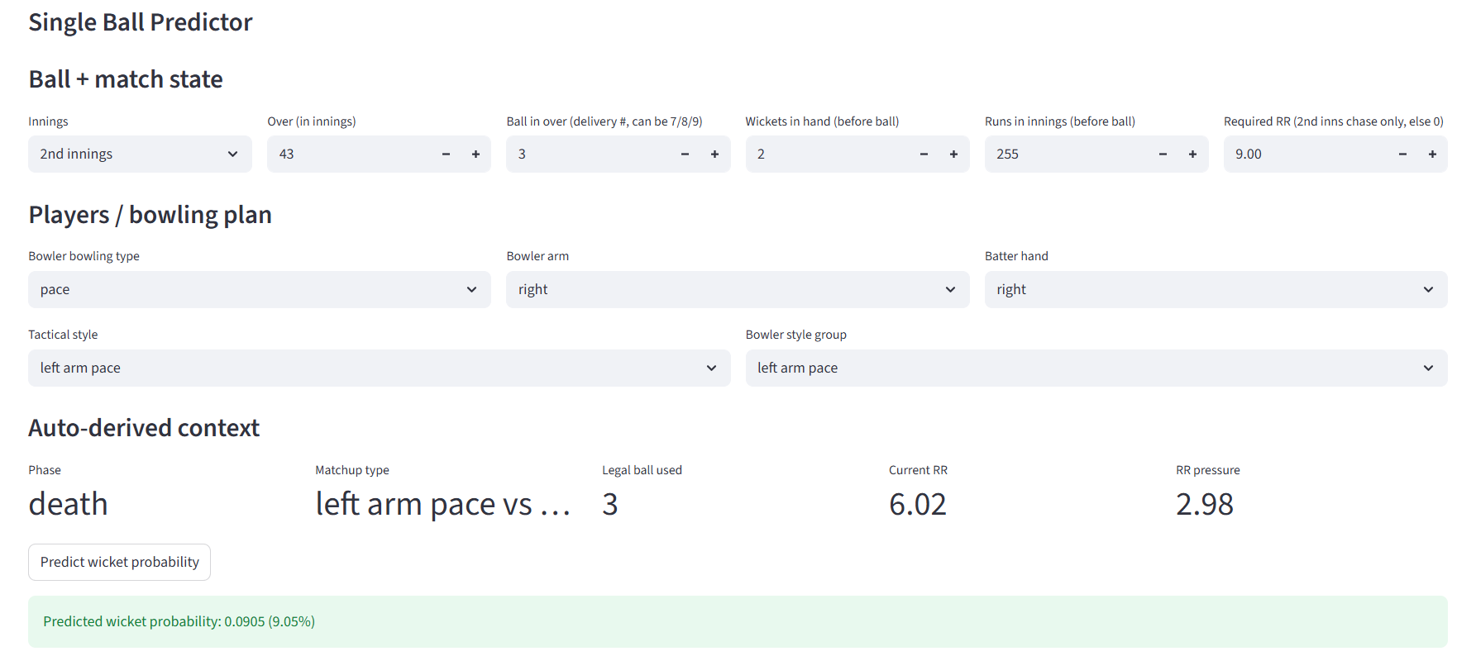
This is the core “wicket predictor” and is the most defensible output, because it is a direct model prediction for one fully specified context.
Inputs (what the user controls)
Tab 1 is intentionally minimal — the user gives:
Match state
- innings (1st / 2nd)
- over (in innings)
- delivery number in over (can be 1–9 to reflect wides/no-balls)
- wickets in hand (before ball)
- runs in innings (before ball)
- required RR (only meaningful in a 2nd innings chase)
Bowling plan
- bowler bowling type (pace/spin)
- bowler arm (left/right)
- batter hand (left/right)
- tactical style (left arm pace / right arm pace / spin_into / spin_away)
- bowler style group (drop-down: offbreak, legbreak, SLA, etc.)
Auto-derived context (what the app computes)
To keep the user interface simple and consistent with the training features, Tab 1 automatically derives the match context features the model actually uses:
- Phase
- powerplay / middle / death computed from over number
- Legal-ball indexing (important)
- delivery numbers can be 7/8/9 in real cricket due to wides/no-balls
- but for ball-count based calculations the app converts this to a legal-ball index:
  - legal_ball_for_calc = min(ball_in_over, 6)
This prevents impossible states (negative balls remaining, inflated ball counts) while still letting the user input realistic over structures.
- Ball index and balls remaining
- ball_num_in_innings (0–299 style index)
- balls_remaining = 300 - balls_faced_before
- Current RR (before ball)
- computed from runs so far and legal balls faced
- Chase-only features
- if not a 2nd innings chase, req_rr and rr_pressure are set to NaN (not forced to 0)
- if chasing: rr_pressure = req_rr - curr_rr
- Capping
To keep predictions stable and guard against extreme inputs, the v2 model uses capped versions:
- runs capped to [0, 500]
- current RR capped to [0, 15]
- required RR capped to [0, 20]
- RR pressure capped to [-15, 15]
Output
The output is shown as:
- Predicted wicket probability: X%
This is best interpreted relative to the base rate (~2.77% per ball). For example:
- values near 2–3% are “normal”
- 5–7% indicates a noticeably risky ball
- double digits indicates a very high-risk context (usually death overs + high pressure + low wickets, etc.)
4.2 Tab 2 — Bowling Advisor (ranking options)
Purpose:
Tab 2 is a decision-support tool. It answers:
“Given this match situation, which bowling option gives the highest wicket probability?”
This is not just “pace vs spin” — it compares multiple tactical profiles and ranks them.
Step 1: user inputs the situation
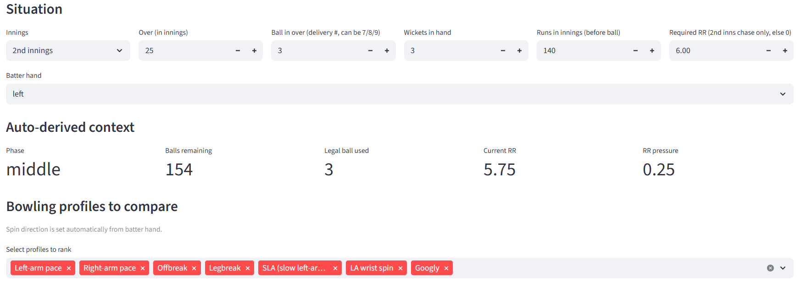
Tab 2 takes the same match state inputs as Tab 1:
- innings, over, delivery number
- runs in innings
- wickets in hand
- required RR (optional, chase-only)
- batter hand
Then it derives the same context features (phase, balls remaining, current RR, RR pressure, capped variables).
Step 2: user defines the bowling options
The user can compare several “options” (by default four are provided):
- left arm pace
- right arm pace
- spin_into
- spin_away
Each option includes:
- tactical style
- style group (chosen from a dropdown)
- and its matchup label is computed automatically from tactical style + batter handedness
Tab 2 then runs the model once per option, holding match context fixed, and produces a ranked table.
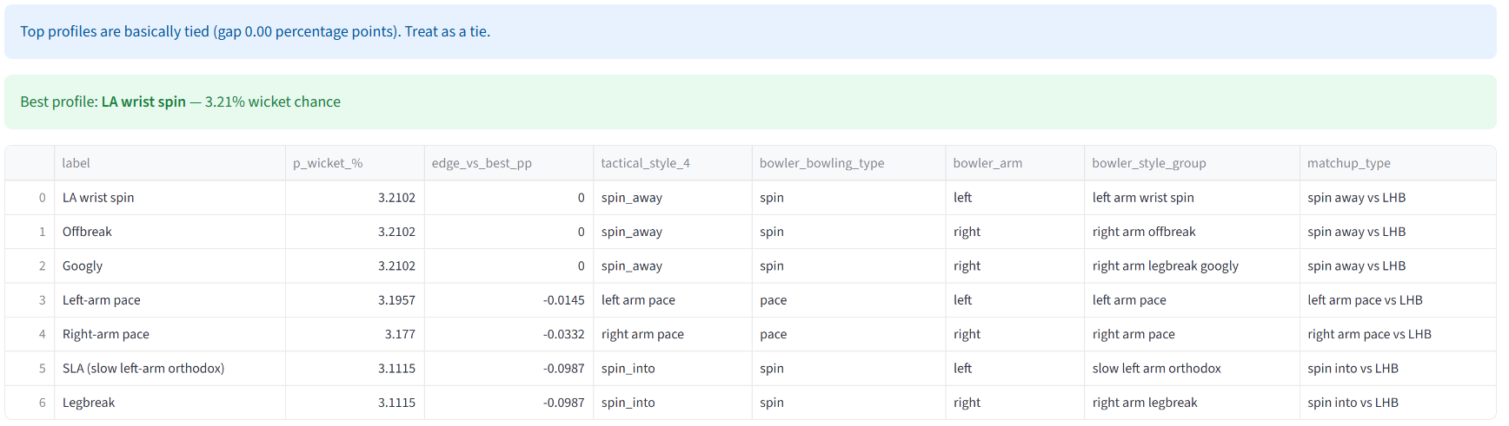
Outputs
Tab 2 returns:
- the best option (highest wicket probability)
- a ranked dataframe listing each option and its predicted wicket %
4.3 How Tab 1 and Tab 2 relate
- Tab 1 is the “atomic” prediction tool: one state, one bowling plan → one wicket probability.
- Tab 2 is just Tab 1 repeated across multiple bowling plans:
one fixed state → compare several bowling plans → ranked answer.
So Tab 2 is only as good as Tab 1, and the most important thing is that both tabs use the same engineered feature logic and the same trained model artifacts.
4.4 Limitations (important for a realistic portfolio write-up)
It’s important to be explicit about what the app does not know, because that explains why the model’s AUC is modest and why predictions cluster around low percentages.
1) No player identity / skill level
The YAML contains names, but the deployed model intentionally does not use player IDs yet. That means it treats:
- an elite bowler and an average bowler of the same style group as “similar”
- an elite batter and a tail-ender as “similar” given the same wickets/over/pressure
This is a huge missing source of signal.
2) No pitch / venue / conditions
ODI wicket-taking varies massively by:
- pitch pace and bounce
- swing/seam conditions
- ground size
- dew / weather
Those are not included in the current v2 feature set.
3) Field setting and batter intent are unobserved
Phase and RR pressure approximate intent, but there’s no direct signal like:
- “attacking field”
- “batter is set / new”
- “shot type”
- “strike rotation style”
So the model learns average behaviours, not the exact tactical detail.
4) Delivery 7/8/9 handling is a compromise
Allowing 1–9 delivery numbers is realistic for UI, but the model features are based on legal-ball indexing. That means Tab 1/2 predictions for ball 7/8/9 are “close approximations” rather than exact modelling of illegal deliveries.
5) Tab 2 is best for comparing styles, not picking named bowlers
Tab 2 ranks bowling profiles, not specific bowlers. It’s useful for deciding:
- “pace vs spin here?”
- “spin into vs away here?”
- “which style group seems best in this context?”
But it isn’t (yet) a true “captaincy assistant” that says:
- “bring on Bowler X now”
That requires player-level features.
4.5 Practical interpretation guide (how to use it)
- Treat the probability as a risk indicator, not a guarantee.
- Use Tab 1 to understand how wicket chance shifts with context:
  - phase
  - wickets in hand
  - RR pressure
  - tactical style group
- Use Tab 2 when you’re deciding between plans:
  - compare profiles in the same state
  - use the ranking rather than obsessing over tiny % differences
If the top two options are separated by something tiny (e.g., 3.20% vs 3.10%), that’s essentially “too close to call” and you’d use cricket judgement (bowler form, matchups, conditions).
5. Future work
This project already delivers a usable end-to-end pipeline (EDA → feature engineering → model → Streamlit app). The next steps are mainly about adding missing cricket signal, improving evaluation realism, and turning the app from “style-based decision support” into something closer to a true bowling assistant.
5.1 Add player-level features (biggest gain)
Right now, the model treats bowlers and batters mostly through style groups and match context. The single biggest improvement would be to add player identity information in a controlled way.
Good next features:
- Bowler ID features
  - bowler name → aggregated historical wicket rate
  - bowler wicket rate by phase (PP / middle / death)
  - bowler wicket rate vs LHB/RHB
  - bowler economy and boundary rate (optional)
- Batter ID features
  - batter dismissal rate by phase
  - dismissal rate under pressure (high RR pressure situations)
  - dismissal rate vs pace/spin and vs style groups
Important: to avoid leakage, these should be calculated using past matches only (or computed in a way that is safe within a training fold).
Why this matters: ODI wicket probability depends heavily on the individuals involved, and style group is a proxy. Adding player-level priors would give Tab 2 real credibility for “who should bowl now?”
5.2 “New batter” and “set batter” indicators
Wicket probability is not constant across an innings even at the same over, because batters change.
Possible engineered features (still deployable from ball-by-ball YAML):
- balls faced by striker before ball (batter_balls_faced_before)
- runs scored by striker before ball (batter_runs_before)
- simple binary: is_new_batter (e.g., < 6 balls faced)
- partnership runs / balls (if the YAML parsing supports it)
These capture a key tactical truth:
- new batters are more likely to get out early
- set batters are more likely to survive but also more likely to accelerate later
5.3 Better match context: target, innings state, and “game situation”
For chase innings:
- runs remaining
- required runs remaining per wicket (a pressure proxy)
- target score (if available in the YAML metadata)
For both innings:
- innings progression (already represented via ball index / balls remaining)
- wickets lost (currently wickets in hand is used; wickets lost could be derived too)
These make the app more like an actual “game state model”.
5.4 Venue / conditions (if you expand beyond YAML)
YAML alone often doesn’t contain:
- venue characteristics
- pitch conditions
- dew/weather
- boundaries size
But merging external sources (e.g., match metadata datasets) using match_id/date/teams could be done.
High-impact additions:
- venue
- country/continent
- day/night
- toss winner & decision (can affect chasing dynamics)
5.5 Tab 2 improvements: from “styles” to “your bowling attack”
To make Tab 2 genuinely useful to a captain/analyst, the workflow should be:
- user selects the actual bowlers available (e.g., 5–6 options)
- app uses each bowler’s style + historical priors
- rank bowlers by wicket probability for this ball
To do this, you need:
- player-level features (Section 6.1)
- a “bowler profile lookup table” built from the dataset
- optional workload constraints (overs left, fatigue proxy)

