# Cover page

**Multimedia University**

**CCP6114 Programming Fundamentals 2430**

**Lecture section: TC2L**

**Tutorial section: TT4L**

**Group number: G07**

**Group leader student name: GOH WEI JING**

|  |  |  |  |  |
| --- | --- | --- | --- | --- |
| **Num** | **Student**  **ID** | **Student Name by**  **alphabetical order** | **Task Descriptions** | **Percentage (%)** |
| 1 | 242UC244K7 | CHIN KUAN SIING | create_insert_into_table,create_table function |  |
| 2 | 242UC244S9 | GOH WEI JING | create_output_screen_and_file, create_table function, select_all_from_table_in_csv_mode |  |
| 3 | 242UC244SJ | KHOO SHEN ZHI | error_handling, flowchart, structured diagram |  |
| 4 | 242UC244S3 | TENG MING HEIN | create_database function, create_table function |  |

Every student is responsible for 100% (task percentage) of this group assignment work.

# 

# 

# Mark sheet checklist (30%)

**Assignment programming and documentation (30%)**

You are required to submit assignment milestone 1 to your respective tutor also before the submission deadline.

Also document all your assignment tasks with this marking table that contain cover page, table of contents, page numbering, inputs, outputs, screenshots, explanations, and others.

|  |  |  |  |  |
| --- | --- | --- | --- | --- |
| **Criteria** | **Max** | **A1** | **A2** | **Mark** |
| Q1.  Create database and view database name  Create table, view table name  Table supports two data types i.e. INT, TEXT  Insert rows to the table  View table in csv mode | 5 | * | * | ? |
| Q2.  Reading from a file, outputting to screen, writing to a file (0 if no files used or no screen outputs) | 3 |  | * | ? |
| Q3.  Update table rows and view table  Delete table rows and view table | 4 |  | * | ? |
| Q4.  Count and output number of rows in the table | 2 |  | * | ? |
| Q5.  Must use vectors or arrays, functions or classes, to store file output contents | 2 |  | * | ? |
| Q6.  Inline comments, function or class comments, indentation, following proper C++ naming and styling conventions  Any violation is penalized by a reduction of 1 mark. | 2 |  | * | ? |
| Q7.  The program demonstrates error handlings.  [0: Below Expectation, 1: Within Expectation, 2: Exceed Expectation] | 2 |  | * | ? |
|  |  |  |  |  |
| Q8.  Correct structured diagrams | 2 |  | * | ? |
| Q9.  Correct flowcharts or pseudocodes with explanations for all the file input statements.  Any missing flowchart or pseudocode will cause you to lose 1 mark. | 2 |  | * | ? |
| Q10.  Sample file inputs at least 3, their screen outputs, their file outputs with screenshots and explanations. | 3 |  | * | ? |
| Q11.  User documentation done and is coherence with the all implementations.  Any missing input statement will cause you to lose 1 mark. | 3 |  | * | ? |
|  |  |  |  |  |
| Total | 30 |  |  | ? |

Additional comments

|  |
| --- |
|  |

You are required to fill in your task percentage and task descriptions.   
Every student is responsible for 100% (task percentage) of this group assignment work.

Student 1

|  |  |
| --- | --- |
| Student ID | 242UC244S9 |
| Student name | GOH WEI JING |
| Task percentage | ? |
| Task descriptions | create_output_screen_and_file,  create_table function,  select_all_from_table_in_csv_mode |
| Total score (30m) | ? |

Student 2

|  |  |
| --- | --- |
| Student ID | 242UC244SJ |
| Student name | Khoo Shen Zhi |
| Task percentage | ? |
| Task descriptions | error_handling, flowchart, structured diagram |
| Total score (30m) | ? |

Student 3

|  |  |
| --- | --- |
| Student ID | 242UC244K7 |
| Student name | CHIN KUAN SIING |
| Task percentage | ? |
| Task descriptions | create_insert_into_table and create_table function |
| Total score (30m) | ? |

Student 4

|  |  |
| --- | --- |
| Student ID | 242UC244S3 |
| Student name | TENG MING HEIN |
| Task percentage | ? |
| Task descriptions | create_database function, create_table function |
| Total score (30m) | ? |

Each feature will be evaluated based on documentation, fulfilment of requirements, correctness, compilation without warnings and errors, error free during runtime, error handlings, quality of comments, user friendliness, good coding format and style.

# 

# 

# Table of contents with page numbers and links

Cover page

Mark sheet checklist (30%)

Table of contents with page numbers and links

Delete this information section

Question Section

Q01, Q09, Q11 [5] Database name, table name, table of two data types, insert table rows, view table in csv mode

Q02, Q09, Q11 [3] Reading from a file, outputting to screen, writing to a file

Q03, Q09, Q11 [4] Update table rows, delete table rows, view table

Q04, Q09, Q11 [2] Count and output number of rows in the table

Q05, Q11 [2] Must use vectors or arrays, functions or classes, to store file output contents

Q06, Q11 [2] Inline comments, function or class comments, indentation, proper C++ naming with styling conventions

Q07, Q09, Q11 [2] The program demonstrates error handlings

Q08, Q11 [2] Structured diagrams

Q10, Q11 [3] Three sample input files, step by step screenshot outputs, output files, explanations

# 

# Delete this information section

Insert the comment below at the beginning of your source code files:

// *********************************************************

// Program: YOUR_FILENAME.cpp

// Course: CCP6114 Programming Fundamentals

// Lecture Class: TC3L

// Tutorial Class: TT5L

// Trimester: 2430

// Member_1: ID | NAME | EMAIL | PHONE

// Member_2: ID | NAME | EMAIL | PHONE

// Member_3: ID | NAME | EMAIL | PHONE

// Member_4: ID | NAME | EMAIL | PHONE

// *********************************************************

// Task Distribution

// Member_1:

// Member_2:

// Member_3:

// Member_4:

// *********************************************************

# Question Section

# Q01, Q09, Q11 [5] Database name, table name, table of two data types, insert table rows, view table in csv mode

Create database and view database name

Create table, view table name

Table supports two data types i.e. INT, TEXT

Insert rows to the table

View table in csv mode

Screenshots (inputs, outputs), explanations

Table supports two data types i.e. INT, TEXT

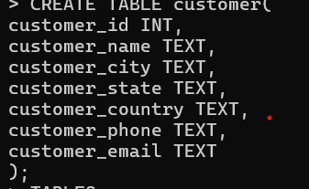

View table in csv mode

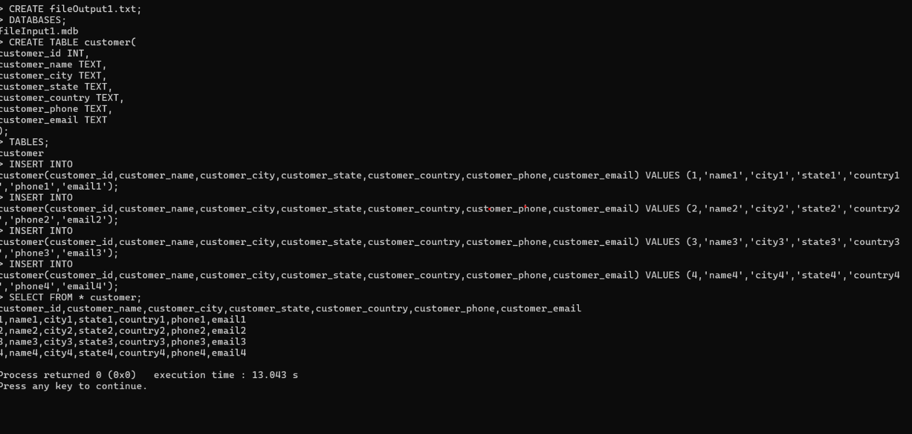

Pseudocode parts, explanations

|  |
| --- |
|  |

## 

# Q02, Q09, Q11 [3] Reading from a file, outputting to screen, writing to a file

0 if no files used or no screen outputs

Screenshots (inputs, outputs), explanations

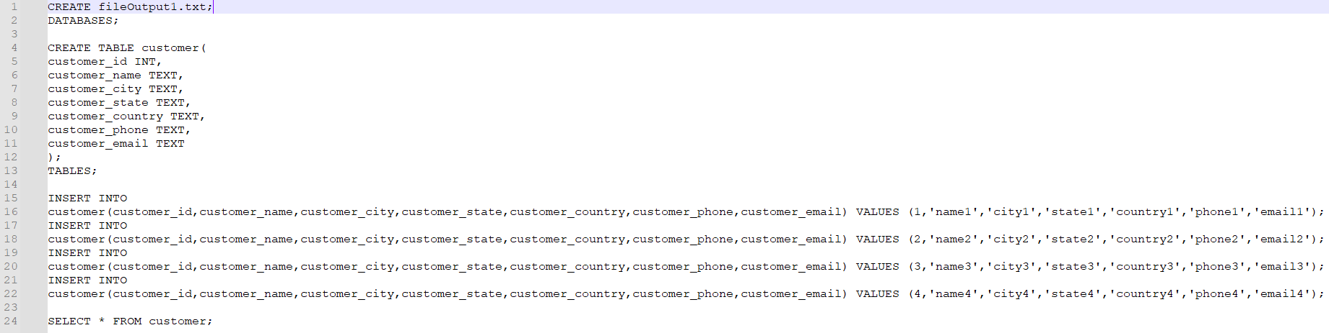

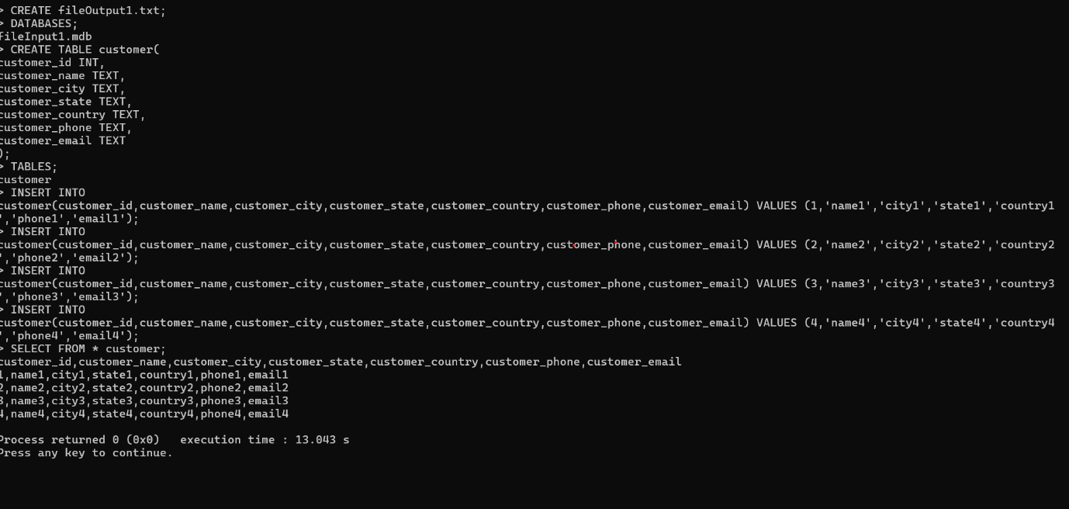

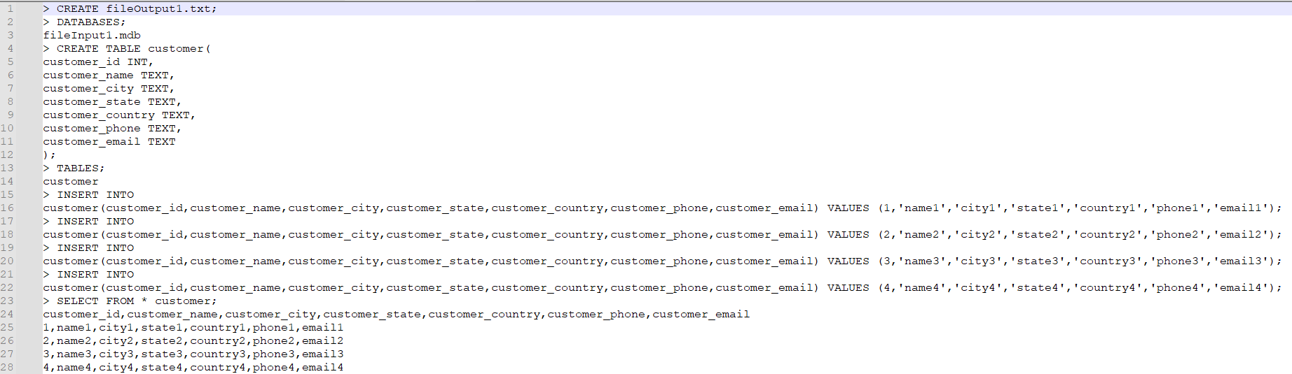

Pseudocode parts, explanations

|  |
| --- |
| FUNCTION create output screen and file  EXTRACT file name from line (text between '(' and ')')  TRY to open file with the extracted name  IF file cannot be opened THEN  PRINT "Error: Unable to create file"  RETURN  END IF  PRINT "CREATE <file name>" to console  WRITE "CREATE <file name>" to the file  END FUNCTION    explainations:  search for space in the first line between “space” and “;” example  CREATE fileOutput1.txt;  Create output file if output file is not opened based on the name  CREATE fileOutput1.txt;  Print “CREATE file name to console  Write “CREATE file name to file |

# Q03, Q09, Q11 [4] Update table rows, delete table rows, view table

Screenshots (inputs, outputs), explanations

Pseudocode parts, explanations

|  |
| --- |
|  |

# Q04, Q09, Q11 [2] Count and output number of rows in the table

Screenshots (inputs, outputs), explanations

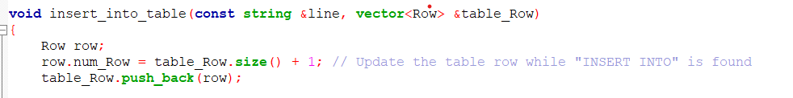

Pseudocode parts, explanations

|  |
| --- |
| 1.FUNCTION create insert_into_table  2.table_row (a vector to track rows in table)  3.Create a new row  4. Calculate row number  5 Add new row to table  6. output confirmation of insertion  Explanation  Create row object to represent new row being inserted into table  Calculate the row based on size of table_row  Add new row to vector (table_ow.push_back(row))meansanew row is added into the table |

# 

# 

# Q05, Q11 [2] Must use vectors or arrays, functions or classes, to store file output contents

Screenshots (inputs, outputs), explanations

?

Code parts, explanations

|  |
| --- |
|  |

# 

# Q06, Q11 [2] Inline comments, function or class comments, indentation, proper C++ naming with styling conventions

Any violation is penalized by a reduction of 1 mark.

Screenshots (inputs, outputs), explanations

Inline comments



Class comments

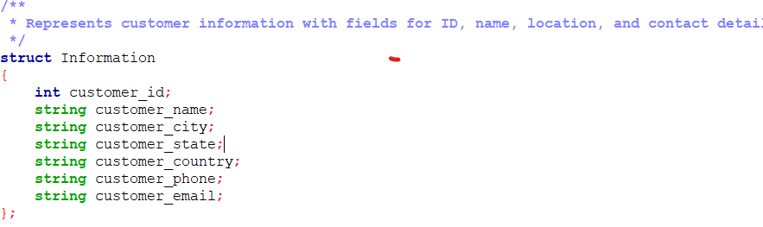

Indentation



Code parts, explanations

|  |
| --- |
| Inline comments  this comment explain that value _eli will contain string of after the word ‘VALUES’ is removed  Class comments  Add comments to explain each roles  Identation  In create_database this line is dense and could split for better readability |

# 

# Q07, Q09, Q11 [2] The program demonstrates error handlings

[0: Below Expectation, 1: Within Expectation, 2: Exceed Expectation]

Screenshots (inputs, outputs), explanations

?

Pseudocode parts, explanations

|  |
| --- |
|  |

# Q08, Q11 [2] Structured diagrams

Figures, explanations

?

# Q10, Q11 [3] Three sample input files, step by step screenshot outputs, output files, explanations

Sample 1 for A1

input file

filename: fileInput1.mdb

|  |
| --- |
| CREATE fileOutput1.txt;  DATABASES;  CREATE TABLE customer(  customer_id INT,  customer_name TEXT,  customer_city TEXT,  customer_state TEXT,  customer_country TEXT,  customer_phone TEXT,  customer_email TEXT  );  TABLES;  INSERT INTO customer(customer_id,customer_name,customer_city,customer_state,customer_country,customer_phone,customer_email) VALUES (1,'name1','city1','state1','country1','phone1','email1');  INSERT INTO customer(customer_id,customer_name,customer_city,customer_state,customer_country,customer_phone,customer_email) VALUES (2,'name2','city2','state2','country2','phone2','email2');  INSERT INTO customer(customer_id,customer_name,customer_city,customer_state,customer_country,customer_phone,customer_email) VALUES (3,'name3','city3','state3','country3','phone3','email3');  INSERT INTO customer(customer_id,customer_name,customer_city,customer_state,customer_country,customer_phone,customer_email) VALUES (4,'name4','city4','state4','country4','phone4','email4');  SELECT * FROM customer; |

output file and screen output

filename: fileOutput1.txt

|  |
| --- |
| > CREATE fileOutput1.txt;  > DATABASES;  C:\mariadb\fileInput1.mdb  **>** CREATE TABLE customer(  customer_id INT,  customer_name TEXT,  customer_city TEXT,  customer_state TEXT,  customer_country TEXT,  customer_phone TEXT,  customer_email TEXT  );  > TABLES;  customer  **>** INSERT INTO customer(customer_id,customer_name,customer_city,customer_state,customer_country,customer_phone,customer_email) VALUES (1,'name1','city1','state1','country1','phone1','email1');  > INSERT INTO customer(customer_id,customer_name,customer_city,customer_state,customer_country,customer_phone,customer_email) VALUES (2,'name2','city2','state2','country2','phone2','email2');  > INSERT INTO customer(customer_id,customer_name,customer_city,customer_state,customer_country,customer_phone,customer_email) VALUES (3,'name3','city3','state3','country3','phone3','email3');  > INSERT INTO customer(customer_id,customer_name,customer_city,customer_state,customer_country,customer_phone,customer_email) VALUES (4,'name4','city4','state4','country4','phone4','email4');  > SELECT * FROM customer;  customer_id,customer_name,customer_city,customer_state,customer_country,customer_phone,customer_email  1,name1,city1,state1,country1,phone1,email1  2,name2,city2,state2,country2,phone2,email2  3,name3,city3,state3,country3,phone3,email3  4,name4,city4,state4,country4,phone4,email4 |

Sample 1 for A2

input file

filename: fileInput2.mdb

|  |
| --- |
| CREATE fileOutput2.txt;  DATABASES;  CREATE TABLE customer(  customer_id INT,  customer_name TEXT,  customer_city TEXT,  customer_state TEXT,  customer_country TEXT,  customer_phone TEXT,  customer_email TEXT  );  INSERT INTO customer(customer_id,customer_name,customer_city,customer_state,customer_country,customer_phone,customer_email) VALUES (1,'name1','city1','state1','country1','phone1','email1');  INSERT INTO customer(customer_id,customer_name,customer_city,customer_state,customer_country,customer_phone,customer_email) VALUES (2,'name2','city2','state2','country2','phone2','email2');  INSERT INTO customer(customer_id,customer_name,customer_city,customer_state,customer_country,customer_phone,customer_email) VALUES (3,'name3','city3','state3','country3','phone3','email3');  INSERT INTO customer(customer_id,customer_name,customer_city,customer_state,customer_country,customer_phone,customer_email) VALUES (4,'name4','city4','state4','country4','phone4','email4');  SELECT * FROM customer;  TABLES;  UPDATE customer SET customer_email='email333' WHERE customer_id=3;  SELECT * FROM customer;  DELETE FROM customer WHERE customer_id=4;  SELECT * FROM customer;  SELECT COUNT(*) FROM customer; |

output file and screen output

filename: fileOutput2.txt

|  |
| --- |
| > CREATE fileOutput2.txt;  > DATABASES;  C:\mariadb\fileInput2.mdb  **>** CREATE TABLE customer(  customer_id INT,  customer_name TEXT,  customer_city TEXT,  customer_state TEXT,  customer_country TEXT,  customer_phone TEXT,  customer_email TEXT  );  **>** INSERT INTO customer(customer_id,customer_name,customer_city,customer_state,customer_country,customer_phone,customer_email) VALUES (1,'name1','city1','state1','country1','phone1','email1');  > INSERT INTO customer(customer_id,customer_name,customer_city,customer_state,customer_country,customer_phone,customer_email) VALUES (2,'name2','city2','state2','country2','phone2','email2');  > INSERT INTO customer(customer_id,customer_name,customer_city,customer_state,customer_country,customer_phone,customer_email) VALUES (3,'name3','city3','state3','country3','phone3','email3');  > INSERT INTO customer(customer_id,customer_name,customer_city,customer_state,customer_country,customer_phone,customer_email) VALUES (4,'name4','city4','state4','country4','phone4','email4');  > SELECT * FROM customer;  customer_id,customer_name,customer_city,customer_state,customer_country,customer_phone,customer_email  1,name1,city1,state1,country1,phone1,email1  2,name2,city2,state2,country2,phone2,email2  3,name3,city3,state3,country3,phone3,email3  4,name4,city4,state4,country4,phone4,email4  > TABLES;  customer  > UPDATE customer SET customer_email='email333' WHERE customer_id=3;  > SELECT * FROM customer;  customer_id,customer_name,customer_city,customer_state,customer_country,customer_phone,customer_email  1,name1,city1,state1,country1,phone1,email1  2,name2,city2,state2,country2,phone2,email2  3,name3,city3,state3,country3,phone3,email333  4,name4,city4,state4,country4,phone4,email4  > DELETE FROM customer WHERE customer_id=4;  > SELECT * FROM customer;  customer_id,customer_name,customer_city,customer_state,customer_country,customer_phone,customer_email  1,name1,city1,state1,country1,phone1,email1  2,name2,city2,state2,country2,phone2,email2  3,name3,city3,state3,country3,phone3,email333  > SELECT COUNT(*) FROM customer;  3 |

Sample 2

Input file covers all tasks, step by step screenshot outputs, output file, explanations

Your own sample?

fileInput2.mdb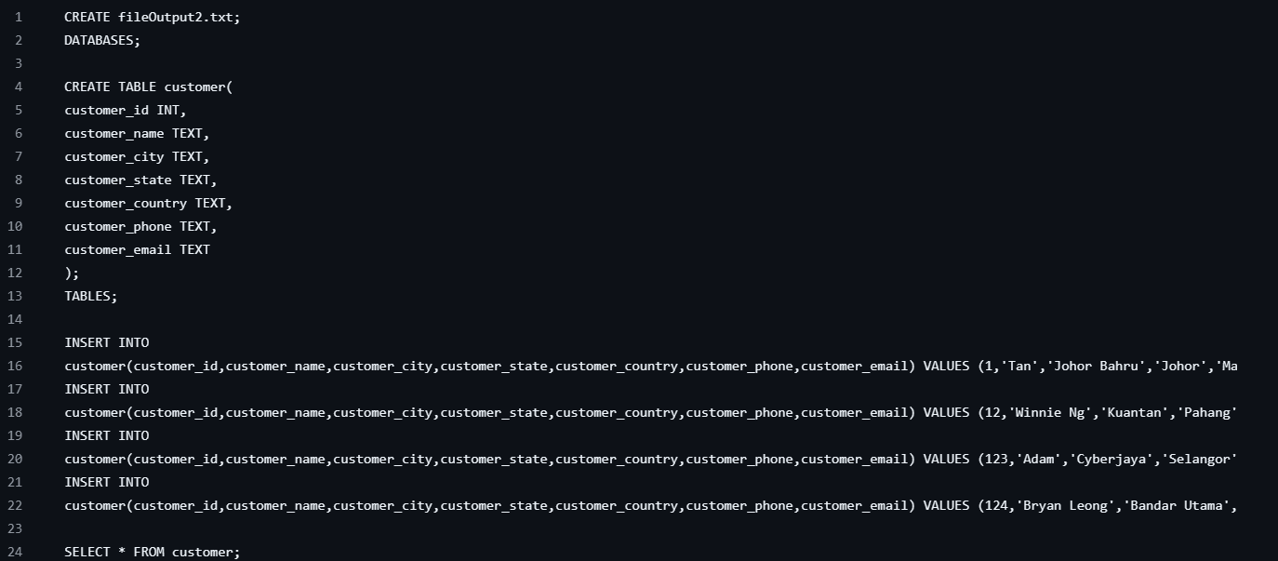

fileOutput2.txt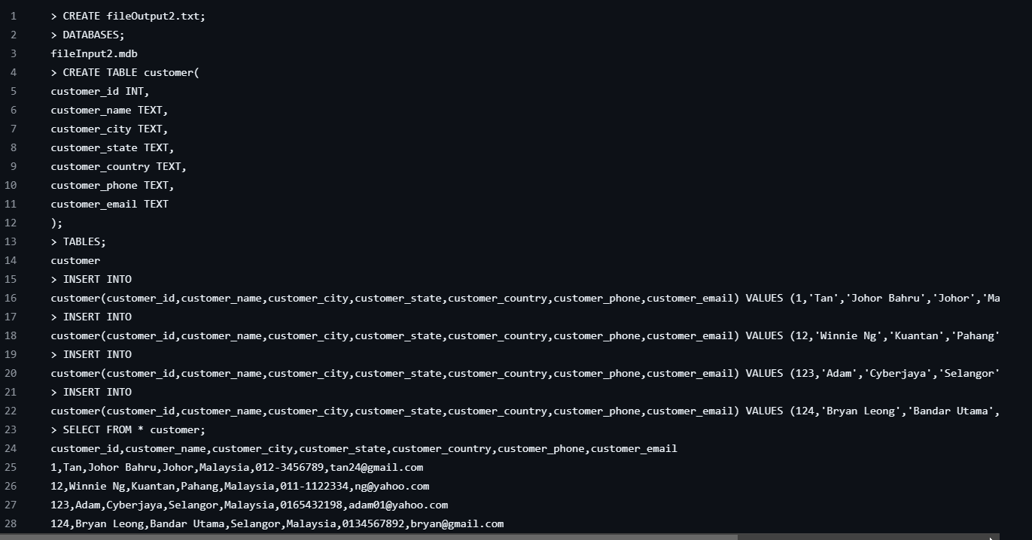

Sample 3

Input file covers all tasks, step by step screenshot outputs, output file, explanations

Your own sample?

fileInput3.mdb

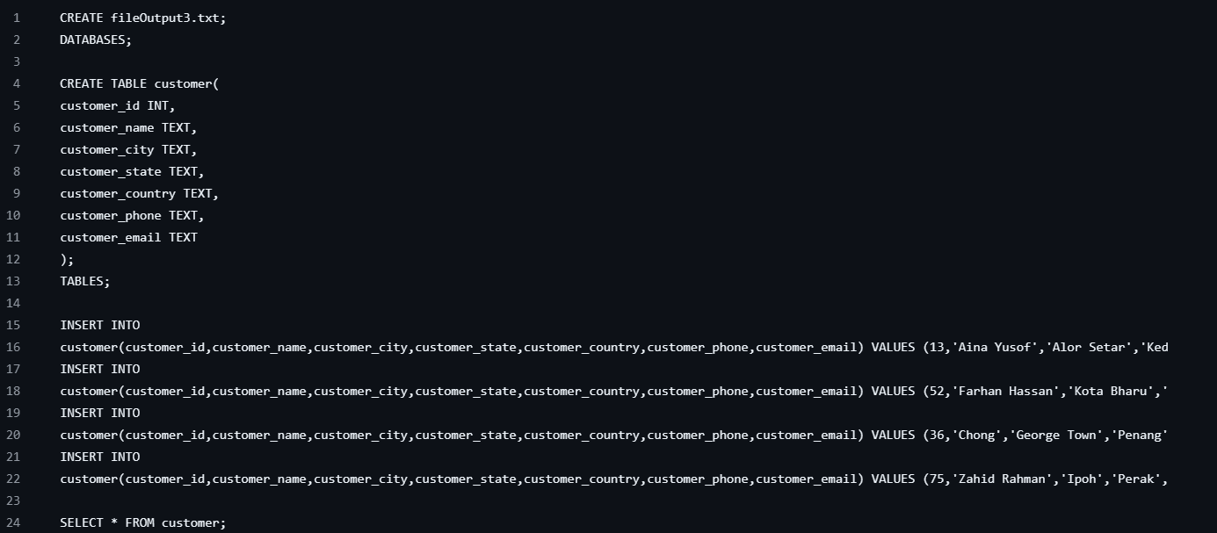

fileOutput3.txt

